Filter/Search List:

Ex1:

var str = "hellow";

var out = str.indexOf("l");

if(out > -1){

console.log(out);

}else{

console.log("none");

}

//2

var str = "hellow";

var out = str.search("l");

if(out > -1){

console.log(out);

}else{

console.log("none");

}

//2

Filter:

<input type="text" id="myText" onkeyup="myFunc()">

<ul id="mylist">

<li>Apple</li>

<li>Banana</li>

<li>Cake</li>

<li>Apple</li>

</ul>

function myFunc(){

var input = document.getElementById('myText');

var filter = input.value.toUpperCase();

var list = document.getElementById('mylist');

var li = list.getElementsByTagName('li');

var i;

for(i = 0; i < li.length; i++){

if (li[i].innerHTML.toUpperCase().indexOf(filter) > -1){

li[i].style.display = "";

}else{

li[i].style.display = "none";

}

}

}

Output:based on input

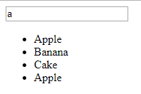

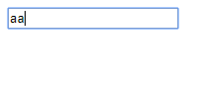

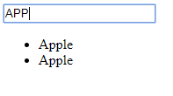

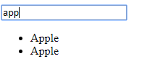

If condition fallow below

if (li[i].innerHTML.toUpperCase().indexOf(filter) == 0 ){

li[i].style.display = "";

}else{

li[i].style.display = "none";

}

Output:

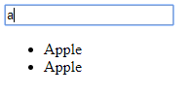

Note: It will only check for index position because value == 0

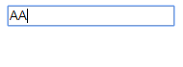

Ex2:

<input type="text" id="myText" onkeyup="myFunc()">

<ul id="mylist">

<li><a href="#">Apple</a></li>

<li><a href="#">Banana</a></li>

<li><a href="#">Cake</a></li>

<li><a href="#">Apple</a></li>

</ul>

function myFunc(){

var input = document.getElementById('myText');

var filter = input.value.toUpperCase();

// it will convert input to uppercase

var list = document.getElementById('mylist');

var li = list.getElementsByTagName('li');

var i;

for(i = 0; i < li.length; i++){

var a = li[i].getElementsByTagName('a')[0];

//each li conatins only one anchor element so that here we used index position 0

if (a.innerHTML.toUpperCase().indexOf(filter) > -1 ){

//ex: "Apple".indexOf("ur input")

//here uppercase used becas input converted to uppercas. we can use lowercase also but both places must be same method.

//if ur index of input is 0 which is greater than -1, condition true.

//indexOf method never return index position as negative value so that why here -1 is used

//indexOf method returns -1 when no match found

li[i].style.display = "";

//ones condition is true it will loop all li elements after taht only it will return ouput

}else{

li[i].style.display = "none";

// if condition fals it will hide all elements

}

}

}

Output:

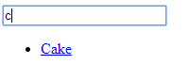

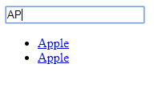

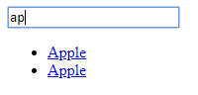

Note: it will always convert input into uppercase bcas we used uppercase in both places