**CRM (Customer Relationship Management) Overview:**

CRM stands for “customer relationship management” and it’s software that stores customer contact information like names, addresses, and phone numbers, as well as keeps track of customer activity like website visits, phone calls, email, and more.

**What CRM do?**

* Actively tracks and manages customer information.
* Connects your entire team from any device.
* Intelligently captures customer emails.
* Simplifies repetitive tasks so you can concentrate on leads.
* Delivers instant insights and recommendations.
* Extends and customises as your business grows.

**Introduction to Cloud Computing:**

🡪The practice of using a **network of remote servers** hosted on the Internet to **store, manage and process data** rather than the local server or personal computer.

Ex: gmail, facebook, salesforce

Advantage: Data can be accessible any where over the internet where as local server can be accessible only through LAN.

Data will be more secure in cloud

**Service Models:**

**SaaS(Software as a Service):**

🡪Instead of servers your accessing the software as a service like gmail, facebook this is called SaaS

**Ex:** CRM, Email, Virtual Desktop, Communications, Games, facebook, twitter

**PaaS(Platform as a Service):**

**Ex:** Web servers, Development Tools, Force.com, Java platform, .Net platform

Platform is environment where we can develop the apps using it.

**IaaS(Infrastructure as a Service):**

It is all about servers that I mentioned at Introduction of cloud computing

Maintaining the data, storing the data such as Backup, Replication and Recovery

**Ex:** Virtual machines, servers, storage ,AWS( Amazon Web Services), GCP( Google Cloud Platform)

**Introduction to Salesforce:**

**A global web based software and cloud computing company best known for its CRM product.**

**Salesforce was founded by former executive of oracle Mark Benioff and Parker Harris in 1991 and specializes in software as a service(SaaS) to help users handle all of their business needs like managing marketing campaigns, analyzing performance, and tracking spending and sales.**

**Salesforce Basics:**

**Salesforce Applications:**

Salesforce includes prebuilt applications for customer relationship management(CRM) ranging from sales force automation to partner relationship management, marketing, and customer services.

EX: veeva, Salesforce adoption dashboards, Data Quality Analysis Dashboards

[Veeva](https://www.veeva.com/) is a CRM application built on the Salesforce platform designed specifically for the pharmaceutical and biotechnology industries.

It also provides platform to develop your own customized applications using Force.com platform.

**Force.com Platform:**

The Force.com platform is the first platform as a service(PaaS) enabling developers to create and deliver any kind of business application entirely on demand and without software.

This platform uses two languages Apex and Visualforce

Apex is for Logic where as VF is for UI

Youtube link: <https://www.youtube.com/watch?v=r2bTuor7wx0&t=2393s>

**What is Visualforce:**

Visualforce is framework that allows developers to build sophisticated, customer user interfaces that can be hosted natively on on the Force.com platform.

The visualforce framework includes a tag-based markup language, similar to HTML.

In visualforce tags will called as components.

**Enable the development mode:**

**Development mode embeds a visualforce page editor that allows you to see the code and preview the page at the same time.**

**To enable Development mode**

UserName->My Settings -> Personal ->Advanced User Settings ->Edit ->Development mode

2.In how many ways we can build visualforce pages?

Ans: 4 ways.

1.Standard navigation

Goto Setup >Develop |Pages > new

2.URL

Add /apex/page1 to the URL aftrer salesforce.com(This is practical way and more developers use this method)

Ex: <https://ap5.lightning.force.com/apex/exp1>

It throws an error like --visualforce error --page exp1 does not exist--create page exp1

You have to click on create page

3. Developer console

4.Eclipse/Force.com IDE

**Visualforce Pages:**

Visualforce page basically consists of two primary components.

**1.Visualforce Markup**

The markup defines the user interface components that should be included on the page, and the way they should appear.

**2.Visualforce Controllers**

Set of instructions that specify what happens when user interacts with the components specified in associated Visualforce markup.

Such as when user clicks a link or button.

Controllers also provide access to the data that should be displayed in the page.

**What is visualforce component?**

Visualforce component is more like html tag and it has open & close tag.

Ex: <apex:page>, <apex:pageBlock>, <apex:pageBlockSection>

Componet should start and end

Ex:<apex:page></apexpage>, <apex:detail/>

**What is attribute?**

Attribute is a functionaliy of component.

Every component has few attributes, each attribute controls the behaviour of the component.

Ex: <apex:page> component has some attributes such as title=”sss”, sidebar=”true”, showHeader=”true”

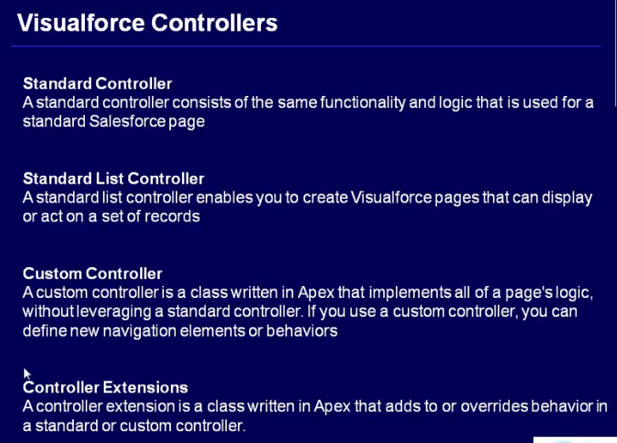

**Standard controller:**

Every standard as well as custom object has standard controller.

It is used to get data from the single record

There is no case sensitive in syntax

**To call the standardcontroller on visualforce page**

Define standardcontroller = object name in the apex:page attribute

Ex: standardController = “Account”

standardController = “Opportunity”

standardController = “Contact”

**To fetch the data from database**

Syntax: {!object name.field name}

Ex: {!Account.Name}

{!Account.Type}

{!Account.Phone}

To get data from Account, you have to select one of account and copy the account id and past in the url

Ex: https://c.ap5.visual.force.com/apex/vf1?id=0017F00000S10NX

Ex1:

