AakashaVani (WeatherGPT)

— Project Specification & Architecture Blueprint

Conversational AI Platform for Real-Time Weather Forecasting, Disaster Early Warning & Climate Intelligence
- Problem Statement ID: 26068
- Organization: Ministry of Earth Sciences (MoES) | India Meteorological Department (IMD)
- Theme: Disaster Management & Rural Accessibility
- Category: Software / AI & Geospatial Systems

1. Executive Summary & Vision
Weather information across India is dispersed across specialized portals (Doppler Weather Radar, Mausam, Meghdoot, NWP bulletins, and INSAT satellite products). For farmers, coastal fishermen, disaster response forces (NDRF/SDMA), and citizens, turning raw meteorological data into actionable advice in their native language is a critical challenge.
AakashaVani (WeatherGPT) is a conversational, voice-first, multilingual AI platform that unifies real-time station feeds, Numerical Weather Prediction (NWP GFS/WRF) models, Doppler radar composites, and Common Alerting Protocol (CAP) disaster feeds.
It uniquely solves rural accessibility, transparency, and comprehension through:
- Low-Bandwidth & Offline Fallback (SMS & IVR Mode): Ensuring 2G/no-internet rural accessibility.
- Granular Trust & Source Citation Engine: Every answer cites whether data stems from IMD Nowcasting (0–3h), GFS/WRF NWP models, or 50-year climate averages.
- Map-Based Visual Answers: Text answers are dynamically paired with embedded mini-maps (cyclone tracks, radar reflectivity, rainfall contours).
- Deterministic Agronomy & Disaster Rule Engine: Zero-hallucination guardrails combined with grounded LLM synthesis in 12+ Indian languages.
Targeted Personas & Core Use Cases
- Rural Farmer (Krishi)
- Primary Goal
Crop sowing, spraying, harvesting, and irrigation decisions.
- Critical Pain Point
Cannot interpret radar grids or complex mm rain charts; speaks regional dialect; weak 2G connectivity.
- Solution Delivered by WeatherGPT
Voice-first in local language (Hindi, Telugu, Marathi, etc.) + SMS / IVR fallback when offline. Delivers clear crop rules with an embedded rainfall mini-map.

- Disaster Manager (NDRF / SDMA)
- Primary Goal
Evacuation planning, flood forecasting, cyclone tracking.
- Critical Pain Point
Alerts scattered across separate bulletins; need auditable proof of data freshness and source provenance.
- Solution Delivered by WeatherGPT
Interactive GIS map with live radar, cyclone cones of uncertainty, auditable source citations, and district impact radius calculation.

- Fisherman / Marine (Sagar)
- Primary Goal
Marine safety, wave swell heights, squall warnings.
- Critical Pain Point
High latency offshore; cannot read complex meteorological terminology.
- Solution Delivered by WeatherGPT
High-contrast audio and visual squall warnings, wind speed in knots, wave swell mini-map, and safe harbor navigation advisories.

- Urban Citizen / Commuter
- Primary Goal
Daily commute planning, localized street flood alerts, AQI.
- Critical Pain Point
General city forecasts miss hyper-local cloudbursts (e.g. 5km radius rain).
- Solution Delivered by WeatherGPT
GPS-based nowcasting (0–3 hr forecast), heat index, and commute rain probability alerts with a live radar thumbnail.

- Logistics & Aviation
- Primary Goal
Crosswind thresholds, turbulence, low visibility / fog.
- Critical Pain Point
Need structured METAR/TAF briefings with predictive risk scoring.
- Solution Delivered by WeatherGPT
Route weather briefings, cloud-base height forecasts, and fog dissipation time estimations.

End-to-End User Flow & Sequence
Step-by-Step Flow Explanation:
- Connectivity Detection & Ingress Channel Routing:
  - Full Bandwidth (App/Web): Captures GPS coordinates (Lat, Lon), loads interactive vector map and live mic.
  - Low Bandwidth / 2G: Activates compressed PWA delta mode.
  - No Internet (Offline Fallback): Routes user query via Toll-Free SMS Gateway or Automated IVR Phone Call.
- Query Ingestion (Voice, Text, SMS, or IVR):
  - Spoken audio is transcribed via Indic Speech-to-Text (STT) into normalized text.
  - SMS/IVR queries are parsed into structured intents (e.g., WEATHER 442001 or voice prompt "Press 1 for rain").
- Query Understanding & Intent Classification:
  - The NLU Engine classifies intent (CROP_ADVISORY, NOWCAST_FORECAST, DISASTER_WARNING, CLIMATE_TREND, GENERAL_WEATHER).
  - Extracts entities: Location, Crop type, Time horizon (tomorrow, next 3 days), Hazard type.

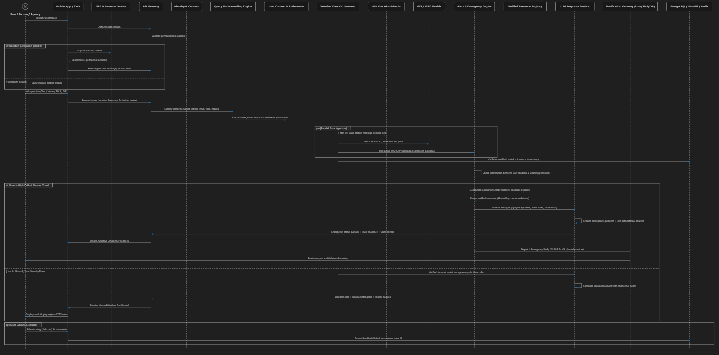

- Parallel Multi-Source Data Orchestration:
  - Current Weather: Queries latest Automatic Weather Station (AWS/ARG) observations.
  - NWP Forecast: Extracts multi-layer GFS/WRF model outputs (Rainfall mm, Temperature, Wind Gusts, Humidity, Cloud Cover).
  - Disaster Warnings: Queries IMD/NDMA active CAP feeds (Red/Orange/Yellow alert polygons).
  - GIS Context: Queries elevation, flood susceptibility, and soil moisture layers.
- Deterministic Rule Engine (Zero-Hallucination Guardrail):
  - The Advisory Engine applies domain rules (e.g., Cotton + Rainfall > 25mm = Stop pesticide spraying, clear drainage).
  - The Alert Engine calculates hazard severity scores based on official thresholds.
- Grounded LLM & Provenance Citation Engine:
  - Compiles verified numbers, rules, and source metadata.
  - Cites specific data sources: [IMD Nowcast (0-3h)], [GFS NWP 0.25°], [IMD 50-Yr Climate Normal], [ICAR Agromet Bulletin].
  - Calculates confidence score, latency (ms), and safety verification.
- Multimodal Delivery & Embedded Mini-Map Rendering:
  - Visual UI: Renders formatted text + Embedded Mini-Map (showing precipitation overlay, cyclone path, or alert zone) + Meteogram card.
  - Audio Stream: Synthetic regional voice (TTS) speaks the advice in the user's language.
  - SMS/IVR Response: For offline users, dispatches concise 160-character advisory or synthesized voice call.

Feature Spotlight: The 3 Core Differentiators
1. Offline / Low-Bandwidth Fallback (Rural Inclusion)
- SMS Gateway: Farmers with basic feature phones send SMS (e.g., BARISH WARDHA or KAPAS 442001) and receive instantaneous actionable SMS in Hindi/Marathi.
- Automated IVR Telephony: Rural users can dial a toll-free number, speak in their regional dialect, and listen to spoken weather advisories without internet access.
- Local PWA Cache (Offline Mode): Mobile app caches the latest 48-hour forecast and district warning boundaries locally in IndexedDB, allowing offline access during power/network outages.
2. Trust & Granular Source Citation (Zero Hallucination)
Judges and disaster managers demand 100% transparency. Every generated answer displays clickable source badges:
- [IMD DWR Nowcast | Updated 12 mins ago] — for short-term 0–3 hour rain predictions.
- [ NOAA GFS 0.25° / IMD WRF Ensemble] — for 24h to 7-day numerical forecasts.
- [ IMD 50-Year Climate Normals (1970–2020)] — for climate anomaly questions.
- [ Agromet Advisory Service (AAS) Bulletin #48] — for crop protection rules.
- Observability Badge: Displays Confidence: 96% | Latency: 240ms | Safety: Verified.
3. Map-Based Visual Answers (Embedded Spatial Context)
Instead of plain text walls, the AI pairs every response with an interactive visual mini-map:
- Rainfall Forecast Query: Renders a localized radar precipitation contour showing rainfall intensity over the user's farm/district.
- Cyclone / Marine Query: Renders the forecasted cyclone track, predicted landfall point, and wave height isolines.
- Extreme Weather Alert: Highlights the user's district polygon with official IMD color coding (Red / Orange / Yellow).

Adaptive Emergency Mode & Disaster Assistance
AakashaVani includes a dedicated Adaptive Emergency Mode designed to prioritize safety-critical information when a verified high-severity weather or disaster warning affects the user's current or selected location.
When an official warning is received, the system performs data validation and geospatial matching against the user's location. If the user falls within the affected region and the warning reaches a high or critical severity level, AakashaVani automatically prioritizes the Emergency Mode interface over the normal weather experience.
Emergency Mode provides:
- Live Emergency Status: Displays the active hazard, severity, affected area, issue time, latest update and verified source.
- Continuous Situation Updates: Automatically updates the user when new verified warning information, severity changes or affected-area updates are received.
- "What's Changed?" Summary: Highlights important changes since the previous warning or update.
- Emergency Map: Shows the user's location, affected zones, rainfall/flood intensity, cyclone or storm tracks, and other relevant GIS layers where available.
- Nearby Verified Assistance: Displays available hospitals, police stations, fire stations, shelters, relief centres and other officially listed emergency resources where authoritative location data is available.
- Recommended Safety Actions: Provides concise, localized and source-grounded guidance relevant to the active hazard.
- Multilingual Voice Guidance: Presents critical information through the user's selected language and supported voice interface.
- Multi-Channel Emergency Alerts: Delivers updates through the mobile application and, where supported, push notifications, SMS and IVR/voice channels.
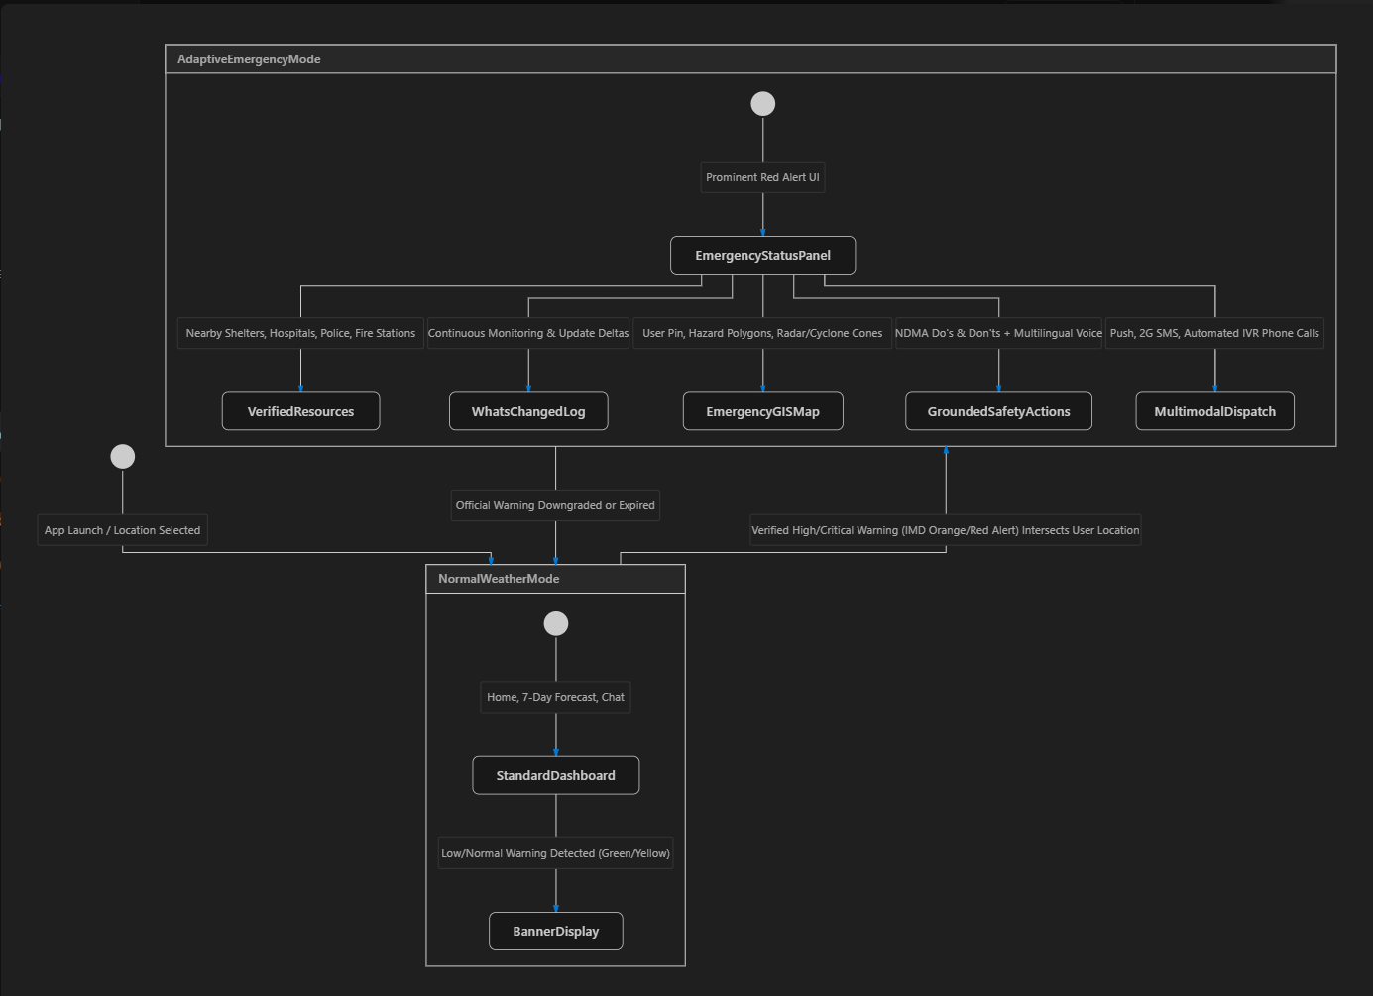
Emergency Mode Flow
Official Warning → Validation → Geospatial Match → Severity Evaluation → Emergency Mode → Situation Update → Emergency Map → Verified Assistance → Safety Guidance → Multichannel Notification
The system should always prioritize verified and authoritative information during emergencies. AakashaVani must not invent rescue-team availability, emergency contacts, shelter status or other operational information. Any simulated resources used in the prototype should be clearly identified as demonstration data.
Emergency Mode Principle
Detect → Verify → Escalate → Inform → Locate Help → Guide → Update

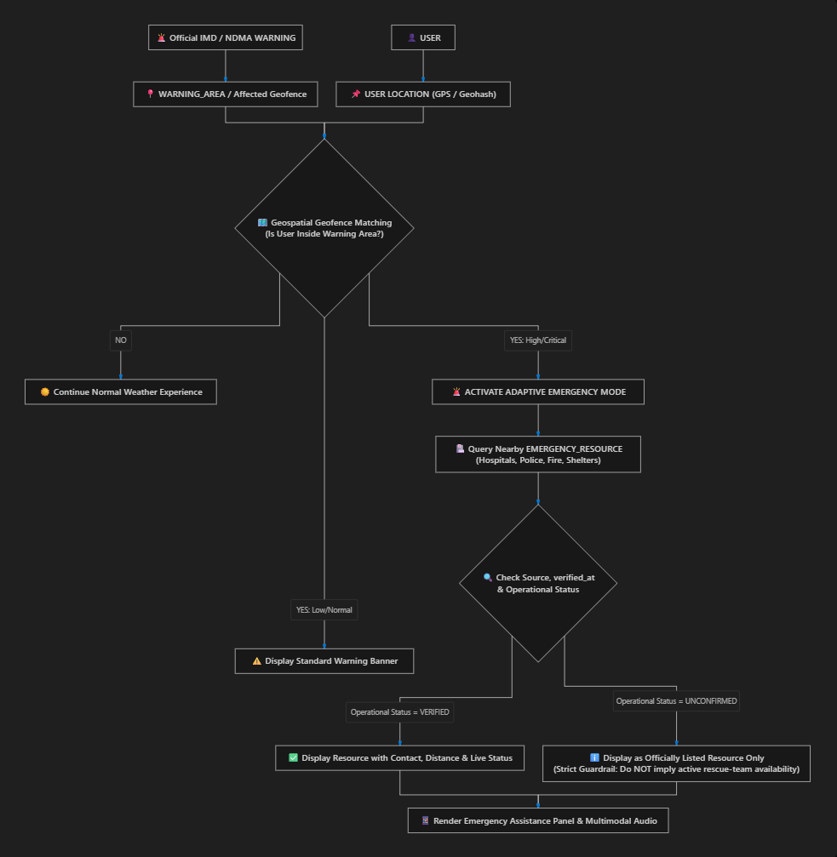

System Architecture & Component Hierarchy

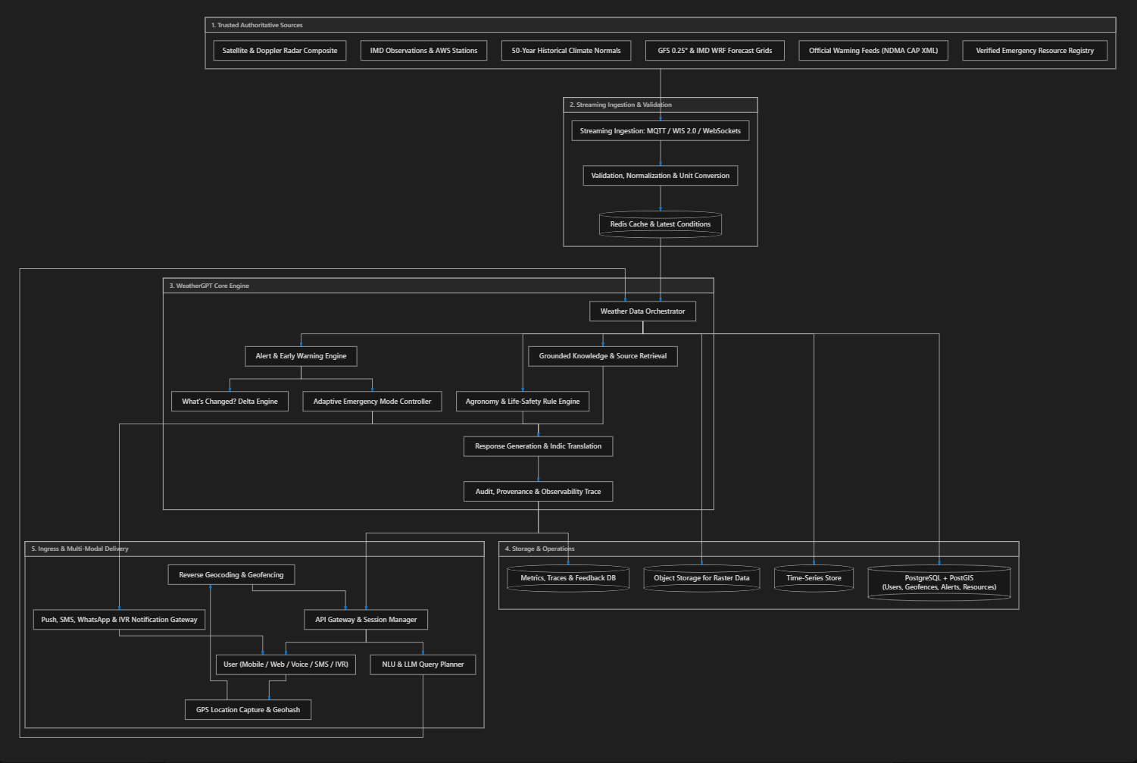
These Diagrams are Detailed Component & Data Flow Architecture and High-Level System Architecture & Services

Database Schema & Data Models (ERD)
Complete Table Specifications:
- USER: user_id (PK, UUID), role (Farmer, Fisherman, Disaster Manager, Citizen), preferred_language, voice_enabled, offline_sms_enabled, created_at.
- DEVICE: device_id (PK, UUID), user_id (FK), platform (Android, iOS, Web, SMS, IVR), push_token, gps_enabled.
- LOCATION: location_id (PK, UUID), user_id (FK), latitude, longitude, village, district, state, accuracy_meters, current_location.
- WEATHER_OBSERVATION: observation_id (PK, UUID), location_id (FK), source (IMD_AWS, OPEN_METEO), temperature, rainfall, wind_speed, humidity, observed_at, ingested_at.
- FORECAST: forecast_id (PK, UUID), location_id (FK), model (GFS_0.25, IMD_WRF), horizon (24h_hourly, 7d_daily), forecast_payload (JSONB), valid_from, valid_to.
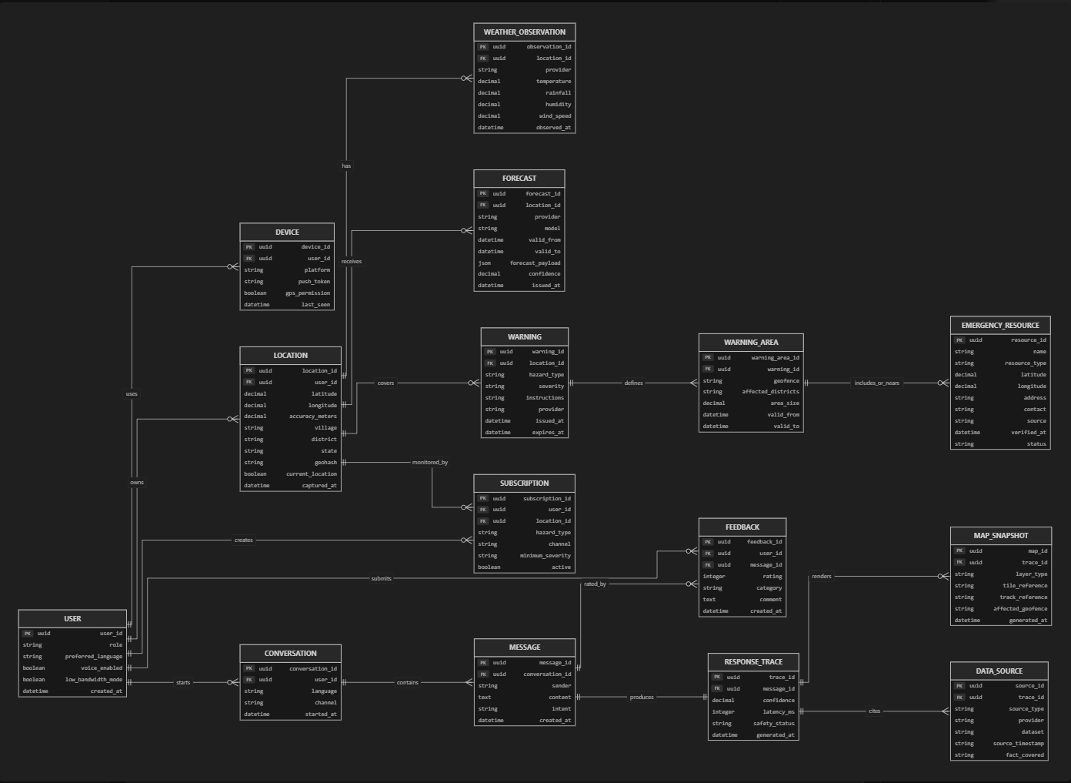
- WARNING: warning_id (PK, UUID), location_id (FK), hazard_type (CYCLONE, HEAVY_RAIN, HEATWAVE), severity (RED, ORANGE, YELLOW, GREEN), instructions, issued_at, expires_at.
- SUBSCRIPTION: subscription_id (PK, UUID), user_id (FK), location_id (FK), hazard_type, channel (PUSH, SMS, WHATSAPP, VOICE_IVR), severity_threshold, active.
- CONVERSATION & MESSAGE: conversation_id (PK), message_id (PK), sender, content, intent, created_at.
- RESPONSE_TRACE & DATA_SOURCE:
  - trace_id (PK, UUID), message_id (FK), confidence (DECIMAL), latency_ms (INT), safety_status, created_at.
  - source_id (PK, UUID), trace_id (FK), provider (e.g. IMD_AWS, GFS_NWP, ICAR_BULLETIN), dataset, timestamp.
- FEEDBACK: feedback_id (PK, UUID), user_id (FK), message_id (FK), rating (1–5), category, comment.
- EMERGENCY_SOURCE
resource_id: UUID (Primary Key) — Unique identifier for each emergency assistance facility.
name: VARCHAR — Facility name (e.g., `Civil Hospital Wardha`, `District Fire Station`).
resource_type: VARCHAR — Facility classification (`hospital`, `police_station`, `fire_station`, `shelter`, `relief_centre`).
latitude: DECIMAL(9,6) — Latitude coordinate of the facility.
longitude: DECIMAL(9,6) — Longitude coordinate of the facility.
address: TEXT — Physical street address or village location.
contact: VARCHAR — Verified official emergency phone number or helpline.
source: VARCHAR — Verifying agency (`NDMA_REGISTRY`, `DISTRICT_ADMIN_PORTAL`).
verified_at: TIMESTAMP — Timestamp of the last official verification.
status: VARCHAR — Operational status (`operational`, `listed_only`, `demo`).

Technology Stack Specification
- Frontend Framework
- Technology
React (Vite) + Tailwind CSS
- Purpose
Ultra-fast, responsive mobile-first UI with dark/light mode and PWA offline support.
- UI Components & Icons
- Technology
Shadcn UI + Lucide React
- Purpose
Clean, modern design with glassmorphism weather cards & source badges.
- Geospatial GIS Engine
- Technology
Leaflet.js / MapLibre GL

- Purpose
Interactive and embedded mini-maps (Doppler radar, cyclone tracks, IMD alert polygons).
- Backend Framework
- Technology
Python (FastAPI)
- Purpose
Asynchronous REST APIs, WebSockets for streaming chat, SMS webhook handlers.
- AI / LLM Orchestration
- Technology
LangGraph / LiteLLM / Gemini API
- Purpose
Multi-agent tool calling, zero-hallucination grounding, and response synthesis.
- Indic Multilingual Voice
- Technology
Bhashini / Web Speech API / IndicTTS
- Purpose
Speech recognition and voice synthesis across 12+ Indian languages.
- Telephony & SMS Fallback
- Technology
Twilio / Exotel / Asterisk IVR
- Purpose
Low-bandwidth 2G SMS query responder and automated voice hotline.
- Relational Database
- Technology
PostgreSQL + PostGIS
- Purpose
Spatial querying (geofencing, district polygons) and ACID reliability.
- In-Memory Cache
- Technology
Redis
- Purpose
Real-time weather caching, session memory, and sub-second nowcasting lookups.

- Streaming Telemetry
- Technology
MQTT / WIS 2.0 Protocol
- Purpose
WMO-compliant lightweight pub/sub for real-time station telemetry

- Containerization
- Technology
Docker & Docker Compose
- Purpose
Reproducible multi-service deployment for backend, frontend, database, and cache.

Innovative "X-Factors" for Evaluation Excellence
- Universal Rural Ingress (Voice, Web, SMS & IVR): No farmer is left behind due to poor internet connectivity; works on 2G feature phones and smartphones alike.
- Auditable Trust & Provenance Citations: Fully transparent answers citing IMD nowcasting vs. NWP model grids vs. historical averages with latency and confidence scores.
- Map-Centric Multi-Modal Answers: Embeds dynamic weather maps directly into the chat stream alongside text and audio.
- Deterministic Rule Engine + Grounded LLM: Guarantees zero hallucinations on numerical forecasts and life-safety advisories.
- WMO WIS 2.0 & MQTT Ingestion: Adheres to global meteorological streaming standards for instantaneous emergency early warnings.

Team Work Breakdown Structure (WBS)

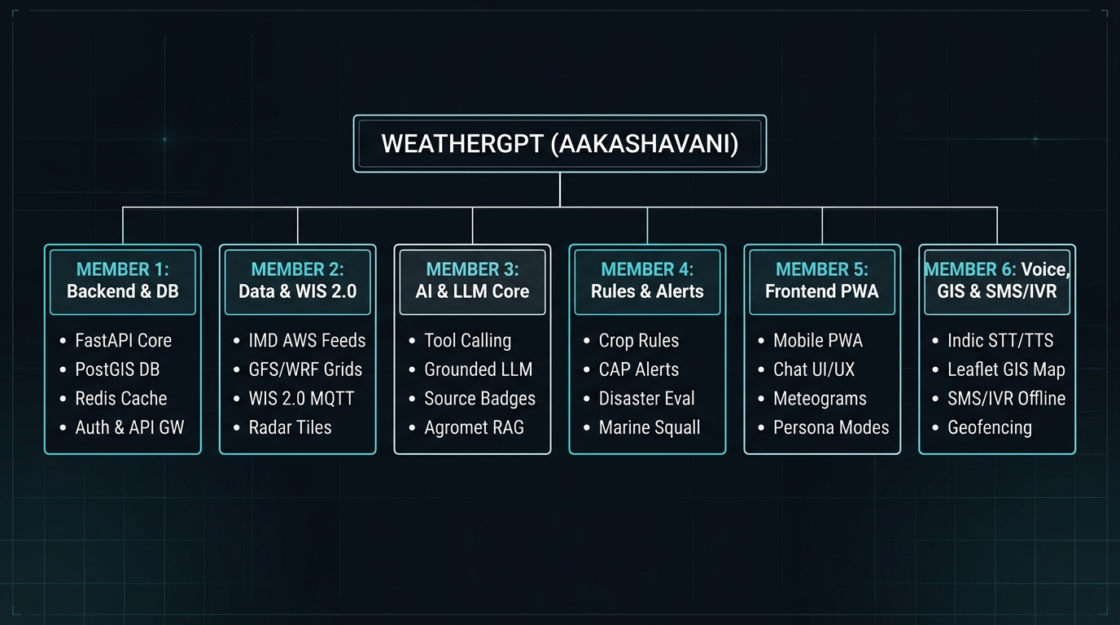

Step-by-Step Implementation Roadmap
- Sprint 1: Core Foundation & Data Pipelines
  - Scaffold FastAPI backend and PostgreSQL + PostGIS database models.
  - Implement Open-Meteo & IMD data fetching adapters (Nowcast, 7-Day, Climate).
  - Build the Agronomy & Disaster threshold rule engine.
- Sprint 2: AI Multi-Agent, Provenance Citations & Indic Voice
  - Develop the Grounded WeatherGPT orchestrator with deterministic tool calling.
  - Implement Granular Source Citation tagging and RESPONSE_TRACE logging.
  - Integrate Indic STT and TTS speech pipeline (Hindi, Telugu, Tamil, Marathi, etc.).
- Sprint 3: Mobile-First Frontend, Mini-Maps & WebGIS Studio
  - Build the React + Tailwind UI with voice-first microphone bar and PWA cache.
  - Create Embedded Mini-Map visual cards (Rainfall heatmap, cyclone cones).
  - Implement Persona Switcher (Farmer, Fisherman, Disaster Manager, Citizen).
- Sprint 4: SMS/IVR Fallback, Alert Broadcasts & Demonstration
  - Build SMS gateway endpoint and IVR simulated loop.
  - Build Geofenced alert subscription manager (Simulate Cyclone / Flash Flood triggers).
  - End-to-end testing across 10+ real Indian district disaster scenarios.

Thank you for your attention

