**MAHE "Young Scientist Award" and Bajpai-Saha "Student Award"**

**(Not to be more than 2000 words to a maximum of 5 pages in single space including figures/tables and references. Figures/tables to be limited to 5. Text should be in running style without any sub-headings)**

**Elastomeric degradable polyurethane with antioxidant properties for cardiac tissue engineering**

Parvaiz A. Shiekh1, Anamika Singh1, Ashok Kumar1,2,3,*

1 *Department of Biological Sciences and Bioengineering; Indian Institute of Technology Kanpur, Kanpur-208016, UP, India,*

*2 Centre for Nanosciences, Indian Institute of Technology Kanpur, Kanpur-208016, UP, India,*

*3 Centre for Environmental Sciences and Engineering, Indian Institute of Technology Kanpur, Kanpur-208016, UP, India,*

*1Email:* [*xxxxx@iitk.ac.in*](mailto:xxxxx@iitk.ac.in)*; *Email:yyyyyy@iitk.ac.in*

**Abstract:**  Myocardial infarction (MI), which occurs due to occlusion of coronary artery and subsequent cardiomyocyte death is one of the leading causes of death worldwide. The end stage of the cardiac disease is congestive heart failure (CHF), a condition where the heart is unable to pump enough blood. Tissue engineering strategies, in which a biodegradable patch in the form of a scaffold of an appropriate mechanical property is populated with cells invitro and implanted into the infarcted region is looked upon as one of alternatives to treat MI. MI generates a very hostile environment such as high oxidative stress, which gives rise to the development of strategies to combat this hostile environment Biomaterials with tunable antioxidant properties will help in attenuating these conditions. In this study, we have developed an elastomeric antioxidant polyurethane scaffold, which could attenuate the oxidative stress under various pathological conditions. These scaffolds rescued cardiomyocyte death under oxidative stress and ischemic reperfusion conditions. In else to that these scaffolds endorsed neonatal rat cardiomyocyte growth, maturation and differentiation thus, will pave the path towards development of antioxidant polymeric patch for treatment of myocardial infarction.

We synthesised antioxidant polyurethane (PUAO) using polycaprolactone diol, hexamethylene diisocyanate and ascorbic acid. Successful synthesis was confirmed by FTIR analysis. The synthesised polymer was further characterised for different physiochemical properties such as thermal properties, mechanical properties and hydrophobicity analysis. PUAO films were fabricated and characterised by scanning electron microscopy and atomic force microscopy for morphological features. Cell compatibility was analysed using C2C12 muscle line and H9C2 cardiomyocytes. DPPH assay was done to analyse its antioxidant properties. Further an in-vitro antioxidant assay as well as an ischemic reperfusion model assay was done to show the effect of antioxidant properties in attenuating oxidative stress. As a proof of concept, neonatal rat cardiomyocytes were cultured on these films and their growth, differentiation and maturation was studied. Immunostaining of α- actinin, troponin-T and connexin-43 along with cyclic calcium imaging was analysed.

FTIR spectra revealed the presence of characteristic bands for polyurethane and ascorbic acid indicating the successful synthesis of polyurethane with ascorbic acid in backbone chain (Fig 1A). Polymeric scaffolds for tissue engineering applications needs to be stable at physiological as well as processing temperature and should not compromise their properties under these variable conditions. TGA analysis was done to measure degradation of PUAO with respect to change in temperature. PUAO showed three degradation peaks, first occurred at around 100 °C which may be due to the release of bound water, followed by gradual degradation of PUAO between 100 °C and 260 °C (Fig1B). This was followed by steep degradation between 260 °C to 340 °C and a final gradual degradation between 340 °C and 470 °C. The degradation was 1%, 10% and 50% at 250 °C, 270 °C and 320 °C, respectively. Thus, the synthesised PUAO polymer is stable at processing as well as physiological temperatures. DSC analysis showed that PUAO has a glass transition temperature of –21 °C indicating elastomeric behavior at physiological temperatures (Fig1C).

**Figure 1:** **(A)** FTIR spectrum of PUAO revealing characteristic peaks of polyurethane. **(B)** TGA and DTGA curve of PUAO **(C)** DSC thermogram of PUAO: Analysis was carried under nitrogen atmosphere. **(D)** Uniaxial tensile testing curve of different concentrations of PUAO film. Cyclic tensile curve of different polyurethane concentrations; **(E)**PUAO5, **(F)**PUAO2.5, **(G)**PUAO1.

Based on the thermal analysis, PUAO was dissolved in DMF at three different concentrations (5%, 2.5% & 1%) at 80 °C and solvent cast into thin films. The fabricated films were characterised by uniaxial tensile testing as well as cyclic mechanical analysis. Scaffold for cardiac regeneration needs to be elastomeric in nature and can sustain cyclic stress-strain as experienced under physiological conditions. The synthesised scaffolds were elastomeric in nature with a maximum elongation of 600% (Fig1D). The elastic modulus ranged between 3-10 MPa depending upon the concentration of the polymer, which is suitable for cardiac tissue engineering. For cyclic analysis, samples were elongated to 10% deformation, relaxed and elongated again up to 10% deformation over a period of 5 cycles (Fig1E, 1F,1G). From load vs displacement and stress-strain curve, stress at 10% deformation, residual deformation and energy loss was calculated. Residual deformation increased from 12% to 16%, 10% to 15% and 9% to 13% in case of PUAO5, PUAO2.5 and PUAO1, respectively. None of the samples showed failure under continuous cyclic stresses. This is important as the implant will experience such stresses under physiological conditions as discussed earlier and should not compromise its mechanical properties.

Invitro biocompatibility of the fabricated films were analysed by cell viability assay using C2C12 and H9C2 cells. Both cell showed increased proliferation studied for a period of 10 and 13 days (Fig 3A, 3B) respectively quantified by MTT assay. To evaluate cell adhesion and cellular morphology, fluorescent imaging was done after day 3 and day 10 respectively (Fig4A, 4B, 5A,5B). SEM analysis was also done at day 10 (Fig 4C, 5C). DAPI (nuclear staining) showed an even distribution of cells on PUAO film. F-actin cytoskeleton staining showed formation of F-actin rings with extended morphology and complex interaction between neighboring cells. SEM images also showed extended cellular morphology confirming results of fluorescent staining.



**Figure 3:** Cell viability assay of **(A)** C2C12, **(B)** H9C2 on PUAO films. PUAO is compatible with both C2C12 and H9C2 cells, showing high proliferation after 7 days of culture on PUAO films. N≥ 3, Mean ± SD. *p<0.05, **p< 0.01, ns: non-significant. TCP: Tissue Culture Plate. PUAO: Polyurethane, H9C2: Ventricular cardiomyoblast, C2C12: Muscle myoblast.

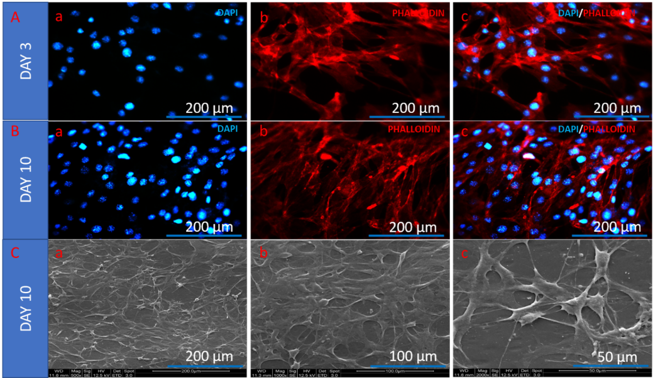

**Figure 4:** DAPI (blue)/Phalloidin-TRITC (red) fluorescent imaging of C2C12 cells of **(A)** day 3and **(B)** day 10 on PUAO film. **(C)** SEM micrographs of C2C12 cells of day 10 on PUAO film. Scale bar: 200 µm (A: a-c; B: a-c; C: a); 100 µm(C-b); 50 µm(C-c).

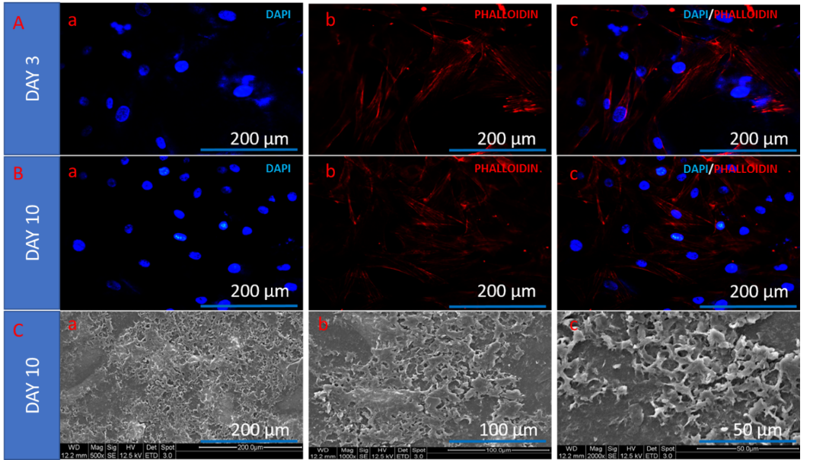

**Figure 5:** DAPI (blue)/Phalloidin-TRITC (red) fluorescent imaging of H9C2 cells of **(A)** day 3 and **(B)** day 10 on PUAO film. **(C)** SEM micrographs of H9C2 cells of day 10 on PUAO film. Scale bar: 200 µm (A: a-c; B: a-c; C: a); 100 µm(C-b); 50 µm(C-c).

The major challenge in the synthesis was to retain antioxidant properties. DPPH assay as one of the most standard procedure for antioxidant assay, showed that these films possess significant antioxidant behavior (Fig 6A). Infact PUAO was able to show sustained and gradual antioxidant behavior as compared to that of free ascorbic acid. Further polyurethane synthesised without ascorbic acid did not show any antioxidant property thus confirming the successful synthesis of this antioxidant using ascorbic acid.

**Figure 6**: (A) DPPH assay shows inhibition of free radicals by PUAO. (B) H9C2 cells exposed to PUAO extract are resistant to oxidative stress. Oxidative stress increased in H9C2 cells exposed to 200 µM H2O2 but was significantly attenuated by PUAO. NN: No H2O2, No polymer; NP: No H2O2, Polymer; HN: H2O2, No polymer; HP: H2O2, Polymer. Phase contrast images showing the cellular morphology of H9C2 cells before and after 12 h menadione treatment; (C) TCP non-treated, (D) PUAO non-treated, (E) TCP treated, (F) PUAO treated. (G) The %age viability of cells after 12 h of treatment. (H) LDH release after 12 h of treatment. Scalebar: 200 µm (C- F), 50 µm (insert). N = 3, Mean ± SD. *p<0.05, **p <0.01, ***p <0.001. TCP: Tissue Culture Plate. PUAO: Polyurethane.

Reactive oxygen species (ROS) play an important role in cardiac remodeling after MI. ROS produced after the ischemic reperfusion causes large cardiomyocyte death as well as limits cellular transplantation. To understand the effect of PUAO in decreasing the intracellular oxidative stress as well as rescue ROS induced cardiomyocyte death, an invitro oxidative stress model was developed. H9C2 cardiomyocytes were exposed to H2O2 as ROS inducer and the intracellular ROS was measured by DCF-DA fluorescence in absence and presence of PUAO (Fig 6B). DCF fluorescence was measured after 10, 20 and 30 min of treatment. We observed that in absence of PUAO as well as oxidative stress, PUAO does not affect the basal levels of ROS which have been shown to be important in various physiological processes. Oxidative stress inside the cells increased on treatment with H2O2 in absence of PUAO. However, when H2O2 treatment was given in presence of PUAO, oxidative stress decreased significantly. To establish the concept that PUAO will attenuate oxidative stress induced cardiomyocyte death, H9C2 cells were treated with menadione, a stable ROS generator in presence and absence of PUAO. When cells cultured on tissue culture plate and PUAO film were treated with menadione, cells on TCP showed round morphology followed by massive cell death (Fig 6C, 6E). However, cells on PUAO showed minor changes in morphology and increased viability as compared to cells on TCP (Fig 6D, 6F). This was further confirmed by cell viability (Fig 6G) and LDH assay (Fig 6H) after 12 h of treatment. Cells on TCP showed reduced viability with increased LDH activity, an indicator of massive cellular damage as compared to cells on PUAO.

These results indicate that PUAO could significantly scavenge free radicals, reduce intracellular oxidative stress as well as attenuate cell death due to ischemic reperfusion and will have serious implications for treatment of myocardial infarction where oxidative stress plays an important role in remodeling and is a major cause of cellular morbidity.

Our study demonstrated that PUAO could reduce intracellular oxidative stress significantly and can combat the menadione as well as ischemic reperfusion induced cell death due to the attenuation of reactive oxygen species.

This study will help in understanding the impact of antioxidant materials to attenuate oxidative stress which is often neglected while developing strategies for cardiac tissue engineering applications. This will help in developing newer strategies for advancement of such materials for tissue engineering applications where oxidative stress is a concern such as cardiovascular diseases. Future studies will consider the preclinical evaluation of this polymer where PUAO in the form of films as well as 3D scaffolds will be implanted into an ischemic model of myocardial infarction and its regeneration will be accessed.

**References**

1. R. Schnabel, S. Blankenberg, Oxidative Stress in Cardiovascular Disease, Circulation. 116 (2007).
2. M. Hori, K. Nishida, Oxidative stress and left ventricular remodelling after myocardial infarction., Cardiovasc. Res. 81 (2009) 457–64. doi:10.1093/cvr/cvn335.
3. R. van Lith, E.K. Gregory, J. Yang, M.R. Kibbe, G.A. Ameer, Engineering biodegradable polyester elastomers with antioxidant properties to attenuate oxidative stress in tissues., Biomaterials. 35 (2014) 8113–22. doi:10.1016/j.biomaterials.2014.06.004.
4. J.R. Venugopal, M.P. Prabhakaran, S. Mukherjee, R. Ravichandran, K. Dan, S. Ramakrishna, Biomaterial strategies for alleviation of myocardial infarction., J. R. Soc. Interface. 9 (2012) 1–19. doi:10.1098/rsif.2011.0301.
5. K.L. Fujimoto, K. Tobita, W.D. Merryman, J. Guan, N. Momoi, D.B. Stolz, M.S. Sacks, B.B. Keller, W.R. Wagner, An elastic, biodegradable cardiac patch induces contractile smooth muscle and improves cardiac remodeling and function in subacute myocardial infarction., J. Am. Coll. Cardiol. 49 (2007) 2292–300. doi:10.1016/j.jacc.2007.02.050.

**Instructions for abstract preparation**

1. Abstracts should be in a single page A4 format and Times New Roman font
2. The title should be in bold with font size 12 followed by authors name(s) in the next line, with the presenting author name underlined
3. List the authors with their first name followed by their last name in Arial Narrow 12-point font and centered
4. Author affiliations should be written in Times New Roman 12-point font, italics in the subsequent line(s) with central alignment
5. Author affiliation should be followed by the Email ID of the presenting and corresponding author
6. The abstract contents in single spaced Times New Roman font should be limited to **2000 words** (including title, author names, affiliations, abstract body and references). The abstract body should be single spaced font size 11.
7. References relevant to the abstract if any should be placed at the bottom. References should not be cited in the text
8. The format may be obtained from the template Abstract and can have maximum of five figures/scheme/flow chart of 1.5”x 6.0” or 3”x3”.
9. Do not include paragraph headings such as Aims, Materials & Methods, Results, etc.
10. Submit abstract using the given template as doc/word file only. No pdf files will be accepted
11. **Those authors who wish to compete for MAHE "Young Scientist Award" and Bajpai-Saha "Student Award" need to submit extended abstract with a maximum of 2000 words containing all results and images with key references. Only those who satisfy these criteria will be considered for awards**

**Guidelines for abstract submission and registration**

1. **Student category:** Any individual who is engaged as a full-time undergraduate or graduate in a university or college program and is actively involved in research. Also researchers engaged in sponsored projects as JRF/SRF/RA are eligible in student category. You can be asked to submit a copy of your student identification card in the registration form.
2. **Postdoctoral Fellows:** Any researcher who is temporarily employed by an academic institution, who has been awarded their doctoral degree within the past **3 years** and who is not holding regular appointment as faculty or academic staff can register under student category.
3. All others will be treated as a faculty category for abstract submission and registration.
4. Single author publications will not be accepted for students and postdoctoral fellows under student category.
5. The authors understand that at least one of the authors and every presenter have to register before the registration deadline for final acceptance and inclusion in the conference schedule and abstract book.
6. All participants who want to attend the conference (even if they don’t present the work) have to register.
7. ICBMI-2020 undertakes that all authors have given their consent to the submitted abstract. All abstracts must be submitted electronically using the given template.
8. ICBMI-2020 accepts no responsibility for submitted abstracts. The responsibility remains with the authors.
9. The copyright of all abstracts rests with the authors and ICBMI-2020 may not be held responsible for any violations because of plagiarism, or any misuse of material.
10. Authors submitting an abstract should abide by the conditions, policies and decisions of the ICBMI-2020 organizing committee.
11. For any clarifications write to us at convener@sbaoi.ac.in