TEMPLE TRAP REPORT

- STATE DEFINATION:
I have used class object to represent the state of the game.
The state object contains :
- Puzzle
- Pawn position in puzzle
- Pawn level (ground or top)
- Blank position
- Parent of the current state
- Action that the parent has taken to come to current state (used to print solution clearly)
- G -> actual cost from starting state to current state
- F -> G() + H()
I have added equallity and less than comparision to State object for comparing and allowing state object to be used in heapq
- TILE DEFINE:
I have used class object to create a tile.
The Tile object contains:
- Shape of the Tile which is at bottom left for non-orentated tile
- Top opening of the tile
- Ground opening of the tile
- Information about the hole(bool)
- Stairs
Originally I have create object tiles_original based on the non-oreinted tiles.
The tiles_original is created based on the below image which is given In the pdf.
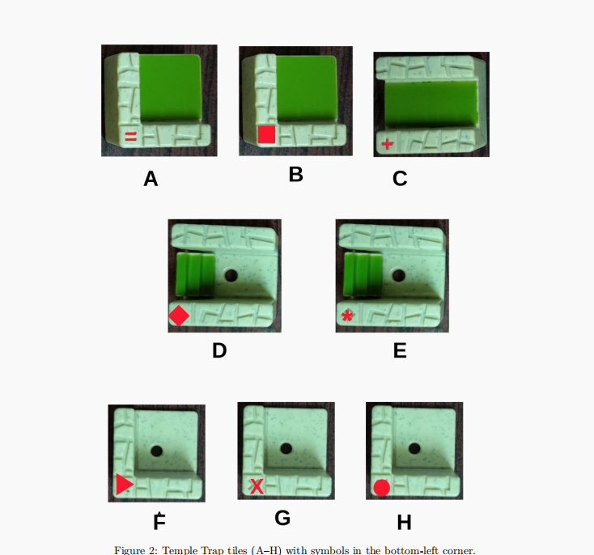

- HERUSTIC:
I have taken herustic function as
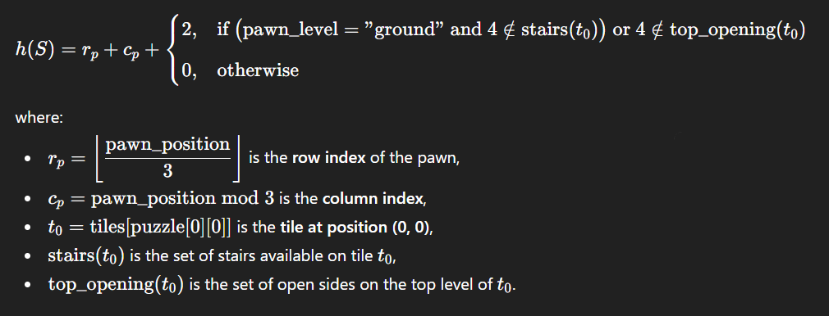
- FUNTIONS:

- GENERATE_NEIGHBOR FUNTION:
It generates neighbors by calling generate_neighbors_tile_change function and generate_pawn_change_neighbor function and merges the both results and returns neighbors

- GENERATE_NEIGHBORS_TILE_CHANGE FUNTION:
This function generates the neighbors by moving blank tile in all four directions and returns the valid neighbors

- GENERATE_PAWN_CHANGE_NEIGHBOR FUNTION:
This function generates the neighbors by changing the pawn position to all possible and tiles and return in vaild neighbors(where pawn can stays on tile containing hole).
I have implemented this function using bfs traversal from the current state by change pawn positions and adding the vaild neighbors to neighbors array.

- Can_reach_exit Function:
This function check wheather the pawn can reach the exit from given state without exchange of tiles using get_exit_path function. Returns true or false

- Get_exit_path Function:
This function checks wheather the pawn can reach the exit from the given state without exchange of tiles using bfs same logic as generate_pawn_change_neighbor function and stores the paths as string for every movement of pawn. This function returns
- Bool value True or False(about the pawn can reach the exit or not)
- Path (from given state to exit as string)
- Length of the path

- Astar Function:
This is the key algorithm of this project. It find the solution for the game from the given state to exit. It uses astar algorithm to find the solution with above hearustic and heap queue
If the solution is found it return the path from the starting state to exit using reconstruct_path.

- Goal_check Function:
It uses can_reach_exit function to check weather the given state can reach goal or not.

- Print_solution Function:
It takes the argument path and prints the path in a detailed manner.

- Update_tiles_orientations Funtion:
It takes the arguments :
- Original tiles
- Board
- Orientations(array of numbers that indicates the orientation of tile corresponding to board to be rotated in clockwise direction)
It updates tile by rotating the the tile features like:
- Top_opening
- Ground_opening
- Stairs
Based on the orientations in the clock wise and returns the tiles dictionary object.

Working of Temple Trap:
- I have written the data of puzzles of four levels with each containing four puzzles.
- I have Choosen the puzzle level
- Retreated the puzzle information from the above data
- Changed the orientation of puzzle by update_tile_orientation function
- Created a starting state
- Called astar algorithm by passing starting state , blank position , pawn position , pawn level from the above extracted data
- After that I have called print_path function to print the solution
To change puzzle to test just change the value of variable puzzle_level if puzzle is in the data
To try for some puzzle that is not in above data need to have data of that puzzle in above data format and pass that data to above working

