**Sensor Input and Output combinations:**

Here,

pin_1 = 5 means,providing **+5v DC** to the sensor pin1(default connected to sensor vdd)

pin_2 = 0 means,providing **GROUND** to the sensor pin2(default connected to sensor gnd)

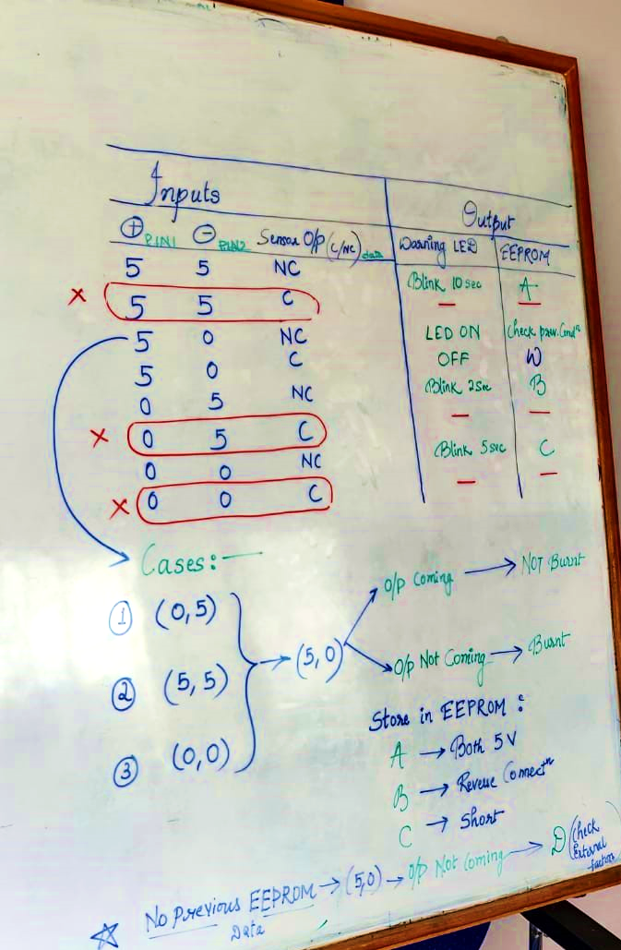

all possible combinations are written in the above image and consecutive actions taken.

**Flowchart :**

