**Motivation for doing making the project and target market**

According to World Health Organizationthere are 285 million visually impaired people worldwide: 39 million are blind and 246 million have low vision. People with such disability face many lifelong challenges. Some of the areas they face difficulties in include reading, writing, navigating through places independently, etc. Immense amount of resources have been spent by governments and institutions to tackle former problems. Some of the solutions include reading machines, talking books, and computers that translate Braille. However, there haven’t been comparable breakthroughs for navigation technologies.

When travelling, visually impaired people have 2 main concerns: avoiding obstacles and Navigation. Eyeshoes aims to tackle the latter problem, i.e. it acts as a turn by turn guide for navigation at street level. The primary target market for Eyeshoes are people who are **partially** visually impaired as they are able to detect nearby obstacles. Therefore, Eyeshoes will make them self-sufficient while travelling as it will provide them with turn by turn navigation. The secondary target market include people with normal vision who do not wish to use their smartphones while navigating. This includes people who would use Eyeshoes in sports (such as running, cycling) as well as tourists.

**Powering**

To make the battery of the device last as long as possible, the use of piezoelectricity is an ideal solution as it will charge the battery while walking. Piezoelectric effect is when mechanical deformation of the piezoelectric material produces a proportional change in the polarization of the material, i.e. electric charge appears on certain opposite faces of the piezoelectric material when it is mechanically loaded. Therefore by applying mechanical strain of the user's weight, the device should be able to produce some current in order to charge the battery. The use of piezo electric transducers increases the battery life by 11.6%, which increases the battery life to 74 days when used for 1 hour a day.

## C:\Users\Nathan\Desktop\Downloads\12791068_573600522808329_8881330699635114466_n.jpg**try and include these photos in the website**

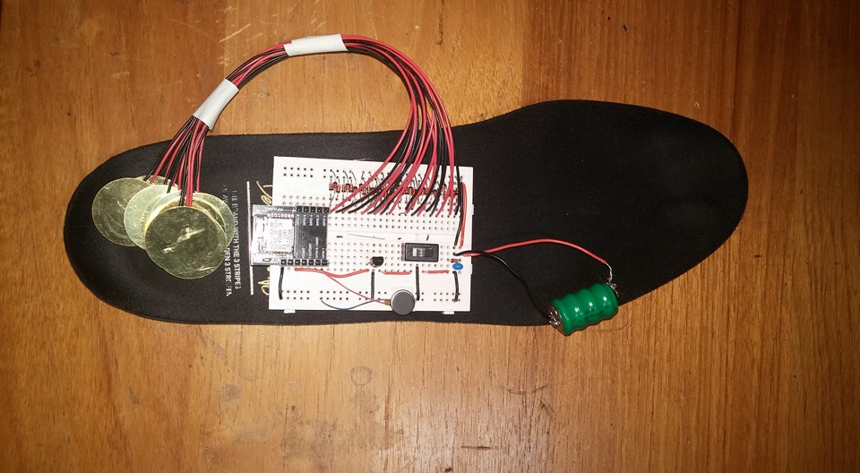

Microcontroller

Vibrator

Piezo-electric plates

