**Tracing, Ocular biometry and their heritability in twins in a hospital-based cohort in South India**

Padma Paul1, Anika Amritanand1, Smitha Jasper1, Prem Doss1, Prasanna Samuel2, Hepsy Chelliah2, Antonisamy B2, David A Mackey 3

Departments of 1Ophthalmology, 2Biostatistics, Christian Medical College, Vellore; 3Lions Eye Institute, Western Australia

**Background**

**Twin models for understanding inheritance – paucity in Indian scenario – reason to suspect difference - pilot**

Introduction

Our constant and most challenging struggles in the race against blindness are for conditions that cause avoidable blindness**.**

The lack of a twin registry in India makes it difficult to conduct studies of inherited diseases.(1) With respect to inherited forms of eye disease, these traits have been well studied in highly resourced countries and now there are studies underway in some other Asian countries (2). However, to the best of our knowledge, there are no such studies looking at ocular traits among twins in India. ROP? Knowing that the Indian population is heterogeneously derived from different ethnicities and that some eye measurement parameters, e.g., axial length, differ significantly from those noted in other populations(3), it is reasonable to believe that the heritability of genetic traits may differ in our country compared to other countries. The Collaborative Longitudinal Evaluation of Ethnicity and Refractive Error (CLEERE) study group has demonstrated racial variations in their preliminary report.(4)8 A population-based study on Australian children from different ethnic backgrounds has also demonstrated this.(5)9 This forms the basis of our embarking on piloting contacting the twins involved in this study and conducting preliminary ophthalmic examinations on them.

**Methodology:**

**This is the report of a cross-sectional study of a hospital-based twin birth cohort.**

**Original Cohort**

The study was conducted in Vellore district, situated in the South Indian state of Tamilnadu. Vellore district has a population of around 4.9 million, with a growth rate of 13.2% (Census website). Our institution is a referral centre for complicated obstetric cases and began its assisted reproductive technology unit in the year 1996. Within the district, on average, 5750 births per year from 1991–1995, the time period our cohort was derived from, were registered in this hospital.

The original database of twins included details of twins born between 1991 and 2005 from the paper-based register of the labour room and clinical records of the Department of Obstetrics and Gynecology. A qualified statistician, as well as two clinical psychologists, collected data on parental demographics, twin addresses, birth weight, gestational age and placental chorionicity for the twins in the register. These were reported in an earlier retrospective study conducted in the institution looking at birth weight centiles by gestational age among twins born between 1991 and 2005. (6)

**Current study**:

For our study, we chose to trace the oldest twins in the cohort (1991–1995). The study followed the tenets of the declaration of Helsinki of 1975 as revised in 2008. It complied with the standards of the Indian Council for Medical Research Bioethics guidelines. Approval of the Institutional review board and the Ethics committee of Christian Medical College and Hospital, Vellore, was sought and received (IRB 2011 Minute No.7441). This study was conducted from from March 2011 to September 2013.

**Tracing**

**Contacting Participants**

Twins from 24 to 42 weeks’ gestational age born live to mothers from the Vellore district in the labor room of CMC Hospital, Vellore between 1991 and 1995 were included for this pilot attempt to trace and recruit a hospital birth register-based twin cohort.

**Mail Survey**

The first contact was made by a postal mail survey. All twin pairs were mailed information sheets, questionnaires and forms to indicate consent to participate (translated into the local language). The information sheets provided basic explanations on heritability of traits, difference between races, how studying twins can help enhance the information base in this aspect and objectives of this study. The participants were asked to fill out a questionnaire regarding sex of the twins, date of birth, and birth weight. There was an explanation that they would be required to visit the Department of Ophthalmology for a free-of-cost eye examination and asked to convey their willingness to participate. In case they were willing to participate they were requested to indicate so by signing on a letter, giving their telephonic contact details and mailing the questionnaire back to the investigators in a self-addressed & postage paid envelope. They were then contacted by telephone to arrange a date for examination.

**Home Visits**

Subsequent to this,all who did not reply to the mailed letter within one month and for whom letters were returned due to the wrong address were contacted through home visits. A trained field worker visited each address to gather the necessary information in the questionnaire, determine willingness to participate and to give an appointment for the free eye examination*.*

**Eligibility**

All twins whose addresses could be confirmed and were physically and mentally able to give assent /sign the informed consent form, and whose parents were willing to allow participation (in the case of twins <18 years of age) were recruited in the study and called for further evaluation. They were also reminded by telephone to attend the ophthalmology appointments. The evaluations were planned for weekends to optimize participation of twins.

**Procedures in the base hospital**

Informed consent

Informed consent from parents and assent from participating twins were obtained in the local language.

Zygosity determination:

Consenting live twin pairs who presented to the eye hospital were administered a questionnaire by a trained health worker wherein details regarding the birth of the twins, their parents, consanguinity of the marriage and, if present, nature of relationship were asked. Zygosity was then determined by a validated zygosity questionnaire by Song et al.(7)

Ophthalmic Evaluation:

Following this, each twin underwent a comprehensive ophthalmic examination, including best-corrected visual acuity (BCVA), using a log MAR chart at a distance of … m in a dimly illuminated room, cycloplegic refraction (Heine beta 200 retinoscope), slit lamp examination, (HAAG STREIT), measurements of intraocular pressure (IOP) by Goldmann Applanation tonometry, axial length (AL) and anterior chamber depth (ACD); (Ocuscan ALCON) , central corneal thickness (CCT : Tomey AC-1000, specular microscopy for endothelial count (Topcon SP -2000P), Spectral OCT/HRT III for retinal nerve fiber layer thickness and a dilated fundus examination using 90 D volk lens and slit lamp and indirect ophthalmoscopy where indicated.

The height and weight was also recorded for correlation with the biometric findings.

Twins requiring spectacles for correction or interventions were provided the same as indicated.

**Statistical Methods**

* 1. **Study variables :** Response rates were calculated and descriptive statistics used to summarize all the study variables using SPSS version 16.0.
  2. **Determination of heritability**

The classical twin model is based on the assumption that monozygotic (MZ) twins share 100% of their genes, while dizygotic (DZ) twins are no more similar genetically than other siblings. Heritability of traits can be estimated by comparing the similarity in traits in MZ and DZ twins. Intra-class correlation coefficients (ICC) were calculated as an index of similarity and compared between the MZ and DZ twins.

Falconer’s formula was then used to determine heritability for each of the biometric traits, which gives an approximation of the variation due to additive genetic factors (biometric values from right eye of each twin were taken as per convention): **h2 = 2(rMZ – rDZ)**

**(**where r = intrapair correlation, MZ denotes Monozygotic Twins and DZ Dizygotic Twins)

RESULTS:

1. Traced Cohort :

According to the hospital records, 28,758 births occurred at the CMC hospital Vellore from 1991–1995, of which 396 were twin births, giving a twinning rate of 13.8 per 1000 deliveries. Of these, 272 twin pairs were from within the Vellore district and chosen for tracing. The twinning rate among those from the Vellore district was therefore 9.5 per 1000 deliveries. Their mean age at the time of tracing was 17.9 years (1.4 SD). The flow of this tracing exercise is as reflected in the flow chart (Fig .1). All 272 pairs were mailed information sheets and surveys for tracing. We received 64 responses to the mailed letters. 38 (14%) families responded to the letters while 26 letters were returned due to invalid address. Among those who responded, both twins had died in 4 pairs and one of the twins had died in another 4 pairs, leaving 30 (11.02%) pairs of twins out of 272 for inclusion.

Of the remaining 234 twins, 26 letters were returned as having the wrong address and there was no response from 208. Following home visits for contact, 63 pairs (23.2%) were further traced, out of whom one of the twins had died in 11 pairs and both in 7 pairs. The reasons for inability to include the rest of the twin pairs is given in Fig.1.

Therefore, 45(19.2%) twin pairs were included from the home visits. Of the 75 twin pairs traced, 37 pairs (49.3%) were followed up for examination. Only one of the twins was examined in 2 pairs and 36 pairs (44%) could not be examined as they were unable to attend despite of repeated reminders. All factors (parental educational status, birth weight of twins, consanguinity and sex) except maternal education were similar (Table1) between traced and untraced twins (Table 1 )

**Fig 1. Flow chart of twin cohort tracing**

234 to be contacted by home visits

26 returned as wrong address

64 responses

208 non responses

272 twin pairs for Mail Survey Tracing

4 pairs one twin died

4 pairs both twins died

162 wrong/

incomplete addresses

2 door locked

6 moved

64 pairs traced correctly

11 one twin died

1 refused consent

7 both twins died

30 pairs for inclusion

45 pairs for inclusion

75 pairs for inclusion

36 pairs not seen

Both twins examined in 37 pairs

One of twins examined in 2 pairs

|  |  |  |  |  |  |  |  |
| --- | --- | --- | --- | --- | --- | --- | --- |
| **Table 1. Distribution of baseline characteristics between traced and not traced, (Total N=272, Traced N=102, Not traced= 170) and seen and not seen (N=76, Seen=39, Not seen=37)** | | | | | | | |
| **Variable** | **Categories** | **N**  **(% )**  **Among seen** | **N**  **(%)**  **Among not seen** | **p**  **value** | **N**  **(%)**  **Among traced** | **N**  **(%)**  **Among not traced** | **p**  **value** |
| **Maternal Education** | Up to middle school | 23  (59%) | 13  (35.1%) | 0.04 | 55  (53.9%) | 69  (40.6%) | 0.03 |
| High school and above | 16  (41%) | 24  (64.9%) | 47  (46.1%) | 101  (59.4%) |
| **Paternal Education** | Up to middle school | 14  (35.9%) | 12  (32.4%) | 0.75 | 39  (38.2%) | 54  (31.8%) | 0.28 |
|  | High school and above | 25  (64.1%) | 25  (67.6%) | 63  (61.8%) | 116  (68.2%) |
| **Consanguinity** | Non-Consanguineous | 29  (74.4) | 23  (62.2) | 0.47 | 62  (60.8) | 124  (72.9) | 0.11 |
| Consanguineous | 8  (20.5%) | 10  (27%) | 30  (29.4%) | 33  (19.4%) |
| Missing | 2  (5.1%) | 4  (10.8%) | 10  (9.8%) | 13  (7.7%) |
| **Twin Pairs Sex** | Male-Male | 12  (30.8%) | 12  (32.4%) | 0.51 | 34  (33.3%) | 57  (33.5%) | 0.37 |
| Female-Female | 13  (33.3%) | 16  (43.2%) | 41  (40.2%) | 56  (32.9%) |
| Male-Female | 14  (35.9%) | 9  (24.4%) | 27  (26.5%) | 57  (33.5%) |

*Cost of tracing*

Identifying twin births as well as obtaining addresses took approximately 13 full days and cost INR 7900. We did not directly bear the cost of obtaining information regarding twin details as this data had already been collected as a part of a previous study (Premumar et al., 2016) in the institution. The cost of contacting one twin pair by post was INR 6913. This included the cost of printing questionnaires, information and consent sheets as well as reply-paid postage. The total cost of home visits was INR 6705. This included INR 3720 for 31 days of wages and INR 2985 towards travel costs. The break-down for the cost of contacting a twin pair by both these methods is given in Table 3.

1. Demographics of twins seen:

* The mean age of 37 pairs of twins in the study was 17.5 yrs (SD 1.6). The distribution of sex was: 29.7% (M-M), 37.8% (M-F) and 32.4% (F-F). Mean birth order was 1.8 (SD 1.2) Twin 1 and 2.4 (SD 1.4) for Twin 2.

1. General parameters;

Mean height of the twins was … (SD…) cms and mean weight … (SD…)

1. Zygosity:

As determined by the validated questionnaire 20, (51.4%) of the twins were monozygotic and 19 (48.6%) dizygotic.

When compared to the chorionicity ....

Table …

Characteristics of Monozygotic and Dizygotic twin pairs

|  |  |  |  |
| --- | --- | --- | --- |
| Characteristic | MZ Twins | DZ Twins | p value |
| **Demographic** **factors** |  |  |  |
| Mother Age (years) | 23.05 (4.62) | 26.22 (4.34) | 0.0389 |
| Father age (year) | 24.57 (13.77) | 27.83 (13.64) | 0.4754 |
| Sex ( male %) |  |  |  |
| 1 | 7 (36.8) | 4 (22.2) | <0.0001 |
| 2 | 12 (63.1) | 0 (0.0) |  |
| 3 | 0 (0.0) | 14 (77.18) |  |
| **Birth Parameters** |  |  |  |
| Birth weight (kg) |  |  |  |
| Low Birth Weight (%) |  |  |  |
| Small for gestational age (%) |  |  |  |
| Birth length (cms) |  |  |  |
| Head circumference (cms) |  |  |  |
| **Prematurity (%)** |  |  |  |
| **Anthropometric measures** |  |  |  |
| Height (M) |  |  |  |
| Weight (Kg) |  |  |  |
| **Ocular Biometry** |  |  |  |
| Amplitude of accommodation | 8.6 (0.98) | 8.7 (0.97) | 0.893 |
| Axial Length |  |  |  |
| AXLENRE (Right) | 23.57 (2.22) | 23.19 (0.98) | 0.486 |
| AXLENLE (Left) | 23.49 (1.98) | 23.16 (0.98) | 0.511 |
| Central Corneal thickness (mm) | 530.2 (39.98) | 544.0 (27.23) | 0.226 |
| Anterior chamber depth (mm) | 3.60 (0.19) | 3.59 (0.28) | 0.902 |
| Lens thickness |  |  |  |
| AXLENRE (Right) | 23.57 (2.22) | 23.19 (0.98) | 0.486 |
| AXLENLE (Left) | 23.49 (1.98) | 23.16 (0.98) | 0.511 |
| Endothelial count (cells / mm3) |  |  |  |
| Keratometry (Diopters) | 45.25 (1.95) | 43.57 (1.77) | 0.009 |
| Refractive error (SPE*) (Diopters) |  |  |  |
| IOP (mm Hg) | 13.23 (3.12) | 12.66 (2.78) | 0.544 |

1. Distribution of ocular features:
2. Distribution of ocular parameters

**Tracing rate**

**Recruitment rate**

**Demography of twins : Baseline characteristics between MZ and DZ (ref GEMS Myopia)**

**Parameters descriptive**

**Parameters heritability**

The mean age of 37 pairs of twins in the study was 17.5 yrs (SD 1.6). The distribution of sex and zygosity are shown in Figs 3 and 4. Mean (Standard deviation [SD]) for the biometric parameters: IOP 13.18 (3.08) mm Hg; axial length 23.37 (1.73) mm; CCT 536.86 (36) microns; ACD 3.55 (0.26) mm; endothelial count 2951(285.6) cells/mm2

The heritability estimates are as shown in Figs 5–9.

**Fig 5. Intraocular pressure h2 = O.34**

**Fig 6. Anterior chamber depth (h2 = 0.88)**

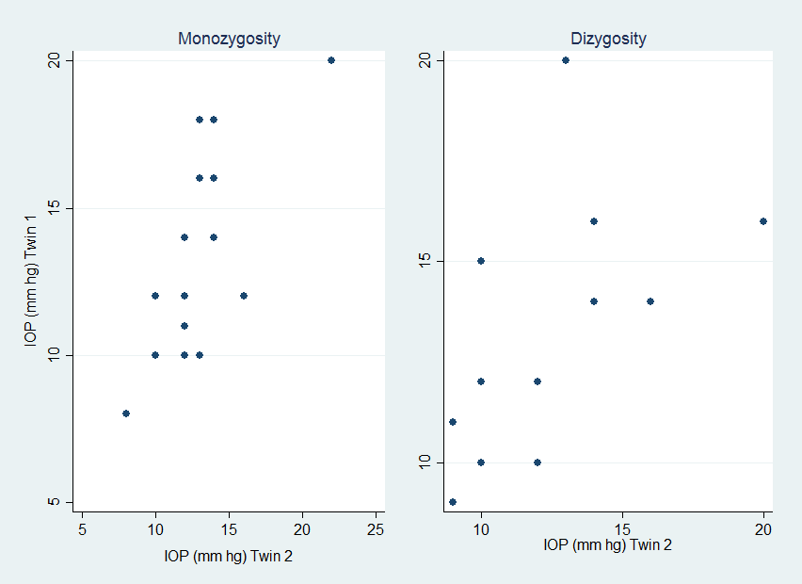

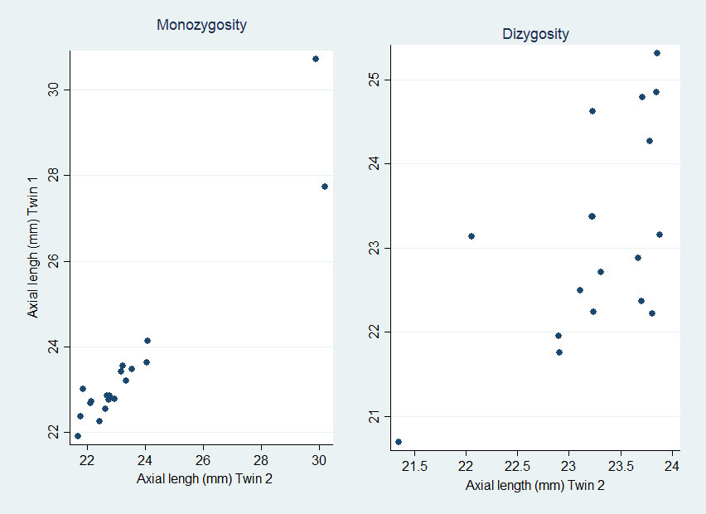

**Fig 7. Axial Length (h2 = 0.92)**

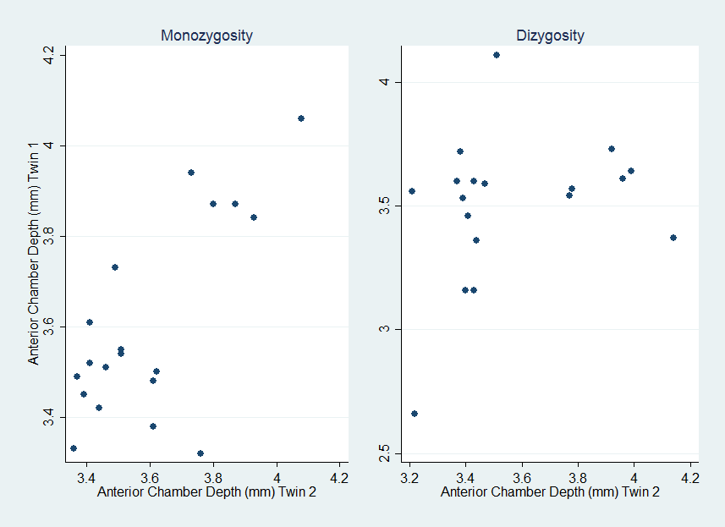

**Fig 8. Central Corneal Thickness h2 = 0.96**

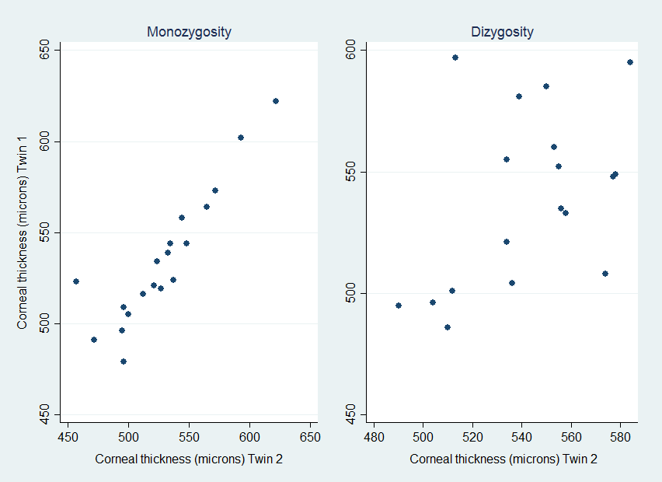

**Fig 9. Endothelial Count h2 = 0.58**

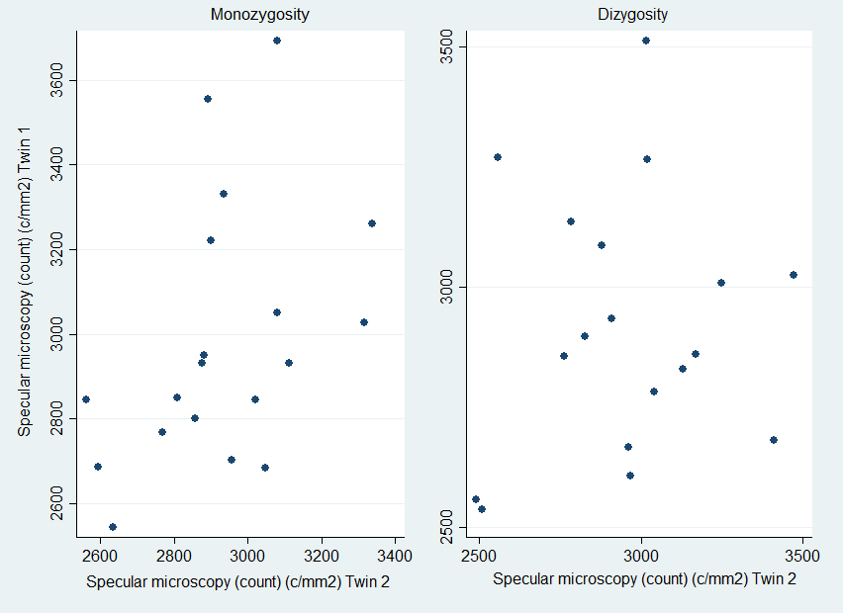

**Table 1. Heritability (h2)**

|  |  |  |  |  |
| --- | --- | --- | --- | --- |
| **Biometric Trait** | **Our Study#** | **Pooled meta-analysis(8)** | **Korean**$**(9)** | **Hungarian*(10)** |
| IOP | 0.34 | 0.55 |  |  |
| Axial length | 0.92 | 0.71 | 0.86 |  |
| CCT | 0.96 | 0.85 |  |  |
| Endothelial Count | 0.58 |  |  | 0.82 |
| ACD | 0.88 | 0.70 | 0.83 |  |

# : Falconer’s formula

$: Variance component method

*: Structural Equation modelling

Abbreviations: ACD=CCT=central corneal thickness; IOP=intraocular pressure

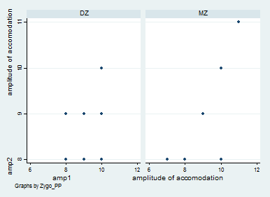

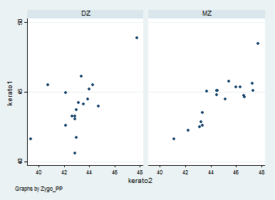

**Discussion**

**Tracing**

**Demography**

**Heritability**

**Conclusions**

BIBLIOGRAPHY

1. Sahu M, Prasuna JG. Twin Studies: A Unique Epidemiological Tool. Indian J Community Med. 2016 Jul-Sep;41(3):177-82.

2. He M, Ge J, Zheng Y, Huang W, Zeng J. The Guangzhou Twin Project. Twin Res Hum Genet. 2006 Dec;9(6):753-7.

3. George R, Paul PG, Baskaran M, Ramesh SV, Raju P, Arvind H, et al. Ocular biometry in occludable angles and angle closure glaucoma: a population based survey. Br J Ophthalmol. 2003 Apr;87(4):399-402.

4. Twelker JD, Mitchell GL, Messer DH, Bhakta R, Jones LA, Mutti DO, et al. Children's Ocular Components and Age, Gender, and Ethnicity. Optom Vis Sci. 2009 Aug;86(8):918-35.

5. Ip JM, Huynh SC, Robaei D, Kifley A, Rose KA, Morgan IG, et al. Ethnic differences in refraction and ocular biometry in a population-based sample of 11-15-year-old Australian children. Eye (Lond). 2008 May;22(5):649-56.

6. Premkumar P, Antonisamy B, Mathews J, Benjamin S, Regi A, Jose R, et al. Birth weight centiles by gestational age for twins born in south India. BMC Pregnancy Childbirth. 2016 Mar 24;16:64.

7. Song YM, Lee D, Lee MK, Lee K, Lee HJ, Hong EJ, et al. Validity of the zygosity questionnaire and characteristics of zygosity-misdiagnosed twin pairs in the Healthy Twin Study of Korea. Twin Res Hum Genet. 2010 Jun;13(3):223-30.

8. Sanfilippo PG, Hewitt AW, Hammond CJ, Mackey DA. The heritability of ocular traits. Surv Ophthalmol. 2010 Nov-Dec;55(6):561-83.

9. Kim MH, Zhao D, Kim W, Lim DH, Song YM, Guallar E, et al. Heritability of myopia and ocular biometrics in Koreans: the healthy twin study. Invest Ophthalmol Vis Sci. 2013 May 01;54(5):3644-9.

10. Racz A, Toth GZ, Tarnoki AD, Tarnoki DL, Littvay L, Suveges I, et al. The inheritance of corneal endothelial cell density. Ophthalmic Genet. 2016 Sep;37(3):281-4.