PROJECT DOCUMENTATION
Student Fee Payments Analysis
Data Cleaning and Reporting in Microsoft Excel | Interactive Dashboard in Power BI

Contents
1. Introduction
2. Dataset Description
3. Microsoft Excel Work
4. Power BI Dashboard
5. Key Insights
6. Excel and Power BI: How They Work Together
7. Limitations and Future Enhancements
8. Conclusion
Appendix A. Optional DAX Measure

1. Introduction

1.1 Project Overview
This project analyses student fee payment records for 500 students across 11 departments and 7 cities, covering payments made between January 2023 and August 2024. The raw data was first cleaned and summarised in Microsoft Excel and then presented as an interactive, single-page dashboard in Power BI Desktop.

1.2 Objectives
- Clean the raw student fee dataset and make it reliable for analysis (remove duplicates, fix data types, validate values).
- Create derived fields such as full name, age at the time of payment and payment month.
- Summarise total fees by department, payment method and year using pivot tables.
- Build an interactive Power BI dashboard with KPI cards, slicers and charts for quick decision-making.

1.3 Tools Used
Tool | Purpose in this project
Microsoft Excel | Data cleaning, calculated columns, Excel Table, conditional formatting and pivot tables.
Power BI Desktop | Data modelling, KPI cards, slicers and interactive visuals on a single dashboard page.

1.4 Project Files
File | Description
Education_dataset1_csv.xlsx | Excel workbook with the raw data, cleaned data and pivot summary (3 sheets).
Mini_project_powerbi_dashboard.pbix | Power BI report containing the data table and the dashboard page.

2. Dataset Description

2.1 Overview
Property | Value
Raw records received | 529 rows x 12 columns
Records after cleaning | 500 unique students (29 duplicate rows removed)
Columns after cleaning | 15 (12 original + 3 calculated)
Payment period | 1 January 2023 to 31 August 2024
Departments | 11 (e.g. Computer Science, Civil, Electronics, Finance)
Cities | 7 (Bengaluru, Chennai, Delhi, Hyderabad, Kolkata, Mumbai, Pune)
Payment methods | 3 (Bank Transfer, Demand Draft, Online Gateway)
Attendance status values | 3 (Present, Late, Absent)
Fee amount range | 75,233.31 to 1,24,699.41 per payment

2.2 Data Dictionary
Column | Type | Description
StudentID | Text | Unique student identifier in the format STU-2023001.
FirstName | Text | Student first name.
LastName | Text | Student last name.
DateOfBirth | Date | Student date of birth.
Gender | Text | Male or Female.
City | Text | City of the student.
Department Name | Text | Department in which the student is enrolled.
Status | Text | Attendance status: Present, Late or Absent.
Amount | Decimal | Fee amount paid by the student.
PaymentDate | Date | Date on which the fee was paid.
Year | Whole number | Year of payment (2023 or 2024).
Method | Text | Mode of payment.
FullName* | Text | First name and last name combined (calculated).
AgeAtPayment* | Whole number | Student age in completed years on the payment date (calculated).
PaymentMonth* | Date | First day of the payment month, used for monthly trends (calculated).
* Calculated columns added during the Excel cleaning stage.

3. Microsoft Excel Work

3.1 Workbook Structure
The workbook keeps the raw data untouched and performs all cleaning and analysis in separate sheets.
Sheet | Size | Purpose
Students | 529 rows x 12 columns | Raw data as received. Dates stored as text and 29 duplicate rows present.
clean data set | 500 rows x 15 columns | Cleaned data held in an Excel Table named StudentsClean, with 3 calculated columns.
Pivot Summary | 2 pivot tables | Department x Method and Year x Method summaries of total fee amount.

3.2 Data Cleaning Steps
Step | Action | Result
1 | Kept the raw sheet unchanged and prepared the cleaned data in a new sheet. | Original data preserved for reference.
2 | Removed fully duplicate rows (Data > Remove Duplicates). | 29 duplicates removed: 529 rows reduced to 500. Every StudentID is now unique.
3 | Converted DateOfBirth and PaymentDate from text (yyyy-mm-dd) to the Date data type. | Dates can now be used in formulas, sorting and monthly grouping.
4 | Validated the data: blank cells, leading or trailing spaces, ID format. | No blank cells, no extra spaces; all IDs follow the STU-0000000 pattern.
5 | Added three calculated columns (see 3.3). | FullName, AgeAtPayment and PaymentMonth available for analysis.
6 | Converted the range A1:O501 into an Excel Table (StudentsClean). | Structured references, filter buttons and banded rows.
After cleaning, the Amount, DateOfBirth and PaymentDate values of the 500 retained rows were checked against the raw sheet and match exactly.

3.3 Calculated Columns
Column | Formula (row 2) | Explanation
FullName | =TRIM(B2&" "&C2) | Joins first and last name with one space and removes stray spaces.
AgeAtPayment | =DATEDIF(D2,J2,"Y") | Completed years between date of birth and payment date.
PaymentMonth | =DATE(YEAR(J2),MONTH(J2),1) | Rounds each payment date to the first day of its month.

3.4 Formatting and Usability
- Table style: Medium 2 (blue banded rows) applied to the StudentsClean table.
- Freeze Panes: the header row is frozen so column names stay visible while scrolling.
- Conditional formatting: data bars on the Amount column make high and low fees visible at a glance.

3.5 Pivot Tables
Pivot 1: Department x Method (Rows: Department Name, Columns: Method, Values: Sum of Amount).
Department | Bank Transfer | Demand Draft | Online Gateway | Grand Total
Chemistry | 15,68,536 | 14,61,900 | 14,25,264 | 44,55,700
Civil | 18,97,015 | 14,16,648 | 13,54,379 | 46,68,043
Computer Science | 17,54,970 | 10,67,569 | 17,22,909 | 45,45,448
Electronics | 16,84,657 | 16,25,192 | 14,33,875 | 47,43,723
English Literature | 10,48,839 | 19,82,420 | 13,85,005 | 44,16,264
Finance | 15,33,476 | 17,41,037 | 12,71,999 | 45,46,512
Human Resources | 15,81,867 | 13,76,394 | 15,67,850 | 45,26,110
Marketing | 10,30,987 | 16,62,470 | 18,65,044 | 45,58,501
Mathematics | 16,48,066 | 14,69,327 | 12,78,294 | 43,95,687
Mechanical | 15,50,580 | 14,04,948 | 17,00,242 | 46,55,769
Physics | 16,04,396 | 12,87,787 | 14,91,736 | 43,83,919
Grand Total | 1,69,03,389 | 1,64,95,693 | 1,64,96,596 | 4,98,95,678
Table 1: Total fee amount by department and payment method (rounded to whole numbers)
Pivot 2: Year x Method (Rows: Year, Columns: Method, Values: Sum of Amount).
Year | Bank Transfer | Demand Draft | Online Gateway | Grand Total
2023 | 1,18,47,973 | 1,17,00,196 | 1,16,78,406 | 3,52,26,574
2024 | 50,55,416 | 47,95,497 | 48,18,190 | 1,46,69,104
Grand Total | 1,69,03,389 | 1,64,95,693 | 1,64,96,596 | 4,98,95,678
Table 2: Total fee amount by year and payment method (rounded to whole numbers)

3.6 Observations from Excel
- Total fees collected: 4,98,95,678 (about 4.99 Cr), averaging 99,791 per student.
- Electronics collects the most (47,43,723) and Physics the least (43,83,919).
- The three payment methods contribute almost equal totals; Bank Transfer is slightly ahead.

4. Power BI Dashboard

4.1 Data Model
The report uses one table, named "Education dataset", built from the cleaned data. Its column names (for example DepartmentName, Method and PaymentMonth) are the same as in the cleaned Excel sheet. Because there is only one table, the model has no relationships to manage.
Columns used by the dashboard: Amount, StudentID, Year, Gender, DepartmentName, PaymentMonth, Method, City and Status.

4.2 Report Setup
Setting | Value
Pages | 1 (Page 1)
Page size / display | 1920 x 1080 pixels, Fit to Page
Theme | Fluent 2 (built-in base theme)
Dashboard title | Student Fee Payments Dashboard (text box)
Number of visuals | 11 (1 text box, 3 cards, 2 slicers, 5 charts)

4.3 Visuals Used
# | Visual | Fields | Purpose
1 | Card: Total Amount | Amount (Sum) | Total fees collected.
2 | Card: Average Amount | Amount (Average) | Average fee per payment.
3 | Card: Students | Student ID (Count) | Number of students.
4 | Slicer: Year | Year | Filter the whole page by year.
5 | Slicer: Gender | Gender | Filter the whole page by gender.
6 | Bar chart | Department Name / Amount (Sum) | Compare fees across departments.
7 | Line chart | Payment Month / Amount (Sum) | Show how fee collection changes over time.
8 | Donut chart | Method / Amount (Sum) | Share of each payment method.
9 | Clustered column chart | City / Student ID (Count) | Number of students in each city.
10 | Donut chart | Status / Student ID (Count) | Attendance split: Present, Late, Absent.

4.4 KPI Cards
The three cards use the default aggregation of a column (Sum, Average, Count) rather than separate DAX measures. The values below are for the unfiltered data.
Card | Source column | Aggregation | Value
Total Amount | Amount | Sum | 4,98,95,678
Average Amount | Amount | Average | 99,791
Students | Student ID | Count | 500
Since each Student ID appears only once after cleaning, the count of Student ID equals the number of unique students.

4.5 Slicers and Interactions
- The Year and Gender slicers filter every card and chart on the page at the same time.
- Interactions between visuals are left at the Power BI default: selecting a bar, slice or column highlights or filters the other visuals (cross-filtering).
- Ctrl + click selects multiple items; clicking the same item again clears the selection.

4.6 Dashboard Layout
The diagram below is drawn from the actual position and size of each visual on the 1920 x 1080 page.
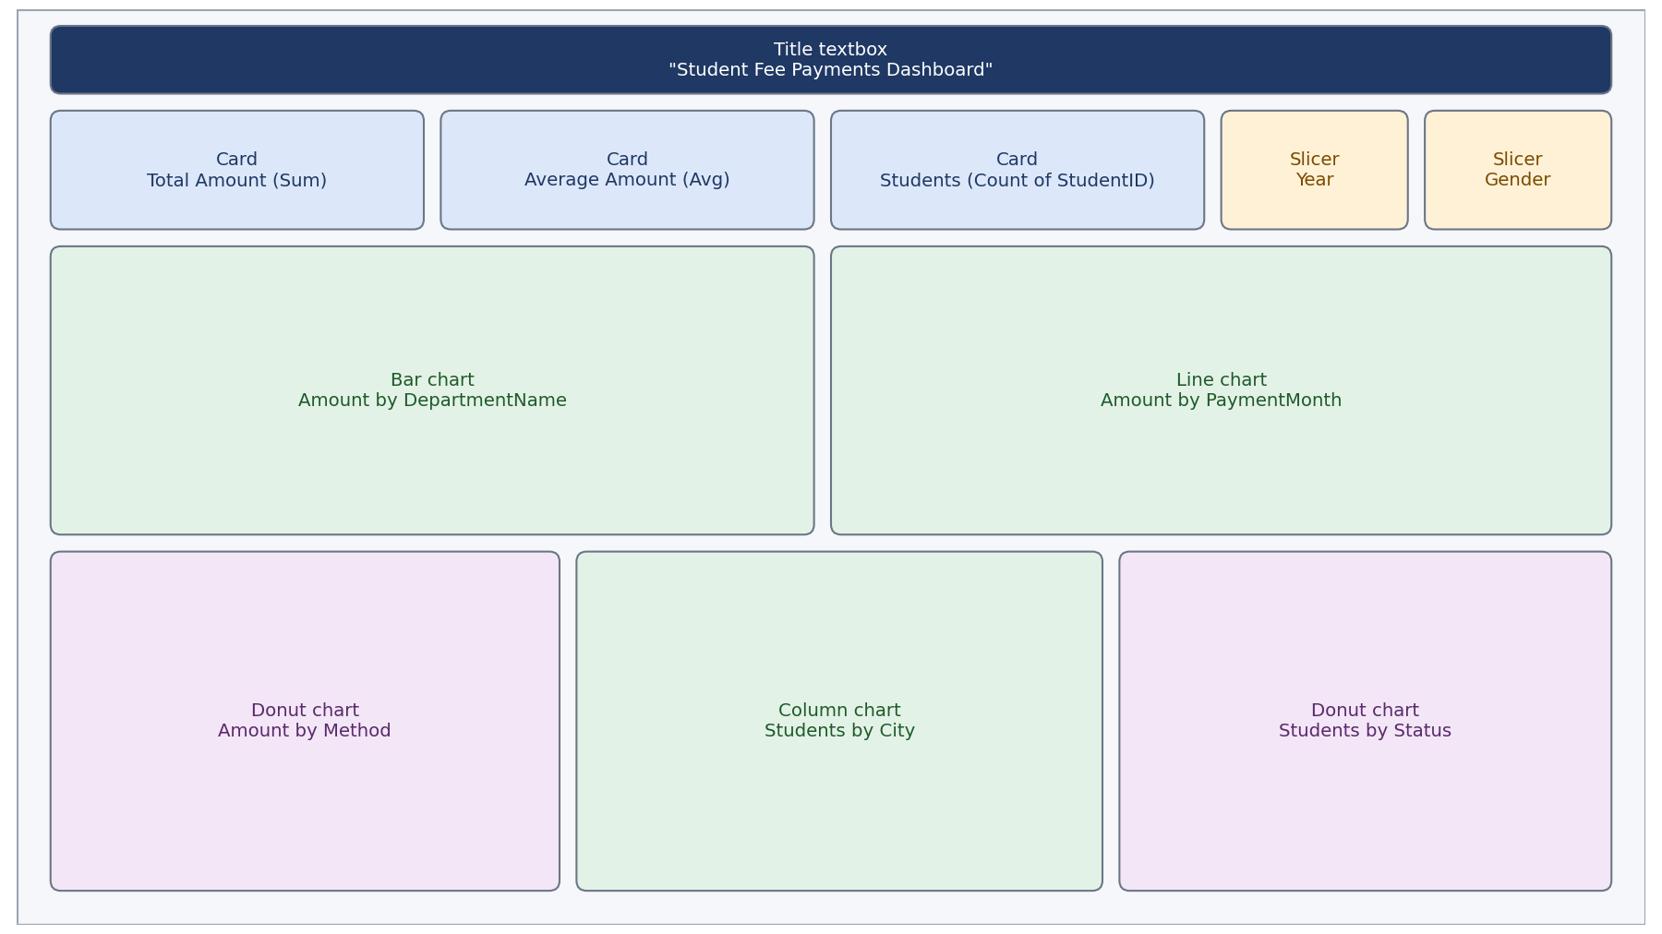

5. Key Insights
The findings below are based on the same data that feeds the dashboard visuals.

5.1 Fees by Department
Department | Total amount | Share
Electronics | 47,43,723 | 9.51%
Civil | 46,68,043 | 9.36%
Mechanical | 46,55,769 | 9.33%
Marketing | 45,58,501 | 9.14%
Finance | 45,46,512 | 9.11%
Computer Science | 45,45,448 | 9.11%
Human Resources | 45,26,110 | 9.07%
Chemistry | 44,55,700 | 8.93%
English Literature | 44,16,264 | 8.85%
Mathematics | 43,95,687 | 8.81%
Physics | 43,83,919 | 8.79%
Table 3: Department-wise fee collection (matches the bar chart)
- Electronics (47.44 L) is the highest and Physics (43.84 L) the lowest.
- The gap between the top and bottom department is under 1 percentage point of the total, so fees are spread fairly evenly.

5.2 Fee Collection over Time
Payment month | Total amount | Payments
Jan 2023 | 1,47,33,120 | 148
Jul 2023 | 2,93,126 | 3
Aug 2023 | 2,02,00,328 | 203
Jan 2024 | 47,12,570 | 46
Aug 2024 | 99,56,533 | 100
Table 4: Monthly fee collection (matches the line chart)
- Payments are concentrated in January and August; August 2023 is the peak month with 203 payments.
- July 2023 has only 3 payments, so the line chart shows five distinct months rather than a continuous monthly trend.

5.3 Payment Methods
Method | Total amount | Share
Bank Transfer | 1,69,03,389 | 33.88%
Online Gateway | 1,64,96,596 | 33.06%
Demand Draft | 1,64,95,693 | 33.06%
Table 5: Share of each payment method (matches the donut chart)
- The three methods are almost equally used (about one third each); Bank Transfer leads by a small margin.

5.4 Students by City
City | Students | Share
Bengaluru | 79 | 15.80%
Kolkata | 75 | 15.00%
Delhi | 75 | 15.00%
Hyderabad | 73 | 14.60%
Mumbai | 71 | 14.20%
Pune | 67 | 13.40%
Chennai | 60 | 12.00%
Table 6: Student count by city (matches the column chart)
- Bengaluru has the most students (79) and Chennai the fewest (60).

5.5 Attendance Status
Status | Students | Share
Present | 452 | 90.40%
Absent | 24 | 4.80%
Late | 24 | 4.80%
Table 7: Attendance status (matches the donut chart)
- 90.4% of the students are marked Present; Late and Absent are each about 4.8%.

5.6 Other Observations
- Gender is balanced: 254 male and 246 female students.
- Students are aged 17 to 21 at the time of payment, with most aged 18 or 19 (141 and 147 students).
- 2023 contributes 70.6% of the total collected and 2024 contributes 29.4%; 2024 only covers payments up to August.

6. Excel and Power BI: How They Work Together
Excel was used to prepare and validate the data, and Power BI was used to present it. The table below summarises the role of each tool.
Aspect | Microsoft Excel | Power BI
Main role | Data cleaning and preparation | Visual reporting and exploration
Output in this project | Clean table and two pivot tables | One-page interactive dashboard
Filtering | Filter buttons and pivot filters | Slicers and click-to-filter on every chart
Calculations | Cell formulas (TRIM, DATEDIF, DATE) | Column aggregations (Sum, Average, Count)
Best suited for | Detailed row-level checking | Quick overview and sharing of results

7. Limitations and Future Enhancements

7.1 Limitations
- Payments fall in only five distinct months, so the time trend has few data points.
- The data does not show what fee was due, so pending or partial payments cannot be analysed.
- The dashboard has two slicers (Year and Gender); department, city, status and payment method cannot be filtered with a slicer.

7.2 Possible Enhancements
- Add an Attendance (Present %) card using the DAX measure given in Appendix A.
- Add slicers for Department, City, Status and Payment Method.
- Add a chart for age at payment and a matrix of Department by Method, as in the Excel pivot table.
- Add a fee-due column to the data to track collection efficiency and pending amounts.

8. Conclusion
The project turned a raw file of 529 records into a clean, validated dataset of 500 students using Excel, and then presented the results in a Power BI dashboard. The analysis shows total fee collection of about 4.99 Cr, evenly spread across departments and payment methods, with payments concentrated in January and August and 90.4% of students marked Present. The workflow of cleaning in Excel and reporting in Power BI makes the results easy to verify, explore and share.

Appendix A. Optional DAX Measure
The following measure can be added in Power BI (Modeling > New measure) to create the Attendance (Present %) card suggested in Section 7.2. It is not part of the current report.
Present % =
DIVIDE(
CALCULATE(COUNTROWS('Education dataset'), 'Education dataset'[Status] = "Present"),
COUNTROWS('Education dataset')
)
Format the measure as a percentage with one decimal place. For the full data the result is 90.4%.

