Below is a cost-focused, practical comparison to help you decide where to purchase a domain for an AWS EC2–hosted application, and whether AWS is cheaper than GCP in this context.

1. Is AWS cheaper than GCP for domain purchase?

Short answer: No.
For domain registration alone, AWS is not cheaper than GCP, and neither is the cheapest overall.
Provider | Domain pricing philosophy
Amazon Web Services (Route 53) | Premium pricing, no discounts
Google Cloud Platform (Cloud Domains) | At-cost pricing, slightly cheaper than AWS
Third-party registrars | Cheapest overall (promos, renewals, privacy included)

2. Actual domain cost comparison (₹ approximate)

Common domains (.com / .in)
Registrar | First year | Renewal | Notes
Route 53 (AWS) | ₹1,200–1,300 | ₹1,200–1,300 | No offers, no discounts
Google Cloud Domains | ₹1,000–1,100 | ₹1,000–1,100 | At-cost, free WHOIS privacy
Namecheap | ₹600–800 | ₹900–1,000 | Best value
GoDaddy | ₹99–₹499 (promo) | ₹1,200+ | Expensive renewal
Porkbun | ₹700–900 | ₹900–1,000 | Very transparent pricing
✅ Cheapest overall: Namecheap / Porkbun
❌ Most expensive: AWS Route 53

3. Should you buy the domain from AWS if hosting on EC2?

From a cost perspective: No.
From an operational simplicity perspective: Sometimes.

Buying domain from AWS (Route 53) – Pros & Cons

Pros
- Seamless integration with EC2, Load Balancer, ACM
- Simplest DNS + SSL setup
- Enterprise-grade DNS reliability

Cons
- Higher annual cost
- No first-year discounts
- No advantage in SEO or performance

4. Best recommended approach (cost-optimized + professional)

✔ Recommended setup
- Buy domain from a low-cost registrar
  - Namecheap / Porkbun / Google Domains
- Use AWS Route 53 only for DNS
  - Create hosted zone
  - Point nameservers from registrar to Route 53

Cost impact
- Domain: ₹700–900/year
- Route 53 hosted zone: ~₹40/month
- Total: Still cheaper than buying domain directly in AWS

5. Summary decision matrix
Question | Best answer
Cheapest place to buy domain? | Namecheap / Porkbun
AWS vs GCP domain cost? | GCP cheaper than AWS
Best for EC2 + long term? | Buy domain outside, DNS in AWS
Avoid if cost sensitive? | Buying domain directly from AWS

Final professional recommendation

Do not purchase the domain directly from AWS if cost matters.
Purchase from a low-cost registrar and manage DNS via AWS Route 53 for a balanced, enterprise-grade yet economical setup.

If you wish, I can:
- Recommend best registrar for .in or .com specifically
- Provide step-by-step DNS linking from registrar → AWS EC2
- Advise on SSL without domain + Let’s Encrypt vs ACM

Please let me know how you would like to proceed.
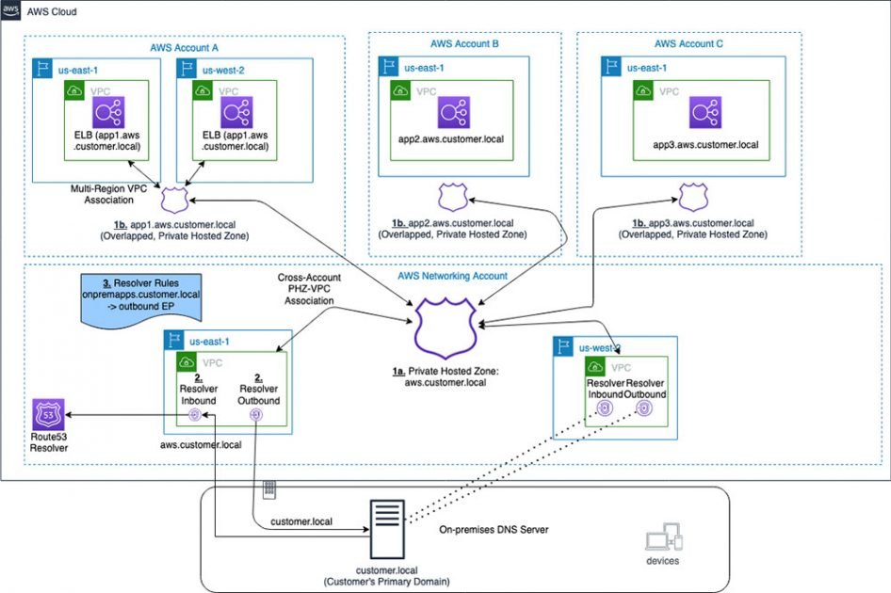

Below is a clear, production-ready procedure to connect a GoDaddy-purchased domain to your AWS EC2 server, covering both direct DNS pointing and the recommended Route 53 DNS method.

Architecture overview (recommended)

Registrar: GoDaddy
DNS (recommended): AWS Route 53
Server: Amazon EC2
IP stability: Elastic IP

STEP 1 — Assign a static public IP (Elastic IP) to EC2

A stable IP prevents outages if the instance restarts.
- Open AWS Console → EC2 → Elastic IPs
- Allocate Elastic IP
- Associate it with your EC2 instance
- Note the Elastic IP (e.g., 13.xxx.xxx.xxx)

STEP 2 — Create a hosted zone in Route 53 (DNS layer)
- Open Route 53 → Hosted zones → Create hosted zone
- Domain name: yourdomain.com
- Type: Public Hosted Zone
- Create

You will receive 4 AWS nameservers (NS).

STEP 3 — Point GoDaddy domain to Route 53
- Login to GoDaddy → My Products → DNS
- Change Nameservers
  - Select Custom
  - Paste the 4 Route 53 NS records
- Save changes

⏳ Propagation: 5–30 minutes (may take up to 24 hours globally)

STEP 4 — Create DNS records in Route 53

After nameservers propagate, add records:

Root domain (

yourdomain.com

)
- Record type: A
- Value: Elastic IP
- TTL: 300

WWW subdomain (

www.yourdomain.com

)
- Record type: A
- Value: Elastic IP
- TTL: 300

STEP 5 — Configure EC2 security group (mandatory)

Allow web traffic:
Type | Port | Source
HTTP | 80 | 0.0.0.0/0
HTTPS | 443 | 0.0.0.0/0
SSH | 22 | Your IP only

STEP 6 — Verify domain mapping

From terminal:
ping yourdomain.com
nslookup yourdomain.com
Browser test:
http://yourdomain.com

OPTIONAL — Fast alternative (without Route 53)

If you prefer not using Route 53:

In GoDaddy DNS:
- Add A record
  - Host: @
  - Points to: Elastic IP
- Add A record
  - Host: www
  - Points to: Elastic IP

⚠️ This works, but Route 53 is strongly preferred for scalability, health checks, and AWS integrations.

SSL (HTTPS) options without Let’s Encrypt
Option | Use case
ACM (free) | If using ALB / NLB
Certbot | Works directly on EC2
Cloudflare SSL | Simple & fast
If you are not yet using a domain-validated SSL, HTTP will still work.

Best-practice recommendation (professional)

Buy domain from GoDaddy → DNS via Route 53 → Static IP via Elastic IP → SSL later

This ensures:
- Zero vendor lock-in
- Stable uptime
- Enterprise-grade DNS
- Lowest long-term operational risk

If you wish, I can:
- Provide exact commands for Nginx/Apache
- Guide SSL setup (ACM or Certbot)
- Help map multiple subdomains (api, app, admin)
- Review your EC2 + Django/Node setup

Please advise how you would like to proceed.

