Flow:
Under public domain:
Preferred time: It can be a drop down to avoid spelling mistakes.
Under reception domain:
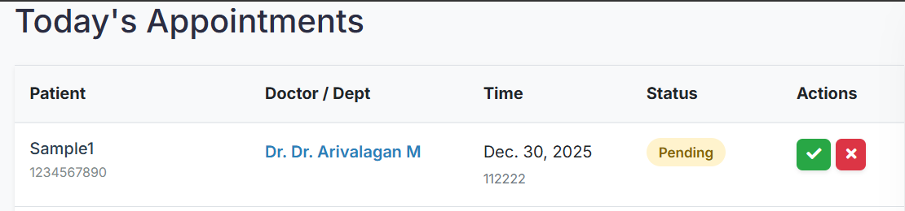
Receptionist accepts it after confirming on mobile with Patient, if the patient says I can’t come on 30th, receptionist has the option to book a new one on the fly.
Under doctor domain.
Doctor starts the consultation, after attending the patient.
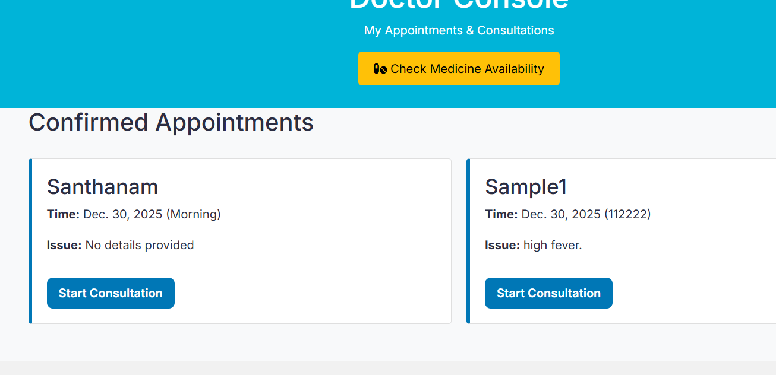

Can I get the medicines, listed out since we may end up typing medicine name with incorrect spelling? not needed it too much
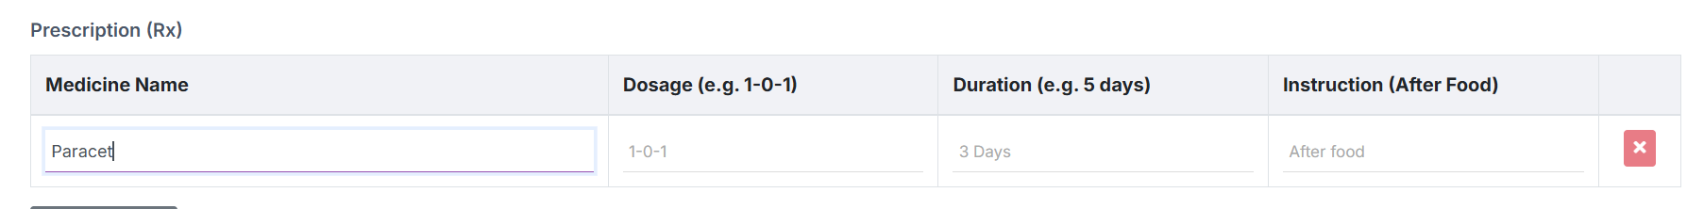
It’s better to put check medicine over here, rather than at the first page.
Also no restriction on the dosage is that ok?
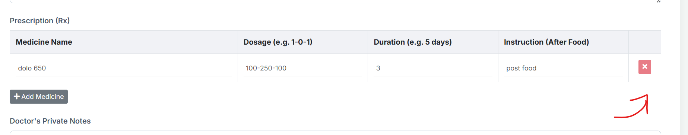
Pharmacy separate login ?

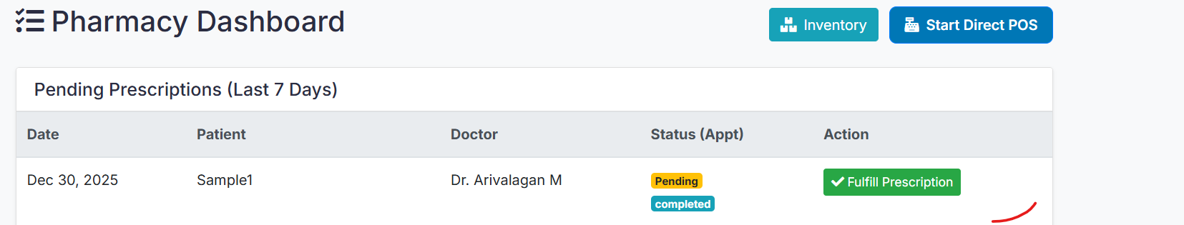

I need to type first 2 letters to get the medicine listed out, why not with first letter itself?
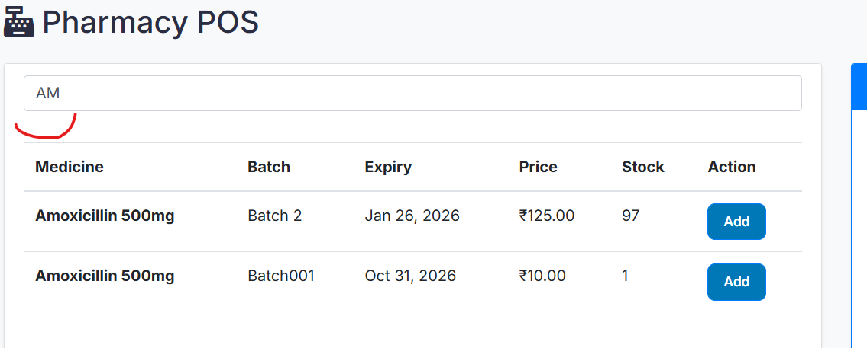

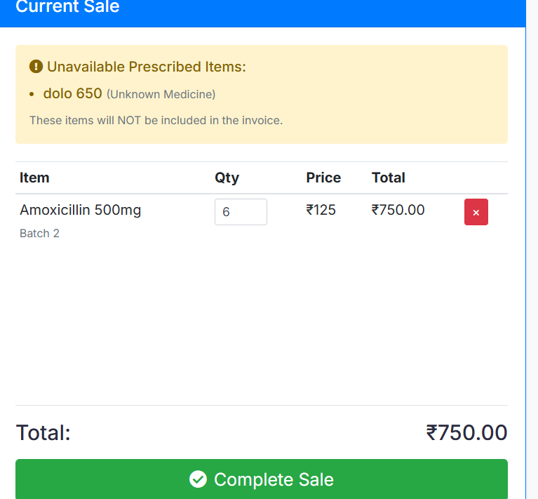

What is this pending status
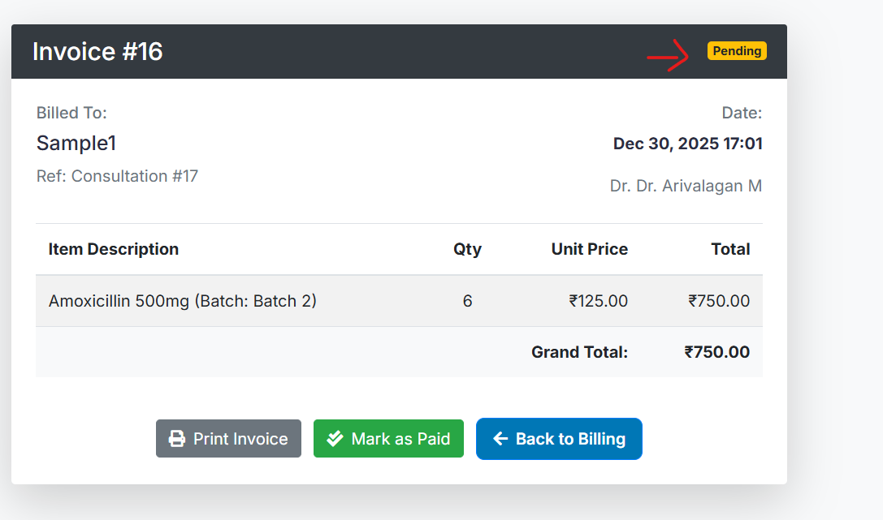
After paid it got changed :
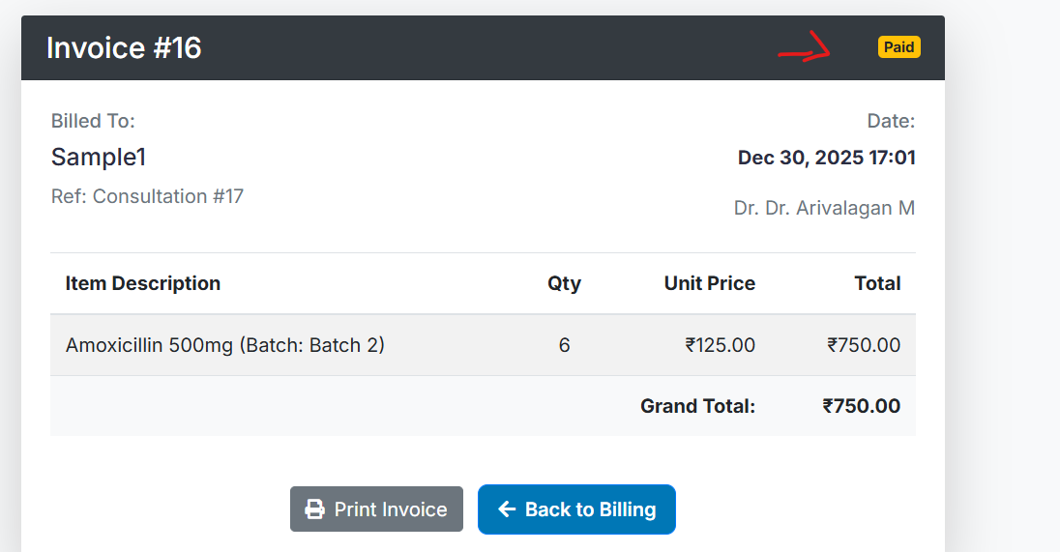
Able to print as well good.
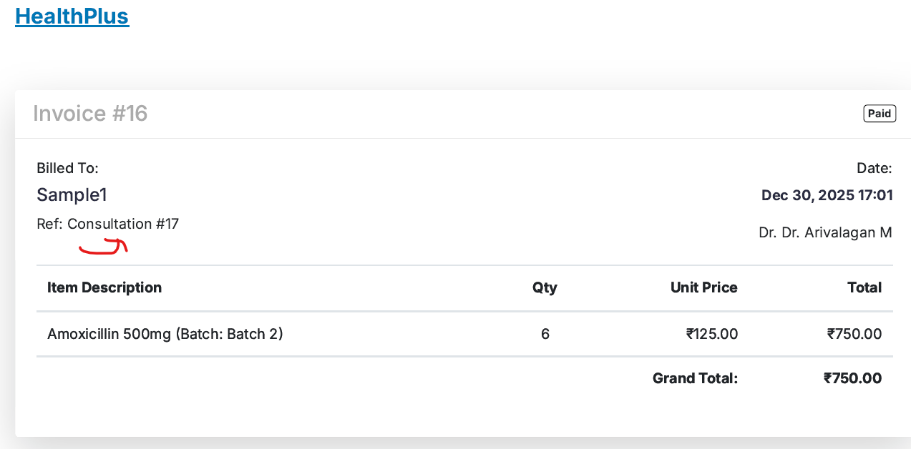
What’s this ref: from where it picks the data? Is it a referred by some other doc
What do we mean by consultation#17 ?
Overall, all good with few observations.

