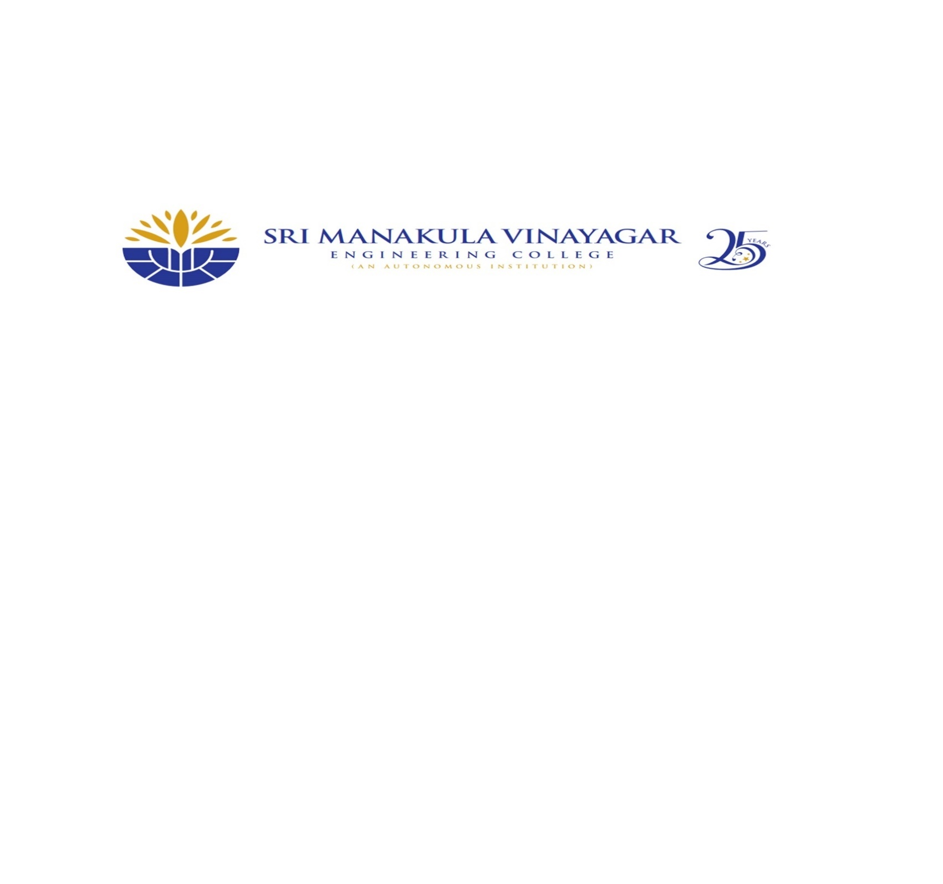

**DEPARTMENT OF COMPUTER SCIENCE AND ENGINEERING**

**ACADEMIC YEAR 2025-26**

**BATCH: 2023-27 YEAR/SEM/SEC: III/V/B**

**NPTEL COURSE REGISTRATION DETAILS**

|  |  |  |  |  |  |  |  |
| --- | --- | --- | --- | --- | --- | --- | --- |
| **SI.NO** | **ENROLL NO** | **REGISTER NUMBER** | **NAME OF THE STUDENT** | **COURSE NAME** | **DURATION** | **TENTATIVE EXAM DATE** | **MENTOR** |
|  | 230130 | 23UCS001 | AASHIKKA G | Programming In Java | 12 weeks course | 25/10/2025 |  |
|  | 231209 | 23UCS011 | AMISH S R | Programming In Java | 12 weeks course | 25/10/2025 |
|  | 230980 | 23UCS022 | BALASUBRAMANIAN S | Programming in Java | 12 weeks course | 25/10/2025 |
|  | 231081 | 23UCS024 | BARATH C | Programming in Java | 12 weeks course | 25/10/2025 |
|  | 231235 | 23UCS047 | GANAPATHI R | Programming in Java | 12 weeks course | 25/10/2025 |
|  | 230402 | 23UCS052 | GILLIVALAVAN G | Programming in Java | 12 weeks course | 25/10/2025 |
|  | 230595 | 23UCS082 | KAVIYA VARDHINI T | Programming in Java | 12 weeks course | 25/10/2025 |
|  | 230613 | 23UCS103 | MOTHISH S | Programming in Java | 12 weeks course | 25/10/2025 |
|  | 230091 | 23UCS112 | PADIKKAL VEETIL NAVDEEP | Programming in Java | 12 weeks course | 25/10/2025 |
|  | 230325 | 23UCS120 | PRAVEEN P | Programming in Java | 12 weeks course | 25/10/2025 |
|  | 230865 | 23UCS130 | REVANTHKUMAR S | Programming in Java | 12 weeks course | 25/10/2025 |
|  | 231039 | 23UCS143 | SHAFEE HAMATH H | Programming in Java | 12 weeks course | 25/10/2025 |
|  | 231244 | 23UCS169 | VISHNU P A | Programming in Java | 12 weeks course | 25/10/2025 |
|  | 241178 | 23CSL003 | SANSKRITHA K S | Programming in Java | 12 weeks course | 25/10/2025 |
|  | 230761 | 23UCS023 | BARANIDHARAN P | Data Structure and Algorithms using Java | 12 weeks course | 01/09/2025 |  |
|  | 230944 | 23UCS101 | MOHAMED NOUSHAD S | Data Structure and Algorithms using Java | 12 weeks course | 01/09/2025 |
|  | 230923 | 23UCS129 | RANJITH R | Data Structure and Algorithms using Java | 12 weeks course | 01/09/2025 |
|  | 230609 | 23UCS139 | SANJAY JERENE M | Data Structure and Algorithms using Java | 12 weeks course | 01/09/2025 |
|  | 230924 | 23UCS007 | AJAY V | Software Project Management | 12 weeks course | 26/10/2025 |  |
|  | 230849 | 23UCS009 | AKSHAYA B | Software Project Management | 12 weeks course | 26/10/2025 |
|  | 230578 | 23UCS019 | ARUTSELVY M | Software Project Management | 12 weeks course | 26/10/2025 |
|  | 230208 | 23UCS051 | GERALDINE A | Software Project Management | 12 weeks course | 26/10/2025 |
|  | 230443 | 23UCS059 | HARINI S | Software Project Management | 12 weeks course | 26/10/2025 |
|  | 230569 | 23UCS072 | JEAN KEVIN D | Software Project Management | 12 weeks course | 26/10/2025 |
|  | 230455 | 23UCS147 | SHREE NIDHI K | Software Project Management | 12 weeks course | 26/10/2025 |
|  | 230810 | 23UCS159 | TANGETI VEERA VIJAYA ANJALI | Software Project Management | 12 weeks course | 26/10/2025 |
|  | 230618 | 23UCS016 | ARJUN N | Python for Data Science | 4 weeks course | 20/09/2025 |  |
|  | 231291 | 23UCS038 | DHARSHAN R | Python for Data Science | 4 weeks course | 20/09/2025 |
|  | 230645 | 23UCS081 | KAVIDHARAN P | Python for Data Science | 4 weeks course | 20/09/2025 |
|  | 230151 | 23UCS104 | MUGILAN S | Python for Data Science | 4 weeks course | 20/09/2025 |
|  | 230339 | 23UCS119 | PRAJAN SANJAY G | Python for Data Science | 4 weeks course | 20/09/2025 |
|  | 230522 | 23UCS173 | YAZHINI G | Machine Learning | 12 weeks course | 25/10/2025 |  |
|  | 231416 | 23UCS037 | DHARANEESWARAN S | Software Testing | 12 weeks course | 26/10/2025 |  |
|  | 231015 | 23UCS163 | VARSHA S | Software Testing | 12 weeks course | 26/10/2025 |
|  | 230888 | 23UCS164 | VARSHA S | Software Testing | 12 weeks course | 26/10/2025 |
|  | 230847 | 23UCS080 | KARTHIK M | Introduction to Programming in C | 8 weeks course | 21/09/2025 |  |
|  | 230228 | 23UCS133 | ROSHINI M | Database management system | 8 weeks course | 21/09/2025 |  |
|  | 230913 | 23UCS086 | KEISHORE G | Data Structures and Algorithms Design | 12 weeks course | 25/10/2025 |  |
|  | 230254 | 23UCS095 | MAHALAKSHMI S | Joy of computing using python | 12 weeks course | 01/09/2025 |  |

**NPTEL COORDINATOR PAC HOD**