Monopoly Game in Swift. A simple game where can play only 2 players. Here you can buy places and see them. Have some bugs((((.

I used UiKit SnapKit.

1st page(Intro page). 2nd page(Main Page)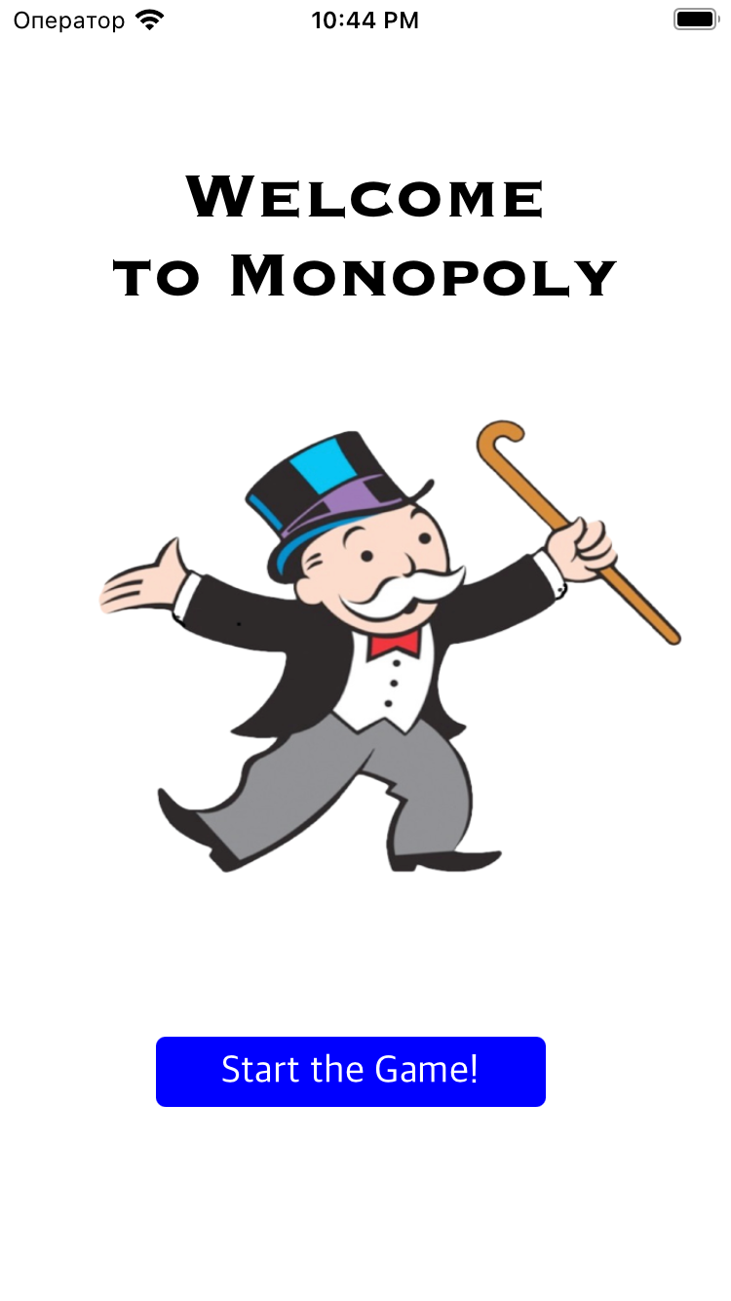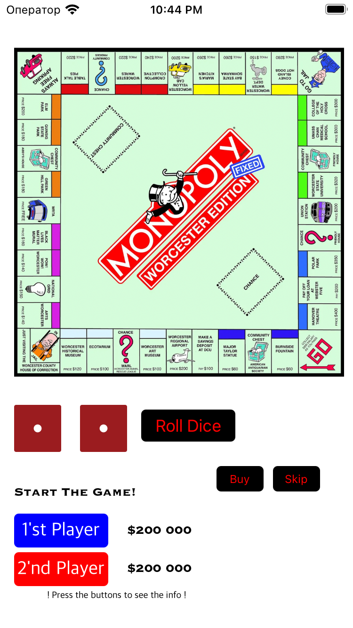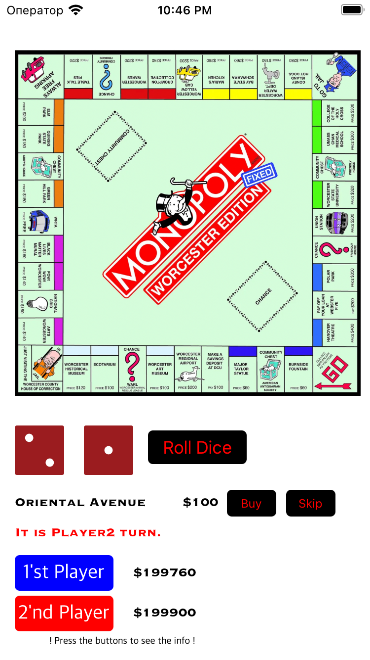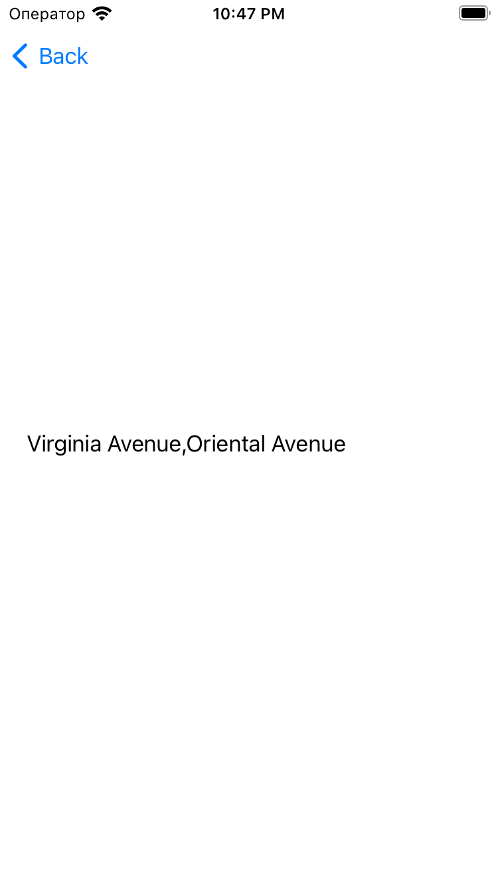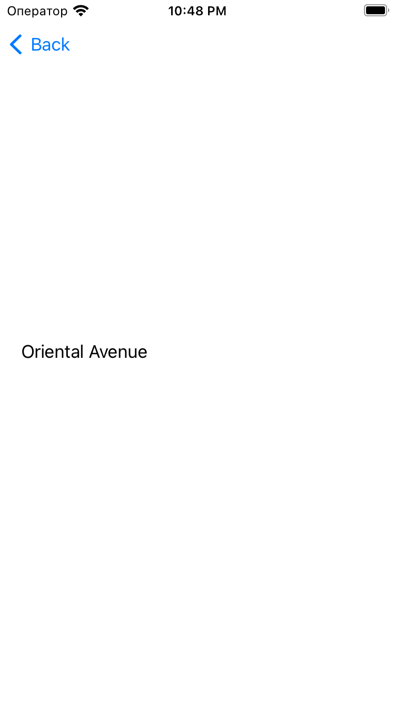

Here place which players buy