**BANK MANAGEMENT SYSTEM**



Problem Solving with Programming(PSP)

**Computer Science & Engineering**

Roll.No-2103A52016 Name- G. RISHITHA REDDY

Roll.No-2103A52012 Name- D. BALA VARSHITHA

Roll.No-2103A52057 Name- M. SIRI CHANDANA

Roll.No-2103A52139 Name- K . UDAYSAI REDDY

Roll.No-2103A52024 Name- MD.AYAZ

Roll.No-2103A52020 Name- K. RAHUL

**Under the Guidance of**

Dr.J.SRINIVAS

Assoc.Professor

**Submitted to**

**June, 2022**



DEPARTMENT OF COMPUTER SCIENCE & ARTIFICIAL INTELLEGENCE Ananthasagar village, Hasanparthy Mandal, Hanamkonda District – 500 376 (2021-22)

**ACKNOWLEDGEMENTS**

First and foremost, we express our sincere thanks for the guidance and encouragement rendered by **J.Srinivas, Assistant Professor** in the Department of Computer Science & Artificial Intellegence, SR University, Ananthsagar, Hanamkonda District. We extend our gratitude for his advice and guidance during the progress of this course project.

Secondly, We express our sincere thanks to **Dr. M.** **Shashikala, Associate Professor & Head**, Department of CS & AI, SR University who stood as silent inspiration behind this course project. Our heartfelt thanks for her endorsement and valuable suggestions.

We wish to express our profound thanks to **Dr. R. Archana,** **Dean, School of Sciences** for providing necessary facilities to make this course project a success.

We thank all the members of teaching and non-teaching staff members, and also who have assisted us directly or indirectly for successful completion of this course project.

Finally, We would like to express our sincere gratitude to our parents who are constantly encouraging us through-out our lives and for completion of this course project.

2103A52016 G.RISHITHA

2103A52012 D.BALA VARSHITHA

2103A52057 M.SIRI CHANDANA

2013A52139 K.UDAYSAI REDDY

2103A52024 MD.AYAZ

2103A52020 K.RAHUL

**CERTIFICATE**

This is to certify that the course project report entitled BANK MANAGEMENT SYSTEM that is being submitted by RISHITHA, BALA VARSHITHA, SIRI CHANDANA, UDAYSAI REDDY, MD.AYAZ and RAHUL in partial fulfillment for the award of B-Tech in Computer Science & Engineering to the SR University, Ananthasagar, Hanmakonda-506371 is a record of bonafide work carried out by them under my guidance and supervision.

Supervisor Department of

Dr.J.Srinivas Computer Science &

AI&ML

**PSP-PROJECT**

TOPIC-BANK MANAGEMENT SYSTEM

SECTION-G1

|  |  |
| --- | --- |
| **CONTENTS** | **PAGENO.** |
| 1. ABSTRACT 2. INTRODUCTION 3. PROJECT REQUIRMENTS(hardware and software) 4. PROJECT DOCUMENTATION(system design and modules) 5. CODE 6. OUTPUTS | 5  6  7-8  9-11    12-18  19-21 |

BANK MAANAGEMENT SYSTEM

ABSTRACT :

PEOPLE’S NATIONAL BANK



Here is a project we developed as a project in c language called BANK MANAGEMENT SYSTEM during our second semester, it is complete and error free. This project is mainly focused on customer account services in bank.

Here, we provide you with every option so that you can create a new account, transfer money, check balance , update existing bank details and login .

FUNCTIONS PERFORMED BY THIS BANK ARE:

1. menu : displays the menu screen where you have the following options

• create a bank account () : This function Is used to create a new bank account .

• transfer money: to transfer money from one account to other or from one person to other.

• See (): This function shows the account number, name, date of birth ,citizen, age, address, phone number, type of account , amount deposited and date of deposit .

• Edit (): This function is used to edit the existing details

• Exit (): To get to home page

Overall with this project, you can perform banking activities like in a real bank.

**INTRODUCTION**

**BANK MANAGEMENT SYSTEM**

The Bank Account Management System is an application for maintaining a person's account in a bank. In this project I tried to show the working of a banking account system and cover the basic functionality of a Bank Account Management System. To develop a project for solving financial applications of a customer in banking environment in order to nurture the needs of an end banking user by providing various ways to perform banking tasks.

Also to enable the user’s work space to have additional functionalities which are not provided under a conventional banking project. The Bank Account Management System undertaken as a project is based on relevant technologies. The main aim of this project is to develop software for Bank Account Management System.

This project has been developed to carry out the processes easily and quickly, which is not possible with the manuals systems, which are overcome by this software.

**PROJECT REQUIREMENTS**

HARDWARE:

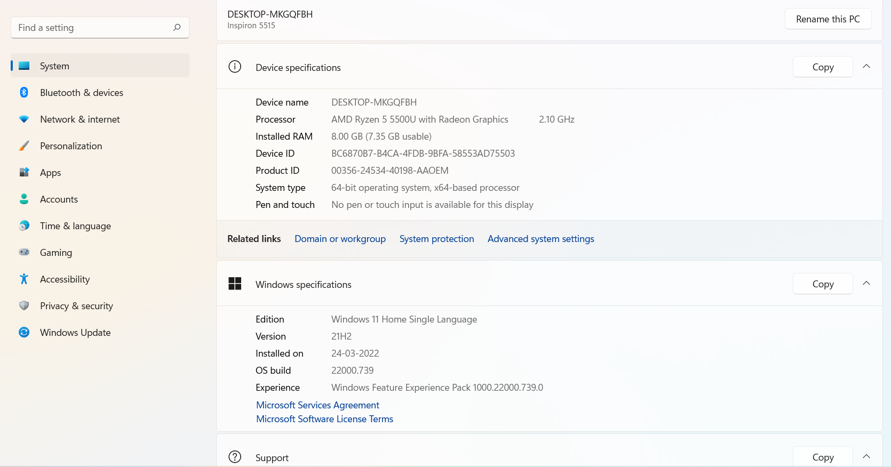

**SOFTWARE:**

DEV C++



Dev-C++ is a free full-featured integrated development environment distributed under the GNU General Public License for programming in C and C++. It is written in Delphi. It is bundled with, and uses, the MinGW or TDM-GCC 64bit port of the GCC as its compiler.

[**Written in**](https://www.google.com/search?safe=active&rlz=1C1NDCM_enIN810IN811&q=dev-c%2B%2B+written+in&stick=H4sIAAAAAAAAAOPgE-LUz9U3MIrPSLfQUsoot9JPzs_JSU0uyczP0y_OTyspTyxKtSovyiwpSc1TyMxbxCqUklqmm6ytrYAQBAAN8MdcRgAAAA&sa=X&ved=2ahUKEwj4qKqaxZ3hAhWe7HMBHQBUCGEQ6BMoADAlegQICxAG)**:**[Object Pascal](https://www.google.com/search?safe=active&rlz=1C1NDCM_enIN810IN811&q=Object+Pascal&stick=H4sIAAAAAAAAAOPgE-LUz9U3MIrPSLdQgjArs9LjtZQyyq30k_NzclKTSzLz8_SL89NKyhOLUq3KizJLSlLzFDLzFrHy-idlAeUVAhKLkxNzAJ7Mls1MAAAA&sa=X&ved=2ahUKEwj4qKqaxZ3hAhWe7HMBHQBUCGEQmxMoATAlegQICxAH)

[**Developer(s)**](https://www.google.com/search?safe=active&rlz=1C1NDCM_enIN810IN811&q=dev-c%2B%2B+developers&sa=X&ved=2ahUKEwj4qKqaxZ3hAhWe7HMBHQBUCGEQ6BMoADAmegQICxAK)**:**Bloodshed Software until 2005, Orwell (Johan Mes) since 2011

[**License**](https://www.google.com/search?safe=active&rlz=1C1NDCM_enIN810IN811&q=dev-c%2B%2B+license&sa=X&ved=2ahUKEwj4qKqaxZ3hAhWe7HMBHQBUCGEQ6BMoADAnegQICxAN)**:**[GNU General Public License](https://www.google.com/search?safe=active&rlz=1C1NDCM_enIN810IN811&q=GNU+General+Public+License&stick=H4sIAAAAAAAAAONgVuLQz9U3MDZPzl3EKuXuF6rgnpqXWpSYoxBQmpSTmazgk5mcmlecCgBHUHbrKQAAAA&sa=X&ved=2ahUKEwj4qKqaxZ3hAhWe7HMBHQBUCGEQmxMoATAnegQICxAO)

[**Stable release**](https://www.google.com/search?safe=active&rlz=1C1NDCM_enIN810IN811&q=dev-c%2B%2B+stable+release&sa=X&ved=2ahUKEwj4qKqaxZ3hAhWe7HMBHQBUCGEQ6BMoADAoegQICxAR)**:**5.11 / [April 27, 2015](https://www.google.com/search?safe=active&rlz=1C1NDCM_enIN810IN811&q=April+27,+2015&stick=H4sIAAAAAAAAAONgVhLQL9E3MjExz6gwLC9PqUrJXsTK51hQlJmjYGSuo2BkYGgKALPTU2glAAAA&sa=X&ved=2ahUKEwj4qKqaxZ3hAhWe7HMBHQBUCGEQmxMoATAoegQICxAS); 3 years ago

[**Operating system**](https://www.google.com/search?safe=active&rlz=1C1NDCM_enIN810IN811&q=dev-c%2B%2B+operating+system&sa=X&ved=2ahUKEwj4qKqaxZ3hAhWe7HMBHQBUCGEQ6BMoADApegQICxAV)**:**[Microsoft Windows](https://www.google.com/search?safe=active&rlz=1C1NDCM_enIN810IN811&q=Microsoft+Windows&stick=H4sIAAAAAAAAAONgVuLQz9U3MCmKt1jEKuibmVyUX5yfVqIQnpmXkl9eDABrmtGqIAAAAA&sa=X&ved=2ahUKEwj4qKqaxZ3hAhWe7HMBHQBUCGEQmxMoATApegQICxAW), [Linux](https://www.google.com/search?safe=active&rlz=1C1NDCM_enIN810IN811&q=Linux&stick=H4sIAAAAAAAAAONgVuLUz9U3SCuoqipYxMrqk5lXWgEATgerNhUAAAA&sa=X&ved=2ahUKEwj4qKqaxZ3hAhWe7HMBHQBUCGEQmxMoAjApegQICxAX) (alpha only)

Windows 11:

Windows 11 is the next client operating system, and includes features that organizations should know. Windows 11 is built on the same foundation as windows 10. If you use Windows 10, then Windows 11 is a natural transition . It’s an update to what you know, and what you’re familiar With.

**PROJECT DOCUMENTATION:**

In C programming, structure is a collection of different data items which are referenced by single name. It is also known as user-defined data-type in C.

Using structure in C language has several benefits.

The following are the different advantages of structured programming

1. It is user friendly and easy to understand.
2. Similar to English vocabulary of words and symbols.
3. It is easier to learn.
4. They require less time to write.
5. They are easier to maintain.
6. These are mainly problem oriented rather than machine based.
7. Program written in a higher level language can be translated into many machine languages and therefore can run on any computer for which there exists an appropriate translator.
8. It is independent of machine on which it is used i.e. programs developed in high level languages can be run on any computer.

**SYSTEM DESIGN AND MODULES**

1.structure:

A structure is a key word that create user defined data type in C/C++. A structure creates a data type that can be used to group items of possibly different types into a single type.

2.switch case:

Switch case statement evaluates a given expression and based on the evaluated value(matching a certain condition), it executes the statements associated with it. Basically, it is used to perform different actions based on different conditions(cases).

* Switch case statements follow a selection-control mechanism and allow a value to change control of execution.
* They are a substitute for long [if statements](https://www.geeksforgeeks.org/decision-making-c-c-else-nested-else/) that compare a variable to several integral values.
* The switch statement is a multiway branch statement. It provides an easy way to dispatch execution to different parts of code based on the value of the expression.

3.while loop:

A **while** loop in C programming repeatedly executes a target statement as long as a given condition is true. Here, **statement(s)** may be a single statement or a block of statements. The **condition** may be any expression, and true is any nonzero value. The loop iterates while the condition is true.

When the condition becomes false, the program control passes to the line immediately following the loop.

4.if-else:

An **if** statement can be followed by an optional **else** statement, which executes when the Boolean expression is false. If the Boolean expression evaluates to **true**, then the **if block** will be executed, otherwise, the **else block** will be executed.

5.stdio.h header file:

The **stdio.h** header defines three variable types, several macros, and various functions for performing input and output.

**printf()**  
It is used to print the strings, integer, character etc on the output screen.

**scanf()**  
It reads the character, string, integer etc from the keyboard.

6.conio.h header file:

conio.h is a C header file used mostly by MS-DOS compilers to provide console input/output.It stands for console input output header file. It is used for following g functions : clrscr, getch, delline, getche, kbhit, gotoxy, wherex, wherey, textcolor, textbackground.

7.getch:

**getch()** is a **nonstandard function** and is present in **[conio.h header](http://en.wikipedia.org/wiki/Conio.h" \t "_blank) file** which is mostly used by [MS-DOS compilers like Turbo C](https://www.geeksforgeeks.org/editors-types-system-programming/). It is **not** part of the C standard library or ISO C, nor is it defined by POSIX.  
Like [these functions](https://www.geeksforgeeks.org/difference-getchar-getch-getc-getche/), getch() also reads a single character from the keyboard. But it does not use any buffer, so the entered character is immediately returned without waiting for the enter key.

SOURCE CODE:

#include<stdio.h>

#include<conio.h>

void creation();

void deposit();

void withdraw();

void bal();

int a=0,i = 101;

struct bank

{

int no;

char name[20];

float bal;

float dep;

}s[20];

int main()

{

int ch;

while(1)

{

printf("\n\*\*\*\*\*\*\*\*\*");

printf("\n BANKING ");

printf("\n\*\*\*\*\*\*\*\*\*");

printf("\n1-Creation");

printf("\n2-Deposit");

printf("\n3-Withdraw");

printf("\n4-Balance Enquiry");

printf("\nEnter your choice");

scanf("%d",&ch);

switch(ch)

{

case 1: creation();

break;

case 2: deposit();

break;

case 3: withdraw();

break;

case 4: bal();

break;

defalut: printf("Enter 1-5 only");

getch();

}

}

}

void creation()

{

printf("\n\*\*\*\*\*\*\*\*\*\*\*\*\*");

printf("\n ACCOUNT CREATION ");

printf("\n\*\*\*\*\*\*\*\*\*\*\*\*\*");

printf("\nYour Account Number is :%d",i);

s[a].no = i;

printf("\nEnter your Name:");

scanf("%s",s[a].name);

printf("\nYour Deposit is Minimum Rs.500");

s[a].dep=500;

a++;

i++;

getch();

}

void deposit()

{

int no,b=0,m=0;

float aa;

printf("\n\*\*\*\*\*\*\*\*\*\*\*\*\*");

printf("\n DEPOSIT ");

printf("\n\*\*\*\*\*\*\*\*\*\*\*\*\*");

printf("\nEnter your Account Number");

scanf("%d",&no);

for(b=0;b<i;b++)

{

if(s[b].no == no)

m = b;

}

if(s[m].no == no)

{

printf("\n Account Number : %d",s[m].no);

printf("\n Name : %s",s[m].name);

printf("\n Deposit : %f",s[m].dep);

printf("\n How Much Deposited Now:");

scanf("%f",&aa);

s[m].dep+=aa;

printf("\nDeposit Amount is :%f",s[m].dep);

getch();

}

else

{

printf("\nACCOUNT NUMBER IS INVALID");

getch();

}

}

void withdraw()

{

int no,b=0,m=0;

float aa;

printf("\n\*\*\*\*\*\*\*\*\*\*\*\*\*");

printf("\n WITHDRAW ");

printf("\n\*\*\*\*\*\*\*\*\*\*\*\*\*");

printf("\nEnter your Account Number");

scanf("%d",&no);

for(b=0;b<i;b++)

{

if(s[b].no == no)

m = b;

}

if(s[m].no == no)

{

printf("\n Account Number : %d",s[m].no);

printf("\n Name : %s",s[m].name);

printf("\n Deposit : %f",s[m].dep);

printf("\n How Much Withdraw Now:");

scanf("%f",&aa);

if(s[m].dep<aa+500)

{

printf("\nCANNOT WITHDRAW YOUR ACCOUNT HAS MINIMUM BALANCE");

getch();

}

else

{

s[m].dep-=aa;

printf("\nThe BalanceAmount is:%f",s[m].dep);

}

}

else

{

printf("INVALID");

getch();

}

getch();

}

void bal()

{

int no,b=0,m=0;

float aa;

printf("\n\*\*\*\*\*\*\*\*\*\*\*\*\*");

printf("\n BALANCE ENQUIRY ");

printf("\n\*\*\*\*\*\*\*\*\*\*\*\*\*");

printf("\nEnter your Account Number");

scanf("%d",&no);

for(b=0;b<i;b++)

{

if(s[b]. no == no)

m = b;

}

if(s[m].no==no)

{

printf("\n Account Number : %d",s[m].no);

printf("\n Name : %s",s[m].name);

printf("\n Deposit : %f",s[m].dep);

getch();

}

else

{

printf("INVALID");

getch();

}

}

**OUTPUTS:**

**Enter 1 to create account**

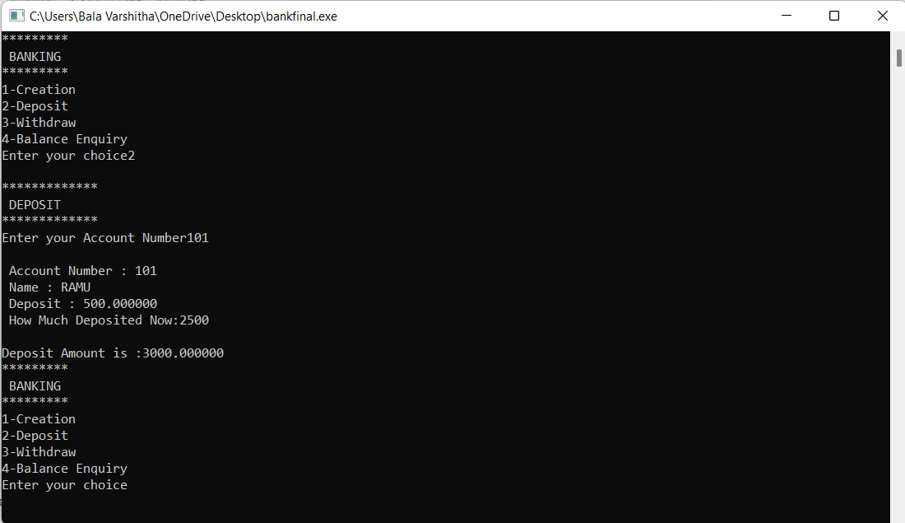

**Enter 2 to Deposit**

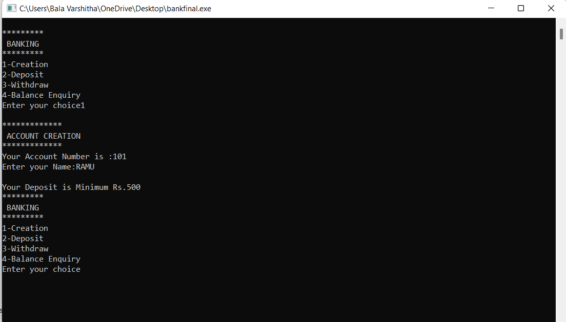

**Enter 3 to withdraw**

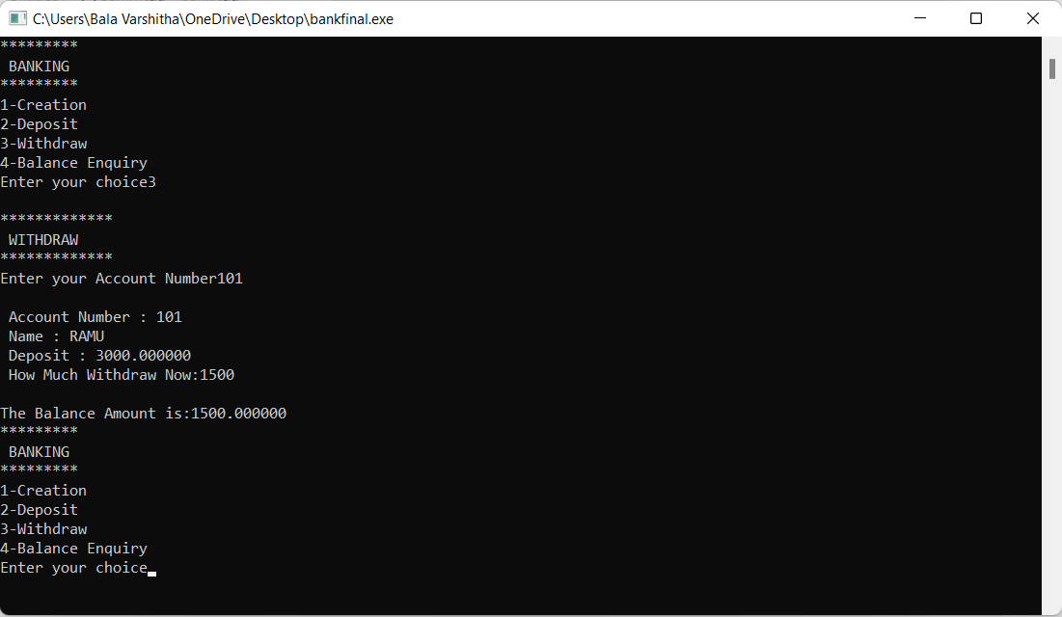

**Enter 4 for balance enquiry**

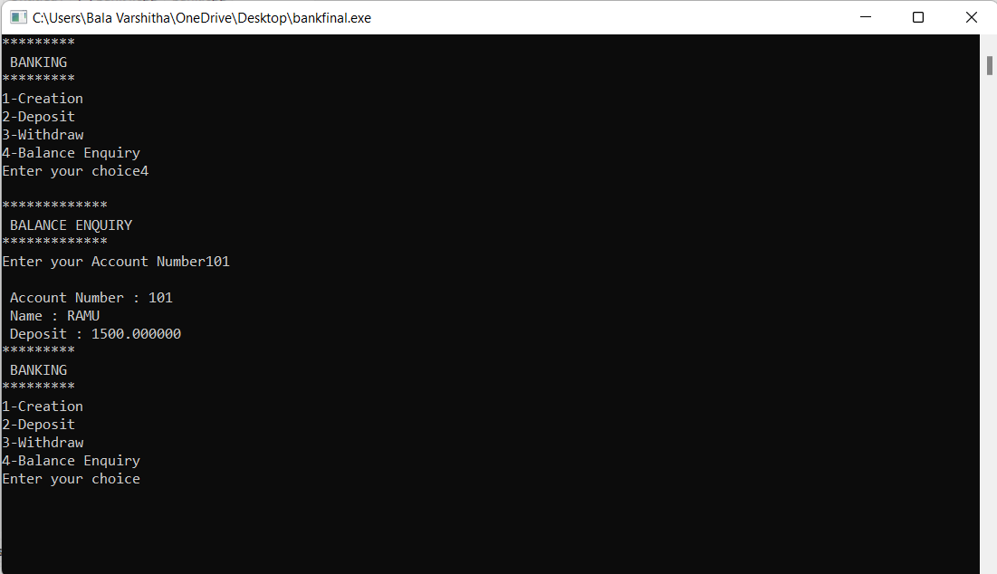

**If invalid entry is given**

