A project report on
NEXUS: A SIMULATION-FIRST PHYSICAL INTELLIGENCE FRAMEWORK FOR DIGITAL TWINS, RULE-BASED DECISIONS AND SAFE ACTUATION
Submitted in partial fulfillment for the award of the degree of
Bachelor of Technology in
Computer Science and Engineering [specialization]
by
[NAME 1] ([REG. NO. 1])
[NAME 2] ([REG. NO. 2])
[NAME 3] ([REG. NO. 3])

SCHOOL OF COMPUTER SCIENCE AND ENGINEERING
October, 2026

A project report on
NEXUS: A SIMULATION-FIRST PHYSICAL INTELLIGENCE FRAMEWORK FOR DIGITAL TWINS, RULE-BASED DECISIONS AND SAFE ACTUATION
Submitted in partial fulfillment for the award of the degree of
Bachelor of Technology in
Computer Science and Engineering [specialization]
by
[NAME 1] ([REG. NO. 1])
[NAME 2] ([REG. NO. 2])
[NAME 3] ([REG. NO. 3])
SCHOOL OF COMPUTER SCIENCE AND ENGINEERING
October, 2026

DECLARATION
I hereby declare that the thesis entitled “NEXUS: A Simulation-First Physical Intelligence Framework for Digital Twins, Rule-Based Decisions and Safe Actuation” submitted by [NAME 1 (REG. NO. 1), NAME 2 (REG. NO. 2), NAME 3 (REG. NO. 3)], for the award of the degree of Bachelor of Technology in Computer Science and Engineering, VIT Chennai, is a record of bonafide work carried out by us under the supervision of [Guide name].
We further declare that the work reported in this thesis has not been submitted and will not be submitted, either in part or in full, for the award of any other degree or diploma in this institute or any other institute or university.
Place: Chennai
Date: [dd-mm-yyyy]
Signature of the Candidate(s)

CERTIFICATE
This is to certify that the report entitled “NEXUS: A Simulation-First Physical Intelligence Framework for Digital Twins, Rule-Based Decisions and Safe Actuation” is prepared and submitted by [NAME 1 (REG. NO. 1), NAME 2 (REG. NO. 2), NAME 3 (REG. NO. 3)] to VIT Chennai, in partial fulfillment of the requirement for the award of the degree of Bachelor of Technology in Computer Science and Engineering [specialization] programme, and is a bonafide record carried out under my guidance. The project fulfills the requirements as per the regulations of this University and in my opinion meets the necessary standards for submission. The contents of this report have not been submitted and will not be submitted either in part or in full, for the award of any other degree or diploma and the same is certified.
Signature of the Guide: ______________
Name: [Guide name]
Date: [dd-mm-yyyy]
Signature of the Examiner 1: ______________ Signature of the Examiner 2: ______________
Name: [Examiner 1] Name: [Examiner 2]
Date: [dd-mm-yyyy] Date: [dd-mm-yyyy]
Approved by the Head of Department,
Computer Science and Engineering [specialization]
Name: [HoD name]
Date: [dd-mm-yyyy]
(Seal of School of Computer Science and Engineering)

ABSTRACT
Buildings, laboratories and small industrial sites are increasingly instrumented with networked sensors and actuators, yet the software that connects readings to decisions and decisions to physical commands is often hard-wired to specific boards, difficult to test safely and poor at explaining why an action happened. This project presents NEXUS, a generic physical-intelligence framework that addresses these problems with a simulation-first, evidence-first design.
NEXUS is a modular monolith built with Spring Boot, PostgreSQL with TimescaleDB, Eclipse Mosquitto and a React Operations Center. Devices are described by data rather than code: capability definitions, templates and per-device bindings, with an onboarding workflow for independently provisioned boards. A Digital Twin keeps reported, desired and verification state with quality and freshness. A rule engine evaluates immutable rule versions against a frozen database snapshot, supports temporal operators, edge, cooldown and hysteresis policies, resolves conflicting actions by deterministic arbitration and persists every decision before any side effect. Command publication, acknowledgement, readback convergence and physical actuation are recorded as separate facts. A backend dry-run reuses the production decision logic without writing, and explanations are generated only from persisted evidence, with an AI-assisted variant constrained by a grounding check.
The system was validated with 1,208 backend tests on real PostgreSQL and Mosquitto containers, 533 frontend tests, a 72-scenario acceptance ledger and an eleven-check validation gate, all passing, and with a simulated three-board deployment in which all eleven scenarios passed. Independent forensic review exposed and corrected defects such as a request-size bypass and connection-pool starvation. The evidence is software and simulation only: no physical actuation has been validated, and the prototype has no authentication. The report states these limits and outlines the work needed to reach a deployable system.
Keywords: physical intelligence; digital twin; rule engine; MQTT; IoT; cyber-physical systems; arbitration; dry-run simulation.

ACKNOWLEDGEMENT
It is my pleasure to express with a deep sense of gratitude to my project guide, [Guide name], [designation], School of Computer Science and Engineering, Vellore Institute of Technology, Chennai, for his/her constant guidance, continual encouragement, understanding, more than all, he/she taught me patience in my endeavor. My association with him/her is not confined to academics only, but it is a great opportunity on my part to work with an intellectual and an expert in the field of the project domain.
I would like to express my gratitude to Dr. G. Viswanathan, Chancellor, Dr. Sekar Viswanathan, Vice President, Dr. G V Selvam, Vice President, Dr. Sandhya Pentareddy, Executive Director, Ms. Kadhambari S. Viswanathan, Assistant Vice-President, Dr. V. S. Kanchana Bhaaskaran, Vice-Chancellor, Dr. T. Thyagarajan, Pro-Vice Chancellor, VIT Chennai and Dr. P. K. Manoharan, Additional Registrar, for providing an environment to work in and for their inspiration during the tenure of the course.
In jubilant mood I express ingeniously my whole-hearted thanks to Dr. Viswanathan V, Dean, School of Computer Science and Engineering, Dr. Nithyanandam P and Dr. Suganya G, Associate Deans, Dr. Sweetlin Hemalatha C, Head of the Department, [specialization], all teaching staff and members working as limbs of our university for their not-self-centered enthusiasm coupled with timely encouragements showered on me with zeal, which prompted the acquirement of the requisite knowledge to finalize my course study successfully. I would like to thank my parents for supporting me throughout my course.
I also acknowledge the use of AI coding assistants during development, as disclosed in Appendix 6. Last but not least, I am thankful to all my friends and well-wishers who helped me in this project.
[Names of the team members]

Table of Contents
Chapter 1 Introduction 1
1.1 INTRODUCTION 1
1.2 BACKGROUND AND MOTIVATION 1
1.3 PROBLEM STATEMENT 2
1.4 OBJECTIVES 2
1.5 SCOPE OF THE PROJECT 3
1.6 EXPECTED OUTCOMES 4
1.7 APPROACH IN BRIEF 4
1.8 DIVISION OF WORK 5
1.9 ORGANISATION OF THE REPORT 5
Chapter 2 Literature Review 6
2.1 INTRODUCTION 6
2.2 CYBER-PHYSICAL SYSTEMS AND THE INTERNET OF THINGS 6
2.3 MESSAGING WITH MQTT 6
2.4 DIGITAL TWINS 7
2.5 RULE AND AUTOMATION ENGINES 7
2.6 RELIABLE MESSAGING AND CONSISTENCY 8
2.7 SAFE USE OF AI EXPLANATIONS 8
2.8 ARCHITECTURE STYLE 9
2.9 SUMMARY OF RELATED WORK 9
2.10 RESEARCH GAP 10
2.11 PATENT SEARCH 10
Chapter 3 Methodology and System Design 11
3.1 DEVELOPMENT METHODOLOGY 11
3.2 REQUIREMENTS 12
3.3 SYSTEM ARCHITECTURE 13
3.4 MODULE DESIGN 16
3.5 DATABASE DESIGN 28
3.6 API DESIGN 29
3.7 CORRECTNESS AND SAFETY PRINCIPLES 29
3.8 TEST AND VALIDATION DESIGN 29
3.9 FEASIBILITY, RISKS AND ETHICS 30
Chapter 4 Implementation and Results 31
4.1 IMPLEMENTATION ENVIRONMENT AND CODE SIZE 31
4.2 DEVELOPMENT CHRONOLOGY 31
4.3 KEY IMPLEMENTATION DETAILS 32
4.4 OPERATIONS CENTER SCREENS 33
4.5 TESTING AND VALIDATION 35
4.6 RESULTS 37
4.7 COMPARISON AND ANALYSIS 39
4.8 LIMITATIONS AND THREATS TO VALIDITY 40
Chapter 5 Conclusion and Future Work 42
5.1 SUMMARY OF THE WORK 42
5.2 WHAT WAS ACHIEVED AND WHAT WAS NOT 42
5.3 LESSONS LEARNED 42
5.4 FUTURE WORK 43
References 44
Appendix 1 Acceptance Ledger of Phase 3 46
Appendix 2 REST Endpoint Inventory 48
Appendix 3 Database Migrations 51
Appendix 4 Validation Commands and Evidence 52
Appendix 5 Individual Contribution Statement 53
Appendix 6 AI-Assistance and Ethics Disclosure 54
Appendix 7 Publication and Patent Status 55

List of Figures
Figure 3.1 Work plan by workstream (approximate weeks from 27 July 2026; workstreams overlap). 12
Figure 3.2 System context: devices, broker, backend, database and Operations Center. 14
Figure 3.3 The sense-to-verify loop and the durable record written at each stage. 14
Figure 3.4 Package dependency flow of the modular monolith. 15
Figure 3.5 Development and isolated validation environments. 16
Figure 3.6 Configuration-driven device model. 17
Figure 3.7 Digital Twin 2.0: reported, desired and verification facts with a derived effective view. 18
Figure 3.8 Command path and the five independent facts it produces. 19
Figure 3.9 Rule lifecycle with immutable versions. 20
Figure 3.10 The persisted rule decision path shared by typed and legacy triggers. 24
Figure 3.11 One decision engine shared by the production path and the dry-run path. 25
Figure 3.12 Transaction design of the dry-run before and after the connection-pool correction. 26
Figure 3.13 Evidence-grounded explanation pipeline with an optional AI reasoning branch. 26
Figure 3.14 Database tables grouped by responsibility. 28
Figure 4.1 Development timeline derived from the commit history. 32
Figure 4.2 Digital Twins page (offline demo mode). 34
Figure 4.3 Rules page with the lifecycle and simulator entry points (offline demo mode). 34
Figure 4.4 Capability framework administration page (offline demo mode). 35
Figure 4.5 Backend automated test count at the recorded validation points. 35
Figure 4.6 Duration of each full-gate check. 36
Figure 4.7 System activity per minute during the Review III run. 38
Figure 4.8 Distribution of command dispatch processing time (n = 140). 38

List of Tables
Table 1.1 Scope of the reported work 3
Table 1.2 Division of work among team members 5
Table 2.1 Summary of related systems and their relevance to NEXUS 9
Table 3.1 The development cycle applied to every slice 11
Table 3.2 Functional requirements 12
Table 3.3 Non-functional requirements 13
Table 3.4 Technology stack and the reason for each choice 14
Table 3.5 MQTT topic contract 17
Table 3.6 Facts recorded for a command and what each does and does not prove 19
Table 3.7 Trigger families 21
Table 3.8 Temporal operators 22
Table 3.9 Candidate dispositions 23
Table 3.10 Dry-run request checks, all applied before any evaluation 25
Table 3.11 Main frontend areas 27
Table 3.12 Simulator device profiles 28
Table 3.13 Invariants enforced by the design 29
Table 3.14 Evidence layers 29
Table 3.15 Principal risks and mitigations 30
Table 4.1 Implementation environment 31
Table 4.2 Repository size at the final checkpoint 31
Table 4.3 Milestones 32
Listing 4.1 Transaction boundary of the dry-run service (excerpt). 32
Listing 4.2 Bounded read in the dry-run controller. 33
Table 4.4 Backend test count at checkpoints 36
Table 4.5 Full validation gate 36
Table 4.6 Review III scenarios (expected versus observed) 37
Table 4.7 Data produced during the Review III run 37
Table 4.8 Experiments on the dry-run engine 38
Table 4.9 Defects found and corrected during final review 39
Table 4.10 Qualitative comparison 39
Table 5.1 Planned work 43
Table A1.1 Phase 3 acceptance scenarios 46
Table A2.1 REST endpoints by controller 48
Table A3.1 Flyway migrations V1 to V36 (forward-only) 51
Table A4.1 Commands used to validate the repository 52
Table A5.1 Individual contribution 53

LIST OF ABBREVIATIONS
Abbreviation | Expansion
ACK | Acknowledgement
AI | Artificial Intelligence
API | Application Programming Interface
CPS | Cyber-Physical System
ESP32 | Espressif 32-bit microcontroller family
HTTP | Hypertext Transfer Protocol
IoT | Internet of Things
JPA | Java Persistence API
JSON | JavaScript Object Notation
MQTT | Message Queuing Telemetry Transport
PIR | Passive Infrared (sensor)
QoS | Quality of Service
REST | Representational State Transfer
SQL | Structured Query Language
STOMP | Simple Text Oriented Messaging Protocol
TLS | Transport Layer Security
UI | User Interface
UUID | Universally Unique Identifier
YAML | YAML Ain't Markup Language

Chapter 1
Introduction

1.1 INTRODUCTION
Physical infrastructure such as buildings, laboratories and industrial plants is increasingly instrumented with low-cost networked sensors and actuators. A single microcontroller board can report temperature, humidity, gas concentration and motion every few seconds, and can switch a fan, a relay or a buzzer on request. The engineering difficulty is no longer reading a sensor; it is turning a continuous stream of measurements into trustworthy decisions and then into physical actions without causing harm. This report describes NEXUS, a software framework that was designed and built to address that difficulty.
NEXUS is organised around a simple processing loop: sense, connect, understand, decide, act, followed by verification of what the action actually achieved. A device publishes telemetry over MQTT; the backend validates it and stores it as typed history; a Digital Twin keeps the current, desired and derived state of every device together with an explicit quality judgement; a rule engine decides what should happen; guarded command dispatch sends the action back to the device; and the platform then records, as separate facts, whether the command was published, acknowledged and confirmed by a matching readback. Every stage persists its evidence in a relational database so that a later reader can answer why a decision was taken.

1.2 BACKGROUND AND MOTIVATION
Home-automation hubs, cloud IoT services and industrial platforms already ingest telemetry and run automations. Studying them, and building earlier versions of NEXUS, exposed recurring weaknesses that matter most when the controlled equipment is physical:
• Device-specific code. Many platforms hard-code a handful of sensor profiles. Adding a new kind of capability means editing and redeploying code.
• Volatile state. Rules, matches and twin state held in memory disappear when the process restarts, so history and in-flight work are lost.
• Ambiguous command status. A command that was published to a broker, acknowledged by firmware, and actually performed by an actuator are three different facts, but dashboards often present a single "success".
• Unsafe rule evaluation. Rules may read stale values, compare incompatible units, fire twice for one event, race with configuration changes or issue conflicting commands to one actuator.
• No safe way to test a rule. Operators can usually only test a rule by letting it act on real equipment.
• Explanations that sound confident but are ungrounded. A language model asked "why did this fire?" can invent a plausible but false reason.

NEXUS was started as a hands-on course project to explore how far these weaknesses can be removed by design rather than by convention. Its guiding principle is that the platform should never claim more than the evidence supports: a published command is not an acknowledged command, an acknowledgement is not convergence, and convergence is not proof that a physical actuator moved.

1.3 PROBLEM STATEMENT
The problem addressed by this project can be stated as follows.
Design and implement a simulation-first, configuration-driven framework that ingests heterogeneous device telemetry, maintains a persistent and quality-aware digital twin of each device, evaluates versioned rules deterministically against a coherent snapshot of that state, arbitrates the resulting actions safely, dispatches commands only under explicit authorisation, verifies their effect separately, and lets operators test and understand rules without touching production, while keeping every claim traceable to persisted evidence.

1.4 OBJECTIVES
1. Generic device model (O1). Replace hard-coded sensor profiles with capability definitions, device templates, per-device bindings and a guided MQTT onboarding workflow.
2. Durable pipeline (O2). Persist telemetry, events, rule matches, actions and pipeline traces in PostgreSQL/TimescaleDB with forward-only migrations, so that a backend restart loses nothing.
3. Digital Twin 2.0 (O3). Represent reported, desired and derived effective state, per-capability quality and freshness, a durable transition history, and readback-based verification of commands.
4. Production-grade rule engine (O4). Provide immutable rule versions with a lifecycle, typed triggers, a frozen evaluation context, temporal operators, cooldown, edge and hysteresis policies, mutual-exclusion arbitration and persisted action plans.
5. Safe actuation (O5). Make command acceptance depend on a persisted, authorised plan and keep acceptance, publication, acknowledgement, convergence and actuation as separate facts.
6. Safe experimentation (O6). Offer a backend dry-run that uses the same decision logic as production but has no ability to write, dispatch or publish.
7. Grounded explanation (O7). Explain rule matches from persisted evidence, with a deterministic fallback, and never let an AI component authorise anything.
8. Evidence-based validation (O8). Verify behaviour with automated tests on disposable infrastructure, a simulated three-ESP32 deployment, and a numbered acceptance ledger, and state honestly what is not proven.

1.5 SCOPE OF THE PROJECT
The scope is deliberately bounded so that every claim in this report can be backed by an executable check. Table 1.1 lists what is inside and outside the scope of the work reported here.
Table 1.1 Scope of the reported work
Area | Included | Not included
Devices | Python-simulated ESP32 profiles; ESP32 telemetry firmware and a PIR bench sketch in the repository | Physical-actuation validation; a physical closed-loop ESP32 test; other protocol adapters
Platform | Modular monolith backend, TimescaleDB persistence, MQTT, realtime STOMP, REST API | Authentication, role-based authorisation, MQTT credentials and ACLs, rate limiting
Twin | Reported/desired/effective state, quality, history, command readback and convergence | Transactional outbox, retries, dead-letter handling, automatic desired-state clearing
Rules | Versions, lifecycle, typed triggers, temporal operators, arbitration, dry-run, explanations | Manual approval workflow, graph branching, cron/timezone scheduling, historical replay
Frontend | Operations Center, framework administration, rule studio, backend-driven simulator | Role-based views, tenant isolation, mobile layout
AI | Evidence-grounded explanations with deterministic fallback | AI-assisted rule creation, autonomous actuation, learning from outcomes

1.6 EXPECTED OUTCOMES
• A working, tested platform in which a simulated device can be provisioned, can report telemetry, can be commanded and can have the effect of that command verified end to end.
• A rule engine whose decisions are reproducible, whose configuration changes cannot race with execution, and whose conflicting actions are resolved deterministically and recorded.
• A dry-run facility whose equivalence with production, and absence of side effects, are demonstrated by tests rather than asserted.
• An acceptance ledger of 72 numbered scenarios, each linked to the automated tests that cover it, and a clear list of limitations.

1.7 APPROACH IN BRIEF
The work followed a simulation-first strategy. The backend does not distinguish a simulated device from physical hardware because both speak the same MQTT contract, so the whole software architecture could be exercised, repeated and measured before any hardware dependency was introduced. Each major capability was developed as a contract, a written statement of the required behaviour, followed by an implementation ticket, an acceptance ledger entry and automated tests. A feature counted as complete only when its exact test had been run and the result recorded. Independent forensic reviews of each milestone looked for defects, and several real defects found that way are reported in Chapter 4.

1.8 DIVISION OF WORK
The project was carried out by a team of at most three members under the guidance of the project guide. Table 1.2 records the division of work; each member also submits an individual contribution statement (Appendix 5).
Table 1.2 Division of work among team members
Member | Register number | Principal responsibilities
[Team member 1] | [Reg. No.] | [e.g. backend platform, rule engine, validation]
[Team member 2] | [Reg. No.] | [e.g. frontend Operations Center, simulator]
[Team member 3] | [Reg. No.] | [e.g. firmware, hardware bench tests, documentation]

1.9 ORGANISATION OF THE REPORT
Chapter 2 reviews the literature and existing platforms and identifies the gap addressed. Chapter 3 presents the methodology, requirements, architecture and the design of each module. Chapter 4 describes the implementation, the testing strategy and the results, including defects found during review and their correction. Chapter 5 concludes and lists future work. The references follow in APA format, and the appendices contain the acceptance ledger, the API and migration inventories, the validation commands, the individual contribution statement and the disclosure of AI assistance.

Chapter 2
Literature Review

2.1 INTRODUCTION
This chapter surveys the technical background on which NEXUS rests and the existing systems it is compared with. It covers cyber-physical systems and the Internet of Things, the MQTT messaging protocol, digital twins, rule and automation engines, reliable-messaging and consistency techniques, and the safe use of AI explanations. The review is based on published papers, standards and the public documentation of widely used platforms. Where a platform comparison relies on vendor documentation, the statement is limited to what that documentation describes.

2.2 CYBER-PHYSICAL SYSTEMS AND THE INTERNET OF THINGS
A cyber-physical system couples computation with physical processes through sensing and actuation (Lee, 2008). Lee argues that the timing, concurrency and reliability assumptions that are harmless in purely computational software become safety-relevant once software controls a physical process. Gubbi et al. (2013) describe the Internet of Things as a layered vision of sensing, networking, data storage and analytics, and Al-Fuqaha et al. (2015) survey its enabling technologies and protocols, identifying interoperability, scalability and security as open challenges. These works motivate two design choices in NEXUS: an explicit, device-independent capability model to address interoperability, and an explicit treatment of failure and uncertainty in the command path to address reliability.

2.3 MESSAGING WITH MQTT
MQTT is a lightweight publish/subscribe protocol designed for constrained devices and unreliable networks (Banks & Gupta, 2014). It defines three delivery guarantees: at most once (QoS 0), at least once (QoS 1) and exactly once (QoS 2). At-least-once delivery means a receiver can see the same message more than once, so handlers must be idempotent. Eclipse Mosquitto is a widely used open-source broker implementing the protocol (Light, 2017). NEXUS uses QoS 1 for telemetry and commands, a thin Eclipse Paho client rather than a heavyweight integration framework, and an external broker so that the broker can be scaled independently of the application. The consequences of at-least-once delivery shape the acknowledgement, deduplication and recovery rules described in Chapter 3.

2.4 DIGITAL TWINS
The digital twin concept, introduced for product lifecycle management, describes a virtual representation of a physical object that is kept synchronised with it (Grieves & Vickers, 2017). Tao et al. (2019) review industrial digital-twin research and note that most published work concentrates on modelling and data fusion, with comparatively less attention to the control loop that returns decisions to the physical asset. Commercial and open-source platforms implement the idea in different ways:
• AWS IoT Device Shadow stores a JSON document per device with reported and desired sections and computes a delta between them, which lets a cloud application express intent while a device is offline (Amazon Web Services, n.d.).
• Azure Digital Twins models environments as a graph of twins described by the Digital Twins Definition Language and routes change events to other services (Microsoft, n.d.).
• Eclipse Ditto exposes devices as "things" with features and properties, a policy model and connectivity to brokers, as a framework for digital-twin back ends (Eclipse Foundation, n.d.).

These systems establish that separating reported from desired state is the right foundation. The documentation reviewed treats the gap between them as a delta to be resolved, and does not describe a notion of per-value quality or a qualified readback that distinguishes "the device said OK" from "the device state now matches the request". NEXUS extends the reported/desired model with exactly those two ideas.

2.5 RULE AND AUTOMATION ENGINES
Rule-based systems have a long history in artificial intelligence (Hayes-Roth, 1985). The Rete algorithm made large production systems efficient by sharing partial matches between rules (Forgy, 1982). IoT platforms use simpler, declarative automation models. Home Assistant describes automations as triggers, conditions and actions, and supports time-qualified triggers and execution traces (Home Assistant, n.d.). Node-RED composes flows of nodes in a visual editor (OpenJS Foundation, n.d.). ThingsBoard processes messages through configurable rule chains (ThingsBoard, n.d.). These tools are valued for usability, and they are generally optimised for convenience in home and light-industrial settings.
Three aspects of rule execution recur as sources of subtle bugs and are central to NEXUS: (1) level versus edge semantics, that is, whether a rule that stays true acts repeatedly or once; (2) debouncing of noisy signals, for example with hysteresis thresholds; and (3) conflict handling, when two rules command the same actuator differently. Industrial control practice treats the third as a safety matter; NEXUS therefore resolves conflicts by deterministic, persisted arbitration with fail-closed tie handling.

2.6 RELIABLE MESSAGING AND CONSISTENCY
Kleppmann (2017) explains why distributed pipelines must tolerate duplicate delivery and crashes between steps, and describes idempotent consumers and the transactional outbox pattern as remedies (see also Richardson, 2018). The outbox is listed as future work for NEXUS (Phase 4 of its roadmap); the current design instead makes each step idempotent by persisting a unique decision per trigger and by recovering unplanned work through a bounded scanner. For consistent reads, Berenson et al. (1995) formalised snapshot isolation, in which a transaction sees one committed state of the database; PostgreSQL implements this as REPEATABLE READ and extends it to serialisable snapshot isolation (Ports & Grittner, 2012). NEXUS uses REPEATABLE READ read-only transactions to give every rule evaluation, and every dry-run, a single coherent view of the world. Nygard (2018) catalogues stability patterns such as timeouts, bulkheads and circuit breakers; a connection-pool starvation defect found in the dry-run endpoint, described in Chapter 4, is a textbook example of the resource-exhaustion failure that book warns about.

2.7 SAFE USE OF AI EXPLANATIONS
Large language models can produce fluent explanations, but they can also generate unsupported statements, commonly called hallucinations (Ji et al., 2023). Retrieval-augmented generation reduces the problem by supplying retrieved evidence to the model (Lewis et al., 2020), but it does not by itself guarantee that every generated claim matches that evidence. Amodei et al. (2016) discuss accident risks in AI systems that act in the world and stress that systems should not be allowed to take unsafe actions based on unreliable outputs. NEXUS follows two conclusions: the explanation component is advisory only, with no path to activation or dispatch, and its output is passed through a deterministic grounding check that compares every asserted fact with the persisted evidence it cites, falling back to a deterministic explanation when nothing survives.

2.8 ARCHITECTURE STYLE
Fowler (n.d.) recommends starting new systems as a well-structured monolith and extracting services only when a real need appears, because distributed systems add operational cost before the domain boundaries are understood. Evans (2003) describes bounded contexts and a ubiquitous language as ways to keep domain logic explicit, and Gamma et al. (1994) describe the observer and strategy patterns used by NEXUS for event dispatch and action executors. NEXUS is therefore built as a modular monolith with a one-way dependency rule between packages (Chapter 3), which keeps the option of extraction open without paying its cost up front.

2.9 SUMMARY OF RELATED WORK
Table 2.1 summarises the surveyed systems against the capabilities that matter for safe physical automation. The entries state what the reviewed documentation describes; absence of a feature in the table means it was not found in that material, not that the product cannot be extended to provide it.
Table 2.1 Summary of related systems and their relevance to NEXUS
System | Relevant strength | Not described in the reviewed material | Relevance to NEXUS
AWS IoT Device Shadow | Reported / desired / delta document per device | Per-value quality; readback-qualified convergence; rule arbitration | Confirms the reported/desired split
Azure Digital Twins | Twin graph, model language, event routing | Built-in rule decision and arbitration engine | Model-driven approach; routing of change events
Eclipse Ditto | Things/features, policies, broker connectivity | Versioned rules with a lifecycle | Framework-style device abstraction
Home Assistant | Triggers, conditions, actions, traces | Immutable versions; persisted arbitration; side-effect-free equivalence test | Automation vocabulary; usability benchmark
Node-RED | Visual flow editor, large node ecosystem | Persisted decision evidence and plans | Inspiration for the visual rule studio
ThingsBoard | Rule chains, dashboards, device profiles | Fail-closed conflict handling and dry-run equivalence proofs | Comparable end-to-end scope
NEXUS (this work) | All of the above in one auditable pipeline | Authentication, outbox, hardware proof (future work) | Evidence-first design for physical safety

2.10 RESEARCH GAP
The review shows that device abstraction, digital twins and automation engines are individually well understood. The following gaps motivated the project:
1. Quality-aware decisions. Rules usually read the latest value without a standard way to refuse stale, offline or unit-incompatible evidence.
2. Truthful command semantics. Command acknowledgement, state convergence and physical effect are rarely separated and persisted as distinct facts.
3. Auditable arbitration. Conflicting actions are seldom resolved by a deterministic, persisted procedure whose outcome can be explained afterwards.
4. Provable dry-run. Testing a rule without side effects is common, but equivalence with real execution and the absence of side effects are rarely demonstrated by tests.
5. Grounded explanation. Explanations are seldom checked against stored evidence before being shown.

NEXUS addresses these gaps as an engineering contribution. It does not claim a new algorithm; its value lies in the careful composition of known techniques and in the evidence presented for their correctness.

2.11 PATENT SEARCH
No formal patent search was carried out for this project, and no claim of novelty in the patent sense is made. The work builds on openly documented standards and software, listed in the references.

Chapter 3
Methodology and System Design

3.1 DEVELOPMENT METHODOLOGY
The project was executed as a sequence of phases, each with a written goal, work items and exit criteria in a shared roadmap (Phase 0 clean baseline; Phase 1 generic device framework; Phase 2 Digital Twin; Phase 3 Rule Engine; Phases 4 to 9 planned). Within a phase, work proceeded in numbered slices (for example P2.1 to P2.4 and P3.0 to P3.6) that each followed the same cycle, shown in Table 3.1.
Table 3.1 The development cycle applied to every slice
Step | Activity | Artefact
1 Contract | Write the normative behaviour: states, invariants, failure handling, compatibility | Contract documents (Twin 2 contract, Rule Engine contract) and architecture decision records
2 Ticket | Order the work by dependency; define what each slice may and may not touch | Implementation ticket
3 Ledger | Enumerate testable scenarios before coding; status PLANNED until proven | Acceptance ledger (72 scenarios for Phase 3, 20+ for P2.4)
4 Implement | Backend, migration, frontend and simulator changes together | Source code, forward-only Flyway migration
5 Verify | Focused tests first, then the complete suite on disposable PostgreSQL and Mosquitto | Automated tests, validation reports
6 Review | Independent forensic review hunting for races, overstated claims and missing evidence | Findings, corrections, re-validation
7 Record | Mark a scenario COVERED only with exact test names and a recorded success | Updated ledger and ticket

Three principles governed every slice. First, simulation first: the backend cannot tell a simulated device from a real one, so behaviour is reproduced and measured in software before it is trusted on hardware. Second, persist before you act: a decision is written to the database before any side effect, so that crashes and replays are diagnosable. Third, claim only what is proven: statuses are recorded as separate facts, and the report distinguishes software evidence from physical evidence. The overall work plan is shown in Figure 3.1.
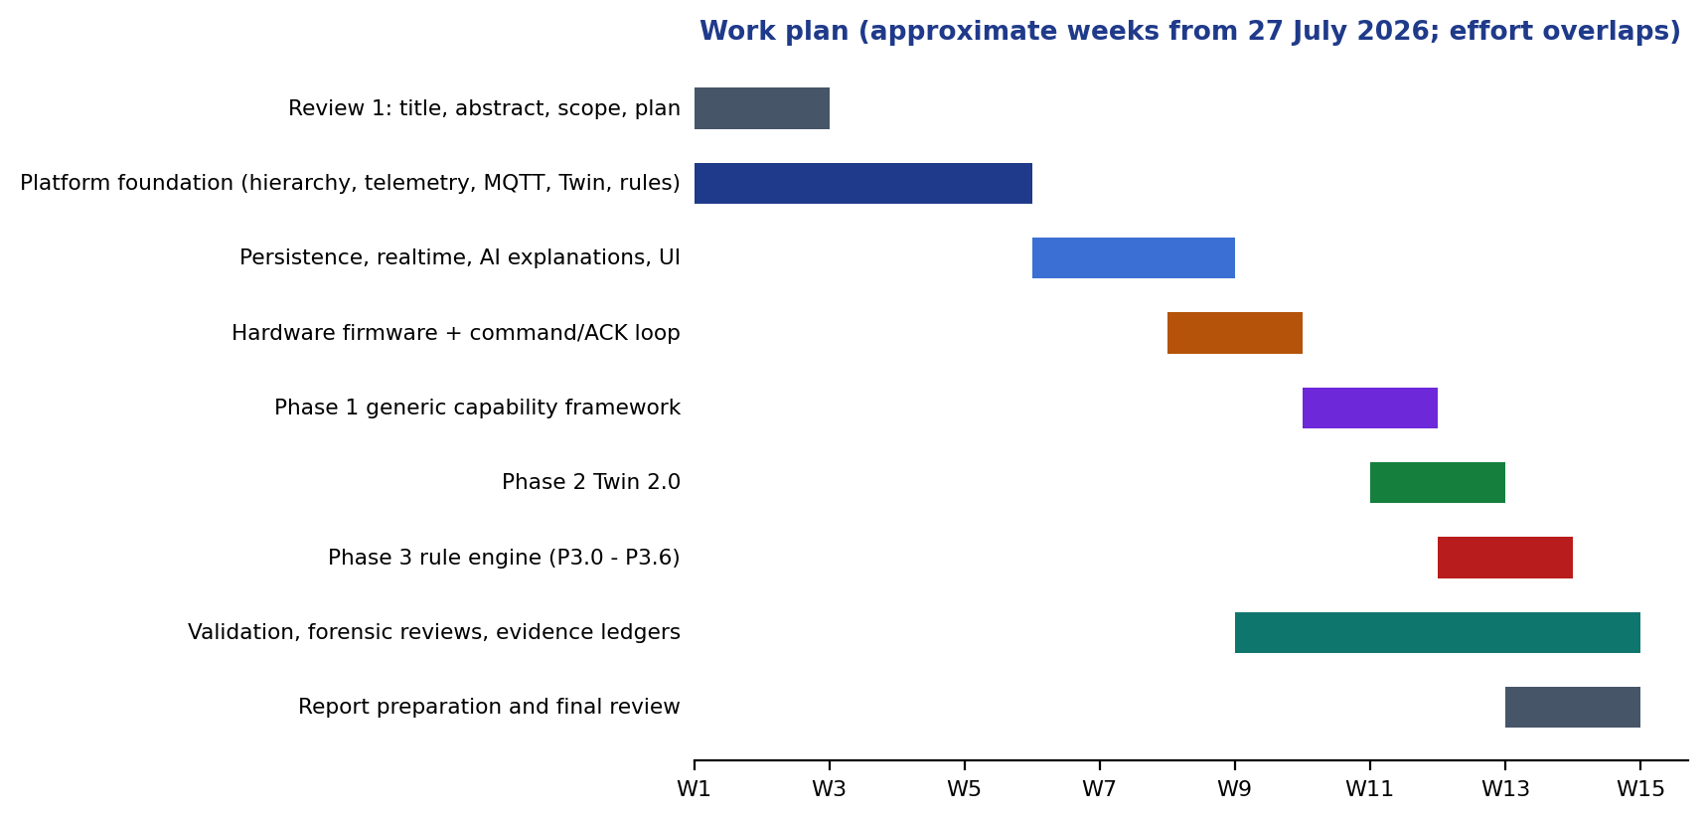
Figure 3.1 Work plan by workstream (approximate weeks from 27 July 2026; workstreams overlap).

3.2 REQUIREMENTS
The functional and non-functional requirements below were derived from the objectives in Chapter 1 and refined during the contract-writing step of each phase.
Table 3.2 Functional requirements
ID | Requirement | Objective
FR1 | Manage a physical hierarchy of sites, buildings, spaces and devices through a REST API and UI | O1
FR2 | Define capabilities, templates and per-device bindings without code changes; provision devices through an MQTT onboarding workflow | O1
FR3 | Ingest telemetry over MQTT and HTTP, validate it against the device contract and store typed history | O1, O2
FR4 | Maintain reported, desired and effective state per device, with quality and freshness, and persist every state transition | O3
FR5 | Dispatch commands only after durable acceptance; record publication, acknowledgement and verification separately | O3, O5
FR6 | Create rules as immutable versions with a lifecycle; evaluate them on typed triggers against a frozen snapshot | O4
FR7 | Support temporal operators (duration, count, absence, offline, trend), cooldown, edge and hysteresis policies | O4
FR8 | Arbitrate conflicting actions deterministically with mutual-exclusion groups and persist the plan | O4, O5
FR9 | Provide a backend dry-run (supplied and current state) with no side effects and an unsupported-mode response for historical replay | O6
FR10 | Explain a rule match from persisted evidence with a deterministic fallback; reject ungrounded claims | O7
FR11 | Publish realtime updates to the UI and expose pipeline traces, analytics and health | O2
FR12 | Provide a rule studio whose save goes through the real API and whose simulator uses the backend engine | O4, O6

Table 3.3 Non-functional requirements
ID | Requirement | How it is checked
NFR1 | Durability: a backend restart must not lose devices, rules, matches, actions, traces or twin state | Restart/persistence smoke test; Review III restart scenario
NFR2 | Correctness under concurrency: no duplicate decision or command for one trigger | Multi-transaction integration tests, unique-key constraints
NFR3 | Safety: stale, offline or unit-incompatible evidence cannot satisfy a rule | Quality and unit-safety tests
NFR4 | Isolation: validation never touches the development database | Testcontainers; startup scripts refused during validation
NFR5 | Backward compatibility: legacy capability types and existing APIs keep working | Three-device fixtures, compatibility regression
NFR6 | Evolvability: schema changes are forward-only and checksummed | 36 Flyway migrations; migration tests on populated databases
NFR7 | Observability: every pipeline step carries a correlation id and a trace | Pipeline traces, correlation tests
NFR8 | Honesty: statements about physical effect are never inferred from software facts | Explanation and ledger rules
NFR9 | Reproducibility: one command validates the repository (fast and full) | validate_nexus.py

3.3 SYSTEM ARCHITECTURE

3.3.1 OVERVIEW
Figure 3.2 shows the system context. Devices (physical ESP32 boards or the Python simulator) communicate with an Eclipse Mosquitto broker. The Spring Boot backend subscribes to device topics, persists data in PostgreSQL with the TimescaleDB extension, evaluates rules and publishes commands. A React single-page application, the Operations Center, calls the REST API and receives realtime updates over STOMP WebSockets.
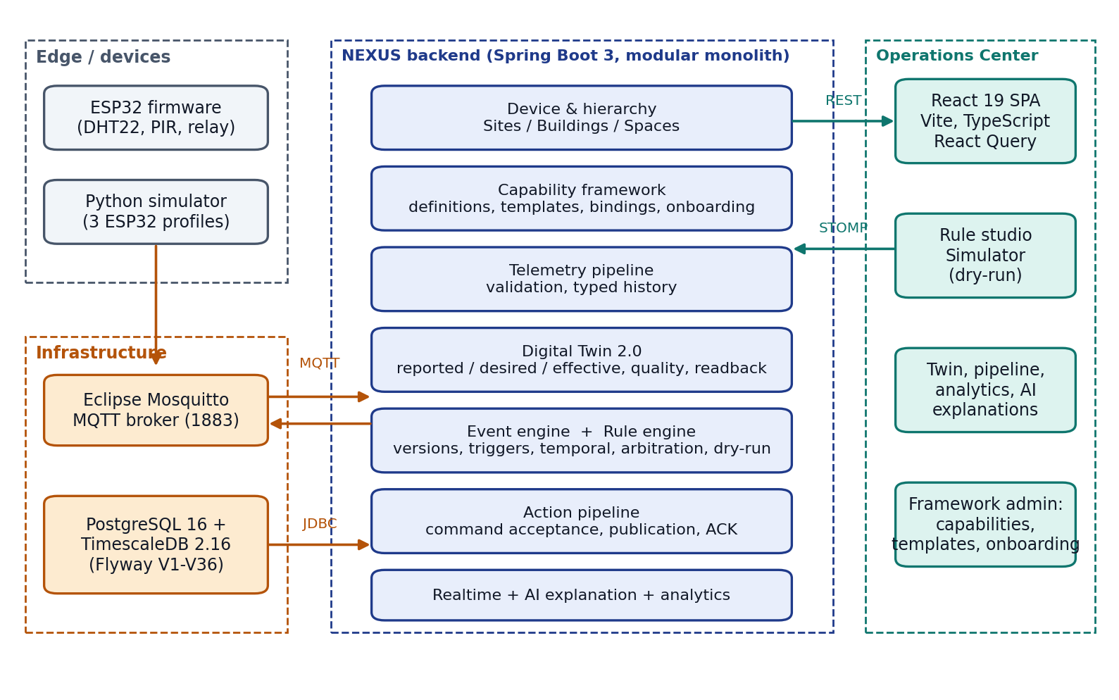
Figure 3.2 System context: devices, broker, backend, database and Operations Center.
Figure 3.3 traces the physical-intelligence loop through the persisted records that each stage produces. Evidence is written at every stage and joined by a correlation identifier, which is what makes a decision explainable after the fact.
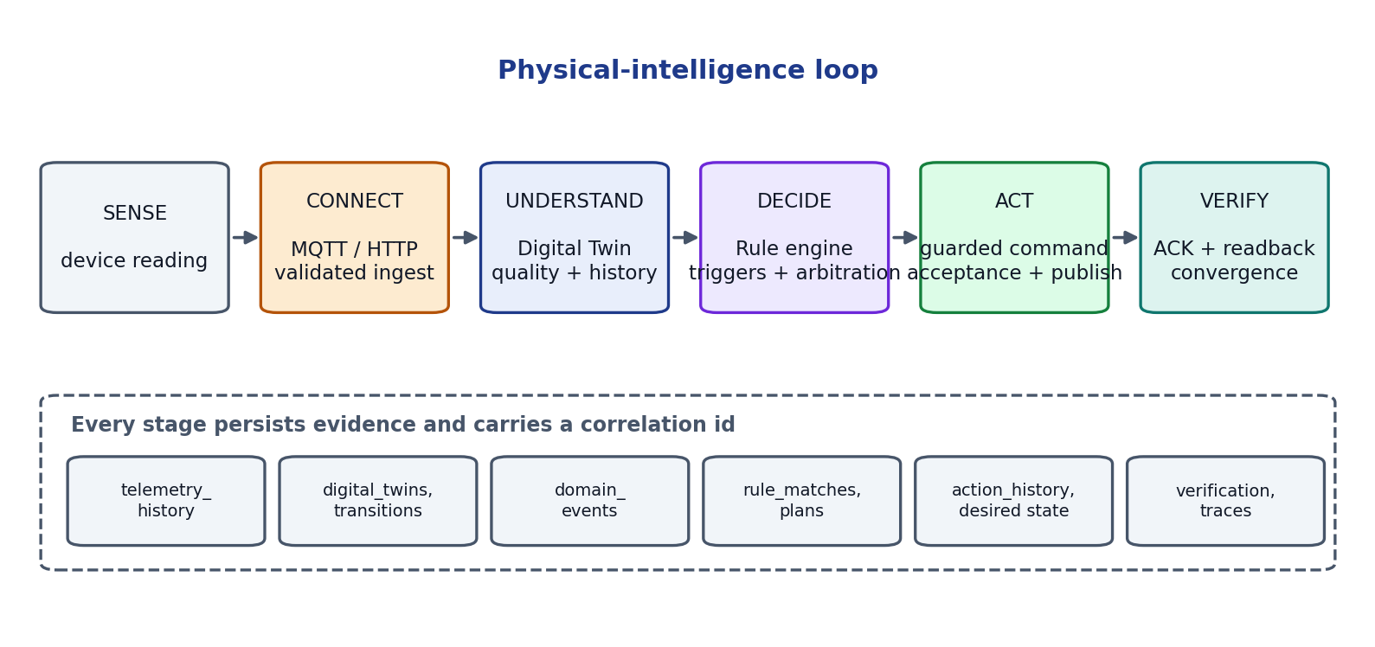
Figure 3.3 The sense-to-verify loop and the durable record written at each stage.

3.3.2 TECHNOLOGY STACK
Table 3.4 Technology stack and the reason for each choice
Layer | Technology | Rationale
Backend | Java 21, Spring Boot 3.3.4, Spring Data JPA, JDBC, Flyway | Mature transactional framework; strong typing for contracts; migration tooling
Messaging | Eclipse Mosquitto 2.x, Eclipse Paho client, Spring STOMP | Standard IoT protocol; broker scales independently; WebSocket push to the UI
Database | PostgreSQL 16 with TimescaleDB 2.16.1 | ACID transactions, REPEATABLE READ snapshots; hypertables and retention for telemetry
Frontend | React 19, TypeScript, Vite, React Query, React Flow, Recharts, Tailwind CSS | Typed UI, server-state caching, graph editor for the rule studio
Simulator | Python 3.11, paho-mqtt, PyYAML | Concurrent virtual ESP32 devices speaking the same MQTT contract
Firmware | PlatformIO, Arduino framework for ESP32, 256dpi MQTT (QoS 1), ArduinoJson, DHT/BME280 libraries | Physical implementation of the telemetry contract
Validation | JUnit 5, Mockito, Testcontainers, Vitest, pytest, Python orchestration scripts | Real PostgreSQL and Mosquitto for integration evidence
Delivery | Docker Compose for infrastructure; start/stop/validate scripts | Reproducible local environment

3.3.3 MODULAR MONOLITH AND PACKAGE DEPENDENCIES
NEXUS is a single deployable Spring Boot application organised into packages that correspond to domain modules (Figure 3.4). Dependencies run in one direction, from domain modules towards shared and foundation packages; an upstream module such as the Digital Twin never depends on a downstream module such as the rule engine. Communication from upstream to downstream is through immutable domain events published to a dispatcher. Decisions (rules) are separated from execution (actions): the rule engine never calls an executor directly, it persists a plan that the action pipeline then carries out. The repository contains 368 production Java files (about 21,300 lines), of which the rule package holds 140, the device package 80 and the twin package 37.
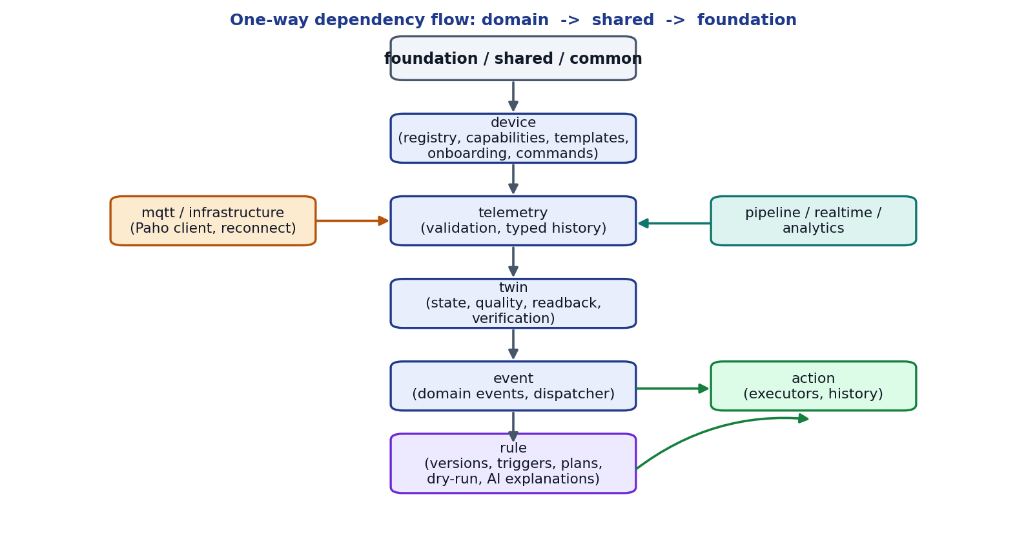
Figure 3.4 Package dependency flow of the modular monolith.

3.3.4 DEPLOYMENT AND TOOLING
The development environment (Figure 3.5) runs the backend on port 8080, the frontend on 5173, PostgreSQL/TimescaleDB on 5432 and Mosquitto on 1883. A Python orchestrator (start_nexus.py) refuses occupied ports, enforces a single live orchestrator, waits for bounded readiness and records ownership under an ignored runtime folder. A separate command (validate_nexus.py) runs the fast gate (eight checks) or the full gate (eleven checks), and refuses to run while the normal application is up so that validation never touches the development database. The MQTT broker is configured for trusted local use only.
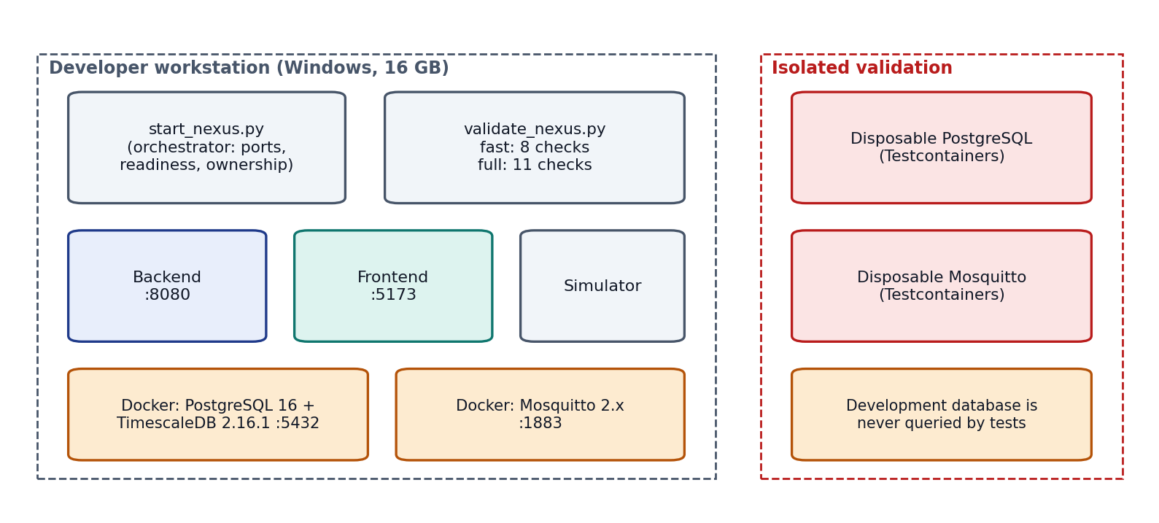
Figure 3.5 Development and isolated validation environments.

3.4 MODULE DESIGN

3.4.1 PHYSICAL HIERARCHY AND DEVICE REGISTRY
Sites contain buildings, buildings contain spaces and spaces contain devices. Each level has a REST resource, a repository and UI pages. Devices carry a serial number, a mode (simulated or hardware), a lifecycle status (REGISTERED, ACTIVE and others) and creation metadata. Deleting a parent that still has children is refused with a conflict response, so the hierarchy cannot be left inconsistent.

3.4.2 CAPABILITY FRAMEWORK
Early versions of NEXUS represented capabilities as a Java enumeration (temperature, humidity, pressure, gas, motion, button, LED, fan, buzzer, relay, servo). Phase 1 replaced this by data (Figure 3.6). A capability definition has a stable key, a direction (READ or WRITE), a value type (number, boolean, string, enumeration or object), a unit and allowed units, numeric limits, enumeration choices and the commands it supports. A device template composes definitions, and a provisioned device is an independent instance whose bindings may narrow, but never widen, the constraints of the definition and template. A single RuntimeCapabilityResolver is the migration boundary: it resolves an explicit binding first and falls back to the legacy adapter, so older devices keep working.
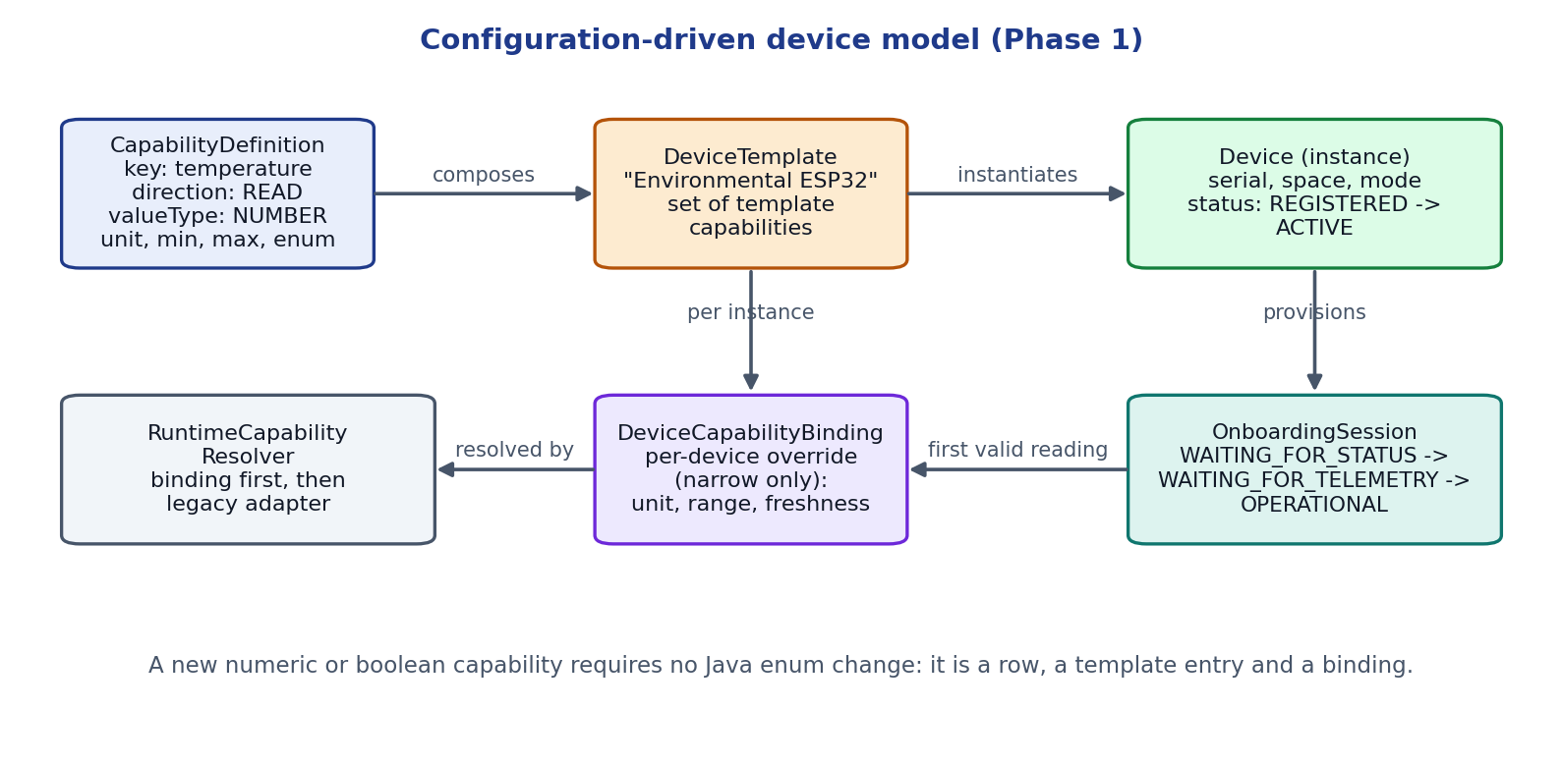
Figure 3.6 Configuration-driven device model.
Onboarding is a persistent session that moves through WAITING_FOR_STATUS, WAITING_FOR_TELEMETRY and OPERATIONAL. Provisioning creates the device in the REGISTERED state, its bindings and the session in one transaction and is idempotent for a repeated request key. A valid online status message advances the session; the first valid telemetry message is passed through the normal resolver and validator, stored, applied to the Twin, and only then does the same transaction activate the device. Invalid onboarding data is recorded as rejected without activating the device, and deadlines allow timeout and retry. The backend generates the MQTT contract for each device (Table 3.5).
Table 3.5 MQTT topic contract
Topic | Direction | Content | QoS
nexus/devices/{deviceId}/telemetry | device to backend | timestamp, sensor type or capability key, typed value, unit | 1
nexus/devices/{deviceId}/status | device to backend | online/offline status used for connectivity | 1
nexus/devices/{deviceId}/commands | backend to device | capability, command, value (for example a relay channel and state) | 1
nexus/devices/{deviceId}/commands/ack | device to backend | command id and acknowledgement status | 1

3.4.3 TELEMETRY PIPELINE
A reading arrives through POST /api/v1/telemetry or through the MQTT listener; both routes use one TelemetryService. The service checks that the device exists and is ACTIVE (or is the narrowly admitted onboarding device), resolves the capability, validates the typed value and unit against the definition and binding, stores the reading in the telemetry hypertable and updates the Twin. Malformed input is dropped early and, for onboarding devices, recorded as a rejection; a transient infrastructure failure is deliberately not classified as invalid data. The MQTT client uses a NEXUS-owned bounded reconnect controller instead of the library default, and a message that cannot be processed is not redelivered forever (a poison-message loop was found and fixed during development).

3.4.4 DIGITAL TWIN 2.0
The Twin keeps three kinds of fact and one derived view (Figure 3.7). Reported state is what the device last reported, with typed value, unit, device time and the exact backend receipt time. Desired state is what NEXUS has accepted as intent, stored durably before any command is published. Verification records whether a mapped readback confirms the desired state. The effective state is a derived structure that presents observation, intent and verification side by side; it is never a third writable truth.
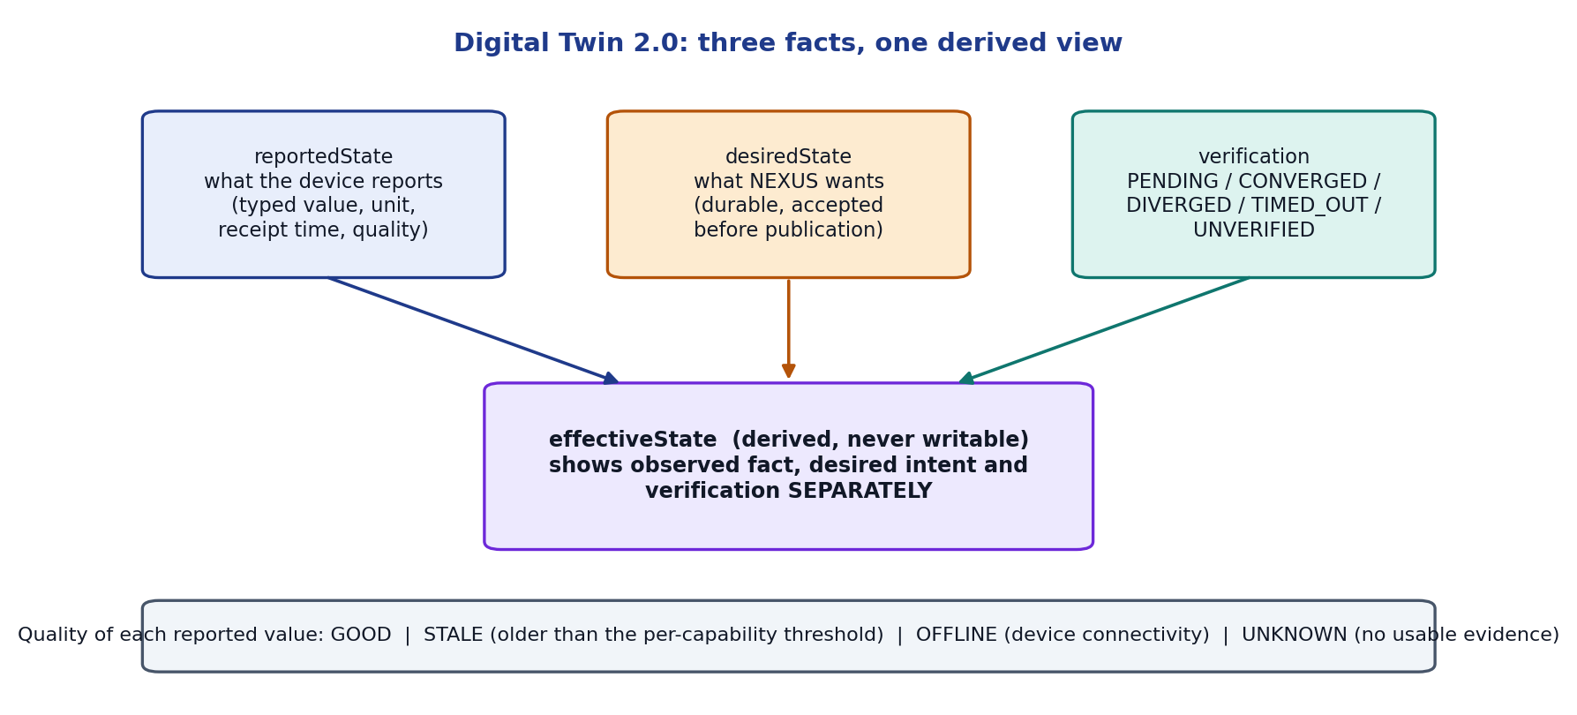
Figure 3.7 Digital Twin 2.0: reported, desired and verification facts with a derived effective view.
Every change is stored as a transition (previous and new value, source, correlation id, command id), which supports a cursor-based history API and a database-backed diff view. Quality is derived per capability from the receipt time and a freshness threshold (system default 120 seconds, overridable but only by narrowing): GOOD when the value is fresh and the device online, STALE when it is older than the threshold, OFFLINE when the device is offline and UNKNOWN when there is no usable evidence such as a missing receipt time or unobserved connectivity. A rejected input is tracked as ingestion health and does not overwrite current state.

3.4.5 COMMAND, ACKNOWLEDGEMENT AND READBACK VERIFICATION
A command passes through the stages shown in Figure 3.8. Acceptance writes the desired state durably before publication; publication then sends the command to the broker; the device acknowledges; and, where an explicit mapping exists from a WRITE binding to a READ binding, a later readback with GOOD quality that matches the desired value establishes convergence. The status of each stage is stored in its own field (Table 3.6); no stage is inferred from another.
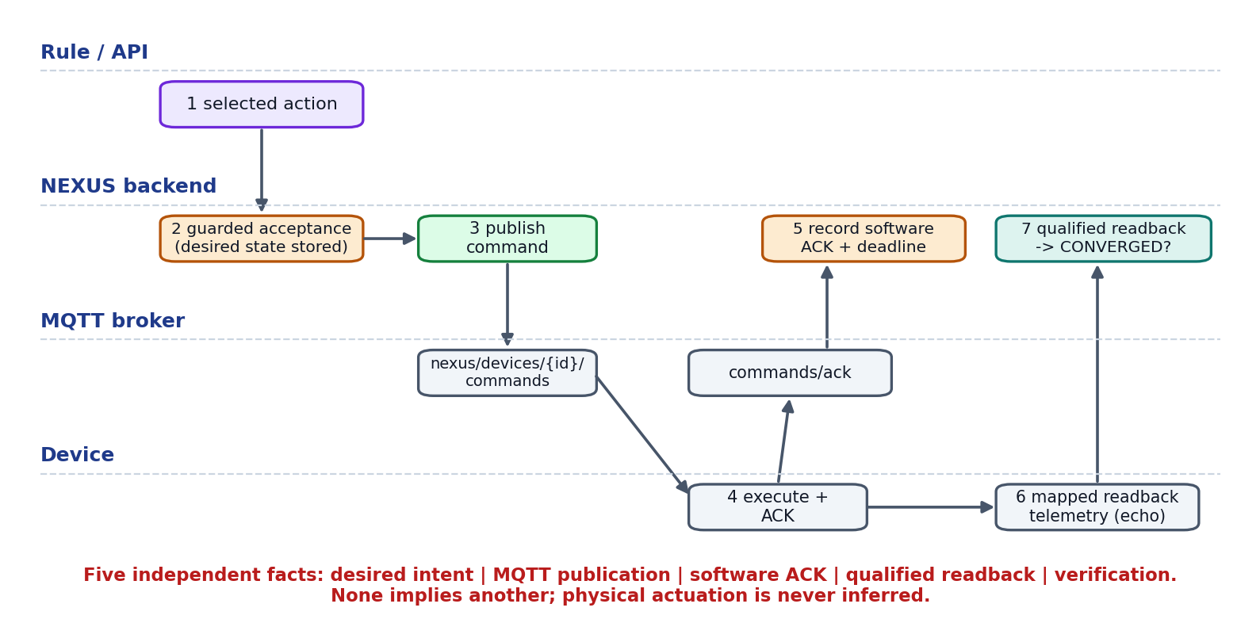
Figure 3.8 Command path and the five independent facts it produces.
Table 3.6 Facts recorded for a command and what each does and does not prove
Fact | Recorded by | What it proves | What it does not prove
Desired intent | Command acceptance | NEXUS accepted the request under guards | That anything was sent
Publication | Action history (SUCCESS) | The command was handed to the broker | That the device received it
Software ACK | ACK handler (receipt time and deadline) | The device software reported a status | That the actuator moved
Qualified readback | Readback mapping and verification state | A fresh GOOD observation matched the desired value (CONVERGED), or not (DIVERGED, TIMED_OUT) | Physical actuation by itself
Physical actuation | Not recorded by software | Nothing: remains UNKNOWN | Always requires independent evidence

Verification states are PENDING, CONVERGED, DIVERGED, TIMED_OUT and UNVERIFIED (for write-only capabilities with no mapping). Deadlines survive restarts. Desired state is never cleared automatically, and there is no retry or outbox in the current release, which is recorded as a limitation.

3.4.6 EVENT ENGINE
The Twin publishes immutable change events to a dispatcher. An event detector turns state transitions into domain events (for example twin created, twin updated, sensor value changed) which are persisted and delivered to subscribers such as the legacy rule adapter. Because subscribers implement a small listener interface, new consumers can be added without changing the Twin or telemetry code.

3.4.7 RULE ENGINE: VERSIONS, LIFECYCLE AND OWNERSHIP
A rule is a logical identity with immutable versions. Editing creates a new version with a higher revision; the previous content is never changed. The logical rule carries ownership data: the lifecycle state, references to the active and working versions, an optimistic row revision and an execution epoch. Pausing, resuming or activating a new version increments the epoch, so work scheduled under an earlier epoch is recognised as stale. Figure 3.9 shows the lifecycle. Execution is persistence-gated: only an ACTIVE version of the current owner with a passed reconciliation may run, and a legacy PUT of an enabled rule performs validation and activation atomically so that a failed activation leaves the previous version in force.
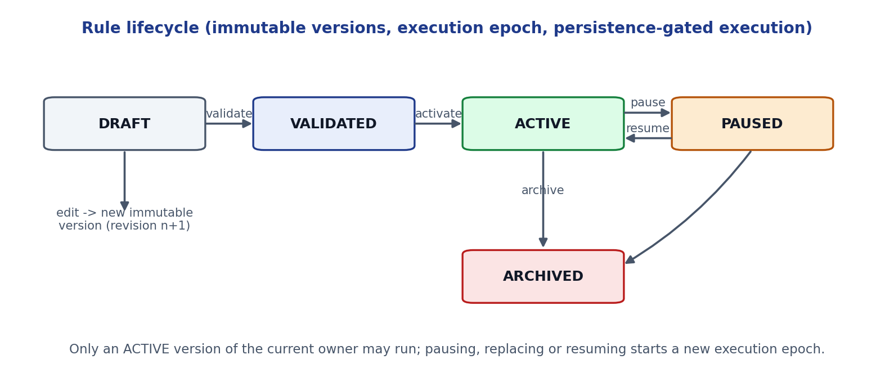
Figure 3.9 Rule lifecycle with immutable versions.

3.4.8 RULE ENGINE: TYPED TRIGGERS
Earlier versions evaluated every rule against every domain event. Phase 3 introduced thirteen explicit trigger families, and a version runs only for triggers it subscribes to (Table 3.7). A trigger is first recorded as a durable fact with a routing disposition; a recovery scanner re-routes facts whose processing failed, and expires those that are no longer eligible to act (for example a fact whose source has since been superseded).
Table 3.7 Trigger families
Family | Source
ACCEPTED_TELEMETRY, TWIN_STATE_CHANGED | A committed telemetry observation or Twin change (optional capability filter)
CONNECTIVITY_CHANGED | Device went ONLINE or OFFLINE
COMMAND_PUBLICATION_FAILED, COMMAND_ACK_REJECTED, COMMAND_ACK_TIMED_OUT | Outcome of a command on the action pipeline
VERIFICATION_CHANGED, VERIFICATION_TIMED_OUT | Readback verification result
MANUAL | A server-issued request addressed to the active version of one rule
SCHEDULE | A durable interval schedule (no cron or timezone support yet)
TEMPORAL_DUE | A temporal condition completed (duration elapsed, count reached, absence confirmed)
RULE_MATCHED | Another rule matched (explicit chains, depth at most 8, cycles rejected)
LEGACY_DOMAIN_EVENT | Compatibility adapter for rules created before Phase 3

3.4.9 RULE ENGINE: FROZEN EVALUATION CONTEXT AND EVALUATOR
For every trigger batch the engine acquires one snapshot inside a single REPEATABLE READ read-only transaction. The snapshot captures the eligible rule versions and owners, the Twin rows, connectivity with its generation, the installed capability contracts, quality inputs, temporal runtime rows and hysteresis latches. Evaluation then reads only the snapshot, never the live registry, so a decision cannot observe two different moments. The snapshot also decides whether the trigger source has already been superseded by a newer observation; if so nothing is evaluated for it.
The evaluator reads typed values. A capability condition is satisfied only when the value is present, its unit is compatible with the installed contract and its quality is GOOD. Unit safety is strict: equality of two missing units is accepted only for a capability whose contract is explicitly unitless, never as a way of ignoring an unestablished dimensional unit. Legacy payload conditions keep their original comparison semantics.

3.4.10 RULE ENGINE: TEMPORAL OPERATORS, REPEAT, COOLDOWN AND HYSTERESIS
Table 3.8 Temporal operators
Operator | Meaning | Bounds
FOR_DURATION | A predicate has been continuously true, with fresh coverage, for N seconds | Window at most 86,400 s
COUNT_WITHIN | At least N qualified samples (or false-to-true edges) inside a window | At most 200 members per state
ABSENCE_FOR | No qualified observation for N seconds | One timer per occurrence
OFFLINE_FOR | Device has been offline for N seconds | One timer per occurrence
TREND | Rising or falling by at least a minimum change over at least three distinct qualified samples, no interpolation | Bounded sample storage

Temporal state lives in the database (rule_temporal_state with evidence in rule_temporal_evidence) and deadlines in rule_timers, so it survives restarts and multiple instances. Late or out-of-order evidence is diagnosed and cannot rewind a window. Three policies prevent noisy or repeated firing. A repeat policy is either EVERY_TRIGGER_WHILE_TRUE or EDGE_TRUE, where only a definite false observation re-arms the edge. A cooldown, global or per device scope, is stored in rule_cooldown_state and serialised by a row lock inside the match transaction so that two backend instances cannot both match. Hysteresis uses an explicit enter threshold and a strictly separated exit threshold on numeric conditions; its latch is stored per rule, condition and device and is updated only by definite enter or exit transitions, never by unknown or non-GOOD evidence.

3.4.11 RULE ENGINE: CANDIDATES, ARBITRATION AND PLANS
Every match yields one candidate per action. A command candidate has a target key (device, capability and, for relays, the channel) and an equivalence key describing the exact command. Arbitration is a pure, deterministic function over the batch (Table 3.9): identical commands on one target are coalesced; different commands on one target are decided by numeric priority, and an equal-priority conflict suppresses every contender (fail closed). Mutual-exclusion groups assign explicit integer ranks to rules; within a group at most one rule may act and an equal best rank suppresses all. Each candidate is judged against the same initial survivor set and by a total order, so the result is independent of group identifiers and input order; winner pointers always refer to a final selected candidate or are absent with an explicit reason.
Table 3.9 Candidate dispositions
Disposition | Meaning | Dispatches?
SELECTED | Chosen by arbitration (independent target, priority winner or coalesced primary) | Yes
COALESCED | Identical to a selected command; recorded as a contributor | No (primary acts)
SUPPRESSED_PRIORITY | Lost to a higher-priority command on the same target | No
SUPPRESSED_CONFLICT | Equal-priority conflict on the same target | No
SUPPRESSED_EXCLUSION | Lost its mutual-exclusion group to a lower rank number | No
SUPPRESSED_EXCLUSION_CONFLICT | Equal best rank inside a group | No

The decisions are written as an action plan keyed by the trigger fact (or, for legacy matches, the persisted event), with one plan per batch enforced by a unique constraint. Only SELECTED candidates reach guarded acceptance, which checks that the request equals the persisted candidate, that the rule is still owned and active under the same epoch, and that the source is still current. The result is recorded on the candidate (ACCEPTED, EXECUTED, EXECUTION_FAILED, UNSUPPORTED, IGNORED or DENIED) and is derived from executor evidence: an ActionHistory row alone proves nothing, and a command is ACCEPTED only if its desired-state transition exists. A legacy match whose plan was never written is recovered by a bounded scanner (30 second grace, 120 second maximum age, five attempts) that rebuilds the batch from persisted evidence only. Unsupported policies, namely safety-override and approval configurations, are rejected at validation rather than silently ignored.
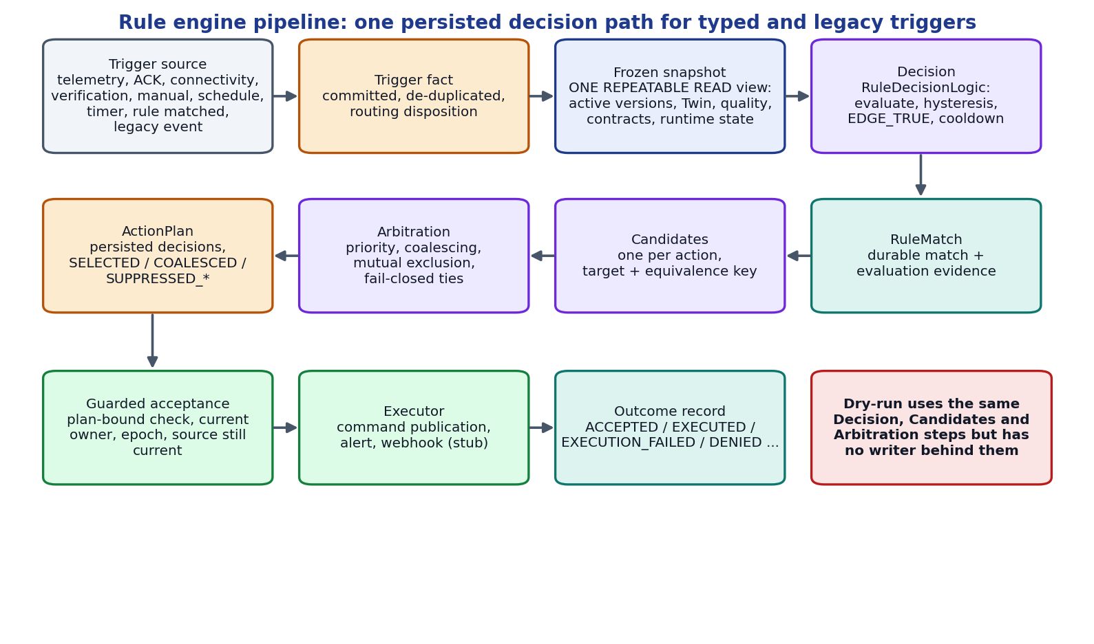
Figure 3.10 The persisted rule decision path shared by typed and legacy triggers.

3.4.12 BACKEND DRY-RUN
Testing a rule must not require letting it act. The dry-run endpoint POST /api/v1/rules/dry-run evaluates selected rule versions, stored or unsaved, and returns the evidence, the proposed candidates with their arbitration outcome and the hypothetical state changes production would make, without persisting anything. Two modes are supported. In SUPPLIED_STATE the caller provides typed Twin values, connectivity, an explicit simulation time and optional runtime seeds (cooldown, edge latch, hysteresis latch, temporal evidence); false, zero, an empty string, an explicit null and a missing value are all distinct. In CURRENT_STATE the backend uses its own consistent snapshot and clock and copies the production runtime state, and refuses browser-supplied state. HISTORICAL_REPLAY is rejected with a typed error because the evidence needed for a faithful replay does not exist.
The design (Figure 3.11) is a single implementation, two callers. The evaluator, RuleDecisionLogic, ActionCandidates and ActionArbiter are shared verbatim; the production path wraps them in writers while the dry-run path wraps them in a pure engine whose only collaborators are read-only. Dry-run results use sim- identifiers that are not UUIDs and therefore can never be replayed as production command ids. Every candidate carries an acceptanceAuthorization: NOT_EVALUATED field, because SELECTED is an arbitration outcome and not a prediction that guarded acceptance would succeed.
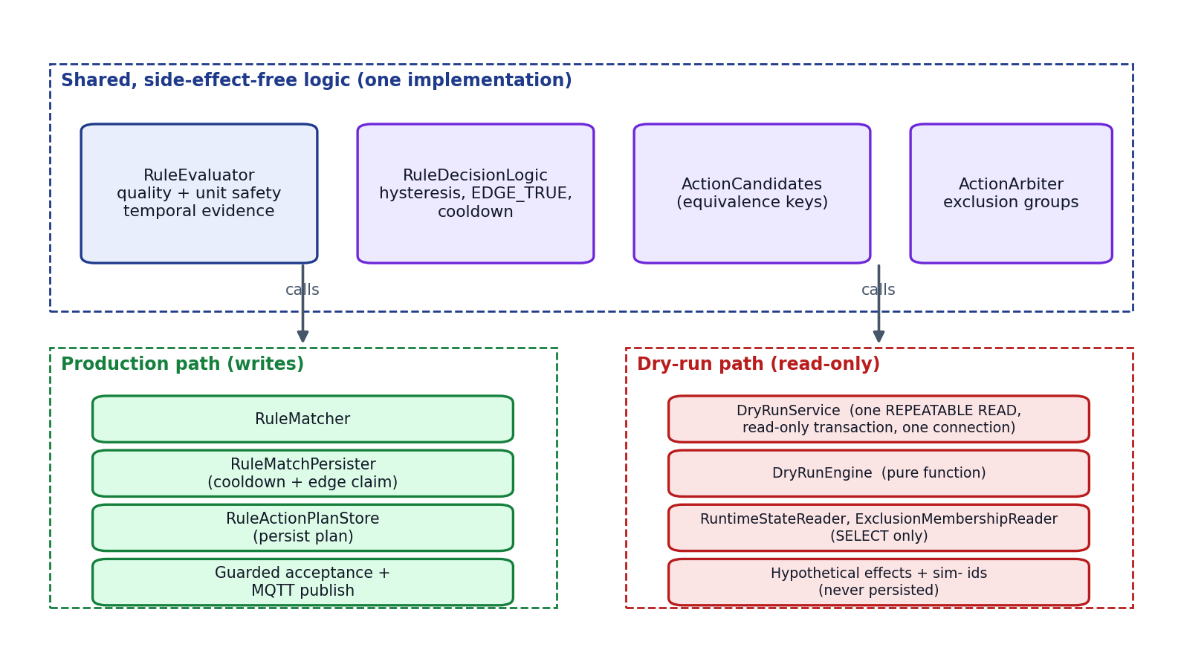
Figure 3.11 One decision engine shared by the production path and the dry-run path.
Safety against abuse is part of the design. The request is limited to one evaluation scope, at most 100 versions, at most 100 conditions per version and 1 MiB of input; the byte limit is enforced by a bounded read before any JSON binding (Table 3.10). The whole request runs as one REPEATABLE READ, read-only transaction on one pooled connection (Figure 3.12), so PostgreSQL itself refuses any write and the version lookup, snapshot, cooldown and exclusion reads agree with each other.
Table 3.10 Dry-run request checks, all applied before any evaluation
Check | Limit or rule | Response
Mode | SUPPLIED_STATE or CURRENT_STATE; HISTORICAL_REPLAY unsupported | 400 / 422 with typed code
Versions | At most 100 | 413 TOO_MANY_VERSIONS
Conditions per version | At most 100 | 413 TOO_MANY_CONDITIONS
Scope | Exactly one device scope | 400 MULTIPLE_SCOPES
Request size | At most 1 MiB (bounded read, no reliance on Content-Length) | 413 INPUT_TOO_LARGE
Unknown fields | Rejected at every level, including inline definitions | 400 INVALID_REQUEST
Supplied values | Typed: numbers must be JSON numbers, no coercion | 400 INVALID_SUPPLIED_VALUE
Browser authority | CURRENT_STATE rejects supplied state and simulation time | 400 CURRENT_STATE_REJECTS_SUPPLIED_INPUT

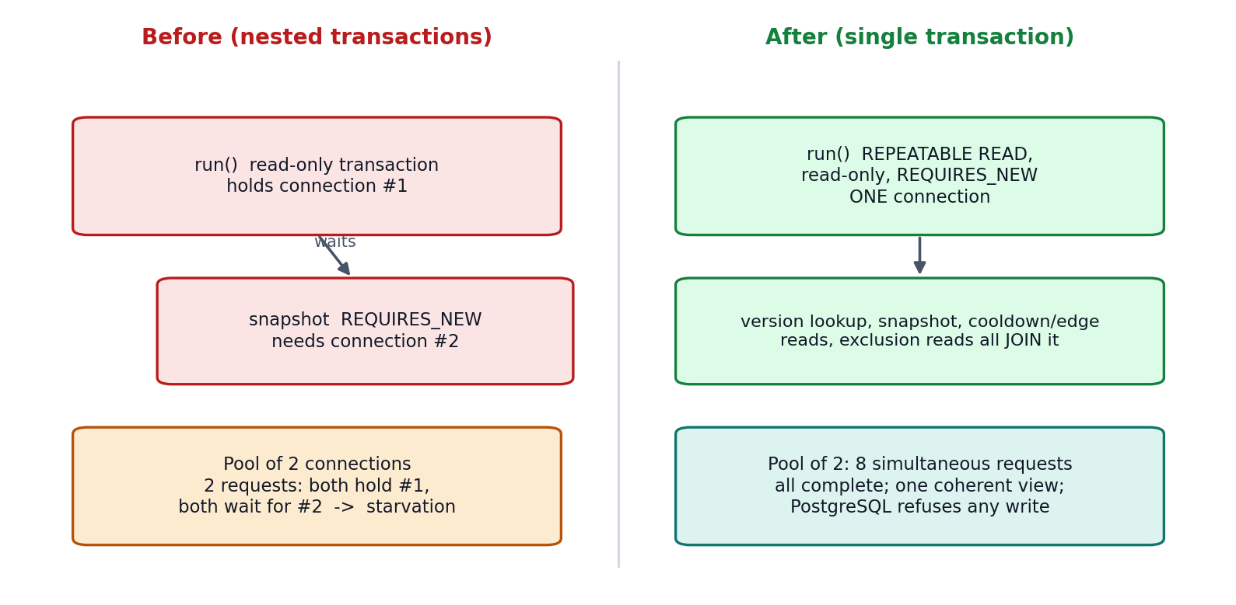
Figure 3.12 Transaction design of the dry-run before and after the connection-pool correction.

3.4.13 GROUNDED EXPLANATIONS
An explanation of a rule match is built from persisted rows only (Figure 3.13): the match, the rule revision and epoch, the evaluation evidence and its quality, the persisted candidates with their dispositions, winners and outcomes, the ActionHistory status, publication and acknowledgement, and the persisted verification state. The deterministic renderer produces claims of two main tiers: a FACT cites a path into the evidence and the exact value found there, and an UNKNOWN states what cannot be determined. When no arbitration record exists the explanation says so instead of inferring a selection from an ActionHistory row, and convergence is stated only from a persisted verification record. Physical actuation is always UNKNOWN. A platform-owned note describes only executors that actually ran: a command is a real publication path while the alert and webhook executors are stubs.
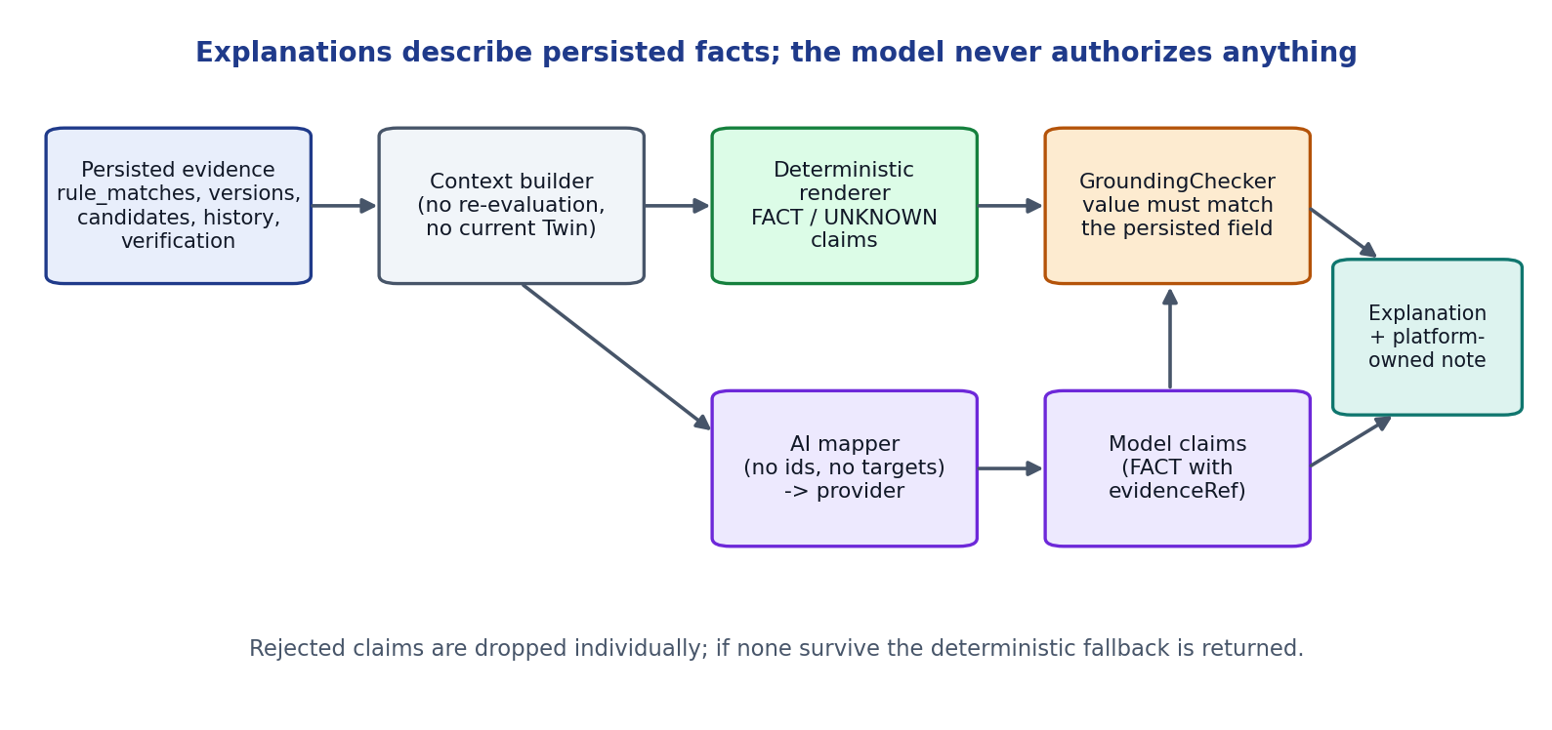
Figure 3.13 Evidence-grounded explanation pipeline with an optional AI reasoning branch.
When AI reasoning is enabled, a mapper removes identifiers and device targets before the context leaves NEXUS, and a deterministic grounding check compares every FACT claim with the value at the path it cites. Claims that do not match are rejected individually; if none survive, the deterministic explanation is returned. This check is structural: it proves the asserted value is present in the evidence, not that the surrounding sentence is a faithful paraphrase.

3.4.14 OPERATIONS CENTER (FRONTEND)
The frontend is a React single-page application with twenty-two routes (Table 3.11). Server state is cached with React Query and live updates arrive through a STOMP subscription that writes directly into the cache. The shipped default is the live backend; an opt-in demo mode driven by a scenario engine allows the interface to run without a backend. The rule studio is a graph editor built on React Flow that compiles to the flat definition the engine executes (all conditions, then all actions); branching graphs are refused rather than silently flattened. Its Save button calls the real create or update endpoint with the revision it loaded, and success is displayed only after the backend responds.
Table 3.11 Main frontend areas
Area | Routes | Purpose
Overview, Explorer | /, /explorer, site/building/space/device pages | Hierarchy navigation and device workspace
Digital Twins | /twins | Current state, quality, history, command and verification display
Telemetry, Events, Pipeline | /telemetry, /events, /pipeline | Time series, domain events, trace explorer
Rules and Actions | /rules, /actions, /framework/rules | Rule list, studio, exclusion groups, simulator, action history
Analytics and AI | /analytics, /ai | Aggregated metrics; evidence-grounded explanations
Framework administration | /framework/capabilities, /framework/templates, /framework/onboarding, /devices/:id/contract | Capability definitions, templates, onboarding sessions, generated MQTT contract
System | /settings, /system, /design, /about | Health, configuration and design system

3.4.15 SIMULATOR AND FIRMWARE
The Python simulator creates concurrent virtual ESP32 devices from a YAML description and publishes telemetry on the same topics as real hardware; it also handles commands, acknowledges them and, for mapped devices, emits correlated echo telemetry that lets the backend establish convergence. The default configuration defines three profiles (Table 3.12). The firmware directory contains a PlatformIO project for a real ESP32 with a DHT22 temperature sensor that publishes the identical contract with QoS 1, NTP-synchronised timestamps and reconnect handling, and a bench sketch for an HC-SR501 PIR sensor. The repository does not contain evidence of a physical closed-loop actuation test, so none is claimed.
Table 3.12 Simulator device profiles
Device | READ capabilities | WRITE capabilities
ESP32-SIM-001 | temperature (CELSIUS), humidity (PERCENT), pressure (HPA), motion (BOOLEAN) | LED
ESP32-SIM-002 | gas (PPM) | relay with channels 1 to 4, fan, buzzer
ESP32-SIM-003 | button (BOOLEAN) | servo (DEGREES)

3.5 DATABASE DESIGN
The schema is created only by forward-only Flyway migrations (V1 to V36) and contains 40 tables (Figure 3.14). Telemetry history is a TimescaleDB hypertable with retention; events and pipeline traces are bounded by retention jobs. Historical migrations are never edited, and every migration is tested on a populated database as well as an empty one. Constraints carry the correctness rules: a unique plan per trigger fact or event, a unique candidate request id, check constraints on states and dispositions, foreign keys that restrict deletion of evidence, and a pair constraint that forbids a cooldown time without its attributed match.
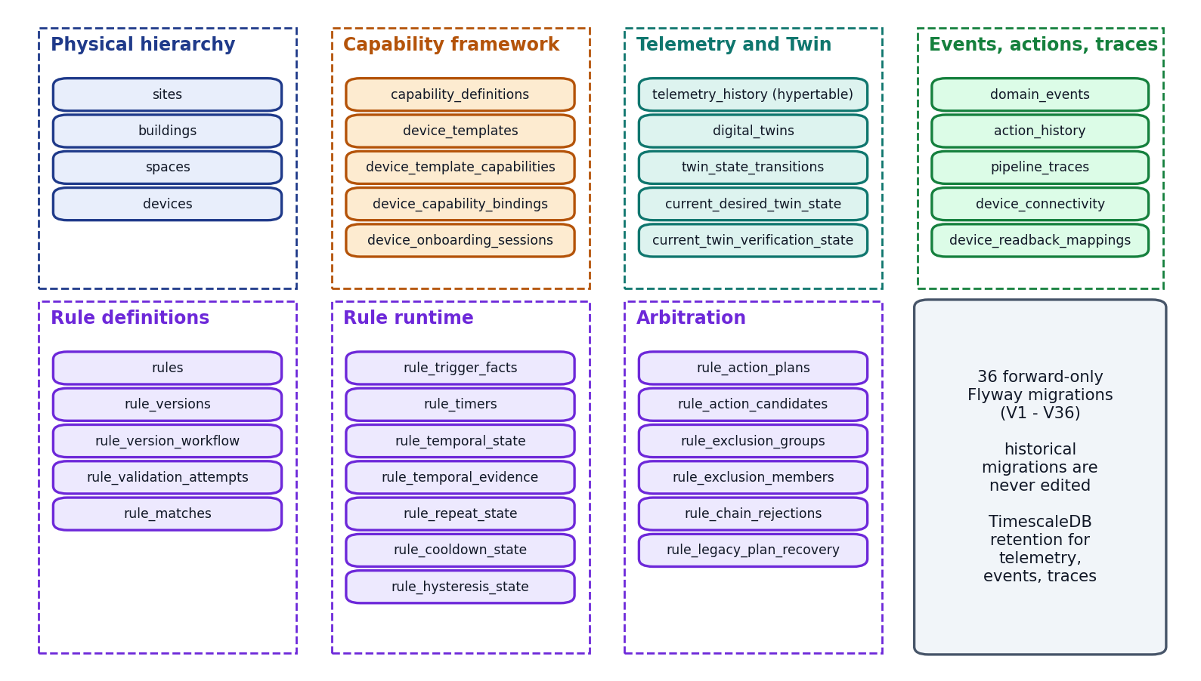
Figure 3.14 Database tables grouped by responsibility.

3.6 API DESIGN
The backend exposes 96 mapped endpoints in 26 controllers under /api/v1, all additive and backward compatible. Appendix 2 lists them by controller. Errors use a consistent structure with status, error, a stable machine code where the contract defines one, a message and a timestamp. Mutating endpoints that guard against concurrent edits take an expected revision and return a conflict when it is stale.

3.7 CORRECTNESS AND SAFETY PRINCIPLES
Table 3.13 Invariants enforced by the design
Invariant | Mechanism
A decision is persisted before any side effect | Plan and candidates are written in one transaction before guarded acceptance
One decision per trigger | Unique plan per fact or event; re-delivery reuses the plan
Stale or unsafe evidence cannot act | GOOD-quality and unit checks in the evaluator; source-currentness verdict in the snapshot
Configuration cannot race execution | Immutable versions, execution epoch, plan-bound authorisation
Conflicts fail closed | Equal-priority and equal-rank ties suppress all contenders
Command facts stay separate | Separate fields for desired, publication, ACK, readback, verification
Dry-run cannot write | Read-only REPEATABLE READ transaction; read-only collaborators; fingerprint tests
AI cannot authorise | Explanation component has no path to activation, arbitration or dispatch; grounding check on claims

3.8 TEST AND VALIDATION DESIGN
Verification is layered (Table 3.14). Unit tests cover pure logic such as arbitration and truthfulness. Integration tests run the full Spring application against a disposable PostgreSQL (TimescaleDB image) and a real Mosquitto broker started by Testcontainers, so migrations, constraints, locks and the MQTT path are exercised for real. Concurrency tests use several transactions with in-process caches and locks disabled to imitate separate instances. Mutation checks temporarily break a guard and confirm that a test fails. The official gate combines repository tooling tests, backend and frontend suites, the simulator tests and three isolated smoke tests.
Table 3.14 Evidence layers
Layer | Examples | Infrastructure
Unit | Arbiter permutations, explanation truthfulness, workflow compiler | None
Integration | Rule lifecycle, temporal operators, dry-run API and equivalence, HTTP limit | Disposable PostgreSQL, Mosquitto
Migration | V24 to V36 on a populated database; checksums of V1 to V25 | Disposable PostgreSQL
Concurrency | Two workers, one plan; two instances, one match; pool of two connections | Disposable PostgreSQL
Mutation | Remove a guard and expect a failure | Temporary source change
End-to-end smoke | Simulated loop; MQTT command and ACK; database restart | Isolated stack
Frontend | Typed forms, canvas save, simulator display | Vitest and jsdom

3.9 FEASIBILITY, RISKS AND ETHICS
The scope was feasible because it relies on open-source components, a laptop-scale environment and a simulation-first strategy that needs no special hardware. Table 3.15 lists the main risks and how they were managed.
Table 3.15 Principal risks and mitigations
Risk | Mitigation
Complexity growth in the rule engine | Contract-first slices, dependency-ordered ticket, acceptance ledger
Claims that exceed the evidence | COVERED only with exact test names; limitations recorded; independent forensic reviews
Tests damaging the development database | Disposable containers; scripts refuse to run against the live application
Machine resource limits (16 GB) | Memory-bounded test runs, sequential execution, bounded JVM settings
Security gaps | Documented: no authentication, anonymous broker for trusted local use; deferred to Phase 7
Misleading AI output | Advisory-only explanations, grounding check, deterministic fallback

Ethical considerations were handled as follows. No personal data is processed. Secrets are kept out of the repository (the firmware credential file is git-ignored). Physical-effect statements are never inferred from software facts, because overstating safety evidence in a system that can switch equipment would itself be an ethical failure. The use of AI coding assistants during development is disclosed in Appendix 6, in line with the course guidelines on acknowledging significant AI use.

Chapter 4
Implementation and Results

4.1 IMPLEMENTATION ENVIRONMENT AND CODE SIZE
Table 4.1 Implementation environment
Item | Version / detail
Operating system for development | Windows 11, 16 GB memory laptop
Backend runtime | Java 21, Spring Boot 3.3.4, Maven wrapper, Flyway
Database | PostgreSQL 16 with TimescaleDB 2.16.1 (container image timescale/timescaledb:2.16.1-pg16)
Broker | Eclipse Mosquitto 2.0 (container)
Frontend | Node.js 22 or later, React 19, TypeScript, Vite, React Query, Vitest
Simulator | Python 3.11 or later, paho-mqtt, pytest
Firmware toolchain | PlatformIO, ESP32 Arduino framework
Test infrastructure | JUnit 5, Mockito, Testcontainers, Docker Desktop

Table 4.2 Repository size at the final checkpoint
Component | Files | Approximate lines
Backend production code (Java) | 368 | 21,300
Backend test code (Java) | 155 | 29,500
Frontend source (TypeScript/TSX) | 189 | 17,800
Frontend tests | 63 files | 533 tests
Simulator (Python) | 30 | 2,400
Flyway migrations | 36 | V1 to V36
Firmware (C++) | 2 sketches/projects | 363 + 51

Test code is larger than production code in the backend, which reflects the evidence-first approach. Within the backend, the rule package is the largest (140 production files), followed by device (80) and twin (37).

4.2 DEVELOPMENT CHRONOLOGY
The repository history contains 109 commits between 27 July and 14 October 2026 (Figure 4.1). Table 4.3 summarises the milestones.
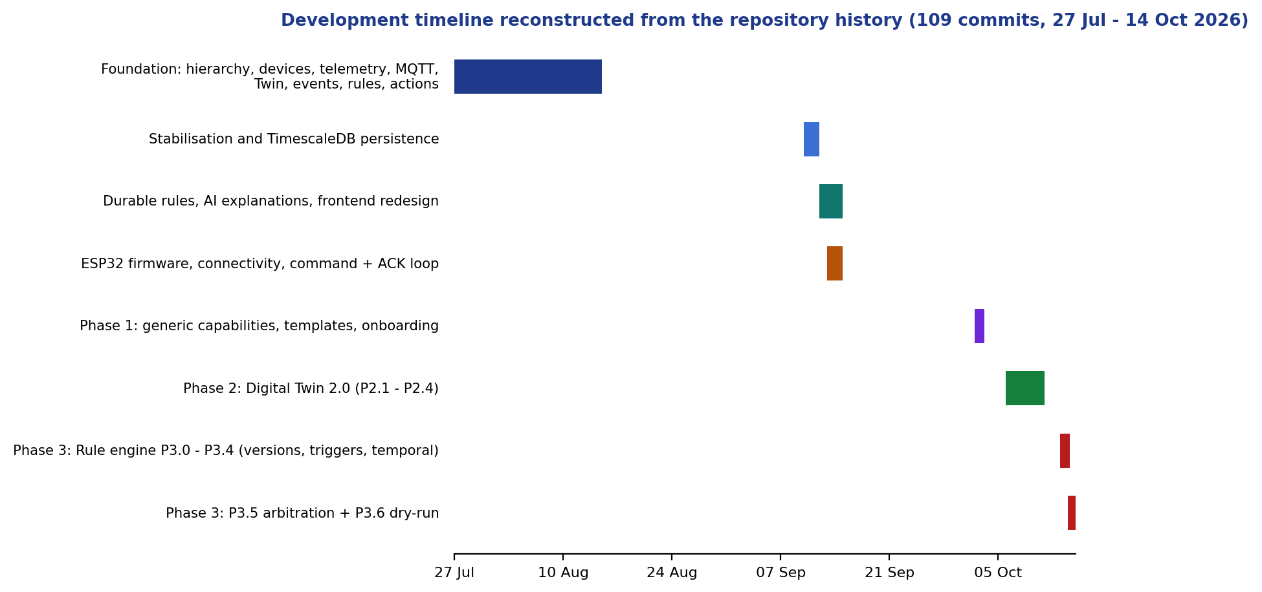
Figure 4.1 Development timeline derived from the commit history.
Table 4.3 Milestones
Period (2026) | Milestone
27 to 31 July | Foundation: hierarchy, devices, MQTT ingestion, telemetry, Twin v1, simulator
15 August | Phase 0 baseline and cleanup
10 to 13 September | Persistence, durable rules, AI explanations, firmware, command/ACK path
14 to 15 September | UI redesign; Review III simulated deployment (15 September)
2 to 3 October | Phase 1: generic capability framework, templates, onboarding
6 to 11 October | Phase 2: Digital Twin 2.0, quality, transitions, verification
13 to 14 October | Phase 3: lifecycle, typed triggers, temporal reasoning, arbitration, dry-run, grounded explanations

4.3 KEY IMPLEMENTATION DETAILS

4.3.1 ONE SNAPSHOT, ONE TRANSACTION
The most important implementation decision in the dry-run is that the whole request executes in one transaction. Listing 4.1 shows the annotation and its rationale as it appears in the source.
Listing 4.1 Transaction boundary of the dry-run service (excerpt).
/** ONE transaction for the whole request: REPEATABLE READ and read-only
* (so PostgreSQL itself refuses any write), on exactly ONE pooled connection.
* REQUIRES_NEW so an ambient read-write transaction is never joined. */
@Transactional(isolation = Isolation.REPEATABLE_READ,
readOnly = true,
propagation = Propagation.REQUIRES_NEW)
public DryRunResponse run(DryRunRequest request) {
// everything is validated BEFORE any rule is evaluated
if ("HISTORICAL_REPLAY".equals(mode))
throw new DryRunRejection("HISTORICAL_REPLAY_UNSUPPORTED", ...,
HttpStatus.UNPROCESSABLE_ENTITY);
...
}

4.3.2 BOUNDED REQUEST READING
A forensic review found that the request-size limit could be bypassed by a request path carrying a path parameter, because the limit was applied by a filter that matched the exact path. The corrected design reads the body inside the handler with a hard byte bound and refuses the first excess byte (Listing 4.2). An HTTP-level test matrix now exercises the path variants.
Listing 4.2 Bounded read in the dry-run controller.
static byte[] readBounded(InputStream in, int limit) throws IOException {
var out = new ByteArrayOutputStream(Math.min(limit, 16 * 1024));
byte[] buffer = new byte[8192];
int total = 0, read;
while ((read = in.read(buffer)) != -1) {
total += read;
if (total > limit)
throw new DryRunRejection("INPUT_TOO_LARGE", "Dry-run input is limited to "
+ limit + " bytes; nothing was evaluated.", HttpStatus.PAYLOAD_TOO_LARGE);
out.write(buffer, 0, read);
}
return out.toByteArray();
}

4.3.3 TRUTHFUL EXECUTION OUTCOMES
The explanation component never states that an action happened unless a persisted fact says so. For example, a command is described as ACCEPTED only if a desired-state transition exists for it, and an ActionHistory row without a candidate plan is reported as a fact about that row, not as proof that the arbiter selected it. The platform-owned note about executors is built only from the executors that ran for the match: a publication path for commands and a clearly labelled stub for alert and webhook executors.

4.4 OPERATIONS CENTER SCREENS
Figures 4.2 to 4.4 show three screens of the Operations Center. The screenshots were captured from the production build running in its opt-in offline demo mode, because the validation policy forbids starting the normal application against the development database. They therefore show empty or demonstration states and are included to illustrate layout and navigation, not live data.
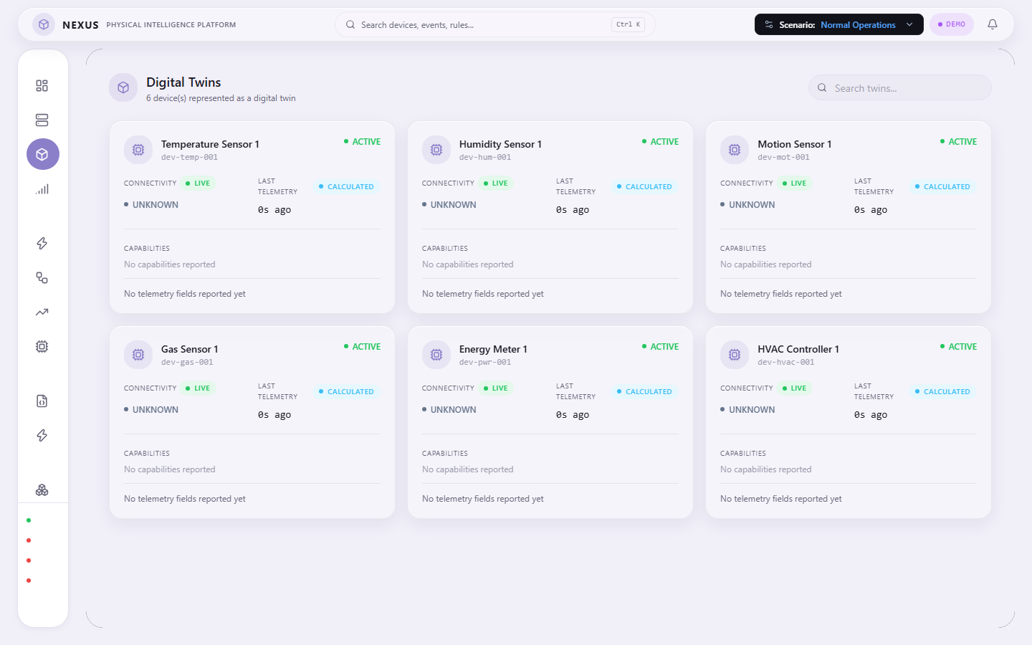
Figure 4.2 Digital Twins page (offline demo mode).
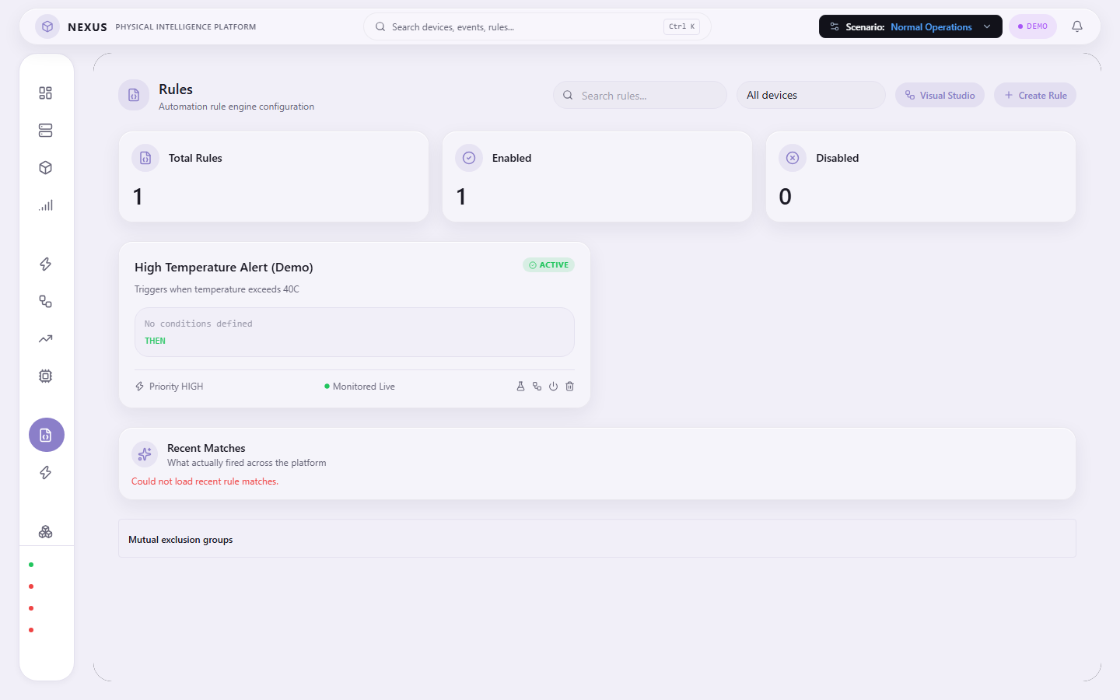
Figure 4.3 Rules page with the lifecycle and simulator entry points (offline demo mode).
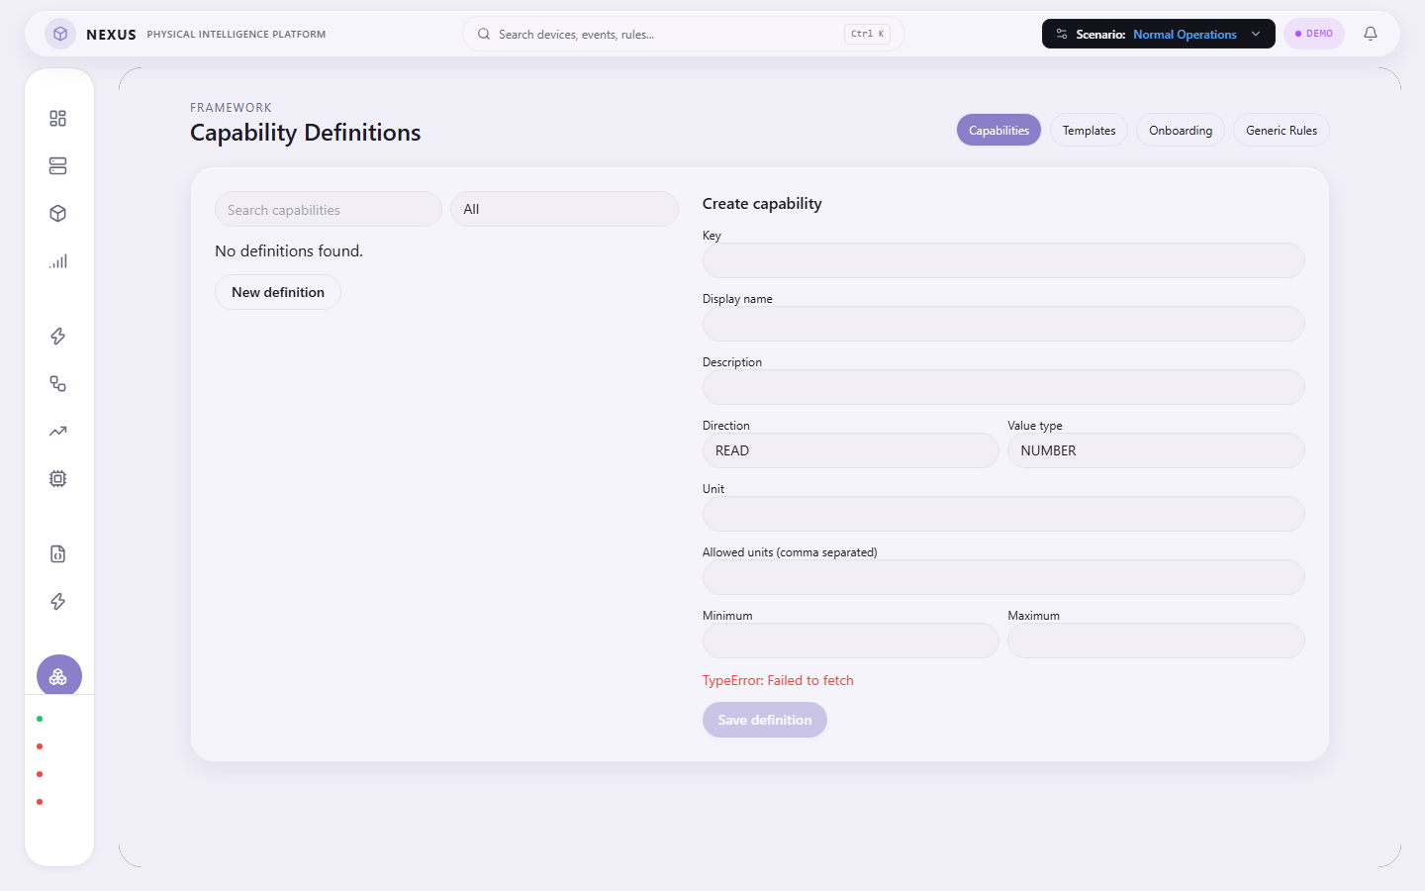
Figure 4.4 Capability framework administration page (offline demo mode).

4.5 TESTING AND VALIDATION

4.5.1 TEST INVENTORY
The final backend suite contains 152 test classes with 1,208 tests; the frontend contains 63 files with 533 tests. Test classes are concentrated where the risk is: the rule package has 80 test classes, device 19, twin 17 and action 9, with the remainder spread across infrastructure, integration, telemetry, event and other packages. Figure 4.5 and Table 4.4 show how the backend suite grew across successive checkpoints.
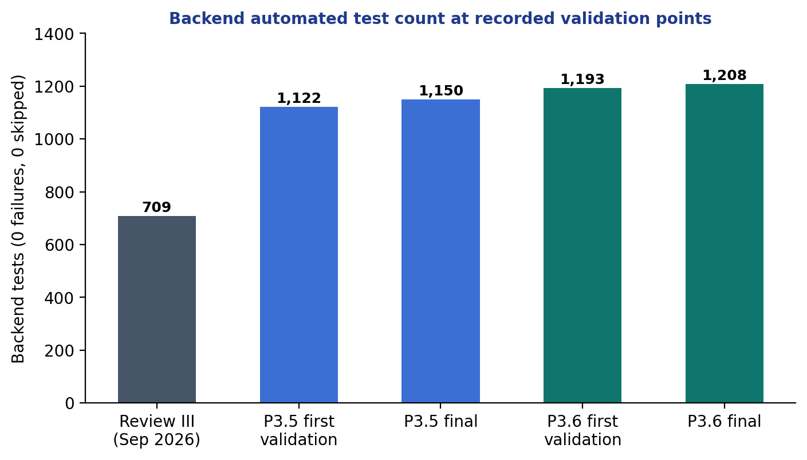
Figure 4.5 Backend automated test count at the recorded validation points.
Table 4.4 Backend test count at checkpoints
Checkpoint | Backend tests | Failures / errors / skipped
Review III (15 Sep 2026) | 709 | 0 / 0 / 0
End of Phase 2 | 1,122 | 0 / 0 / 0
After P3.3 temporal reasoning | 1,150 | 0 / 0 / 0
After P3.5 arbitration | 1,193 | 0 / 0 / 0
After P3.6 and forensic corrections (final) | 1,208 | 0 / 0 / 0

4.5.2 OFFICIAL VALIDATION GATE
The command python validate_nexus.py --full ran eleven checks in an isolated environment and passed 11 of 11 (Figure 4.6, Table 4.5). The fast gate passes 8 of 8. The backend step dominates the duration because it runs the entire integration suite against real containers.
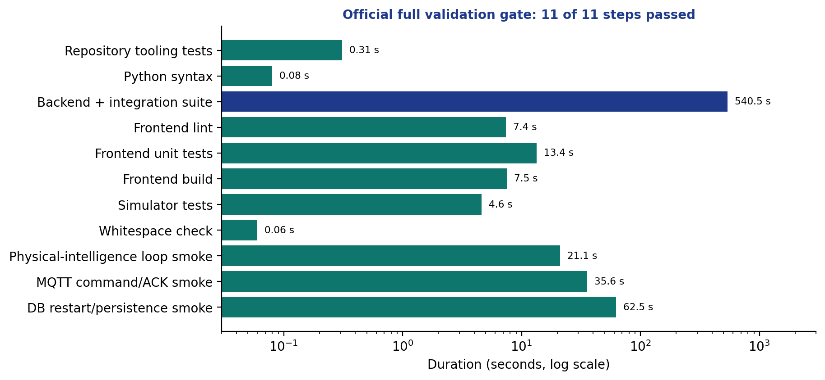
Figure 4.6 Duration of each full-gate check.
Table 4.5 Full validation gate
Check | Duration (s) | Result
Repository tooling tests | 0.31 | PASS
Python syntax | 0.08 | PASS
Backend unit and integration tests | 540.5 | PASS
Frontend lint | 7.4 | PASS
Frontend unit tests | 13.4 | PASS
Frontend production build | 7.5 | PASS
Simulator tests | 4.6 | PASS
Whitespace check | 0.06 | PASS
Simulated loop smoke test | 21.1 | PASS
MQTT command/ACK smoke test | 35.6 | PASS
Database restart smoke test | 62.5 | PASS

Frontend lint reports zero errors and twelve pre-existing warnings; TypeScript compilation and the production build are clean.

4.5.3 PHASE 3 ACCEPTANCE LEDGER
The Phase 3 ledger enumerates 72 scenarios; all 72 have status COVERED, none remain PLANNED (Appendix 1). COVERED means that exact automated tests exist and passed; it does not mean the feature is production ready. Open items recorded in the ledger are listed in Section 4.8.

4.6 RESULTS

4.6.1 REVIEW III: SIMULATED THREE-BOARD DEPLOYMENT
On 15 September 2026 a simulated deployment of three virtual ESP32 boards ran for about 230 seconds against the then-current backend (709 tests). Table 4.6 lists the eleven scenarios and Table 4.7 the volume of data produced.
Table 4.6 Review III scenarios (expected versus observed)
Scenario | Expected behaviour | Result
Normal | Telemetry and Twin update, no rule match | PASS
High temperature | TEMPERATURE above 35 triggers FAN ON through the rule engine | PASS
Motion detected | MOTION true triggers LED ON (44 matches) | PASS
Gas alert | GAS above 400 triggers BUZZER ON | PASS
Gas + motion | GAS above 500 and MOTION true triggers buzzer and fan; above 700 also relay channel 1 (GAS 700.9, MOTION true observed) | PASS
Relay control | Three manual relay commands accepted through the real command path | PASS
Servo control | Three manual servo commands (0, 90, 180 degrees) accepted | PASS
Button press | BUTTON true triggers LED ON | PASS
Recovery | TEMPERATURE below 26 triggers FAN OFF | PASS
Multi-device isolation | Motion on a different device does not fire a device-scoped rule (43 to 43); on the right device it does (43 to 44) | PASS
Persistence and restart | Counts identical before and after a backend restart (devices 12, rules 9, matches 826, actions 893, traces 30,531) | PASS

Table 4.7 Data produced during the Review III run
Measure | Value
Telemetry records | +276
Domain events | +353
Rule matches | +132
Actions | +142
Pipeline traces | +694
Commands accepted | 140

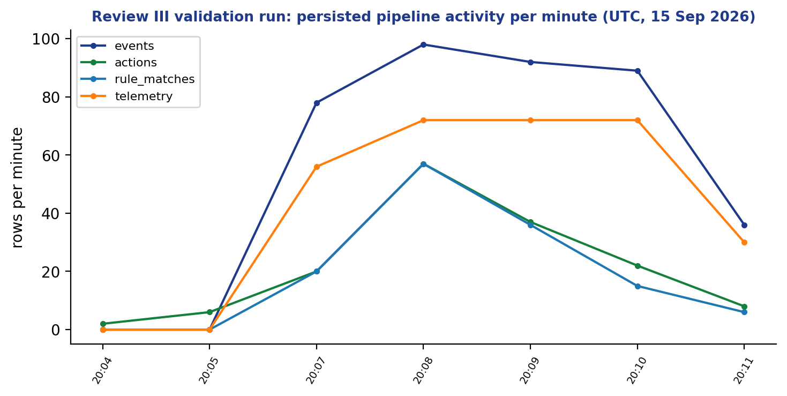
Figure 4.7 System activity per minute during the Review III run.
Command dispatch processing time inside the backend (n = 140) had a median of 5 ms, a 95th percentile of 49 ms and a maximum of 51 ms (mean 19.1 ms), shown in Figure 4.8. This measures backend processing only; it is not a device round-trip time and says nothing about physical actuation latency.
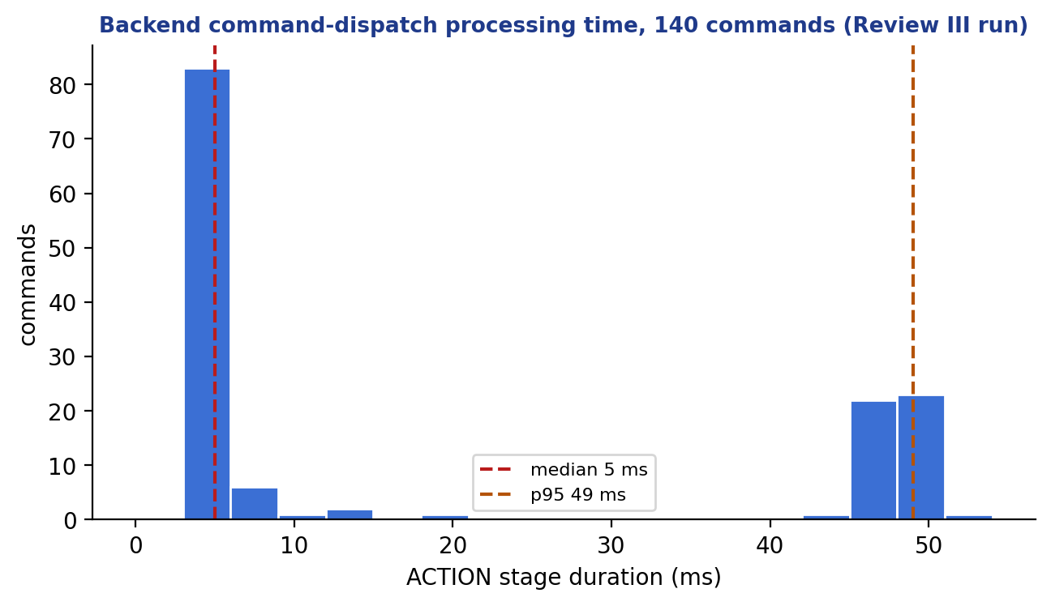
Figure 4.8 Distribution of command dispatch processing time (n = 140).

4.6.2 EQUIVALENCE, ZERO-EFFECT AND ROBUSTNESS EXPERIMENTS FOR THE DRY-RUN
Table 4.8 Experiments on the dry-run engine
Experiment | Method | Outcome
Production equivalence | Same inputs through production persistence and through the dry-run; compare matches, candidates, dispositions and winners | Identical for typed, temporal, edge, cooldown, hysteresis and exclusion cases
Zero effect | Fingerprint every relevant table before and after dry-run requests, including rejected ones | No row changed
HTTP limit matrix | Oversized bodies on exact, parameterised and trailing-slash paths | All refused with 413 before evaluation
Connection pool | Pool of two connections, concurrent requests | Initially starved; single-transaction design removed the starvation
Mutation checks | Temporarily remove a guard and run the guarding tests | Tests failed as intended; guards restored

4.6.3 FINDINGS FROM FORENSIC REVIEW
Independent review of the final slice reproduced and then corrected the defects summarised in Table 4.9. Each was first demonstrated by a failing test or experiment and then fixed.
Table 4.9 Defects found and corrected during final review
ID | Defect | Correction
B1 | Request-size limit bypassed by a path parameter | Handler-side bounded read and HTTP matrix test
B2 | Connection-pool starvation from nested transactions | Single read-only REPEATABLE READ transaction
B3 | Documentation claimed TREND was unsupported | Documentation corrected; TREND covered by scenario 49
B4 | Temporal dry-run behaviour not proven equivalent | Equivalence tests added
B5 | Edge re-arming not proven equivalent | EDGE_REARMED equivalence test
B6 | Explanation note described executors that had not run | Note limited to executors that ran; verification claims persisted
B7 | Inline definition accepted unknown fields | Strict inline definition
B8 | Missing device configuration gave no diagnostic | DEVICE_NOT_CONFIGURED diagnostic
B9 | Ownership and acceptance status unclear in output | Ownership fields and acceptanceAuthorization NOT_EVALUATED

4.7 COMPARISON AND ANALYSIS
Table 4.10 compares NEXUS with the approaches reviewed in Chapter 2 along the dimensions that motivated the project. The comparison is qualitative and is based on the documentation cited in Chapter 2; the other systems are mature, widely deployed products with capabilities (scale, security, device management) that NEXUS does not attempt to match.
Table 4.10 Qualitative comparison
Dimension | Typical flow-based or home-automation engine | Cloud device shadow / twin service | NEXUS
Decision evidence persisted | Usually logs only | State documents | Match, plan, candidates, outcome
Stale-data safety | Usually application-defined | Timestamps provided | GOOD quality required to act
Conflict handling | Last write or order dependent | Not applicable | Deterministic arbitration, fail closed
Command facts | Often one success flag | Desired and reported | Five independent facts
Test before activation | Manual trial | Not applicable | Backend dry-run on the real engine
Operational maturity | High | High | Prototype

The analysis shows that the contribution is a coherent combination of known techniques (immutable versions, snapshot isolation, arbitration, readback verification) in a single traceable pipeline, together with a methodology that keeps claims within evidence. It is not a performance or scale contribution.

4.8 LIMITATIONS AND THREATS TO VALIDITY
• No physical actuation evidence. All command evidence is software-level (publication, acknowledgement, simulated readback). Physical closed-loop validation with real actuators has not been performed.
• Simulated workload. Review III used virtual boards for most scenarios; the single physical firmware covers temperature only.
• No authentication or authorisation on the REST API, and the broker is anonymous; rate limiting is absent. The system must be run only on a trusted network.
• No outbox, retry or dead-letter for commands; a dispatch failure is recorded, not retried.
• Rule engine open items: historical replay, manual approval, branching rule graphs, cron and time-zone schedules, cross-batch global arbitration, hypothetical devices and dry-run simulation of temporal arming from telemetry. Two behaviours are recorded as limits: a late match is not retroactively arbitrated, and a decided command is not re-dispatched if its executor failed.
• Scale. Correctness under concurrency was tested with a few workers and two simulated instances; no large-scale load or soak test was run, and unlimited scalability is not claimed.
• Internal validity. Tests were written by the same team (and AI assistants) that wrote the code. Independent forensic reviews and mutation checks reduce, but do not remove, shared blind spots.
• Latency measure. The dispatch latency is backend processing time only.
• Screenshots in this report come from offline demo mode.

Chapter 5
Conclusion and Future Work

5.1 SUMMARY OF THE WORK
This project designed and implemented NEXUS, a generic physical-intelligence framework that connects devices, a Digital Twin, a rule engine and a command pipeline in one traceable system. The work moved from a three-board prototype to a configuration-driven framework with capability definitions, templates and onboarding (Phase 1), a Digital Twin with quality, history and readback verification (Phase 2) and a persistence-gated rule engine with typed triggers, temporal reasoning, deterministic arbitration, a backend dry-run and evidence-grounded explanations (Phase 3). The final repository contains about 21,300 lines of backend production code, 17,800 lines of frontend code, 36 forward-only migrations, 1,208 backend tests and 533 frontend tests, and passes the official eleven-check validation gate.

5.2 WHAT WAS ACHIEVED AND WHAT WAS NOT
The project achieved its software objectives O1 to O8 at the level of automated, simulated evidence: devices can be defined and provisioned without code changes, state and decisions are persisted, conflicting actions are resolved deterministically, rules can be tested without side effects, and explanations are restricted to persisted facts. These statements are bounded by the evidence described in Chapter 4.
Several things were not achieved or not shown. No physical closed-loop actuation test was performed, so no claim is made that an actuator moved in response to a rule. The system has no authentication, authorisation, rate limiting or transport security and is unsuitable for exposure to an untrusted network. Commands have no outbox or retry. Large-scale load, long-duration soak tests and independent third-party review were not carried out. Historical replay, manual approval, branching graphs, calendar schedules and cross-batch global arbitration remain open. No paper has been published and no patent has been filed.

5.3 LESSONS LEARNED
• Persisting a decision before acting turns debugging from guesswork into reading rows.
• Separating facts (accepted, published, acknowledged, converged, actuated) prevents optimistic status reporting.
• Concurrency defects appear only when tests use several real transactions against a real database; mocks hid them.
• Independent adversarial review found defects that the author's own tests had not (Table 4.9).
• Stating limits explicitly is cheaper than defending an overclaim later.

5.4 FUTURE WORK
Table 5.1 Planned work
Area | Description
Reliable dispatch (Phase 4) | Transactional outbox, idempotency keys, retries with backoff, dead-letter handling
Adapters (Phase 5) | Adapter SDK and additional protocols such as Modbus, so non-MQTT equipment can be bound
Safe AI assistance (Phase 6) | Natural-language rule drafting that always produces a reviewable, dry-run-tested draft; never activates
Security and operations (Phase 7) | Authentication, role-based access, MQTT ACLs and TLS, rate limiting, audit log, metrics and alerting
Frontend completion (Phase 8) | Remaining workflows, accessibility, end-to-end browser tests
Release engineering (Phase 9) | Packaging, upgrade and rollback procedures, documentation
Hardware validation | Closed-loop tests with real actuators and independent measurement of physical effect
Rule engine extensions | Historical replay, manual approval, branching graphs, cron and time-zone schedules, dry-run of temporal arming from telemetry, cross-batch arbitration
Scale evaluation | Load and soak tests with many simulated devices and multiple backend instances

These items are ordered by dependency in the project roadmap; none is a promise of completion within the course timeline.

References
Al-Fuqaha, A., Guizani, M., Mohammadi, M., Aledhari, M., & Ayyash, M. (2015). Internet of Things: A survey on enabling technologies, protocols, and applications. IEEE Communications Surveys & Tutorials, 17(4), 2347–2376.
Amazon Web Services. (n.d.). AWS IoT Core developer guide: Device Shadow service. https://docs.aws.amazon.com/iot/
Amodei, D., Olah, C., Steinhardt, J., Christiano, P., Schulman, J., & Mané, D. (2016). Concrete problems in AI safety (arXiv:1606.06565). arXiv.
Banks, A., & Gupta, R. (Eds.). (2014). MQTT Version 3.1.1 (OASIS Standard). OASIS.
Berenson, H., Bernstein, P., Gray, J., Melton, J., O'Neil, E., & O'Neil, P. (1995). A critique of ANSI SQL isolation levels. ACM SIGMOD Record, 24(2), 1–10.
Eclipse Foundation. (n.d.). Eclipse Ditto documentation. https://eclipse.dev/ditto/
Evans, E. (2003). Domain-driven design: Tackling complexity in the heart of software. Addison-Wesley.
Forgy, C. L. (1982). Rete: A fast algorithm for the many pattern/many object pattern match problem. Artificial Intelligence, 19(1), 17–37.
Fowler, M. (n.d.). MonolithFirst. https://martinfowler.com/bliki/MonolithFirst.html
Gamma, E., Helm, R., Johnson, R., & Vlissides, J. (1994). Design patterns: Elements of reusable object-oriented software. Addison-Wesley.
Grieves, M., & Vickers, J. (2017). Digital twin: Mitigating unpredictable, undesirable emergent behavior in complex systems. In F.-J. Kahlen, S. Flumerfelt, & A. Alves (Eds.), Transdisciplinary perspectives on complex systems (pp. 85–113). Springer.
Gubbi, J., Buyya, R., Marusic, S., & Palaniswami, M. (2013). Internet of Things (IoT): A vision, architectural elements, and future directions. Future Generation Computer Systems, 29(7), 1645–1660.
Hayes-Roth, F. (1985). Rule-based systems. Communications of the ACM, 28(9), 921–932.
Home Assistant. (n.d.). Automation documentation. https://www.home-assistant.io/docs/automation/
Ji, Z., Lee, N., Frieske, R., Yu, T., Su, D., Xu, Y., Ishii, E., Bang, Y. J., Madotto, A., & Fung, P. (2023). Survey of hallucination in natural language generation. ACM Computing Surveys, 55(12), Article 248.
Kleppmann, M. (2017). Designing data-intensive applications. O'Reilly Media.
Lee, E. A. (2008). Cyber physical systems: Design challenges. In Proceedings of the 11th IEEE International Symposium on Object and Component-Oriented Real-Time Distributed Computing (ISORC) (pp. 363–369). IEEE.
Lewis, P., Perez, E., Piktus, A., Petroni, F., Karpukhin, V., Goyal, N., Küttler, H., Lewis, M., Yih, W., Rocktäschel, T., Riedel, S., & Kiela, D. (2020). Retrieval-augmented generation for knowledge-intensive NLP tasks. Advances in Neural Information Processing Systems, 33, 9459–9474.
Light, R. A. (2017). Mosquitto: Server and client implementation of the MQTT protocol. Journal of Open Source Software, 2(13), 265.
Microsoft. (n.d.). Azure Digital Twins documentation. https://learn.microsoft.com/azure/digital-twins/
Nygard, M. T. (2018). Release it! Design and deploy production-ready software (2nd ed.). Pragmatic Bookshelf.
OpenJS Foundation. (n.d.). Node-RED documentation. https://nodered.org/docs/
Ports, D. R. K., & Grittner, K. (2012). Serializable snapshot isolation in PostgreSQL. Proceedings of the VLDB Endowment, 5(12), 1850–1861.
Richardson, C. (2018). Microservices patterns: With examples in Java. Manning Publications.
Tao, F., Zhang, H., Liu, A., & Nee, A. Y. C. (2019). Digital twin in industry: State-of-the-art. IEEE Transactions on Industrial Informatics, 15(4), 2405–2415.
ThingsBoard. (n.d.). Rule engine documentation. https://thingsboard.io/docs/user-guide/rule-engine-2-0/overview/

Appendix 1
Acceptance Ledger of Phase 3
The ledger below is reproduced from the repository. Each scenario is COVERED by named automated tests; COVERED does not mean production ready.
Table A1.1 Phase 3 acceptance scenarios
No. | Scenario | Evidence layer | Status
1 | Missing device/binding rejected | Unit + PostgreSQL activation | COVERED
2 | Disabled binding rejected | PostgreSQL activation/runtime | COVERED
3 | Wrong READ/WRITE direction rejected | Typed validator | COVERED
4 | Invalid enum/Boolean/numeric value rejected | Unit boundaries | COVERED
5 | Incompatible unit rejected | Unit + binding integration | COVERED
6 | Invalid action type/parameters rejected | Validator + API | COVERED
7 | Re-enable reruns current validation | API + PostgreSQL | COVERED
8 | Failed activation changes nothing | Transaction rollback | COVERED
9 | Draft validates a specific version | PostgreSQL lifecycle | COVERED
10 | Activation selects validated version | PostgreSQL ownership | COVERED
11 | Pause prevents new dispatch | Matcher/planner + guarded acceptance integration | COVERED
12 | Resume revalidates and resets temporal progress | Lifecycle + runtime | COVERED
13 | Archive is terminal | API + database | COVERED
14 | Active edit creates successor draft | Version integration | COVERED
15 | Legacy enabled PUT performs composite activation | API compatibility | COVERED
16 | Old match survives edits/archive | History + explanation | COVERED
17 | Concurrent edits with same revision token conflict | PostgreSQL barriers | COVERED
18 | Activation/evaluation sees one pinned version | Deterministic concurrency | COVERED
19 | Restart restores active ownership | Fresh Spring context + PostgreSQL | COVERED
20 | Snapshot remains frozen during concurrent telemetry | PostgreSQL snapshot race | COVERED
21 | DEVICE scope ignores unrelated device | Router/evaluator | COVERED
22 | TRIGGER_DEVICE resolves one device | Scope tests | COVERED
23 | Action target may differ from scope | Generic command integration | COVERED
24 | Ambiguous legacy scope diagnosed | Populated migration preflight | COVERED
25 | Accepted newer telemetry triggers | Producer + PostgreSQL | COVERED
26 | Same-value telemetry is not semantic change | PostgreSQL transition counts | COVERED
27 | Semantic change/creation triggers once | Transition identity integration | COVERED
28 | Replayed/out-of-order/future-rejected telemetry does not trigger | Ingestion/ordering integration | COVERED
29 | Legacy multiple-event behavior remains | EventDetector + matcher | COVERED
30 | Connectivity duplicates do not trigger | Status transaction/concurrency | COVERED
31 | Publication failure differs from validation failure | Command integration | COVERED
32 | First ACK rejection triggers; duplicates do not | Handler + real Mosquitto | COVERED
33 | ACK deadline equality does not time out | Controlled Clock | COVERED
34 | Verification timeout differs from ACK timeout | P2.4 transition integration | COVERED
35 | Convergence/divergence stay qualified readback facts | P2.4 regression | COVERED
36 | Manual evaluation has truthful trigger/scope | API + persistence | COVERED
37 | Schedule missed-run policy bounded | Clock + restart/multi-worker | COVERED
38 | Rule-chain cycle/depth limits terminate | Router tests | COVERED
39 | FOR_DURATION exact boundary | Controlled Clock + PostgreSQL | COVERED
40 | Stale sample cannot prove duration | Quality gap tests | COVERED
41 | COUNT_WITHIN window/counting mode | Unit + runtime integration | COVERED
42 | ABSENCE_FOR ignores invalid/replayed data | Producer + timer | COVERED
43 | OFFLINE_FOR rejects UNKNOWN/reset on ONLINE | Connectivity + timer | COVERED
44 | Duplicates do not advance temporal state | Runtime identity tests | COVERED
45 | Late/out-of-order evidence does not rewind | Temporal integration | COVERED
46 | Pending state survives restart safely | Fresh Spring context + PostgreSQL | COVERED
47 | Timer/telemetry race coherent | Forced PostgreSQL lock orders | COVERED
48 | New version does not inherit temporal progress | Lifecycle/runtime | COVERED
49 | TREND sample/span/change limits | Later temporal unit/integration | COVERED
50 | Smaller numeric priority wins | Arbitration + PostgreSQL plan | COVERED
51 | Equal-priority conflict suppresses | Arbitration evidence | COVERED
52 | Identical commands coalesce with contributors | Plan + command integration | COVERED
53 | Relay channel isolation | Command integration | COVERED
54 | Different devices independent | Canonical target tests | COVERED
55 | Cooldown survives versions/restart | Compatibility/history + durable gate integration | COVERED
56 | Concurrent cooldown checks allow one match | Multi-processor PostgreSQL race | COVERED
57 | Mutual exclusion/safety policy explicit | Arbitration integration | COVERED
58 | Hysteresis enter/exit boundaries | Controlled numeric tests | COVERED
59 | Live/dry decisions equivalent | Shared-context comparison | COVERED
60 | Dry-run zero production effects | API + DB/MQTT/realtime spies | COVERED
61 | false/zero/valid empty STRING work | Backend + frontend | COVERED
62 | Supplied-state limits/types enforced | API validation | COVERED
63 | Current-state mode uses backend state | API + snapshot | COVERED
64 | Dry-run temporal isolation | Runtime assertions | COVERED
65 | Dry-run returns arbitration evidence | API + frontend | COVERED
66 | Legacy and generic rules supported | Existing regression + new adapters | COVERED
67 | Explanation uses persisted facts | Grounding/fallback integration | COVERED
68 | Rule -> command -> ACK -> echo -> convergence | Real Mosquitto + PostgreSQL | COVERED
69 | Unsupported manual approval cannot dispatch | Feature validation + planner | COVERED
70 | Historical replay unsupported-mode validation | API + UI | COVERED
71 | Populated migration preserves history | Real populated V24 -> V25 | COVERED
72 | Source/event persistence failure blocks dispatch | Failure-injection integration | COVERED

Appendix 2
REST Endpoint Inventory
Endpoints discovered from the controller mappings (96 in 26 controllers).
Table A2.1 REST endpoints by controller
Controller | Method | Path
Action | GET | /api/v1/actions/history
Action | GET | /api/v1/actions/executors
Analytics | GET | /api/v1/analytics/summary
Analytics | GET | /api/v1/analytics/timeseries
Building | POST | /api/v1/sites/{siteId}/buildings
Building | GET | /api/v1/sites/{siteId}/buildings
Building | GET | /api/v1/buildings/{buildingId}
Building | PUT | /api/v1/buildings/{buildingId}
Building | DELETE | /api/v1/buildings/{buildingId}
Device | GET | /api/v1/spaces/{spaceId}/devices
Device | GET | /api/v1/devices/active
Device | GET | /api/v1/devices
Device | GET | /api/v1/devices/{id}
Device | POST | /api/v1/spaces/{spaceId}/devices
Device | PUT | /api/v1/devices/{id}
Device | DELETE | /api/v1/devices/{id}
Device | GET | /api/v1/devices/{deviceId}/capabilities
Device | POST | /api/v1/devices/{deviceId}/capabilities
Device | DELETE | /api/v1/devices/{deviceId}/capabilities/{capabilityId}
Device | POST | /api/v1/devices/{deviceId}/commands
Device | GET | /api/v1/devices/{deviceId}/connectivity
DeviceCapabilityBinding | GET | /api/v1/devices/{deviceId}/capability-bindings
DeviceCapabilityBinding | POST | /api/v1/devices/{deviceId}/capability-bindings
DeviceCapabilityBinding | PUT | /api/v1/devices/{deviceId}/capability-bindings/{bindingId}
CapabilityDefinition | GET | /api/v1/capability-definitions
CapabilityDefinition | GET | /api/v1/capability-definitions/{id}
CapabilityDefinition | POST | /api/v1/capability-definitions
CapabilityDefinition | PUT | /api/v1/capability-definitions/{id}
DeviceContract | GET | /api/v1/devices/{deviceId}/contract
DeviceOnboarding | POST | /api/v1/device-onboarding
DeviceOnboarding | GET | /api/v1/device-onboarding
DeviceOnboarding | GET | /api/v1/device-onboarding/{sessionId}
DeviceOnboarding | POST | /api/v1/device-onboarding/{sessionId}/retry
DeviceOnboarding | POST | /api/v1/device-onboarding/{sessionId}/disable
DeviceTemplate | GET | /api/v1/device-templates
DeviceTemplate | GET | /api/v1/device-templates/{id}
DeviceTemplate | POST | /api/v1/device-templates
DeviceTemplate | PUT | /api/v1/device-templates/{id}
DeviceTemplate | GET | /api/v1/device-templates/{id}/capabilities
DeviceTemplate | POST | /api/v1/device-templates/{id}/capabilities
DeviceTemplate | PUT | /api/v1/device-templates/{id}/capabilities/{associationId}
DeviceTemplate | DELETE | /api/v1/device-templates/{id}/capabilities/{associationId}
Event | GET | /api/v1/events
PlatformHealth | GET | /api/v1/platform-health
Pipeline | GET | /api/v1/pipeline/history
Pipeline | GET | /api/v1/pipeline/{correlationId}
Pipeline | GET | /api/v1/pipeline/metrics
RealtimeReplay | GET | /api/realtime/replay
RealtimeReplay | GET | /api/realtime/status
AiExplanation | GET | /api/v1/ai/explanations/rule-match/{matchId}
RuleArbitration | GET | /api/v1/rule-matches/history/{matchId}/arbitration
Rule | POST | /api/v1/rules
Rule | GET | /api/v1/rules
Rule | GET | /api/v1/rules/{id}
Rule | PUT | /api/v1/rules/{id}
Rule | DELETE | /api/v1/rules/{id}
Rule | POST | /api/v1/rules/{id}/enable
Rule | POST | /api/v1/rules/{id}/disable
Rule | GET | /api/v1/rule-matches
Rule | GET | /api/v1/rule-matches/history
Rule | GET | /api/v1/rule-matches/history/{matchId}
RuleExclusionGroup | GET | /api/v1/rule-exclusion-groups
RuleExclusionGroup | GET | /api/v1/rule-exclusion-groups/{groupId}
RuleExclusionGroup | POST | /api/v1/rule-exclusion-groups
RuleExclusionGroup | PUT | /api/v1/rule-exclusion-groups/{groupId}/members/{ruleId}
RuleExclusionGroup | DELETE | /api/v1/rule-exclusion-groups/{groupId}/members/{ruleId}
RuleExclusionGroup | DELETE | /api/v1/rule-exclusion-groups/{groupId}
RuleLifecycle | POST | /api/v1/rules/drafts
RuleLifecycle | GET | /api/v1/rules/{id}/versions
RuleLifecycle | POST | /api/v1/rules/{id}/draft
RuleLifecycle | POST | /api/v1/rules/{id}/lifecycle/{operation}
RuleRuntime | POST | /api/v1/rules/{id}/manual-executions
RuleRuntime | GET | /api/v1/rules/{id}/runtime
RuleDryRun | POST | /api/v1/rules
Site | POST | /api/v1/sites
Site | GET | /api/v1/sites
Site | GET | /api/v1/sites/{id}
Site | PUT | /api/v1/sites/{id}
Site | DELETE | /api/v1/sites/{id}
Space | POST | /api/v1/buildings/{buildingId}/spaces
Space | GET | /api/v1/buildings/{buildingId}/spaces
Space | GET | /api/v1/spaces/{spaceId}
Space | PUT | /api/v1/spaces/{spaceId}
Space | DELETE | /api/v1/spaces/{spaceId}
Telemetry | POST | /api/v1/telemetry
Telemetry | GET | /api/v1/telemetry
Telemetry | GET | /api/v1/devices/{deviceId}/telemetry
Telemetry | GET | /api/v1/devices/{deviceId}/telemetry/latest
DigitalTwin | GET | /api/v1/devices/{deviceId}/twin
DigitalTwin | GET | /api/v1/twins
ReadbackMapping | GET | /api/v1/devices/{deviceId}/readback-mappings
ReadbackMapping | POST | /api/v1/devices/{deviceId}/readback-mappings
ReadbackMapping | DELETE | /api/v1/devices/{deviceId}/readback-mappings/{mappingId}
ReadbackMapping | GET | /api/v1/device-templates/{templateId}/readback-mappings
ReadbackMapping | POST | /api/v1/device-templates/{templateId}/readback-mappings
TwinHistory | GET | /api/v1/devices/{deviceId}/twin/history

Appendix 3
Database Migrations
Table A3.1 Flyway migrations V1 to V36 (forward-only)
Version | Description
V1 | init
V2 | create sites
V3 | create buildings
V4 | create spaces
V5 | create devices
V6 | create persistence schema
V7 | create rules table
V8 | create rule matches table
V9 | create device connectivity
V10 | create device capabilities
V11 | alter action history match id nullable
V12 | add action history acknowledgement columns
V13 | add device mode and twin capability identity
V14 | add rule cooldown
V15 | create capability definitions
V16 | create device templates
V17 | create device capability bindings
V18 | add typed telemetry
V19 | add typed twin state
V20 | create device onboarding sessions
V21 | create current desired twin state
V22 | canonical twin identity and history
V23 | twin receipt time and freshness
V24 | command readback convergence
V25 | rule versions and lifecycle
V26 | rule trigger facts and action plans
V27 | rule timers and repeat state
V28 | rule temporal runtime
V29 | rule chain rejections
V30 | rule routing disposition timer attempts retention
V31 | rule fact recovery expiry
V32 | rule durable cooldown
V33 | rule hysteresis state
V34 | rule unified arbitration
V35 | rule candidate execution outcomes
V36 | rule legacy plan recovery

Appendix 4
Validation Commands and Evidence
Table A4.1 Commands used to validate the repository
Scope | Working directory | Command
Fast gate (8 checks) | Repository root | python validate_nexus.py --fast
Full gate (11 checks) | Repository root; normal app stopped, Docker available | python validate_nexus.py --full
Backend | backend/ | ./mvnw.cmd test
Backend, one class | backend/ | ./mvnw.cmd "-Dtest=ClassName" test
Frontend tests | frontend/ | npm.cmd test -- --run
Frontend lint and build | frontend/ | npm.cmd run lint; npm.cmd run build
Simulator | simulator/ | ./.venv/Scripts/python.exe -m pytest -q
Whitespace | Repository root | git diff --check

Final recorded results: full gate 11 of 11 passed; fast gate 8 of 8; backend 152 classes, 1,208 tests, 0 failures, 0 errors, 0 skipped; frontend 63 files, 533 tests; Phase 3 ledger 72 COVERED, 0 PLANNED.

Appendix 5
Individual Contribution Statement
The guidelines require each team member to state their individual contribution. This section must be completed by each member before submission.
Table A5.1 Individual contribution
Team member | Register number | Contribution
[Name 1] | [Reg. No.] | [Describe modules, files, tests and report chapters personally authored]
[Name 2] | [Reg. No.] | [Describe]
[Name 3] | [Reg. No.] | [Describe]

Appendix 6
AI-Assistance and Ethics Disclosure
In line with the course guidelines on professional and ethical conduct, significant use of AI tools is disclosed here. Project handoff documents in the repository record that AI coding agents (Claude Code and Codex) were used to help implement, test and review code, and to help draft this report. All generated code was subject to the automated test suites and independent review described in Chapter 4, and the team remains responsible for the content. [Team to confirm the exact extent of AI assistance and edit this paragraph to match their own account.]
No personal data was collected. No credentials are stored in the repository. The AI explanation feature inside NEXUS is advisory and cannot activate rules or dispatch commands.

Appendix 7
Publication and Patent Status
No research paper has been submitted or published, and no patent has been filed, for this work. No formal patent search was performed, and no claim of novelty or patentability is made. The contribution described in Chapter 4 is an engineering integration rather than a new algorithm. [Update this appendix if a publication or patent is later obtained.]

