CURRICULUM VITAE

Tanaji Jadhav – D-902, Pratham Yash Vrindavan , Pune - 412105

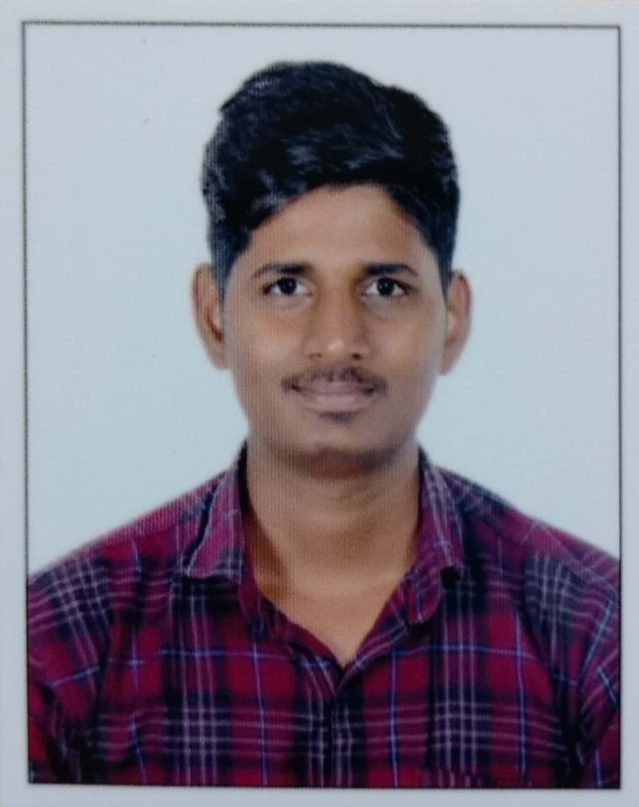

Phone Number : +91-9004217097

E – Mail ID : [jadhavtanaji09@gmail.com](mailto:jadhavtanaji09@gmail.com)

Date of Birth : 09-May-1992 in India

Marital Status : Unmarried

LinkedIn ID : TANAJI JADHAV



Education Details:

June 2009 – June 2013: D.Y.Patil Institute of Engineering & Technology ,University of Pune, India (Bachelor of Engineering)

Stream Of Study : Electronics Engineering (63%).



Tools and Technical Skills:

* Products worked FCM (Front Camera Module), VGM(Vehicle Gateway Module), BCM (Body Control Module) & ACC(Adaptive cruise control).
* Programming Languages: Basics of Embedded C, CAPL & Python.
* Test Automation Framework Vector HIL Test Bench.
* Protocols worked CAN,CAN-FD,LIN,ETH, UDS and KWP200.
* Test Management tool Integrity PTC,MITE, Polarion ,JIRA & DOORs.
* Defect tracking tool Integrity PTC ,JIRA and IBM Rational Change.
* Requirement Tracking tool Integrity PTC ,DOORS and Polarion.
* Test Environment Vector HIL Test Bench
* Tools and software CANoe, CANalyzer , CANape, Synopsys defensic tool , ODIS tool, ODX/PDX Creator, Audi SFD tool, Golden Algo, & CAN-StressTool
* SDLC V-model and Agile.
* Protocol Standard: ISO-27032,ISO-26262 ,ISO-13400 and ISO-15765 .



Work Experience : 7 Years and 1 months of Experience in Testing Automotive Domain.

**May 2021 – Present:** Senior System test Engineer for Cyber security of Front Camera module at

Magna electronics Electronics, Customer: Audi

* Requirement Analysis and Performing Test Design of Cyber security module.
* Performed testing for Secure Communication
* Performed testing for Secure Diagnostic
* Performed testing for Key management system (VKMS)
* Performed testing for Secure flash
* Performed testing for Firewalling
* Performed testing for TLS & DTLS
* Performed testing for Secure logging
* Performed Fuzz (Defensic) testing for Ethernet using Synopsys defensic tool
* Performed KPI automation for Lane detection using Python
* Performed Overnight flashing automation using Python
* Scripting Test cases in **Dspace Autodesk**.
* Responsible for Cyber security ASPICE Audit

**June 2017 – May 2021:** Senior Software Engineer for Vehicle Gateway Application at APTIV

**Customers: GWM (Great Wall Motors)**

* Requirement Analysis and Performing Test Design.
* Scripting Test cases in **C**AN **A**ccess **P**rograming **L**anguage and Execution.
* Protocol testing for Ethernet, CAN and LIN
* Performed CAPL and Python scripting to automate the test scenarios
* Performed Diagnostic testing for Ethernet, CAN and LIN
* Rest-bus script creation for various modules

Software Engineer for Body Control Module Application at APTIV

Technical Centre India

**Customers: GWM (Great Wall Motors) and Changan Motors.**

* Performed HIL (Hardware in Loop) testing of Body Control Module

Components using VectorTest Bench (HIL Setup).

* Requirement Analysis and Performing Test Design.
* Scripting Test cases in **C**AN **A**ccess **P**rograming **L**anguage and Execution.
* Performed validation for Power-Mode , Sleep current, Wiper & Key Search modules.
* Performed Diagnosis Communication tests with UDS Protocol for BCM.

**April 2015 – May 2017:** Software Engineer for Adaptive Cruise Control at KPIT technologies Pvt.Ltd., Bangalore

**Customers: Jaguar and Land rover.**

* Performed System Verification and Validation for Adaptive Cruise Control
* Preparation CAN timing related tests, DTC related tests
* Debugging and testing using Trace32.
* Requirement Analysis and Performing Test Design
* Involved in preparation of Traceability for prepared test cases against requirements.



Languages Known:

 🡪 Expert



Social Competences: Decision Making, Patience, Problem Solver, Leadership, Flexibility and Perseverance.

Hobbies: Badminton, Table-tennis, Watching Movies, Playing TV Videos games and Playing Cricket.

**Tanaji Jadhav**

**Pune**