UNIVERSITATEA BABEŞ-BOLYAI CLUJ-NAPOCA

FACULTATEA DE MATEMATICǍ ŞI INFORMATICǍ

SPECIALIZAREA INGINERIE SOFTWARE

LUCRARE DE DISERTAŢIE

Analysis and Design of a Peer-To-Peer Music Streaming Service

Conducător ştiinţific
Conf. Dr. Simona Motogna

Absolvent

Balázs Béla

2014

BABEŞ-BOLYAI UNIVERSITY CLUJ-NAPOCA

FACULTY OF MATHEMATICS AND COMPUTER SCIENCE

SOFTWARE ENGINEERING SPECIALIZATION

DISSERTATION THESIS

Analysis and Design of a Peer-To-Peer Music Streaming Service

Supervisor
Conf. Dr. Simona Motogna

Author

Balázs Béla

2014

Table of Contents

1.Introduction 3
2. Motivation and Background 4
2.1 Short history of P2P networks 4
2.2 General purpose P2P frameworks 6
2.2.1 GNUnet 6
2.2.2 MaidSafe 6
2.3 State of the art 7
2.3.1 Tomahawk 7
2.3.2 Spotify 8
2.3.3 Retroshare 9
3. Implementation 10
3.1 Peer-to-peer Network Topologies 10
3.2 Distributed Hash Table 13
3.2.1 MaidSafe DHT 15
3.2.2 BitDHT 16
3.3 Solving NAT traversal 17
3.4 Other used technologies 19
3.4.1 Qt 19
3.4.2 Phonon 19
3.4.3 QXmpp 20
3.4.4 libPortFwd 20
3.5 Architecture 20
3.5.1 audioplayer 21
3.5.2 lighthttpdaemon 22
3.5.3 xmpp 23
8.References 24

Introduction

Peer-to-peer networks have been applied successfully for a number of applications with success. They provide a way of implementing decentralized and resilient systems and are considered a valid alternative to traditional client-server architectures.
In this paper, we will explore the possibility of creating a fully decentralized, peer-to-peer music streaming service that makes use of a users social connection data.
Such a system would allow users to log into any XMPP(Jabber) account and discover their friends in the peer-to-peer network, once discovered it would allow users to search, browse and stream music shared by their friends. Each node would have a real life identity attached.
XMPP providers would include Facebook, from which we can get real data about the identity of each user and their list of friends, so when we search in the network we know exactly who we are streaming from and who is providing the content to us. Furthermore, nodes would forward queries to their social circle if they find no local results, therefore it would enable users to discover people from their extended social circle who are interested in the same kind of music or have similar music tastes, therefore it would enable the creation of new social connections. The list of real life friends of a user would act as a ring of trust in the peer-to-peer network and since real life social connections tend to be mostly geographically bounded to the same region, it is reasonable to assume that users have comparable connection speeds and can stream from each other in higher quality than from geographically far regions.
Since, users know exactly from whom they are streaming an they have ways to verify the identity of the other party, they can accurately assess the legality of this transaction and they can apply their local laws, since no parties from other countries are involved. Users would be informed that the content they share has to be licensed in a way that permits this, therefore we expect that most of the shared content would be from new, independent bands, looking to promote their material and gain a wider audience, therefore the system would have rich and rare content that would be hard to find in other services, like new albums from local bands. This would allow enthusiastic music fans to take advantage of their extended social circle.
The rest of this study will detail the challenges faced when designing such a system and will provide justifications for the design decisions taken.

2. Motivation and Background

2.1 Short history of P2P networks

“Peer-to-peer (P2P) networks connect many end-hosts (also referred to as peers) in an ad-hoc
manner. P2P networks have been typically used for file sharing applications, which enable peers
to share digitized content such as general documents, audio, video, electronic books, etc. Recently,
more advanced applications such as real-time conferences, online gaming, and media streaming
have also been deployed over such networks. Unlike traditional client-server networks, where
servers only provide content, and clients only consume content, in P2P networks, each peer is
both a client and a server [1].”

Peer-to-peer networking is not a new concept. These kind of architectures have been in use for more than 30 years. The internet was originally developed in the late 1960's to be a peer-to-peer system. The original ARPANET connected UCLA, Stanford Research Institute, UC Santa Barbara and the University of Utah not in a client-server manner, but as equal computing peers. In the early days of minicomputers and mainframes, the servers even acted as clients as well.
In 1979 two Duke University graduate students and one from the University of North Carolina developed USENET to exchange information in the Unix community.
“Students at the two universities could post “news” on certain topics, read messages within that topic, and exchange the messages between the two schools. Usenet grew from the original two sites to hundreds of thousands of sites but retained the same basic model of peer-to-peer networking. A Usenet site joins the rest of the world by setting up a news exchange connection with at least one other news server on the Usenet network. Typically exchange is provided by a company’s ISP. The company’s news server contacts the ISP's news server, and they exchange messages on a regular schedule [2].”

USENET can be considered the grandfather of today's peer-to-peer networks and has provided developers with valuable lessons learned in more than two decades of existence.
In May 1999, Shawn Fanning introduced the music and file-sharing application called Napster, which is considered, by many, the beginning of peer-to-peer networks, as we think of this concept today. Napsters database was centrally located. Truly decentralized file-sharing applications started appearing in early 2000, examples of these are Gnutella, eDonkey2000 and Kazaa. Gnutella was originally created by Nullsoft and it was once the most used network due to LimeWire, it was shut down in 2010.
The Kazaa team later created Skype, which is still widely used and was acquired by Microsoft and has since been migrating from a P2P supernode based network to Microsoft hosted cloud services.
Perhaps the largest and most well-known example of a P2P system is BitTorrent, which has been estimated to collectively account for approximately 43% to 70% of all internet traffic as of February 2009.
“Peer-to-peer file sharing (P2P) still generates by far the most traffic in all monitored regions – ranging from 43 percent in Northern Africa to 70 percent in Eastern Europe.[3]”

As of 2009 BitTorrent reportedly had about the same number of active users online as Youtube and Facebook combined.
Other contemporary P2P applications include various instant messaging systems and online chat networks, the Bitcoin digital currency system and it's alternatives, Spotify (hybrid), BitTorrent Sync, a P2P decentralized, distributed storage systems (Dropbox alternative) and various others.

2.2 General purpose P2P frameworks

Along the specialized applications mentioned above, there are a few project which aim to provide a reusable framework for any P2P applications, in the form of extra protocols that complement or replace existing infrastructure by building new P2P networks, which can be used easily by applications. We will present two such projects.

2.2.1 GNUnet

“GNUnet is a framework for secure peer-to-peer networking that does not use any centralized or otherwise trusted services. Our high-level goal is to provide a strong free software foundation for a global network that provides security and in particular respects privacy. GNUnet started with an idea for anonymous censorship-resistant file-sharing, but has grown to incorporate other applications as well as many generic building blocks for secure networking applications. In particular, GNUnet now includes the GNU Name System, a privacy-preserving, decentralized public key infrastructure [4].”

The framework offers link encryption, peer discovery, resource allocation, various peer-to-peer algorithms for routing, multicast and network size estimation and supports various transports (tcp, udp, http, https, wlan and bluetooth). The network topology used by GNUnet is a basic mesh network and GNUnet also offers a distributed hash table implementation based on a randomized variant of Kademlia it also allows a user to restrict connections to trusted friends and it allows friends of friends to communicate with the user, never using his ip address directly. It uses Uniform Resource Identifiers consisting of two major parts: module and module specific identifier. It also has its own DNS replacement, the GNU Name System (GNS). The framework is free software and is part of the GNU project.

2.2.2 MaidSafe

MaidSafe is a Scottish company that is aiming build a new decentralized Internet. They are working to replace most of the major internet protocols (like HTTP, SMTP, FTP, DNS). They have open-sourced their main product the MaidSafe platform. The name stands for “Massive Array of Internet Disks, Secure Access For Everyone”. It is aiming to do for data what Bitcoin did for currencies. They have services at multiple layers, all part of the same system. They have a reliable UDP layer named rUDP and a Routing layer, a Passport layer for cryptographic authentication, a network file system, a data vault and much more.
It is based on the Safe network and it introduces SAFE coin as an economic incentive. The network will automatically pay safecoins to the user based on how much their application is utilized by the users of the network, therefore aiming to provide revenue and incentive to application developers and eliminating the need for every application developer to come up with a revenue source model. Initially it started out as a Distributed Hash Table, maidsafe-dht, but then that evolved into MaidSafe routing. This DHT is also based on Kademlia, but it introduces a number of optimizations.
It is very similar to the theoretical network proposal named BitCloud. The company was founded in 2006 and has received more than $5m in funding to date.

2.3 State of the art

There are a number of peer-to-peer music streaming applications similar to what we propose, but they have differences in their approach.

2.3.1 Tomahawk

The goal of Tomahawk project is to completely decouple music from its source and to unify all music source into one music player application. The music sources include SoundCloud, Spotify, Last.fm, Grooveshark and more. It uses various identity providers to help discover your friends from the network and also stream from them. It supports zeroconf local networking to discover friends who are on the same network, it supports XMPP and Google Talk. You can login with your XMPP account and it will discover your friends and let you stream from them. It does this by sending custom XMPP messages to them which are detected by their Tomahawk client on their side and they automatically respond with their ip address and port, to which we can connect. These are supported by some XMPP extensions, XMPP providers such as Google Talk allow this, but the biggest drawback is that the XMPP service provided by Facebook is very limited and does not allow custom XMPP messages, if we would do the same on Facebook XMPP, we would have to use standard messages and those would appear in any Facebook client as chat messages, which is very intrusive. Therefore, although Tomahawk is very similar to our proposed application, it does not support services that we consider vital, since Facebook comes closest to containing the real, verifiable, real-world social connections of a user. It also doesn't have a DHT (distributed hash table) extension which we could use to discover our friends, no matter what their identity provider is. If it would have a DHT, the actual peer discovery and session initiation would be decoupled from the identity provider and would not depend on the availability of the XMPP service (we could store the list of friends locally, once retrieved and we could cache their calculated node ids). We only need the XMPP provider to be able to compute the node id of our friends and we can use that to discover them using the DHT. In this case, even if the XMPP service is unavailable, or no longer permits the custom messages Tomahawk relies on, we already have the node ids of our friends and we can re-launch the query based on that, assuming it hasn't changed since it was last retrieved. Therefore we can not consider the peer-to-peer module of Tomahawk to be truly decentralized.
The Tomahawk project simply has different goals, although its functionality overlaps with what we propose. Their goal is to build a universal music player that can use any music source including major music streaming services and the collections of our friends, while our goal is to build a decentralized, social music streaming service that users can use to discover new music and new people from their extended social circle. Providing users access to their own music collection (no matter where it may be) is out of scope for us. The average use-case for our project would be, for a user to log in, browse the music collection of a friend, discover a new artist he likes and then use other music services (like Tomahawk) to listen to that artist, since he can not rely on his friend being online all the time or on that artist to be sufficiently replicated in the collections of his friends in order to be able to access it any time. Another use case would be, a user searching for a specific artist in order to see which members of his extended social circle also listen to that artist. Facebook Graph Search also offers this and maybe is more well suited for this use-case. We can issue queries like “My friends of friends who listen to Bob Marley” and it will list all the friends who explicitly liked Bob Marley's page, but this only works for artists and not songs and we can not expect Facebook users to like every song they listen to. It also has a drawback of exposing our queries to Facebook and they can use it for further data-mining. Also, people who use Facebook wouldn't necessarily be open to the user contacting them because they listen to an artist, but if they use a specialized application, like the one we proposed, then they opt-in for this, since it is an integrated part of the application, which they can use. And last but not least, there are not many third-party alternatives for the features Facebook Graph Search offers, so even if this use case is not the most common case, having it covered is fairly unique and it definitely is not a goal that Tomahawk shares.

2.3.2 Spotify

Spotify is a commercial music streaming service and was launched in October 2008 by a Swedish startup, Spotify AB. Its desktop clients use a peer-to-peer network, each client serves the songs it has completely cached to other requesting peers. There is no overlay routing in the network, so peers who wish to exchange data must be directly connected. Since tracks are usually small and short, looking up tracks is a frequent operation. Spotify has a tracking service in the backend, but also allows queries in the network. It does not use a DHT to keep the protocol simple and since lookup time is a big issue.
“As two complementary mechanisms are used, the tracker can be simplified compared to many other system. In particular, the tracker only keeps a list of the 20 most recent peers for each track. Furthermore, clients are only added to the tracker when they play a track and do not periodically report the contents of their caches, or explicitly notify the tracker when content is removed. This helps in keeping overhead down, and simplifies the implementation of the tracker. As clients keep a TCP connection open to a Spotify server, the tracker knows which clients are currently online. When a client asks the trackers for peers who have a track, the tracker replies with up to 10 peers who are currently online. The response is limited in size to minimize overhead.
In addition to the tracker-based peer searches, clients also send search requests in the overlay network, similar to the method used in Gnutella. A client in search of a track sends a search request to all its neighbors in the overlay, who forward the request to all their neighbors. Thus, all peers within distance two of the searcher in the overlay see the request, and send a response back if they have the track cached. Search queries sent by clients have a query id associated with them, and peers remember the 50 most recent searches seen, allowing them to ignore duplicate messages. This limited message forwarding is the only overlay routing in the Spotify peer-to-peer protocol [5].”

The server serves the first 15 seconds of a track, while a peer who has a copy is located, if the peer is too slow or is unresponsive and no other peer can take it's place, the server steps in and serves the connection. It also pre-loads the next track in a playlist. Custom headers are added to the Ogg Vorbis format to better facilitate seeking. It uses TCP and the Linux kernel on each server is configured to not reduce the congestion window when no data was sent in an interval exceeding the retransmission timeout, since the congestion window starts out small and grows as data is successfully sent, this allows the server to send almost all the latency-critical initial data without waiting for ACK-s from the client. Each client simultaneously uploads to a maximum of 4 peers.

2.3.3 Retroshare

While Retroshare does not have a music streaming functionality it is of interest for us from several points of view. Retroshare describes itself as an open source, peer-to-peer, decentralized, communication and collaboration platform. It relates a “Friend-to-friend” network, which means you can form a network of handpicked, trusted friends and that your computer will only transfer files and searches to and from them, all information is relayed through them. The features include: chatting in real time with friends and friends of friends, sending messages (like e-mails) to friends, participating in forums, reading channels that contain news or files, sharing files publicly between friends, sharing files anonymously.
It uses a BitTorrent compatible peer-to-peer overlay network. It uses GPG (GNU Privacy Guard) for generating keypairs, then SSH is used to establish a connection. End to end encryption is accomplished by OpenSSL. Adding friends is possible by importing their public key (which is sent outside of the network), then we can locate them in the network and we can initiate an encrypted connection. If we disabled the DHT and the IP/certificate exchange services the Retroshare network is a real Darknet.
It has its own URL scheme for sharing files, it's completely decentralised, it presents a variety of NAT (Network Address Translation) traversal methods, it has a Kademlia based DHT which is compatible in protocol with the BitTorrent DHT, IRC like channels and it even has a Voice over IP plugin.

While similar tools do exists, none of them have the same goals as the solution we proposed. They do contain solutions to a number of challenges that we also face and their implementation serves as a good basis for our own design. We can reuse Spotify's optimizations like pre-loading the next song in the playlist, TCP congestion techniques, searching for multiple peers to switch to and maybe even adding headers to facilitate seeking. Tomahawk's well written streaming server can serve as a reference implementation for our own. Retroshare's BitTorrent compatible Distributed Hash Table is also worth investigating.
We will detail each design decision and its justification.

3. Implementation

Our implementation is named Streamphony and we chose to write it in C++ 11, using the Qt5 framework.

3.1 Peer-to-peer Network Topologies

Peer-to-peer networks can be classified in two classes: structured P2P systems and unstructured P2P systems. In structured P2P systems, connections among peers in the network are fixed and peers maintain information about the resources their neighbors possess, therefore the queries can be directed to neighbor peers that have the desired data, even if the data is rare. The most common indexing that is used to structure P2P systems is the Distributed Hash Tables indexing (DHT). A DHT provides a lookup service with (key, value) pairs that are stored in the DHT. Different DHT systems like Chord, Pastry, CAN, Tapestry are different in their routing strategies.
Unlike structured systems, in unstructured P2P systems (mesh networks) connections among peers in the network are formed arbitrarily in flat or hierarchical manners. In order to locate peers having the desired data, peers in unstructured P2P systems query data based on several techniques such as flooding, random walking and expading ring (like the Time-To-Live counter in Gnutella). There are three different designs for unstructured P2P systems: centralized unstructured P2P systems, hybrid unstructured P2P systems and decentralized (or pure) unstructured P2P systems.
In centralized unstructured P2P systems there is a central entity used for indexing and bootstrapping the entire system, but connections among peers are not determined by this central entity. A great example of this model is Napster, the network that pioneered the idea of P2P file sharing. A peer in the network informs the central server about its IP address and the names of the contents that it makes available for sharing, thus the central server can respond to queries. The entire network relies on the central server.
The decentralized or pure model provides an overlay network. An overlay network is a logical network where an edge in this network exists between any pair of peers that maintain a TCP connection. The decentralized unstructured overlay network is flat, meaning that all peers act as equals. There is no central server nor are there any preferred peers with a special infrastructure function. This network has a single routing layer. An example of this is Gnutella, where in order to connect a peer has to connect to several known bootstrapping peers, which respond with the information about one or more existing peers in the overlay network. The information includes the IP address and port of each peer. The peers in Gnutella are only aware of their neighbor peers. Queries are distributed among the peers using a variation of the flooding mechanism. A peer, in order to search for content launches a query to its neighbors in the overlay network. Every neighbor forwards the query to all of its neighbor peers. This continues until a specified TTL is reached. When receiving a query, a peer who has the content will respond with a “query-hit response” to the peer that initiated the query. This response is sent on the reverse path of the query, using the pre-existing TCP connections. The peer then proceeds to download the desired content through a direct TCP connection from a selected peer. The drawbacks of this approach are non-scalability, since a peer may not find the desired content even though it's available in the network and query traffic can grow linearly with the number of queries. To address these problems, we have the hybrid unstructured P2P system model.
“A hybrid unstructured P2P network allows the existence of infrastructure nodes, often referred to as super-peers (or super-nodes or overlay nodes). This creates a hierarchical overlay network that addresses the scaling problems on pure unstructured P2P networks such as Gnutella. A peer in such network can typically change roles over time. For example, a regular peer can become a super-peer that takes part in coordinating the P2P network structure. KaZaA (http://www.kazaa.com/), which is based on the FastTrack (http://www.fasttrack.nu/) protocol, is an example of a hybrid unstructured P2P network. This network uses specially designated superpeers with high bandwidth, disk space and processing power. When a peer joins the network, it is assigned to a super-peer. The peer then informs its super-peer about the content that it will share. The super-peer facilitates the search by maintaining a database that maps content to peers, and tracks only the content of its assigned peers. Similar to the centralized design, the super-peer plays the role of a directory server, although only to its assigned peers. The super-peers together create a structured overlay of super-peers, which makes search for content more efficient. A query in this network is routed to a super-peer. Then, as in the decentralized design, the query is flooded in the overlay super-peer network. The super-peer then responds to the peer that originated the query with a list of peers having the content. The hybrid networks are no longer dedicated to a single server, since the database is distributed among the super-peers. Moreover, the size of the database is relatively small, since each super-peer tracks only the contents of its assigned peers. However, the drawback of this approach is that it is considerably complicated, and requires non-trivial maintenance of the overlay network. Moreover, the fact that super-peers may have more responsibilities than ordinary peers can result in a bottleneck [1].”

Figure 1: P2P Topologies

In our implementation we will use an unstructured P2P network, mainly because we want to build a truly decentralized system and we want to keep the protocol simple. Establishing criteria upon which we can promote users to supernode status could be based on availability statistics or upon content, but for now we don't see the need to do this. Spotify's overlay network doesn't have supernodes either, but they do have the tracker in the backend which is somewhat similar to a central server. We do expect the network to be relatively small and partitioned into several networks, based on the social graphs of the users.
Since each user has around 150 friends in average (Dunbar's number) out of which we estimate around 15% will use the service, initially, that is 22 friends for each users. If we establish the depth limit in the social graphs (depth of the friends of friends network) to be around 3, meaning that each of our friends will forward our queries through another 2 layers of friends and that the time to live of each packet is 3, that means that our friends will send our queries to 22 of their friends and those friends will forward it to their 22 friends at a maximum of 3 times. Therefore the number of nodes reached by our query is 22 at the power of 3, which is 10648. This number should be sufficient to answer any fairly common query and if it proves slow we will reduce it later on. Either way, our network should be able to handle this without supernodes.

3.2 Distributed Hash Table

We have decided on the structure of our peer-to-peer network, but first we need to be able to discover peers and for this we will need an entirely different peer-to-peer network.
A Distributed Hash Table is basically a key-value store distributed across the network, any participating node can efficiently retrieve the value associated with a given key. The responsibility of maintaining the mapping from keys to values is distributed among the nodes in such a way that a change in the set of participants causes only a minimal amount of disruption. This allows distributed hash tables to scale and to handle continuous node arrivals, departures and failures. The structure of a DHT can be decomposed into several components. The foundation is an abstract keyspace, such as a the set of 160-bit strings. A keyspace partitioning scheme splits ownership of this keyspace among the participating nodes. An overlay network then connects the nodes, allowing them to find the owner of a given key in the keyspace. A typical use of the distributed hash table for storage and retrival might proceed as follows: to store a specific file, the SHA-1 hash of the filename is generated, producing a 160-bit key k, and a message put(k, data) is sent to any node participating in the DHT. The message is forwarded from node to node through the network until it reaches the single node responsible for key k as specified by the keyspace partitioning. Then that node stores the key and the data. Any other client can get the contents of the file by hashing the filename to produce k and asking any DHT node to find the data associated with k with a message get(k).
The message will be again routed through the overlay network to find the node responsible for k, which will reply with the stored data.
Each DHT uses some form of consistent hashing to map keys to nodes. This technique defines the abstract notion of distance between two keys. This is unrelated to geographical distance or network latency. Each node is assigned a single key, called its identifier. A node owns all the keys to which its ID is deemed the closest by the distance function.
Each node maintains a set of links to other nodes, its neighbors. Together these form the overlay network, a node picks its neighbors according to a certain structure, called the network topology. All DHT topologies share an essential property: for any key each node either has a node ID that owns that key or has a link to a node whose ID is closer to that key. Then it is easier to route a message to the owner of any key using a simple greedy algorithm that is not necessarily globally optimal: at each step forward the message to the neighbor whose ID is closest to the key, until there is no such neighbor, meaning that we have arrived to the closest node which is the owner of the key, since that is how its ID was chosen. This is sometimes called key-based routing.
The most common distributed hash table implementation is Kademlia.
“Kademlia has a number of desirable features not simultaneously offered by any previous peer-to-peer system. It minimizes the number of configuration messages nodes must send to learn about each other. Configuration information spreads automatically as a side-effect of key lookups. Nodes have enough knowledge and flexibility to route queries through low-latency paths. Kademlia uses parallel, asynchronous queries to avoid timeout delays from failed nodes. The algorithm with which nodes record each other’s existence resists certain basic denial of service attacks. Finally, several important properties of Kademlia can be formally proven using only weak assumptions on uptime distributions (assumptions we validate with measurements of existing peer-to-peer systems). Kademlia takes the basic approach of many peer-to-peer systems. Keys are opaque, 160-bit quantities (e.g., the SHA-1 hash of some larger data). Participating computers each have a node ID in the 160-bit key space. (key,value) pairs are stored on nodes with IDs “close” to the key for some notion of closeness.
Finally, a node-ID-based routing algorithm lets anyone locate servers near a destination key. Many of Kademlia’s benefits result from its use of a novel XOR metric for distance between points in the keyspace. XOR is symmetric, allowing Kademlia participants to receive lookup queries from precisely the same distribution of nodes contained in their routing tables. Without this property, systems such as Chord do not learn useful routing information from queries they receive. Worse yet, because of the asymmetry of Chord’s metric, Chord routing tables are rigid. Each entry in a Chord node's finger table must store the precise node proceeding an interval in the ID space; any node actually in the interval will be greater than some keys in the interval, and thus very far from the key. Kademlia, in contrast, can send a query to any node within an interval, allowing it to select routes based on latency or even send parallel asynchronous queries.To locate nodes near a particular ID, Kademlia uses a single routing algorithm from start to finish. In contrast, other systems use one algorithm to get near the target ID and another for the last few hops [6].”

The distance between two nodes is calculated using the exclusive or of the two node identifiers, taking the result as an integer number. Keys and node identifiers have the same format and lenth, so distance can be calculated among them in exactly the same way. Node ids are typically a large random number that is chosen with the goal of being unique for a particular node.
Exclusive or as a distance metric was chosen because it shares the following properties with the geometric distance formula:
- The distance between the node and itself is zero.
- It is symmetric: the distance calculated from A to B is the same as from B to A.
- It follows the triangle inequality
A basic Kademlia network withnodes will only take n steps (worst case) to find that node. Kademlia routing tables consist of a list for each bit of the node identifier. A list has many entries. Every entry holds the necessary data to locate another node. The data in each entry includes the ip address port and the node identifier of another node. Every list corresponds to a specific distance from the node. With an ID of 160 bits, every node in the network will classify other nodes in one of the 160 different distances, one distance per bit. As nodes are encountered in the network, they are added to these lists. These lists are referred to as k-buckets, where k is a system-wide number. Every k-bucket is a list having up to k entries inside. When a k-bucket is full and a new node is discovered for that k-bucket, the least recently seen node in the k-bucket is PING-ed, if the node is found to be still alive, the new node is placed in a secondary list, a replacement cache, which is used only when the node stops responding. New nodes are only used when old nodes disappear, in order to favor long-lived connections.
Kademlia has four protocol messages:
- PING -used to verify if a node is still alive.
- STORE – Stores a (key, value) pair in one node
- FIND_NODE – The recipient of the request will return the k nodes in his own buckets that are the closest ones to the requested key.
- FIND_VALUE – Same as FIND_NODE, but if the recipient of the request has the requested key in its store, it will return the corresponding value.
Joining the network happens through the bootstrap process, in this phase the joining node needs to know the IP address and port of another node, that is already participating in the network. The joining node inserts the bootstrap node into one of its k-buckets and then issues a FIND_NODE of its own ID against the bootstrap node. The self-lookup will populate other nodes' k-buckets with the new node identifier and will populate the joining node's k-bucket with the nodes in the path between it and the bootstrap node.

Upon inspecting the existing libraries implementing Distributed Hash Tables in C++ we have narrowed down our choices to two libraries, which we will compare.

3.2.1 MaidSafe DHT

MaidSafe DHT, now known as MaidSafe Routing and an integrated part of the MaidSafe project, brings numerous improvements to the Kademlia network.
“The maidsafe_dht presented here is very loosely based on Kademlia. The addition of managed connections is very interesting and makes great use of a connections based protocol where it would appear more obvious to use a connectionless protocol for speed and network efficiency. The move from multiple iterative searches to single recursive searches should prove to be vastly more efficient and significantly faster. The disconnection of κ bucket size from number of replicants values is also significant in allowing a smaller number of routing table entries, but improving data retention and validity. This represents a use of a DHT system that is exceptionally powerful in distributing network knowledge (Kademlia) and extending this with a system of improvements that transform the DHT into a network that can cope with increasingly quickly altering data. This should represent an improvement in distributed networking and distributed processing [7].”

Advantages:
- Modern C++ codebase
- Support for Store and Delete operations
- Fast network reconfiguration (5 seconds compared to 60 minutes for other DHTs)
- Node identification guaranteed via Public Key Infrastructure via MaidSafe-Passport (no Spartacus attacks).
- Asymmetric encryption provided node identification to prevent Sybil attacks
- Encrypted end to end communication
- Send/Ack system to ensure message is checked as forwarded at any node (with zero speed impact on sending)
- RUDP integration to provide resistance to 'man in the middle' attacks
- Has high code coverage and comes with integrated testing suite.
- Responsive developers

Drawbacks:
- A lot more than just a simple DHT library, it can't be built alone, if we decide to use it, we have to import the entire MaidSafe system with all its dependencies.
- No clear examples of usage yet, no real-world apps that we can study.
- Very little documentation on usage, requires studying source-code, even though the code is very readable.

The drawbacks are the main reason we decided that this was not suitable for such a small project as ours.

3.2.2 BitDHT

BitDHT is a C++ library and it provides compatibility with the BitTorrent DHT, enabling us to leverage this network and bootstrap our own DHT. It provides an implementation of the BitTorrent DHT protocol, which is based on Kademlia and implemented over UDP. The DHT in BitTorrent is used for trackerless torrents and for magnet links, in effect each peer becomes a tracker. It uses 160 bit Node ids and the same format for infohashes.
It uses the same Kademlia XOR metric.
“When a node wants to find peers for a torrent, it uses the distance metric to compare the infohash of the torrent with the IDs of the nodes in its own routing table. It then contacts the nodes it knows about with IDs closest to the infohash and asks them for the contact information of peers currently downloading the torrent. If a contacted node knows about peers for the torrent, the peer contact information is returned with the response. Otherwise, the contacted node must respond with the contact information of the nodes in its routing table that are closest to the infohash of the torrent. The original node iteratively queries nodes that are closer to the target infohash until it cannot find any closer nodes. After the search is exhausted, the client then inserts the peer contact information for itself onto the responding nodes with IDs closest to the infohash of the torrent.
The return value for a query for peers includes an opaque value known as the "token." For a node to announce that its controlling peer is downloading a torrent, it must present the token received from the same queried node in a recent query for peers. When a node attempts to "announce" a torrent, the queried node checks the token against the querying node's IP address. This is to prevent malicious hosts from signing up other hosts for torrents. Since the token is merely returned by the querying node to the same node it received the token from, the implementation is not defined. Tokens must be accepted for a reasonable amount of time after they have been distributed. The BitTorrent implementation uses the SHA1 hash of the IP address concatenated onto a secret that changes every five minutes and tokens up to ten minutes old are accepted .[8]”

The routing table makes a distinction between “good” and “bad” nodes, routing tables most only contain good nodes. A good node is a node that has responded to one of our queries in the last 15 minutes, a node is also good if it never responded to one of our queries and has sent us a query within the last 15 minutes. After 15 minutes of inactivity a node becomes questionable. Nodes become bad when they fail to respond to multiple queries in a row.
Advantages:
- By maintaining compatibility with BitTorrent, we can leverage the BitTorrent network to search for our own nodes and to bootstrap into the network. This is a huge advantage since it minimizes the chance of not being able to bootstrap into the network (all last known nodes being offline).
- Small codebase, not many dependencies
- Used by RetroShare for years, therefore it's stable and we have a reference implementation.
- Very responsive developers.

Drawbacks:

- Not a full DHT, in the classical sense, doesn't support PUT and GET operations for any custom value. It supports find node operations and getting values for an infohash, but the returned values are always an ip, a port and the node id.

- Code is somewhat hard to follow.

The first drawback can be addressed. Upon contacting one of the main developers of BitDHT, I was redirected to another developer who implemented a custom key value store. This was done by adding new message types post_hash and get_hash, extensions to the BitTorrent standard. Mainline BitTorrent nodes will simply drop these messages.
Using this code, with a few modifications, will prove as a fair DHT implementation for the proposed application.
The advantages outweigh the disadvantages and it also integrates nicely into our build process. The lookup proved to take some time, together with the bootstrapping process, but we can mitigate this by storing the last known ip for each of our friends.
Therefore we can justify choosing BitDHT over MaidSafe, in our case.

3.3 Solving NAT traversal

In principle Internet technology allows the interconnection of every device to every other device, in practice, sadly, this is not the case and for many reasons devices tend to be behind routers that allow them to go unnoticed or at least act as a proxy device.
Thousands of devices behind a router may appear with the same ip address from outside.
This is an elegant solution to the IP v4 shortage, but even with IP v6, Network Address Translation would still exist.
We will explore several methods of NAT traversal like Session Traversal Utilities for Nat (STUN) which is an extended form of Interactive Connectivity Establishment (ICE) and Universal Plug and Play (UPnP).
Universal Plug and Play is the most common form of NAT traversal, it utilizes HTTP over UDP to negotiate a port mapping with an enabled router. This allows a node to appear as though it has a directly connected IP (that of the router) and port combinations. From this perspective the node appears directly connected (from that port). UPnP is seen as a security risk by many vendors and is switched off by default on many devices. We should take care to request a permanent mapping, which would last until we explicitly unmap or the router is reset. Many routers will have a low limit of concurrent available UpnP mappings.
Network Address Translation Port Mapping Protocol (NAT-PMP) is considered an upgrade to UPnP and is not currently provided in many routers. This is also a UDP controlled protocol and will not work if UDP is blocked.
“Hole punching can successfully traverse approximately 82% of NAT devices. It makes use of the fact that a router will leave a UDP port mapped after sending data out. This is done whether the UDP packet is successfully delivered or not. This is a necessity for a connectionless protocol as the router cannot tell whether the transmission will be successful or whether there is to be a reply (which all well defined protocols using UDP should ensure there is). The basis of the process is described in Algorithm 1, it is relatively simple and uses this conversation method to operate. It should be noted for BSD type socket API’s it is important to
ensure the SO_REUSE_ADDR is set, allowing address reuse (very important). Using a UDP overlay type protocol such as UDT would introduce some new difficulties here and the connection set-up time-out should be set very small, as the first connection attempt will most likely fail, reducing timeouts makes for more efficient code.
Algorithm 1 Let A and B be the two hosts, each in its own private network; N1 and N2 are the two NAT devices; S is a public server with a well-known globally reachable IP address. A and B each send a UDP packet to S; the NAT devices N1 and N2 create UDP translation states and assign temporary external port numbers S relays these port numbers back to A and B A and B contact each others’ NAT devices directly on the translated ports; the NAT devices use the previously created translation states and send the packets to A and B [9].”

STUN usually operates on a server that has 2 network interfaces on different IP addresses. Its purpose is to allow an application running on a host to determine whether or not it is located behind a NAT or not. The basic protocol is as follows: the client sends a message to a stun server on the public internet, the stun server response with a success response that contains the IP address and port of the client as observed from the server's perspective.
STUN messages are usually sent via User Datagram Protocol packets, STUN messages are retransmitted periodically, since UDP is not reliable.
A DHT can easily act as a server with two network interfaces and nodes can reply to these kinds of messages.
“To achieve the STUN type functionality, we simply carry out the process as defined in section III-C, where we usenode on the network to perform NAT detection and traversal techniques. This negates the requirement for a server, but, how do other clients know which sever to speak to in case of a port restricted situation, where the server requires a message to be sent and relayed to the node we intended. Without this any port restricted node would be unreachable. This is where we use a DHT component that provides us with such capability
and this is the routing table or list of contacts. In the contact tuple for each contact, where an intermediate node is required (AKA STUN server) a node’s address is stored along with the end nodes address. So every node that requires an intermediate, establishes the details of the
intermediary and publishes this to the network as part of its contact details. This is extremely effective and simple to implement [9].”

For the proof of concept version of our project, simple UPnP port forwarding should be enough.

3.4 Other used technologies

3.4.1 Qt

Figure 2: Qt Logo
Qt is a cross-platform application framework that is commonly used to develop applications with a graphical user interface, but can also be used for command line applications. It runs on various embedded platforms including Embedded Linux and QNX and also supports Android and iOS.
Qt uses standard C++, along with QML (Qt Meta Language) and JavaScript and makes extensive use of a code generator called the Meta Object Compiler (moc).
Qt is available under several licenses: commercial, LGPL v2, GPL v3. All editions support many compilers like g++ and clang. It comes with an integrated development environment, QtCreator. Qt allows decoupled designs via its signals and slots mechanism, which now supports lambda functions in C++ 11.

3.4.2 Phonon

Figure 3: KDE logo
Phonon is part of KDE Platform 4 and used to be part of Qt4, although it has been dropped from the official Qt5 release in favor of Qt Multimedia, it supports Qt5 in the form of a Qt plugin (if we build it with the PHONON_BUILD_PHONON4QT5 flag).
The main reasons why we chose Phonon over QtMultimedia are the VLC backend , it supports the playback of a memory buffer and overall has a simpler API than QtMultimedia. It has also been tried and tested by various projects like Amarok or Tomahawk. QtMultimedia is still in early stages, but we will consider migrating to it in the future, since it supports multiple platforms, unlike Phonon.
Phonon does support Windows and Mac, but we could not find anything regarding Android or iOS support.

3.4.3 QXmpp

QXmpp is a cross-platform, C++ XMPP client and server library. It is written in C++ and makes use of the Qt framework. It strives for a simple API, by encapsulating the underlying socket, the core XMPP RFC, and the XMPP extensions into classes. It comes with full API documentation, automatic tests and numerous examples (including a full, functional, GUI Client). It is licensed under the GNU Lesser General Public License, version 2.1 or later and its only dependency is Qt.

3.4.4 libPortFwd

LibPortFwd is a basic, lightweight C++ wrapper around the miniupnp and nat-pmp libraries for setting up port forwarding, detecting max up/downstream bandwidth and for finding out the external IP address. It detects any UpNP or NAT-PMP router and uses the appropriate library.

3.5 Architecture

From an architectural point of view, the system is composed of the following submodules.
Submodules consist of multiple classes, having similar responsibilities.
- The audioplayer module, which is responsible for connecting to peers and streaming songs (playback control), but it also has a Rest client responsibility, it issues Rest requests to the server, for querying songs.
- A lighthttpdaemon module, which implements the Rest API, allowing other connected nodes to issue queries and request songs.
- An xmpp module, which is responsible for all xmpp related functionality, including connecting to the xmpp server, receiving contacts (rosters and their vcard), handling presence updates, retrieving profile pictures.
- A dhtmanager module which is responsible for all DHT related functionality, bootstrapping into the network, announcing our presence and issuing queries for our contacts.
- The connectionmanager module is the central control module, it launches DHT queries for our contacts, based on the details received from the xmpp module, when our friends are found it establishes a connection to them and can issue commands to the audioplayer. It also caches the last known ip address of each node and tries to connect to that first. It does this to mitigate the long DHT lookup time.
We will detail the architecture of each module.

3.5.1 audioplayer

The main classes of the audioplayer module are the MediaPlayer and the RestClient.
The PhononMediaPlayer uses the MediaStream as a MediaSource. MediaStream overrides a number of internal methods called by Phonon in various situations, like needData(), enoughData(), reset(), seekStream(). It takes a QNetworkReply received as a response from the RestClient. The PhononMediaPlayer class is responsible for playback control and uses the RestClient to request songs from a given URL. It is also responsible for the initialization of the Phonon subsystem.

Figure 4: Class diagram overview of the audioplayer component

3.5.2 lighthttpdaemon

The lighthttpdaemon module implements a minimal HTTP server, over a TCP socket.
TCP was chosen because if we keep the connections open to all our contacts and occasionally exchange data in form of ping messages (to avoid closing them), we deemed it fast enough.
The TCP congestion window size reduction that Spotify avoids by disabling it on the server side, does present a problem, but we assume that once we start exploring a friend's collection we will continue streaming from them. The assumed usage pattern therefore would lead to the TCP congestion window increasing as more data is transferred.
If we experience frequent buffer under-runs, we can later switch to a reliable UDP based implementation. The most latency critical operation is seeking, but since then the connection is already open we don't need to do the TCP three-way handshake anymore and hopefully the congestion window is large enough to deliver data quick enough to avoid noticeable buffering.
The slowest operation would be starting to stream from a contact from whom we haven't streamed before, but this also benefits from the already open connection, the only bottleneck is the small initial TCP congestion window, which forces us to send limited amount of data and wait for it to be acknowledged.
Our HTTP implementation is minimal, with the least possible overhead to TCP.
The Rest API is entirely stateless, therefore we avoid the need to implement session handling. We abstracted the concept of ContentResolver, even though we currenly only use files on local storage.

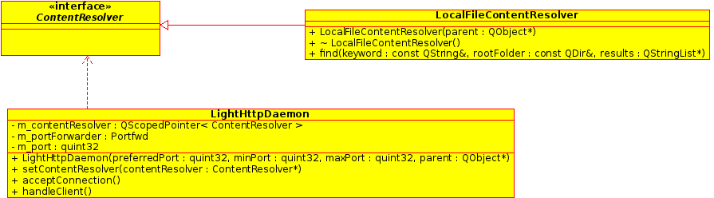
Figure 5: Main classes in the lighthttpdaemon module

3.5.3 xmpp

The main controller class of the xmpp module is the XmppManager, it deals with all major Xmpp operations and provides data about our contacts to other classes.
It has a RosterItemModel and an XmppImageProvider that is exposed to the user interface layer. It uses the vCardCache to cache the received vCards. vCards contain detailed information about contacts, like their full name, their profile photo, their organization, etc.
vCards need to be cached because they are expensive to request. We are notified on vCard changes and we update the cache.

We use xmpp information like the full name and the profile photo to generate the 160 bit SHA-1 hash, that is assigned as node identifier in the DHT. We also calculate this hash for other contacts in order to be able to find them in the DHT. This is mainly because of a Facebook restriction that uses generated jabber identifiers (jids). While we can see the jid of each contact, we do not know our own jid, therefore we can't use it as a node id. We need to use data that is available to us and also to our friends.

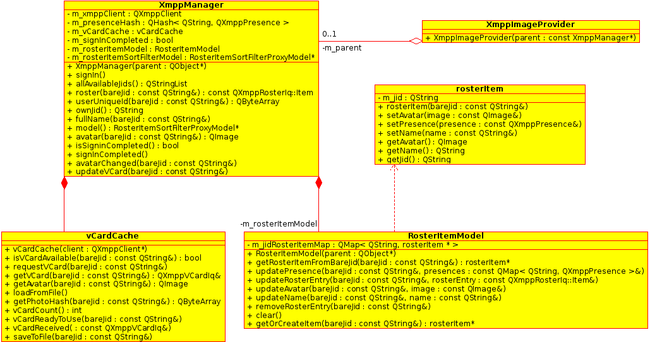
Figure 6: Main classes of the xmpp module

3.5.4 dhtmanager

The central class is the DhtManager class, this initializes libbitdht and registers callbacks.
These callbacks are called from the libbitdht's UDP thread, therefore we can not make meta object connections to our original DhtManager parent object. Because of this we rely on periodic polling. As each node is discovered, we push our info to them (if they support the put_hash message (implemented as an extension over the standard BitTorrent DHT protocol), also we check if we have a query running targeting them (them being the result of the query), we also issue our get_hash messages to them, for all our contacts. We use get_hash in parallel with the standard find_node method in order to speed up queries and to not rely solely on our own extension. We can launch at most five find_node queries per minute.

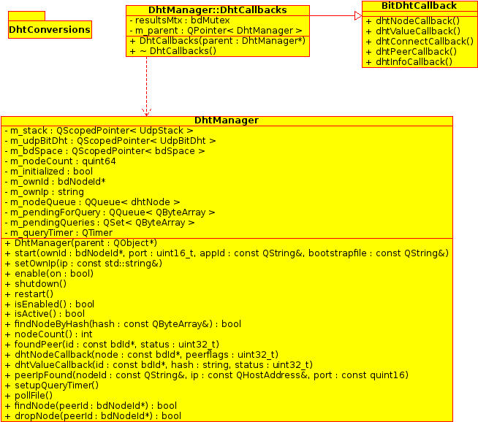
Figure 7: Class diagram overview of the dhtmanager module

The newly discovered nodes are all queued and processed with a timer, every minute.
We also provide DHT related information to other classes.

3.5.5 connectionmanager

The central class is ConnectionManager, which keeps one Node object for each discovered contact. The Node object encapsulates the capabilities and operations of a Node. The ConnectionManager also handles the caching of each valid Node. It also exposes the search functionality to the user interface layer. Once a search is triggered, ConnectionManager invokes the search method of each Node object and aggregates the results.

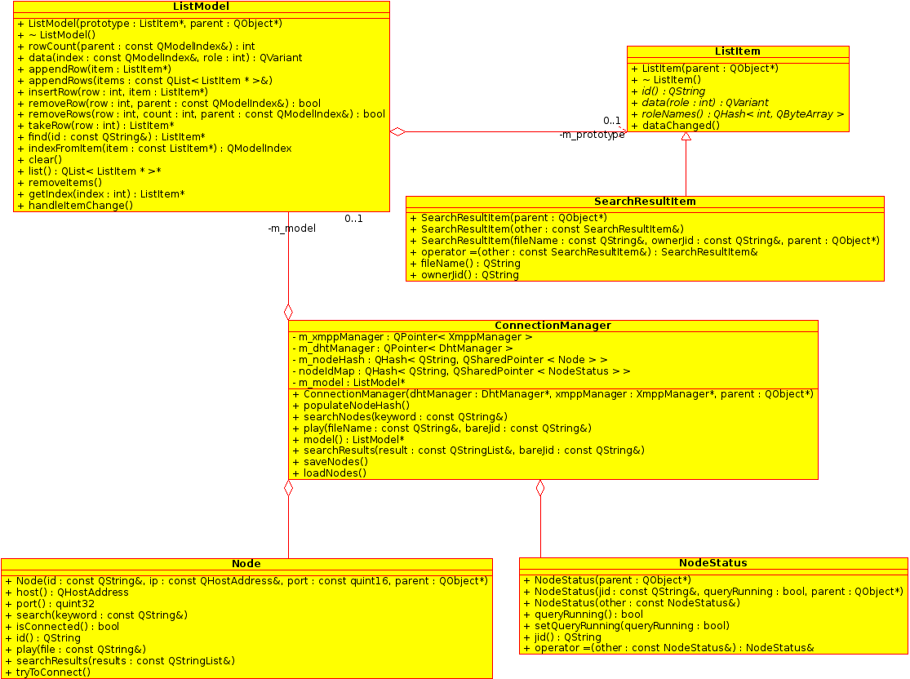
Figure 8: Main classes of the connectionmanager module

The ConnectionManager also maintains a NodeStatus object for each Node, in order to gather meta-data about the Node and keep track of running queries, in order to not launch them again. Node objects send requests using a RestClient class (which is part of the audioplayer module).
Regarding the verification of each Node's identity, we propose a system similar to what RetroShare implements. We would import a public key for each friend and once the friend was discovered, we would implement a handshake and then keep the connection encrypted and make sure we could only decrypt data if we have a valid public key. This would avoid Spartacus attacks.
Nodes forward search queries to their neighbors and notify us of the results and the identity of the node which provides the results, via a rest callback. Then we proceed to connect directly to that node and all the rest calls that we can perform on friend nodes are accessible to us.

3.6 User Interface Layer

References

Each publication or source of information used for the research of this article is listed below.

[1] | H. Park, M. van der Schaar, R. I. Ratzin, “Peer-to-Peer Networks –Protocols, Cooperation and Competition”, Chapter 11 of Streaming Media Architectures, Techniques, and Applications, Pennsylvania: IGI Global, 2010
[2] | M. Moody, “A brief(ish) history of P2P” [Online] http://iml.jou.ufl.edu/projects/fall02/moody/history.html
[3] | Schulze, Hendrik; Klaus Mochalski (2009), "Internet Study 2008/2009", Leipzig, Germany: ipoque, Retrieved 3 October 2011.
[4] | C. Grothoff, “About GNUnet”, GNUnet official site, [Online] https://gnunet.org/about
[5] | F. Niemelä G. Kreitz, “Spotify – Large Scale, Low Latency, P2P Music-on-Demand Streaming”, KTH – Royal Institute of Technology and Spotify Stockholm, Sweden, [Online]  http://www.csc.kth.se/~gkreitz/spotify-p2p10/spotify-p2p10.pdf
[6] | D. Mazieres, P. Maymounkov, “Kademlia: A Peer-to-peer Information System Based on the XOR Metric”, New York University [Online] http://pdos.csail.mit.edu/~petar/papers/maymounkov-kademlia-lncs.pdf
[7] | D. Irvine, “MaidSafe Distributed Hash Table”, MaidSafe.net limited, [Online] https://github.com/maidsafe/MaidSafe/wiki/unpublished_papers/MaidSafeDistributedHashTable.pdf
[8] | A. Loewenstern, A. Norberg, “DHT Protocol”, BitTorrent Standard, 31 January 2008, [Online]  http://www.bittorrent.org/beps/bep_0005.html
[9] | D. Irvine, “DHT-based NAT Traversal”, MaidSafe.net Limited, [Online] https://github.com/maidsafe/MaidSafe/wiki/unpublished_papers/DHTbasedNATTraversal.pdf

