Time Manager Manual:

1. Input

The input layer must already exist in QGIS layers. The input data could be a shapefile layer or just a csv file. Both of these different data should have a time field, the time format could be various, for example: 2012-10-30 08:30:00, the timestamp must be in a right format otherwise the layer cannot be input, also if the timestamp is 2012-10-30 8:30:00, the data can be input but will never show on the screen, so the format is very important.

The table can be like this:

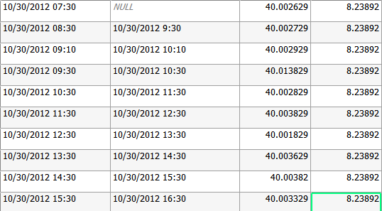

Notice the first record will never be shown if the second field is used, because the second field is empty. Also the second record will never disappear if the second field is end time because the time is not in right format (should be 09:30).

1. Input Settings

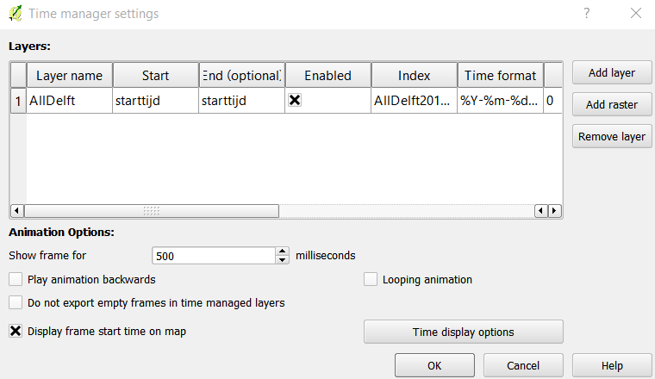

Click add layer, then the add-layer window:

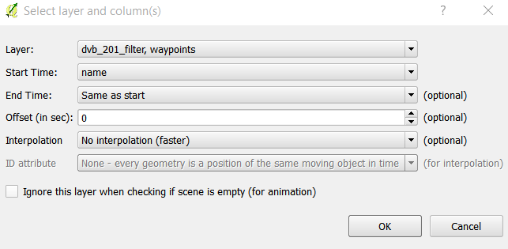

Here we can choose the start time which is necessary and end time which is optional. If the end time is the same as start, the features will pop up and disappear, if there is a field for end time, then the features will disappear at the end time, if the end time is no end time – accumulate features, the features will come out at start time and will never disappear.

1. Display setting

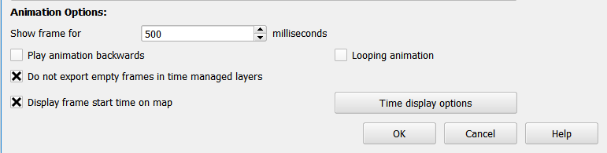

In animation options, here you can set some display settings. 500 milliseconds means the frame will refresh every 0.5 seconds.

Combine with this:



Then it means the frame will refresh every 0.5 seconds with a 10 minutes increment. With these two settings, you can decide the speed of the whole program.