9th International Conference on Computer Science and Computational Intelligence (ICCSCI 2024)
UI/UX Evaluation of Educational Games for Children: A Comparative Study between Prodigy and Matific
UI/UX Evaluation of Educational Games for Children: A Comparative Study between Prodigy and Matific
Muhammad iqbal, Fadhil Munzir, Reinert Yosua Rumagit, Galih Dea Pratama.
Computer Science Department, School of Computer Science, Bina Nusantara University, Jakarta 11480

Computer Science Department, School of Computer Science, Bina Nusantara University, Jakarta 11480Abstract
Abstract
This research paper presents a comparative analysis of the user interface (UI) and user experience (UX) of two prominent educational mathematics games: Prodigy and Matific. The study aims to assess the effectiveness of UI/UX design elements in facilitating mathematical learning among children. Through a comprehensive examination of qualitative and quantitative data, the research provides insights into the strengths and weaknesses of each game's UI/UX, informing educators, game developers, and parents about potential impacts on engagement and learning outcomes. The methodology involves user tests and surveys with a sample of young learners, assessing factors such as ease of navigation, visual appeal, educational effectiveness, and overall user satisfaction. By comparing features, interactivity, and educational content, the study contributes to designing effective educational games, with implications for improving future learning-oriented digital experiences iin educational games, enhancing educational experiences in mathematics.

Keywords:
- Introduction
In the contemporary educational landscape, digital platforms are increasingly utilized to enhance learning experiences, particularly through the gamification of educational content. Among these platforms, Prodigy and Matific stand out as prominent providers of math-focused educational games aimed at engaging young learners while promoting mathematical proficiency.

However, while both Prodigy and Matific share the common objective of facilitating math learning in children, disparities in their user interface (UI) and user experience (UX) design elements may significantly impact user engagement, motivation, and learning outcomes. Thus, this study undertakes a comparative analysis of the UI/UX features of Prodigy and Matific, aiming to elucidate insights into their respective strengths, weaknesses, and overall effectiveness as educational tools.
This research endeavors to address the following key inquiries:

How do the UI designs of Prodigy and Matific influence children's engagement and interaction with the games?
What distinctive UX features characterize Prodigy and Matific, and how do they contribute to the overall learning experience?
What implications do the UI/UX disparities between Prodigy and Matific hold for children's mathematical learning outcomes and academic motivation?

Through a systematic examination of UI elements, game mechanics, feedback mechanisms, and user interactions, this comparative study seeks to offer valuable insights into the design principles essential for crafting engaging and impactful educational games for young learners. Ultimately, the findings of this research endeavor aspire to inform educators, game developers, and stakeholders in the educational technology domain about effective strategies for designing enriching learning experiences for children in the digital era.
The present study employs a mixed-methods approach to assess and compare the UI/UX features of Prodigy and Matific. Firstly, a qualitative analysis will be conducted to examine the design elements, game mechanics, and feedback mechanisms of both platforms. This analysis will involve a thorough review of the platforms' interfaces, interactive features, visual aesthetics, and instructional components.
Subsequently, a quantitative evaluation will be undertaken to measure user engagement, satisfaction, and perceived learning outcomes. This quantitative analysis will entail the administration of structured questionnaires to a sample of participants who have used both Prodigy and Matific. The questionnaires will be designed to gather data on participants' preferences, experiences, and perceptions regarding the UI/UX aspects of each platform.
The respondents targeted for this study will primarily comprise parents, teachers, and students in primary education settings. Parents and teachers will provide valuable insights into the usability and educational efficacy of Prodigy and Matific from an observer's perspective, while students will offer direct feedback on their experiences interacting with the platforms.
The respondents will be selected through purposive sampling to ensure representation from diverse demographic backgrounds, including varying socio-economic status, geographical locations, and educational settings. Additionally, efforts will be made to include participants with varying levels of familiarity with digital learning platforms, ranging from novice users to those with extensive experience.
The questionnaire will consist of both closed-ended and open-ended questions to capture a comprehensive range of responses. Closed-ended questions will employ Likert scales to measure respondents' agreement or satisfaction levels with specific UI/UX features, while open-ended questions will allow participants to elaborate on their experiences and provide qualitative feedback.

The questionnaire will be structured into sections corresponding to different aspects of the UI/UX design, such as visual appeal, navigational ease, educational content quality, and overall user satisfaction. Additionally, demographic information will be collected to facilitate subgroup analyses and identify any potential correlations between respondent characteristics and platform preferences.

Overall, the methodology adopted in this study aims to provide a holistic understanding of the UI/UX features of Prodigy and Matific, incorporating both qualitative and quantitative perspectives to generate comprehensive insights into their comparative effectiveness as educational tools.

II. Research Methodology

2.1. Research Design
This study adopts a mixed-methods research design, combining qualitative and quantitative approaches to comprehensively analyze the UI/UX features of Prodigy and Matific. By integrating these methodologies, the research aims to provide a thorough understanding of the effectiveness of both platforms as educational tools.

2.2. Qualitative Analysis
The qualitative component involves a meticulous examination of the design elements, game mechanics, and feedback mechanisms of Prodigy and Matific. Through systematic review and analysis, this phase aims to uncover the underlying design principles and features inherent in the platforms. Established frameworks for evaluating educational technology and gamified learning environments guide this qualitative assessment, ensuring a robust examination of pertinent aspects.

2.3. Quantitative Evaluation
In the quantitative phase, structured questionnaires are administered to gather empirical data on user engagement, satisfaction, and perceived learning outcomes. This approach aims to quantify user perceptions and experiences regarding various aspects of the UI/UX features of Prodigy and Matific. Statistical techniques are employed to analyze the collected data and derive meaningful insights into the comparative effectiveness of the two platforms.

2.4. Participant Selection
Participants are purposively sampled to ensure representation from diverse demographic backgrounds and user groups, including parents, teachers, and students involved in primary education settings. Variability in familiarity and experience with digital learning platforms is considered to provide a balanced representation of perspectives.

2.5. Questionnaire Design
The questionnaire is thoughtfully designed to capture nuanced feedback on the UI/UX features of Prodigy and Matific. Structured questions with Likert-scale responses measure participants' agreement or satisfaction levels, while open-ended questions allow for qualitative insights and suggestions. Pilot testing ensures the clarity, relevance, and reliability of the questionnaire before administration.

2.6. Data Collection Procedure
Data collection involves distributing questionnaires electronically or via physical copies, considering participants' preferences and logistical constraints. Clear instructions are provided, emphasizing confidentiality and anonymity. Ethical guidelines, including informed consent and protection of participants' rights, are strictly adhered to throughout the process.

2.7. Data Analysis
Qualitative data obtained from platform analysis undergo thematic analysis to identify patterns and trends. Quantitative data from questionnaires are subjected to statistical analysis, including descriptive statistics and inferential techniques, to draw meaningful conclusions about UI/UX effectiveness.

2.8. Validity and Reliability
Validity and reliability are ensured through triangulation, member checking, and inter-rater reliability. Findings are corroborated across multiple sources and methods, and participant feedback is sought to validate interpretations. Independent coding and analysis by multiple researchers mitigate subjective bias.

2.9. Limitations
Acknowledgment of limitations, such as sample size constraints and potential biases, is crucial. Robust methodological procedures and transparent reporting are employed to mitigate these limitations and enhance the credibility of the findings.

2.10. Ethical Considerations
The study adheres to ethical principles, including informed consent, confidentiality, and voluntary participation. Participants' rights are protected throughout the research process, ensuring ethical integrity and respect for human subjects.

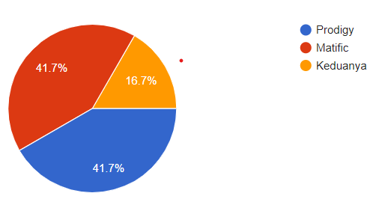
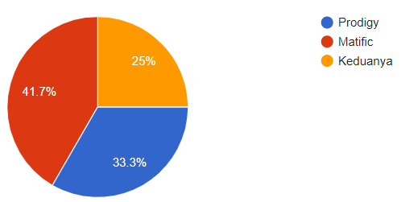
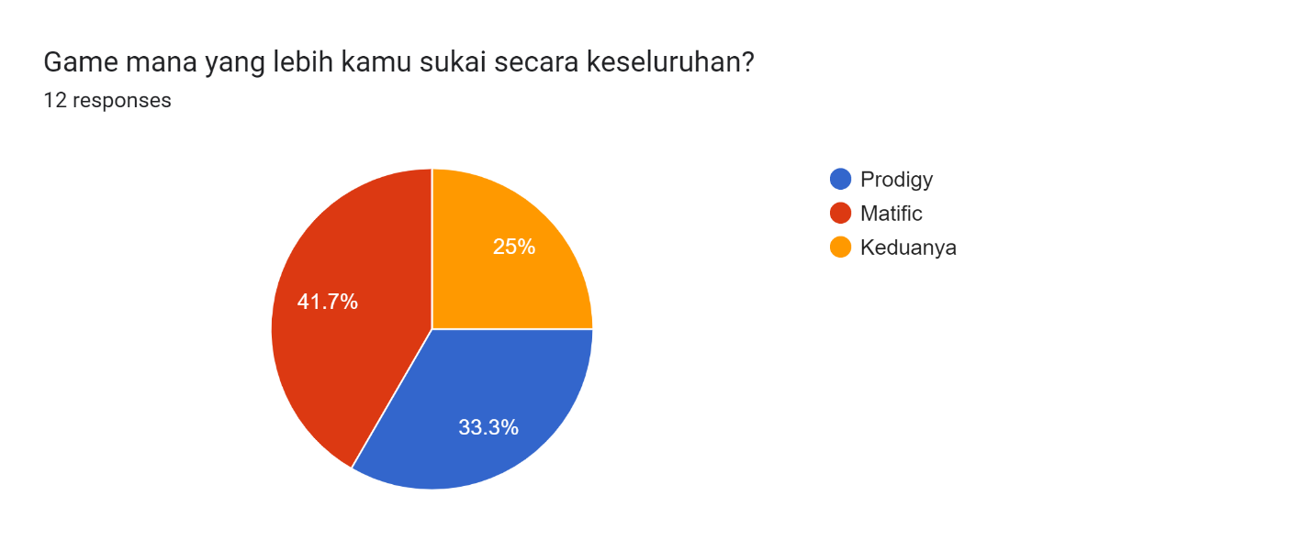

Fig. 1. (a) graph a ; (b) graph b

III. Results and Discussion

3.1 User Experience (UX) Evaluation

The findings reveal a notable preference for Matific in terms of user experience (UX), with 41.7% of the respondents favoring it over Prodigy. This preference suggests that Matific's UX design elements, such as game mechanics, feedback mechanisms, and user interactions, resonate more effectively with the young users, potentially enhancing their engagement and motivation in mathematical learning.
Graph A: UX Preference
- Matific: 41.7%
- Prodigy: 33.3%
- No Preference: 25%

Discussion
The higher preference for Matific's UX may be attributed to its interactive and engaging features that cater to the needs and preferences of the targeted age group. It indicates that Matific's UX design elements are more aligned with the expectations and preferences of children aged between 6-16 years old, contributing to a more immersive and enjoyable learning experience.

3.2 User Interface (UI) Evaluation
Interestingly, the UI preference between Prodigy and Matific is evenly split, with both receiving 41.7% of the votes. This suggests that both games have effectively designed UI elements that appeal to the young users, offering intuitive navigation and visual aesthetics that enhance the overall user experience.
Graph B: UI Preference
- Prodigy: 41.7%
- Matific: 41.7%
- No Preference: 16.7%

Discussion
The equal preference for Prodigy and Matific's UI underscores the importance of intuitive design and visual appeal in educational games. Both platforms seem to have successfully incorporated UI elements that facilitate easy navigation and provide a visually appealing environment, contributing to a positive user experience.

3.3 Comparative Analysis
The comparative analysis of Prodigy and Matific's UI/UX features reveals interesting insights into their respective strengths and weaknesses. While Matific excels in UX design, offering an engaging and interactive learning environment, both Prodigy and Matific are equally appreciated for their UI design, indicating a balance between functionality and aesthetics.

Discussion
The disparities in UX design between Prodigy and Matific highlight the significance of user-centered design in educational games. Tailoring UX elements to the specific needs and preferences of the target audience can significantly impact user engagement and learning outcomes. On the other hand, the similar UI preferences for both games emphasize the importance of intuitive design and visual appeal in creating enjoyable and accessible learning experiences.

IV. Conclusion
The comparative study between Prodigy and Matific provides valuable insights into the UI/UX design elements that influence children's engagement and learning experiences in educational games. While Matific demonstrates superior UX design, both games offer well-designed UI features that cater to the preferences of young users. These findings emphasize the importance of balancing functional and aesthetic design elements to create engaging and effective educational games for children.

Recommendations
Based on the findings, game developers and educators should prioritize user-centered design principles when developing educational games. Incorporating interactive and engaging UX features, along with intuitive and visually appealing UI elements, can enhance user engagement, motivation, and learning outcomes. Future research may explore additional factors, such as educational content quality and instructional design, to further refine and optimize the design of educational games for children.

References
[1] D. R. Olsen, R. B. Arthur, and SIGCHI (Group : U.S.), Proceedings of the 27th International Conference on Human Factors in Computing Systems : April 4-9, 2009, Boston, MA, USA. ACM Press, 2009.
[2] Z. Yu, M. Gao, and L. Wang, “The Effect of Educational Games on Learning Outcomes, Student Motivation, Engagement and Satisfaction,” Journal of Educational Computing Research, vol. 59, no. 3, pp. 522–546, Jun. 2021, doi: 10.1177/0735633120969214.
[3] V. Shute et al., “Maximizing learning without sacrificing the fun: Stealth assessment, adaptivity and learning supports in educational games,” J Comput Assist Learn, vol. 37, no. 1, pp. 127–141, Feb. 2021, doi: 10.1111/jcal.12473.
[4] C. Kidnet and M. Tapola, “Using Low-Tech Prototype to Study Children’s Preferences for UI Components,” 2023.
[5] T. H. Laine and R. S. N. Lindberg, “Designing Engaging Games for Education: A Systematic Literature Review on Game Motivators and Design Principles,” IEEE Transactions on Learning Technologies, vol. 13, no. 4, pp. 804–821, Oct. 2020, doi: 10.1109/TLT.2020.3018503.
[6] A. A. Razak and T. M. Connolly, “Using games-based learning: How it influences the learning experience and outcomes of primary school children,” International Journal of Emerging Technologies in Learning, vol. 8, no. SPL.ISSUE2, pp. 47–54, 2013, doi: 10.3991/ijet.v8iS2.2782.
[7] K. F. Whitmore, C. Angleton, J. Pruitt, and S. Miller-Crumes, “Putting a Focus on Social Emotional and Embodied Learning with the Visual Learning Analysis (VLA),” Early Child Educ J, vol. 47, no. 5, pp. 549–558, Sep. 2019, doi: 10.1007/s10643-019-00955-3.
[8] Z. Zainuddin and C. M. Keumala, “GAMIFICATION CONCEPT WITHOUT DIGITAL PLATFORMS: A STRATEGY FOR PARENTS ON MOTIVATING CHILDREN STUDY AT HOME DURING COVID-19 PANDEMIC,” Jurnal Pedagogik, vol. 08, no. 01, 2021, [Online]. Available: https://ejournal.unuja.ac.id/index.php/pedagogik
[9] A. Cetin and E. Y. Ince, “The Eurasia Proceedings of Educational & Social Sciences (EPESS) The Eurasia Proceedings of Educational Development of Educational Math Game,” & Social Sciences (EPESS), vol. 23, 2021, [Online]. Available: www.isres.org
[10] C. Y. Wong, C. W. Khong, and K. Chu, “Interface Design Practice and Education Towards Mobile Apps Development,” Procedia Soc Behav Sci, vol. 51, pp. 698–702, 2012, doi: 10.1016/j.sbspro.2012.08.227.

Click or tap here to enter text.

