Appendix
Balbina Zanon
10/02/2024
Table of Contents

Libraries setup
pacman::p_load("readxl", "tidyverse", "rio", "ggplot2", "pacman", "leaflet", "Metrics", "caret", "dplyr", "nloptr", "writexl", "openxlsx", "reshape2", "neuralnet", "nnet")

Importing the data
Before diving into the functions used and the optimization methods, we take a first view at the datasets that we have.
parties <- read.csv("parties_2.csv", sep = ";")
candidates <- read.csv("candidates_2.csv", sep = ";")

Function RxC_2
The function RxC_2 implements the solution without constraints using the Euclidean norm. This method’s goal is to adjust the proportions in a matrix that will relate rows and columns in a quadratic form for the Euclidean norm (Norm 2).
Where: - x: NxR matrix (data.frame) of observed row margins - y: NxC matrix (data.frame) of observed column margins
x <- parties
y <- candidates
## We create the RxC_function
RxC_2 <- function(x, y){
# matrix transformation
x <- as.matrix(x)
y <- as.matrix(y)
# dimension variables definition
N <- nrow(x) # number of observations (rows)
R <- ncol(x) # number of row categories (parties)
C <- ncol(y) # number of column categories (candidates)
# Initialization of results matrix to save outputs
TM <- matrix(NA, nrow = R, ncol = C) # matrix for categories results adjustments
TM.units <- array(NA, dim = c(R, C, N)) # to save the unitary adjust for each observation
# Weighted matrix xw of the systemof ecuations AA calculation
w <- 1/rowSums(x^2) # inverted weights based on the sum of the squares for each row in x
xw <- x*w # weighted matrix of x based on the weights
AA <- crossprod(x, xw) # quadratic product of x and xw (coefficients matrix for the system of equations)
# system of equations resolution
for (jj in 1L:C){
bb <- crossprod(xw, y[, jj]) # results vector of the weighted jj column in y
TM[, jj] <- solve(AA, bb) # solution of the lineal system for every jj column of y
}
return(TM)
}
RxC_2(x = parties, y = candidates)
## [,1] [,2] [,3] [,4] [,5]
## [1,] 0.330836581 0.16953352 0.76441505 -0.23904251 -0.025742641
## [2,] 0.029677096 -0.04057367 0.95259050 0.04843138 0.009874699
## [3,] 0.003848048 0.95440804 -0.09378202 0.06125912 0.074266811
## [4,] 0.100902122 0.33862193 0.21997886 0.09729668 0.243200406
A tm matrix is generated with the adjusted values of each category. These values are the best possible estimation of the necessary adjustments between x (observed rows margins) and y (observed columns margins) for this model without restrictions.
We obtain the marginals for every unit. With these marginals, the goal is to find the internal proportions/probabilities to the tables (the proportion of each party in each candidate and the probability of a party to vote an specific candidate)
Since the function doesn’t take into consideration the specific constraints of our problem, the he matrix shows negative proportions.

Function MDMC_RxC
The function MDMC_RxC implements the double generalization in terms of size of the table and the distance norm of the MDMC approach to ecological inference.
Where:
- x: NxR matrix (data.frame) of observed row margins
- y: NxC matrix (data.frame) of observed column margins
- alfa.norm: A positive real number defining the norm to be used in the optimization problem. For instance, alpha.norm = 2 entails an Euclidean distance and alpha.norm = 1 a absolute distance distance.
- weights: Weights to be used to ponder the distance to the different units in the restricted minimization problem. It could be either a vector of length N, a matrix of order NxR, or a character string from the set {“constant”, “size”, “row”}. When weights is a vector of length N all the coordinates of each unit receive the same weight. (For instance, when weights = “size” the number of votes of each unit is used as weight). When weights is a matrix of size NxR the rth coordinate of the ith unit receives as weight the (i,r) cell of the matrix. (For instance, using weights = “row” is equivalent to define weights as the matrix x).
The following function: - Turns incog in a matrix with the shape of weights. - Calculates the weights as a normalized version of weights. - Calculates averages as the weighted average of incog.m using alpha.norm - Calculate resid, the sum of the weighted errors raised to the power of alpha.norm.
MDMC_RxC <- function(x, y, alpha.norm = 2, weights = "constant"){
}
# Base function to define the objective function
f_obj <- function(incog, alpha.norm, weights){
# incog: vector of order N*R of unit proportions: p_ir
# weights: matrix of order NxR of with the weight to be assigned to each discrepancy
if (alpha.norm != 1L){
incog.m <- matrix(incog, nrow = nrow(weights), byrow = TRUE)
pesos <- t(weights) / rowSums(t(weights))
medias <- (rowSums(pesos * t(incog.m ^ (alpha.norm - 1)))) ^ (1/(alpha.norm - 1))
resid <- sum( pesos * (t(incog.m) - medias) ^ alpha.norm )
} else {
# Norm 1: absolute value
}
return(resid)
}
Now, we define a simplified version of f_obj that only requires the argument zz, by directly using alpha.norm and weights.
fobj <- function(zz){
f_obj(incog = zz,
alpha.norm = alpha.norm,
weights = weights)
}

Optimization based on Rsolnp::solnp
This is the optimization for each column using rsolp. It minimizes the objective function for each jj column of y, by generating adjusted proportions for each unit in x with constraints and optimization.
optimizacion_column_solnp <- function(x, jj, alpha.norm, weights){
nr <- ncol(x) # Number of rows
nu <- nrow(x) # Number of units
# Constraint of proportion values between 0 and 1
yj <- y[, jj]
# lower and upper constraints
lb <- rep(0, nr*nu)
ub <- rep(1, nr*nu)
# Constraints
A <- NULL
for (ii in 1:nrow(x)){
e <- rep(0, nrow(x))
e[ii] <- 1
A <- rbind(A, kronecker(e, x[ii, ]))
}
B <- as.numeric(yj)
eval_g_eq <- function(zz){
return ( as.numeric(A %*% zz - B))
}
sol <- Rsolnp::solnp(pars = runif(nr * nu),
fun = fobj,
eqfun = eval_g_eq,
eqB = rep(0, nu),
LB = lb,
UB = ub,
control = list("rho" = 10,
inner.iter = 2000,
outer.iter = 5,
tol = 1e-4,
trace = 0))
prop <- matrix(sol$pars, nr, nu, byrow = FALSE)
return(prop)
}
Execution of the optimization for all the columns of y
alpha.norm <- 2
x <- as.matrix(parties)
weights <- matrix(1, nrow = nrow(x), ncol = ncol(x))
# weights <- x
y <- as.matrix(candidates)
nr <- ncol(x) # Number of rows
nu <- nrow(x) # Number of units
nc <- ncol(y) # Number of columns
prop.units <- array(NA, dim = c(nr, nc, nu))
for (jj in 1L:nc){
prop.units[, jj, ] <- optimizacion_column_solnp(x = x,
jj = jj,
alpha.norm = alpha.norm,
weights = weights)
}
This applies the optimization of optimization_column_solnp to every jj column of y, saving the proportions in the prop.units array.
Now, we minimize the error to each of the specific jj columns in y, by returning the adjusted matrix proportion of x with the necessary constraints.
The initial proportions that will be optimized are established. It will call the function RxC_2, making sure that the x0 values are between 0 and 1 and it repeats x0 for every unit (row) of x.
print(prop.units[1:4, 1:5, 1])
## [,1] [,2] [,3] [,4] [,5]
## [1,] 0.10748709 0.22326689 0.47663014 0.01550565 0.02371368
## [2,] 0.08233324 0.03252309 0.87466982 0.11862305 0.08717944
## [3,] 0.04272856 0.41209142 0.04916488 0.05264776 0.05571501
## [4,] 0.04509422 0.09967231 0.39586371 0.02455106 0.03692743
The last column shows problems by having missing values.
alpha.norm <- 2
x <- as.matrix(parties)
weights <- matrix(1, nrow = nrow(x), ncol = ncol(x))
weights <- x
y <- as.matrix(candidates)
jj <- 3 ## initially, we will work with only a 3x3 matrix (the we will have to try for more and see if the program overloads because of too much data)
optimizacion_column <- function(x, jj, alpha.norm, weights){
nr <- ncol(x) # Number of rows
nu <- nrow(x) # Number of units
# x0 <- runif(nr * nu) # matrix of initial initial proportions
x0 <- RxC_2(x = x, y = y)[, jj]
x0[x0 < 0] <- 0
x0[x0 > 1] <- 1
x0 <- rep(x0, nu)
yj <- y[, jj]
# lower and upper constraints
# restricciones de límites
lb <- rep(0L, nr*nu)
ub <- rep(1L, nr*nu)
fobj <- function(zz){
f_obj(incog = zz,
alpha.norm = alpha.norm,
weights = weights)
}
# Constraints
A <- NULL
for (ii in 1:nrow(x)){
e <- rep(0, nrow(x))
e[ii] <- 1
A <- rbind(A, kronecker(e, x[ii, ]))
}
B <- yj # it defines the yj column, making sure that the sum of the proportions in A are equal to each value in yj
sol <- NlcOptim::solnl(X = x0,
objfun = fobj,
Aeq = A,
Beq = B,
lb = lb,
ub = ub)
round(sol$par*100, 2)
sol$fn
prop <- matrix(sol$par, nr, nu, byrow = FALSE)
# votes <- prop*t(kronecker(vector.fila, rep(1L, nc)))
return(list("m.prop" = prop, "m.votes" = votes))
}
This makes the optimizated proportions vector in a prop matrix with nr rows and nu columns.
The following function will optimize the proportions of jj column in y by adjusting the values in x under norm 2 and the weights.
alpha.norm <- 2
x <- apply(as.matrix(parties), 2, as.numeric)
weights <- matrix(1, nrow = nrow(x), ncol = ncol(x))
# weights <- x
y <- as.matrix(candidates)
jj <- 3 # column 3 of y, specifying the column in which the optimization is focused
optimizacion_column_v2 <- function(x, jj, alpha.norm, weights){
nr <- ncol(x) # Number of rows
nu <- nrow(x) # Number of units
x0 <- RxC_2(x = x, y = y)
x0[x0 < 0] <- 0
x0[x0 > 1] <- 1
x0 <- (x0/rowSums(x0))[,jj]
x0 <- rep(x0, nu) + runif(nu, -0.05, 0.05)
x0[x0 < 0] <- 0
x0[x0 > 1] <- 1
# x0 <- runif(nr * nu) # matrix of initial initial proportions
yj <- y[, jj]
# lower and upper constraints
lb <- rep(0, nr*nu)
ub <- rep(1, nr*nu)
fobj <- function(zz){ # to calculate the error
f_obj(incog = zz,
alpha.norm = alpha.norm,
weights = weights)
}
# Constraints
A <- NULL
for (ii in 1:nrow(x)){
e <- rep(0, nrow(x))
e[ii] <- 1
A <- rbind(A, kronecker(e, x[ii, ]))
}
B <- as.numeric(yj)
eval_g_eq <- function(zz){
return ( as.numeric(A %*% zz - B))
}
# Set optimization options.
local_opts <- list( "algorithm" = "NLOPT_LD_MMA",
"xtol_rel" = 1.0e-05 )
opts <- list( "algorithm" = "NLOPT_GN_ISRES",
"xtol_rel" = 1.0e-5,
"maxeval" = 10^5,
"tol_constraints_eq" = rep(1.0e-05, nu),
"local_opts" = local_opts
)
# use nloptr with specific algorithms to solve the restricted problem, we obtain sol with eval_f = fobj and the constraints
sol <- nloptr::nloptr(x0 = runif(nr * nu),
eval_f = fobj,
eval_g_eq = eval_g_eq,
lb = lb,
ub = ub,
opts = opts)
prop <- matrix(sol$solution, nr, nu, byrow = FALSE)
sol2 <- Rsolnp::solnp(pars = runif(nr * nu),
fun = fobj,
eqfun = eval_g_eq,
eqB = rep(0, nu),
LB = lb,
UB = ub,
control = list("rho" = 10,
inner.iter = 2000,
outer.iter = 5))
prop2 <- matrix(sol2$pars, nr, nu, byrow = FALSE)
}
nr <- ncol(x) # Number of rows
nu <- nrow(x) # Number of units
x0 <- RxC_2(x = x, y = y)
x0[x0 < 0] <- 0
x0[x0 > 1] <- 1
x0 <- (x0/rowSums(x0))[,jj]
x0 <- rep(x0, nu) + runif(nu, -0.05, 0.05)
x0[x0 < 0] <- 0
x0[x0 > 1] <- 1
# x0 <- runif(nr * nu) # matrix of initial initial proportions
yj <- y[, jj]
lb <- rep(0, nr*nu)
ub <- rep(1, nr*nu)
A <- NULL
for (ii in 1:nrow(x)){
e <- rep(0, nrow(x))
e[ii] <- 1
A <- rbind(A, kronecker(e, x[ii, ]))
}
B <- as.numeric(yj)
eval_g_eq <- function(zz){
return ( as.numeric(A %*% zz - B))}
local_opts <- list( "algorithm" = "NLOPT_LD_MMA",
"xtol_rel" = 1.0e-05 )
opts <- list( "algorithm" = "NLOPT_GN_ISRES",
"xtol_rel" = 1.0e-5,
"maxeval" = 10^5,
"tol_constraints_eq" = rep(1.0e-05, nu),
"local_opts" = local_opts
)
sol <- nloptr::nloptr(x0 = x0,
eval_f = fobj,
eval_g_eq = eval_g_eq,
lb = lb,
ub = ub,
opts = opts)
prop <- matrix(sol$solution, nr, nu, byrow = FALSE)
print(prop)
## [,1] [,2] [,3] [,4] [,5] [,6] [,7]
## [1,] 0.6263484 0.6527927 0.5569247 0.6335919 0.6402861 0.6383347 0.5981139
## [2,] 0.9583068 0.9381510 0.8666998 0.8683872 0.9635130 0.9290160 0.8998678
## [3,] 0.0000000 0.0000000 0.0000000 0.0000000 0.0000000 0.0000000 0.0000000
## [4,] 0.2351090 0.2135469 0.2123208 0.1787255 0.1995237 0.1777876 0.1938790
## [,8] [,9] [,10] [,11] [,12] [,13] [,14]
## [1,] 0.5775688 0.58587128 0.6514303 0.65112704 0.62718524 0.5611174 0.58915264
## [2,] 0.8707893 0.92603830 0.9199543 0.92543272 0.93631060 0.8798786 0.89949197
## [3,] 0.0000000 0.02831521 0.0107228 0.03930891 0.01116292 0.0000000 0.02918181
## [4,] 0.2402108 0.19137601 0.1992264 0.19196917 0.24966994 0.2161029 0.18109724
## [,15] [,16] [,17] [,18] [,19] [,20] [,21]
## [1,] 0.5969881 0.6479777 0.556893304 0.60773292 0.6264935 0.6141124 0.61937700
## [2,] 0.9648241 0.8947691 0.876477374 0.86868805 0.9424532 0.9253606 0.93594457
## [3,] 0.0000000 0.0000000 0.003111628 0.01001112 0.0000000 0.0000000 0.03917342
## [4,] 0.2467979 0.2304975 0.172416656 0.18299770 0.2543562 0.2360350 0.25874583
## [,22] [,23] [,24] [,25] [,26] [,27] [,28]
## [1,] 0.56749128 0.61951341 0.5979514 0.5967252 0.56312992 0.58392812 0.5621921
## [2,] 0.93741253 0.96385685 0.8679888 0.9446560 0.95135019 0.94939883 0.9091780
## [3,] 0.04285932 0.02270354 0.0000000 0.0000000 0.04806559 0.01356852 0.0000000
## [4,] 0.19010904 0.20014826 0.2188375 0.1754452 0.17786520 0.20383893 0.1760369
## [,29] [,30] [,31] [,32] [,33] [,34] [,35]
## [1,] 0.5782835 0.62461531 0.575780462 0.58363086 0.57637363 0.6340744 0.6005074
## [2,] 0.8886330 0.89693539 0.962494398 0.96219116 0.93824936 0.8721815 0.9002168
## [3,] 0.0000000 0.01059087 0.004506885 0.00998529 0.02086316 0.0000000 0.0000000
## [4,] 0.2120906 0.24829407 0.230701658 0.25928777 0.23114178 0.1995663 0.2491607
## [,36] [,37] [,38] [,39] [,40] [,41] [,42]
## [1,] 0.56550170 0.6312024 0.6149019 0.5568211 0.56740216 0.638760683 0.62043946
## [2,] 0.90805223 0.9590418 0.8679574 0.9187970 0.93755758 0.925176494 0.93044112
## [3,] 0.04937667 0.0000000 0.0000000 0.0000000 0.02700576 0.009913187 0.02049714
## [4,] 0.19272890 0.1720080 0.2230905 0.2299900 0.18175426 0.186617528 0.25915228
## [,43] [,44] [,45] [,46] [,47] [,48] [,49]
## [1,] 0.6431503 0.57451350 0.5845527 0.60324192 0.55984963 0.56226966 0.5882434
## [2,] 0.8785554 0.93057753 0.9090155 0.90778936 0.87419404 0.89499223 0.8732562
## [3,] 0.0219651 0.04840941 0.0000000 0.02920856 0.03590276 0.03395139 0.0000000
## [4,] 0.2628382 0.24268240 0.1712312 0.17291864 0.26804446 0.23354738 0.2043993
## [,50] [,51] [,52] [,53] [,54] [,55] [,56]
## [1,] 0.5604414 0.5964951 0.63269853 0.61510612 0.64369223 0.6155462 0.5839707
## [2,] 0.8893476 0.9356794 0.88684458 0.89469497 0.88743774 0.9451385 0.9115715
## [3,] 0.0000000 0.0000000 0.04704696 0.04674372 0.02280193 0.0000000 0.0000000
## [4,] 0.1753208 0.2305697 0.22448575 0.22996415 0.24084203 0.1844101 0.2040234
## [,57] [,58] [,59] [,60] [,61] [,62]
## [1,] 0.6335651 0.5771334 0.5564124 0.607494947 0.61439444 0.566158716
## [2,] 0.8765658 0.9422665 0.9259660 0.867885227 0.87846627 0.949824798
## [3,] 0.0000000 0.0435944 0.0000000 0.003349597 0.02211015 0.009729061
## [4,] 0.2693555 0.1993006 0.1810088 0.173219482 0.24698462 0.229892049
## [,63] [,64] [,65] [,66] [,67] [,68] [,69]
## [1,] 0.57102198 0.6435567 0.6472426 0.6270869 0.5556357 0.5573231 0.6524489
## [2,] 0.93150358 0.9542144 0.8855776 0.8956168 0.9143060 0.8709137 0.8733338
## [3,] 0.01499368 0.0000000 0.0151301 0.0000000 0.0000000 0.0000000 0.0000000
## [4,] 0.24047600 0.2419440 0.2683883 0.1725202 0.2491874 0.2558816 0.2539303
## [,70] [,71] [,72] [,73] [,74] [,75] [,76]
## [1,] 0.6179518 0.5888037 0.55972521 0.6149742 0.6088902 0.6143686 0.62524648
## [2,] 0.8993075 0.8715055 0.90755921 0.9437626 0.9261702 0.9547563 0.92661035
## [3,] 0.0000000 0.0000000 0.02023199 0.0000000 0.0000000 0.0000000 0.02969108
## [4,] 0.2137095 0.1931644 0.20146682 0.2670258 0.2667226 0.2427808 0.17671292
## [,77] [,78] [,79] [,80] [,81] [,82] [,83]
## [1,] 0.5688145 0.5884279 0.65375999 0.58370501 0.5654133 0.5576239 0.63138908
## [2,] 0.8950349 0.9446292 0.88819747 0.86747653 0.9185591 0.9254586 0.87722283
## [3,] 0.0000000 0.0000000 0.02681903 0.01051862 0.0000000 0.0000000 0.03437736
## [4,] 0.2047482 0.2125837 0.26357326 0.17248885 0.2233285 0.2420890 0.22970792
## [,84] [,85]
## [1,] 0.61429651 0.62488046
## [2,] 0.88208610 0.95462085
## [3,] 0.01605615 0.03876696
## [4,] 0.23497255 0.18308683

Graphic Results

Visualizations for RxC_2
# We execute the RxC_2 function to obtain the proportions matrix
tm_matrix <- RxC_2(x = parties, y = candidates)
# long format
tm_df <- melt(tm_matrix)
colnames(tm_df) <- c("Party", "Candidate", "Proportion")
# factorizing
tm_df$Party <- as.factor(tm_df$Party)
tm_df$Candidate <- as.factor(tm_df$Candidate)
# Heatmap of the proportions
ggplot(tm_df, aes(x = Candidate, y = Party, fill = Proportion)) +
geom_tile(color = "white") +
scale_fill_gradient2(low = "blue", mid = "white", high = "red", midpoint = 0) +
labs(title = "Heatmap of the Adjusted Proportions - RxC_2 Function",
x = "Candidates",
y = "Parties",
fill = "Proportion") +
theme_minimal()
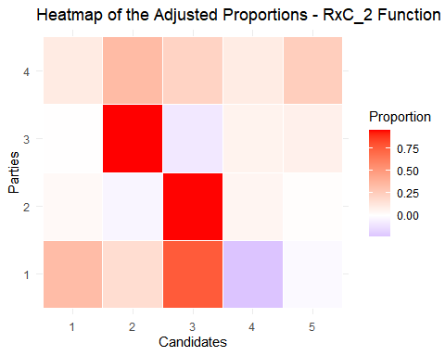
With this heatmap we can see how each party is vinculated to each candidate by following the RxC_2 Function.
Visually, we can also see it through a barplot, where we can see the proportion of each paty in each candidate:
# Normalize the data
tm_df$Proportion <- tm_df$Proportion / ave(tm_df$Proportion, tm_df$Candidate, FUN = sum)
# Barplot
ggplot(tm_df, aes(x = Candidate, y = Proportion, fill = Party)) +
geom_bar(stat = "identity", position = "fill") +
labs(title = "Distribution of the proportions per candidate - RxC_2 Function",
x = "Candidates",
y = "Proportions",
fill = "Parties") +
theme_minimal()
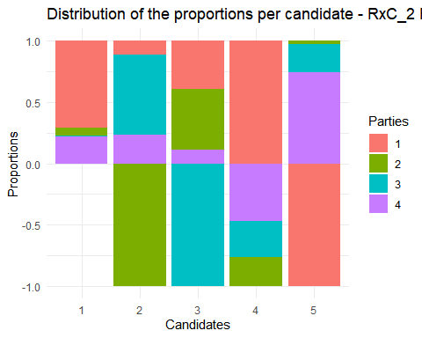

Visualizations for MDMC_RxC
f_obj <- function(incog, alpha.norm, weights){
if (alpha.norm != 1L) {
incog.m <- matrix(incog, nrow = nrow(weights), byrow = TRUE)
pesos <- t(weights) / rowSums(t(weights))
medias <- (rowSums(pesos * t(incog.m ^ (alpha.norm - 1)))) ^ (1/(alpha.norm - 1))
resid <- sum(pesos * (t(incog.m) - medias) ^ alpha.norm)
} else {
stop("Norm 1 not yet implemented")
}
return(resid)
}
MDMC_RxC <- function(x, y, alpha.norm = 2, weights = "constant") {
x <- as.matrix(x)
y <- as.matrix(y)
N <- nrow(x)
R <- ncol(x)
C <- ncol(y)
TM <- matrix(NA, nrow = R, ncol = C)
if (weights == "constant") {
weights <- matrix(1, nrow = N, ncol = R)
} else if (weights == "size") {
weights <- x
} else if (weights == "row") {
weights <- x
}
for (jj in 1:C) {
bb <- crossprod(x, y[, jj])
TM[, jj] <- solve(crossprod(x, x), bb)
}
return(TM)
}
parties <- read.csv("parties_2.csv", sep = ";")
candidates <- read.csv("candidates_2.csv", sep = ";")
result_mdmc <- MDMC_RxC(parties, candidates, alpha.norm = 2, weights = "constant")
print(result_mdmc)
## [,1] [,2] [,3] [,4] [,5]
## [1,] 0.398531434 0.01826934 0.68144968 0.007220295 -0.105470751
## [2,] 0.006218634 -0.02983327 0.95775734 0.058250601 0.007606701
## [3,] -0.071020061 1.18312037 -0.09227891 -0.016214883 -0.003606524
## [4,] 0.331210605 0.04696760 0.15060043 0.102955321 0.368266037
result_mdmc_df <- melt(result_mdmc)
colnames(result_mdmc_df) <- c("Party", "Candidate", "Proportion")
# barplot
ggplot(result_mdmc_df, aes(x = Candidate, y = Proportion, fill = Party)) +
geom_bar(stat = "identity", position = "dodge") +
labs(title = "Adjusted proportions per party and candidate",
x = "Candidates",
y = "Proportions",
fill = "Parties") +
theme_minimal()
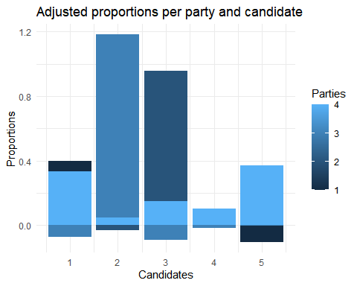

Visualizations for Rsolnp::solnp
optimizacion_column_solnp <- function(x, jj, alpha.norm, weights){
nr <- ncol(x)
nu <- nrow(x)
yj <- y[, jj]
lb <- rep(0, nr * nu)
ub <- rep(1, nr * nu)
A <- NULL
for (ii in 1:nrow(x)){
e <- rep(0, nrow(x))
e[ii] <- 1
A <- rbind(A, kronecker(e, x[ii, ]))
}
B <- as.numeric(yj)
eval_g_eq <- function(zz){
return(as.numeric(A %*% zz - B))
}
sol <- Rsolnp::solnp(pars = runif(nr * nu),
fun = fobj,
eqfun = eval_g_eq,
eqB = rep(0, nu),
LB = lb,
UB = ub,
control = list("rho" = 10,
inner.iter = 2000,
outer.iter = 5,
tol = 1e-4,
trace = 0))
prop <- matrix(sol$pars, nr, nu, byrow = FALSE)
return(prop)
}
# For optimization
alpha.norm <- 2
x <- as.matrix(parties)
weights <- matrix(1, nrow = nrow(x), ncol = ncol(x))
y <- as.matrix(candidates)
nr <- ncol(x)
nu <- nrow(x)
nc <- ncol(y)
prop.units <- array(NA, dim = c(nr, nc, nu))
for (jj in 1:nc){
prop.units[, jj, ] <- optimizacion_column_solnp(x = x,
jj = jj,
alpha.norm = alpha.norm,
weights = weights)
}
# long format
prop_df <- melt(prop.units[,,1])
colnames(prop_df) <- c("Party", "Candidate", "Proportion")
# barplot
ggplot(prop_df, aes(x = Candidate, y = Proportion, fill = Party)) +
geom_bar(stat = "identity", position = "dodge") +
labs(title = "Adjusted Proportions per party and candidate",
x = "Candidates",
y = "Proportions",
fill = "Parties") +
theme_minimal()
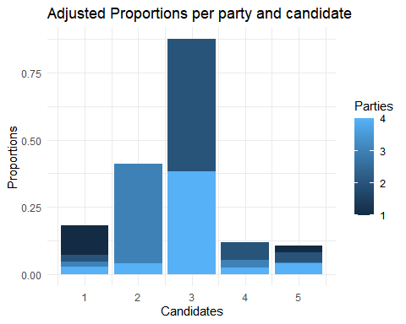

Refinement Case RxC_2
logarithmic_change_variables <- function(x, y, prop_units) {
R <- length(x) # number of units (85)
C <- length(y) # number of candidates (5)
P <- dim(prop_units)[1] # number of parties (4)
# Beta matrix to save the results
beta <- array(0, dim = c(P, C - 1, R)) # (parties x candidates-1 x units)
# Beta matrix with the prop.units values as starting point
for (i in 1:R) {
for (j in 1:(C - 1)) { # From 1 to C-1 to work on the first C-1 candidates
for (p in 1:P) {
# logarithmic change
# prop_units[p, j, i] is the value to the party p, candidate j, unit i
# prop_units[p, C, i] is the value to the party p, last candidate C, unit i
beta[p, j, i] <- log(prop_units[p, j, i] / prop_units[p, C, i]) # Index C-1 because we have 5 candidates
}
}
}
# Calculate P_rj and P_rc
P_rj <- array(0, dim = c(C - 1, R)) # P_rj for each candidate, for all the units
P_rc <- array(0, dim = c(1, R)) # P_rc for each unit
for (i in 1:R) {
for (j in 1:(C - 1)) {
# Calculate P_rj based on the beta values
P_rj[j, i] <- exp(beta[1, j, i]) / (1 + sum(exp(beta[, j, i]))) # to P_rj
}
# Calculate P_rc for the last candidate (C-1) in each unit
P_rc[1, i] <- 1 / (1 + sum(exp(beta[, C-1, i]))) # to P_rc (last candidate)
}
return(list(beta = beta, P_rj = P_rj, P_rc = P_rc))
}
# Example call to the function
result <- logarithmic_change_variables(x, y, prop.units) ## dimension error
## Error in prop_units[p, C, i]: subíndice fuera de los límites
# We can access to the results as following:
beta_result <- result$beta
## Error: objeto 'result' no encontrado
P_rj_result <- result$P_rj
## Error: objeto 'result' no encontrado
P_rc_result <- result$P_rc
## Error: objeto 'result' no encontrado

Test: Reduction of dimensions for the refinement case function
# Select the first two parties (columns of x) and two candidates (columns of y)
x2 <- x[, 1:2] # First two parties (columns 1 and 2 of x)
y2 <- y[, 1:2] # First two candidates (columns 1 and 2 of y)
# Filter the `prop.units` array for two parties and two candidates
prop_units2 <- prop.units[1:2, 1:2, ] # First two parties, first two candidates across all units
result <- logarithmic_change_variables(x2, y2, prop_units2) ## still obtain the same dimension error
## Error in prop_units[p, C, i]: subíndice fuera de los límites

Analysis of the Efficiency of Weighting in the Solution
Let’s save the information from prop.units into a dataframe that we could export.
# Assuming 'prop.units' is already your 3D matrix with dimensions (4, 5, 85)
R <- dim(prop.units)[1] # Number of parties (rows)
C <- dim(prop.units)[2] # Number of candidates (columns)
N <- dim(prop.units)[3] # Number of units
# Initialize a new Excel workbook
wb <- createWorkbook()
# Add a worksheet to the workbook
addWorksheet(wb, "Proportions")
# Starting row in the Excel sheet
start_row <- 1
# Loop through each unit (N units in total)
for (i in 1:N) {
# Extract the current unit's matrix (4x5)
unit_matrix <- prop.units[,,i]
# Write the unit matrix to the Excel sheet
writeData(wb, sheet = "Proportions", unit_matrix, startRow = start_row, startCol = 1, rowNames = TRUE, colNames = TRUE)
# Update the start row for the next unit by adding the number of rows in this unit (R) + 3 empty rows
start_row <- start_row + R + 3
}
# Save the workbook to a file
saveWorkbook(wb, "prop_units.xlsx", overwrite = TRUE)

Neural Network Optimization

Step 1: Revise the data and normalize
# We make sure that the rows are normalized
normalize_rows <- function(mat) {
row_sums <- rowSums(mat)
return(sweep(mat, 1, row_sums, "/"))
}
x <- normalize_rows(x)
y <- normalize_rows(y)
# Verify the dimensions and proportions to see that everything is correct
print(dim(x)) # Dimensions of parties (N x R)
## [1] 85 4
print(dim(y)) # Dimensions of candidates (N x C)
## [1] 85 5
print(rowSums(x)) # Rows must sum 1
## [1] 1 1 1 1 1 1 1 1 1 1 1 1 1 1 1 1 1 1 1 1 1 1 1 1 1 1 1 1 1 1 1 1 1 1 1 1 1 1
## [39] 1 1 1 1 1 1 1 1 1 1 1 1 1 1 1 1 1 1 1 1 1 1 1 1 1 1 1 1 1 1 1 1 1 1 1 1 1 1
## [77] 1 1 1 1 1 1 1 1 1
print(rowSums(y)) # Rows must sum 1
## [1] 1 1 1 1 1 1 1 1 1 1 1 1 1 1 1 1 1 1 1 1 1 1 1 1 1 1 1 1 1 1 1 1 1 1 1 1 1 1
## [39] 1 1 1 1 1 1 1 1 1 1 1 1 1 1 1 1 1 1 1 1 1 1 1 1 1 1 1 1 1 1 1 1 1 1 1 1 1 1
## [77] 1 1 1 1 1 1 1 1 1

Step 2: Combine the matrixes
So each row will be an observation and each column will be the proportions for parties and candidates.
data <- as.data.frame(cbind(x, y))
# We add names to the columns so it's clearer
colnames(data) <- c(paste0("Party_", 1:ncol(x)), paste0("Candidate_", 1:ncol(y)))
# Verify the combined data
head(data)
## Party_1 Party_2 Party_3 Party_4 Candidate_1 Candidate_2
## 1 0.07272727 0.6363636 0.25454545 0.03636364 0.07272727 0.14545455
## 2 0.03703704 0.5370370 0.35185185 0.07407407 0.01851852 0.38888889
## 3 0.01063830 0.8914894 0.02765957 0.07021277 0.02340426 0.02553191
## 4 0.01038062 0.8858131 0.02768166 0.07612457 0.02076125 0.03460208
## 5 0.00000000 0.8947368 0.05263158 0.05263158 0.00000000 0.05263158
## 6 0.00000000 1.0000000 0.00000000 0.00000000 0.00000000 0.00000000
## Candidate_3 Candidate_4 Candidate_5
## 1 0.6181818 0.09090909 0.07272727
## 2 0.5185185 0.05555556 0.01851852
## 3 0.8744681 0.04468085 0.03191489
## 4 0.8754325 0.03114187 0.03806228
## 5 0.8947368 0.05263158 0.00000000
## 6 0.8333333 0.00000000 0.16666667

Step 3: Split the data into training and test set
# 80% for training and 20% for test set
set.seed(123)
trainIndex <- createDataPartition(data$Candidate_1, p = 0.8, list = FALSE)
train <- data[trainIndex, ]
test <- data[-trainIndex, ]

Step 4: Neural Network Formula
f <- as.formula(paste(paste0("Candidate_", 1:C, collapse = " + "), "~", paste0("Party_", 1:R, collapse = " + ")))

Step 5: Train the Neural Network
Using the neuralnet package, we add 5 neurons in the hidden layer to the model.
# Training the NN
set.seed(123)
nn <- neuralnet(f,
data = train,
hidden = c(5), # 5 neurons on the hidden layer
linear.output = TRUE)
We can see the network as follows:
plot(nn)

Step 6: Model evaluation
With the test set we predict the candidates proportions and evaluate the model precision.
# Predictions on the test set
predictions <- compute(nn, test[, paste0("Party_", 1:R)])
# Results
predicted_values <- as.data.frame(predictions$net.result)
colnames(predicted_values) <- paste0("CandidatePred_", 1:C)
# We create a comparison dataframe
comparison <- cbind(predicted_values, test[, paste0("Candidate_", 1:C)])
colnames(comparison)[(C + 1):(2 * C)] <- paste0("CandidateReal_", 1:C)
print(head(comparison))
## CandidatePred_1 CandidatePred_2 CandidatePred_3 CandidatePred_4
## 3 0.03703648 0.03044928 0.8569306 0.04730304
## 13 0.04995171 0.22215070 0.6209738 0.04380630
## 18 0.05747798 0.13694143 0.7201767 0.03232633
## 19 0.03777076 0.10967661 0.7718173 0.03762559
## 25 0.03989775 0.04004180 0.8419376 0.04577549
## 27 0.07039354 0.25117343 0.5727496 0.04113552
## CandidatePred_5 CandidateReal_1 CandidateReal_2 CandidateReal_3
## 3 0.03197091 0.02340426 0.02553191 0.8744681
## 13 0.05864677 0.05723906 0.28282828 0.5858586
## 18 0.05054182 0.12500000 0.12500000 0.7083333
## 19 0.03809711 0.03030303 0.11688312 0.7705628
## 25 0.03517138 0.02968460 0.03153989 0.8775510
## 27 0.06839793 0.05263158 0.42105263 0.4736842
## CandidateReal_4 CandidateReal_5
## 3 0.04468085 0.03191489
## 13 0.02020202 0.05387205
## 18 0.04166667 0.00000000
## 19 0.04761905 0.03463203
## 25 0.03153989 0.02968460
## 27 0.00000000 0.05263158
# We calculate the Mean Squared Error for all the candidates
for (i in 1:C) {
mse <- mean((comparison[[paste0("CandidateReal_", i)]] - comparison[[paste0("CandidatePred_", i)]])^2)
print(paste("Mean Squared Error (Candidate", i, "):", mse))
}
## [1] "Mean Squared Error (Candidate 1 ): 0.000578022924669474"
## [1] "Mean Squared Error (Candidate 2 ): 0.00309575642304156"
## [1] "Mean Squared Error (Candidate 3 ): 0.0021619173121691"
## [1] "Mean Squared Error (Candidate 4 ): 0.000757828224838596"
## [1] "Mean Squared Error (Candidate 5 ): 0.000483775088049238"

Step 7: Adjust the Neural Network
We add another hidden layer with 10 neurons and make more iterations so the model can improve.
nn_optimized <- neuralnet(f,
data = train,
hidden = c(10, 5),
linear.output = TRUE,
stepmax = 1e6)

Step 8: Visualize the results
Finally, let’s see the results obtained:
The final optimized neural network looks like this:
plot(nn_optimized)
The results for the new predictions:
predictions2 <- compute(nn_optimized, test[, paste0("Party_", 1:R)])
predicted_values2 <- as.data.frame(predictions2$net.result)
colnames(predicted_values2) <- paste0("Candidate_", 1:C)
comparison2 <- cbind(predicted_values2, test[, paste0("Candidate_", 1:C)])
colnames(comparison2)[(C + 1):(2 * C)] <- paste0("CandidateReal_", 1:C)
print(head(comparison2))
## Candidate_1 Candidate_2 Candidate_3 Candidate_4 Candidate_5 CandidateReal_1
## 3 0.02742882 0.02380757 0.8670991 0.04127150 0.04531692 0.02340426
## 13 0.05872392 0.22542651 0.6154502 0.04513817 0.05317341 0.05723906
## 18 0.06040340 0.13979965 0.7112047 0.04019547 0.03958475 0.12500000
## 19 0.04477894 0.10937352 0.7707936 0.04610530 0.03406665 0.03030303
## 25 0.03272715 0.03525886 0.8495258 0.04150992 0.04464355 0.02968460
## 27 0.06650774 0.25180711 0.5669133 0.03805245 0.06062586 0.05263158
## CandidateReal_2 CandidateReal_3 CandidateReal_4 CandidateReal_5
## 3 0.02553191 0.8744681 0.04468085 0.03191489
## 13 0.28282828 0.5858586 0.02020202 0.05387205
## 18 0.12500000 0.7083333 0.04166667 0.00000000
## 19 0.11688312 0.7705628 0.04761905 0.03463203
## 25 0.03153989 0.8775510 0.03153989 0.02968460
## 27 0.42105263 0.4736842 0.00000000 0.05263158
The model prediction can be seen with the MSE:
for (i in 1:C) {
mse2 <- mean((comparison2[[paste0("CandidateReal_", i)]] - comparison2[[paste0("Candidate_", i)]])^2)
print(paste("Mean Squared Error (Candidate", i, "):", mse2))
}
## [1] "Mean Squared Error (Candidate 1 ): 0.000450632504543779"
## [1] "Mean Squared Error (Candidate 2 ): 0.00312965649041336"
## [1] "Mean Squared Error (Candidate 3 ): 0.00193539998275799"
## [1] "Mean Squared Error (Candidate 4 ): 0.000736433439435666"
## [1] "Mean Squared Error (Candidate 5 ): 0.000542431843072978"
The MSEs are low, which indicates that the model is giving proportions very similar to the real ones.
For example, for candidate 1, we can see the difference in a dispersion chart:
ggplot(data = comparison2, aes(x = CandidateReal_1, y = Candidate_1)) +
geom_point(color = "blue") +
geom_abline(slope = 1, intercept = 0, color = "red") +
labs(title = "Predicted vs Real Values for Candidate 1",
x = "Real Value",
y = "Predicted Value")
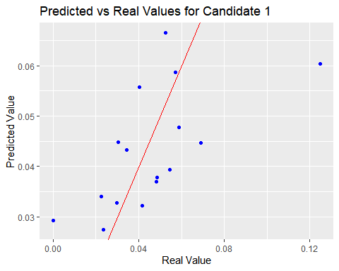
The nearer to the red line, the better the predictions.
Finally, we can do a cross-validation to see if the model is robust and it’s not overfitted to the training set:
control <- trainControl(method = "cv", number = 5)
model_cv <- train(f, data = data, method = "nnet", trControl = control, linout = TRUE)
print(model_cv)
## Neural Network
##
## 85 samples
## 8 predictor
##
## No pre-processing
## Resampling: Cross-Validated (5 fold)
## Summary of sample sizes: 68, 67, 68, 69, 68
## Resampling results across tuning parameters:
##
## size decay RMSE Rsquared MAE
## 1 0e+00 0.0008634740 0.03754070 6.831997e-04
## 1 1e-04 0.0001029772 0.04723715 8.074208e-05
## 1 1e-01 0.0012643103 0.05149712 1.155474e-03
## 3 0e+00 0.0010680280 0.04796773 8.150263e-04
## 3 1e-04 0.0002417802 0.04839492 1.686819e-04
## 3 1e-01 0.0009657510 0.05092604 8.349360e-04
## 5 0e+00 0.0014659218 0.06827547 9.700276e-04
## 5 1e-04 0.0003748937 0.07835599 2.943916e-04
## 5 1e-01 0.0007550388 0.05092647 6.530315e-04
##
## RMSE was used to select the optimal model using the smallest value.
## The final values used for the model were size = 1 and decay = 1e-04.

Obtaining the Final Predictions
In order to obtain correctly the final predictions, we must use all our data by generating initial predictions to the internal proportions:
predictions <- compute(nn_optimized, data[, paste0("Party_", 1:R)])
predicted_values <- as.data.frame(predictions$net.result)
colnames(predicted_values) <- paste0("CandidatePred_", 1:C)
Now, we have to normalize the predictions, since the neural network may not give us outputs that follows our sum constraints.
normalized_predictions <- t(apply(predicted_values, 1, function(row) {
row_sum <- sum(row)
if (row_sum > 0) {
return(row / row_sum) # row sum 1
} else {
return(rep(1 / length(row), length(row)))
}
}))
print(dim(normalized_predictions))
## [1] 85 5
Since we want our output to be a matrix with dimensions 4x5x85, we need to adjust the proportions to match with the original marginals.
output_data <- array(0, dim = c(4, 5, 85)) # empty initial array
for (i in 1:85) {
output_data[, , i] <- matrix(normalized_predictions[i, ], nrow = 4, ncol = 5, byrow = TRUE)
}
row_sums <- apply(normalized_predictions, 1, sum)
print(row_sums)
## [1] 1 1 1 1 1 1 1 1 1 1 1 1 1 1 1 1 1 1 1 1 1 1 1 1 1 1 1 1 1 1 1 1 1 1 1 1 1 1
## [39] 1 1 1 1 1 1 1 1 1 1 1 1 1 1 1 1 1 1 1 1 1 1 1 1 1 1 1 1 1 1 1 1 1 1 1 1 1 1
## [77] 1 1 1 1 1 1 1 1 1
print(dim(output_data))
## [1] 4 5 85
# We check that the row sums are 1 and the dimension is 4x5x85
So, for unit 1 and 2, the proportions will be:
print(output_data[, , 1])
## [,1] [,2] [,3] [,4] [,5]
## [1,] 0.04609688 0.2411531 0.6369553 0.03831948 0.03747518
## [2,] 0.04609688 0.2411531 0.6369553 0.03831948 0.03747518
## [3,] 0.04609688 0.2411531 0.6369553 0.03831948 0.03747518
## [4,] 0.04609688 0.2411531 0.6369553 0.03831948 0.03747518
print(output_data[, , 2])
## [,1] [,2] [,3] [,4] [,5]
## [1,] 0.03476902 0.3538073 0.5135248 0.03898668 0.05891229
## [2,] 0.03476902 0.3538073 0.5135248 0.03898668 0.05891229
## [3,] 0.03476902 0.3538073 0.5135248 0.03898668 0.05891229
## [4,] 0.03476902 0.3538073 0.5135248 0.03898668 0.05891229
And for the last units, 84 and 85:
print(output_data[, , 84])
## [,1] [,2] [,3] [,4] [,5]
## [1,] 0.05057084 0.1270955 0.7336395 0.04679872 0.04189537
## [2,] 0.05057084 0.1270955 0.7336395 0.04679872 0.04189537
## [3,] 0.05057084 0.1270955 0.7336395 0.04679872 0.04189537
## [4,] 0.05057084 0.1270955 0.7336395 0.04679872 0.04189537
print(output_data[, , 85])
## [,1] [,2] [,3] [,4] [,5]
## [1,] 0.04524785 0.08519301 0.7744407 0.0460177 0.04910074
## [2,] 0.04524785 0.08519301 0.7744407 0.0460177 0.04910074
## [3,] 0.04524785 0.08519301 0.7744407 0.0460177 0.04910074
## [4,] 0.04524785 0.08519301 0.7744407 0.0460177 0.04910074
We can see some kind of nonsense in the results, since for all of the parties (rows) we obtain the same results. This might indicate some issues on how the proportions were created and transformed into the model.

Error Evaluation
Now that we have the total final proportions calculated, we are able to calculate the MSE (Mean Squared Error) and RMSE (Root Mean Squared Error). For each cell of the matrix (for all the rows, columns and units), we will compare the predicted values with the real marginal values, allowing us to calculate the total MSE and see if the predictions are accurate or not.
errors <- array(0, dim = c(4, 5, 85))
mse_per_unit <- numeric(85)
for (i in 1:85) {
errors[, , i] <- (output_data[, , i] - matrix(x[i, ], nrow = 4, ncol = 5, byrow = TRUE))^2
mse_per_unit[i] <- mean(errors[, , i])
}
# MSE
total_mse <- mean(mse_per_unit)
print(paste("Total Mean Squared Error:", total_mse))
## [1] "Total Mean Squared Error: 0.147883085280812"
# RMSE
total_rmse <- sqrt(total_mse)
print(paste("Total Root Mean Squared Error:", total_rmse))
## [1] "Total Root Mean Squared Error: 0.384555698541593"
The MSE value of 0.1479 indicates that the average squared difference between predicted and real value is quite small, so we can assume that the model is capturing some patterns in the data.
The RMSE of 0.3846 indicates that on average, the model’s predictions deviate from the actual values by approximately 0.3864 units.
Even though the errors show good results, there is always room for improvement in the model’s performance, as we can see that the results of each units is the same for each column.
Graphically:
# Histogram of the absolute errors
error_values <- as.vector(errors)
error_df <- data.frame(errors = error_values)
ggplot(error_df, aes(x = errors)) +
geom_histogram(binwidth = 0.0001, fill = "blue", color = "black", alpha = 0.7) +
labs(title = "Distribution of the Absolute Errors",
x = "Absolute Error",
y = "Frequence")
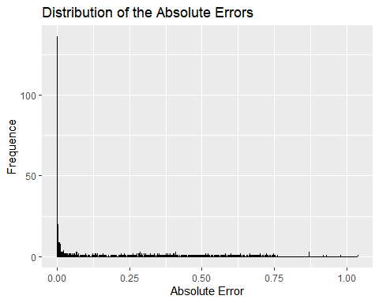
We observe that most of the errors are close to 0, which indicates that most of the predictions have a very small error.
There are some atypical high errors, which might indicate that there is either overfitting or underfitting in the model.

Graphic Representation of the Results
Finally, let’s see graphically the results obtained; first for only the first unit/candidate as an example and then for all of them.
For example, now we can see the heatmap for unit 1, which allows us to see represented the proportions combined of parties and candidates.
unit_1_matrix <- output_data[, , 1]
unit_1_heatmap <- melt(unit_1_matrix)
colnames(unit_1_heatmap) <- c("Party", "Candidate", "Proportion")
unit_1_heatmap$Party <- factor(unit_1_heatmap$Party)
unit_1_heatmap$Candidate <- factor(unit_1_heatmap$Candidate)
ggplot(unit_1_heatmap, aes(x = Candidate, y = Party, fill = Proportion)) +
geom_tile(color = "white") +
scale_fill_gradient(low = "blue", high = "red") +
labs(title = "Heatmap of the Predicted Proportions for Unit 1",
x = "Candidate",
y = "Party",
fill = "Proportion") +
theme_minimal()
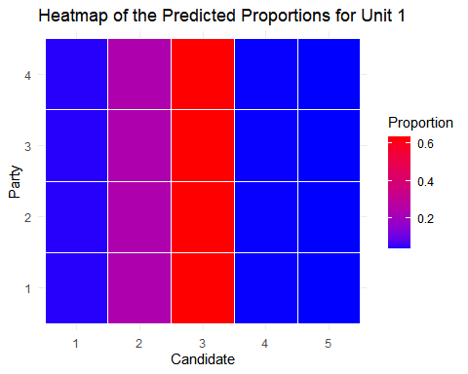
However, as we saw before, since the proportions for all the parties are the same, we obtain a heatmap that only differentiates the candidates, seeing that the proportion of candidate 3 is the highest.
If we do the same for all the units, we can see it as follows:
all_units_long <- data.frame()
for (i in 1:85) {
unit_predictions <- normalized_predictions[i, ]
unit_df <- data.frame(Unit = rep(i, length(unit_predictions)),
Candidate = 1:5,
Proportion = unit_predictions)
all_units_long <- rbind(all_units_long, unit_df)
}
# Converting to factor
all_units_long$Unit <- factor(all_units_long$Unit)
all_units_long$Candidate <- factor(all_units_long$Candidate)
ggplot(all_units_long, aes(x = Candidate, y = Unit, fill = Proportion)) +
geom_tile(color = "white") +
scale_fill_gradient(low = "blue", high = "red") +
labs(title = "Heatmap of the Predicted Proportions for all the Units and Candidates",
x = "Candidate",
y = "Unit",
fill = "Proportion") +
theme_minimal() +
theme(axis.text.x = element_text(angle = 45, hjust = 1))
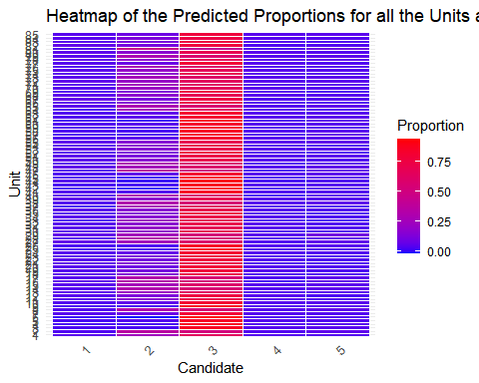
We see a pattern through the 85 units, where we see that Candidate 3 is the one with most of the voting proportions, followed by candidate 2.
Let’s now see the evolution per unit, for example for the first unit:
# Proportions of candidate 1 in all units
candidate_1_proportions <- apply(output_data[, 1, ], 2, mean)
line_plot_data <- data.frame(Unit = 1:85, Proportion = candidate_1_proportions)
ggplot(line_plot_data, aes(x = Unit, y = Proportion)) +
geom_line(color = "blue", size = 1) +
geom_point(color = "red", size = 2) +
labs(title = "Evolution of Predicted Proportions for Candidate 1",
x = "Unit",
y = "Proportion") +
theme_minimal()
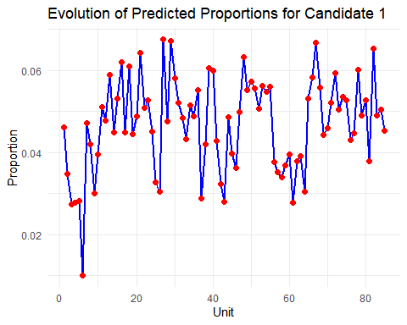
If we want to see the evolution for all the candidates through all the 85 units, we can see it as follows:
candidate_proportions <- apply(output_data, c(2, 3), mean)
print(dim(candidate_proportions)) # Must be 5x85
## [1] 5 85
line_plot_data_all <- data.frame(
Unit = rep(1:85, times = nrow(candidate_proportions)),
Candidate = rep(1:nrow(candidate_proportions), each = 85),
Proportion = as.vector(candidate_proportions))
head(line_plot_data_all) # To verify, we see if the first data makes sense
## Unit Candidate Proportion
## 1 1 1 0.04609688
## 2 2 1 0.24115312
## 3 3 1 0.63695535
## 4 4 1 0.03831948
## 5 5 1 0.03747518
## 6 6 1 0.03476902
ggplot(line_plot_data_all, aes(x = Unit, y = Proportion, color = as.factor(Candidate))) +
geom_line(size = 1) +
geom_point(size = 2) +
labs(title = "Evolution of the Predicted Proportions by Unit for all the Candidates",
x = "Unit",
y = "Proportion",
color = "Candidate") +
theme_minimal() +
theme(legend.position = "bottom")
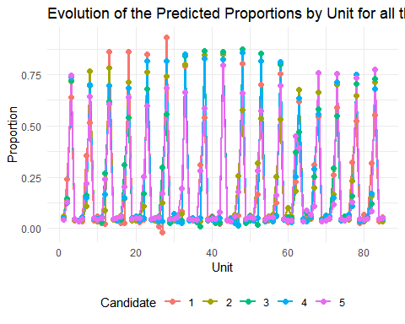
We see a very noticeable pattern that might indicate cyclic behavior throughout the units that might indicate that the model is capturing the moments where the candidates receive higher proportions of votes.

