**Programming Assignment-2 Multivariate Linear Regression with[1]**

**First Name1: __Richu___ Last Name1: ___Mathew____**

**First Name2:_Andrew___ Last Name 2: __King______**

**Part-I:**

The Jupyter notebook file, LR-Multivariate-incomplete.ipynb, is provided.

Please fill in the blanks, where you can find the indications -- “### START YOUR CODE HERE ###”.

**As you can see, the methods of the class are spread over several cells. In this case, you can concentrate on each method separately. An additional package “jdc” is needed to support this feature. Please read** [**https://alexhagen.github.io/jdc/**](https://alexhagen.github.io/jdc/) **and install this package in your Anaconda or whatever IDE you use.**

**Part-II:**

Two files, “prj2data1.csv” and “prj2data1_test.csv” are provided. Please put down the following information after training (learning rate = 0.01 and epochs=1000):

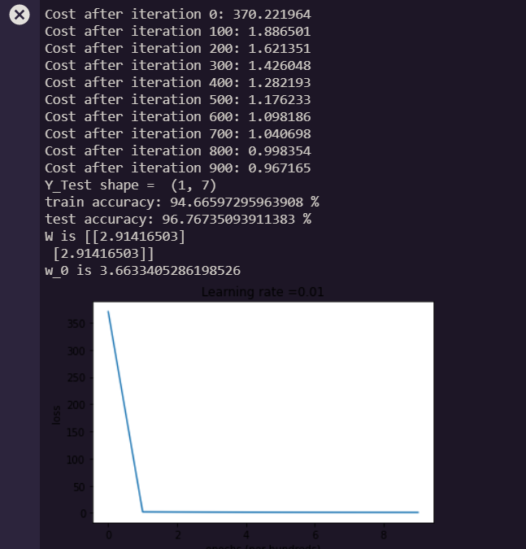

*w*0 = 3.6633405286198526

*w*1 = 2.91416503

*w*2 = 2.91416503

**Part-III:**

Two files, “prj2house.csv” and “prj2house_test.csv” are provided. Please use these two files to retrain your model and answer the following questions:

**Q1:** What is the output if you don’t perform feature scaling for the training and testing sets?

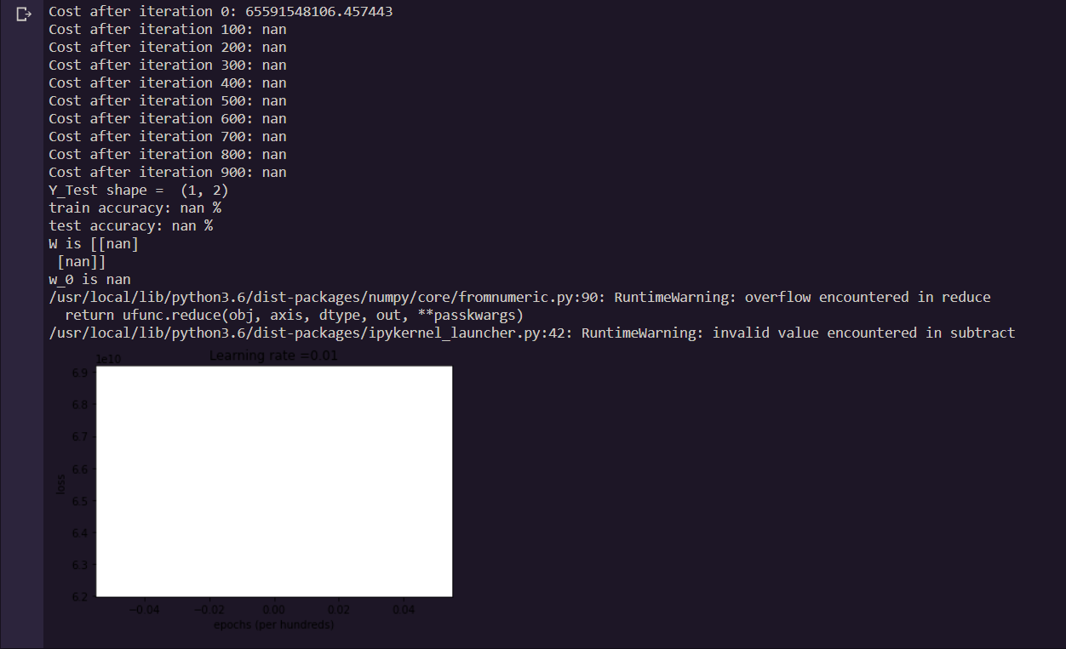

**Q2:** Where did you put the codes for data normalization?

At the beginning of the Run Experiment function, before training occurs.

**Q3:** After normalizing your features, put down the following values (learning rate = 0.01 and epochs=1000):

*w*0 = 340397.96353531966

*w*1 = 51434.72080774

*w*2 = 51434.72080774

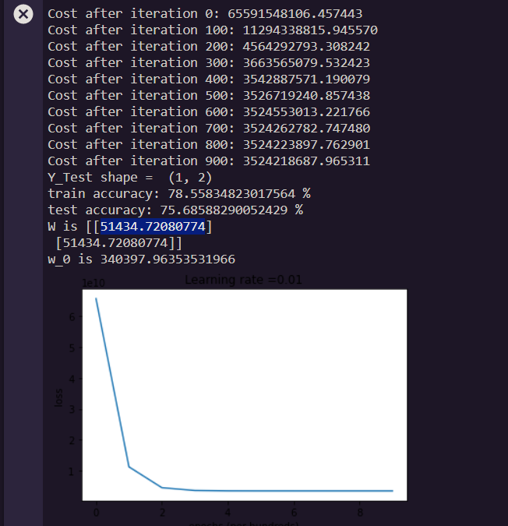

**Submission:**

* **Rule1:**
  + If you work with a partner, please name your zipped file as follows:

PA2_LNAME1_LNAME2.Zip for folder and PA2_LNAME1_LNAME2.docx for a word document, i.e., the file names should include both LAST NAMEs.

* + If you work on your own, the format should be

PA2_LNAME.Zip for folder and PA2_LNAME.docx for a word document.

* **Rule2:**
  + Put your FULL names whether working in a group or individual in the word document that answers all the questions.
* **Rule3:**
  + **EVERYONE** in the class should submit this Assignment, which should provide all files (like test excel files etc.. ) that are necessary for the execution of code in the submission folder.
* **Rule4:**
  + Please submit three Jupyter files, each of which is corresponding to Part II, Q1 of Part III, and Q2 of Part III, accordingly.

1. Some materials are from Dr. Andrew Ng’s course.