**Programming Assignment-4: A Two-Layer ANN[1] Part II**

**First Name1: _Andrew___________ Last Name1: _King________________**

**First Name2:____________ Last Name 2: _________________**

**Introduction**

In this programming assignment, you will build an artificial neural network with a hidden layer. You will implement the backward propagation algorithm and apply it to the given data set. You will use the **leaky relu** activation function in the hidden layer

**Two layer artificial neural network**

In this part of the assignment, you will implement an artificial neural network with a hidden layer.

**Steps:**

1. Define the artificial neural network structure (# of input units and # of hidden units, as we only have one hidden layer).

2. Initialize the network’s parameters, **including the parameter**

3. Iterations:

- Implement forward propagation

- Compute loss function

- Implement backward propagation to get the gradients

- Update parameters (gradient descent)

**Question 1:** By using the provided alpha, eta ($η)$, # of epochs, and # of hidden units, what is the classification accuracy?

**72%**

**Question 2:** Does the initialization of the weights play a role in determining the classification accuracy? Compared to Part I of the assignment, should you initialize the weights to bigger values or smaller values?

Yes, weight initialization does play a part in determining classification accuracy. The weights should be bigger values.

**Question 3:** Please play with alpha, eta ($η)$**,** # of hidden units, and # of epochs, what’s the highest classification accuracy?

alpha = 0.6

eta = 0

# of hidden units = 10

# of epochs = 30000

**Question 4:** Please paste the decision boundary diagram in this document (the one corresponding to the highest accuracy).

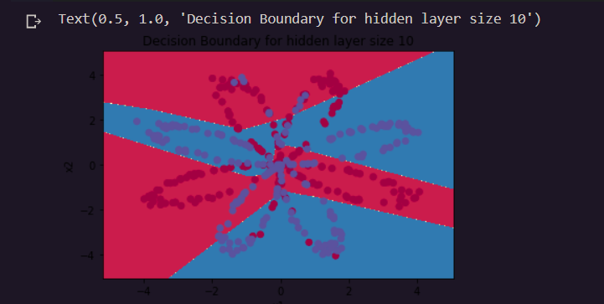

**Submission:**

* **Rule1:**
  + If you work with a partner, please name your zipped file as follows:

PA4_LNAME1_LNAME2.Zip for folder and PA4_LNAME1_LNAME2.docx for a word document, i.e., the file names should include both LAST NAMEs.

* + If you work on your own, the format should be

PA4_LNAME.Zip for folder and PA4_LNAME.docx for a word document.

* **Rule2:**
  + Put your FULL names whether working in a group or individual in the word document that answers all the questions.
* **Rule3:**
  + **EVERYONE** in the class should submit this Assignment, which should provide all files (like test excel files etc.. ) that are necessary for the execution of code in the submission folder.
* **Rule4:**
  + Please submit two Jupyter files, each of which is corresponding to Part I and Part II, respectively.

1. Data is obtained from Dr. Andrew Ng’s Machine Learning course.