**Programming Assignment-4: A Two-Layer ANN[1] Part I**

**First Name1: Andrew____________ Last Name1: King________________**

**First Name2:____________ Last Name 2: _________________**

**Introduction**

In this programming assignment, you will build an artificial neural network with a hidden layer. You will implement the backward propagation algorithm and apply it to the given data set.

**1: Plot the training data**

Please load and plot the training data. By visualizing the data, you can see that it is not linearly separable. PLEASE copy the data plot to this document.

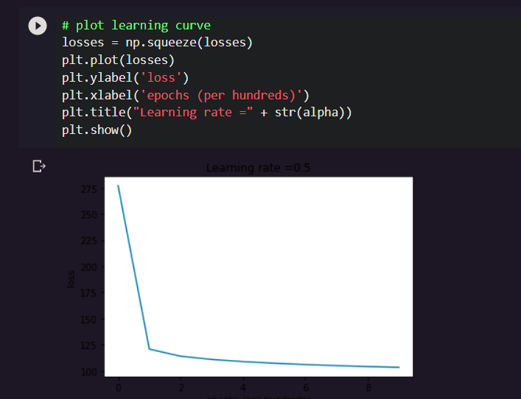

**2: Logistic Regression**

Use the logistic regression model you have built in your programming assignment-3 to classify the given data. What is the classification accuracy?

**3: Two layer artificial neural network**

In this part of the assignment, you will implement an artificial neural network with a hidden layer.

**Attention: You should use “self.method_name” if you want to call a method inside a class.**

**Steps:**

1. Define the artificial neural network structure (# of input units and # of hidden units, as we only have one hidden layer).

2. Initialize the network’s parameters

3. Iterations:

- Implement forward propagation

- Compute loss function

- Implement backward propagation to get the gradients

- Update parameters (gradient descent)

**Question 1:** Can we initialize all weights including the b’s to 0? Why?

**No, because if all the weights are zero no learning will occur.**

**Question 2:** By using the provided alpha, # of epochs, and # of hidden units, what is the classification accuracy?

**90%**

**Question 3:** For the given code, is this batch gradient descent or stochastic gradient descent? Why?

**Batch gradient descent because it is updated once per iteration instead of 400 times per iteration.**

**Question 4:** Please play with alpha, # of hidden units, and # of epochs, what’s the highest classification accuracy?

**accuracy = 92%**

**alpha = 0.6**

**# of hidden units = 12000**

**# of epochs = 30000**

**Question 5:** Please paste the decision boundary diagram in this document (the one corresponding to the highest accuracy).

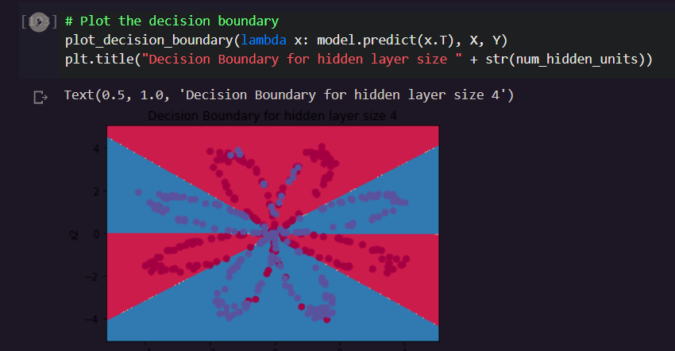

**Submission:**

* **Rule1:**
  + If you work with a partner, please name your zipped file as follows:

PA4_LNAME1_LNAME2.Zip for folder and PA4_LNAME1_LNAME2.docx for a word document, i.e., the file names should include both LAST NAMEs.

* + If you work on your own, the format should be

PA4_LNAME.Zip for folder and PA4_LNAME.docx for a word document.

* **Rule2:**
  + Put your FULL names whether working in a group or individual in the word document that answers all the questions.
* **Rule3:**
  + **EVERYONE** in the class should submit this Assignment, which should provide all files (like test excel files etc.. ) that are necessary for the execution of code in the submission folder.
* **Rule4:**
  + Please submit two Jupyter files, each of which is corresponding to Part I and Part II, respectively.

1. Data is obtained from Dr. Andrew Ng’s Machine Learning course.