PPrS (Public Plate Reporting System) | by pcondemand.com
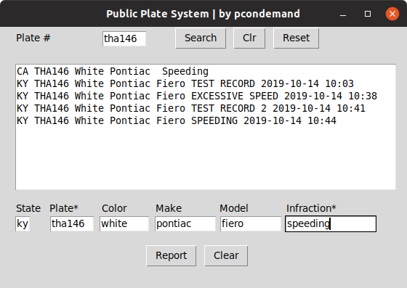

PPrS is written in Python 3 and only a few requirements.
Tkinter module is required but is now standard with most Python 3 installations.

1. Make sure Python 3 is installed on your PC, with Tkinter module.

2. Install gspread module for Python 3 (Google sheets)
a. at your Linux command prompt, sudo pip3 install gspread

3. Install oauth2client module for Python 3 (login credentials)
a. at your Linux command prompt, sudo pip3 install oauth2client

4. Download the following 2 files from the link below. Make sure you DL them both to the same directory from where you plan to run the program.

https://www.dropbox.com/sh/25sgves0zsa197m/AADo82rml9NRvHzXHVfhapAZa?dl=0
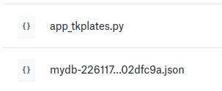

← The Python 3 code

← The software key file

5. Change to the directory where you saved the two files, (for example, type cd Download) then, at your Linux command prompt type, python3 app_tkplates.py All current records will load. This will take a few seconds, or minutes in some cases.

6. Perform searches based on license plate numbers and letters. If no data is returned after search button is clicked, that plate # is not in the system. Don’t worry about CAPS.

7. Report offenders or good drivers by entering data in all fields and press Report button. Plate* and Infraction* fields are required fields to make a report. Email, is your complete, correct email address. Your email won’t be visible in public searches and is optional to legitimize the report.

