Forecasting Daily NYC 311 DEP Phone Requests
Trevor Cudmore
Purdue University Global
IN311: Data Analytics in Action
Dr. Todd Wolfe
October 27, 2026

Forecasting Daily NYC 311 DEP Phone Requests
Introduction
Call-center and customer-service managers must make staffing decisions before they know exactly how many contacts will arrive. When demand is underestimated, customers may wait longer and employees may face heavier workloads. When demand is overestimated, labor may be scheduled when it is not needed. Forecasting does not remove this uncertainty, but it can give managers a more consistent starting point for planning. Call-center workforce planning depends on connecting demand forecasts with capacity and scheduling decisions (Koole & Li, 2023).
The purpose of this project was to examine whether historical NYC 311 telephone-request data could be used to forecast daily demand. The analysis focused on requests assigned to the New York City Department of Environmental Protection (DEP) during 2025. My analytical thesis was that historical request volume could identify recurring weekday, seasonal, and extreme-demand patterns and produce a useful forecast to support workforce-planning decisions. Because the dataset does not contain staffing, average handling time, wait time, or abandonment information, the project evaluates demand patterns rather than the effectiveness of staffing decisions.
Methods
The analysis was completed on an ASUS VivoBook running Windows 11. I used R version 4.5.1 through RGui. The main packages were tidyverse version 2.0.0 for data organization, lubridate version 1.9.5 for working with dates, and ggplot2 version 4.0.3 for visualizations. The linear regression and k-means models used functions included with base R and the stats package. Recording the hardware and software versions makes the analysis easier for another analyst to reproduce (R Core Team, 2025).
The source was the 311 Service Requests from 2020 to Present dataset maintained by NYC OpenData (NYC OpenData, n.d.). I limited the file to records created from January 1 through December 31, 2025. I then filtered Agency to DEP and Open Data Channel Type to PHONE. The filtered data contained 78,211 service requests. I checked the Unique Key field for duplicate records, reviewed missing values in the Created Date field, converted the date and time into a usable date value, and sorted the records chronologically. The requests were then grouped by date, producing 365 daily observations.
I created variables for day of the week, day of the year, month, and whether the date fell on a weekend. The regression model used day-of-week indicators and annual sine and cosine terms to represent repeating calendar patterns. The first 292 days, January 1 through October 19, were used for training. The final 73 days, October 20 through December 31, were held out for testing. This chronological split avoided training the model on information from dates that occurred after the dates being predicted.
The regression model was evaluated with mean absolute error (MAE), root mean squared error (RMSE), and R-squared. I also compared it with a simple baseline that predicted the training-period average for every test date. Residual autocorrelation and the Durbin-Watson statistic were reviewed to see whether the model left a time pattern unexplained. Plotting a time series and checking model errors are important steps because they show patterns that a summary statistic alone may hide (Hyndman & Athanasopoulos, 2021).
K-means clustering was used as a secondary method. Daily request volume and the weekend indicator were standardized so that the different measurement scales would not control the clusters. Three clusters were requested, with a fixed random seed and 25 starting configurations. The groups were interpreted according to their average request volume and their weekday or weekend composition. This method was not treated as a competing forecast. Its purpose was to describe different types of operating days.
Results
The 2025 dataset averaged 214.28 DEP telephone requests per day, with a standard deviation of 133.45. Daily volume ranged from 56 to 1,462 requests. Weekdays were generally busier than weekends, and June and July had the highest monthly averages. Four days stood out as extreme-volume weekdays: June 23, June 24, June 25, and October 30.
Linear Regression Results
On the 73-day test period, the regression model produced an MAE of 53.73 requests and an RMSE of 135.44 requests. Its R-squared was 0.114, meaning that the model explained only a limited share of the daily variation. The baseline model produced an MAE of 73.98 and an RMSE of 145.46. The regression therefore improved MAE by 27.4% and RMSE by 6.9% compared with the baseline. This shows that calendar patterns added value, although the model was not strong enough to explain unusual spikes by itself.
Model | MAE | RMSE | R-squared
Linear regression | 53.73 | 135.44 | 0.114
Mean baseline | 73.98 | 145.46 | Not applicable
Figure 1 shows that the regression followed the normal weekly pattern but missed the October 30 spike. The lag-one residual autocorrelation was 0.718, and the Durbin-Watson statistic was 0.562. Figure 2 confirms that several residual correlations exceeded the approximate 95% bounds, showing that additional time-based or outside variables could improve the model.

Figure 1
Actual and Predicted Daily DEP Phone Requests
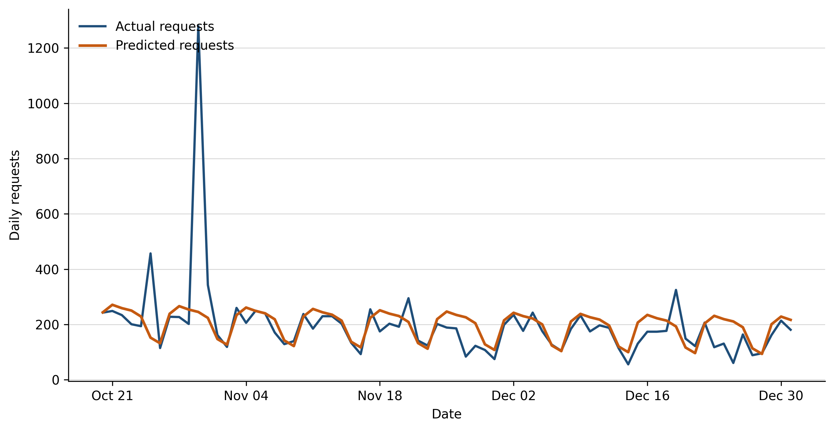
Figure 2
Autocorrelation of Linear Regression Residuals
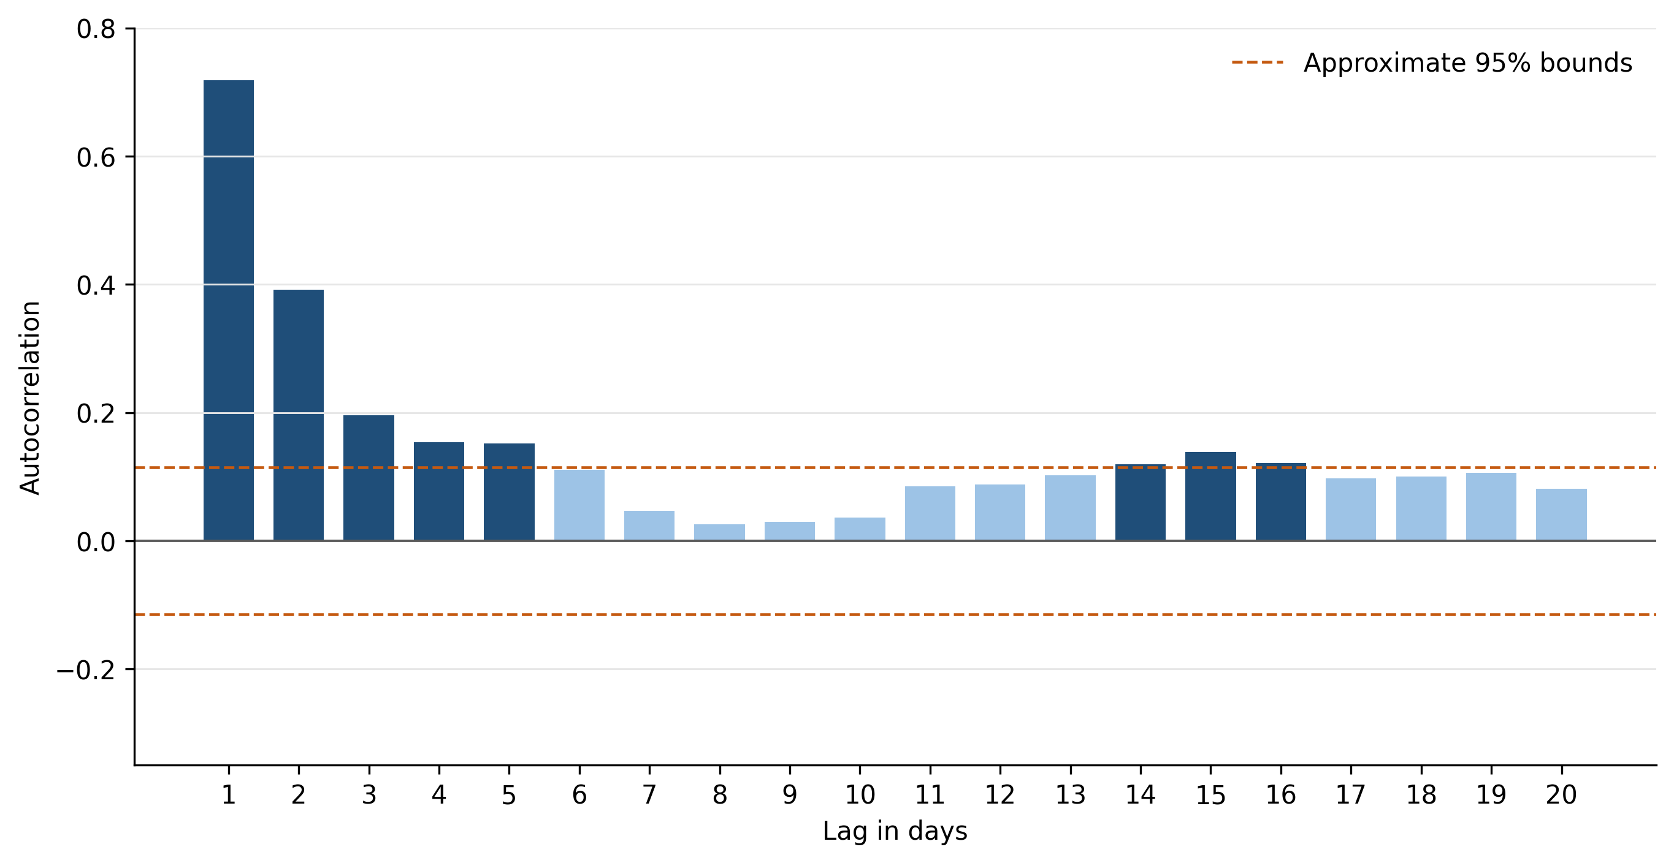

K-Means Results
The k-means model produced three understandable groups. All 104 weekend days formed one cluster and averaged 141.20 requests. A second cluster contained 257 typical weekdays and averaged 228.59 requests. The final cluster contained four extreme-volume weekdays and averaged 1,194.50 requests. Figures 3 and 4 show that the extreme days were clearly different from the normal weekday and weekend patterns.
Cluster | Days | Average requests
Weekend days | 104 | 141.20
Typical weekdays | 257 | 228.59
Extreme-volume weekdays | 4 | 1,194.50
Figure 3
K-Means Clusters of Daily DEP Phone Requests
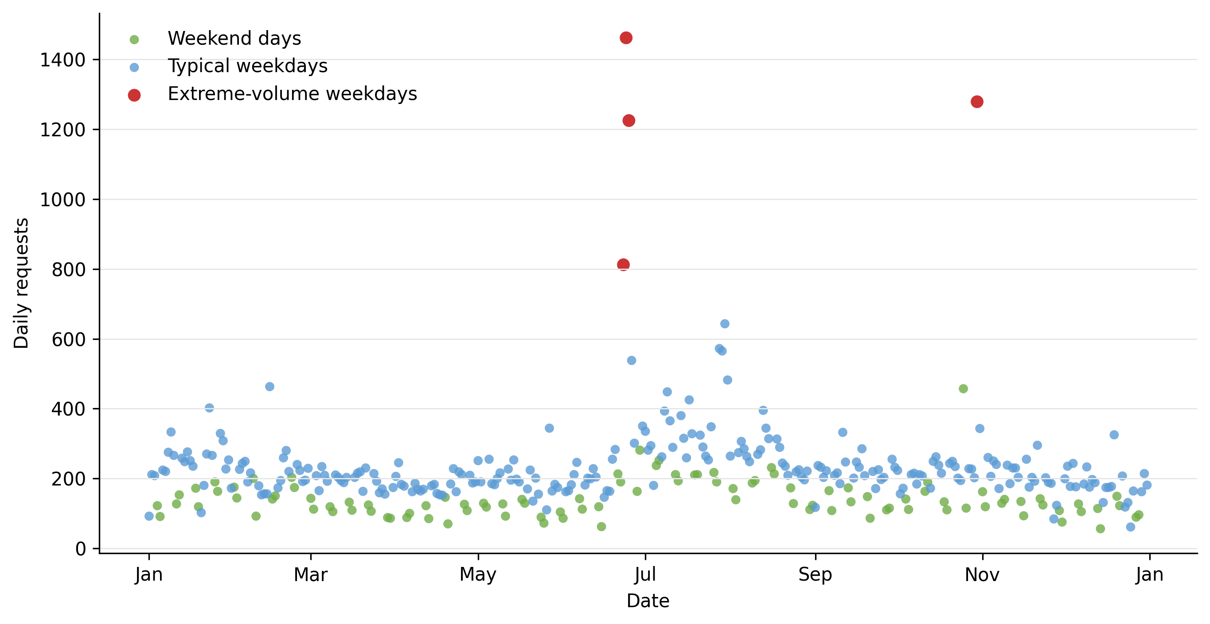

Figure 4
Average Daily Requests by K-Means Cluster
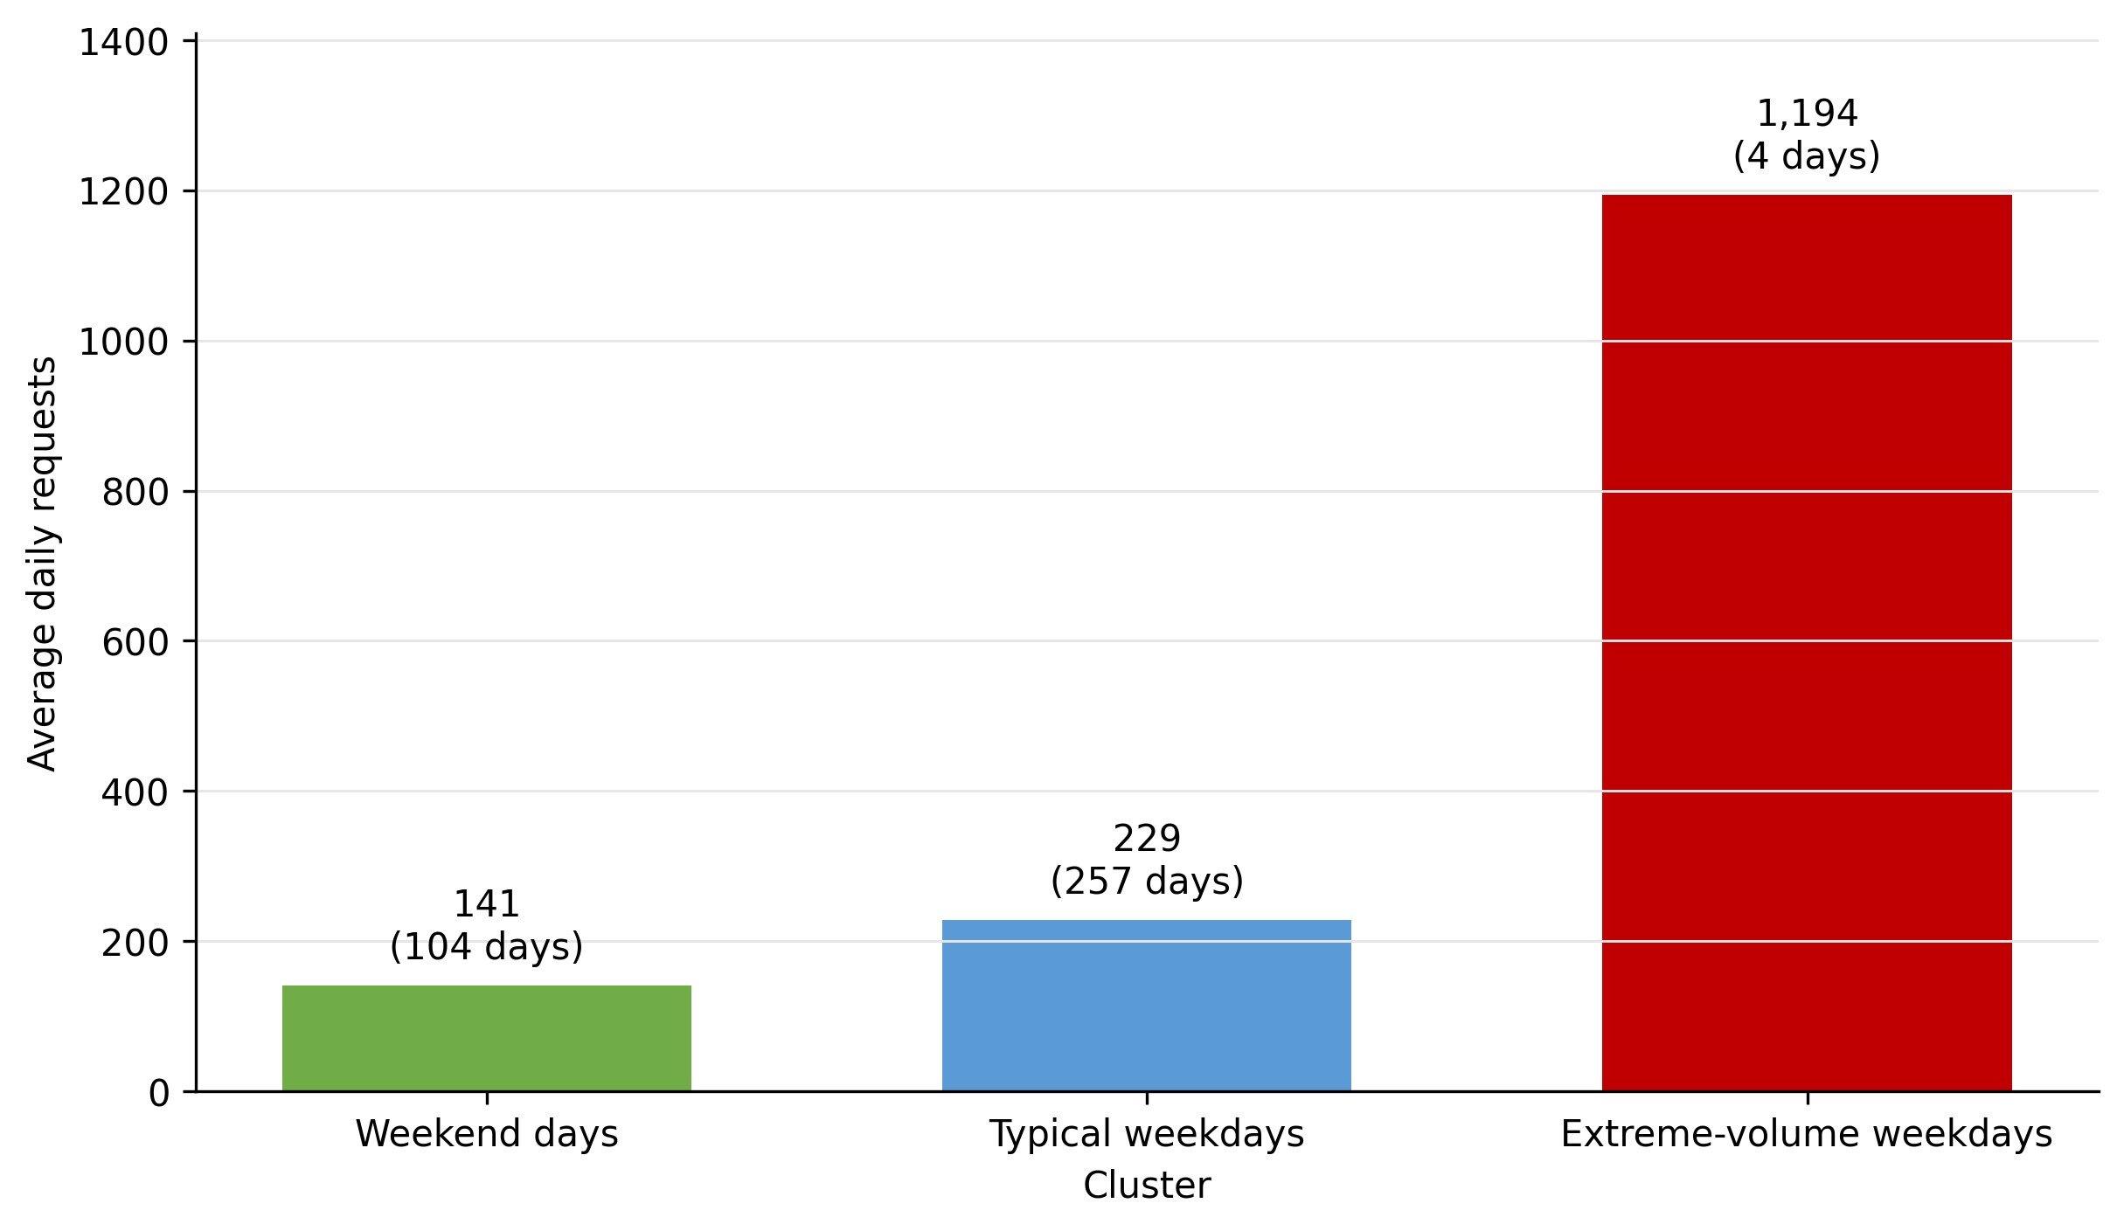
Conclusion
The results support the thesis that historical telephone-request data can identify useful demand patterns and provide a starting point for forecasting. The linear regression was the best primary model because it generated future daily estimates and performed better than the mean baseline on both MAE and RMSE. The k-means analysis added useful context by separating weekends, typical weekdays, and extreme-volume weekdays, but it did not predict future request totals and therefore could not replace the regression model.
The regression should still be treated as a basic planning model rather than a complete forecasting solution. Its low R-squared and strong residual autocorrelation show that important influences were missing. Even with that limitation, the model accomplished two useful goals: it measured the normal weekday and seasonal pattern and created a repeatable baseline against which unusually high or low demand could be identified.
Recommendation
I recommend using the regression forecast as an initial demand estimate that managers review before making workforce decisions. The forecast could help establish the expected daily pattern, while the cluster results could help managers recognize whether a date resembles a normal weekday, a weekend, or an extreme-demand day. Because the data does not include staffing or service performance, the forecast should not be used by itself to determine an exact staffing requirement.
The next version of the analysis should include multiple years of request history, holidays, complaint categories, and weather. Daily precipitation and temperature are available through NOAA's Climate Data Online system (National Centers for Environmental Information, n.d.). These variables may help explain the June and October spikes and reduce the time pattern remaining in the residuals. After adding them, the revised regression should be compared with a time-series method such as exponential smoothing or ARIMA. The best model should be the one that improves test-period accuracy while remaining understandable enough for managers to use and challenge.
If internal call-center data later becomes available, the demand forecast could be combined with average handling time, scheduled staffing, customer wait time, service level, and abandonment rate. That would allow a separate analysis of staffing effectiveness. For the current project, the appropriate recommendation is to use the forecast as a demand-planning aid, apply managerial judgment to unusual events, and continue improving the model as additional information becomes available.

References
Hyndman, R. J., & Athanasopoulos, G. (2021). Forecasting: Principles and practice (3rd ed.). OTexts. https://otexts.com/fpp3/
Koole, G. M., & Li, S. (2023). A practice-oriented overview of call center workforce planning. Stochastic Systems, 13(4), 479–495. https://doi.org/10.1287/stsy.2021.0008
National Centers for Environmental Information. (n.d.). Climate Data Online. National Oceanic and Atmospheric Administration. https://www.ncei.noaa.gov/cdo-web/
NYC OpenData. (n.d.). 311 service requests from 2020 to present [Data set]. Retrieved October 23, 2026, from https://data.cityofnewyork.us/d/erm2-nwe9
R Core Team. (2025). R: A language and environment for statistical computing (Version 4.5.1) [Computer software]. R Foundation for Statistical Computing. https://www.R-project.org/

