Trade-offs between multifunctionality and disturbance resilience in forests of Central Europe
High multifunctionality comes at a resilience cost in forests of Central Europe
The resilience–multifunctionality dilemma: Trade-offs across management strategies in Central European forests
Baldo M. ¹, Dobor, L.¹, Merganičová, K. ¹, Kumar Das, A. ¹, Bílek, L. ¹, Seidl, R. ², Rammer, W. ², Hlásny, T. ¹
¹Czech University of Life Sciences Prague, Faculty of Forestry and Wood Sciences, Czech Republic
²Technical University of Munich, Ecosystem Dynamics and Forest Management Group Freising, Germany
Abstract
Resilience to a changing climate and shifting disturbance regimes is a key objective of contemporary forest management. At the same time, enhancing resilience may entail trade-offs with the provision of multiple ecosystem services. These trade-offs are closely linked to how resilience is achieved – either through a coerced approach relying on substantial human inputs, or through an ecological approach that promotes natural dynamics and cross-scale diversity. Such trade-offs remain rarely considered in forestry practice, potentially leading to suboptimal management decisions.
Here, we investigate these interactions using a landscape-scale modelling study conducted in a 40,000 ha Central European forest. We assessed the effects of five management strategies, aligned along a gradient of management intensity, on forest multifunctionality and resilience to an extreme disturbance event, and examined how these relationships are modulated by climate change.
The highest levels of multifunctionality – encompassing biodiversity, water and climate regulation, and wood production – were associated with lower-intensity management regimes, primarily because higher growing-stock levels supported the provision of multiple ecosystem services. In contrast, resilience was lowest under these regimes, as higher growing stock experienced greater disturbance impacts and longer recovery times. Climate change moderately reduced multifunctionality and significantly eroded forest resilience across all management regimes.
We conclude that resilience and multifunctionality are negatively related: enhancing multifunctionality may require tolerating increased disturbance dynamics, whereas coercing resilience through high-intensity management risks a loss of multifunctionality.
Key words: ecosystem management, simulation modelling, climate change, disturbance ecology, Central Europe
- Introduction
Forests provide a broad spectrum of goods and services upon which human societies depend – from timber and biomass to climate and water regulation, and biodiversity conservation (Gamfeldt et al. 2013; ….; … ). Yet the capacity of forests to sustain these functions is increasingly threatened by climate change and intensifying natural disturbance regimes (Lecina-Díaz et al. 2024; Thom and Seidl 2016). In Europe, forest disturbance from wind, bark beetles, and wildfires has followed a long-term upward trajectory (Patacca et al. 2023, Hlásny et al. 2025), a trend projected to accelerate through the 21st century (Grunning et al. 2026). Climate change intensifies fire, drought, and insect outbreaks, and their interactions often produce dangerously non-additive effects (Seidl et al. 2017; … ; …). Enhancing the resilience of forest ecosystems – the capacity to absorb disturbance and recover while retaining key functions, structures, and processes (Holling 1973; Walker et al. 2004) – has therefore become a central objective of contemporary forest management and policy (Newton 2016; Ludvig et al. 2024).
Managing for resilience, however, does not occur in isolation. For example, while expectations for forests to deliver multiple ecosystem services are rising, the empirical basis linking resilience and multifunctionality remains weak. For example, more diverse and structurally complex forests support higher levels of multifunctionality than monospecific, even-aged forests optimized for timber production (van der Plas et al. 2016; Müller et al. 2023). The same structural and compositional diversity also underpins resilience through insurance and response diversity: diverse species and functional types respond differentially to disturbance and stress, buffering losses and accelerating recovery (Elmqvist et al. 2003; Mori et al. 2013). On the other hand, intensive management practices oriented toward risk reduction – such as shortened rotation lengths, sanitation harvesting, deploying resistant genotypes, and the use of insecticides – may reduce disturbance susceptibility in the near term (Dobor et al. 2019, Zimová et al. 2020) but simultaneously diminish the growing stock, biodiversity, and structural complexity upon which multifunctionality depends (Gustafsson et al. 2012; …). Studies from temperate and boreal forests demonstrated that intensive forestry produces long-lasting reductions in multifunctionality that are difficult to reverse (Eyvindson et al. 2021) and that productivity-oriented silviculture narrows the portfolio of ecosystem services relative to lower-intensity, close-to-nature alternatives (Caicoya et al. 2023; Abate et al. 2024).
The trade-off between resilience and multifunctionality thus seems to be tied to the pathway through which resilience is achieved. In this regard, Felton et al. (2024) proposed two contrasting resilience modes: ecological resilience that emerges from natural processes, species diversity, structural heterogeneity, and cross-scale interactions; and coerced resilience that is maintained through sustained and intensive human interventions, disturbance control, and the suppression of natural dynamics. So managed forests can show high resilience in the targeted functions (notably productivity), but the deliberately constrained variability in forest conditions may reduce multifunctionality and weaken the capacity to recover from unforeseen disturbances. The choice between these pathways therefore has implications not only for ecosystem services provision, but also for the robustness of a forest's response to future disturbance regimes (….).

Despite the conceptual clarity of this framework, the trade-offs between resilience and multifunctionality remain poorly quantified and are rarely accounted for in operational forest management. Moreover, climate change adds further complexity to this nexus by altering disturbance regimes, recovery dynamics, and the mechanisms underpinning multifunctionality. These knowledge gaps may, for example, risk management decisions that promote coerced resilience at the cost of the ecological properties that sustain both objectives over the long term.
Here, we address this knowledge gap through a landscape-scale simulation experiment in Central Europe. We assessed five management strategies spanning a gradient of management intensity and evaluated their effects on forest multifunctionality — encompassing biodiversity, water and climate regulation, and timber production — and resilience to an extreme disturbance event, and examined how climate change modulates these relationships. Specifically, we asked: (i) how management intensity affects forest multifunctionality and disturbance resilience; (ii) how climate change modifies these responses across management strategies; and (iii) whether multifunctionality and resilience exhibit trade-offs or synergies, and how climate change shapes this interaction.
- Methods
  - Study landscape
The study area (centre coordinates: lat. 49° 95', long. 14° 78'; Figure 1) is located in the Czech Republic, Central Europe. The size of the area is 40 928 ha with 45 % forest cover (18 500 ha). The elevation range is 240 – 540 m a.s.l., and the annual mean air temperature and precipitation sum ranges are 7.8-9.2°C and 604-683 mm, respectively (1961-2018 data). The forest composition is dominated by Norway spruce (Picea abies) (57.7%), Scots pine (Pinus sylvestris L.; 10.7%), European beech (7.6%), Sessile oak (Quercus petraea [Matt.] Liebl) and pedunculate oak (Quercus robur L.; 8.8% together).
The forests are managed primarily for timber production, with Norway spruce being commercially the most important species. Spruce that naturally occurs in mountainous conditions started to be planted here ca 200-250 years ago due to its high productivity in lower elevations (Gömöry et al., 2012); this has been a common practice across Central Europe. In recent decades, the intensifying climate change caused dramatic increase in spruce mortality mainly driven by outbreaks of spruce bark beetle (Ips typographus). Adaptive management practices aimed at adapting species composition to drier and warmer conditions as well as to intensifying disturbance regimes have started to replace the traditional monoculture-oriented management in recent decades (Perunová et al. 2026). The dominant management systems are shelterwood and clearcutting. Salvage harvesting of infested or windfelled trees is an important part of management strategies, aiming to reduce the spread of bark beetles and mitigate economic impact of disturbances.
Can we try some EcoVis image here? To have here finally sth new

Fig. 1 Study area position in Europe. Forest cover and elevation are indicated.
  - Simulation model
We simulated forest dynamics using the individual-based forest landscape and disturbance model iLand (Seidl et al. 2012; Rammer et al. 2024). iLand simulates forest dynamics as an emergent property of environmental drivers, ecosystem processes, and dynamic interactions across scales. It integrates population-level processes, such as the growth, mortality, and regeneration, with above- and belowground cycling of carbon, nitrogen, and water. The model operates within a multi-scale hierarchical framework, with large-scale processes forming constraints for finer-scale dynamics, and fine-scale processes feeding back into higher-level patterns.
iLand operates at several temporal and spatial scales: (i) resource availability is simulated for grid cells with a resolution of 100 × 100 m; (ii) resource competition is simulated at the level of individual trees; (iii) environmental constraints are considered on a daily scale; (iv) primary production and soil processes operate on a monthly scale; (v) and mortality, disturbances, and management are considered annually.Seedlings and saplings are simulated as cohorts until reaching 4 m in height, at which point they are represented as individually tracked trees (Rammer et al. 2024).
Tree growth is grounded in production physiology. Stand-level gross primary production is estimated using a light use efficiency approach and then reduced by species-specific environmental response functions (Landsberg and Waring 1997). Net primary production is then derived after accounting for autotrophic respiration and distributed among individual trees according to their competitive status in the canopy. Within each tree, carbon is allocated to roots, foliage, carbohydrate reserves, and stem. When environmental conditions limit carbon uptake, allocation to reserves and stem is reduced, increasing a tree's stress level and mortality risk (Seidl et al. 2012). Individual tree mortality is determined by carbon starvation – reflecting stress from light competition or water limitation – combined with age- and size-dependent senescence (Seidl et al. 2012).
Regeneration depends on the presence of seeds, light availability, and a favorable abiotic environment. Tree establishment passes through a series of species-specific abiotic filters, while soil water availability and growing-season frost events further modify establishment probabilities. The dispersal is calculated through species-specific dispersal kernels, considering species-specific return intervals of seed years (Lexer & Hönninger, 2001). In case of managed forests, natural regeneration occurs concurrently with tree planting defined based on prescribed species proportions and densities for different sites or arbitrary defined management units
Wind damage is modelled at the level of individual trees and simulated iteratively, accounting for changes in forest structure during storm events (….). Both upwind gap size and local shelter from neighbouring trees are considered explicitly. Critical wind speeds for uprooting and stem breakage are distinguished. Wind impact is calculated using a dose–response model that accounts for the vertical wind profile and the resulting turning moment, with wind speed, direction, storm duration, and soil frost as the primary external drivers. The bark beetle module (Seidl and Rammer 2017) explicitly represents beetle phenology and development, spatially explicit dispersal, host tree colonization and defence, and temperature-sensitive overwintering success. Outbreak probability is derived from a climate-sensitive baseline modified by interannual variation in summer precipitation. and is further elevated when a wind disturbance event has been simulated, reflecting the documented role of windthrow in triggering beetle outbreaks.
Forest management is represented through the Agent-Based management Engine (ABE; Rammer and Seidl 2015). ABE simulates different management agents across the landscape, which following specific stand treatment programs (STP). STPs specify sequences of silvicultural activities over the course of stand development and respond dynamically to changing conditions. In addition to stand-level silvicultural decision-making, agents consider landscape-level constrains. such as minimum or maximum harvest levels, which feed back to stand-level decisions.
  - Simulation design
All simulations started from the same initial forest conditions that represented the real forest state in 2020. The subsequent forest development was simulated under the combinations of five management regimes and XX climatic scenarios, combined in a full-factorial design. Each simulation was exposed to a series of low to medium intensity windthrows randomly distributed across the simulation period. Bark beetle disturbance, related to the presence of Norway spruce, was introduced as an emergent property. The simulation length was 100 years. These simulations were used for the assessment of the effect of management on forest multifunctionality. Specifically, the level of multifunctionality was evaluated in a 30-year window centred on year 2070 (i.e., 50 years after the initial management change) (Fig. 2a).
To facilitate the resilience assessment, another set of simulations was developed. All the previous settings were retained, but the forest was exposed to an exceptionally severe windthrow in year 2070. Windthrow intensity (windspeed and the number of recurrent impacts) was iteratively set to reach the impact of 40% of growing stock affected under the business-as-usual management under the reference (stable) climatic scenario. Under the remaining management and climatic scenarios, the magnitude of impact depended on forest conditions in the year of windthrow, which were largely influenced by the applied management (Fig. 2b).
Reference climate conditions were defined by randomly sampling from observed climatic records spanning 1961–1990. Climate change was represented by eight scenarios generated by combining four regional climate models (RCMs) with two emission pathways, RCP4.5 and RCP8.5 (Appendix XX). To increase outcomes` robustness, all scenarios were replicated five times using different stochastic background wind sequences. In total, 450 simulation runs were analyzed, arising from: 5 management strategies × 9 climate scenarios (1 reference + 4 RCMs × 2 RCPs) × 5 background wind replicates × 2 disturbance scenarios (with and without a major windthrow event).
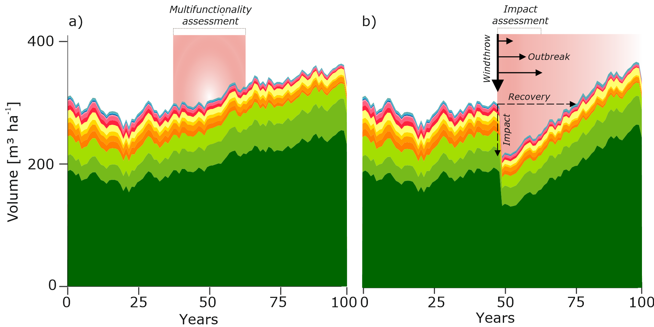
Fig. 2 Framework for assessing forest multifunctionality and resilience, illustrated for a single management strategy and climate scenario. (a) Multifunctionality is quantified within a 30-year window centered on year 2070. (b) Resilience is assessed in response to a large-scale windthrow imposed in year 2070, using the relative impact on growing stock and the subsequent recovery time as indicators. Where Norway spruce is present, the windthrow may trigger a bark beetle outbreak, prolonging the recovery period.

  - Management systems definition
The tested management scenarios differ in managed area, rotation length, planted species after final harvests, post-harvest retention, salvage removal of windfelled trees and the magnitude of browsing pressure reduction (Table 1).
Unmanaged development aims to restore natural forest dynamics. The only intervention applied is a reduction of game browsing pressure, which significantly exceeds the carrying capacity of the environment under reference conditions as a result of historical mismanagement. Conservation-oriented management sets 14% of the forest aside from active management and applies lower-intensity practices in the remaining area. This includes extended rotation periods, restoration of natural species composition through planting, post-harvest tree retention, and active reduction of browsing pressure. Half of all windfelled trees are retained. Business-as-usual management represents conventional spruce-oriented forestry typical of many Central European regions. Planting aims to maintain spruce dominance, browsing is uncontrolled, and the majority of windfelled material is salvaged. Adaptation-oriented management aims to proactively prepare the forest for a changing climate. Rotation lengths are shortened to accelerate stand turnover, and planting prioritises natural species composition with an emphasis on drought-tolerant species. Post-harvest tree retention is practiced and browsing pressure is reduced to facilitate natural regeneration. Bioeconomy-oriented management represents the most intensive regime, with clearcutting as the dominant harvesting system. Rotations are the shortest across all strategies, planting consistently favours spruce, and windfelled material is largely salvaged. Browsing is uncontrolled, supporting the persistence of spruce-dominated stands.

Table 1 Key attributes of the tested management regimes
 | Unmanaged | Conservation | Business-as-usual | Adaptation | Bioeconomy
Description | Unmanaged forest development | Low intensity management, passive adaptation | Spruce timber-oriented management with long rotations | Management promoting active adaptation to climate change | Management promoting the intensified production of spruce timber
Managed area [%] | 0 | 85.9, waterlogged and exposed sites are set-aside | 100 | 100 | 100
Mean rotation length, weighted by forest area [year] | No harvesting | 140 | 122 | 102 | 82
Planting objective | No planting | Restore natural species composition | Maintain spruce dominance | Restore natural species composition, higher drought tolerance | Maintain spruce dominance
Management type (% of forest type) | No management | Shelterwood | Shelterwood | Shelterwood | Clearcutting (85.9%) and shelterwood at waterlogged and exposed sites (14.1%)
Post-harvest retention of trees (dbh> 5 cm) | Irrelevant | 10 trees ha⁻¹ with dbh>30 cm  (non spruce preference) | - | 10 non-spruce trees ha⁻¹ with dbh>30 cm if any | -
Controlling ungulate populations and protecting forest regeneration | 50 % reduction of browsing pressure, closer to the carrying capacity of the environment | 50% reduction of browsing pressure | No control, maintaining high forest exposure to game | 50 % reduction of browsing pressure | No control, maintaining high forest exposure to game
Salvage removal of windfelled trees | No deadwood removal | 50% removal / retention in unmanaged sites | 80% removal | 80% removal | 80% removal

  - Multifunctionality definition
We evaluated four ecosystem services, each represented by two indicators (Table 2). All indicators were normalized to the [0,1] range, using the maximum value observed across all simulations as the upper bound. The lower bound was set to zero for all indicators except NEP; for NEP, it was the minimum value observed across all simulations. To calculate the degree of multifunctionality, the indicators within each ES were averaged and then summed across ES; hence the maximum reachable multifunctionality value was 4.
Table 2. Investigated ecosystem services and indicators used to represent them.
Ecosystem service | Indicator
Wood production | Annual increment [m³ ha⁻¹ year⁻¹]
 | Annual harvest [m³ ha⁻¹ year⁻¹]
Biodiversity | Shannon-index [-]
 | Carbon in deadwood [tC ha⁻¹]
Water regulation | Leaf area index (LAI) [-]
 | Standing volume [m³ m⁻³]
Climate regulation | Carbon stock [tC ha⁻¹]
 | Net ecosystem production (NEP) [tC ha⁻¹ year⁻¹]

  - Resilience assessment
We followed an engineering resilience framework, using growing stock as the response variable and an exceptionally large windthrow as the disturbance. Impact relative to the pre-disturbance growing stock and recovery time were used as resilience metrics.
To obtain a single resilience indicator, we calculated the area under the curve in a space where X-axis is time to recovery (years) and Y-axis is change in growing stock relative to pre-disturbance conditions (%) (Fig. 3). The Y-axis ranges from 0 to −100% (total growing stock loss), while the X-axis is limited to 50 years, corresponding to the length of our simulation period (i.e., allowing for a 50-year recovery from the major windthrow simulated in year 2070, Fig. 2). The indicator is scaled to a 0 –1 range, with 1 representing theoretical maximum resilience (no impact and instantaneous recovery) (Fig, 3a) and 0 the opposite case, when the growing stock was completely depleted by the disturbance and no recovery occurred (Fig, 3c).
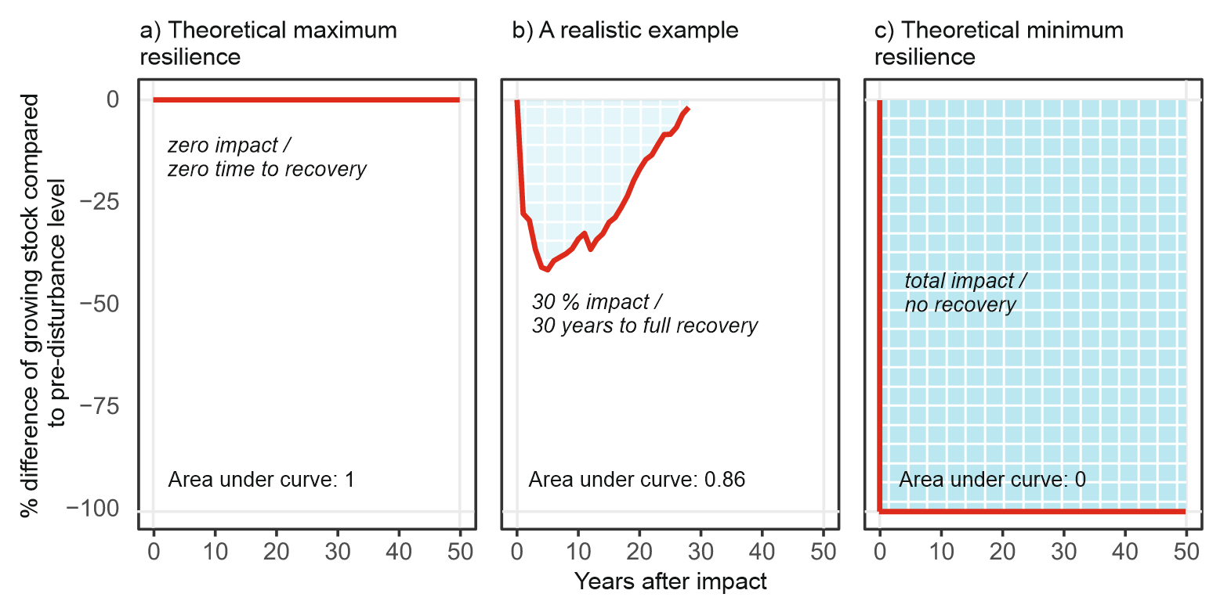
Fig. 3 Area under the curve in a space defined by relative impact (Y-axis, %) and recovery time (X-axis, years), used as a resilience indicator. The two edge cases represent hypothetical maximum (a) and minimum resilience (c), while the intermediate case (b) illustrates a realistic scenario.

- Results
  - Forest multifunctionality
Overall multifunctionality was relatively balanced across management strategies and climate scenarios, ranging from 2.62 to 2.98 on the 0–4 scale, as changes in individual indicators tended to offset one another (Table X). Under reference climate, unmanaged development achieved the highest multifunctionality (2.98), driven by maximum values in water regulation, climate regulation, and biodiversity. On the other hand, wood production ranked lowest owing to the absence of harvesting. Conservation-oriented management ranked second, with a near-identical ecosystem service profile to unmanaged development.
Business-as-usual, bioeconomy, and adaptation-oriented management reached similarly high timber production, climate regulation, and water regulation scores, though all three lagged behind conservation and unmanaged development.
Both adaptation- and conservation-oriented managements, and unmanaged development ranked high in terms of biodiversity, yet for different reasons: while adaptation management was more efficient in increasing tree species diversity but not in deadwood, conservations and unmanaged development reached a more balanced performance in both indicators. Business-as-usual and bioeconomy reached lower scores in biodiversity both, in terms of species diversity and deadwood.
Climate change reduced multifunctionality across all management strategies by 2.8–7.0% (Fig. X). Adaptation-oriented management was least sensitive to climate change, while the largest declines occurred under conservation-oriented management and unmanaged development. At the level of individual ecosystem services, all services were adversely affected by climate change except for biodiversity, which increased by 3–10% under climate change.
Although overall multifunctionality was relatively stable across scenarios, a small number of indicators accounted for most of the variation in ecosystem service provision among management strategies and climate scenarios (Fig. 3).

Annual harvest was the most discriminating indicator, reflecting the contrast between managed strategies (scaled scores 0.56–0.85) and the unmanaged scenario (0.00). It was almost entirely driven by management differences, with a minor proportion of unexplained variance.
NEP ranked second in discriminatory power (SD = 0.140) but was highly variable among replicates, because net ecosystem productivity is strongly influenced by the stochastic timing and severity of individual wind disturbance events, making it noisy rather than a clean management signal.
Carbon in deadwood (SD = 0.121) and standing volume (SD = 0.119) were consistent and reliable indicators that responded clearly to management intensity — increasing steadily under low-intensity regimes — while remaining largely unaffected by climate change.
The Shannon index (SD = 0.093) stood out as the most climate-sensitive indicator in the dataset (ω² = 0.187) and was also highly consistent across replicates, making it the most suitable indicator for detecting climate effects on biodiversity. Carbon stock, LAI, and annual increment added progressively less information and were largely redundant with standing volume. Management was the dominant driver of variation for all eight indicators (ω² = 0.355–0.954; all p < 0.001), while climate was a significant secondary driver for six of eight — the exceptions being carbon in deadwood, which was almost entirely determined by management, and annual increment, which showed little sensitivity to the climate scenarios tested. Importantly, the interaction between management and climate was non-significant for all indicators (all p > 0.05), meaning that the relative performance of management strategies was consistent regardless of which climate scenario was considered.
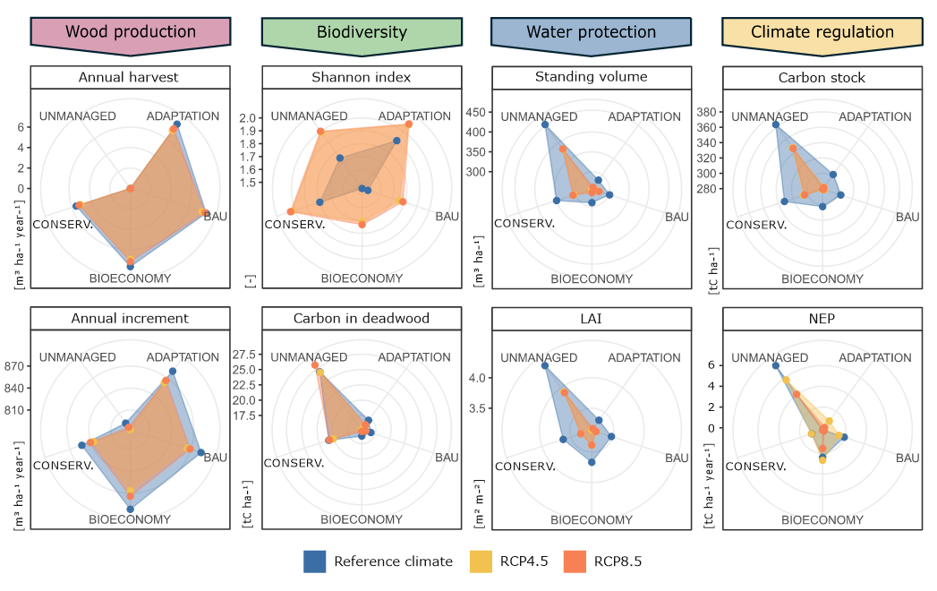
Fig. 4 The provision of selected ecosystem services under five management scenarios combined with three climatic scenarios. Mean values across all replicates are shown.
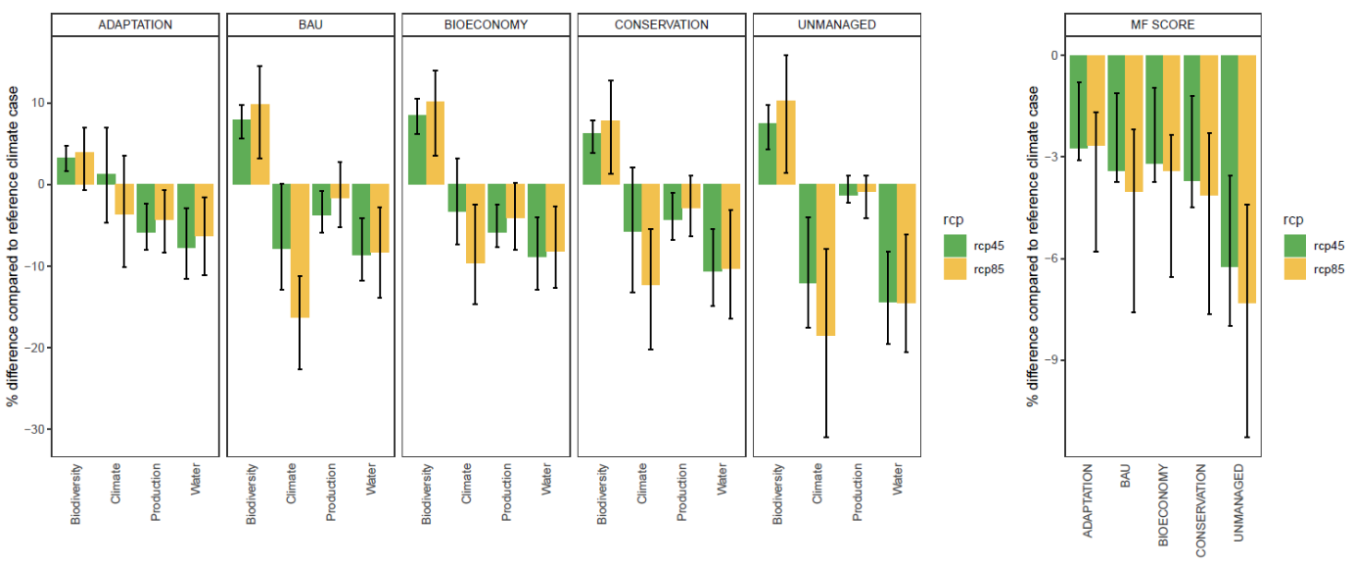
Fig. 5. Climatic sensitivity of ecosystem services provision (a) and the overall forest multifunctionality (b) under different management and climatic scenarios. Error bars show the interquartile range of all simulations (climate models x wind replicates).

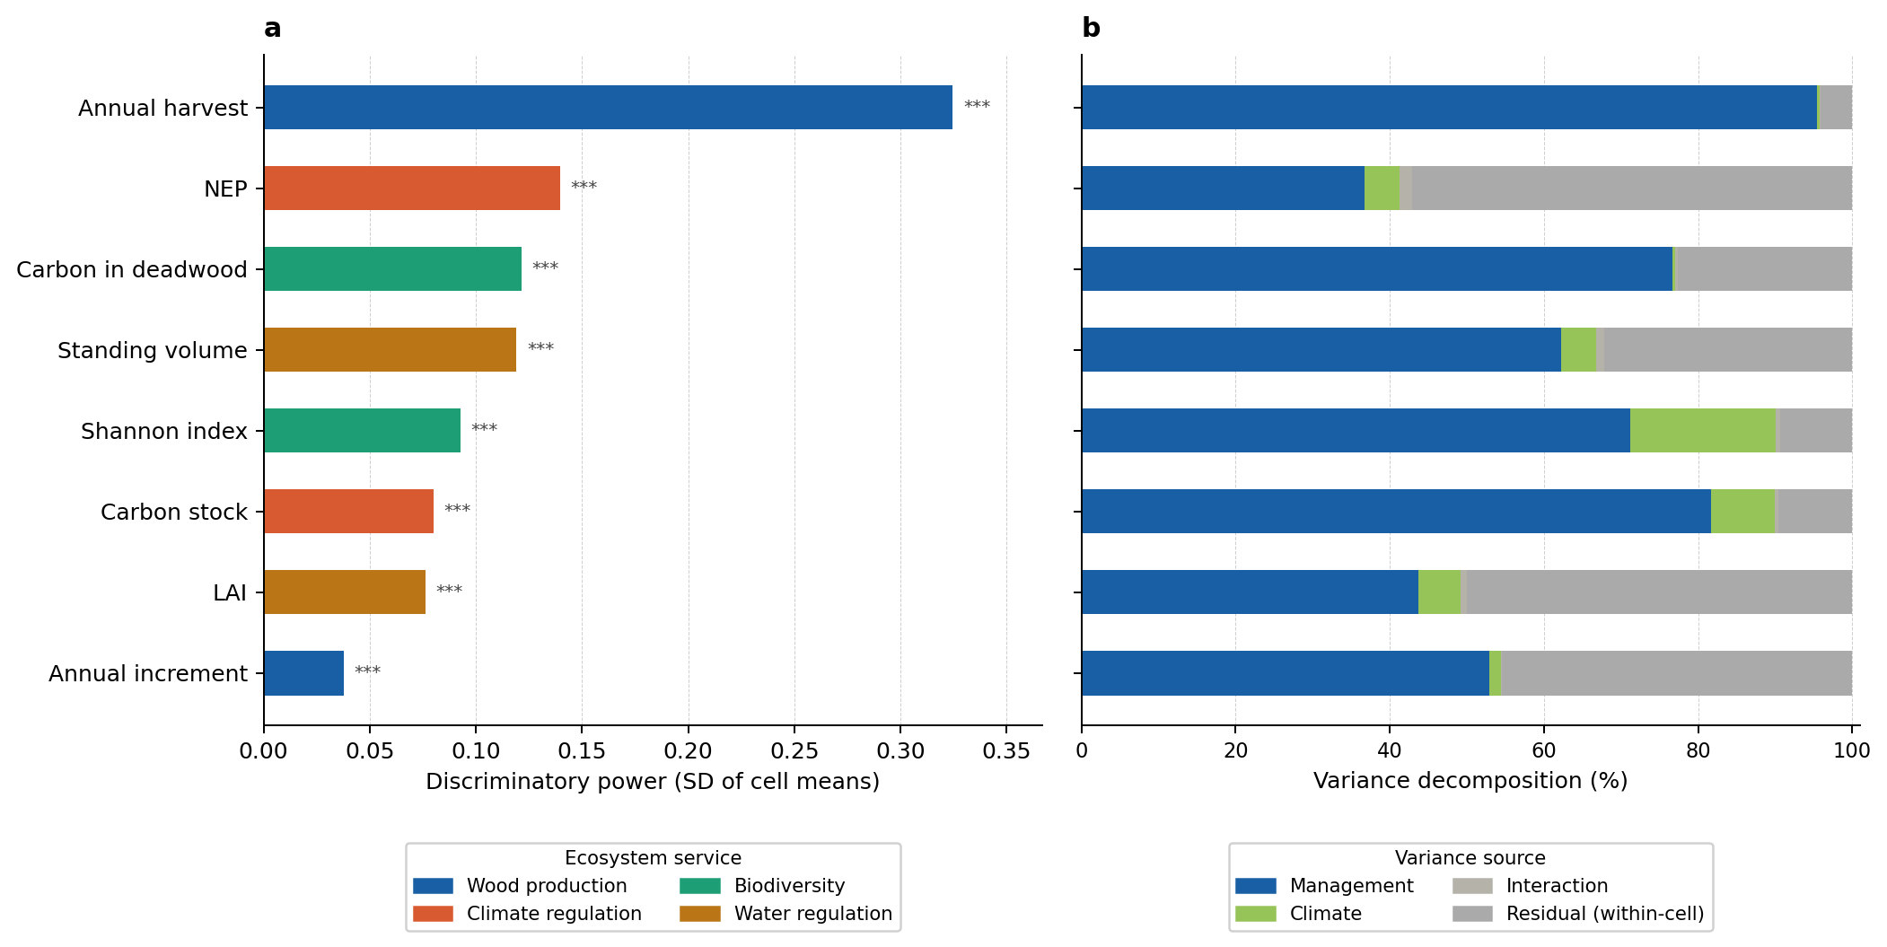
Fig. 6. (a) Discriminatory power of individual ecosystem service indicators, expressed as the standard deviation of cell means across all 15 climate–management combinations. Bars are colored by ecosystem service category. (b) Variance decomposition based on a two-way ANOVA with replication. Each bar is partitioned among management, climate, interaction, and within-cell residual variability reflecting variation among simulation replicates (n=5).
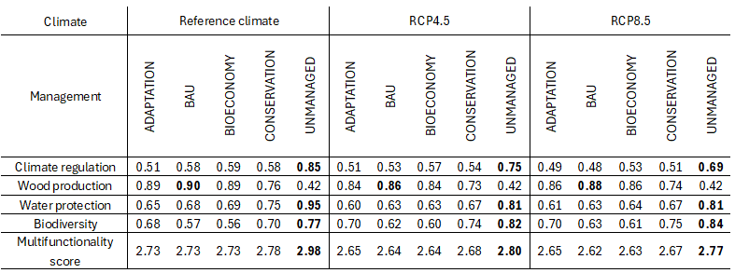
Table 3. Multifunctionality scores across management and climate scenarios, with contributions from the four constituent ecosystem services. For each climate scenario and service, the highest values are shown in bold.

  - Disturbance dynamics and resilience

We need to update this section a bit:
- Wind and bark beetle impacts: need similar graphs as above, with whiskers showing rcm and wind replicate variation
- We have three resilience indicators, impact, recover, and area under the curve. For the final analysis we use AUC only, be here we should present all three, effect of management and climate change
- To be consistent with the previous section, I would probably add variance decomposition

Fig. 4. Relative damage (% of pre-disturbance standing volume) from a large wind event simulated for 2050 followed by a 10-year bark beetle outbreak, under alternative management and climate scenarios. Values represent the ensemble mean of five replicates and climate models.
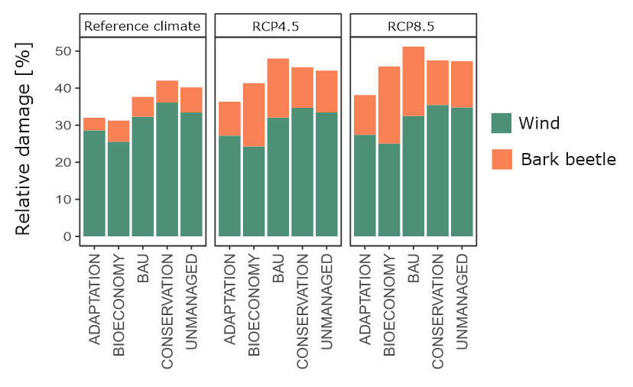
Fig. 5. Relative damage of the large wind event simulated in 2050 and the following bark beetle outbreak in a 10-year window compared to the pre-disturbance standing volume under different management and climatic scenarios. Values show the average of the 5 replicates and the climate models for the future.

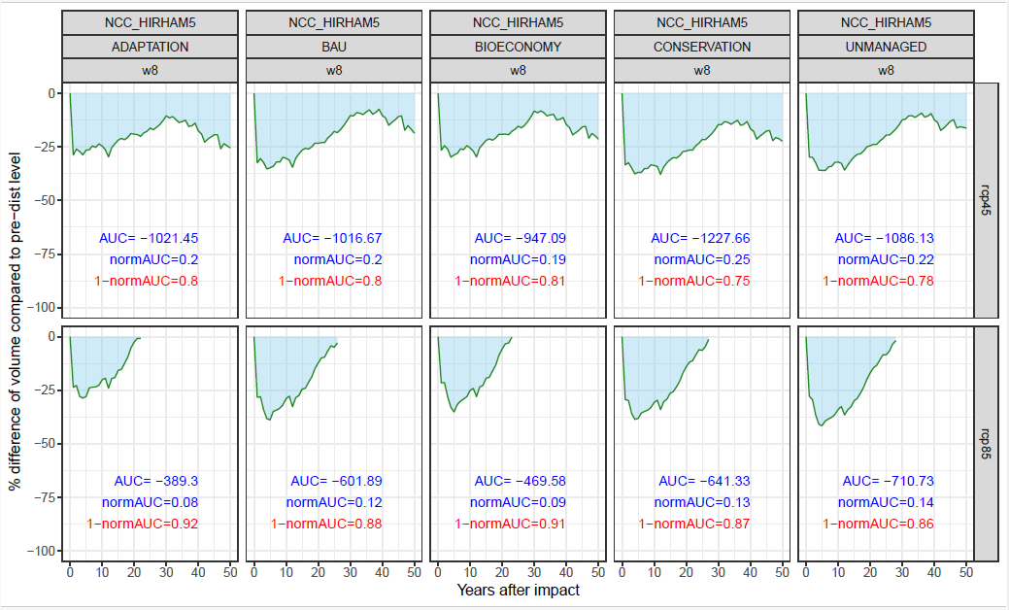
This is an example of calculating the resilience index based on the scheme in Fig. 2 above.

  - Trade-offs between multifunctionality and resilience
Regressing resilience against multifunctionality reveals a consistent negative relationship across all climate scenarios. Under reference climate conditions, both axes were compressed into a narrow range, but the trade-off was already apparent — Unmanaged and Conservation occupied the high-multifunctionality, low-resilience end of the distribution, while Bioeconomy and BAU clustered at the opposite extreme.
Climate change substantially increased the spread along both axes. This spread reflects both the amplified differences between management scenarios but also increased within-scenario variability emerging from climate models and wind replicates.
. Under RCP4.5 and RCP8.5, the spread of resilience values widened markedly, with Conservation and Unmanaged replicates falling as low as 0.75 while intensively managed strategies retained values above 0.90. The regression slope steepened and confidence intervals broadened, indicating that warming not only reduces mean resilience but increases its variability across simulation replicates. The wide within-strategy scatter under warming is consistent with the high stochastic sensitivity of resilience to individual windthrow sequences identified in the ANOVA.
Adaptation and Conservation showed the greatest spread under warming, suggesting that the performance of ecologically oriented strategies becomes less predictable as disturbance regimes intensify.
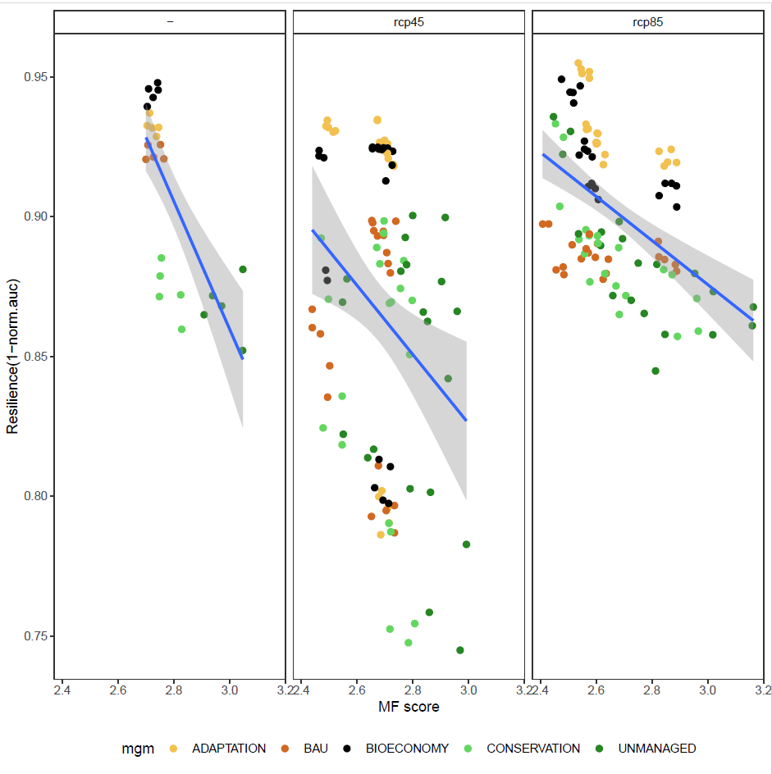
Fig. 6 Relationship between forest multifunctionality, and (i) relative disturbance impact (%, top) and a mean recovery time (years, bottom) under five management regimes and three climate scenarios (left to right: reference climate, RCP4.5, RCP8.5). Each dot represents one simulation for a given climate and windthrow sequence.

- Discussion
I guess you defined “dynamic baseline” as the pre-disturbance growing stock, which is different for each simulation, as we have it in our current approach. Then, the “static baseline” would be a single value used across all simulations, right? For example, GS from the simulation year one (or some longer initial period), which is identical for all simulations. I am not sure how this could work. Imagine that forest managers have decided to change their management in simulation year one to reach different objectives. I do not think that they see resilience as the ability of their forest to return to the initial state, before they decided to change the management. I would say the opposite – they want the forest that is able to maintain conditions reached by the “new” management they decided for. As this state is different under each management narrative, this leads us to the use of the “dynamic baseline”. Each forest manager has a different priority and wants to maintain the forest in different conditions (in our case, having in resilient in terms of recovering pre-disturbance GS, though it is quite a narrow perspective). Does it make sense for you? I elaborated a bit more on this baseline issue below, in response to other comment of yours.

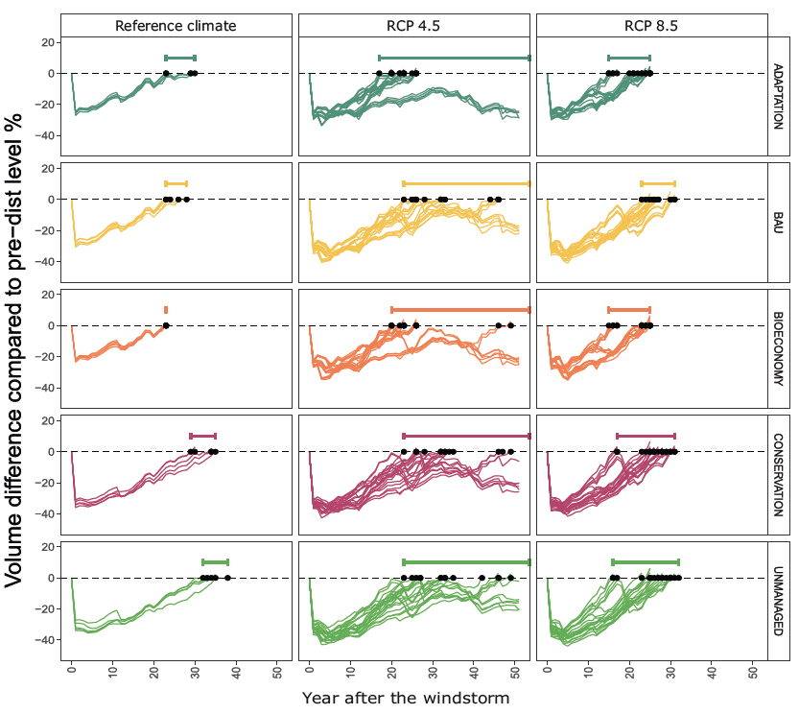
Fig. 6 Relative impact of a large windthrow event on forest growing stock under five management regimes and combinations of climatic-disturbance scenarios (each line represents a single climate scenario with a prescribed sequence of background wind events). Year 0 is 2050, when the windthrow was imposed. Horizontal lines indicate recovery-time spans.
References – chaotic, to be carefully checked, many items are just in comment frames
Abate D, Marques S, Bushenkov V, Riffo J, Weintraub A, Constantino M, Lagoa C, Borges JG (2024) Assessment of tradeoffs between ecosystem services in large spatially constrained forest management planning problems. Frontiers in Forests and Global Change 7:1368608. https://doi.org/10.3389/ffgc.2024.1368608
Dollinger C, Rammer W, Suzuki KF, Braziunas KH, Keller TT, Kobayashi Y, Mohr J, Mori AS, Turner MG, Seidl R (2024) Beyond resilience: Responses to changing climate and disturbance regimes in temperate forest landscapes across the Northern Hemisphere. Global Change Biology 30:e17468. https://doi.org/10.1111/gcb.17468
Elmqvist T, Folke C, Nyström M, Peterson G, Bengtsson J, Walker B, Norberg J (2003) Response diversity, ecosystem change, and resilience. Frontiers in Ecology and the Environment 1(9):488–494. https://doi.org/10.1890/1540-9295(2003)001[0488:RDECAR]2.0.CO;2
Eyvindson K, Repo A, Mönkkönen M (2021) Forest multifunctionality is not resilient to intensive forestry. European Journal of Forest Research 140:537–547. https://doi.org/10.1007/s10342-020-01348-7
Felton A, Seidl R, Lindenmayer DB, Messier C, Löf M, de Koning JHC, Ranius T, Cleary M, Hedwall P-O, Torres García MT, Felton AM (2024) The choice of path to resilience is crucial to the future of production forests. Nature Ecology & Evolution 8:1561–1563. https://doi.org/10.1038/s41559-024-02473-x
Gamfeldt L, Snäll T, Bagchi R, Jonsson M, Gustafsson L, Kjellander P, Ruiz-Jaen MC, Fröberg M, Stendahl J, Philipson CD, Mikusiński G, Andersson E, Westerlund B, Andrén H, Moberg F, Moen J, Bengtsson J (2013) Higher levels of multiple ecosystem services are found in forests with more tree species. Nature Communications 4:1340. https://doi.org/10.1038/ncomms2328
Gustafsson L, Baker SC, Bauhus J, Beese WJ, Brodie A, Kouki J, Lindenmayer DB, Lõhmus A, Martínez Pastur G, Messier C, Neyland M, Palik B, Sverdrup-Thygeson A, Volney WJA, Wayne A, Franklin JF (2012) Retention forestry to maintain multifunctional forests: a world perspective. BioScience 62(7):633–645. https://doi.org/10.1525/bio.2012.62.7.6
Holling CS (1973) Resilience and stability of ecological systems. Annual Review of Ecology and Systematics 4:1–23. https://doi.org/10.1146/annurev.es.04.110173.000245
Holling CS, Meffe GK (1996) Command and control and the pathology of natural resource management. Ecological Applications 6(2):328–337. https://doi.org/10.2307/2269483
Caicoya et al. (2023) What drives forest multifunctionality in central and northern Europe? Exploring the interplay of management, climate, and policies. Ecosystem Services 64:101571. https://doi.org/10.1016/j.ecoser.2023.101571
Jactel H, Bauhus J, Boberg J, Bonal D, Castagneyrol B, Gardiner B, Gonzalez-Olabarria JR, Koricheva J, Meurisse N, Brockerhoff EG (2017) Tree diversity drives forest stand resistance to natural disturbances. Current Forestry Reports 3:223–243. [Note: verify exact year/volume — cited in text as Jactel et al. 2021 in some databases; the reviewing resilience paper in Current Forestry Reports is also:]
Nikinmaa L, Lindner M, Cantarello E, Jump AS, Seidl R, Winkel G, Muys B (2020) Reviewing the use of resilience concepts in forest sciences. Current Forestry Reports 6:61–80. https://doi.org/10.1007/s40725-020-00110-x (This is the PMC-indexed review of resilience concepts cited in the text as "Jactel et al. 2021" — please verify the correct author/year for your version of the manuscript.)
Lecina-Díaz J, Senf C, Grünig M, Seidl R (2024) Ecosystem services at risk from disturbance in Europe's forests. Global Change Biology 30:e17242. https://doi.org/10.1111/gcb.17242
Mori AS, Furukawa T, Sasaki T (2013) Response diversity determines the resilience of ecosystems to environmental change. Biological Reviews 88:349–364. https://doi.org/10.1111/brv.12003
Müller J, Mitesser O, Cadotte MW, van der Plas F, Mori AS, Ammer C, Eisenhauer N, Feldhaar H, Fridman E, Schall P, Schulze E-D, Simons NK, Weisser WW, Gossner MM (2023) Enhancing the structural diversity between forest patches — a concept and real-world experiment to study biodiversity, multifunctionality and forest resilience across spatial scales. Global Change Biology 29:1437–1450. https://doi.org/10.1111/gcb.16564
Patacca M, Lindner M, Lucas-Borja ME, Cordonnier T, Fidej G, Gardiner B, Hauf Y, Jasinevičius G, Labonne S, Linkevičius E, Mahnken M, Milanovic S, Nabuurs G-J, Nagel TA, Nikinmaa L, Panyatov M, Bercak R, Seidl R, Ostrogović Sever MZ, Socha J, Thom D, Vuletic D, Zudin S, Schelhaas M-J (2023) Significant increase in natural disturbance impacts on European forests since 1950. Global Change Biology 29(5):1359–1376. https://doi.org/10.1111/gcb.16531
Seidl R, Schelhaas M-J, Rammer W, Verkerk PJ (2014) Increasing forest disturbances in Europe and their impact on carbon storage. Nature Climate Change 4:806–810. https://doi.org/10.1038/nclimate2318
Seidl R, Spies TA, Peterson DL, Stephens SL, Hicke JA (2016) Searching for resilience: addressing the impacts of changing disturbance regimes on forest ecosystem services. Journal of Applied Ecology 53(1):120–129. https://doi.org/10.1111/1365-2664.12511
Seidl R, Thom D, Kautz M, Martin-Benito D, Peltoniemi M, Vacchiano G, Wild J, Ascoli D, Petr M, Honkaniemi J, Lexer MJ, Trotsiuk V, Mairota P, Svoboda M, Fabrika M, Nagel TA, Reyer CPO (2017) Forest disturbances under climate change. Nature Climate Change 7:395–402. https://doi.org/10.1038/nclimate3303
Thom D, Seidl R (2016) Natural disturbance impacts on ecosystem services and biodiversity in temperate and boreal forests. Biological Reviews 91(3):760–781. https://doi.org/10.1111/brv.12193
Thom D, Mohr J, Seidl R (2024) Are uneven-aged forests in Central Europe less affected by natural disturbances than even-aged forests? Forest Ecology and Management 559:121816. https://doi.org/10.1016/j.foreco.2024.121816
van der Plas F. et al. (2016) Jack-of-all-trades effects drive biodiversity–ecosystem multifunctionality relationships in European forests. Nature Communications 7:11109. https://doi.org/10.1038/ncomms11109
Walker B, Holling CS, Carpenter SR, Kinzig A (2004) Resilience, adaptability and transformability in social–ecological systems. Ecology and Society 9(2):5. https://doi.org/10.5751/ES-00650-090205

Appendices

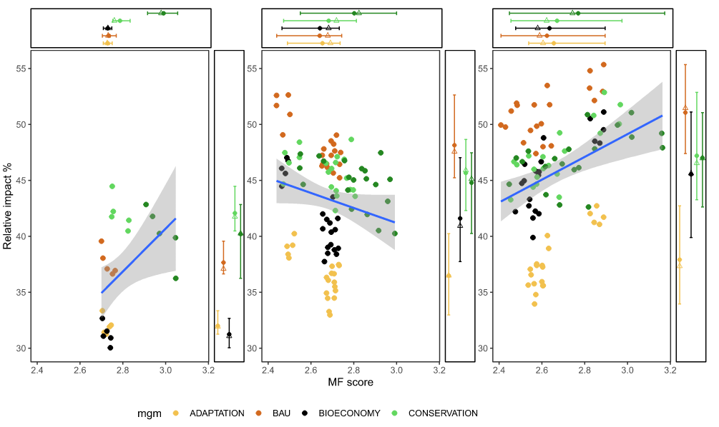
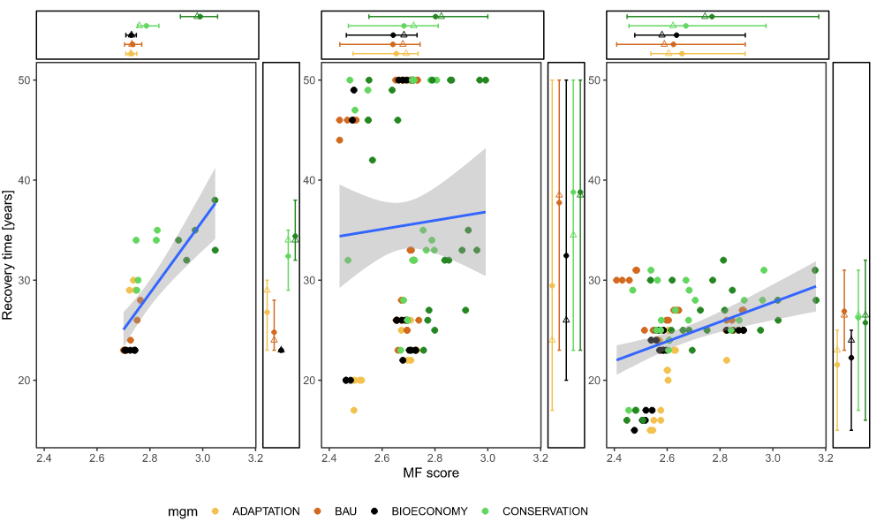
Fig. 6 Relationship between forest multifunctionality, and (i) relative disturbance impact (%, top) and a mean recovery time (years, bottom) under five management regimes and three climate scenarios (left to right: reference climate, RCP4.5, RCP8.5). Each dot represents one simulation for a given climate and windthrow sequence.

Main messages
Multifunctionality
- The highest level of multifunctionality – considering biodiversity, water and climate regulation, and wood production – was associated with lower-intensity management regimes (unmanaged and conservation-oriented). This reflects the higher growing stocks maintained under lower-intensity management, which are generally associated with increased provision of several ecosystem services. Hence, higher multifunctionality under low-intensity regimes resulted from higher provision of non-production services and biodiversity, which compensated for the effect of reduced wood provision.
- Climate change had a moderately negative effect on multifunctionality (up to −11%), with unmanaged forests affected the most and forests under adaptation-oriented management the least.
- At the level of individual ecosystem services, biodiversity increased under climate change across all management regimes, driven by the increased tree diversity and deadwood. This effect is context-specific: initial biodiversity in the studied forest was low due to long-term rotation forestry focused on a small number of productive species. By contrast, water and climate regulation were affected the most, reflecting reduced carbon stocks and canopy closure under increased disturbance impacts.
Resilience
- Contrary to expectation, resilience was lowest under lower-intensity regimes aimed at fostering natural dynamics. Higher growing stock experienced greater impact and longer recovery. By contrast, high-intensity management (shorter rotations, more frequent interventions) was most resilient in terms of both impact and recovery, owing to the reduced growing stock, despite greater structural homogeneity and reduced species diversity.
- Climate change significantly extended the range of recovery times (23–34 years under the reference climate, with the mean of … years), with some simulation runs not recovering by 2100. Mean recovery time differed among management regimes by ±Xx %.
- The reference impact (XX % of pre-disturbance growing stock affected by windthrow plus the follow-up bark beetle outbreak) was amplified under climate change by XX–XX %, driven mainly by increased bark-beetle dynamics; the effect on windthrow was weak.
Trade-offs between multifunctionality and resilience
- Forest conditions exhibiting higher multifunctionality show lower resilience in terms of both the relative impact and recovery time. This relationship is the most distinct under reference climate and more varied under RCP8.5. Under RCP4.5, the effect highly varied.

