Two-way ANOVA with replication — the math
*Reference: (Two-way ANOVA theory — Zar (2010), Biostatistical Analysis, 5th ed., Prentice Hall)

The basic idea
You have a response variable (e.g. Shannon index) measured across combinations of two factors:
- Management (e.g. 4 levels: BAU, CTL, EXT, INT)
- Climate (e.g. 3 levels: current, RCP4.5, RCP8.5)
With replication meaning each cell has multiple observations (forest plots/sites).

The model
$$Y_{ijk}=μ+α_{i}+β_{j}+(αβ)_{ij}+ϵ_{ijk}$$
Where:
- $Y_{ijk}$= observation $k$in management $i$, climate $j$
- $μ$= overall mean
- $α_{i}$= effect of management level $i$
- $β_{j}$= effect of climate level $j$
- $\left(αβ)_{ij}\right.$= interaction effect
- $ϵ_{ijk}$= residual error ~ N(0, σ²)

Residuals
The residual $ϵ_{ijk}$is simply the difference between what the model predicts and what you actually observed:
$$ϵ_{ijk}=Y_{ijk}-{\hat{Y}}_{ijk}$$
So if your model predicts Shannon index = 2.5 for a plot under intensive management + RCP4.5, but the actual measured value is 2.8, the residual is +0.3. It represents everything the model cannot explain — natural variability between plots, measurement error, missing variables.

The assumption ~ N(0, σ²)
This is read as "the residuals follow a normal distribution with mean 0 and variance σ²". Breaking it down:
N — Normal distribution (bell curve shape)
0 — mean of zero, meaning errors are equally likely to be positive or negative. The model is not systematically over or under predicting.
σ² — variance, meaning the spread of errors is constant across all groups. This is called homoscedasticity — intensive management plots should have similar residual spread as extensive management plots.

Concrete example
Say you have 5 replicates in one cell (intensive management + RCP4.5):
Plot | Observed | Predicted | Residual
1 | 2.8 | 2.5 | +0.3
2 | 2.2 | 2.5 | -0.3
3 | 2.6 | 2.5 | +0.1
4 | 2.4 | 2.5 | -0.1
5 | 2.5 | 2.5 | 0.0
The residuals average to ~0 ✓, and their spread (σ²) should be similar across all cells.

Why it matters
If residuals are not normally distributed or variance is unequal across groups, the F-statistics and p-values from the ANOVA are unreliable. You can check this with:
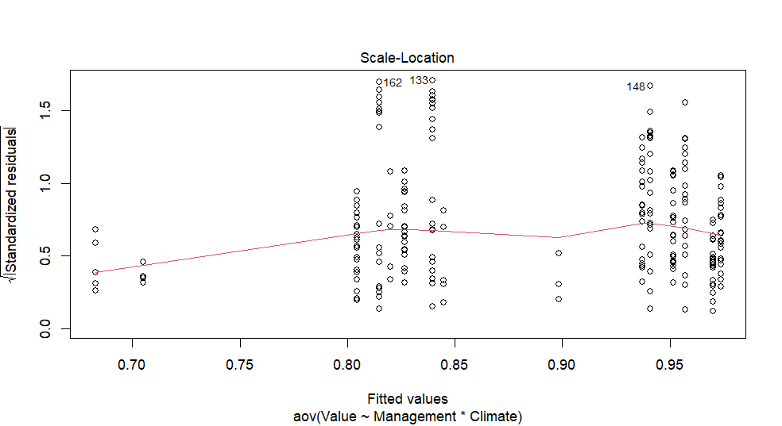
This is the Scale-Location plot (one of the 4 diagnostic plots from plot(fit)). It checks homoscedasticity — whether residual spread is constant across fitted values.

How to read it
- X-axis — fitted (predicted) values from the model
- Y-axis — square root of absolute standardized residuals
- Red line — should be roughly horizontal if variance is constant

What this plot tells you
The red line is not perfectly flat — it rises slightly in the middle then drops — but it's relatively stable overall. This suggests mild heteroscedasticity but nothing severely problematic.

Variance decomposition
The total variance is partitioned:
$$SS_{total}=SS_{management}+SS_{climate}+SS_{interaction}+SS_{residual}$$
With a concrete example — say you have 4 management × 3 climate × 5 replicates = 60 observations, and:
Source | SS | %
Management | 450 | 60%
Climate | 150 | 20%
Interaction | 75 | 10%
Residual | 75 | 10%
Total | 750 | 100%
This means management explains 60% of all variation in that indicator.

What variance decomposition means
It answers the question: "out of all the variation we see in this indicator, how much is attributable to each source?"
For example if Shannon index varies across your dataset, is that because:
- Forests were managed differently? (Management)
- They experienced different climates? (Climate)
- The combination of both? (Interaction)
- Just random plot-to-plot variation? (Residual)

How variance is calculated — from scratch
Start with the total variance. Say you have these 6 observations of Shannon index:
Obs | Value
1 | 2.1
2 | 2.4
3 | 1.8
4 | 2.9
5 | 2.2
6 | 2.6
Overall mean $\overset{ˉ}{Y}$= 2.33
Total Sum of Squares measures total spread around the grand mean:
$$SS_{total}=\sum_{i}{(}Y_{i}-\overset{ˉ}{Y})^{2} \\ =(2.1-2.33)^{2}+(2.4-2.33)^{2}+...=0.717$$

Then partition it
ANOVA splits $SS_{total}$by asking: how much of that spread is explained by each factor?
$$SS_{total}=SS_{management}+SS_{climate}+SS_{interaction}+SS_{residual}$$
$SS_{management}$— how much do group means differ from the grand mean due to management alone:
$$SS_{mgmt}=n\sum_{i}{(}{\overset{ˉ}{Y}}_{mgmt_{i}}-\overset{ˉ}{Y})^{2}$$
If BAU plots average 2.1 and intensive plots average 2.8, that difference from the grand mean 2.33 contributes to $SS_{mgmt}$.
$SS_{residual}$— what's left unexplained, the within-cell spread:
$$SS_{resid}=\sum_{ijk}{(}Y_{ijk}-{\overset{ˉ}{Y}}_{ij})^{2}$$
i.e. how much do individual plots deviate from their own cell mean.

Converting to percentages
This is exactly what your code does:
r
pct_mgmt = s['Management', 'Sum Sq'] / ss_total * 100
So if $SS_{mgmt}$= 450 and $SS_{total}$= 750:
$$\%_{mgmt}=\frac{450}{750}×100=60\%$$

Intuition summary
% high for... | Means...
Management | Your management choices strongly drive indicator variation
Climate | Climate scenario matters more than what you do
Interaction | Management effectiveness depends on climate context
Residual | Unexplained plot-to-plot noise dominates

The F-statistic
Each term is tested with an F-ratio:
$$F_{management}=\frac{MS_{management}}{MS_{residual}}=\frac{SS_{management}/df_{management}}{SS_{residual}/df_{residual}}$$
Where $MS$= Mean Square = SS divided by degrees of freedom. A large F means the factor explains much more variance than the unexplained noise — leading to a small p-value.

What the interaction means
This is the most important and subtle part. An interaction means the effect of management depends on which climate you are in. For example:
- Under current climate: intensive management increases Shannon index by +0.5
- Under RCP8.5: intensive management decreases Shannon index by -0.2
If there were no interaction, the management effect would be consistent across all climates. A significant interaction term means you cannot interpret management and climate effects independently.

The F-statistic
The F-ratio answers: "is this factor explaining more variance than we'd expect by chance?"
$$F_{management}=\frac{MS_{management}}{MS_{residual}}=\frac{SS_{management}/df_{management}}{SS_{residual}/df_{residual}}$$

What is MS (Mean Square)?
Raw SS values are not directly comparable because they depend on degrees of freedom. Dividing by df normalizes them into a variance estimate called Mean Square.
- $MS_{management}$= variance explained by management
- $MS_{residual}$= variance explained by nothing (pure noise)

Degrees of freedom
For your case with 4 management levels and 3 climate levels:
Source | df
Management | levels - 1 = 3
Climate | levels - 1 = 2
Interaction | 3 × 2 = 6
Residual | N - (total groups)

Concrete example
Say for Shannon index:
Source | SS | df | MS | F
Management | 450 | 3 | 150 | 150/5 = 30
Climate | 100 | 2 | 50 | 50/5 = 10
Residual | 60 | 12 | 5 | —
F = 30 means management explains 30× more variance than pure noise — very unlikely to happen by chance, giving a very small p-value.
Why divide by degrees of freedom?
The problem with raw SS is that it accumulates with more data. If you have 4 management levels you sum 4 squared deviations, but if you have 8 levels you sum 8 — the SS will be larger just because you have more terms, not because the effect is stronger.
Dividing by df corrects for this, converting a cumulative sum into an average squared deviation — that's literally what Mean Square means:
$$MS=\frac{SS}{df}=\text{average squared deviation per degree of freedom}$$

Concrete example
Say management explains SS = 450 with 3 df:
$$MS_{mgmt}=\frac{450}{3}=150$$
This means on average, each management contrast accounts for 150 units of squared deviation. Now it's comparable to:
$$MS_{residual}=\frac{60}{12}=5$$
Which means on average, each residual unit accounts for only 5 units of squared deviation.

Why the ratio makes sense
$$F=\frac{MS_{mgmt}}{MS_{residual}}=\frac{150}{5}=30$$
You are essentially asking: "is the average variance explained by management large compared to the average background noise?"
If management had no real effect, both MS values would be estimating the same underlying noise, and F would be close to 1. The further F is from 1, the more confident you are that management has a genuine effect beyond random variation.

