Statistical Methods: Resilience Analysis of Forest Growing Stock under Climate Change and Management Scenarios

1. Overview
This analysis quantifies how five forest management strategies affect the resilience of growing stock following wind disturbance events, across three climate scenarios. Three complementary resilience indicators are compared against a historical baseline climate: (i) disturbance impact, (ii) resistance as measured by the area above the recovery curve, and (iii) recovery time. The analytical framework combines deterministic imputation of non-recovering simulation runs with a mean-difference discrimination approach to characterise both the direction and magnitude of climate-driven changes in resilience.

2. Study Design and Simulation Structure
Simulations were conducted across a factorial combination of five management strategies (ADAPTATION, BAU, BIOECONOMY, CONSERVATION, UNMANAGED), three climate scenarios (historical baseline [refclim], RCP 4.5, RCP 8.5), multiple regional climate models, and wind disturbance cases, yielding a total of 225 simulation units. Each simulation unit is identified by a unique combination of management strategy, climate scenario, regional climate model, and wind disturbance case (group_key = mgm_rcp_model_windcase). The simulation horizon was set to 50 years.

3. Resilience Indicators

3.1 Impact
Impact was defined as the maximum proportional loss of growing stock observed immediately following disturbance. Higher absolute values indicate greater disturbance severity. This indicator captures the initial resistance of the stand to the wind event, independent of subsequent recovery trajectory.

3.2 Resistance (one_minus_norm_auc)
Resistance was quantified as one minus the normalised area under the post-disturbance growing stock trajectory curve (1 − norm.AUC). Geometrically, this corresponds to the area above the recovery curve and below the pre-disturbance reference level: a larger value indicates greater cumulative loss over time and therefore lower resistance. The normalisation ensures comparability across simulation units with different pre-disturbance growing stock levels.

3.3 Recovery Time (rt)
Recovery time was defined as the number of years required for growing stock to return to its pre-disturbance level following a wind event. Simulation runs in which growing stock did not return to the pre-disturbance level within the 50-year simulation horizon were recorded as non-recovering cases.

4. Handling of Non-Recovering Simulation Cases

4.1 Identification and distribution
Of the 225 simulation units, 27 (12.0%) did not achieve full recovery within the simulation horizon and therefore yielded no finite recovery time value. These cases were not distributed randomly: all 27 were concentrated under the RCP 4.5 scenario and clustered within specific regional climate models, indicating that non-recovery is a structurally determined outcome associated with particular climate trajectories rather than a random artefact. This non-random censoring pattern means that omitting these cases would systematically bias any comparison of recovery time across management strategies and climate scenarios.

4.2 Imputation strategy
To retain non-recovering cases in the analysis while accurately representing their ecological meaning, recovery time for these 27 simulation units was imputed at the simulation horizon boundary (rt = 50 years). This approach treats non-recovery as the most severe outcome on the recovery time scale, consistent with the right-censoring convention used in survival analysis: the stand had not recovered by the last observed time point. The imputed value is conservative in the sense that it is the minimum possible value for a non-recovering stand; the true recovery time, if it exists, would be equal to or greater than 50 years.

4.3 Sensitivity analysis
To assess the robustness of results to the imputation choice, all analyses involving recovery time were repeated using an alternative imputation value of 75 years (rt = 75), representing a scenario in which non-recovering stands are assumed to require substantially longer recovery than the simulation window. Comparison of results under the two imputation values (50 vs. 75 years) provides a direct test of whether conclusions are sensitive to the arbitrary boundary imposed by the simulation horizon.

5. Discrimination Analysis: Mean Difference from Reference Climate

5.1 Rationale
The core analytical question is whether, and to what degree, projected climate change (RCP 4.5 and RCP 8.5) alters each resilience indicator relative to historically observed conditions. To answer this, we computed the mean difference in each resilience indicator between each future climate scenario and the historical baseline (refclim) for each management strategy. This discrimination approach directly quantifies the climate-driven shift in resilience, separately for each management type, and allows visual comparison of the direction and magnitude of effects across the three indicators.

5.2 Computation
For each combination of management strategy (mgm) and resilience variable (impact, one_minus_norm_auc, rt_imp), a reference mean was calculated across all simulation units belonging to the historical baseline climate (refclim). For each future climate scenario (RCP 4.5, RCP 8.5), the mean indicator value across all simulation units in that scenario and management group was then computed, and the reference mean subtracted to yield the mean difference. Uncertainty around each mean difference was quantified as the standard error of the mean (SEM) within each management × climate × variable group, and 95% confidence intervals were derived as ±1.96 × SEM.

5.3 Interpretation
A positive mean difference in impact or resistance (one_minus_norm_auc) indicates that climate change is associated with greater disturbance severity or greater cumulative loss, respectively, relative to historical conditions. A positive mean difference in recovery time indicates slower recovery under future climate. Negative values indicate improvement relative to the baseline. The magnitude of the difference, relative to its confidence interval, indicates the strength of the climate signal for each management strategy.

6. Visualisation
Results are presented as grouped bar plots faceted by management strategy (× axis) and resilience variable (y-axis panels), with free y-axis scales to accommodate the different units and magnitudes of the three indicators. Each bar represents the mean difference from the reference climate for one RCP scenario; error bars show 95% confidence intervals. The horizontal dashed line at zero indicates no change from the historical baseline. The note on each panel records that the 27 non-recovering cases under RCP 4.5 were imputed at rt = 50 years.

7. Software
All analyses were conducted in R (v4.x) using the tidyverse suite for data manipulation and ggplot2 for visualisation. Survival analysis was performed using the survival and survminer packages. Code and data are available in the project repository.

8. Results

penalty_primary <- 50 # primary imputation: rt = sim_horizon (boundary)
penalty_sensitivity <- 75 # sensitivity check: rt = 75 (beyond window)

df <- df |>
mutate(
rt_imp = if_else(is_censored, as.numeric(penalty_primary), rt),
rt_imp_sens = if_else(is_censored, as.numeric(penalty_sensitivity), rt)
)
# ── 4. Compute mean differences vs. reference climate (refclim) ──────────────
# Same logic as your existing discrimination plot
ref_means <- df_long |>
filter(rcp == "refclim") |>
group_by(mgm, variable) |>
summarise(ref_mean = mean(value, na.rm = TRUE), .groups = "drop")

mean_diffs <- df_long |>
filter(rcp != "refclim") |>
group_by(mgm, rcp, variable) |>
summarise(
mean_val = mean(value, na.rm = TRUE),
se_val = sd(value, na.rm = TRUE) / sqrt(n()),
.groups = "drop"
) |>
left_join(ref_means, by = c("mgm", "variable")) |>
mutate(
mean_diff = mean_val - ref_mean,
ci_low = mean_diff - 1.96 * se_val,
ci_high = mean_diff + 1.96 * se_val
)

print(plot_primary)

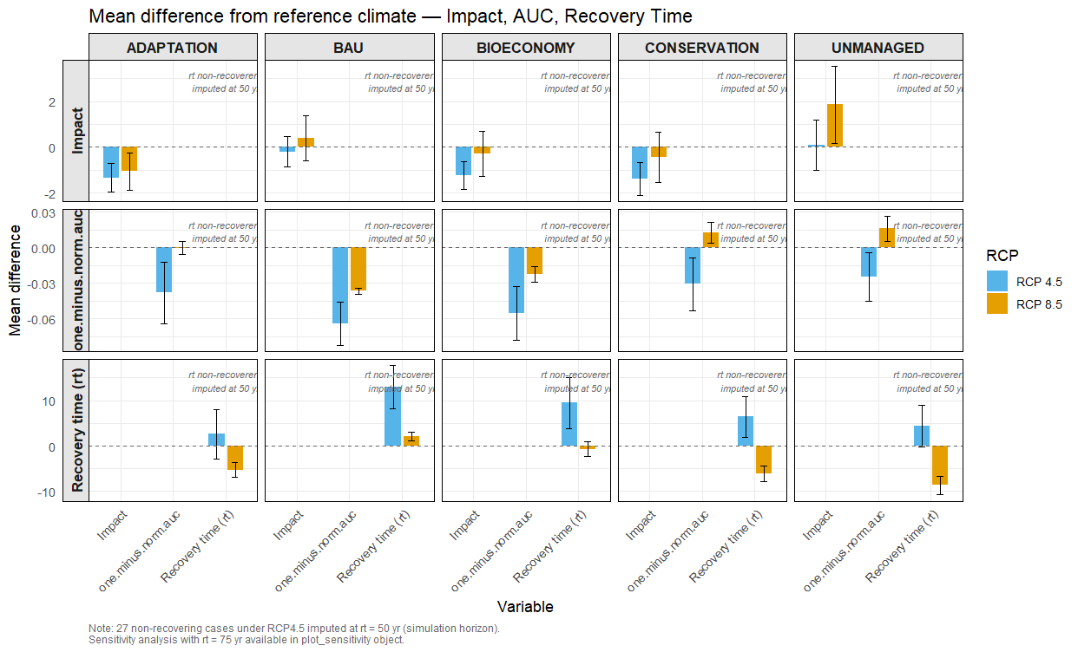

plot_sensitivity

