The Cox proportional hazards model is modeling:
how different variables change the recovery rate over time.
In your study:
- the event = forest recovery
- the model estimates how management and climate affect the speed of recovery.

Intuition: what the Cox model does
Imagine two forests:
- one under ADAPTATION
- one under UNMANAGED
At every year, the Cox model compares:
which forest is more likely to recover at that moment, given it has not yet recovered.
That “instantaneous recovery likelihood” is called the hazard.
In your case:
$$\text{hazard}=\text{instantaneous recovery rate}$$
Higher hazard:
- faster recovery
Lower hazard:
- slower recovery

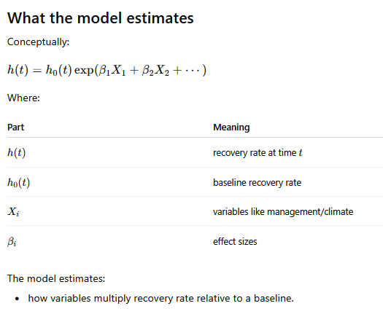
Need to set reference baseline case: BAU and refclim for our case.

1) Fit an additive model: (cox1 <- coxph( surv_obj ~ mgm + rcp , data = df))
-management effects adjusted for climate
-climate effects adjusted for management

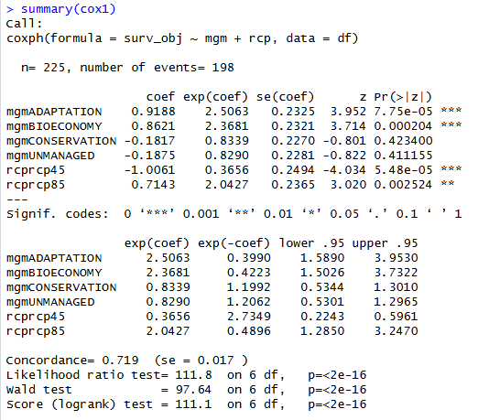

So all effects are interpreted relative to:
- BAU management
- reference climate
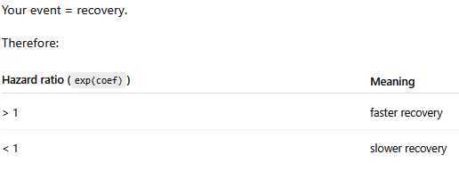

Management effects
ADAPTATION strongly accelerated recovery
- HR = 2.51
- 95% CI = 1.59–3.95
- p < 0.001
Forests under ADAPTATION recovered approximately 2.5 times faster than under BAU management.

BIOECONOMY strongly accelerated recovery
- HR = 2.37
- 95% CI = 1.50–3.73
- p < 0.001
BIOECONOMY management increased recovery rates by approximately 137% relative to BAU. (2.4 times faster)

CONSERVATION showed no significant difference from BAU
- HR = 0.83
- 95% CI = 0.53–1.30
- p = 0.42
Recovery tended to be slightly slower than under BAU, but the effect was not statistically supported.

UNMANAGED also showed no significant difference from BAU
- HR = 0.83
- 95% CI = 0.53–1.30
- p = 0.41
Recovery was slightly slower than under BAU, but uncertainty was large and the effect was not statistically significant.

Climate effects
rcp45 substantially reduced recovery rates
- HR = 0.37
- 95% CI = 0.22–0.60
- p < 0.001
Recovery rates under rcp45 were approximately 63% lower than under reference climate conditions.

rcp85 increased recovery rates
- HR = 2.04
- 95% CI = 1.29–3.25
- p = 0.003
Recovery rates under rcp85 were approximately twice as high as under reference climate conditions.

Predictive performance was good
- Concordance = 0.719
Interpretation:
The model correctly ranked recovery timing in approximately 72% of comparisons.

Overall model significance was very strong
- Likelihood ratio test: p < 2 × 10⁻¹⁶
- Wald test: p < 2 × 10⁻¹⁶
- Score test: p < 2 × 10⁻¹⁶
Interpretation:
Management and climate together explained a substantial proportion of variation in recovery dynamics.

The model indicates that:
- adaptive management strategies substantially enhanced forest resilience and accelerated recovery
- moderate climate forcing (rcp45) delayed recovery
- severe climate forcing (rcp85) unexpectedly accelerated recovery relative to the reference climate
- unmanaged and conservation scenarios did not differ substantially from BAU in recovery dynamics

2) Fit an interaction model (cox2 <- coxph(surv_obj ~ mgm * rcp , data = df))
Baseline condition is: BAU + refclim

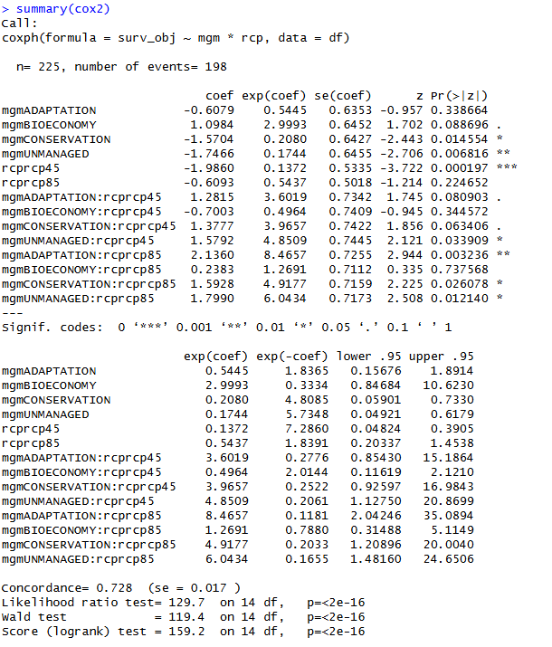

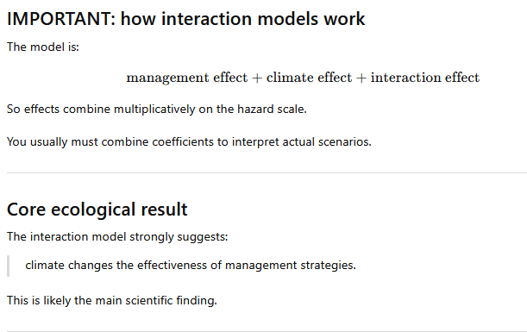

  - Main climate effects
These describe climate effects ONLY under the reference management (BAU).

rcp45 under BAU
HR = 0.137
p < 0.001
Interpretation:
Under BAU management, rcp45 reduced recovery rates by about 86% relative to reference climate.
Very strong negative effect.

rcp85 under BAU
HR = 0.544
p = 0.22
Interpretation:
Under BAU, rcp85 tended to reduce recovery rates, but evidence was weak.
Notice:
- this is VERY different from the additive model.
That means:
- climate effect depends strongly on management.

  - Main management effects
These describe management effects ONLY under reference climate.

ADAPTATION under refclim
HR = 0.54
p = 0.34
Interpretation:
Under reference climate, ADAPTATION did not significantly differ from BAU.

BIOECONOMY under refclim
HR = 3.00
p = 0.089
Interpretation:
BIOECONOMY tended to accelerate recovery under reference climate, though uncertainty was substantial.

CONSERVATION under refclim
HR = 0.21
p = 0.015
Interpretation:
CONSERVATION substantially slowed recovery under reference climate.

UNMANAGED under refclim
HR = 0.17
p = 0.007
Interpretation:
UNMANAGED forests recovered much more slowly than BAU under reference climate.

  - INTERACTION TERMS (most important)
These tell you:
how climate modifies management effects.
This is the heart of the model.

ADAPTATION × rcp85
HR = 8.47
p = 0.003
This is huge.
Interpretation:
Under rcp85, ADAPTATION strongly increased recovery rates relative to what would be expected from additive effects alone.
Ecologically:
- adaptation strategies become highly effective under severe climate forcing
- or adaptation compensates for climate stress.
This is probably your strongest finding.

CONSERVATION × rcp85
HR = 4.92
p = 0.026
Interpretation:
Under rcp85, the negative recovery effect of CONSERVATION was substantially reduced.
Meaning:
- climate modifies conservation outcomes.

UNMANAGED × rcp85
HR = 6.04
p = 0.012
Interpretation:
Under rcp85, unmanaged forests recovered substantially faster than expected from additive effects.
Interesting ecological signal.

ADAPTATION × rcp45
HR = 3.60
p = 0.081
Marginal evidence that:
- adaptation also helps under rcp45.

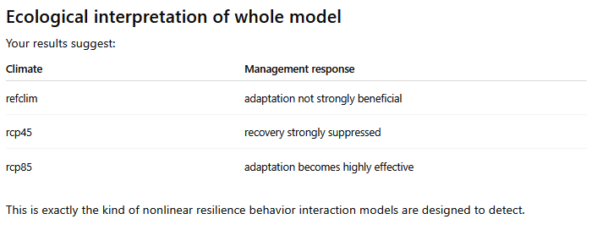

Model quality
Concordance
0.728
Slightly better than additive model.
Good predictive discrimination.

Model comparison implication
Because:
- concordance improved
- likelihood strongly significant
- interactions significant
the interaction model is probably ecologically superior to the additive model.
You should formally compare:
anova(cox_add, cox2, test = "LRT")
I suspect interaction model will win.

------ MODEL COMPARISON

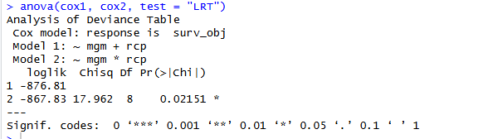

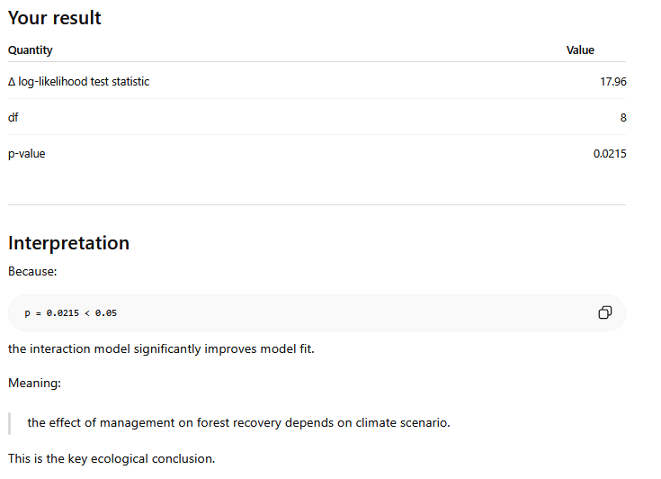

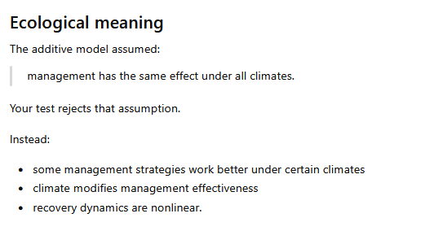

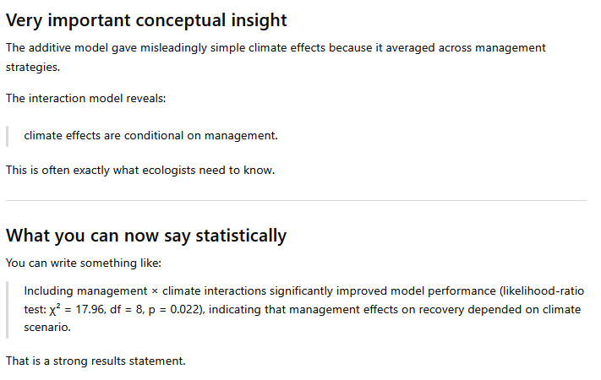

Checking if the non-recovering cases are handled well:
Yes — this is actually one of the major strengths of survival analysis and the Cox proportional hazards model.
Your “not recovering” simulations are handled naturally through right censoring.

What your censored cases mean
In your study:
Situation | Interpretation
recovery observed | event
no recovery before simulation ended | right-censored observation
So if a forest never recovers during the simulation horizon:
is_censored = TRUE
then the model interprets this as:
recovery time is longer than the observed simulation period.
NOT as:
recovery time = infinite.
This distinction is very important.

Why ordinary statistics fail here
Suppose simulation ends at year 40.
Two forests:
Forest | Observed
A | recovered at year 25
B | not recovered by year 40
We know:
- A recovered at 25
- B survived unrecovered at least until 40
But we do NOT know:
- whether B would recover at year 45
- year 100
- or never.
Survival analysis handles exactly this uncertainty.

How Cox handles censoring
Censored forests:
- contribute information up to censoring time
- then leave the risk set.
They still help estimate:
- recovery rates
- hazard differences
- survival curves.
This is statistically correct.

In your case
You said:
under rcp45 many forests never recover.
That is ecologically meaningful and the Cox model incorporates it appropriately.
In fact, this is WHY:
rcprcp45 HR = 0.137
became so strongly negative.
Because:
- many forests remained unrecovered
- recovery events were rare/slower.
The model interprets this as:
greatly reduced recovery hazard.

Very important conceptual point
The Cox model does NOT require all forests to recover.
That is one reason it is ideal for resilience studies.

When censoring becomes problematic
Censoring is handled well IF it is:
Non-informative censoring
Meaning:
- censoring occurs because simulation ended
- not because of some hidden biological mechanism.
Your setup likely satisfies this.

Example of problematic censoring
Bad case:
forests were removed from analysis because severely damaged landscapes crashed computationally.
Then censoring depends on system state.
That could bias results.
But your censoring seems administrative:
- simulation horizon ended.
That is appropriate.

One important ecological interpretation
Under rcp45:
- many forests never recovered within simulation time
- therefore survival curves remain high
- hazard ratios become very low.
Ecologically this suggests:
- delayed recovery
- resilience loss
- possible regime-shift behavior.
This is not a statistical problem.
It is part of the signal.

One thing to check
You should inspect how much censoring exists.
Example:
table(df$rcp, df$is_censored)
If rcp45 has dramatically more censoring than others, that strengthens your interpretation.

Another useful quantity
You can estimate recovery probabilities directly.
Example:
summary(km_rcp, times = 40)
This tells you:
what fraction recovered by simulation end.
Very interpretable ecologically.

One caveat
If censoring becomes extremely high (e.g. >70–80%):
- estimates become unstable
- confidence intervals widen
- proportional hazards may weaken.
But your data still had:
198 events out of 225
So overall event rate is high enough for reliable Cox modeling.

Ecological takeaway
Your many unrecovered rcp45 forests are not a problem for survival analysis.
They are actually one of the strongest pieces of evidence that:
- climate strongly alters recovery dynamics
- resilience declines under rcp45
- recovery delays become substantial.
The Cox model is specifically designed to use this information correctly.

Additional visualization of the statistical results:
