- Kaplan-Meier curve
To see the probabilities for recovery. Compare management effects on recovery and rcp effects on recovery.
- Cox model
Build model to see what is influencing the recovery more. Management or rcps-s or interactions.
------------------------------------------------------------------------------------------------------
Kaplan-Meier curve

Kaplan Meier curve shows the probability forest has not recovered yet.
Rapidly declining curve: faster recovery
High flat curve: slow recovery
The curve is characterized by median and confidence interval (95 %, lower and upper limits). Additionally the number of events (recoveries) are given and the number of observations that were used for the calculation.

Median: Probability of not yet recovered cases has dropped to 50%. So half of the cases have recovered by that time.
Confidence interval: A 95% confidence interval means:
if we repeated the whole simulation study many times, 95% of the intervals constructed this way would contain the true median recovery time.
It is a measure of uncertainty.
Confidence intervals are about the estimate, not individual forests.
They do NOT mean:
“95% of forests recover between e.g. 23 and 25 years.”
Instead they mean:
“we are reasonably confident the true median recovery time lies in this range.”

We can make K-M curves per rcps or per managements to show the effect of management and rcps on the recovery probabilities. See below.
Line: the probability that a forest has NOT yet recovered by a given year after disturbance. So the median is at 0.5 on y, when half of the forests recovered.
When the line is up at 1: not any recovered
Dropped to 0 : all of them are recovered which are in that group.

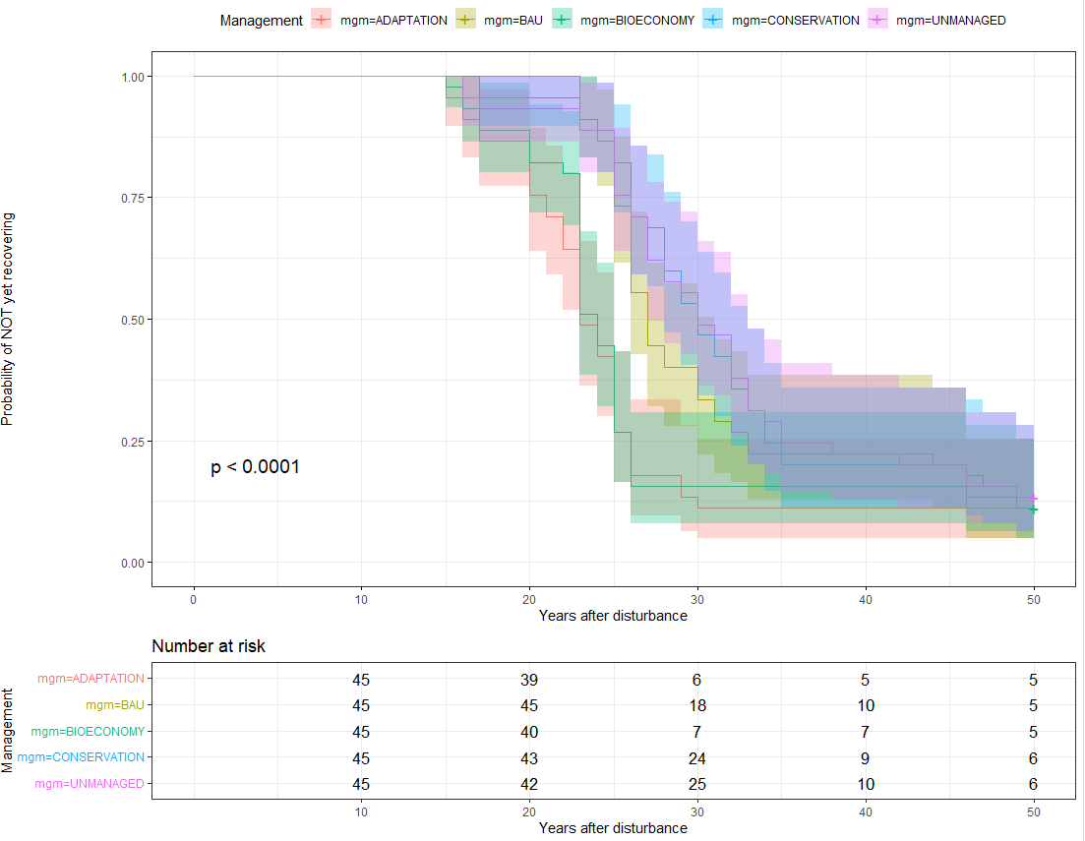

The area is the confidence interval, line is the median.
Numbers shows the non-recovered cases in each 10years.
n.risk = number of simulations still “at risk” immediately before that time.

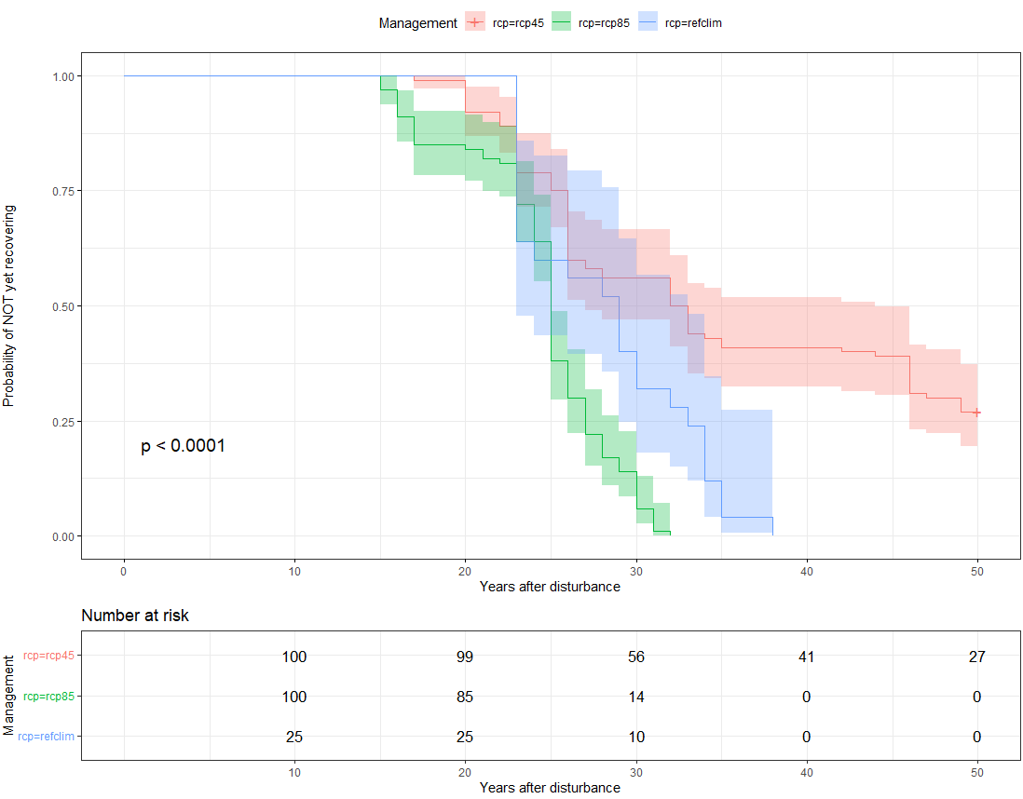

Same here, 27 is not recovered at all in rcp4.5.

Looking the grouped effect rcp_management makes no sense here, as they would have very little number of runs to use. (for refclim, only 5 I think)

Fastest median recovery across managements:
n events median 0.95LCL 0.95UCL
mgm=ADAPTATION 45 40 23 23 25
mgm=BAU 45 40 27 26 31
mgm=BIOECONOMY 45 40 24 23 25
mgm=CONSERVATION 45 39 30 28 33
mgm=UNMANAGED 45 39 30 27 33

I can derive the probability of NOT recovering at year 23:
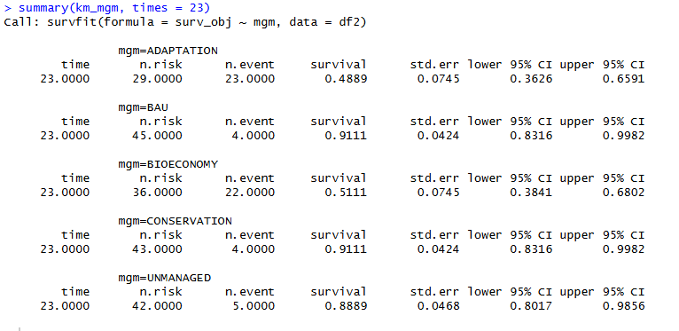
Look the survival number (probability of NOT recovering by y23)
n.risk = number of simulations still “at risk” immediately before that time.
n.event = number of recovery events occurring exactly at that time.
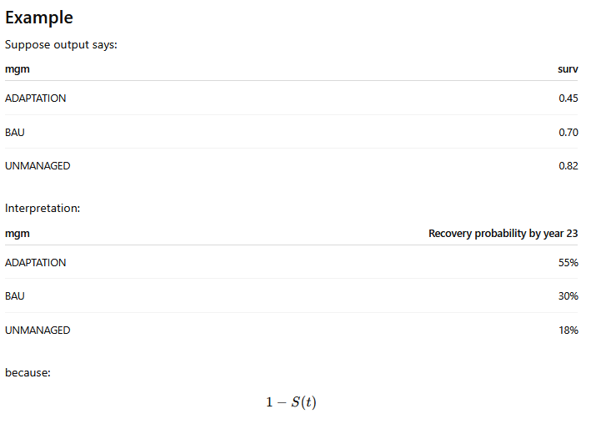
Recovery probability will be 1- survival.
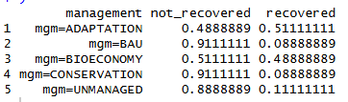

You are anchoring comparison to the fastest scenario's recovery timeline.
This is scientifically meaningful because it compares: how delayed other systems are relative to the most resilient management.

If I want to assess the effects of climate change on the probabilities that they recovered in y 23.
Do K-M per rcps:
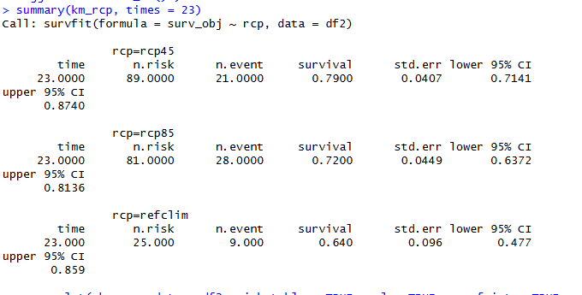
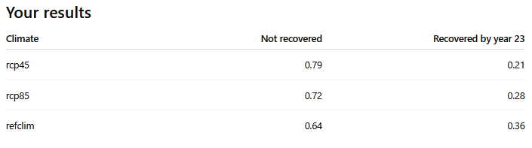

This 23 is not the fastest recovery, it is when half of the simulations recovered in case of adaptation mgm.
Overall fastest recovery was 15 years (when the upper graph first drops), there was 3 cases:
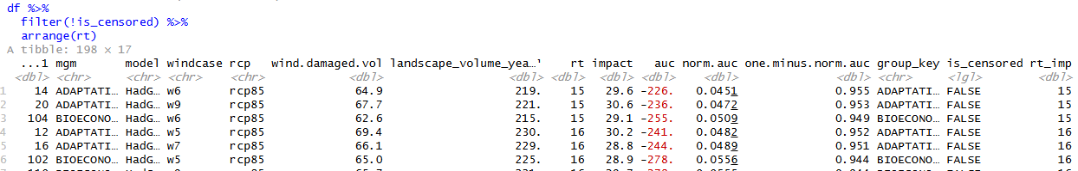

I would not really do any comparison like those column graphs. I think the graphs above is saying it all, needs some explanation but gives full picutre.
We can change the y axis to have it as recovery prob. Not the NO recovery.
Mabye can improve visualization for mgms, they are a bit over each other
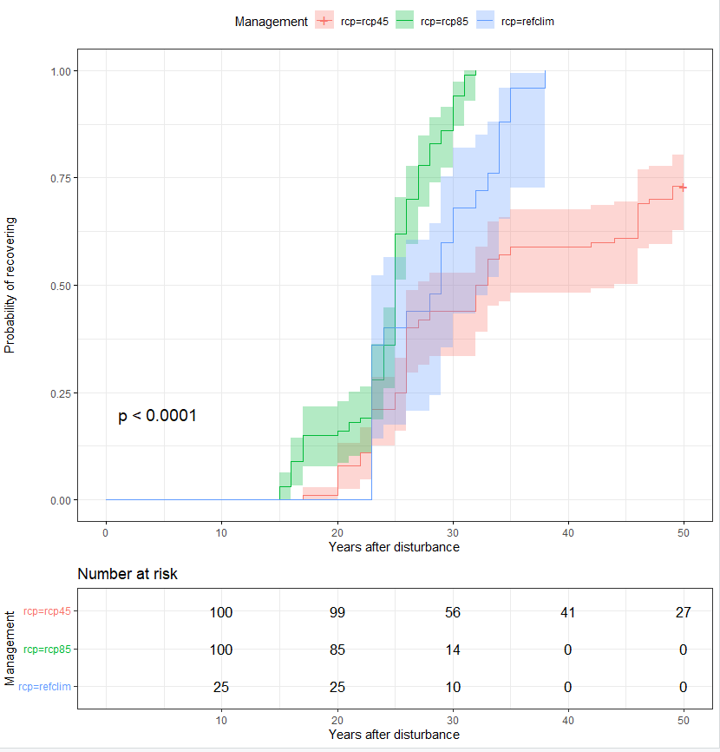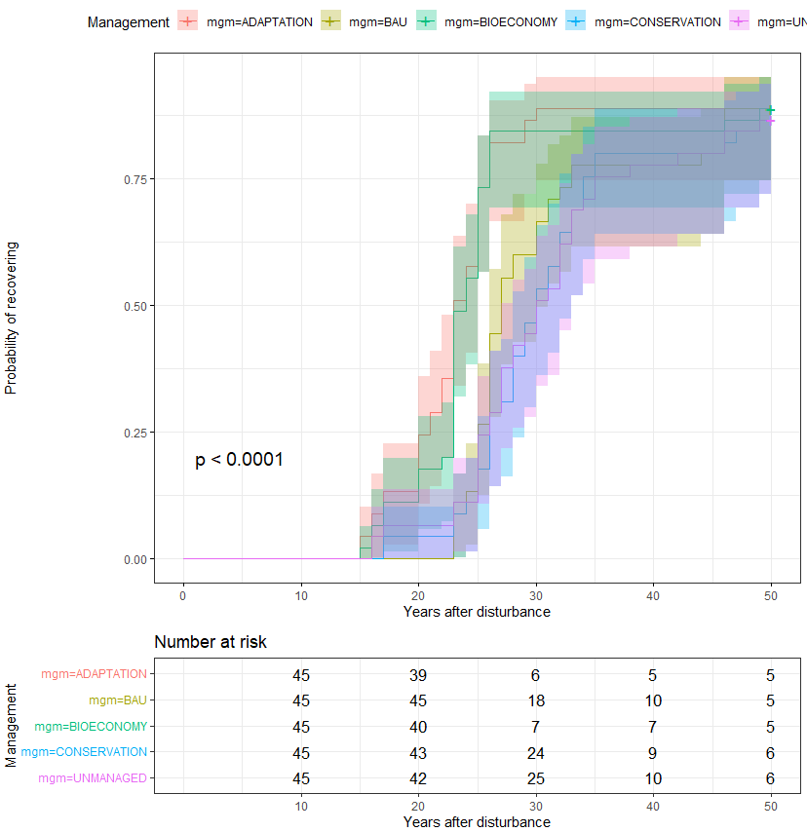
Proseguing the analysis 2026 05 12 Kaplan-Meier LB – MB Let’s make some visualization editing – the survfit results aren’t changed so refer above.

# ── Plot A: KM by Management ───────────────────────────────────────────────────
km_mgm <- survfit(Surv(time, event) ~ mgm, data = df)
g_mgm <- make_km(km_mgm, df, management_colors, "mgm", "Management")

# ── Plot B: KM by RCP ─────────────────────────────────────────────────────────
km_rcp <- survfit(Surv(time, event) ~ rcp, data = df)
g_rcp <- make_km(km_rcp, df, rcp_colors, "rcp", "Climate")

First overview!
km_mgm <- survfit( surv_obj ~ mgm, data = df2)

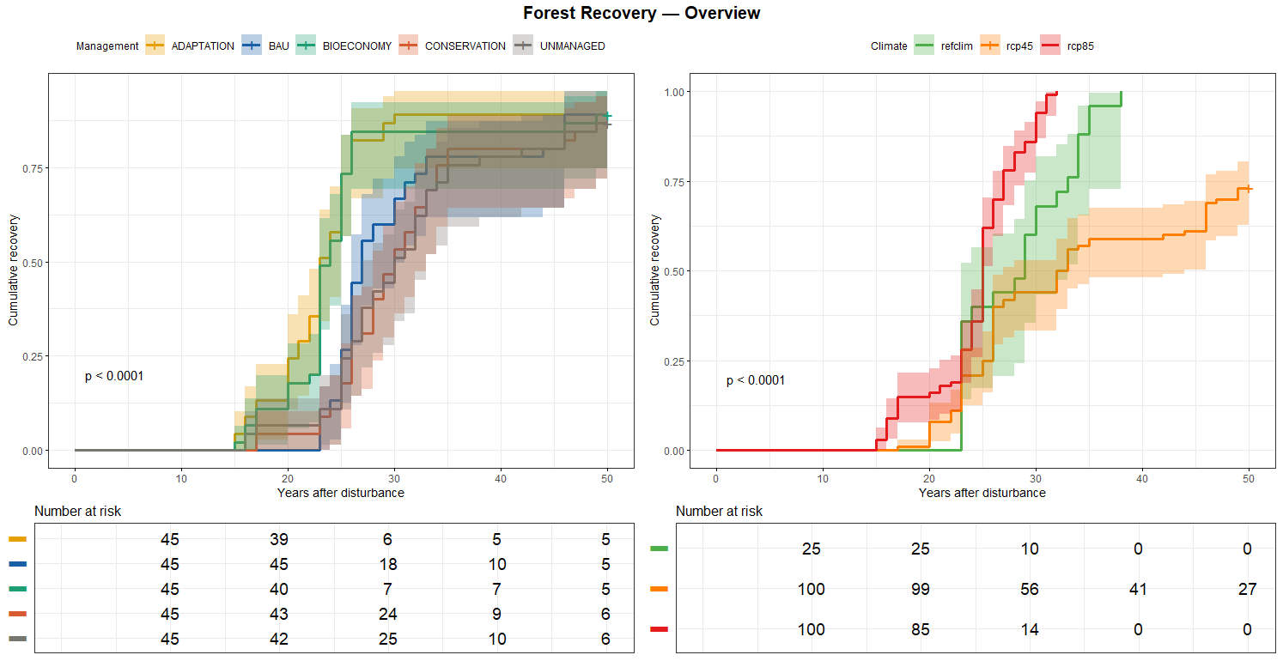

km_rcp <- survfit( surv_obj ~ rcp , data = df2)
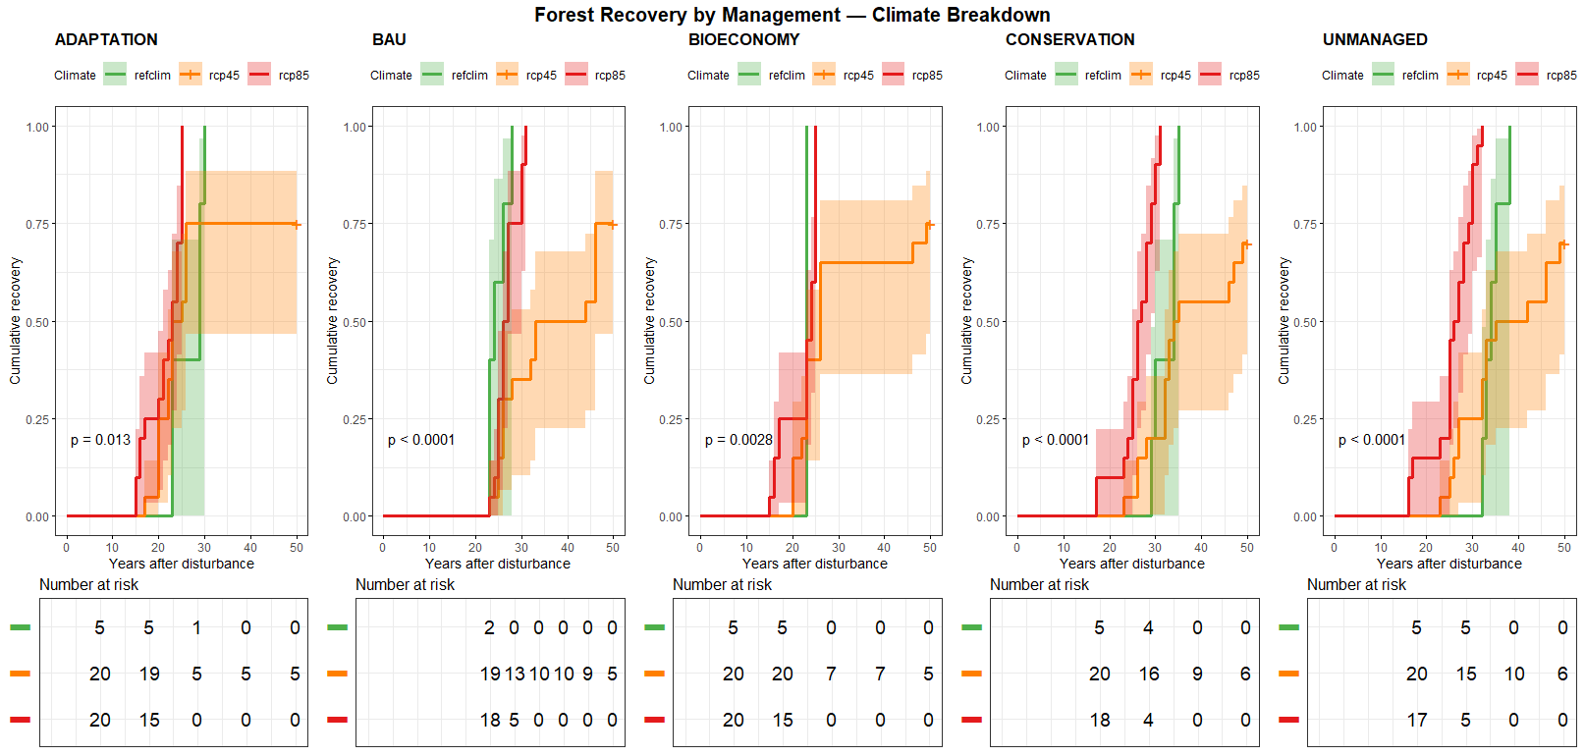

(Me attaching the above script) I have this script. Is it the evolution of the previous by chance? For visualization this is better. I don't know logically and statistically what changed
(Claude reply in the chat on SA) Yes, this is an earlier version of the script we were working on. Let me break down what's different:
What's the same goal — showing cumulative recovery probability faceted by Management × Climate.

Key differences:
1. Cox model instead of pure K-M
This script fits a coxph() model and then uses survfit() on that model to get predicted curves for each Management × Climate combination. The previous clean version used raw K-M (survfit directly on data). Cox gives model-smoothed curves that borrow strength across groups; K-M gives empirical step functions from the raw data only.
2. cluster(cluster_id)
Uses model + windcase as a clustering variable to account for correlated observations within the same simulation setup. This is a variance correction (robust standard errors), not a stratification — it affects the CIs but not the point estimates.
3. The loop over Climate × Management
Generates one predicted curve per combination by passing newdata into survfit(cox_model, newdata = ...). This is what produces the smooth, well-behaved curves you see in the better-looking plot.
4. facet_grid(Climate ~ Management) with ggplot directly
Instead of ggsurvplot, this uses raw ggplot2 with geom_step + geom_ribbon. This gives you full layout control — which is why the plot looks cleaner and more publication-ready.
5. Monotonicity enforcement
The cummax trick forces curves to never decrease, fixing numerical artifacts from the Cox prediction.

The core statistical tradeoff:
This script (Cox)Previous (K-M)CurvesModel-predicted, smootherEmpirical, stepwiseSmall n robustnessBetter (borrows across groups)Worse (each group standalone)AssumptionsProportional hazardsNoneSeparation problemYes (the infinite coefficient warning)NoPlot controlFull ggplot2ggsurvplot constraints
My recommendation: given your small n per cell (~9 obs for refclim), the Cox-predicted curves are actually more honest visually — but you need to resolve the separation warning first. The K-M approach is assumption-free and safer if you want to stay conservative. The ggplot2 faceted layout from this script is definitely superior and worth keeping regardless.

Ok let’s show the advanced model version
SCRIPT #12_Surv_Anal_essential.R

df_surv |> count(Management, recovered)
# A tibble: 10 × 3
Management recovered(censored) n
<fct> <int> <int>
1 ADAPTATION 0 5
2 ADAPTATION 1 40
3 BAU 0 5
4 BAU 1 40
5 BIOECONOMY 0 5
6 BIOECONOMY 1 40
7 CONSERVATION 0 6
8 CONSERVATION 1 39
9 UNMANAGED 0 6
10 UNMANAGED 1 39

Kaplan – Meier curve is fitted with the Cox model results. This has two reason the first it is because apply a smoothig model into the results, the second can be analysed the variance partitioning with the Nagelkerke test.

# ── 3. Cox model + predicted survival curves (Management * Climate) ───────────
cox_model <- coxph(
Surv(time, recovered) ~ Management * Climate + cluster(cluster_id),
data = df_surv
)

# in the K-M estimator fuction
all_plot_data <- data.frame()

for (clim in levels(df_surv$Climate)) {
for (mgm_level in levels(df_surv$Management)) {

newdata <- data.frame(
Management = mgm_level,
Climate = clim,
cluster_id = NA
)

fit <- survfit(cox_model, newdata = newdata)

n_sims <- df_surv |>
filter(Climate == clim, Management == mgm_level) |>
nrow()

all_plot_data <- bind_rows(
all_plot_data,
surv_summary(fit, data = df_surv) |>
mutate(
Management = mgm_level,
Climate = clim,
n_sims = n_sims
)
)
}
}

Test cox.zph
cox.zph(cox_model)
chisq df p
Management 49.7 4 4.2e-10
Climate 68.5 2 1.4e-15
Management:Climate 59.3 8 6.3e-10
GLOBAL 115.7 14 < 2e-16

print(final_plot)
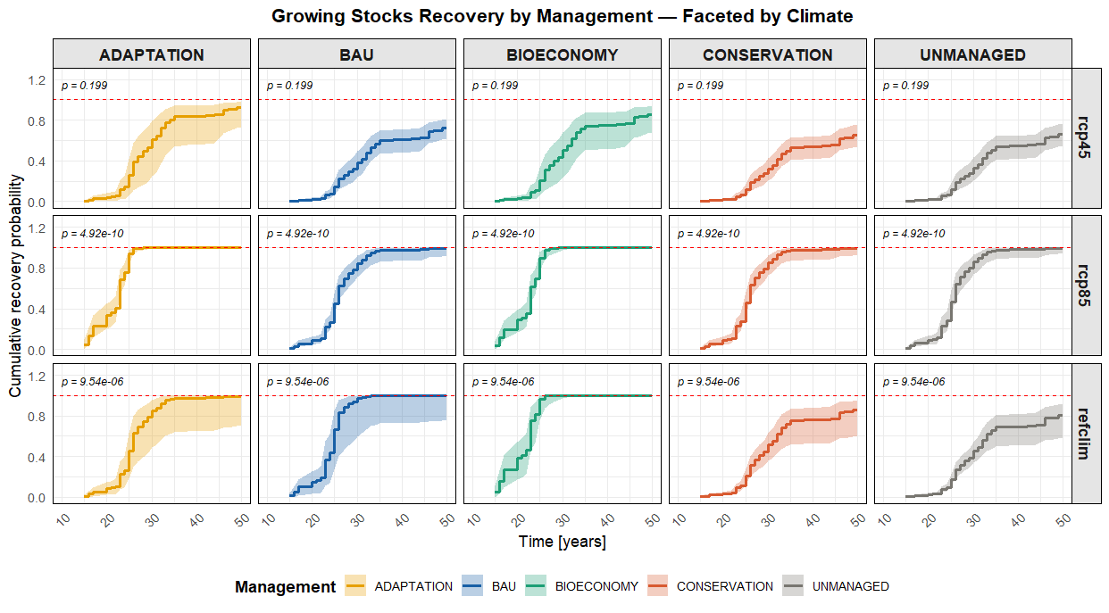

# ── Survival-based Variance Decomposition
# Full model with interaction
cox_full <- coxph(Surv(time, recovered) ~ Management * Climate + cluster(cluster_id),
data = df_surv)
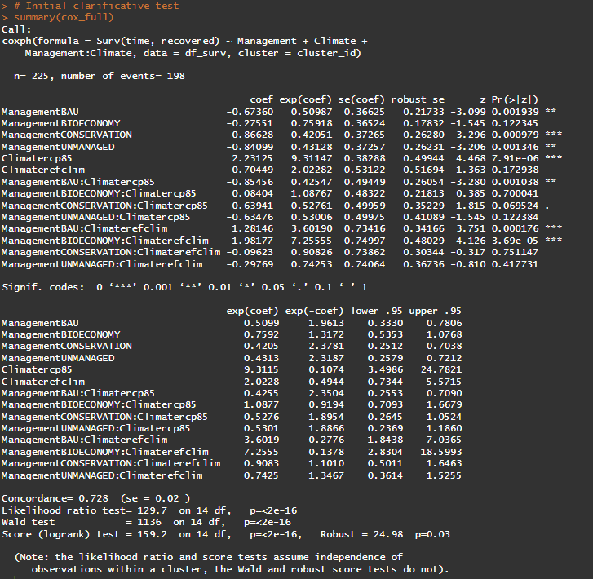

# ── 2. Likelihood Ratio Tests (LRT)
# ── 3. Convert to % of explained variation (analogous to η²)

variance_decomp
cat("════════════════════════════════════════════════\n")
cat("Variance Decomposition — Cox LRT (Type II, analogous to η²)\n")
cat("════════════════════════════════════════════════\n")
as.data.frame(variance_decomp) |> print()

as.data.frame(r2_table) |> print()
# A tibble: 3 × 5
Term LRT_chi2 df p_value pct_explained
1 Management 40.4 4 0 27.8
2 Climate 87 2 0 59.9
3 Management × Climate 18.0 8 0.0215 12.4

# ── 4. Nagelkerke R² per model (overall explanatory power) ────────────────────
# R²_Nagelkerke = (1 - exp(-LRT/n)) / (1 - exp(2*logLik(null)/n))
# For Cox, null loglik is loglik[1] (before any covariates)
null_loglik <- cox_mgm$loglik[1] # same for all models

nagelkerke <- function(full_loglik, null_loglik, n) {
lrt <- 2 * (full_loglik - null_loglik)
r2_cs <- 1 - exp(-lrt / n)
r2_max <- 1 - exp(-2 * abs(null_loglik) / n) # abs() fixes sign issue
round(r2_cs / r2_max, 3)}
cat("\n════════════════════════════════════════════════\n")
cat("Overall Explanatory Power — Nagelkerke R²\n")
cat("════════════════════════════════════════════════\n")

as.data.frame(r2_table) |> print()
Model Nagelkerke_R2
1 Management only 0.104
2 Climate only 0.272
3 Management + Climate 0.392
4 Management * Climate 0.438 (total explanation)

SCRIPT #11_Surv_Anal_test_long

Extract the year of first cell (mgn * clim) reaching full recovery in cases at 99% (Adaptation rcp85 at year 28)
cat("Earliest T99 combination:\n")
Earliest T99 combination:
> as.data.frame(t99_threshold)
Management Climate T99 T99_lower T99_upper
1 ADAPTATION rcp85 28 25 30
> # Extract the threshold year
> threshold_year <- round(t99_threshold$T99)
> cat("\nUsing threshold year:", threshold_year, "\n")
Using threshold year: 28

recovery_28 df cumulative recovery imputation from the year 28 of the K-M
# ── Step 1: Extract T99 for all combinations ──────────────────────────────────
t99_results <- data.frame()
for (clim in levels(df_surv$Climate)) {
sub <- df_surv |> filter(Climate == clim)
if (nrow(sub) < 5 || all(sub$recovered == 0)) next
cox_model <- tryCatch(
coxph(Surv(time, recovered) ~ Management, data = sub),
error = function(e) NULL
)
if (is.null(cox_model)) next
for (mgm_level in levels(df_surv$Management)) {
if (!(mgm_level %in% sub$Management)) next
fit <- survfit(cox_model,
newdata = data.frame(Management = mgm_level),
conf.type = "plain")
q <- quantile(fit, probs = 0.9999) # 99% recovered

t99_results <- bind_rows(
t99_results,
tibble(
Management = mgm_level,
Climate = clim,
T99 = q$quantile[1],
T99_lower = q$lower[1],
T99_upper = q$upper[1]))}}
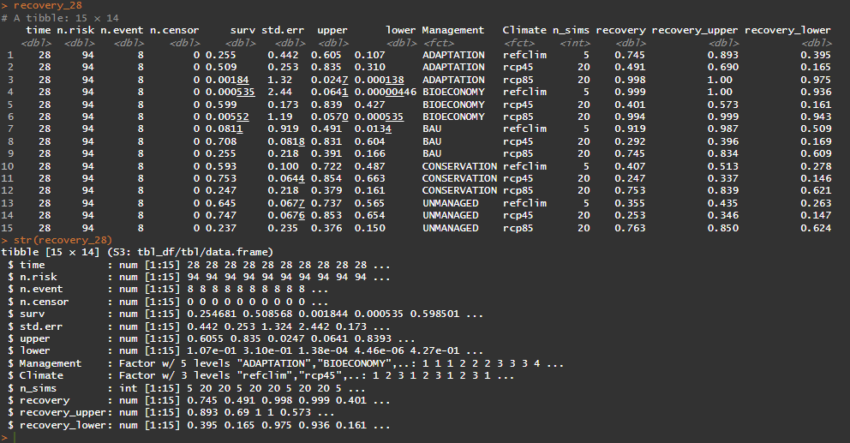
ggplot(recovery_28,…
