STSM_report_01
Marco Baldo
2026-06-20

Data Initial Rendering & Saving
path: C:_CROSS_CASCADE\03_rawdata\02_process_storage
- Step 01: Load and prepare the Field Inventory Data 2015_2019 FID_2015_2019 and 2022 FID_2022 complete with species names converted, dead and alive trees and their condition = cond (if snag, broken, dry etc.).
1a. split the dead and alive trees in 0 - 1 dead/alive 2015_2019 all in the same data frame FID_2015_2019_D
1b. split the dead and alive trees in 0 - 1 dead/alive 2022 into the same data frame FID_2022_D
1c. Create six separate df 2015 - 2019 & alive - dead FID_2015 all trees but 2015 FID_2019 all trees but 2019 FID_2015_alive only alive 2015 FID_2015_dead only dead 2015 FID_2019_alive FID_2019_dead
1d. 2022 alive / dead (same logic as above) FID_2022_alive FID_2022_dead
1e. Check the whole n. of tree presence in 2015-2019 and the n. removal - regrowth (tree different between years).
1f. Inspect and create a df of trees (removal - regrowth) comparable between them. problem_cases
1g. Create a data frame to make estensive comparison analysis: time-series modeling - mixed models - growth/mortality transitions analysis. FID_2015_2019_long
1h. FID 2015 vs 2019 differences | FID 2015 vs 2022 differences | FID 2019 vs 2022 differences The 2022 plots are always present in 2015 & 2019 dataset
- Step 02: Save all the data frame separetly and in .csv & .rds (rds is the format to get injected in R directly as dataframe in the environment)
- Step 03: Extract the ALS based data from the GIS shape file - Table of attribute. NB: here the volume isn’t present. Only Important information column structure for init table in iLand: x y species dbh height ALS_2015
3a. Check the species names and figure it out the corrispondence of not consisten names
3b. Make a consistent species name, including dead trees where needed, using the reference of the GEE article based species names: https://gee-bialowiezamaps.projects.earthengine.app/view/bialowiezamapviewer
reference: Lisiewicz, M., Kamińska, A., Kraszewski, B., Kuberski, Ł., Pilch, K., Stereńczak, K. 2025. Comprehensive mapping of individual living and dead tree species using leaf-on and leaf-off ALS and CIR data in a complex temperate forest. Forestry: An International Journal of Forest Research. https://doi.org/10.1093/forestry/cpaf007
3c. # fix ALS plot IDs to match FID format (KS001). contingency variables column names between FID and ALS using the FID: ALS_2015
3d. Check and SAVE MATCHING CONTROL PLOTS FILE between FID 2015 and ALS 2015: matching_plots.txt, FID_not_in_ALS.txt, ALS_not_in_FID.txt.
3e. Let’s filter the data frame for FID 2015 - FID 2019 - ALS 2015 in the way to keep only matching plots 668
FID_match 2015 only ALS_match 2015
3f. Define common plot set across ALL datasets ALS 2015 - FID 2015 and 2019 valid_plots
3g. filter ALL datasets to same plots and create the df: FID_2015_clean, FID_2019_clean, ALS_2015_clean.
THIS ARE THE IMPORTANT DATAFRAMES
3h. Let’s create different data frame for alive and dead trees as in FID and for ALS 2015 same plots ALS_clean_alive ALS_clean_dead FID_2015_clean_alive FIS_2015_clean_dead FID_2019_clean_alive FIS_2019_clean_dead
3i. Save in csv and rds all the clean data set and ALS based dataset including the full
- Step 4: Global Test
4a. Test if is true that the 2015 2019 and ALS 2015 dataset have the same plot ids. Make a random check o then number of trees in some selected plots.
4b. Import the FID plots information table with age and dominant species and edit the df according to species names and number of matching plots FID_2015_2019_Info_clean
4c. TEST OF PLOTS NUMBERS AND TREE COUNTS summary_plot, plot_count_check

Including Plots
You can also embed plots, for example:
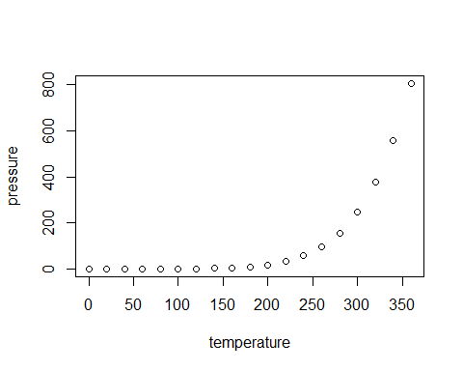
Note that the echo = FALSE parameter was added to the code chunk to prevent printing of the R code that generated the plot.

