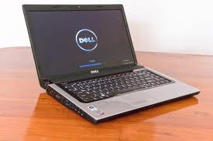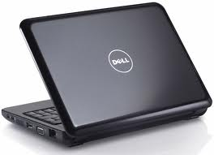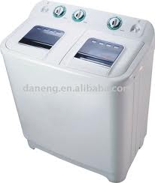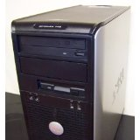

**We are always online**

Computer hardware and software solution

* Reaper software frailer
* Install Drivers
* Install operating system (windows 7,8 ,10,linx,Ubuntu )
* Install application software
* Install antivirus and clean infected files
* Recover lost files
* Upgrade Hard disk and RAM
* Install and maintenance office machine like printer scanner copy machine

Call us on

Tel :0924138935

0918127772