
DEBRE BERHAN UNIVERSITY
INSTITUTE OF TECHNOLOGY
COLLEGE OF COMPUTING
DEPARTMENT OF COMPUTER SCIENCE
Project on
Debre Berhan Teacher Educational and Vocational Training College E-Learning System
In Partial Fulfillment of the Requirements for the Bachelor of Degree in computer science
FULL NAME ID NUMBER
- MUJIB FUJAGA COMPR/032/04
- WERKU SHEWAFERA COMPR/049/04
- DAVID AMANUEL COMPR/011/04
- RAHEL KIROS COMPR/036/04
- SAMRAWIT YIMER COMPR/040/04

June, 2015
DEBRE BERHAN, ETHIOPIA
Declaration
The Project is our own and has not been presented for a degree in any other university and all the sources of material used for the project/thesis have been duly acknowledged. (Name and Signature of the project group members)

Name signature
- MUJIB FUJAGA ……………………………………………………….
- WERKU SHEWAFERA ……………………………………………………….
- DAVID AMANUEL ……………………………………………………….
- RAHEL KIROS ……………………………………………………….
- SAMRAWIT YIMER …………………………………………………….
This is to certify that I have read this project and that in my opinion it is fully adequate, in scope and quality, as a project for the degree of Bachelor of Science.

BINIYAM .TEKALEGN (MS)
…………………………… ……………………………………….
Name of Advisor Signature

Examiner Name Signature
1. Examiner 1 ………………………………….. ………………………
2. Examiner 2 …………………………………… ……………………….
3. Examiner 3 …………………………………… ……………………….
4. Examiner 4 …………………………………… ……………………….

Debre Berhan Teacher Educational and Vocational Training College E-Learning System
I

Acknowledgment
Any accomplishment requires the blessing of the God. This work is not any different to that. So the first thanks goes to God. Next we would like to thank our honorable advisor Instructor Biniyam Tekalegn for his continuous comments in every steps of the project that he forwards throughout the semester. We also would like to thank student Shambel and all the staff members of the Department of Computer Science involved in the process as well as our classmates for working together in different projects and assignments in harmony and understandings.

II
Abstract
The learning process needs techniques and tools to present the knowledge (from different Resources) interact with it and share it with others. In this context, E-Learning is becoming an important tool to support the learning system to achieve its goal. This phase of the project is about Analysis and design part of E-learning system for Debre Berhan Teacher Educational and Vocational training College. The effectiveness of any learning activity bases on proven learning theory. E-learning is not any different. There are basically three approaches of E-learning: Enhanced Approach, Blended approach and online approach. This project is mainly focused on Blended approach of E-learning system because this approach mixes traditional f2f and online learning, consequently, substantial portion of content is delivered online; typically this approach can reduce 25 to 74% of f2f meetings.

III

Contents
CHAPTER ONE 1
1.1 Introduction 1
1.2 Background 2
1.3 Statement of the Problem 2
1.4 Significance of the Project 3
1.5 Objectives of the project 3
1.5.1 General objectives 3
1.5.2 Specific objectives 3
1.6 Scope of the project 4
1.7 Limitation of the project 4
1.8 Risk Assessment & Management 5
1.9 Method of data collection 5
1.10 Development Tools 6
1.11 Schedule of the project 6
1.12 Feasibility analysis 8
1.13 Team organization 10
CHAPTER TWO 11
2 System Analysis 11
2.1 Introduction 11
2.2 Problems of the Existing System 11
2.3 Role players in the existing system 12
2.4 Business Rules 13
2.5 Proposed System 13
2.5.1 Functional Requirement 13
2.5.2 Non- Functional Requirement 14
IV

2.6 Activities of the proposed system 15
2.7 Use case model 16
2.8 Activity diagrams 30
2.9 Sequence diagram 35
2.10 Collaboration Diagram 45
2.11 State chart diagram 50
2.12Analysis class diagram 54
CHAPTER THREE 56
3 System Design 56
3.1 Introduction 56
3.2 Design goals 56
3.3 System Decomposition 57
3.4 Design level class diagram 58
3.5 User interface prototyping design 60
3.6 Database design 61
CHAPTER FOUR 62
4 Implementation Deliverable of the New System 62
4.1 Component diagram 62
4.2 Deployment diagram 63
4.3 User Interface 64
CHAPTER FIVE 69
5.1 Prototype Development 69
CHAPTER SIX 73
6.1 Conclusion and Recommendation 73
6.2 Appendix 74
Reference 75

V

List of Figures
Fig 2.1 use case diagram for system 18
Fig2. 2 Activity diagram for login 30
Fig 2.3 Activity diagram for upload course material 31
Fig 2.4 Activity diagram for download course material 31
Fig 2.5 Activity diagram for upload Assignment 32
Fig 2.6 Activity diagram for download Assignment 32
Fig 2.7 Activity diagram for post course result 33
Fig 2.8 Activity diagram for view course result 33
Fig 2.9 Activity diagram for student registration 34
Fig2.10 Activity diagram for manage account 34
Fig 2.11 sequence diagram for login 35
Fig 2.12 sequence diagram forupload course material 36
Fig 2.13 sequence diagram for download course material 37
Fig 2.14 sequence diagram for upload assignment 38
Fig2.15 sequence diagram for download assignments 39
Fig 2.16 sequence diagram for Post course result 40
Fig2.17 sequence diagram for view course result 41
Fig 2.18 sequence diagram student registration 42
Fig2.19 sequence diagram for course registration 43
Fig 2.20 Sequence diagram for semister registration 44
Fig 2.21 collaboration diagram for login 45
Fig 2.22 collaboration diagram for upload course material 46
Fig 2.23 collaboration diagram for upload assignment 46
Fig 2.24 collaboration diagram for download course material 47
Fig 2.25 collaboration diagram for download assignment 47
Fig 2.26 collaboration diagram for post course result 48
Fig 2.27 collaboration diagram for view course rsult 48
Fig 2.28 collaboration diagram for student registration 49
Fig 2.29 collaboration diagram for course registration 49

VI

Fig 2.30 state chart diagram for login 50
Fig 2.31 state chart diagram for upload course material 51
Fig 2.32 state chart diagram for download course materials 51
Fig2.33 state chart diagram for upload assignment 52
Fig2.34 state chart diagram for download assignment 52
Fig 2.35 state chart diagram for post course result 53
Fig 3.36 state chart diagram for view course result 53
Fig 2.37 state chart diagram for student registration 54
Fig 2.38 analysis class diagram 55
Fig 3.1 system decomposition 57
Fig 3.2 design class diagram 59
Fig 4.1 component diagram 62
Fig 4.2 deployment diagram 63
Fig 4.3 User interface for home page 64
Fig 4.4 user interface for Login 65
Fig 4.5 user Interface for Create Account 66
Fig 4.6 user Interface for upload Assignment 67
Fig 4.7 user interface for Database 68

List of Tables
Table 1.1 Time schedule 7
Table 1.2 Cost estimation 8
Table 1.3 Team organization 10
Table 2.1 description of login 19
Table 2.2 description of upload course material 20
Table 2.3 description of download course material 21
Table 2.4 description of upload assignment 22
Table 2.5 description of download assignment 23
Table 2.6 description of manage user account 24
Table 2.7 description of register student 25
Table 2.8 description of post course result 26
Table 2.9 description of view course result 27
Table 2.10 description of course registration 28
Table 2.11 description of department registrstion 29
Table 6.1 acronyum 74

VII

CHAPTER ONE

1.1 Introduction
The learning process needs techniques and tools to present the knowledge (from different resources) interact with it and share it with others. In this context, E-Learning is becoming an important tool to support the learning system to achieve its goal. E-Learning became hot topic in the 1990's after the spread of the Internet.
Generally, the internet is new media, it has been spread in 1990’s, furthermore, the E-Learning is very recent tool, and so this sector needs more and more researches. E-learning, like many terms in Internet, does not have current definition which can be accepted by all. Some terms which are frequently interchanged with E-learning include:
- Online learning/ education
- Distance education/ learning
- Technology-based training
- Web-based learning/training
E-learning is not intended to replace conventional methods of training such as classroom Teaching. Its aim is to create an augmented learning environment where technology is used to deliver a combined range of teaching techniques aimed at maximizing the individual's participation in the learning process.
Types of ELearning Approaches:-There are three types
1. Enhanced approach: the e-Learning solutions used to support, facilitate and enhance the f2f (face to face) learning by using web-based technology, e.g. Course management systems. Even if this approach can reduce some academic seat time (f2f), the reduction must be no more than 24%.
2. Blended approach: this kind mixes traditional f2f and online learning, consequently, substantial portion of content is delivered online; typically this approach can reduce 25 to 74% of f2f meetings.
3. Online approach: it uses the virtual learning (VL), which can be realized without any need to f2f meeting, however, this approach could have some f2f meeting, e.g. for exams, but more than 75% of the course content is delivered online.

1.2 Background
Debre berhan Teachers educational and vocational training College is located in Debre Berhan city of Amhara Regional state, which is 130kms north of Addis Ababa. The college started its operation in 1949 E.C. The main objective of the college is to produce teachers and educational experts capable of building up citizens by shaping the generation with knowledge, morality, ability and skills, feeling national responsibilities, enjoying positive human and democratic outlook, having developed research capacity, standing for the quality and development of education and equipped with ethical values of teaching and other related professions committed to serving the society to the best of their capacity and ability.

1.3 Statement of the Problem
At present Debre Berhan Teachers educational and vocational Training College has no E-learning system that is available for all courses and introduces students with the technology .The college course coordinators distribute modules to instructors, and instructors provide these modules to students based on their department type. The applicability of those modules is not more than two semester. It is compulsory to prepare such modules year by year to continue teaching-learning process on the college. In order to prepare such modules tones of papers, high human power and other module preparation equipment is also needed. This module distribution system leads the Debre Berhan teacher’s educational and vocational training college to great crisis of economy. The students also waste time, money and effort in always going back to their instructor to submit assignments and to view the result of course including quizzes, tests and assignments. Also most of the college students have no computer skill that is expected from the college students. Overburden of work on the employee of the college is also another problem during preparing, duplicating and distributing modules. Therefore, we will need to improve existing system by eliminating the above problems to increase satisfaction of teaching-learning system.

1.4 Significance of the Project
After completion of this project it will provide the following significant for DBTEVT College.
- Allowing students to receive and submit their assignment with short period of time.
- Eliminate preparation of modules per year.
- Reduce wastage of college’s resource.
- Making course grade showing process simple.
- Minimize work overload of the employee.
- Providing full access of course material for students.
- Enabling students to use today’s ICT technology.

1.5 Objectives of the project

1.5.1 General objectives
The general objective of this project is to design and develop an E-learning System for Debre Berhan Teacher Training College.

1.5.2 Specific objectives
Specific objective of this project are:-
- Studying about problem of the existing system of the college
- Gathering required information for proposed system
- Analyzing the gathered information
- Compare and contrast the proposed system with existing system
- Considering applicability of proposed system for the college.
- Designing the proposed system
- Implementing the system
- Testing system

1.6 Scope of the project
In Debre Berhan Teacher Educational and Vocational Training College the following sub systems are required to be automated.
- Providing tutorial online
- Online examination
- Online video learning
- Online grading
- Distributing course materials not only modules as existing system but also other materials like slides, pdfs, word documents etc… via the internet.
- Distributing assignments for students
Because of taking the time and budget allotted to this project in to account only selected activities are going to be automated and implemented in this proposed system. Specifically the activities that are supposed to be automated are:
- Provide course materials online that students can access it everywhere, at all time.
- Providing online Assignment for students.
- Show course result for students online without going to their instructors.
- Students submit their assignment online
- Student registration
- providing online tutorial

1.7 Limitation of the project
Due to the shortage of time and other mini projects the following activities will not include to be automated in the existing system. It is better to inform others who are interested to do on this project.
- It doesn’t generate CGPA of students.
- It doesn’t give online examination.
- Online evaluation of students is not included in the system.
- Online registration

1.8 Risk Assessment & Management
- The unavailability of data source (information gathering) on time may extend the project completion time. We will manage this problem by searching information from college
- Damaging the computers that we work on, it will be managed by using backup.
- Unavailability of internet also another problem we will use other reference materials
- Shortage of Time. We managed such problem by using additional time from our rest time.
- Virus can attack our project. We used updated antivirus to manage this problem. Power fluctuation problem. It is using laptop that have high power pack ups are used.

1.9 Method of data collection
The data collection process to conduct this project includes both the qualitative and quantitative data. This will be done through the use of instruments such as observations, interviewing and the Internet. From these three data gathering tools, interview will be used to collect data from the office of the registrar and from the instructors. Observation will also be used to oversee the required things in the college.

Interview
Interview is a conversation or questioning, for the purpose of eliciting information for publication, the available statement so elicited. To get the basic information and background information about the existing system, the team members has interviewed the Academic dean and some students about the services that are given to them, and the problems associated with that environment.

Observation
Observation is the other instrument that will use to collect data which will be necessary for our web-based system project for the college. In this process we will try to investigate the information by making our selves participates in the process. And observations will also helping us to relate the information obtained from the interviewee by looking to the reality of the college.

1.10 Development Tools
Developing DBTEVTC E-learning system needs a number of tools that makes the process easy and fast. These development tools are hardware tools and software tools both collaboratively work to achieve specific goals. Hardware tools are all tools that we touch and feel and help to work with the project. Software tools are programs or instructions that help us to simplify work. Here are some development tools:-
Hardware tools
- Personal computer(Pc)
- Digital camera
- Pen and paper
- Hard disk
- RAM
- Flash
Software tools
- Web browser (Mozilla Firefox, Google chrome, opera):
- Operating system of window7.
- Adobe Photoshop: for editing images and icons for the interface of the system.
- XAMP server
- Widow notepad, edit plus and notepad++ editor
- Microsoft office word and power point
- Rational Rose and visual paradigm for UML diagram

1.11 Schedule of the project
This project is expected to be completed in two semesters of 2014/2015 GC academic year. Some parts of the project component to be completed in the first semester are up to design and the rest of activities such as implementation, testing and maintenance would complete in the next semester including other minor activities.

Time schedule
Gant Chart
No. | Task Name | 2007 EC.
No. | Task Name | Nov8,2007- Dec26,2007- Jan 16,2007- May 25,2014- Jun7,2007-  Dec25, 2007 jan15,2007 Feb18,2007 Jun5,2007 Jun9,2007
1 | Requirement gathering
2 | System requirement specification
3 | System designing
4 | System implementation
5 | Operation testing

Table 1.1 time schedule

Cost estimation
For the successful accomplishment of the project, the costs associated with each items required have been estimated. This will help us to limit the constraints related to cost while the project is conducted. From the beginning up to the end of this project we planned the following cost list.
No. | Item | quantity | Price per item | Total price
1 | Paper | 300 | 25cent | 75
2 | CD | 3 | 10 birr | 30
3 | Pen | 5 | 5 birr | 25
4 | Mobile card | 4 | 25 birr | 100
5 | Print | 150 | 1 birr | 150
6 | Binding | 2 | 10 birr | 20
7 | Miscellaneous cost | - | - | 400
8 | transport |  | 2.5 | 50
Total | 8 | 464 |  | 850
Table 1.2 cost estimation

1.12 Feasibility analysis
Feasibility is a measure of how beneficial and practical the development of an information system will be. Given enough time, money, and personnel, almost all system projects are feasible. Feasibility studies provide the information that allows management to:
- Pick one of several possible alternative systems that meet the requirements.
- Decide if a system project should proceed to the next phase.
- Choose between several systems projects that must compete for the same set of limited resources.
Economic feasibility
Economic feasibility is a measure of how cost effective the proposed solution will be. It is possible to develop the proposed system in minimum cost and also can be hosted in lower price. The E-learning system can be used after completion free of cost.

Operational feasibility
Operational feasibility is a measure of how well the solution will work in the organization. Operational feasibility is dependent up on the human resources available for the system. This web based system for E-learning in Debre Berhan teacher educational and vocational training college will attain its desired objectives. It can solve the problems in distributing module (course material) and assignment; therefore it will minimize the amount of effort to do all through manually. And it will perform the basic content management functionality.
Technical Feasibility
Technological feasibility measures the practicality of a specific technical solution to the problem. It is also a measure of the availability of technical resources and expertise. Technical feasibility is assessing the organization‘s ability to construct the system. Since This online system for educational purpose need technical resources to implement, like computer with network. We expect that, the system can be operated in simple way and all users can access easily by giving some training for them.

1.13 Team organization
The project team member is structured with 5 members, one group leader, one vise leader, one secretary, and 2 other members’ Problem solving takes place in group. Decision making on problem solving process are made by group member’s agreement, which is much better than individual decision making.
Debre Berhan Teacher Educational And Vocational Training College E-Learning System
No | Name | ID NO. | Email Address | Responsibilities
1. | David Amanuel | COMPR/011/04 | - | - Data collector  -Designer
2. | Mujib Fujaga | COMPR/032/04 | Mujibf032@gmail.com | Group coordinator  -Manager
3. | Rahel kiros | COMPR/036/04 | - | Secretary  -Designer
4. | Samrawit Yimer | COMPR/040/04 | - | - Data collector  -Designer
5. | Werku Shewafera | COMPR/049/04 | Werkushewafera2112@gmail.com | V/group Coordinator  -programmer
Table 1.3 Team organization

CHAPTER TWO

2 System Analysis

2.1 Introduction
The existing system of Debre Berhan Teacher Educational and Vocational Training College is manually operated. Different activities are performed as follows:
Distributing modules, allocating assignments and showing course results are performed by instructor and registration process is performed by registrar office. The overall teaching –learning process is controlled by academic dean.
The current system that we have observed is faced a lot of problems, due to this reason we analyze those problems to provide some alternative solutions.

2.2 Problems of the Existing System
As we have observed in the data collecting phase, the main problems in Debre Berhan Teacher Educational and Vocational Training College are wastage of resources during preparing, duplicating and process of distributing modules.
Overburden of work on the college’s employee is also seen on the current system of Debre Berhan Teacher Educational and Vocational Training College during duplicating and distributing modules, since each course has its own module to be distributed per student. Students also submit their assignment to their instructor in hard copy, and they view result of the course such as quizzes, tests and assignments by going back to their instructor. Such process leads students to waste their time, effort, money and make them unsatisfied.
Generally those problems can be defined as:
- Wastage of college’s resource
- Time consuming because of it is manually operated
- Lack of consistency of data
- Work overload on college’s employee
- Lack of students’ satisfaction

2.3 Role players in the existing system

Student
- Applying to be registered
- Collecting modules or reading materials from instructor
- Collecting assignments from the instructor
- Take lecture by coming to class
- Submit assignments
- View grade from registrar office
- Receive diploma certificate from registrar
Instructor
- Distribute modules
- Give examination
- Receive assignments
- Give lecture on class
- Show course results including assignment, quizzes and examination results.

Office of registrar
- Checking the student’s previous information.
- Registering student.
- Preparing and giving student’s grade report.
- Process withdrawal and give withdrawal form.
- Preparing and giving diploma certificate for students.
Academic dean
- Control teaching-learning process
- Prepare class schedule
- Assign instructors

2.4 Business Rules
This part specifies and gives understanding of activities which are being done in the existing system in terms of business rule.
BR1: If student is above first year first semester he/she must score promotion grade for registration
BR2: The registrar Determines registration date and clarify required criteria.
BR3: Student should be registered on the specified registration date.
BR4: Each student should have unique identification card to be identified.
BR5: Choice for field of study is based on the student’s interest.
BR6: The academic dean is the one who is responsible to control the overall teaching learning process.

2.5 Proposed System

The proposed system that we analyze can solve some portion of the existing system. When we see the solution, making the college computerized system, it will solve most of the problems in the teaching-learning process. This project has much significance
- Reduce the extravagancy of the college’s resource.
- Reduce the time and task required to perform the operation within the college.
- It will provide speed, efficient, Flexibility and reliability system.
- For students, better satisfaction of the speed provided by the instructor in course material distributing, seeing course result and submitting assignment.
- And it improves the moral (motivation) of the users.

2.5.1 Functional Requirement
DBTEVTC E-Learning system has the following functionalities:
- Course Material uploading: Enables the instructors to login to the system and upload Course materials.
- Downloading: Enables the students to access course material.
- Viewing course result: Enables the students to login to the system and view their course results including quizzes, tests and assignments.
- Registration: Enables registrar office to register student who fulfill required criteria, department and course.
- Posting course result: Enables the instructors to login to the system and post course result for students.
- Take assignments: Enables the student to take assignments online.
- Manage accounts: Enables Academic Dean to create/activate/deactivate accounts.
- Assign instructor; enables academic dean to assign instructor for course
- Authentication: The system will be verified by denying unauthorized user from using the system.

2.5.2 Non- Functional Requirement
DBTEVTC E-Learning system has the following Non-Functional Requirements to achieve its functionality.
- NFR1: Usability:-The system is easy to learn and operate. The User interface for this system will be simple and clear. The E-Learning services are easy to gain and use i.e. the service doesn’t require special training.
- NFR2: Availability:-This system is available in everywhere (where internet/intranet service reach) and at all time for those who have access to use the system.
- NFR3: Performance- The system will have good performance i.e. fast response time and optimal workload.
- NFR4: Security: – we use very strong user name and password in order to secure the system. And also encrypts user’s password on database.
So it is designed to be very secure by providing a login feature which authenticates the user by means of a user name and password with which user will be able to login to his/her respective pages and use the system as required.
- NFR5: Portability:-The system is machine independent and software system independent so it can be moved to different target platforms.
- NFR6: Reliability: – The system is effective and consistent in that integrity of information is maintained and supplied to the system.
- NFR7: Documentation: –The system contains the required documents needed to implement the project

2.6 Activities of the proposed system
Registration process
To join Debre Berhan teacher educational and vocational training college the registration process is performed by registrar office. The registration process is performed as every students or applicant who want to join Debre Berhan teacher educational and vocational training college and fulfills the entire requirement can get registration after approved all supportive documents and photos. After the registrar officers complete the registration process they submit the report about those registered students to instructor.
Upload Course materials and assignments
Students those who have been registered for the course can download all Course materials from internet that is uploaded by instructors. Assignment questions are uploaded for student who registered for given course.
Submission of assignments
Every student is expected to submit his/her assignments via internet; the student should have to write his/her full name, ID number and course code in the form. The system verifies the information provided by the student and then submits by clicking the submit button.
Viewing of course result
Every student is expected to view his course results including quizzes, test, final examination and assignment result online. The student should have to write his/her full name, id number, course name, department name, academic year and semester in the form. The system verifies the information provided by the student and then show by clicking the view button.

2.7 Use case model
To model a system the most important aspect is to capture the dynamic behavior. To clarify in details, dynamic behavior means the behavior of the system when it is running or operating. So only static behavior is not sufficient to model a system rather dynamic behavior is more important than static behavior. In UML there are five diagrams available to model dynamic nature and use case diagram is one of them. Now as we have to discuss that the use case diagram is dynamic in nature there should be some internal or external factors for making the interaction. These external agents are known as actors. So use-case diagrams are consists of actors, use cases and their relationships. The diagram is used to model the system or subsystem of an application. A single use case diagram captures a particular functionality of a system. So to model the system we used the following use case diagrams.
Actor identification
The purpose of actor analysis is to identify all of the actors that interact with the system. An actor has a role in that interacting with the system. The actors that interact with the system are:-
- Academic Dean
- Student
- instructor
- registrar officer
Use-case identification
Identifying the activities that are mainly performed on the proposed system is the basic thing in analyzing a new system. The following use cases have been identified from the system specification.
- Upload Course material
- Download Course materials
- Upload assignment
- Download assignment
- Post course result
- View course result
- Manage user account
- Assign Instructor
- Login
- register student
- register course/curriculum
Use case diagrams graphically describe system behavior (use cases). These diagrams present a high level view of how the system is used as viewed from an outsider’s (actor’s) perspective. From the identified use cases and actors the use case diagram of the system is shown in Fig2.1

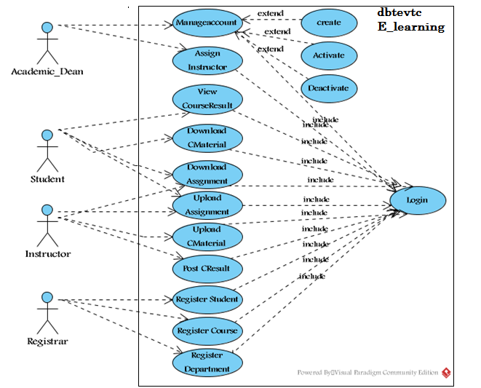
Fig 2.1 Use case diagram for E-learning system

Use Case Name | Login
Identifier | Uc1
Description | To authenticate the user
Actor | Academic-Dean, Registrar-officer, Instructor and student.
Pre-condition | The user must be registered on the system
Post-condition | The authenticated user gets the appropriate page.
Basic course of actions | Step1: Select the login link  Step2: The system displays the login form  Step3: Fill user name and password  Step4: system Validate user name and password.  Step5: The system displays the appropriate page.
Alternative course of action | If the username and password is incorrect  The system displays incorrect user name and password message.  The system redirects to go step 3 i.e.to enter the username and password

Table 2.1 description of login use case

Use-case name | Upload Course material
Identifier | Uc2
Description | The process will start by activating the system or the window and then home page and the login link also displays.
Actor | Instructor
Pre-condition | - the instructor should prepare file to upload  - An instructor should have to enter a valid user name and password.
Post-condition | - Upload Course material successfully.  - Finally logout from page
Basic course of actions | Step 1: The instructor should clicks on upload Course material link.  Step 2: instructor should have to click on browse the file button  Step 3: browses where the file to be uploaded  Step 4: Then instructor click on upload button.
Alternative course of action | Step 3: If the size or type of file to be uploaded is out of size, the instructor should compress the file.

Table 2.2 Description of upload Course material use case.

Use-case name | download Course material
Identifier | Uc3
Description | The process will start the student by activating the system or the window and the home page and login link will be displayed.
Actor | Student
Pre-condition | - There should be uploaded course material.  - Student must insert his/her ID number as user name and password.
Post-condition | - Download Course material successfully  - Finally logout from the page
Basic course of actions | Step 1: the student should click on download Course material link.  Step 2:he/she enter course code and course name  Step 3:student click on download file button
Alternative action | Step 3: if no uploaded file it shows No file message

Table 2.3 Description of download Course material use case.

Use-case name | Upload assignment
Identifier | Uc4
Description | - This process can be performed by instructor as well as by student. An instructor uploads assignment questions for student.  - Student downloads the assignment questions and after completion the student should submit the answers to instructor.
Actor 1 | instructor
Actor2 | Student
Pre-condition | 1: An instructor must prepare assignment questions to upload.  2: students must do their assignment to submit
Post-condition | - The assignment was uploaded successfully.  - Finally logout from the page
Basic course of actions | Step 1: the user click on upload assignment link  Step 2: user fills the form.  Step 3:then he/she press on upload button  Step 4: The system should have to check the submission date.
Alternative course of action | Step 4: if submission date has been passed the student cannot upload the assignment so, student must submit on the provided date.

Table 2.4 Description of upload assignment use case.

Use-case name | Download assignment
Identifier | Uc5
Description | This process can be performed by instructor as well as by student.  - An instructor can download assignment answers submitted by student.  - Student can download assignment questions that uploaded by instructor.
Actor 1 | instructor
Actor2 | Student
Pre-condition | - There should be uploaded assignment questions to students  - There should be submitted assignment for instructor.
Post-condition | - The assignment was downloaded successfully.  - Finally logout from the page
Basic course of actions | Step 1: the user click on download assignment link  Step 2: user enters course code and course name.  Step 3: then user press on download button.
Alternative course of action | Step 3. If no uploaded assignment no file message will be displayed

Table 2.5 Description of download assignment use case

Use case name | Manage user account
Identifier | Uc6
Description | - An Academic Dean manages users’ account.  - Updates user account like changing user name and password.  - Academic Dean creates new account for instructors.
Actor | Academic Dean
Pre-condition | - An Academic Dean should have to enter a valid user name and password in order to create, update and delete user account.
Post-condition | - You update, create and delete user account successfully message will be displayed.  - Finally logout from the page.
Basic course of actions | Step 1. Academic Dean should have to choose account item  Step 2. Then click on the selected account item.  Step3.The Academic Dean should have to create/activate/deactivate the user’s account.
Alternative course of action | Step 3. Confirmation/rejection message will be displayed.

Table 2.6 Description of manage user account use case.

Use case name | Register student
Identifier | Uc7
Description | Registrar officer registers students who fulfill necessary criteria
Actor | Registrar officer
Pre-condition | 1. Registrar officer enter valid user name and pass word to get student registration form.
Post-condition | - Instructor can access the registered student list  - Finally logout from the page
Basic course of actions | Step 1.The registrar officer fills the basic information of the student.  Step 2. After completion of filling the form he/she click on register button.  Step 3.If ID repetition occurs the error message will be displayed
Alternative course of action | Step 3.If the same id is present on the same academic year the system displays this student already registered message. So the registrar officer must give unique ID for each student on the same academic year.

Table 2.7 Description of register student use case.

Use case name | Post course result
Identifier | Uc8
Description | The course instructor posts the result of the course including quizzes, tests and assignments for students
Actor | Instructor
Pre-condition | - Student must submit the assignment and take all class exams.  - An instructor should have to enter a valid user name and password in order to post course result.
Post-condition | - Post Success message will be displayed  - . Finally logout from the page.
Basic course of actions | Step 1: instructor clicks on post student result link.  Step 2: Then he/she fill every result of the course including assignment, quizzes and final examination.  Step 3: then he/she click on post button.
Alternative course of action | Step 2: if instructor fills incorrect result such as filling the result out of bound he must check the result.

Table 2.8 Description of post course result use case.

Use case name | View course result
Identifier | Uc9
Description | The students can view the result of the course including quizzes, tests and assignments posted by the instructor.
Actor | Student
Pre-condition | - There should be posted result by instructor.  - Student should have to enter a valid user name and password in order to post course result.
Post-condition | - The result of the course will be displayed successfully  - . Finally logout from the page.
Basic course of actions | Step 1: student clicks on view course result link.  Step 2: Then he/she fills course code.  Step 3: then he/she click on view button.
Alternative course of action | Step 2: if the student fills incorrect course code he must check it.

Table 2.9 Description of view course result use case.

Use case name | Register Course
Identifier | Uc10
Description | Registrar officer registers course (curriculum) of the college.
Actor | Registrar officer
Pre-condition | 1. Registrar officer enter valid user name and pass word to get course registration form.  2. If student is above first year first semester he/she must score promotion grade for course.^{BR3}
Post-condition | - Finally logout from the page
Basic course of actions | Step 1.The registrar officer fills the basic information of the  Course.  Step 2. After completion of filling the form he/she click on register button.  Step 3. If course code repetition occurs the error message will be displayed
Alternative course of action | Step 3. If the same course code is present the system displays this course already registered message. So the registrar officer must give unique course code for each course.

Table 2.10 description for course registration use case

Use Case Name | Department registration
Identifier | Uc11
description | Registrar officer registers the department
Actor | Registrar officer
precondition | - Registrar officer enter valid user name and pass word to get Department registration link  - He/she clicks the link
Post condition | - Finally logout from the page
basic course of action | Step 1.The registrar officer fills the name of the Department.  Step 2. After filling the name he/she click on register button.
Alternative course of action | Step 3. If not registered correctly system generates error message

Table 2.11 description for department registration use case

2.8 Activity diagrams
Activity diagram is another important diagram in UML to describe dynamic aspects of the system. Activity diagram is basically a flow chart to represent the flow form one activity to another activity. The activity can be described as an operation of the system. So the control flow is drawn from one operation to another. This flow can be sequential, branched or concurrent. The following activity diagrams are specified in the new system of DBTEVTC E-learning.

Fig 2.2 Activity diagram for user login
Fig 2.3 Activity diagram for upload Course material

Fig 2.4 Activity diagram for download Course material

Fig 2.5 Activity diagram for upload assignment
Fig 2.6 Activity diagram for download assignment

Fig 2.7 Activity diagram for post course result
Fig 2.8Activity diagram for view course result
Fig 2.9 Activity diagram for register student
Fig 2.10 Activity diagram for manage account

2.9 Sequence diagram
A sequence diagram links use case with objects. It shows the interaction between participating objects in a given use case. It is helpful to identify the missing objects that are not identified in the analysis object model.
Fig 2.11 Sequence diagram for login

Fig 2.12 Sequence diagram for upload Course material

Fig 2.13 Sequence diagram for download Course material
Fig 2.14 Sequence diagram for upload assignment

Fig 2.15Sequence diagram for download assignment
Fig 2.16Sequence diagram for post course result

Fig 2.17Sequence diagram for view course result

Fig 2.18 Sequence diagram for student registration

Fig 2.19 course registration

Fig 2.20 semester registration

2.10 Collaboration Diagram
Collaboration diagram is another form of interaction diagram. It represents the structural organization of a system and the messages sent/received. Structural organization consists of objects and links.
The purpose of collaboration diagram is similar to sequence diagram. But the specific purpose collaboration diagram is to visualize the organization of objects and their interaction.

Fig 2.21 Collaboration diagram for user login

Fig 2.22 Collaboration diagram for upload Course material

Fig 2.23 Collaboration diagram for upload assignment

Fig 2.24 Collaboration diagram for download course material
Fig 2.25 Collaboration diagram for download assignment
Fig 2.26 Collaboration diagram for post course result
Fig 2.27 Collaboration diagram for view course result
Fig 2.28 Collaboration diagram for student registration

Fig 2.29 collaboration diagram for course registration

2.11 State chart diagram
State-chart diagram describes the flow of control from one state to another state. States are defined as a condition in which an object exists and it changes when some event is triggered. So the most important purpose of State-chart diagram is to model life time of an object from creation to termination.
The main purposes of using State-chart diagrams are:
- To model dynamic aspect of a system
- To model life time of a reactive system
- To describe different states of an object during its life time
- Define a state machine to model states of an object
Fig 2.30 State chart diagram for Login
Fig 2.31 State chart diagram for upload Course material
Fig 2.32 State chart diagram for download Course material
Fig 2.33 State chart diagram for upload assignment

Fig 2.34 State chart diagram for download assignment
Fig 2.35 State chart diagram for post course result
Fig 2.36 State chart diagram for view course result

Fig 2.37 State chart diagram for student registration

Analysis class diagram

Class diagram is static model that shows the classes and the relationships among classes that remain constant over the time. Class is the main building block of class diagram, which stores and manages information in the system. In the phase of conceptual class modeling we just create or classes ad their interrelationship. Identified classes are shown in Fig 2.34.

Fig 2.38 analysis class diagram

CHAPTER THREE

3 System Design

3.1 Introduction
System design is the transformation of the analysis model into a system design model. System design is the first part to get into the solution domain in a software development. This chapter focuses on transforming the analysis model into the design model that takes into account the nonfunctional requirements and constraints described in the problem statement and requirement analysis sections discussed earlier.

3.2 Design goals
The objectives of design are to model the system with high quality. The design goals are derived from non-functional requirements that means non-functional requirement is the description of the feature characteristics and attribute of the system as well as any constraints that may limit the boundary of the proposed solution.
Design goals describe the qualities of the system that the developers should consider.
- Fault Tolerance: DBTEVTC system should be fault tolerant to loss of connectivity with the service.
- Security: for our system we use strong password inorder to secure the system.
- Modifiability: - DBTEVTC system should be modifiable for further modification and enhancement of the application.
- Performance: - DBTEVTC system should respond fast with high throughput, i.e. it should perform the task quickly as possible such as upload and download Course material and assignments.
- Cost: The system should be developed with minimum cost possible.
- End User Criteria: - The system should have simple and understandable graphical user Interface such as forms and buttons, which have descriptive names.

3.3 System Decomposition
In order to simplify and minimize the complexity of the solution domain, our system has been divided into three subsystems. These are learning subsystem, registering Subsystem and Administration subsystems. The decomposition of the system is represented in the Figure below.
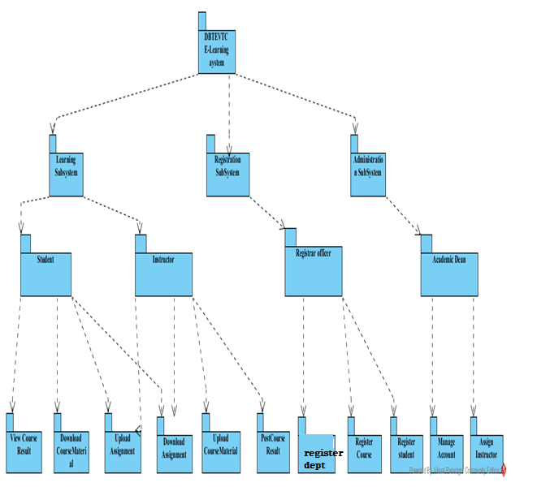
Fig 3.1 system decomposition

Learning Subsystem
The learning subsystem is responsible for providing education service. This service is for both instructor to student and student to instructor interaction.
The student class is responsible for providing students information and instructor class is for providing instructor information.
Administration Subsystem
This subsystem enables the Academic Dean to manage user accounts. The management includes creation of new accounts, removing the existing accounts and modification of accounts. The management of user account is the responsibility of the account class. The account class is the one that creates displays and modify the user account.
Registration subsystem
This subsystem enables the registrar officer to register student’s information and course information. The registering of student’s information is the responsibility of the registrar class and registering of course information is also course class.

3.4 Design level class diagram

The class diagram is a static diagram. It represents the static view of an application. Class diagram is not only used for visualizing, describing and documenting different aspects of a system but also for constructing executable code of the software application.
The class diagram describes the attributes and operations of a class and also the constraints imposed on the system. The classes diagrams are widely used in the modeling of object oriented systems because they are the only UML diagrams which can be mapped directly with object oriented languages. The class diagram shows a collection of classes, interfaces, associations, collaborations and constraints. It is also known as a structural diagram.
Fig 3.2 Design class diagram

3.5 Database design
Fig 3.3 database design

CHAPTER FOUR

4 Implementation Deliverable of the New System

4.1 Component diagram
In this Diagram components of the system will be wired showing that there is relation among components, management of the system, database and operations performed on databases such security issue. This in some extent shows which component or objects will be accessed by whom and what type of security infrastructures it is using. The diagram is simulated below.
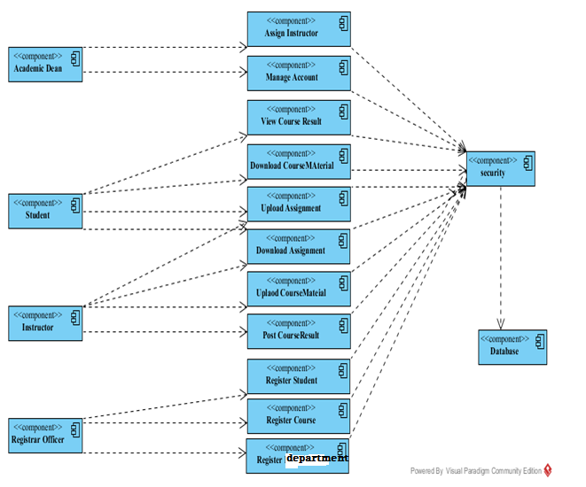

Fig 4.1 Component diagram

4.2 Deployment diagram
The name Deployment itself describes the purpose of the diagram. Deployment diagrams are used for describing the hardware components where software components are deployed. Component diagrams and deployment diagrams are closely related.
Component diagrams are used to describe the components and deployment diagrams shows how they are deployed in hardware.
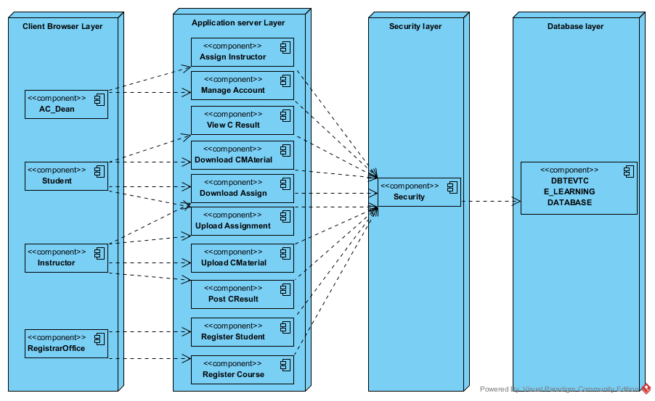
Fig 4.2 deployment diagram

4.3 User Interface

In this system users will communicate with it through the following user interfaces.
- Home Page: This form contains some links which lead it to the concerned page, and if the user has an account he/she will directly go to concerned page by entering their username and password.
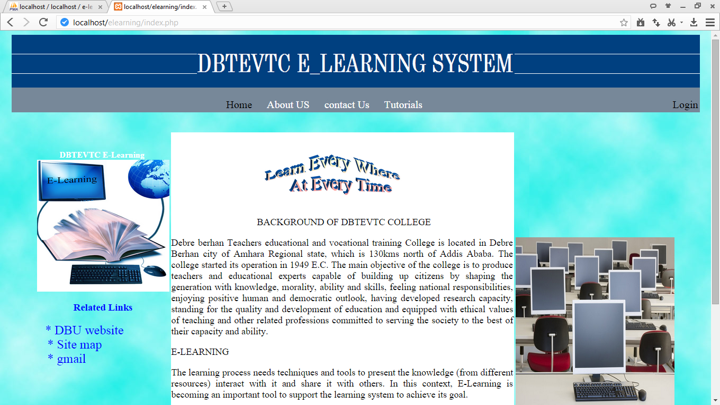
Fig 4.3 User interface for home page

II Log In form:-this form found immediately following the home page. Home page appears as the site on which the system is deployed is opened. Academic Dean, Instructor, Registrar and Student will have their own password. Those forms appeared using password and user name will not accessible by other persons except for those who have privilege.

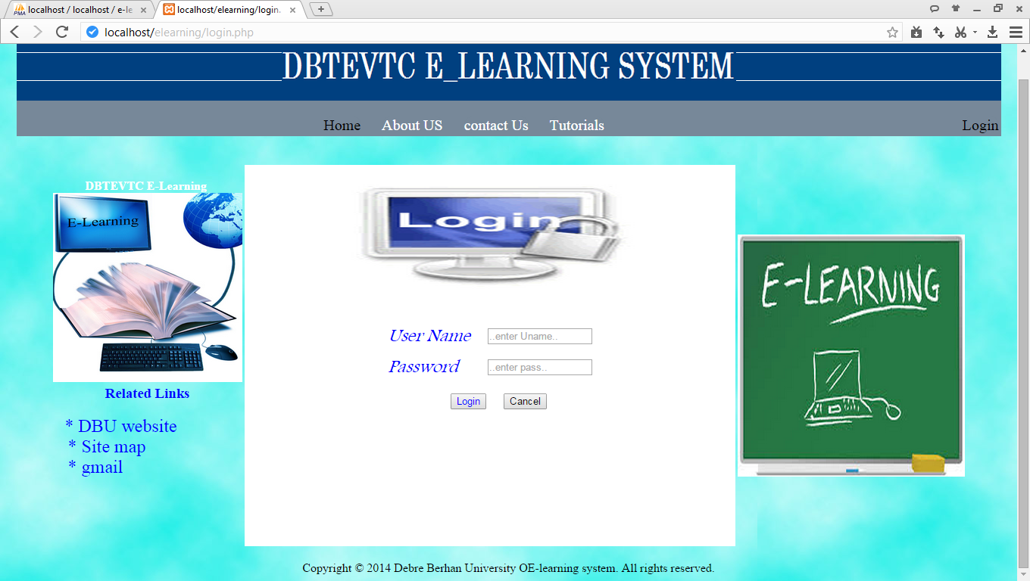

Fig 4.4 User interface for login page

III Create Account: this is creating account page in this page the academic Dean create accounts for the user (academic Dean, Registrar, and Student).

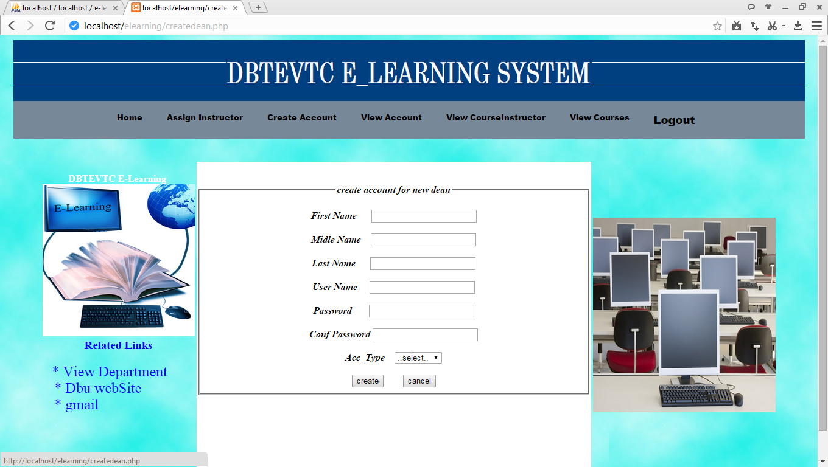

Fig 4.5 User interface for Create Account page
IV Upload Assignment: This is instructor assignment upload page in this page after the instructor login into the instructor page by selecting file he/she uploads question
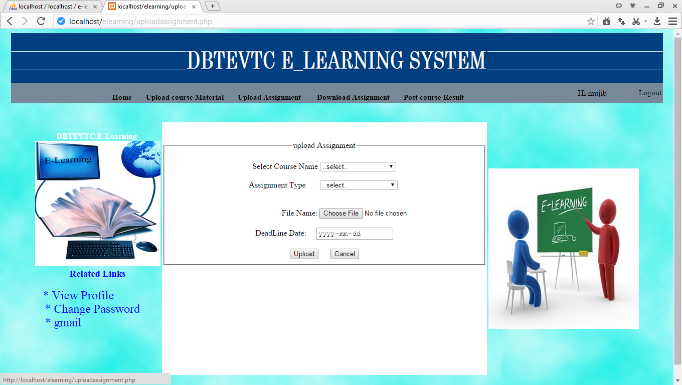

Fig 4.6 User interface for Upload Assignment page

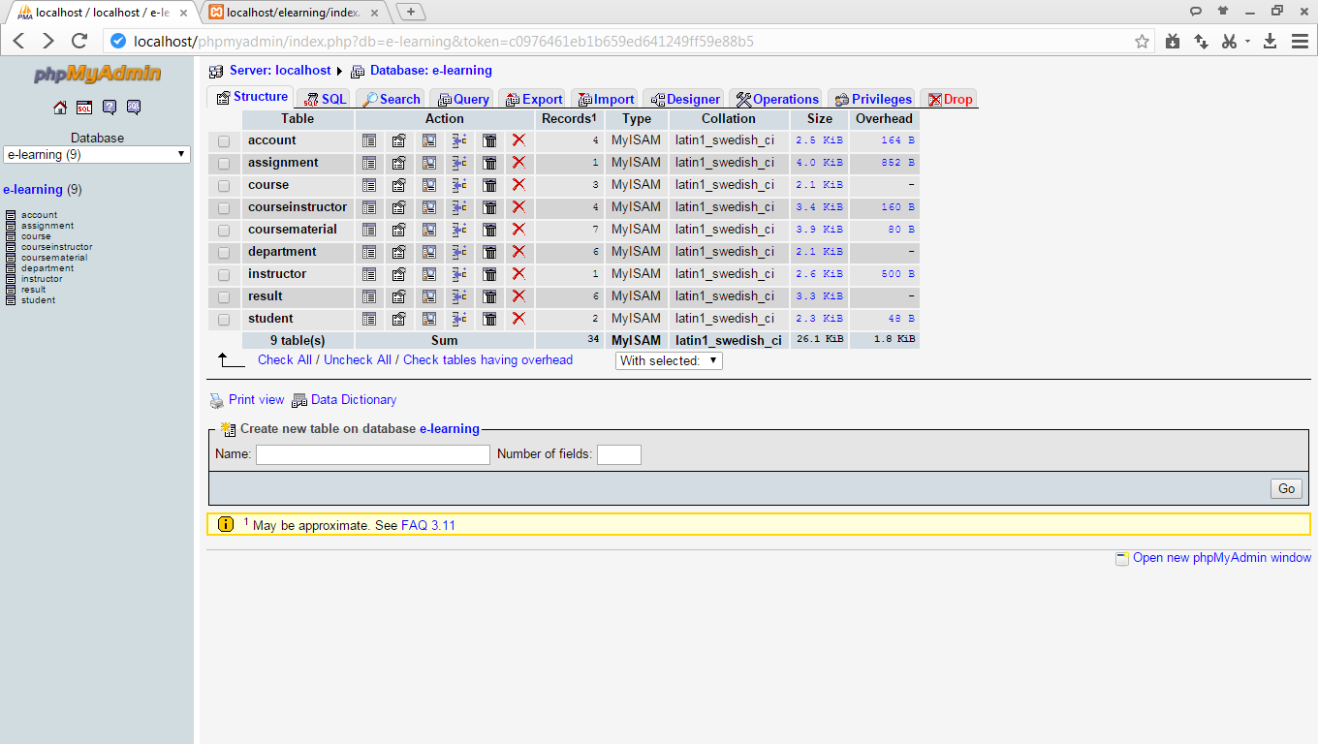
Fig 4.7 User interface for the database

CHAPTER FIVE

5.1 Prototype Development
The physical design specification created by the designers is turned in to working computer code by the programmer using Php, HTML, Java script and Css.
Sample Code for Login
<?php
if(isset($_POST['login']))
{ $username =$_POST['username'];
$password1=$_POST['password'];
$password= md5($password1);
$result_set = mysql_query("SELECT * FROM account WHERE username= '{$username}' AND password= '{$password}' ");
if(mysql_num_rows($result_set)==0)
{ $result = mysql_query("SELECT * FROM instructor WHERE username= '{$username}' AND password= '{$password}' ");
if(mysql_num_rows($result)==0)
{ $result_set2 = mysql_query("SELECT * FROM student WHERE username= '{$username}' AND password= '{$password}' ");
$row2 = mysql_fetch_array($result_set2);
if(mysql_num_rows($result_set2)>0)
{ session_start();
$_SESSION['studentid']=$row2['studentid'];
echo "<script>window.location='student.php';</script>";
echo'<meta content="3;login.php" http-equiv="refresh"/>';
}}
else{
$ins=mysql_fetch_array($result);
if(mysql_num_rows($result)>0)
{ $status=$ins['status'];
if($status=='on') {
session_start();
$_SESSION['instructorid']=$ins['instructorid'];
echo "<script>window.location='instructor.php';</script>";
echo'<meta content="3;login.php" http-equiv="refresh"/>';
}else{echo"your account was deactivated so ask for academic dean!!";

echo'<meta content="2;login.php" http-equiv="refresh"/>';}
}}}elseif($row=mysql_fetch_array($result_set)) {

$usertype=$row['usertype'];
if($usertype==dean)
{if(mysql_num_rows($result_set)>0)
{ session_start();
$_SESSION['accountid']=$row['accountid'];
echo "<script>window.location='dean.php';</script>";}
else{ echo '<center>';
echo '<font face="monotype corsiva" size="5"color="red">User Name & Password Not Match !!</font>';
echo '</center>';}}
if($usertype==registrar)
{

if(mysql_num_rows($result_set)>0)
{
session_start();
$_SESSION['accountid']=$row['accountid'];

echo "<script>window.location='registrar.php';</script>";
}

else{
echo '<center>';
echo '<font face="monotype corsiva" size="5"color="red">User Name & Password Not Match !!</font>';
echo'<meta content="3;login.php" http-equiv="refresh"/>';
echo '</center>';
} } }
else
{ echo '<center>';
echo '<font face="monotype corsiva" size="5"color="red">User Name & Password Not Match !!</font>';
echo'<meta content="2;login.php" http-equiv="refresh"/>';
echo '</center>'; }
mysql_close($conn);
?>

Sample code for upload course material
<?php
include('connection.php');session_start();$user_id=$_SESSION['instructorid'];
$result=mysql_query("select * from instructor where instructorid='$user_id'")or die(mysql_error);
$row=mysql_fetch_array($result); $instructorid=$row['instructorid'];
$firstname=$row['firstname'];
$lastname=$row['lastname'];
$sex=$row['sex'];
$username=$row['username'];
$password=$row['password'];?>
<?php
if(isset($_POST['upload']))
{ $ccode=$_POST['coursename'];
$res=mysql_query("select * from course where coursecode='{$ccode}'");
$col=mysql_fetch_array($res);
$cname=$col['coursename'];
foreach($_FILES['files']['tmp_name'] as $key => $name_tmp)
{$name=$_FILES['files']['name'][$key];
$tmpnm=$_FILES['files']['tmp_name'][$key];
$type=$_FILES['files']['type'][$key];
$size=$_FILES['files']['size'][$key];

if($size>10000000)
{echo "<script> alert('please compress the file it is out of range!!')</script>";
}
else{$dir="module\\" . $_FILES["file"]["name"];
$mov=move_uploaded_file($tmpnm,$dir.$name);
if($mov)
{
$res=mysql_query("insert into coursematerial values('','$instructorid','$firstname','$cname',
'$ccode','$name','$type','$size',now())");
if($res)
{
echo "<script> alert('uploaded successfully!!')</script>";
echo "<script>window.location='uploadcoursematerial.php';</script>";
}else{echo "<script> alert('something wrong')</script>";
echo "<script>window.location='uploadcoursematerial.php';</script>";
}}else{ echo "<script> alert(file not found)</script>";
}}}} ?>

CHAPTER SIX

6.1 Conclusion and Recommendation

The development and advancement of computer technology makes computers to be a part of everyday human life activities. Education is an area where the human is involved in a day to day activity of his life. It is an area which requires due attention, for it deals with behavioral, attitude and skill changes. The same is true for the use of computer in education. This project has enabled the delivery of learning materials to be efficient and it has also achieved interactivity among students and instructors. This project is going to develop using the PHP web technology. This technology choice has enabled the work to have portability, extendibility and security. The portability enables the work to be deployed on a given platform. The extendibility can be expressed as features for the work to tolerate the future expansions on the area. The security features of the PHP language can be incorporated to the level of requirement in need.
The system that we have tried to develop is not the whole system of the college .Because of time limitation and budget we can’t develop all parts of the system, but we have tried to automate some sub systems and functionalities. The following functionalities can’t be automated because of the limitations that we have discussed above.
- Online examination
- Online CGPA of the students.
- Online registration
Therefore, others who are interested to develop on this e-learning system of the college can get some initial idea about the system will improve the system.

6.2 Appendix
Acronym
# | Short Name | Description
1 | E-learning | Electronic Learning
2 | DBTEVTC | Debre Berhan teachers educational and vocational training
3 | PDF | Portable document file
4 | CD | Compact disk
5 | F2F | Face to Face
6 | VL | Virtual learning
7 | CGPA | Cumulative Grade Point Average
8 | ICT | Information communication technology
9 | Pc | Personal computer
10 | GB | Gaga byte
11 | XAMPP | X-any operating system, A-apache server, M-MySQL, P-PHP and P-Perl
12 | BR | Business rule
13 | UML | Unified modeling language
14 | NFR | Non-Functional requirement
15 | C material | Course material
16 | C result | Course result
Table 6.1 acronym

Reference
[1] Derek Stockley, October (2012), “E-learning Definition and Explanation (E-learning Online Training, Online Learning)”.
[2] SIMON BENNETT, STEVE McROBB& RAY FARMER December 2002, Object Oriented System Analysis and Design Using UML, 2nd edition, McGraw-Hill Education.
[3] BRUEGHEL& BERND January 2000, Object oriented Software Engineering Conquering Complex and Changing System. Upper Saddle River: Prentic Hall.
[4]NIKHILESH BARIK and DR. SUNIL KARFORMA, January 2012, Risks and Remedies in E-Learning System Department of Computer Science, Burdwan University, West Bengal, India
[5] EPIGNOSIS LLC, January 2014, E-Learning Concepts, Trends and applications, San Francisco, California

