## CHAPTER ONE

**1.0 INTRODUCTION**

The learning process needs techniques and tools to present the knowledge (from different Resources) interact with it and share it with others. In this context, E-Learning is becoming an Important tool to support the learning system to achieve it’s goal. E-Learning became hot topic in the 1990's after the spread of the Internet. Although it has a relative short history, it is becoming an important part of the learning.

Generally, the internet is new media, it has been spread in 1990’s, furthermore, the E-Learning is very recent tool, and so this sector needs more and more researches.E-learning, like many terms in Internet, does not have current definition which can be accepted by all. Some terms which are frequently interchanged with E-learning include:

* Online learning/ education
* Distance education/ learning
* Technology-based training
* Web-based learning/training

The researchers can find many definitions of E-learning much more than what they expected because E-learning is becoming very interest to many. Also we find a specific definition, "E-Learning: the use of new multimedia technologies and the Internet to improve the quality of learning by facilitating access to resources and services as well as remote exchanges and collaboration."

**Types of ELearning Approaches:**

There are three types:

1. **Enhanced approach**: the e-Learning solutions used to support, facilitate and enhance the f2f (face to face) learning by using web-based technology, e.g. Course management systems. Even if this approach can reduce some academic seat time (f2f), the reduction must be no more than 24%.

2**. Blended approach**: this kind mixes traditional f2f and online learning, consequently, substantial portion of content is delivered online; typically this approach can reduce 25 to 74% of f2f meetings.

3. **Online approach**: it uses the virtual learning (VL), which can be realized without any need to f2f meeting, however, this approach could have some f2f meeting, e.g. for exams, but more than 75% of the course content is delivered online.

**1.1 Background**

Debre berhan teacher educational and vocational College is located in debre berhan city of amhara Regional state, which is 130kms north of Addis Ababa. The college started its operation in 1949 E.C. The main objective of the college is to produce teachers and educational experts capable of building up citizens by shaping the generation with knowledge, morality, ability and skills, feeling national responsibilities, enjoying positive human and democratic outlook, having developed research capacity, standing for the quality and development of education and equipped with ethical values of teaching and other related professions committed to serving the society to the best of their capacity and ability.

**1.2 Statement of the Problem**

At present Debre Berhan Teacher educational and vocational Training College has no E-learning system that is available for all courses and introduces students with the technology .The college course coordinators distribute modules to instructors, and instructors provide these modules to students based on their department type. The applicability of those modules is not more than two semester. It is compulsory to prepare such modules year by year to continue teaching-learning process on the college. In order to prepare such modules tones of papers, high human power and other module preparation equipment are also needed. This module distribution system leads the debre berhan teacher educational and vocational training college to great crisis of economy. The students also waste time, money and effort in always going back to their instructor to submit assignments and to view the result of course including quizzes, tests and assignments. Also most of the college students have no computer skill that is expected from the college students**. Overburden of work on the employee of the college is also another problem during preparing, duplicating and distributing modules.** Therefore, we will need to improve existing system by eliminating the above problems to increase satisfaction of teaching-learning system.

**1.3 Project Initiation**

* Coming and going of students so many times for purpose of receiving and submitting assignment
* Preparation of modules per year
* Wastage of college’s resource
* Lack of course material for students
* Tedious process of grade showing process.
* Work overload on the employee.
* Requiring of today’s ICT technology.

**1.4 Objectives of the project**

**1.4.1 General objectives**

The general objective of this project is to design and to develop an E-learning System for Debre Berhan Teacher Training College.

**1.4.2 Specific objectives**

The specific objective of this project is:

* Studying about problem of the existing system of the college
* Gathering required information for proposed system
* Analyzing the gathered information
* Compare and contrast the proposed system with existing system
* Considering applicability of proposed system for the college.
* Designing the proposed system
* Implementing the system
* Testing system

## 

## 1.5 Scope of the project

In **Debre** Berhan Teacher Educational and Vocational Training College the following sub systems are required to be automated.

* Providing tutorial online
* Online examination
* Online video learning
* Online grading
* Distributing course materials not only modules as existing system but also other materials like slides, pdfs, word documents etc… via the internet.
* Distributing assignments for students

**Because of taking the time and budget allotted to this project in to account only selected activities are going to be automated and implemented in this proposed system. Specifically the activities that are supposed to be automated are:**

* Provide course materials online that students can access it everywhere, at all time.
* Providing online Assignment for students.
* Show course grades for students online without going to their instructors.
* Students submit their assignment online
* providing online tutorial

**1.6 Limitation of the project**

**Due to the shortage of time and other mini projects the following activities will not include to be automated in the existing system. It is better to inform others who are interested to do on this project.**

* It doesn’t generate CGPA of students.
* It doesn’t give online examination.
* Online evaluation of students is not included in the system.
* Online registration

### 1.7 Risk Assessment & Management

**The project can’t be completed as it is initially planned. This is due to the fact that a problem may happen in the process of project development. We assumed the following risks can be encountered:**

* **The unavailability of data source (information gathering) on time may extend the project completion time. We will manage this problem by searching information from college**
* **Damaging the computers that we work on, it will be managed by using backup.**
* **Unavailability of internet also another problem we will use other reference materials**
* **Shortage of Time. We managed such problem by using additional time from our rest time.**
* **Virus can attack our project. We used updated antivirus to manage this problem. Power fluctuation problem. It is using laptop that have high power pack ups are used.**

### 1.8 Method of data collection

The data collection process to conduct this project includes both the qualitative and quantitative data. This will be done through the use of instruments such as observations, interviewing and the Internet. From these three data gathering tools, interview will be used to collect data from the office of the registrar and from the instructors. Observation will also be used to oversee the required things in the college.

### Interview

Interview is a conversation or questioning, for the purpose of eliciting information for publication, the available statement so elicited.to get the basic information and background information about the existing system, the team members has interviewed the Academic dean and some students about the services that are given to them, and the problems associated with that environment.

### Observation

Observation is the other instrument that will use to collect data which will be necessary for our web-based system project for the college. In this process we will try to investigate the information by making our selves participates in the process. And observations will also helping us to relate the information obtained from the interviewee by looking to the reality of the college.

### 1.9 Development Tools

Developing DBTEVTC E-learning system needs a number of tools that makes the process easy and fast. These development tools are hardware tools and software tools both collaboratively work to achieve specific goals. Hardware tools are all tools that we touch and feel and help to work with the project. Software tools are programs or instructions that help us to simplify work. Here are some development tools:-

**Hardware tools**

* Personal computer(Pc)
* Digital camera
* Pen and paper
* Hard disk with minimum of 512GB
* RAM with minimum of 2GB
* Processor with Pentium IV
* Flash

**Software tools**

* Web browser (Mozilla Firefox, Google chrome, opera): So we can check the system across a variety of platforms.
* Operating system of window7 to develop the system
* Adobe Photoshop: for editing images and icons for the interface of the system.
* XAMP server
* Widow notepad
* Microsoft office word and power point
* Rational Rose for UML diagram

## 1.10 Schedule of the project

This project is expected to be completed in two semesters of 2014/2015 GC academic year. Some parts of the project component to be completed in the first semester are up to design and the rest of activities such as implementation, testing and maintenance would complete in the next semester including other minor activities.

**Time schedule**

Gant Chart

|  |  |  |
| --- | --- | --- |
| No. | Task Name | ***2007 EC.*** |
| ***Nov8,2007- Dec26,2007- Jan 16,2007- May 25,2014- Jun7,2007-***  ***Dec25, 2007 jan15,2007 Feb18,2007 Jun5,2007 Jun9,2007*** |
| 1 | Requirement gathering |  |
| 2 | System requirement specification |  |
| 3 | System designing |  |
| 4 | System implementation |  |
| 5 | Operation testing |  |

# *Table 1.1 time schedule*

# Cost estimation

For the successful accomplishment of the project, the costs associated with each items required have been estimated. This will help us to limit the constraints related to cost while the project is conducted. From the beginning up to the end of this project we planned the following cost list.

|  |  |  |  |  |
| --- | --- | --- | --- | --- |
| No. | Item | quantity | Price per item | Total price |
| 1 | Paper | 300 | 25cent | 75 |
| 2 | CD | 3 | 10 birr | 30 |
| 3 | Pen | 5 | 5 birr | 25 |
| 4 | Mobile card | 4 | 25 birr | 100 |
| 5 | Print | 150 | 1 birr | 150 |
| 6 | Binding | 2 | 10 birr | 20 |
| 7 | Miscellaneous cost | - | - | 400 |
| 8 | transport |  | 2.5 | 50 |
| Total | 8 | 464 |  | 850 |

*Table 1.2 cost estimation*

**1.11 Feasibility analysis**

**Feasibility is a measure of how beneficial and practical the development of an information system will be. Given enough time, money, and personnel, almost all system projects are feasible. Feasibility studies provide the information that allows management to:**

* **Pick one of several possible alternative systems that meet the requirements.**
* **Decide if a system project should proceed to the next phase.**
* **Choose between several systems projects that must compete for the same set of limited resources.**

**Economic feasibility**

Economic feasibility is a measure of how cost effective the proposed solution will be. It is possible to develop the proposed system in minimum cost and also can be hosted in lower price. The E-learning system can be used after completion free of cost.

**Operational feasibility**

**Operational feasibility is a measure of how well the solution will work in the organization. Operational feasibility is dependent up on the human resources available for the system. This web based system for E-learning in** Debre Berhan teacher educational and vocational training college **will attain its desired objectives. It can solve the problems in distributing module (course material) and assignment; therefore it will minimize the amount of effort to do all through manually. And it will perform the basic content management functionality.**

**Technical Feasibility**

**Technological feasibility measures the practicality of a specific technical solution to the problem. It is also a measure of the availability of technical resources and expertise. Technical feasibility is assessing the organization‘s ability to construct the system. Since This online system for educational purpose need technical resources to implement, like computer with network. We expect that, the system can be operated in simple way and all users can access easily by giving some training for them.**

**1.12 Team organization**

**The project team member is structured with 5 members, one group leader, one vise leader, one secretary, and 2 other members’ Problem solving takes place in group. Decision making on problem solving process are made by group member’s agreement, which is much better than individual decision making.**

|  |  |  |  |  |
| --- | --- | --- | --- | --- |
| **Debre Berhan Teacher Educational And Vocational Training College E-Learning System** | | | | |
| **No** | **Name** | **ID NO.** | **Email Address** | **Responsibilities** |
| 1. | **David Amanuel** | COMPR/011/04 | - | **-** Data collector  -Designer |
| 2. | **Mujib Fujaga** | COMPR/032/04 | Mujibf032@gmail.com | Group coordinator  -Manager |
| 3. | **Rahel kiros** | COMPR/036/04 | - | Secretary  -Designer |
| 4. | **Samrawit Yimer** | COMPR/040/04 | - | - Data collector  -Designer |
| 5. | **Werku Shewafera** | COMPR/049/04 | Werkushewafera2112@gmail.com | V/group Coordinator  -programmer |

*Table 1.3 Team organization*

**CHAPTER TWO**

**2. System Analysis**

**2.1 Introduction**

**The existing system of Debre Berhan Teacher Educational and Vocational Training College is manually operated. Different activities are performed as follows:**

**Distributing modules, allocating assignments and showing course results are performed by instructor and registration process is performed by registrar office. The overall teaching –learning process is controlled by academic dean.**

**The current system that we have observed is faced a lot of problems, due to this reason we analyze those problems to provide some alternative solutions.**

### 2.2 Problems of the existing system

**As we have observed in the data collecting phase, the main problems in Debre Berhan Teacher Educational and Vocational Training College are wastage of resources during preparing, duplicating and process of distributing modules.**

**Overburden of work on the college’s employee is also seen on the current system of Debre Berhan Teacher Educational and Vocational Training College during duplicating and distributing modules, since each course has its own module to be distributed per student.** Students also submit their assignment to their instructor in hardcopy, and they view result of the course such as quizzes, tests and assignments by going back to their instructor. Such process leads students to waste their time, effort, money and make them unsatisfied.

**Generally those problems can be defined as:**

* **Wastage of college’s resource**
* **Time consuming because of it is manually operated**
* **Lack of consistency of data**
* **Work overload on college’s employee**
* **Lack of students’ satisfaction**

### 

### 2.3 Role players in the existing system

### ****Student****

* **Applying to be registered**
* **Collecting modules or reading materials from instructor**
* **Collecting assignments from the instructor**
* **Take lecture by coming to class**
* **Submit assignments**
* **View grade from registrar office**
* **Receive diploma certificate from registrar**

**Instructor**

* **Distribute modules**
* **Give examination**
* **Receive assignments**
* **Give lecture on class**
* **Show course results including assignment, quizzes and examination results.**

## ****Office of registrar****

* **Checking the student’s previous information.**
* **Registering student.**
* **Preparing and giving student’s grade report.**
* **Process withdrawal and give withdrawal form.**
* **Preparing and giving diploma certificate for students.**

**Academic dean**

* **Control teaching-learning process**
* **Prepare class schedule**
* **Assign instructors**

**2.4 Business Rules**

This part specifies and gives understanding of activities which are being done in the existing system in terms of business rule.

**BR1: The student must pass the exam prepared by amhara region educational bureau.**

**BR2: Students who want to join Debre Berhan teacher education and vocational training college must have full of documents and qualification of Ministry of education certificates.**

**BR3:If student is above first year first semester he/she must score promotion grade for registration**

**BR4: The registrar Determines registration date and clarify required criteria.**

**BR5: Student should be registered on the specified registration date.**

**BR6: Each student should have unique identification card to be identified.**

**BR7: Choice for field of study is based on the student’s interest.**

**BR8: The academic dean is the one who is responsible to control the overall teaching learning process.**

**2.5 Proposed System**

**The proposed system that we analyze can solve some portion of the existing system. When we see the solution, making the college computerized system, it will solve most of the problems in the teaching-learning process. This project has much significance**

* **Reduce the extravagancy of the college’s resource.**
* **Reduce the time and task required to perform the operation within the college.**
* **It will provide speed, efficient, Flexibility and reliability system.**
* **For students, better satisfaction of the speed provided by the instructor in course material distributing, seeing course result and submitting assignment.**
* **And it improves the moral (motivation) of the users.**

**2.5.1 Functional Requirement**

DBTEVTC E-Learning system has the following functionalities:

* **Course Material uploading:** Enables the instructors to login to the system and upload Course materials.
* **Downloading:** Enables the students to login to the system and download Course materials.
* **Viewing course result:** Enables the students to login to the system and view their course results including quizzes, tests and assignments.
* **Registration:**enables registrar office to register student who fulfill required criteria and course.
* **Posting course result:** Enables the instructors to login to the system and post course result for students.
* **Take assignments:** Enables the student to take assignments online.
* **Manage accounts:** Enables **Academic Dean** to update/delete accounts.
* **Authentication:** The system will be verified by denying unauthorized user from using the system.

### 2.5.2 Non- Functional Requirement

DBTEVTC **E**-Learning system has the following Non-Functional Requirements to achieve its functionality.

* **NFR1: Usability:-**The system is easy to learn and operate. The User interface for this system will be simple and clear. The E-Learning services are easy to gain and use i.e. the service doesn’t require special training.
* **NFR2: Availability:** – This system is available in everywhere (where internet/intranet service reach) and at all time for those who have access to use the system.
* **NFR3: Performance**-The system will have good performance i.e. fast response time and optimal workload.
* **NFR4: Security:** – The system will be secured as much as possible so that there is permissible information flow regarding to that can do what.

So it is designed to be very secure by providing a login feature which authenticates the user by means of a user name and password with which user will be able to login to his/her respective pages and use the system as required.

* **NFR5: Portability:**-The system is machine independent and software system independent so it can be moved to different target platforms.
* **NFR6: Reliability: –** The system is effective and consistent in that integrity of information is maintained and supplied to the system.
* **NFR7: Documentation: –**The system contains the required documents needed to implement the project

**2.6 Activities of the proposed system**

**Registration process**

**To join Debre Berhan teacher educational and vocational training college the registration process is performed by registrar office. The registration process is performed as every students or applicant who want to join Debre Berhan teacher educational and vocational training college and fulfills the entire requirement can get registration after approved all supportive documents and photos. After the registrar officers complete the registration process they submit the report about those registered students to instructor.**

**Upload Course materials** **and assignments**

**Students those who have been registered for the course can download all** Course materials **from internet that is uploaded by instructors. Assignment questions are uploaded for student who registered for given course.**

**Submission of assignments**

**Every student is expected to submit his/her assignments via internet; the student should have to write his/her full name, ID number and course code in the form. The system verifies the information provided by the student and then submits by clicking the submit button.**

**Viewing of course result**

Every student is expected to view his course results including quizzes, test, final examination and assignment result online. The student should have to write his/her full name, id number, course name, department name, academic year and semester in the form. **The system verifies the information provided by the student and then show by clicking the view button.**

**2.7 Use case model**

**To model a system the most important aspect is to capture the dynamic behavior. To clarify in details, dynamic behavior means the behavior of the system when it is running or operating. So only static behavior is not sufficient to model a system rather dynamic behavior is more important than static behavior. In UML there are five diagrams available to model dynamic nature and use case diagram is one of them. Now as we have to discuss that the use case diagram is dynamic in nature there should be some internal or external factors for making the interaction. These internal and external agents are known as actors. So use-case diagrams are consists of actors, use cases and their relationships. The diagram is used to model the system or subsystem of an application. A single use case diagram captures a particular functionality of a system. So to model the system we used the following use case diagrams.**

**Actor identification**

**The purpose of actor analysis is to identify all of the actors that interact with the system. An actor has a role in that interacting with the system. The actors that interact with the system are:-**

* **Academic Dean**
* **Student**
* **instructor**
* **registrar officer**

**Use-case identification**

**Identifying the activities that are mainly performed on the proposed system is the basic thing in analyzing a new system. The following use cases have been identified from the system specification.**

* **Upload** Course material
* **Download** Course materials
* **Upload assignment**
* **Download assignment**
* **Post course result**
* **View course result**
* **Manage user account**
* **Login**
* **register student**
* **register course**
* **Semester Registration**

**Use case diagrams graphically describe system behavior (use cases). These diagrams present a high level view of how the system is used as viewed from an outsider’s (actor’s) perspective. From the identified use cases and actors the use case diagram of the system is shown in Fig2.1**

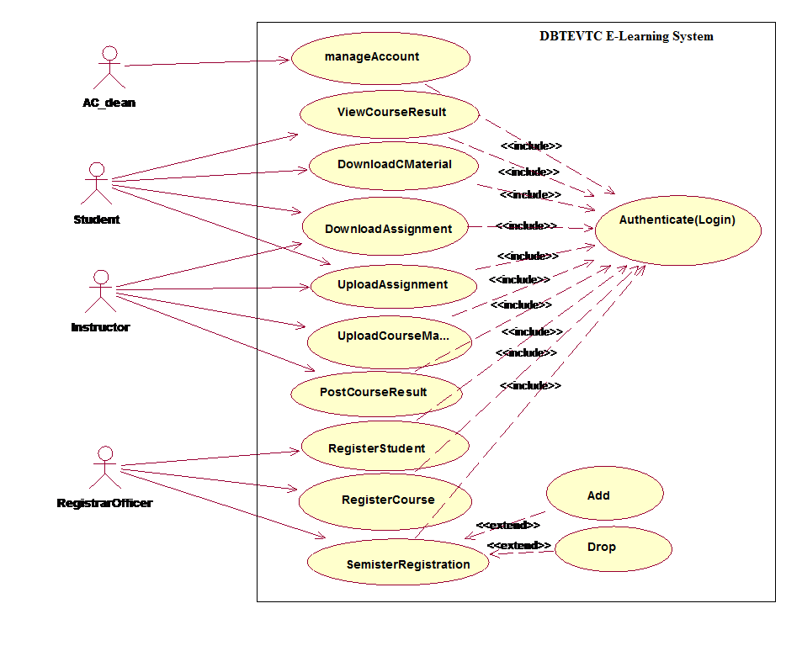

*Fig 2.1 Use case diagram for E-learning system*

|  |  |
| --- | --- |
| Use Case Name | Login |
| **Identifier** | Uc1 |
| **Description** | To authenticate the user |
| **Actor** | Academic-Dean, Registrar-officer, Instructor and student. |
| **Pre-condition** | The user must be registered on the system |
| **Post-condition** | The authenticated user gets the appropriate page. |
| **Basic course of actions** | **Step1**: Select the login link  **Step2:** The system displays the login form  **Step3:** Fill user name and password  **Step4:** systemValidate user name and password.  **Step5:** The system displays the appropriate page. |
| **Alternative course of action** | If the username and password is incorrect  The system displays incorrect user name and password message.  The system redirects to go **step 3** i.e.to enter the username and password |

*Table 2.1 description of login use case*

|  |  |
| --- | --- |
| **Use-case name** | **Upload**  Course material |
| **Identifier** | **Uc2** |
| **Description** | **The process will start by activating the system or the window and then home page and the login link also displays.** |
| **Actor** | **instructor** |
| **Pre-condition** | 1. **the instructor should prepare file to upload** 2. **An instructor should have to enter a valid user name and password.** |
| **Post-condition** | 1. **Upload Course** material **successfully.** 2. **Finally logout from page** |
| **Basic course of actions** | **Step 1: The** instructor **should clicks on upload** Course material **link.**  **Step 2: instructor should have to click on browse the file button**  **Step 3: browses where the file to be uploaded**  **Step 4: Then** instructor **click on upload button.** |
| **Alternative course of action** | **Step 3: If the size or type of file to be uploaded is out of size, the** instructor **should compress the file.** |

***Table 2.2*** *Description of upload* Course material *use case.*

|  |  |
| --- | --- |
| **Use-case name** | **download** Course material |
| **Identifier** | **Uc3** |
| **Description** | **The process will start the student by activating the system or the window and the home page and login link will be displayed.** |
| **Actor** | **Student** |
| **Pre-condition** | 1. **There should be uploaded course material.** 2. **Student must insert his/her ID number as user name and password.** |
| **Post-condition** | 1. **Download** Course material **successfully** 2. **Finally logout from the page** |
| **Basic course of actions** | **Step 1: the student should click on download** Course material **link.**  **Step 2: he/she enter course code and course name**  **Step 3: student click on download file button** |
| **Alternative action** | **Step 3: if no uploaded file it shows No file message** |

***Table 2.3*** *Description of download* Course material *use case.*

|  |  |
| --- | --- |
| **Use-case name** | **Upload assignment** |
| **Identifier** | **Uc4** |
| **Description** | 1. **This process can be performed by instructor as well as by student. An instructor uploads assignment questions for student.** 2. **Student downloads the assignment questions and after completion the student should submit the answers to instructor.** |
| **Actor 1** | **instructor** |
| **Actor2** | **Student** |
| **Pre-condition** | **1: An instructor must prepare assignment questions to upload.**  **2: students must do their assignment to submit** |
| **Post-condition** | 1. **The assignment was uploaded successfully.** 2. **Finally logout from the page** |
| **Basic course of actions** | **Step 1: the user click on upload assignment link**  **Step 2: user fills the form.**  **Step 3: then he/she press on upload button**  **Step 4: The system should have to check the submission date.** |
| **Alternative course of action** | **Step 4: if submission date has been passed the student cannot upload the assignment so, student must submit on the provided date.** |

***Table 2.4*** *Description of upload assignment use case.*

|  |  |
| --- | --- |
| **Use-case name** | **Download assignment** |
| **Identifier** | **Uc5** |
| **Description** | **This process can be performed by instructor as well as by student.**   1. **An instructor can download assignment answers submitted by student.** 2. **Student can download assignment questions that uploaded by instructor.** |
| **Actor 1** | **instructor** |
| **Actor2** | **Student** |
| **Pre-condition** | 1. **There should be uploaded assignment questions to students** 2. **There should be submitted assignment for instructor.** |
| **Post-condition** | 1. **The assignment was downloaded successfully.** 2. **Finally logout from the page** |
| **Basic course of actions** | **Step 1: the user click on download assignment link**  **Step 2: user enters course code and course name.**  **Step 3: then user press on download button.** |
| **Alternative course of action** | **Step 3. If no uploaded assignment no file message will be displayed** |

***Table 2.5*** *Description of download assignment use case.*

|  |  |
| --- | --- |
| **Use case name** | **Manage user account** |
| **Identifier** | **Uc6** |
| **Description** | 1. **An Academic Dean manages users’ account.** 2. **Updates user account like changing user name and password.** 3. **Academic Dean creates new account for instructors.** |
| **Actor** | **Academic Dean** |
| **Pre-condition** | 1. **An Academic Dean should have to enter a valid user name and password in order to create, update and delete user account.** |
| **Post-condition** | 1. **You update, create and delete user account successfully message will be displayed.** 2. **Finally logout from the page.** |
| **Basic course of actions** | **Step 1. Academic Dean should have to choose account item**  **Step 2. Then click on the selected account item.**  **Step3.The Academic Dean should have to create/delete/modify the user’s account.** |
| **Alternative course of action** | **Step 3. Confirmation/rejection message will be displayed.** |

***Table 2.6*** *Description of manage user account use case.*

|  |  |
| --- | --- |
| **Use case name** | **Register student** |
| **Identifier** | **Uc7** |
| **Description** | **Registrar officer registers students who fulfill necessary criteria** |
| **Actor** | **Registrar officer** |
| **Pre-condition** | **1. Registrar officer enter valid user name and pass word to get student registration form.**  **2. The student must pass the exam prepared by amhara region educational bureau if he/she is fresh.BR1** |
| **Post-condition** | 1. Instructor can access the registered student list 2. **Finally logout from the page** |
| **Basic course of actions** | **Step 1**.The registrar officer fills the basic information of the student.  **Step 2**. After completion of filling the form he/she click on register button.  **Step 3.** If ID repetition occurs the error message will be displayed |
| **Alternative course of action** | **Step 3. If the same id is present on the same academic year the system displays this student already registered message. So the registrar officer must give unique ID for each student on the same academic year.** |

***Table 2.7*** *Description of register student use case.*

|  |  |
| --- | --- |
| **Use case name** | **Post course result** |
| **Identifier** | **Uc8** |
| **Description** | The course instructor posts the result of the course including quizzes, tests and assignments for students |
| **Actor** | **Instructor** |
| **Pre-condition** | 1. Student must submit the assignment and take all class exams. 2. An instructor should have to enter a valid user name and password in order to post course result. |
| **Post-condition** | 1. Post Success message will be displayed 2. . Finally logout from the page. |
| **Basic course of actions** | **Step 1:** instructor clicks on post student result link.  **Step 2:** Then he/she fill every result of the course including assignment, quizzes and final examination.  **Step 3:** then he/she click on post button. |
| **Alternative course of action** | **Step 2:** if instructor fills incorrect result such as filling the result out of bound he must check the result. |

***Table 2.8*** *Description of post course result use case.*

|  |  |
| --- | --- |
| **Use case name** | **View course result** |
| **Identifier** | **Uc9** |
| **Description** | The students can view the result of the course including quizzes, tests and assignments posted by the instructor. |
| **Actor** | **Student** |
| **Pre-condition** | 1. There should be posted result by instructor. 2. Student should have to enter a valid user name and password in order to post course result. |
| **Post-condition** | 1. The result of the course will be displayed successfully 2. . Finally logout from the page. |
| **Basic course of actions** | **Step 1:** student clicks on view course result link.  **Step 2:** Then he/she fills course code and department name.  **Step 3:** then he/she click on view button. |
| **Alternative course of action** | **Step 2:** ifthe student fills incorrect course code or department name he must check it. |

***Table 2.9*** *Description of view course result use case.*

|  |  |
| --- | --- |
| **Use case name** | **Register Course** |
| **Identifier** | **Uc10** |
| **Description** | **Registrar officer registers course (curriculum) of the college.** |
| **Actor** | **Registrar officer** |
| **Pre-condition** | **1. Registrar officer enter valid user name and pass word to get course registration form.**  **2. If student is above first year first semester he/she must score promotion grade for course. BR3** |
| **Post-condition** | 1. **Finally logout from the page** |
| **Basic course of actions** | **Step 1**.The registrar officer fills the basic information of the  Course.  **Step 2**. After completion of filling the form he/she click on register button.  **Step 3.** If course code repetition occurs the error message will be displayed |
| **Alternative course of action** | **Step 3. If the same course code is present the system displays this course already registered message. So the registrar officer must give unique course code for each course.** |

*Table 2.10 description for course registration use case*

|  |  |
| --- | --- |
| Use Case Name | Semester registration |
| Identifier | Uc11 |
| description | Registrar officer registers the semester courses for students |
| Actor | Registrar officer |
| precondition | **1. Registrar officer enter valid user name and pass word to get semester registration form.**  **2. If student is above first year first semester he/she must score promotion grade for course. BR3**  **3.** prerequisite of the course must be not F grade |
| Post condition | 1. Finally logout from the page |
| basic course of action | **Step 1**.The registrar officer fills the basic information of the  Course.  **Step 2**. After completion of filling the form he/she click on register button.  **Step 3.** If course code repetition occurs the error message will be displayed |
| Alternative course of action | **Step 3. If the same course code is present the system displays this course already registered message. So the registrar officer must give unique course code for each course.** |

*Table 2.11 description for semester registration use case*

**2.8 Activity diagrams**

Activity diagram is another important diagram in UML to describe dynamic aspects of the system. Activity diagram is basically a flow chart to represent the flow form one activity to another activity. The activity can be described as an operation of the system. So the control flow is drawn from one operation to another. This flow can be sequential, branched or concurrent. The following activity diagrams are specified in the new system of DBTEVTC E-learning.



*Fig 2.2 Activity diagram for user login*



*Fig 2.3 Activity diagram for upload* Course material



*Fig 2.4Activity diagram for download* Course material



*Fig 2.5 Activity diagram for upload assignment*



*Fig 2.6 Activity diagram for download assignment*



*Fig 2.7 Activity diagram for post course result*



*Fig 2.8 Activity diagram for view course result*

**

*Fig 2.9 Activity diagram for register student*



*Fig 2.10 Activity diagram for manage account*

**2.9 Sequence diagram**

A sequence diagram links use case with objects. It shows the interaction between participating objects in a given use case. It is helpful to identify the missing objects that are not identified in the analysis object model.



*Fig 2.11 Sequence diagram for login*



Fig 2.12 Sequence diagram for upload Course material



*Fig 2.13 Sequence diagram for download* Course material

 *Fig 2.14 Sequence diagram for upload assignment*



*Fig 2.15 Sequence diagram for download assignment*



*Fig 2.16 Sequence diagram for post course result*



*Fig 2.17 Sequence diagram for view course result*



*Fig 2.18 Sequence diagram for student registration*



*Fig 2.19 course registration*

**

*Fig 2.20 semester registration*

**2.10 Collaboration Diagram**

Collaboration diagram is another form of interaction diagram. It represents the structural organization of a system and the messages sent/received. Structural organization consists of objects and links.

The purpose of collaboration diagram is similar to sequence diagram. But the specific purpose of collaboration diagram is to visualize the organization of objects and their interaction.



*Fig 2.21 Collaboration diagram for user login*



*Fig 2.22 Collaboration diagram for upload* Course material



*Fig 2.23 Collaboration diagram for upload assignment*



*Fig 2.24 Collaboration diagram for download course material*



*Fig 2.25 Collaboration diagram for download assignment*



*Fig 2.26 Collaboration diagram for post course result*



*Fig 2.27 Collaboration diagram for view course result*



*Fig 2.28 Collaboration diagram for student registration*



*Fig 2.29 collaboration diagram for course registration*

**2.11 State chart diagrams**

State-chart diagram is one of the five UML diagrams used to model dynamic nature of a system. They define different states of an object during its lifetime. And these states are changed by events. So State-chart diagrams are useful to model reactive systems. Reactive systems can be defined as a system that responds to external or internal events.

State-chart diagram describes the flow of control from one state to another state. States are defined as a condition in which an object exists and it changes when some event is triggered. So the most important purpose of State-chart diagram is to model life time of an object from creation to termination.

The main purposes of using State-chart diagrams are:

* To model dynamic aspect of a system
* To model life time of a reactive system
* To describe different states of an object during its life time
* Define a state machine to model states of an object



*Fig 2.30 State chart diagram for Login*



*Fig 2.31 State chart diagram for upload* Course material



*Fig 2.32 State chart diagram for download* Course material



*Fig 2.33 State chart diagram for upload assignment*



*Fig 2.34 State chart diagram for download assignment*



*Fig 2.35 State chart diagram for post course result*



*Fig 2.36 State chart diagram for view course result*



*Fig 2.37 State chart diagram for student registration*

**2.12 Analysis class diagram**

Class diagram is static model that shows the classes and the relationships among classes that remain constant over the time. Class is the main building block of class diagram, which stores and manages information in the system. In the phase of conceptual class modeling we just create or classes ad their interrelationship**. Identified classes are shown in Fig 2.34.**



*Fig 2.38 analysis class diagram*

**CHAPTER THREE**

**3. System Design**

### 3.1 Introduction

**System design is the transformation of the analysis model into a system design model. System design is the first part to get into the solution domain in a software development. This chapter focuses on transforming the analysis model into the design model that takes into account the nonfunctional requirements and constraints described in the problem statement and requirement analysis sections discussed earlier.**

**3.2 Design goals**

The objectives of design are to model the system with high quality. The design goals are derived from non-functional requirements that means non-functional requirement is the description of the feature characteristics and attribute of the system as well as any constraints that may limit the boundary of the proposed solution.

Design goals describe the qualities of the system that the developers should consider.

* **Reliability:** DBTEVTC system should be reliable.
* **Fault Tolerance:** DBTEVTC system should be fault tolerant to loss of connectivity with the service.
* **Security:** DBTEVTC system should be secured, i.e., not allow other users or unauthorized users to access data that has no the right to access it.
* **Modifiability:** DBTEVTC system should be modifiable for further modification and enhancement of the application.
* **Performance**: - DBTEVTC system should respond fast with high throughput, i.e. it should perform the task quickly as possible such as upload and download Course material and assignments.
* **Cost**: The system should be developed with minimum cost possible.
* **End User Criteria**: - The system should have simple and understandable graphical user Interface such as forms and buttons, which have descriptive names. It should give reliable response for each user request. All the interfaces, forms and buttons are written or designed in a simple language or common language so that the user can access it without any difficult.
  1. **System Decomposition**

In order to simplify and minimize the complexity of the solution domain, our system has been divided into three subsystems. These are learning subsystem, registering Subsystem and Administration subsystems. The decomposition of the system is represented in the Figure below.



*Fig 3.1 system decomposition*

**Learning Subsystem**

The learning subsystem is responsible for providing education service. This service is for both instructor to student and student to instructor interaction.

The student class is responsible for providing students information and instructor class is for providing instructor information.

**Administration Subsystem**

This subsystem enables the **Academic Dean** to manage user accounts. The management includes creation of new accounts, removing the existing accounts and modification of accounts. The management of user account is the responsibility of the account class. The account class is the one that creates displays and modify the user account.

**Registration subsystem**

This subsystem enables the registrar officer to register student’s information and course information. The registering of student’s information is the responsibility of the registrar class and registering of course information is also course class.

**3.4 Design class diagram**

The class diagram is a static diagram. It represents the static view of an application. Class diagram is not only used for visualizing, describing and documenting different aspects of a system but also for constructing executable code of the software application.

The class diagram describes the attributes and operations of a class and also the constraints imposed on the system. The classes diagrams are widely used in the modeling of object oriented systems because they are the only UML diagrams which can be mapped directly with object oriented languages. The class diagram shows a collection of classes, interfaces, associations, collaborations and constraints. It is also known as a *structural diagram*.



*Fig 3.2 Design class diagram*

**3.5 Component diagram**

In this Diagram components of the system will be wired showing that there is relation among components, management of the system, database and operations performed on databases such security issue. This in some extent shows which component or objects will be accessed by whom and what type of security infrastructures it is using. The diagram is simulated below.

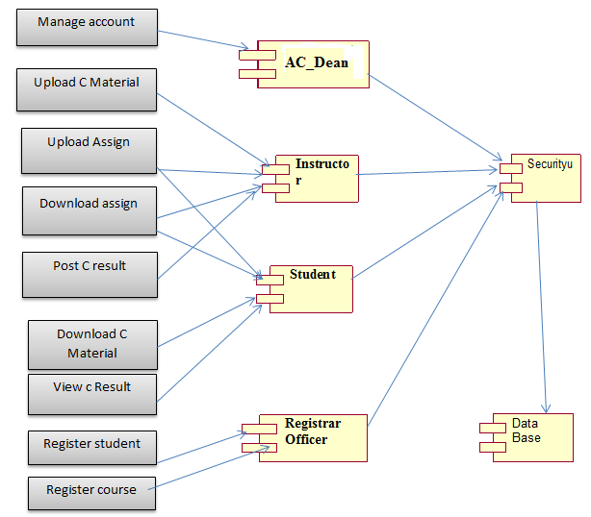

Fig 3.3 *Component diagram*

**3.6 Deployment diagram**

The name *Deployment* itself describes the purpose of the diagram. Deployment diagrams are used for describing the hardware components where software components are deployed. Component diagrams and deployment diagrams are closely related.

Component diagrams are used to describe the components and deployment diagrams shows how they are deployed in hardware.

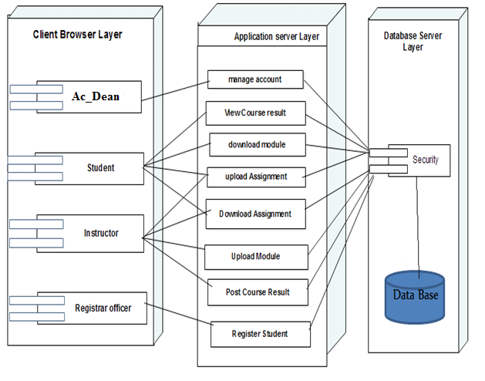

*Fig 3.4 deployment diagram*

**3.7 User interface prototyping design**

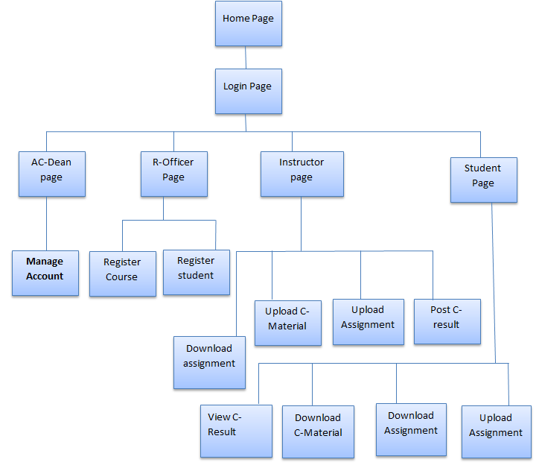

*Fig 3.5 prototype design*

**3.8 Database design**

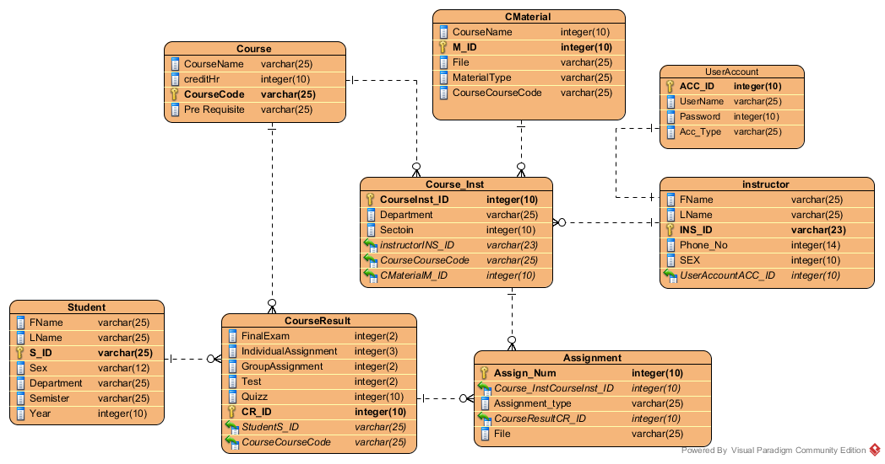

*Fig 3.6 database design*

**CHAPTER FOUR**

**4.1 implementation tools and techniques**

Systems implementation is the construction of the new system and the delivery of that system into production (that is, the day-to-day business or organization operation).  
We use PHP programming language to develop Debre Berhan Teacher Educational and vocational training college E-learning system.

Xampp server

Edit-plus

Notepad++

**4.2 conclusion and Recommendation**

The development and advancement of computer technology makes computers to be a part of everyday human life activities. Education is an area where the human is involved in a day to day activity of his life. It is an area which requires due attention, for it deals with behavioral, attitude and skill changes. The same is true for the use of computer in education. This project has enabled the delivery of learning materials to be efficient and it has also achieved interactivity among students and instructors. This project is going to develop using the PHP web technology. This technology choice has enabled the work to have portability, extendibility and security. The portability enables the work to be deployed on a given platform. The extendibility can be expressed as features for the work to tolerate the future expansions on the area. The security features of the PHP language can be incorporated to the level of requirement in need.

The system that we have tried to develop is not the whole system of the college .Because of time limitation and budget we can’t develop all parts of the system, but we have tried to automate some sub systems and functionalities. The following functionalities can’t be automated because of the limitations that we have discussed above.

* **Online examination**
* **Online CGPA of the students.**
* Online registration

**Therefore, others who are interested to develop on this e-learning system of the college can get some initial idea about the system will improve the system.**

**4.3 Appendix**

|  |  |  |
| --- | --- | --- |
| **#** | **Short Name** | **Description** |
| 1 | E-learning | Electronic Learning |
| 2 | DBTEVTC | Debre Berhan teacher educational and vocational training |
| 3 | PDF | Portable document file |
| 4 | CD | Compact disk |
| 5 | F2F | Face to Face |
| 6 | VL | Virtual learning |
| 7 | CGPA | Cumulative Grade Point Average |
| 8 | ICT | Information communication technology |
| 9 | Pc | Personal computer |
| 10 | GB | Gaga byte |
| 11 | XAMPP | X-any operating system, A-apache server, M-MySQL, P-PHP and P-Perl |
| 12 | **BR** | Business rule |
| 13 | UML | Unified modeling language |
| 14 | NFR | Non-Functional requirement |

*Table 3.1 appendix*

**Reference**

[1] SIMON BENNETT, STEVE McROBB & RAY FARMER, Object Oriented System Analysis and Design Using UML, **2nd** edition, McGraw-Hill Education Publishers, 2002.

[2]Brueghel, Bernd (2000) ***Object oriented Software Engineering Conquering Complex and Changing System.*** Upper Saddle River: Prentic Hall.

**[3]Books available in the library**

[4]The ***Object primer: The application Developers Guide to Object Oriented and the UML***.2nd rev. Ed England: The Colombia University.