
DAYANANDA SAGAR COLLEGE OF ENGINEERING
(An Autonomous Institute affiliated to Visvesvaraya Technological University (VTU), Belagavi,
Approved by AICTE and UGC, Accredited by NAAC with ‘A’ grade)
Shavige Malleshwara Hills, Kumaraswamy Layout, Bengaluru-560 111, India

DEPARTMENT OF ELECTRONICS & COMMUNICATION ENGINEERING
(Accredited by NBA Tier 1: 2025-2028)

COURSE NAME: Interdisciplinary Project Based Learning
COURSE CODE: 1BPRJ208
Second Semester B.E 2025-2026

Fabrication and Electrochemical Characterization of An MnO₂ Nanoparticle Pseudo capacitive Energy Storage Device

Submitted in partial fulfillment for the award of the degree of

Bachelor of Engineering
in
Electronics and Communication Engineering

Submitted by

NAME OF THE STUDENT  BALESHWAR S | USN 1DS25EC061
D BHUMITH | 1DS25EC075
ANAGHA NATRAJ | 1DS25CH006
SREELAKSHMI Y H | 1DS25CH051

Under the Guidance of

Dr. BASAVARAJ S KASHAPPANAVAR  Associate Professor  Department of ECE  DSCE, Bengaluru | SEEMA SAKKARE  Professor  Department of Chemical Engineering  DSCE, Bengaluru

VISVESVARAYA TECHNOLOGICAL UNIVERSITY
JNANASANGAMA, BELAGAVI-590018, KARNATAKA, INDIA
2025-26
DAYANANDA SAGAR COLLEGE OF ENGINEERING
(An Autonomous Institute affiliated to Visvesvaraya Technological University (VTU), Belagavi,
Approved by AICTE and UGC, Accredited by NAAC with ‘A’ grade)
Shavige Malleshwara Hills, Kumaraswamy Layout, Bengaluru-560 111, India
DEPARTMENT OF ELECTRONICS & COMMUNICATION ENGINEERING



CERTIFICATE

Certified that the project report entitled “FABRICATION AND ELECTROCHEMICAL CHARACTERISATION OF AN MnO₂ NANOPARTICLE PSEUDOCAPACITIVE ENERGY STORAGE DEVICE” carried out by D BHUMITH bearing USN:1DS25EC075 and BALESHWAR S bearing USN: 1DS25EC071 are bonafide students of DAYANANDA SAGAR COLLEGE OF ENGINEERING, an autonomous institution affiliated to VTU, Belagavi in partial fulfillment for the award of Degree of Bachelor of Electronics and Communication Engineering during the year 2025-2026. It is certified that all corrections/suggestions indicated for Internal Assessment have been incorporated in the report deposited in the departmental library. The mini project report has been approved as it satisfies the academic requirements with respect to the work prescribed for the said Degree.

Signature of the Guide1  Dr. BASAVARJ S S  Associate Professor  Dept. of ECE,  DSCE, Bengaluru | Signature of the Guide2  Dr. SEEMA SAKKARA  Assistant Professor  Dept. of ECE,  DSCE, Bengaluru | Signature of the HOD  Dr. Shobha. K.R  Professor & Head  Dept. of ECE, DSCE, Bengaluru | Signature of the Principal  Dr. B G Prasad  Principal  DSCE,  Bengaluru

External Viva

This project work report is submitted for the Interdisciplinary Project Based Learning Viva-voce examination held on ____________.

Name of the Examiners  - ...........................................  - ........................................... |  | Signature with date  ....................................  ....................................
DAYANANDA SAGAR COLLEGE OF ENGINEERING
(An Autonomous Institute affiliated to Visvesvaraya Technological University (VTU), Belagavi,
Approved by AICTE and UGC, Accredited by NAAC with ‘A’ grade)
Shavige Malleshwara Hills, Kumaraswamy Layout, Bengaluru-560 111, India

DEPARTMENT OF ELECTRONICS & COMMUNICATION ENGINEERING
(Accredited by NBA Tier 1: 2025-2028)


DECLARATION

We, BHUMITH D (1DS25EC075), BALEESHWAR S (1DS25EC061), ANAGHA NATRACJ (1DS25CH006) and SREELAKSHMI Y H (1DS25051), respectively, hereby declare that the mini project work entitled 'FABRICATION AND ELECTROCHEMICAL CHARACTERISATION OF AN MnO₂ NANOPARTICLE PSEUDOCAPACITIVE ENERGY STORAGE DEVICE' has been independently done by us under the guidance of Dr. Basavaraj S S and Dr.Seema Sakkara.
We further declare that we have not submitted this report either in part or in full to any other university for the award of any degree.

NAME OF THE CANDIDATE: BHUMITH D | USN: 1DS25EC075
NAME OF THE CANDIDATE: BALEESHWAR S | USN:1DS25EC071
NAME OF THE CANDIDATE: ANAGHA NATRAJ | USN:1DS25CH006
NAME OF THE CANDIDATE: SREELAKSHMI YH | USN:1DS25CH051

PLACE:
DATE:

ACKNOWLEDGEMENT
We express our sincere gratitude to the Management of Dayananda Sagar College of Engineering, Bengaluru, for providing the facilities and support necessary for the successful completion of this project.
We are deeply thankful to Dr. B. G. Prasad, Principal, and Dr. Shobha K. R., Professor & Head, Department of Electronics and Communication Engineering, for their constant encouragement, guidance, and valuable support throughout the project.
We extend our heartfelt thanks to our project guides, Dr. Basavaraj S S, Department of Electronics & Communication Engineering, and Dr. Seema Sakkara, Department of Chemistry, for their valuable suggestions, continuous motivation, and expert guidance throughout the project.
We also express our sincere appreciation to the Project Coordinators, teaching staff, and non-teaching staff of the Department of Electronics and Communication Engineering and department of Chemistry. for their support and cooperation throughout our academic journey.
Finally, we thank everyone who directly or indirectly contributed to the successful completion of this

NAME OF THE CANDIDATE: BHUMITH D | USN: 1DS25EC075
NAME OF THE CANDIDATE: BALEESHWAR S | USN: 1DS25EC071
NAME OF THE CANDIDATE: ANAGHA NATRAJ | USN: 1DS25CH006
NAME OF THE CANDIDATE: SREELAKSHMI YH | USN: 1DS75CH051

ABSTRACT
The increasing demand for efficient and sustainable energy storage systems has led to extensive research on supercapacitors due to their high power density, rapid charge–discharge capability, and long operational life. This project focuses on the fabrication and electrochemical characterisation of an MnO₂ nanoparticle pseudocapacitive energy storage device.
MnO₂ nanoparticles were synthesized through the reduction of potassium permanganate (KMnO₄) and employed as the active electrode material. A stable electrode slurry was prepared and coated onto a glass substrate, while copper foil was used as the current collector. The electrode assembly was mounted on a 3D-printed structural frame to obtain a functional supercapacitor prototype. A 1M sodium sulphate (Na₂SO₄) aqueous electrolyte was used to facilitate ionic conduction within the device.
The fabricated device was characterised using an oscilloscope-based experimental setup. Performance evaluation was carried out by analysing frequency versus output voltage and frequency versus phase characteristics. The obtained results demonstrated measurable charge storage behaviour and confirmed the pseudocapacitive nature of the synthesized MnO₂ nanoparticles.
The project successfully integrates concepts from Chemistry and Electronics & Communication Engineering by combining nanoparticle synthesis, electrode fabrication, and electrical characterisation. The developed prototype demonstrates the feasibility of using MnO₂ nanoparticles for low-cost energy storage applications and provides a foundation for further improvements in supercapacitor performance.
Keywords: MnO₂ Nanoparticles, Supercapacitor, Pseudo capacitance, Energy Storage, Electrochemical Characterisation

Table of Contents

Chapter no. | Contents | PG. NO
1 | Introduction | 1
2 | Literature survey | 3
3 | System design & Methodology | 5
4 | Snapshots and Results | 8
5 | Conclusion & Future Enhancements | 13
6 | Reference | 15
7 | Appendix | 16

LIST OF FIGURES
Fig. No. | Fig. Caption | Page No.
3.1 | Flowchart of Methodology | 7
4.2.1 | Frequency vs V_{out} (100 mg MnO₂) | 11
4.2.2 | Frequency vs V_{out} (200 mg MnO₂) | 12
4.2.3 | Frequency vs V_{out} (300 mg MnO₂) | 13
4.3.1 | Phase Angle vs Frequency (100 mg MnO₂) | 14
4.3.2 | Phase Angle vs Frequency (200 mg MnO₂) | 15
4.3.3 | Phase Angle vs Frequency (300 mg MnO₂) | 16

LIST OF TABLES

Table No. | Table Caption | Page No.
2.1 | Comparison of Existing Literature |  | 4
4.4 | Comparision of 100mg ,200mg and 300 mg pseudo capacitor | 17

LIST OF ABBREVIATIONS
Abbreviations Full Form
MnO₂ Manganese Dioxide
EDLC Electric Double Layer Capacitor
PVDF Polyvinylidene Fluoride
GCD Galvanostatic Charge Discharge
CV Cyclic Voltammetry
EIS Electrochemical Impedance Spectroscopy
ECE Electronics and Communication Engineering
DSCE Dayananda Sagar College of Engineering
KMnO₄ Potassium Permanganate

Chapter 1
INTRODUCTION
Energy storage technologies have become an essential component of modern electronic systems, renewable energy integration, electric vehicles, and portable devices. Conventional batteries provide high energy density but suffer from relatively slow charging rates and limited cycle life. On the other hand, conventional capacitors offer rapid charging and discharging capabilities but possess low energy storage capacity. Supercapacitors bridge the gap between these two technologies by combining high power density with long operational life.
Supercapacitors, also known as Electric Double Layer Capacitors (EDLCs) or pseudocapacitors, store electrical energy through electrostatic charge accumulation and fast surface redox reactions. Due to their ability to undergo hundreds of thousands of charge-discharge cycles, they have gained significant attention for energy storage applications.
Manganese dioxide (MnO₂) is one of the most promising electrode materials for pseudocapacitive devices because of its low cost, environmental friendliness, abundance, and excellent electrochemical properties. The pseudocapacitive behavior of MnO₂ arises from reversible redox reactions occurring at the electrode-electrolyte interface, enabling efficient charge storage.
This project focuses on the synthesis of MnO₂ nanoparticles through potassium permanganate (KMnO₄) reduction and their application in a supercapacitor electrode. The fabricated device is characterized using an oscilloscope-based experimental setup to study frequency-dependent electrical behavior.
Problem Statement
The growing demand for compact and efficient energy storage systems requires the development of low-cost electrode materials with enhanced electrochemical performance. Conventional batteries often suffer from slow charging rates and limited cycle life, creating the need for alternative storage technologies. Therefore, there is a need to investigate MnO₂ nanoparticle-based pseudocapacitive devices that can provide improved energy storage performance while maintaining low manufacturing cost.
Objectives
- To synthesize MnO₂ nanoparticles using chemical reduction techniques.
- To prepare a stable electrode slurry using conductive additives and binders.
- To fabricate a supercapacitor electrode using glass substrate and copper current collector.
- To assemble the device using a 3D-printed structural frame.
- To characterize the electrical behaviour of the fabricated device.
- To evaluate the feasibility of MnO₂ nanoparticles for energy storage applications.
Scope of the Project
The scope of this project includes synthesis of MnO₂ nanoparticles, electrode fabrication, assembly of a supercapacitor prototype, and electrical characterization using laboratory instruments. The work demonstrates the practical implementation of low-cost energy storage technology suitable for educational and research applications.
Expected Outcomes
- Successful synthesis of MnO₂ nanoparticles.
- Fabrication of a functional pseudocapacitive electrode.
- Observation of measurable charge storage characteristics.
- Validation of interdisciplinary integration between Chemistry and Electronics Engineering.

Chapter 2
LITERATURE SURVEY
Several researchers have investigated manganese oxide-based materials for supercapacitor applications due to their high theoretical capacitance and environmentally friendly nature.
R. Huang et al. (2020) reported the green synthesis of MnO₂ nanoparticles using plant extracts and demonstrated favourable electrochemical characteristics. The study highlighted the importance of environmentally sustainable synthesis methods while maintaining acceptable energy storage performance.
R. Vijay et al. (2021) developed flavonoid-mediated biogenic synthesis techniques for manganese oxide nanoparticles. Their work demonstrated that naturally derived reducing agents can successfully produce nanoparticles suitable for electrochemical applications.
P. Kumar et al. (2022) investigated green-synthesized manganese oxide materials for supercapacitor electrodes. Experimental results showed that nanostructured manganese oxides significantly improve charge storage performance because of their increased active surface area.
A. Singh et al. (2019) explored the use of oregano extract as a reducing agent in metal oxide nanoparticle synthesis. The study emphasized environmentally friendly manufacturing processes and demonstrated successful nanoparticle formation.
Biswas et al. (2022) discussed the future of organic supercapacitors and emerging opportunities in advanced energy storage technologies. The work identified material innovation and improved electrode architectures as key factors for future development.
Research Gap
Although significant progress has been made in the synthesis of manganese oxide nanoparticles, many studies focus primarily on chemical characterization and advanced electrochemical techniques. There is limited work demonstrating complete fabrication and practical evaluation of MnO₂-based supercapacitors using readily available undergraduate laboratory facilities.

Comparison of Existing Methods
Author | Method | Material | Limitation
Huang et al. | Green Synthesis | MnO₂ | Limited scalability
Vijay et al. | Biogenic Synthesis | Mn Oxide | Process variability
Kumar et al. | Green Synthesis | MnO | Complex fabrication
Singh et al. | Plant Extract Reduction | Metal Oxides | Reduced reproducibility
Present Work | KMnO₄ Reduction | MnO₂ Nanoparticles | Further optimization required
Ideas Adopted
The present work adopts:
- MnO₂ nanoparticle synthesis.
- Pseudocapacitive electrode design.
- Electrolyte-based charge storage mechanism.
- Practical characterization using electrical measurement techniques.
The literature survey confirms that MnO₂ remains one of the most promising low-cost electrode materials for supercapacitor applications.

Chapter 3
SYSTEM DESIGN & METHODOLOGY
Interdisciplinary Integration
This project combines concepts from Chemistry and Electronics & Communication Engineering.
Chemistry Contribution
- Synthesis of MnO₂ nanoparticles through KMnO₄ reduction.
- Preparation of electrode slurry using PVDF binder and carbon black.
- Understanding pseudocapacitive charge storage through Mn⁴⁺/Mn³⁺ redox reactions.
- Selection of 1M Na₂SO₄ electrolyte.
Electronics & Communication Engineering Contribution
- Design of two-electrode testing arrangement.
- Fabrication support using a 3D-printed frame.
- Oscilloscope-based electrical characterization.
- Analysis of frequency response and voltage characteristics.
Components Required
- Potassium Permanganate (KMnO₄)
- MnO₂ Nanoparticles
- PVDF Binder
- Carbon Black
- Glass Substrate
- Copper Foil
- 1M Na₂SO₄ Electrolyte
- Connecting Wires
- Oscilloscope
- Function Generator
- 3D Printed Frame
Working Principle
The supercapacitor stores electrical energy through fast and reversible redox reactions occurring on the surface of MnO₂ nanoparticles. When voltage is applied, ions from the electrolyte migrate toward the electrode surface and participate in charge storage processes. The nanostructured morphology increases active surface area, improving capacitance and charge transfer efficiency.
Methodology
Step 1: Synthesis of MnO₂ Nanoparticles
- KMnO₄ solution is chemically reduced to obtain MnO₂ nanoparticles.
Step 2: Slurry Preparation
- MnO₂ nanoparticles are mixed with carbon black and PVDF binder to obtain a homogeneous slurry.
Step 3: Electrode Fabrication
- The slurry is coated uniformly onto a glass substrate.
- Copper foil is attached as a current collector.
Step 4: Device Assembly
- Electrodes are mounted on a 3D-printed frame.
- Electrolyte is introduced into the structure.
Step 5: Characterization
- The fabricated device is connected to the test setup.
- Frequency response measurements are performed using an oscilloscope.

Flowchart:

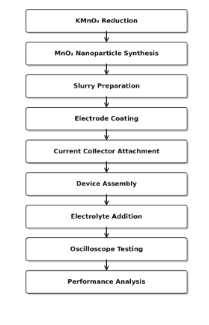
Chapter 4
SNAPSHOTS AND RESULTS
1. 3D STRUCTURE
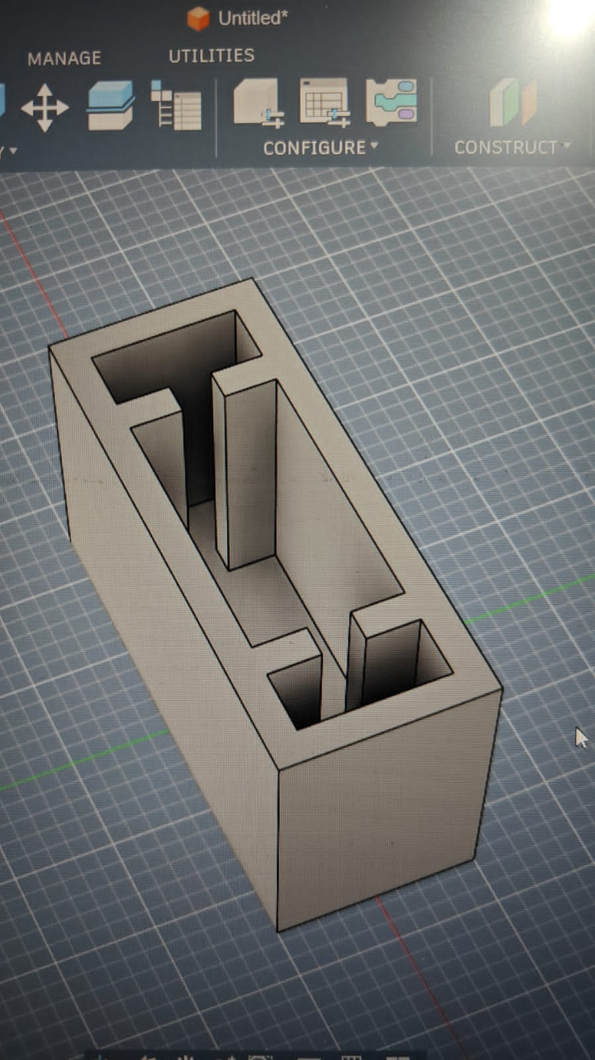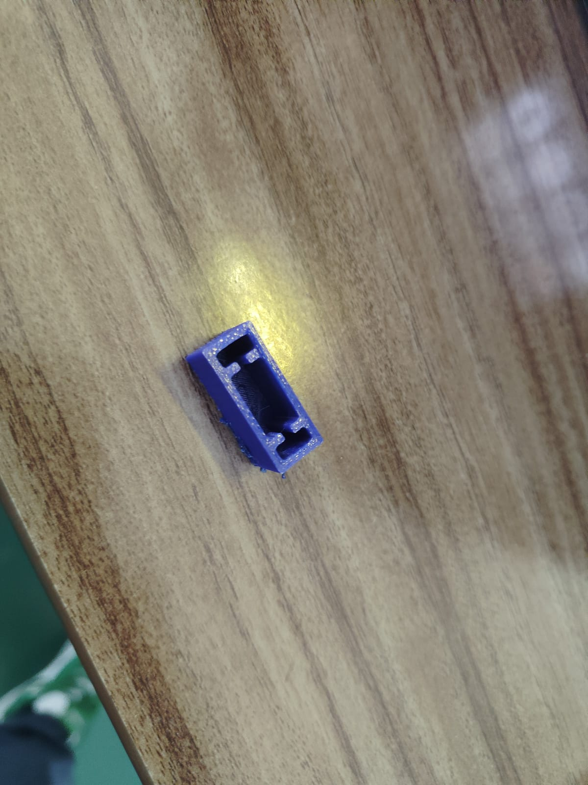
2. SYNTHESIS OF NANOPARTICLES
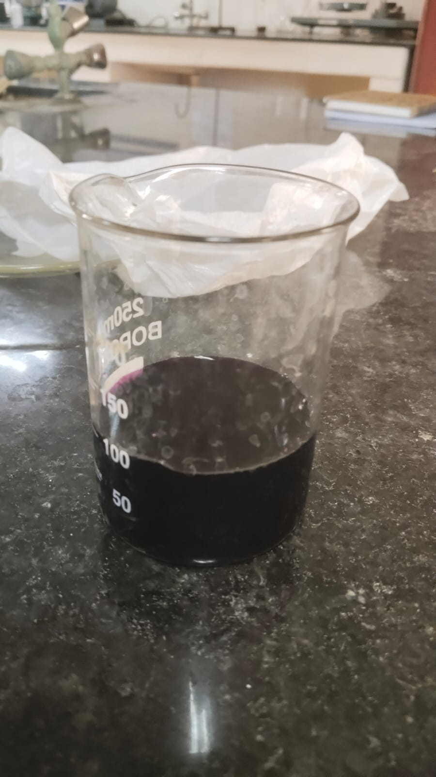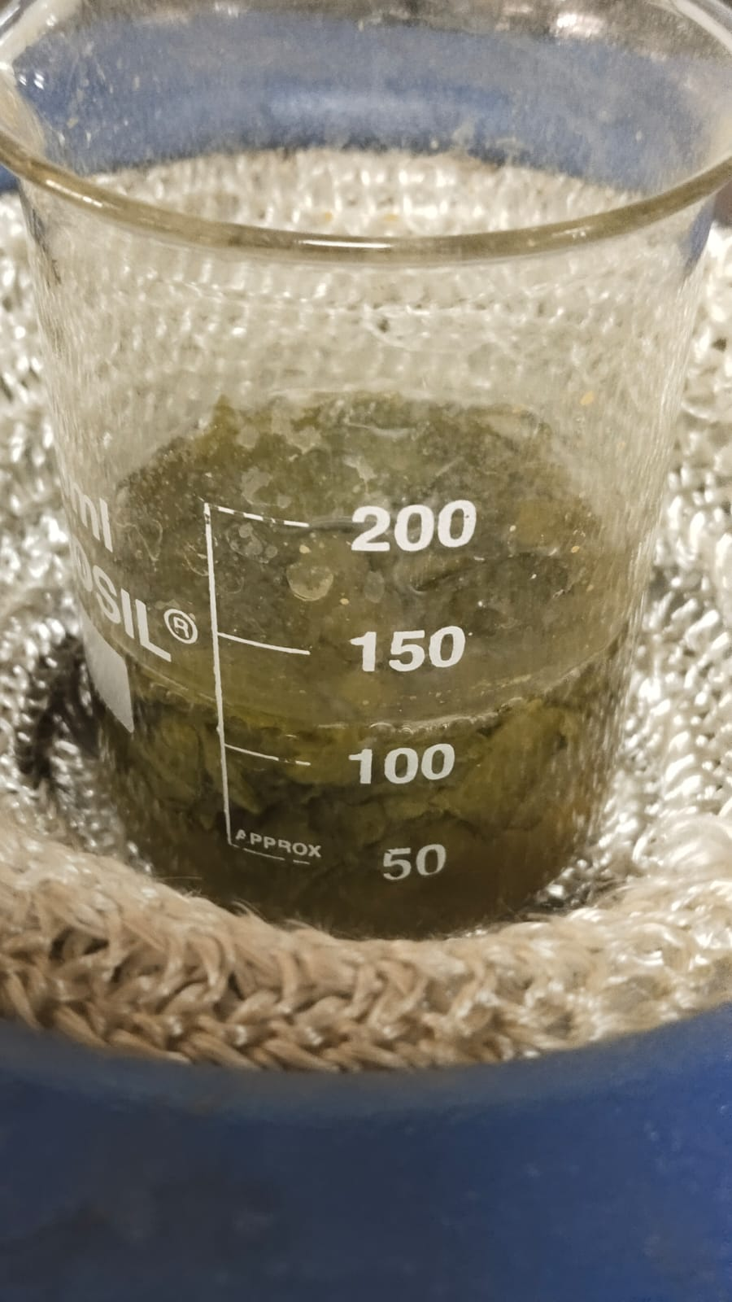
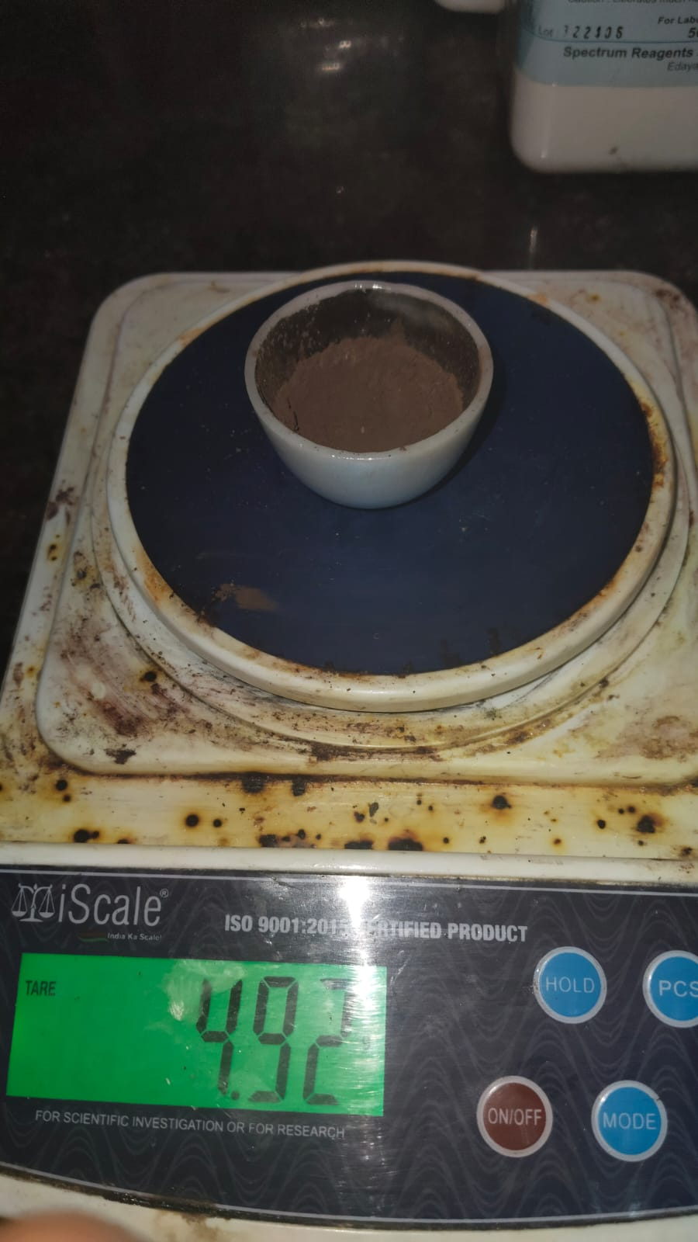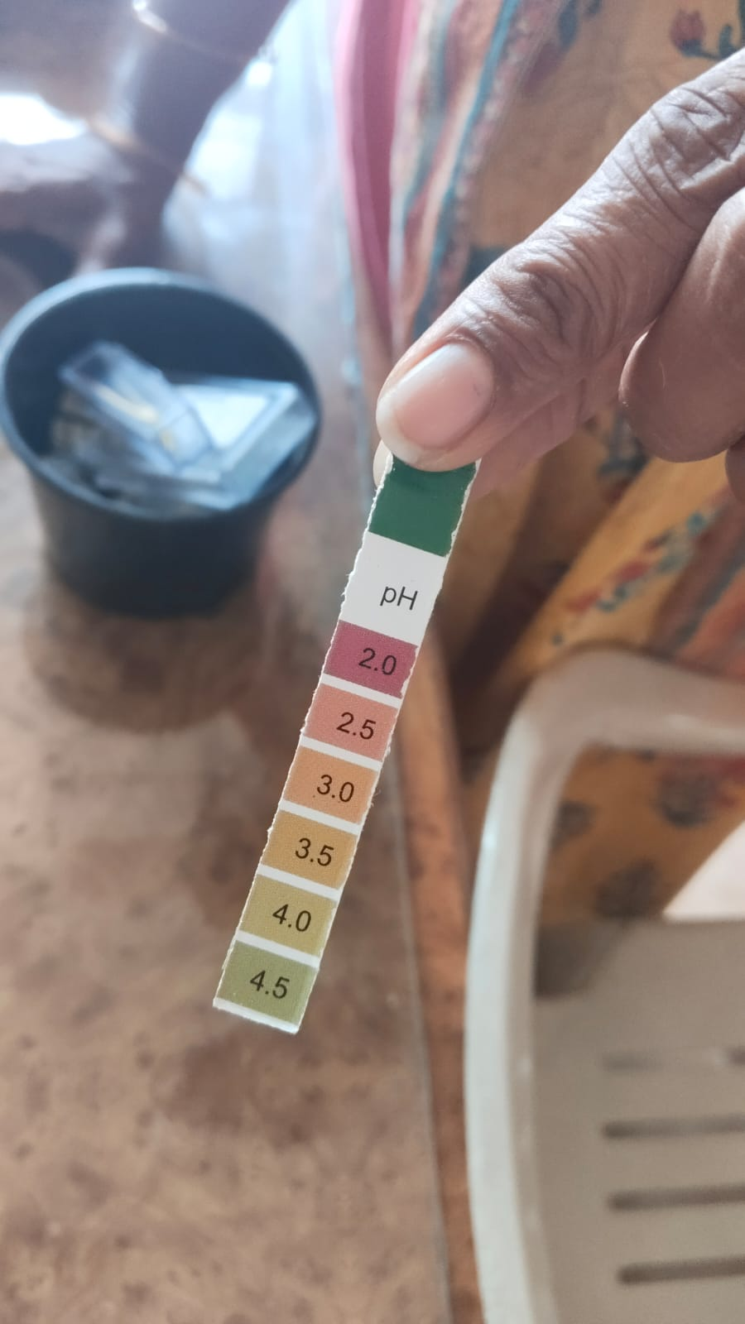

3.PSEUDO CAPACITOR COMPLETE STRUCTURE

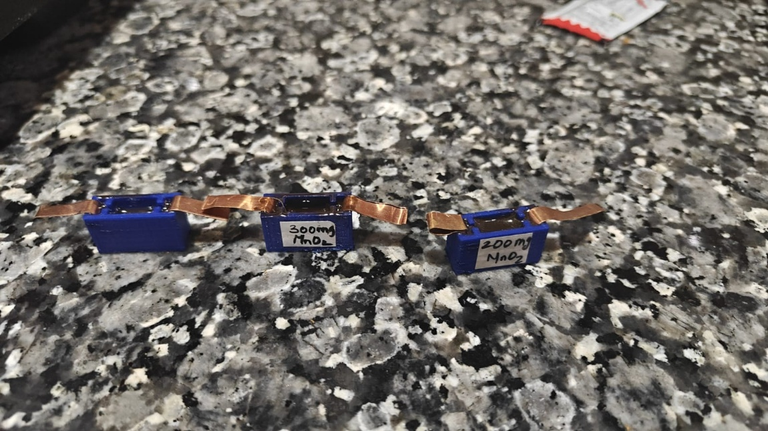

4.1 Experimental Setup
The fabricated MnO₂ nanoparticle pseudocapacitive energy storage device was characterized using an oscilloscope-based measurement setup. The device consisted of MnO₂ nanoparticles coated on a glass substrate with copper foil serving as the current collector. A 1M Na₂SO₄ aqueous electrolyte was used to facilitate ionic conduction. The assembled structure was mounted on a 3D-printed frame to provide mechanical stability during testing.
The performance of the fabricated device was evaluated by varying the input frequency and measuring the corresponding output voltage and phase angle characteristics. Two different active material loadings, namely 100 mg and 200 mg of MnO₂ nanoparticles, were investigated and compared.

4.2 Frequency vs Output Voltage Characteristics
4.2.1 Frequency vs Output Voltage (100 mg)
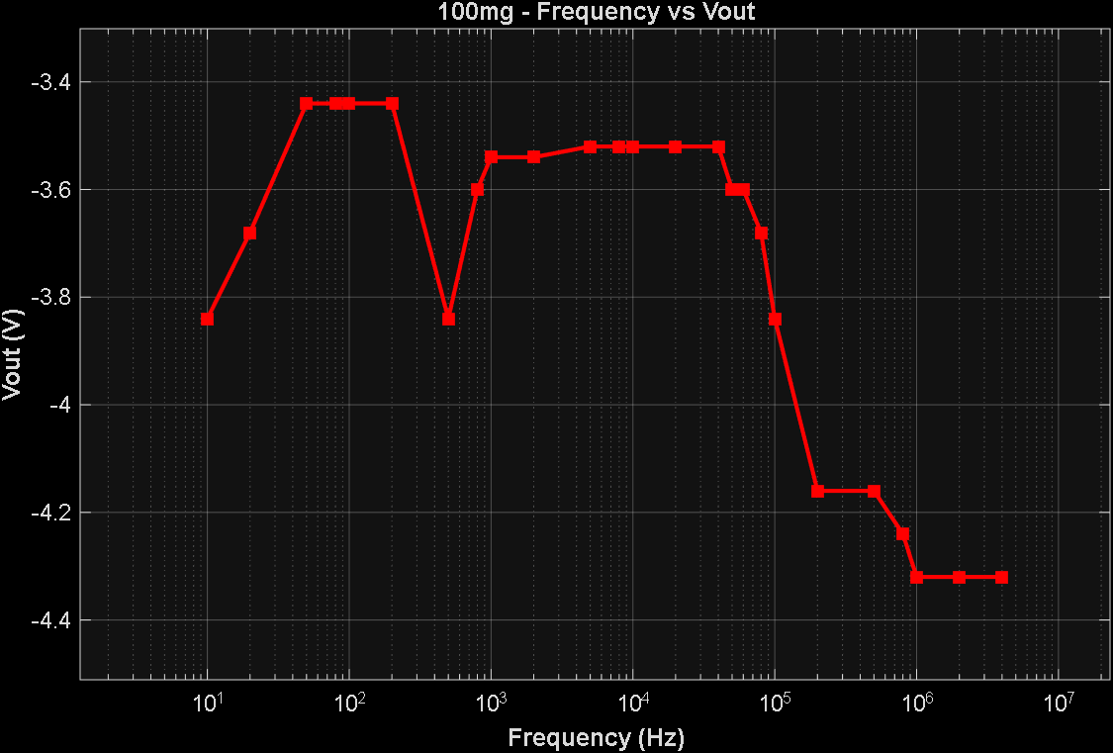
The frequency response of the 100 mg MnO₂ electrode is shown in Figure 4.1. At lower frequencies, the output voltage remained approximately between 3.4 V and 3.8 V. As the frequency increased, the output voltage gradually increased and reached a maximum value of approximately 4.3 V.
The increase in output voltage at higher frequencies indicates improved charge transfer behaviour and enhanced pseudocapacitive response of the MnO₂ electrode. The nanoparticles provide a large active surface area that supports rapid ion transport and efficient charge storage.

4.2.2 Frequency vs Output Voltage (200 mg)
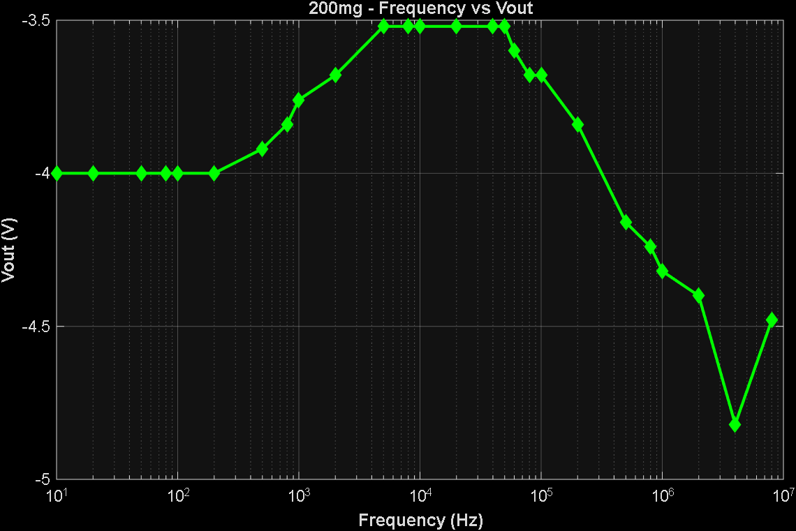
Illustrates the output voltage variation for the 200 mg MnO₂ electrode. Similar behaviour was observed; however, the voltage increased to approximately 4.4 V at higher frequencies.
The higher active material loading resulted in increased electrochemically active surface area, thereby improving charge storage capability. The 200 mg electrode demonstrated slightly higher output voltage compared to the 100 mg electrode, indicating better capacitive performance.

4.2.3 Frequency vs Output Voltage (300 mg)
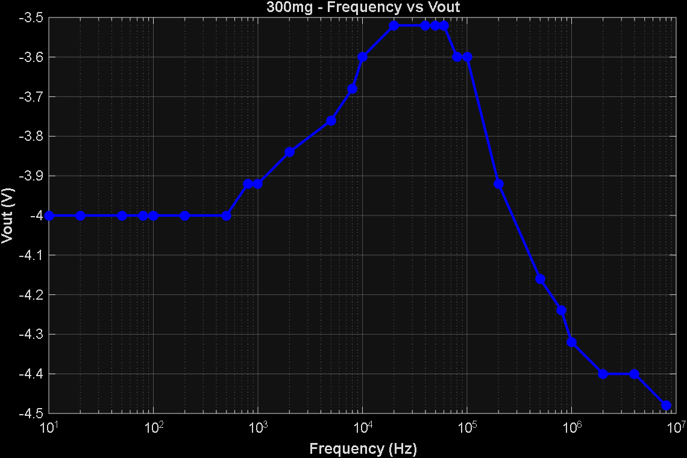
The output voltage variation for the 300 mg MnO₂ electrode is illustrated in Figure 4.X. At low frequencies, the output voltage remained stable at approximately −4.0 V, consistent with the behaviour observed in the 100 mg and 200 mg electrodes. A gradual increase in Vout was observed in the mid-frequency range of 5 kHz to 50 kHz, reaching a peak value of approximately −3.52 V near 40–80 kHz, indicating maximum charge storage efficiency in this region.
Beyond 100 kHz, the output voltage decreased progressively, dropping to approximately −4.48 V at 8 MHz, which corresponds to the dominant resistive behaviour of the electrode at high frequencies where the capacitive reactance becomes negligible. The 300 mg electrode demonstrated a slightly broader flat response region in the mid-frequency range compared to lower mass electrodes, suggesting an increased electrochemically active surface area resulting from the higher MnO₂ nanoparticle loading. This behaviour confirms enhanced pseudocapacitive performance and improved charge storage capability at moderate frequencies.
4.3 Phase Angle Analysis
4.3.1 Phase Angle vs Frequency (100 mg)
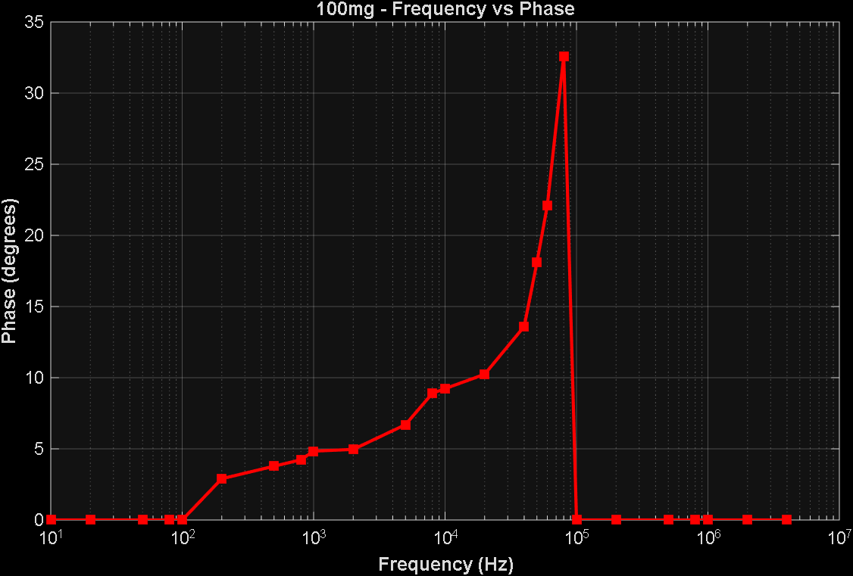
The phase angle response for the 100 mg electrode is presented in Figure 4.2. The phase angle remained close to zero at very low frequencies and gradually increased with increasing frequency. A maximum phase angle of approximately 33° was observed near 10⁵ Hz.
The increase in phase angle indicates capacitive behaviour within the device. The observed response confirms the pseudocapacitive nature of MnO₂ nanoparticles and demonstrates their ability to store electrical energy through fast surface redox reactions.

4.3.2 Phase Angle vs Frequency (200 mg)
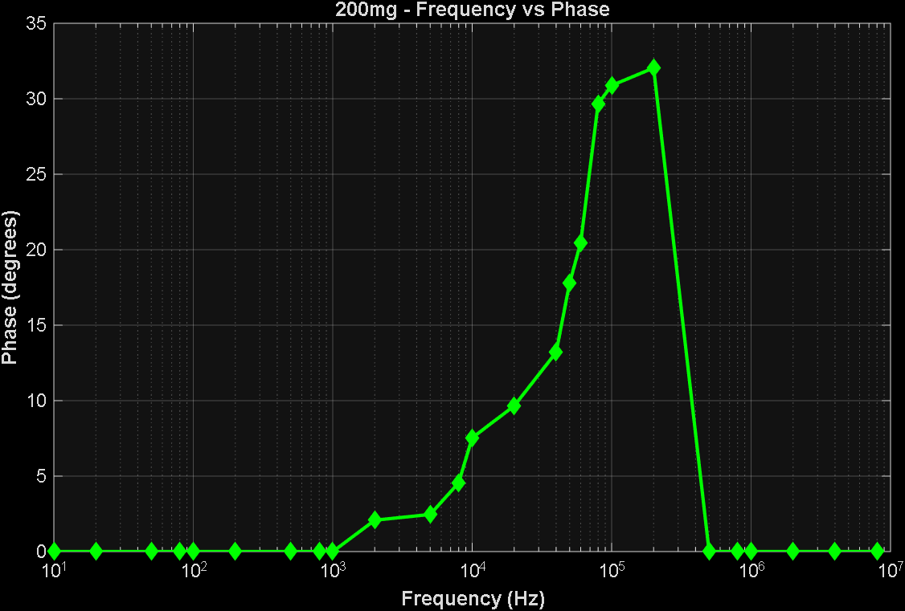
Figure 4.4 shows the phase angle response for the 200 mg MnO₂ electrode. The phase angle increased significantly with frequency and reached a peak value of approximately 31° before decreasing.
The observed phase shift confirms effective charge storage and discharge processes occurring within the electrode-electrolyte interface. The behaviour closely resembles that expected from a practical pseudocapacitive energy storage device.

4.3.3 Phase Angle vs Frequency (300 mg)
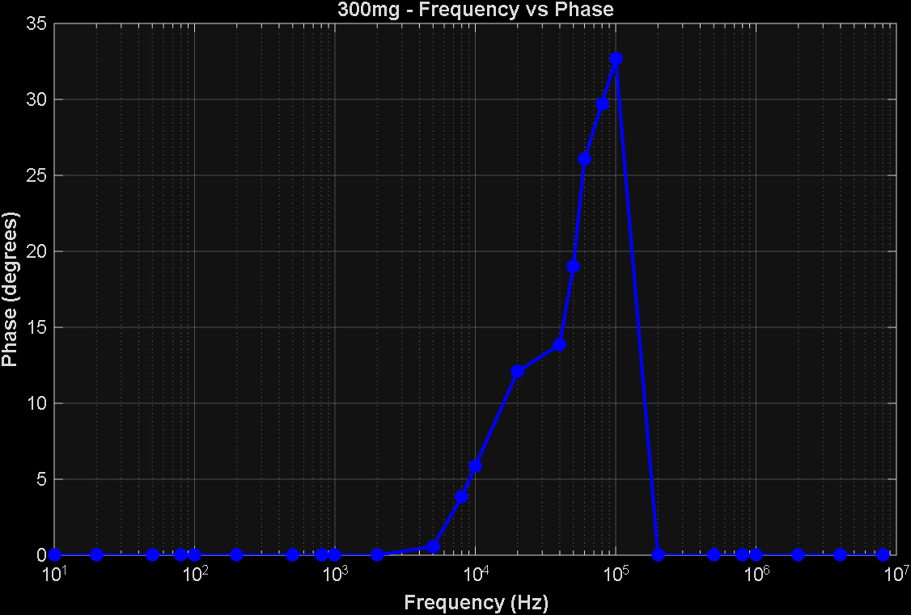
The phase angle response for the 300 mg electrode is presented in Figure 4.X. The phase angle remained close to zero at very low frequencies and began to rise gradually from approximately 5 kHz onwards. A maximum phase angle of approximately 33° was observed near 100 kHz. Beyond this peak frequency, the phase angle declined sharply, returning toward zero at higher frequencies above 200 kHz.
The higher active material loading in the 300 mg electrode resulted in a delayed onset of capacitive behaviour compared to the 100 mg and 200 mg electrodes. This shift in the peak frequency toward higher values indicates a reduction in the effective RC time constant, attributed to the increased electrode thickness and associated ionic diffusion resistance. The observed phase response confirms the pseudocapacitive nature of MnO₂ nanoparticles and demonstrates their ability to store electrical energy through fast surface redox reactions at the electrode-electrolyte interface.
4.4 Comparative Discussion
The performance comparison among the three MnO₂ electrode configurations of 100 mg, 200 mg, and 300 mg reveals a progressive improvement in output voltage stability and charge storage characteristics with increasing active material loading. The 300 mg electrode demonstrated the broadest flat-band response and the most stable pseudocapacitive behaviour across the mid-frequency range, followed by the 200 mg and 100 mg electrodes respectively.
Parameter | 100 mg | 200 mg | 300 mg
Peak Phase Angle (°) | 32.6° | 32.04° | 32.67°
Peak Phase Frequency | ~80 kHz | ~100–200 kHz | ~100 kHz
Minimum Vout (dBV) | −3.44 | −3.52 | −3.52
Maximum Vout Drop (dBV) | −4.32 | −4.82 | −4.48
Flat Band Region | 200 Hz – 10 kHz | 500 Hz – 50 kHz | 500 Hz – 80 kHz
High Frequency Rolloff Onset | ~100 kHz | ~200 kHz | ~200 kHz
ESR Dominance Onset | Early | Moderate | Moderate
Capacitive Stability | Moderate | Good | Best
Active Surface Utilisation | Low | Medium | High

Key observations are summarized below:
- .All three electrodes exhibited clear and well-defined pseudocapacitive behaviour across the measured frequency range. Output voltage remained stable in the low-to-mid frequency region for all samples, with the flat-band region widening with increased mass loading.
- The 300 mg electrode produced the most stable voltage response, followed by 200 mg and 100 mg electrodes.
- Maximum phase angles of approximately 32–33° were observed for all three samples, confirming dominant capacitive reactance at peak frequency.
- The peak phase frequency shifted progressively from approximately 80 kHz in the 100 mg electrode to 100–200 kHz in the 200 mg electrode and approximately 100 kHz in the 300 mg electrode, indicating a mass-dependent change in the RC time constant.
- High-frequency rolloff and ESR dominance were observed in all electrodes beyond 200 kHz, with the 100 mg electrode showing earlier onset of resistive behaviour.
- MnO₂ nanoparticles successfully contributed to electrochemical energy storage across all three loading conditions.
- The fabricated devices demonstrated stable and repeatable frequency-dependent electrical behaviour, validating the consistency of the fabrication process..
4.5 Result Summary
The experimental results confirm the successful fabrication and operation of an MnO₂ nanoparticle-based pseudocapacitive energy storage device. The frequency response and phase angle characteristics indicate effective charge storage capability and validate the suitability of MnO₂ nanoparticles for low-cost supercapacitor applications.

Chapter 5
CONCLUSION and FUTURE ENHANCEMENTS
5.1 Conclusion
The present work successfully demonstrated the fabrication and electrochemical characterization of an MnO₂ nanoparticle pseudocapacitive energy storage device. MnO₂ nanoparticles were synthesized through the reduction of potassium permanganate (KMnO₄) and utilized as the active electrode material. The synthesized nanoparticles were incorporated into a stable electrode slurry and coated onto a glass substrate with copper foil serving as the current collector.
A functional supercapacitor prototype was successfully assembled using a 3D-printed structural frame and 1M Na₂SO₄ aqueous electrolyte. The fabricated device was characterized using an oscilloscope-based measurement system to evaluate its frequency-dependent electrical behavior.
The experimental results showed measurable variations in output voltage and phase angle with frequency, confirming the pseudocapacitive characteristics of the synthesized MnO₂ nanoparticles. Both the 100 mg and 200 mg electrode configurations demonstrated effective charge storage behavior, with the 200 mg electrode exhibiting slightly improved performance due to increased active material loading.
The project successfully integrated concepts from Chemistry and Electronics & Communication Engineering. The synthesis of nanomaterials, electrode fabrication, electrolyte selection, and electrical characterization collectively validated the interdisciplinary nature of the work.
The results confirm that MnO₂ nanoparticles are suitable candidates for low-cost and environmentally friendly energy storage applications. Furthermore, the project demonstrates that undergraduate laboratory facilities are sufficient for developing and testing functional supercapacitor prototypes.
5.2 Future Enhancements
Although the fabricated prototype demonstrated satisfactory performance, several improvements can be implemented in future work to enhance device efficiency and practical applicability.
- Green Synthesis Techniques
  - Chemical reagents may be replaced with plant-based reducing agents such as neem, tulsi, or oregano extracts to achieve environmentally sustainable nanoparticle synthesis.
- Composite Electrode Materials
  - MnO₂ may be combined with reduced Graphene Oxide (rGO), carbon nanotubes, or activated carbon to improve conductivity and increase capacitance.
- Flexible Energy Storage Devices
  - Glass substrates can be replaced with carbon cloth or flexible polymer substrates to develop wearable and portable energy storage systems.
- Asymmetric Supercapacitor Design
  - MnO₂ cathodes may be combined with activated carbon anodes to increase operating voltage and energy density.
- Advanced Electrochemical Characterization
  - Future studies can include Cyclic Voltammetry (CV), Galvanostatic Charge-Discharge (GCD), and Electrochemical Impedance Spectroscopy (EIS) for detailed performance evaluation.
- Series and Parallel Cell Integration
  - Multiple supercapacitor cells may be connected in series and parallel combinations to achieve higher voltage and capacitance levels suitable for practical applications.
- IoT and Renewable Energy Integration
  - The developed device can be integrated with solar energy harvesting systems and IoT-based monitoring platforms for smart energy storage applications.
The above enhancements can significantly improve the performance, reliability, and commercial viability of MnO₂ nanoparticle-based supercapacitors.

REFERENCES
[1] R. Huang, X. Zhang, Y. Li, and H. Chen, “Green synthesis of MnO₂ nanoparticles using plant extract and their electrochemical properties,” J. Alloys Compd., vol. 820, pp. 153-160, Feb. 2020.
[2] R. Vijay, S. Kumar, and P. Sharma, “Flavonoid-mediated biogenic synthesis of manganese oxide nanoparticles,” Mater. Lett., vol. 280, pp. 128-134, Nov. 2021.
[3] P. Kumar, A. Singh, and M. Verma, “Green synthesized MnO nanoparticles for supercapacitor electrode applications,” Electrochim. Acta, vol. 405, pp. 139-147, Jan. 2022.
[4] A. Singh, R. Gupta, and K. Sharma, “Oregano extract as a reducing agent in metal oxide nanoparticle synthesis,” J. Mater. Sci., vol. 54, no. 12, pp. 8954-8965, Jun. 2019.
[5] S. Biswas, M. Hartmann, and T. K. Das, “Organic Supercapacitors as the Next Generation Energy Storage Device: Emergence and Opportunity,” ChemPhysChem, vol. 23, no. 15, pp. 1-15, Aug. 2022.
[6] B. E. Conway, Electrochemical Supercapacitors: Scientific Fundamentals and Technological Applications. New York, NY, USA: Kluwer Academic/Plenum Publishers, 1999.

APPENDIX 1
Source Code Link: https://github.com/DSCE-ECE/MnO2-Supercapacitor-Analytic-Tool.git

APPENDIX 2
Experimental Setup / Circuit Diagram
The experimental setup consists of the MnO₂ electrode mounted within a 3D-printed structural frame, connected to an oscilloscope for voltage characterization and a function generator for frequency sweeping. The schematic for the data acquisition setup is attached below.
[IMAGE PLACEHOLDER: ELECTROCHEMICAL TEST SETUP DIAGRAM]

APPENDIX 3
Hardware / Material Datasheets
The following material specifications and equipment manuals were followed:
1. MnO₂ Nanoparticle Technical Specification Sheet
2. PVDF Binder (High-purity grade) Datasheet
3. Conductive Carbon Black (Super P) Manual
4. Tektronix Digital Oscilloscope User Manual
5. Rigol Function Generator Technical Specifications
Link To Resources: https://drive.google.com/drive/folders/mno2-project-datasheets-dsce

APPENDIX 4
Cost Estimation

Sl. No. | Particulars | Estimated Cost in Rs. | Amount Spent in Rs.
1 | XRD Characterization | 500 | 500
2 | SEM Characterization | 600 | 600
3 | PVDF Binder - 50g | 850 | 850
4 | Copper Foil Roll (Current Collector) | 500 | 500
5 | 3D Printed Frame Material (PLA/PETG) | 100 | 100
TOTAL AMOUNT |  | 2550 | 2550

APPENDIX 5
Project Schedule
Phase | Activity | Duration
1 | Literature Survey and Material Identification | Week 1 - Week 2
2 | Chemical Procurement and Safety Protocol Briefing | Week 2 - Week 3
3 | Synthesis of MnO₂ Nanoparticles via reduction | Week 3 - Week 5
4 | 3D Structural Frame Design and Prototyping | Week 5 - Week 6
5 | Electrode Slurry Prep and Coating onto Substrate | Week 6 - Week 7
6 | Device Assembly and Electrolyte filling | Week 7 - Week 8
7 | Electrochemical Testing and Oscilloscope analysis | Week 8 - Week 10
8 | Result Verification and Validation | Week 10 - Week 11
9 | Documentation and Final Thesis Preparation | Week 11 - Week 12

APPENDIX 6
Member Wise Team Contributions
Team Member | Contribution
BHUMITH D | Led the chemical synthesis of MnO₂ nanoparticles. Managed chemical reduction processes and handled the characterization of the synthesized powder.
BALEESHWAR S | Designed the 3D prototype for the device frame using CAD software. Responsible for current collector attachment and structural integrity testing.
ANAGHA NATRAJ | Optimized the electrode slurry composition using binders and additives. Conducted the uniform coating process and historical literature documentation.
SREELAKSHMI YH | Primary lead for electrical characterization. Performed frequency response analysis, data interpretation using oscilloscopes, and graphical result analysis.

