**Test Script Builder Dependency Installation**

# Windows Install

1. Install the Kivy Portable Package for Python 2.7, following the install instructions here: <http://kivy.org/docs/installation/installation-windows.html>
2. Download SQLAlchemy here: <http://www.sqlalchemy.org/download.html>
3. Find the Python Distribution shipped with your Kivy package (it’s located inside the Kivy folder, wherever you unzipped it to). Copy the path to the python executable:

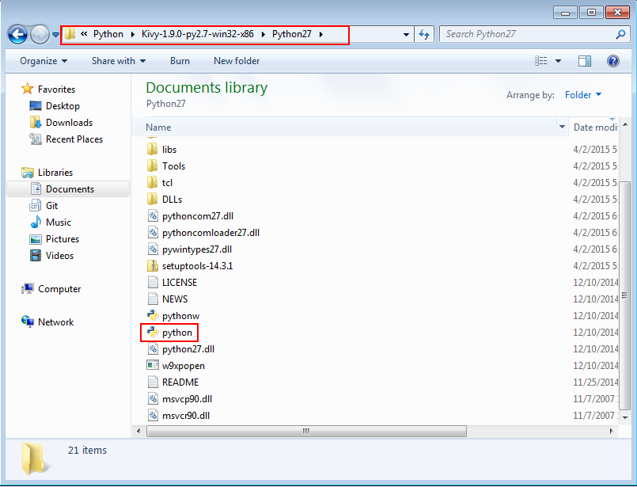

1. Open the command prompt. Go to the directory to which you unzipped sqlalchemy and run the following command:
   1. *<Path_to_Python_Executable>\python.exe .\setup.py install*
2. For instance, my system compiled successfully with:
   1. *C:\Users\ABarry.US\Documents\Development\Python\Kivy-1.9.0-py2.7-win32-x86\python27\python.exe .\setup.py install*
3. Follow the instructions below to start the application: <http://kivy.org/docs/installation/installation-windows.html#start-a-kivy-application>

# Linux Install

1. Install Python (may not be necessary depending on distribution & version. For instance, Python is included with Ubuntu 14.04 and later)
2. Install Kivy using your package manager per the instructions here: <http://kivy.org/docs/installation/installation-linux.html>
3. Install SQLAlchemy using PIP: *sudo pip install sqlalchemy*
4. Start the application using: *sudo python TestScriptBuilder*