AO Workflow Developer Quick Start Guide

Version 1.0
Alex Barry

Table of Contents
Overview 2
Configuration 2
Modules, System Areas, Key Actions 2
Input Parameters 2
Clients, Projects, Test Scripts 3
Data Loading 3
Use 3
Key Action Manager 3
Workflow Designer 3
Workflow Export 3

Overview
Welcome to the AO Workflow Developer Quick Start Guide! This document will serve as a quick reference for you, should you have any questions on how to use this application. The AO Workflow Developer is a piece of software designed to assist in documenting large scale workflows in complex applications. It integrates heavily with Microsoft Excel, and relies on SQLite for database storage. This combination, along with a python integration suite, makes the Developer ideal for design & long term tracking of workflows within an application. Currently, the AO Workflow Developer is certified on Ubuntu 14.04, Windows 7, and Windows 10. However, it can be installed on almost any operating system.
The Developer is highly configurable, offering users the ability to define Key Actions on which to build Workflows. While this does add some complexity to the software, it also allows for a much wider set of uses. Please see below for a discussion of the configuration elements of the software.
The Developer also offers a unique flowchart-based User Interface, designed heavily for touch-screen devices. This makes the software uniquely suited to be in the design room with the designer, who can document the workflows as the are discovered using almost any device.

Basic Use

Navigation

Key Action Manager

Configuration
The AO Workflow Developer Configuration resides in two places: they Key Action Manager and the Test Script Options Popup. Using these, a user can effectively configure the Workflow Developer to handle many different types of flows.

Modules, System Areas, Key Actions
The fundamental data element of the AO Workflow Developer is the Key Action. A Key Action represents a single action taken by the end user during a workflow. Key Actions are organized by System Area and Module.
A single application (or product) will contain many Modules. Within each of these Modules are one or more System Areas. Each System Area, in turn, contains one or more Key Actions. Modules and system areas can then be utilized to effectively filter Key Actions from the Key Action Manager page.
The Key Action Manager Page contains all information and functionality necessary to maintain sets of Key Actions in the long term.

Key Action Attributes
Name | Data Type | Description
Module | Text | The Module associated to the Key Action
System Area | Text | The System Area associated to the Key Action
Name | Text | The name of the Key Action
Description | Text | A description of the Key Action
Custom | Boolean | Whether or not the Key Action is utilizing custom functionality

Products
A single tester may work across a variety of products over a long period of time, so the Workflow Developer tracks Product Data. The product can be set via the Product tab in the Advanced Options pop-up from the Key Action Manager Page.
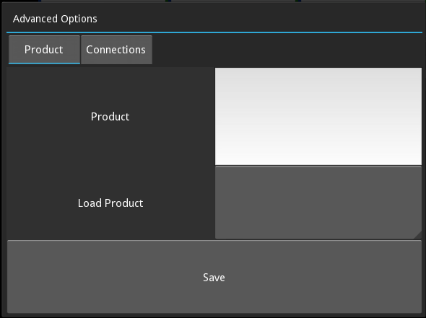

You can add a new product by entering the name into the text field, or you can select an existing product from the drop down menu.
Using the Save button sets the current product based on your input. Filters in the Key Action Manager page are always applied by product, according to the current product.

Input Parameters
Each Key Action may have some number of Input Parameters. Input Parameters allow for Key Actions to be varied easily between workflows, by allowing the user to enter an input value against the parameter for each individual workflow.
Input Parameters can be configured in the Key Action Carousel from the Key Action Manager page.
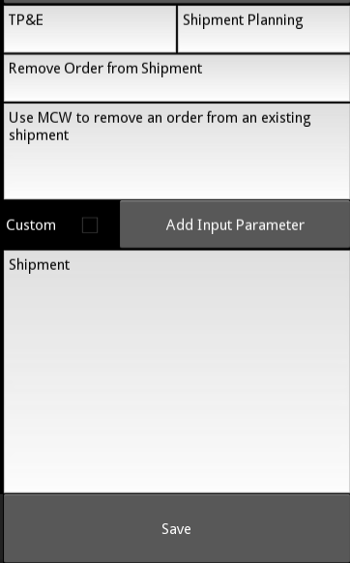

Use the 'Add Input Parameter' button to generate a new Input Parameter for the Key Action in the carousel. You can then update the name, which will be displayed as hint text in the Workflow Developer.

Clients, Projects, Test Scripts
Clients, Projects, and Test Scripts are used to organize Workflows. A Client has many Projects, a Project has many Test Scripts, and a Test Script has many Workflows.
These can be defined in the Test Script Options Popup from the Workflow Developer Page.
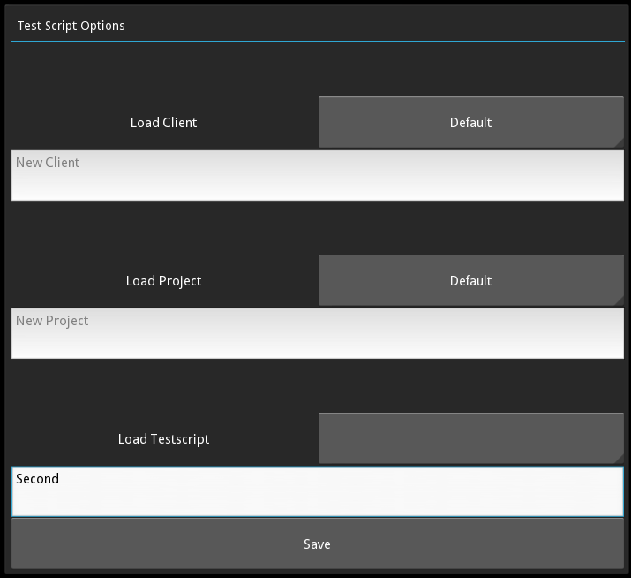

You can use the drop down menus to load a client/project/testscript, or enter a new name into the text fields to create new values. Please take note that, if you decide to create a new Client or Project, that the objects lower in the hierarchy (TestScript and/or Project) must also be created new.

Data Loading
The Data Loader Engine for the Workflow Developer is quite sophisticated, and speaks several different languages. You should find, along with this document, sample data for each format.

Database

Microsoft Excel

CSV

Workflow Development

Workflow Designer

Workflow Export

