Low dispersal of adults in a nursery-dependent fish metapopulation revealed by modeling mark-recovery data.

|  |
| --- |
| Jean-Baptiste Lecomte1, Helene Baillif1, Matthieu Veron1, Olivier Le Pape1, Marie Nevoux1, Youen Vermard2, Sigrid Lehuta2, Marie Savina2, Ewan Hunter3, & Etienne Rivot1 |
| 1 Research Unit Ecology and Ecosystem Health UMR 0985 ESE INRA, Agrocampus Ouest, Rennes, France |
| 2 Unit of Fisheries Ecology and Modelling, French Research Institute for Exploitation of the Sea, Nantes, France |
| 3 Centre for Environment, Fisheries and Aquaculture Science, Pakefield Road, Lowestoft, United Kingdom |
|  |

# Author note

Correspondence concerning this article should be addressed to Jean-Baptiste Lecomte, 65 rue de Saint-Brieuc, 35042 Rennes, France. E-mail: [jean-baptiste.lecomte@agrocampus-ouest.fr](mailto:jean-baptiste.lecomte@agrocampus-ouest.fr)

Abstract

Quantifying connectivity within fish metapopulations is critical to understand population dynamics and to provide an evidence base for assessment and management. Connectivity determines the meta-population dynamics, the resilience of populations to natural and anthropic stressors, and should ultimately conditions the design of spatial management strategies. We investigate meta-population connectivity of the common sole (Solea solea L.) in the English Channel (EC), one of the main fisheries resources in the area. Adults spawn offshore in spring. Eggs and larvae drift passively for several weeks before settling in coastal nursery grounds, where the juveniles spend their first two years. When approaching maturity, juveniles migrate offshore to deeper waters where they recruit to the exploited adult population. Based on results from neutral genetic markers, the stock of common sole is the EC is currently assessed as single, spatially homogeneous population. However, larval drift models and limited in situ movement of larvae and juveniles within nurseries suggest very low connectivity between EC sub-populations. Yet, connectivity induced by adult movements remains effectively unknown. To fill this knowledge gap, we developed a state-space mark-recapture model, designed to estimate adult connectivity. The data set collates multiple tagging campaigns spanning from 1970 to 2018 and covering a large area from the Western English Channel to the west to the North Sea in the east, including the EC. More than 32739 fish have been tagged using passive Pertersen discs tags and 4036 tagged fish have been recovered by the fishery. Time between tagging and recapture spans from 81 to 7549 days. The model estimates movements of fish between five pre-defined sub-areas (Western English Channel, Eastern English Channel split in three different areas and North Sea) on a seasonal basis considering three seasons. Model selection supports the existence of different movements between seasons. Overall, our results suggest that few movements occur at the adult stage with very low estimates of dispersal patterns among spatial units in the English Channel and even lower imports from adjacent areas. During winter, low to moderate exports to the North Sea and to the western channel are estimated. Our results support the hypothesis of segregated population subunits within the EC and the importance of considering such structure in the management process.

*Keywords:* Population structure, capture-mark-recapture, multi-event modeling, *Solea solea*, Eastern English Channel

The Markdown code '**#####**' is originally reserved for *header 5*. However, we will use it to insert a pagebreak in a .docx document.

Pagebreak

Low dispersal of adults in a nursery-dependent fish metapopulation revealed by modeling mark-recovery data.

# Introduction

Understanding movement and dispersal of wild animals at any life stage in their life cycle is critical to understand population dynamics and to provide an evidence base for population assessment and management. Movements of individuals determine connectivity between habitats and control the meta-population dynamics, the resilience of populations to natural and anthropic stressors.

In fisheries, an accurate definition of the spatial structure of fish populations is critical for fish stock assessment and for setting fisheries management strategies (Kutkuhn 1981; Smith *et al.* 1990; Begg *et al.* 1999; Fogarty & Botsford 2007). A misspecification of the spatial and temporal limits of a stock can lead to bias estimates of population vitals rates (Cadrin *et al.* 2014; Kerr *et al.* 2017). Dispersal process should be addressed at all life-history stages in order to accurately assess the spatial and temporal delineation of populations and to accurately specify spatial management measures that could eventually target specific areas and life stages (e.g. nursery area, spawning aggregations) (Fogarty & Botsford 2007).

Stock divisions are commonly based on jurisdictional and management convenience instead of biological inference (Stephenson 1999; Smedbol & Stephenson 2001). Recent studies conducted on the delineation of historical fish stocks using a wide variety of tools and methods are employed to assess connectivity within populations (Le Bris *et al.* 2017; Östman *et al.* 2017; Rogers *et al.* 2017; Moreira *et al.* 2018; Randon *et al.* 2018). Genetic studies using genetic markers such as microsatellites (Cuveliers *et al.* 2012; Jasonowicz *et al.* 2016; Martinez *et al.* 2017) or single nucleotide polymorphism (Milano *et al.* 2014; Bekkevold_2015; Laconcha *et al.* 2015) are often used to assess the spatial structure of a population and in particular the reproductive isolation within populations (Östman *et al.* 2017). Otoliths are also extensively used to study fish population connectivity by analyzing their shape (Bacha *et al.* 2016; Hüssy *et al.* 2016; Mahe *et al.* 2016) or chemistry (Tanner *et al.* 2016; Callicó Fortunato *et al.* 2017; Régnier *et al.* 2017; Moreira *et al.* 2018). Other approaches such as morphometry and meristics (Allaya *et al.* 2016; Sley *et al.* 2016), parasites (Catalano *et al.* 2014; MacKenzie & Abaunza 2014) or life history traits [Begg and Waldman (1999); Cadrin *et al.* (2014); Erlandsson *et al.* (2017); Randon *et al.* (2018); DuPontavice_2018]are common methods to assess stock delineations.

Mark-recapture experiments have proven to be relevant to investigate movement of individuals and the spatial structure of populations (Howe & Coates 1975; Hilborn 1990; Gillanders *et al.* 2001; Patterson III *et al.* 2001; McGarvey & Feenstra 2002; Adlerstein *et al.* 2008; Cadrin *et al.* 2014; Hanselman *et al.* 2014; Le Bris *et al.* 2017). When considering commercial fish stocks, tagging data often consist of mark-release and tag-recovery which usually depend on volunteer reporting by the harvesters. The disadvantage of such data is that the reporting rate is unknown and the non-reporting rate can be substantial (Henny & Burnham 1976; Frusher_2001; Pollock_2002; Cadigan & Brattey 2003, 2006). On the other hand, external information is often available (McGarvey & Feenstra 2002). Catch and fishing-effort data are collected for most exploited stocks. In some fisheries, estimates of total and fishing mortality, and thereby total abundance, are produced annually, for example from virtual population analysis. Such information can be used as input in the analysis of tagging data of harvested fish populations.

The common sole (*Solea solea*, L) is a flatfish species particularly harvested in the Western English Channel to the North Sea (ICES 2017). Today, three stock divisions are considered (VIIe, VIId, IVc) and stock assessment are conducted separately (ICES 2017). The Eastern English Channel (EEC) stock has been overexploited during the last ten years (ICES 2017) and is managed as one homogeneous population. Dispersal of the sub-adult components is well known with larvae drifting passively to coastal nurseries (Rochette 2011) and juveniles migrating offshore where they reproduce and are harvested (Riou *et al.* 2001). However, the adult connectivity of the sole population in the EEC remains unclear. Key life history traits (density-at-age and length-at-age data) highlighted a potential spatial structure of the adult component of the sole stock within the EEC into three spatial subunits (Du Pontavice *et al.* 2018; Randon *et al.* 2018).

In this paper, we study movements of adults sole to assess the connectivity of the adult sole population within the EEC and with adjacent management areas. We tested the hypothesis of a meta-population structure with small mixing between populations within the EEC as suggested by previous studies (Du Pontavice *et al.* 2018; Randon *et al.* 2018). For that purpose, we developed a state-space model to estimate adult sole movement probabilities by analyzing mark-recovery data collected over 49 years. Results of this modeling approach would also provide a better understanding of dispersal patterns according to sole biological seasons (Rochette 2011). Finally, we provided recommendations for the management of the sole stock in the EEC in light of our results.

# Materials and Methods

## Data Collection

The data set collates four tagging campaigns carried out by (i) the Center of Environment Fisheries and Aquaculture Science (CEFAS) from 1955 to 1985 and 2002 to 2007 (Burt & Millner 2008) and (ii) the French Research Institute for Exploitation of the Sea (IFREMER) from 1976 to 1980 and 2016 to 2018 (Table 1, Figure 1). For each tagging campaign, standard or mini “Petersen” discs were used (Burt & Millner 2008). Discs are uniquely numbered and placed on the dorsal side. Fish were released close to the capture position as soon as possible after tagging. Recapture of marked fish occurred at any time and were mainly recovered by the fisheries, which declared the date and spatial coordinates of the recapture and sometimes the length of the recaptured fish. To assess the existence of temporal variations in key model parameters (see below) the dataset is separated into four tagging campaigns denoted (1) ${CEFAS}_{1970}$ from 1970 to 1985, (2) ${CEFAS}_{2002}$ from 2002 to 2007, (3) ${IFREMER}_{1976}$ from 1976 to 1980 and (4) ${IFREMER}_{2016}$ from 2016 to 2018. The data collected before 1970 were discarded because no reliable time series of fishing mortality could be found before 1970 for all spatial area considered in the model. Fish with no GPS data at tagging and/or at recovery or with no date at recovery where discarded (3314 fish).

Figure 1 represents the spatial distribution of tagged individuals per tagging campaign and Table 1 summarizes the number of tagged individuals as well as the number of recovery by tagging campaign.

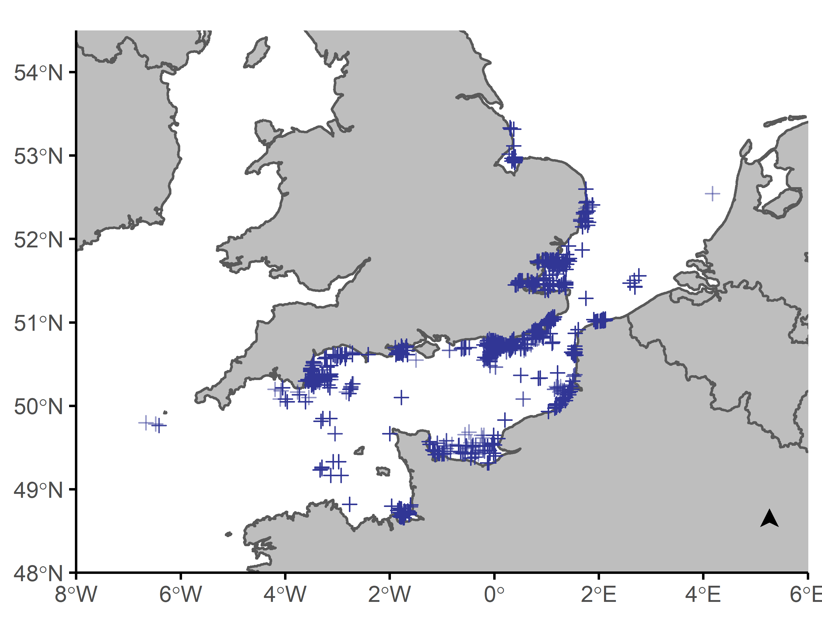

Figure 1 Map of release locations of tagged common sole in the English Channel and west of North Sea.

Table 1 Summary of the number of marked and recovered fish per marking campaign with their associated recapture rates.

|  |  |  |  |  |
| --- | --- | --- | --- | --- |
| Campaign | Marked | Recovered | Average time at liberty | Recapture rate |
| $${CEFAS}_{1970}$$ | 21994 | 3627 | 6.26 | 0.16 |
| $${CEFAS}_{2002}$$ | 2644 | 29 | 5.59 | 0.01 |
| $${IFREMER}_{1976}$$ | 5028 | 305 | 4.07 | 0.06 |
| $${IFREMER}_{2016}$$ | 3073 | 70 | 3.04 | 0.02 |
| Total | 32739 | 4031 | 6.03 | 0.12 |

## Spatial structure

The potential spatial structuration of the sole population along the English Channel is analyzed using five spatial units (Figure 2): the Western Channel (WC), the North Sea (NS) and three spatial units for the EEC: English coast of the Eastern English Channel (UK), Southern French coast (SE) and Northern French coast of the Eastern English Channel (NE). The WC and NS area are based on spatial management units currently use to provide decision advice (ICES 2017). The division of the EEC into three subunits (UK, SE, NE) is based on natural barriers with unsuitable sole habitat (i.e. large and deep gravel grounds in the middle of Eastern Channel, wide rocky reefs in deep areas along the coasts; Rochette *et al.* (2012); Archambault *et al.* (2016); Randon *et al.* (2018) and Du Pontavice *et al.* (2018))

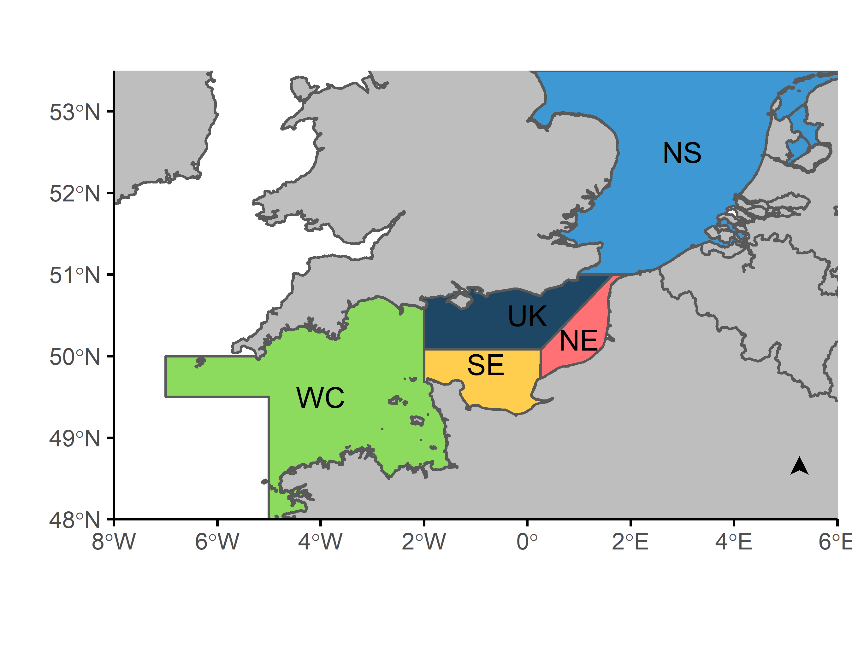

Figure 2 Map of the English Channel with the five areas potentially structuring common sole stocks: ICES division VIIe denoted as Western Channel, VIId divided into UK, SE and NE and IVc denoted as North Sea).

## Time at liberty and time step

For each individual, the time at liberty: elapsed time between the date of release (day) and recapture by the fishery was recorded. A quarter (4 months) discrete time-step approach was used for the modeling approach. The time at liberty was then converted into a number of time step. Quarters were based on biological seasons representing the life cycle of the sole: spawning (February to May), foraging (June to September) and overwintering (October to January). Individuals recovered at the same time step as tagging are removed from the analysis.

## Modeling approach

Dataset is formed and analyzed under a multi-event modeling approach (Pradel 2005). Observations are linked to underlying biological states through a series of steps defined by transition matrices.

### Core modeling structure

The final data sets consist of 32739 fish with known date (quarters) and areas (5 zones) of release and recovery, and additional ancillary data such as tagging campaign (4 campaigns) and length at release. Dataset is formed and analyzed under a multi-event mark-recapture modeling approach (Pradel 2005).

The model tracks the history of each individual released fish on a quarter discrete time step. The trajectory of each individual starts with the release events, for which the date and areas are assumed to be recorded without errors. The transition between each time step $t$ and $t+1$ then consists of a three-step series of transition representing ecological and observation process (Figure 3). Each transition is stochastic and is modeled as Bernoulli or Multinomial probability distributions depending on the number of outcomes. A matrix of parameters is associated to transition. Detailed transition matrices are provided in the appendix. The first step corresponds to the movement process ($D$), any alive fish at time $t$ can stay in its current location or move to another area between $t$ and $t+1$. The second step accounts for survival ($S$), a fish can survive or die. Death occurs by the fisheries or from natural causes. The model assumes that dispersal occurs before survival; a tagged fish can move to a new area and be caught by the fisheries in this new area. The third, and last step, corresponds to the observation process, which links observations to biological states. Fish caught by the fisheries are detected with probability $ψ$. Alive fish or dead fish from natural causes are not observable and hence cannot be detected (detection probability is 0 for those fish). We consider 6 observation events: not seen (0), captured in WC (1), captured in UK (2), captured in SE (3), captured in NE (4), captured in NS (5). In our multi-event model, observations are linked to 16 biological states:

$$\{A_{WC}, A_{UK}, A_{SE}, A_{NE}, A_{NS}, F_{WC}, F_{UK}, F_{SE}, F_{NE}, F_{NS},M_{WC}, M_{UK}, M_{SE}, M_{NE}, M_{NS}, †\}$$

States $A$ correspond to alive fish, states $F$ correspond to dead fish from fishing and states $M$ corresponds to dead fish from natural causes located respectively in areas WC, UK, SE, NE, NS. State $†$ corresponds to “long time dead” fish. It is an unobservable dead state which distinguishes the “newly dead” fish from the unobservable “long-time-dead” fish (Lebreton *et al.* 1999; Fernández-Chacón *et al.* 2016). This state is required to estimate the detection rate of fish caught by the fisheries and to distinguish the different causes of mortality.

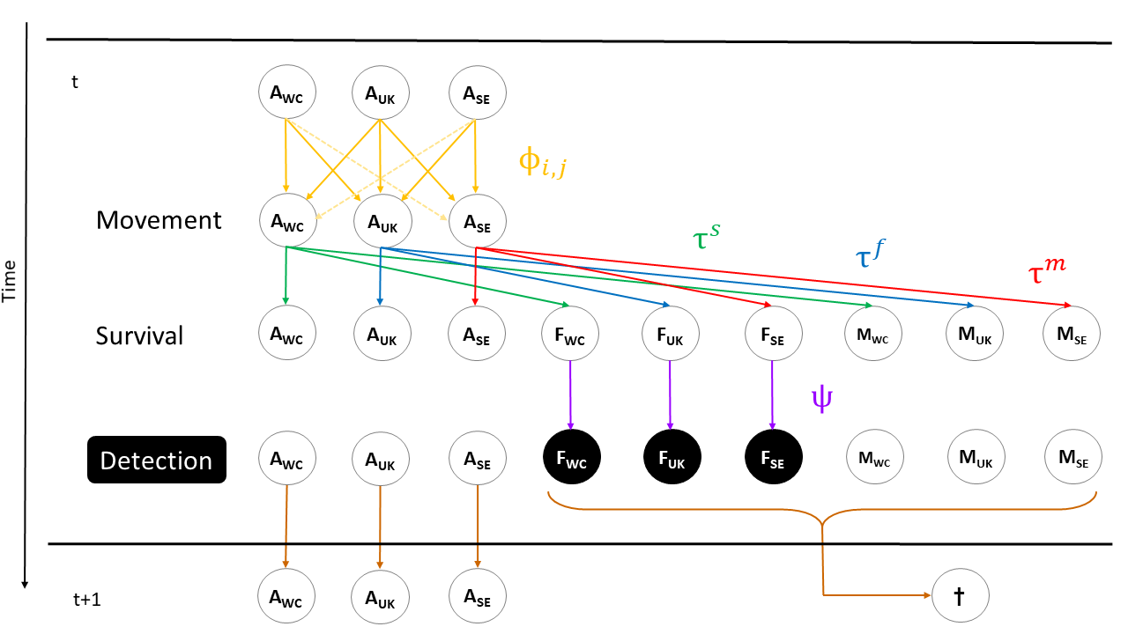

Figure 3 Model structure for each transition between time step $t$ and $t+1$. Only three (WC, UK, SE) of the five areas are represented for ease of reading.

### parameterization

Below we detail the parameterization used in the full model that accounts for seasonal migration patterns, seasonal declaration rate and inter-annual variation of the mortality (Table 2). Alternative simpler models with no seasonal variations of dispersion, mortality constant in space and/or time and a unique detection rate were also tested (see Table 2).

*Parameterization of dispersal process*

Probabilities of movement are estimated for each pair of departure and arrival areas and for each quarter separately. Except for the probabilities of movement from the Western Channel to the North Sea, and from the North Sea to the Western Channel, which are set to 0 and are not estimated. The important distance separating the two areas does not allow for such movement in one time step (i.e. 4 months), and over the 32739 fish histories, no fish were recovered making these two migrations in one time step. Our parameterization of the dispersal process allows to test for two migration hypotheses: (i) no variability between seasons’ movements (i.e. same probabilities of dispersal between seasons) and (ii) variability of movement between seasons (i.e. potential different probabilities of moving between seasons).

*Parameterization of survival process*

Survival probabilities for each time step are fixed and supposed known without errors, defined as

$$\begin{matrix}τ^{f}= & \frac{f}{f+m}(1-exp(-(f+m)) \\ & \\ τ^{m}= & \frac{m}{f+m}(1-exp(-(f+m)) \\ & \\ τ^{s}= & 1-(τ^{f}+τ^{m})\end{matrix}$$

where $m$ and $f$ are respectively the natural mortality and fishing mortality per quarter estimated in stock assessment (ICES 2017). $τ^{f}$ is the probability of a fish to die from fishing during a quarter, $τ^{m}$ is the probability of a fish to die naturally during a quarter and $τ^{s}$ is the probability of survival of a fish during a quarter.

The values of $m$ and $f$ were derived from results of published stock assessment evaluations (ICES 2017). Available data on survival of each stock assessment differ per area (ICES 2017): estimates of natural and fishing mortality are available since 1955 for the IVc area, from 1969 for the VIIe area and from 1982 for the VIId area (Figure 4). In order to use the longest time series of tagging data, we assumed that the fishing and natural mortality are similar between VIIe and VIId areas during the period 1969 to 1981. No tagging event occurred in 1969, so the time series considered in this analysis starts in 1970 and ends in 2018. Because of great uncertainty that surrounds estimates of fishing mortality, time series are smoothed to decrease year to year variability (Figure 4). Smoothed time series of $f$ improve numerical stability of resulting dispersal estimates. For the three ICES area (IVc, VIId and VIIe) the natural mortality was estimated to $m=0.1$ (ICES 2017).

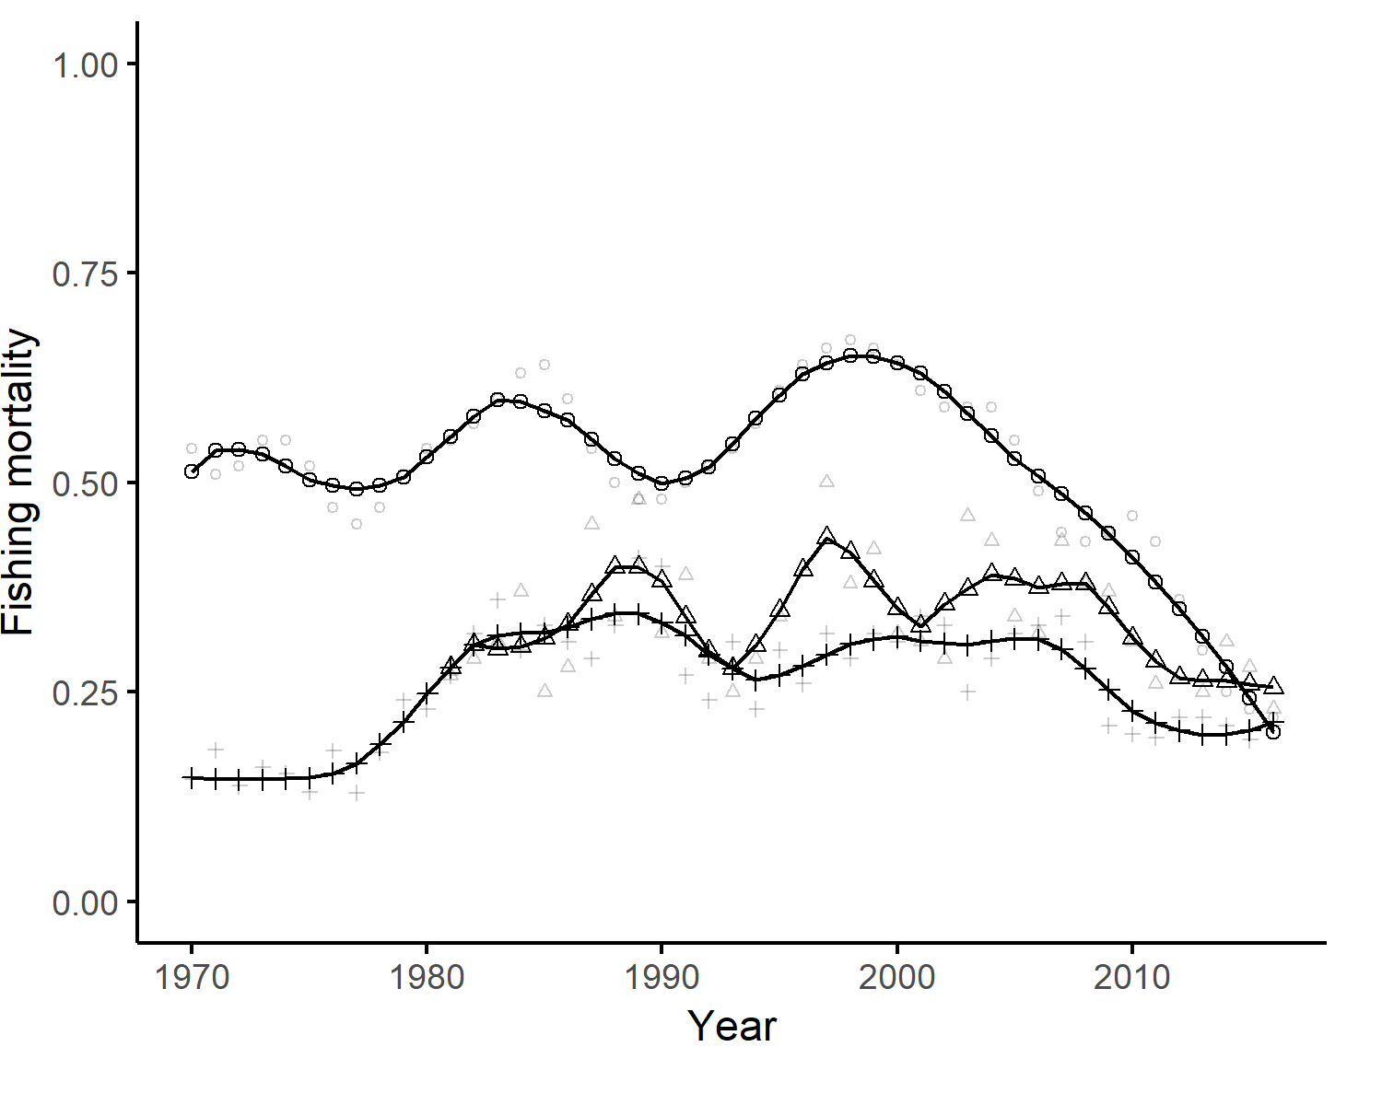

Figure 4 Annual fishing mortality estimates from stock assessments (ICES 2017). Dotted line represents $f$ for the IVc area, triangle line represents $f$ for the VIId area, and cross-line is for the VIIe area. Shaded triangle, dot and cross represent estimates from stock assessment without smoothing. Locally weighted least squares regression was used to perform smoothing with 30% of smoothing span.

### Hypotheses testing and sensitivity analysis

The full model (model 1, Table 2), accounts for (i) a dispersal process per seasons, (ii) a yearly and spatially varying survival as input in the model, and (iii) a detection rate variable between tagging campaign. We then fit less complex models for hypotheses testing and sensitivity analysis. Models with no variability of movements between seasons (i.e. a unique transition matrix $D$ for all seasons) are fitted to test the hypothesis of different seasonal dispersal patterns. We also tested the sensitivity of our results to the input of the survival process by reducing the variability of the fishing mortality input by using: (i) a spatially varying survival computed as the mean of fishing and natural mortality over time series per area, and (ii) a single survival probability for each area calculated as the mean over areas and times series. Finally, the full model (model 1, Table 2) with a detection rate per release campaigns is compared to a model with one detection rate over all release campaigns. The simplest model uses a unique transition matrix $D$ for all seasons, unique survival probability per area. Tested models are summarized in Table 2.

Finally, the full-time series (1970 to 2018) of tagging data was separated in two time series to account for potential differences in dispersal patterns in recent and historical tagging campaigns. Recent release campaigns correspond to release events which occurred during 2002 to 2018, and historical tagging campaign began in 1970 to 1998. Table 3 presents the number of fish released and recovered by area and time series. The best model, selected with QAIC, is used to estimate dispersal patterns and detection rates for these two truncated time series and results are compared with the ones obtained for the full-time series.

Table 2 Model definition.

|  |  |  |  |  |
| --- | --- | --- | --- | --- |
| Model | Dispersal | Declaration | Fishing mortality | Time Series |
| $$M_{1}$$ | Seasonal | Release campaigns | Area x Years | 1970-2018 |
| $$M_{2}$$ | - | Release campaigns | Area x Years | 1970-2018 |
| $$M_{3}$$ | Seasonal | - | Area x Years | 1970-2018 |
| $$M_{4}$$ | Seasonal | Release campaigns | Area | 1970-2018 |
| $$M_{5}$$ | - | Release campaigns | Area | 1970-2018 |
| $$M_{6}$$ | Seasonal | Release campaigns | - | 1970-2018 |
| $$M_{7}$$ | - | Release campaigns | - | 1970-2018 |
| $$M_{8}$$ | Seasonal | Release campaigns | Area x Years | 1970-1998 |
| $$M_{9}$$ | Seasonal | Release campaigns | Area x Years | 2002-2018 |

### Model fit and selection

All models were fitted in the maximum likelihood framework using the E-SURGE program (version 1.9.0, (Choquet & Nogue 2010). Specification of the transition matrices are available appendix.

A goodness-of-fit test was conducted prior to model selection. GOF is performed using the U-CARE software (version 2.2, Choquet *et al.* (2009)) which can account for datasets that only includes dead recoveries (Gauthier & Lebreton 2008). Detailed process used to perform the goodness-of-fit test is provided in the appendix.

Model selection was used to assess which model formulation in Table 2 has the most support from the data. Model selection was based on the Akaike’s information criterion corrected for overdispersion (QAIC). The model with the lowest score of QAIC is considered as the best model. Only models with the same data set (same length of the time series of data) were compared together.

### Sensitivity to area’s frontier

A sensitivity analysis to the delineation of the spatial units was performed. We removed from the dataset released or recaptured fish close to a unit’s border: 30 km buffers were computed around each boundary; released and recovered fish inside those buffers were removed from the dataset (3364 fish were removed). Those fish were potentially crossing the border using smaller migration path than fish released in the center part of each subunit. Our sensitivity analysis aimed at accounting for the importance of fish released and recovered near a border. All models were re-run with this new dataset to test for a potential edge effect of fish released or recovered close to borders.

Table 3 Number of fish released per area and time series and in parentheses the number of recovered fish per area and time series.

|  |  |  |  |
| --- | --- | --- | --- |
|  | 1970-1998 | 2002-2018 | 1970-2018 |
| WC | 5025 (949) | 250 (10) | 5275 (959) |
| UK | 6897 (1298) | 1861 (13) | 8758 (1311) |
| SE | 1448 (90) | 1048 (7) | 2496 (97) |
| NE | 1143 (93) | 2148 (55) | 3291 (148) |
| NS | 12509 (1505) | 410 (16) | 12919 (1521) |
| Total | 27022 (3935) | 5717 (101) | 32739 (4036) |

# Results

The GOF test performed on the full dataset (from 1970 to 2018) revealed a lack of fit ($χ^{2}=57.476$, $P=0.000$ and $df=24.000$). A $\overset{̂}{c}$ coefficient of 2.39 was applied to all models to account for overdispersion ( $\overset{̂}{c}$ superior to one, Burnham and Anderson (2003), Choquet *et al.* (2009)).

Overall, the tagging-recovery data are best explained by the full model $M1$ including seasonal migration, detection rate per release campaigns, and mortality variable across space and time. The results provide support to the existence of seasonal migration whilst only weak differences exist in the movement pattern between seasons. The conclusion that the data support the existence of seasonal migration patterns is then robust to the hypotheses maid on the fishing mortality. Indeed, models with seasonal movements in general presented better QAIC scores when considering pairs of models with the same survival input (QAIC M1 < QAIC M2 ; QAIC M4 < QAIC M5; QAIC M6 < QAIC M7).

The data also support the hypotheses of different declaration rates for the releasing campaigns (QAIC M1 < QAIC M3). Detection rate estimates were similar among models and are presented in Table 5 for model 1. Detection rates differed among tagging campaign with the lowest detection rate estimated for the ${CEFAS}_{2002}$, comparable detection rate between ${IFREMER}_{1976}$ and ${IFREMER}_{2016}$ campaigns and relatively high detection rate for the ${CEFAS}_{1970}$ tagging campaign. These differences among tagging campaign highlight the importance of estimating one detection rate per release campaign. Results are in accordance with the number of fish released and recovered per campaign (Table 1).

Overall, results support the hypothesis of very low connectivity between the different areas (Figure 5). For most areas and seasons, no dispersal pattern is estimated (i.e. probabilities of staying in the area of origin are close to one). This result highlights the fact that the adult component of the sole population is mainly resident and a small proportion of adult fish migrate among spatial units. Low probabilities of movement are estimated ($Φ_{i,j}<0.25$) for fish in the UK area which moves to WC during overwintering season. Similar value of movement probabilities are estimated for fish within the SE area moving to WC area during spawning seasons. Finally, low movement probabilities are estimated for overwintering seasons between NS and NE. Estimated movement probabilities with model 4 (model with no variability between seasons’ movements) are in favor of sedentariness of sole with even less positive probabilities of movement among areas (appendix Figure 8).

In addition, the conclusion that very low connectivity exists between area is robust to the time series of data considered. When comparing estimates of dispersion rates obtained between the whole data set (1970-2018) and the 1970-1998 time series corresponding to historical tagging campaigns, ${CEFAS}_{1970}$ and ${IFREMER}_{1976}$, results revealed consistent movement patterns, except for the NE and NS area. Important movements between these two areas are estimated when considering historical release campaigns only. During foraging season, all fish from NS move to NE, whereas in spawning and overwintering all fish from NE move to NS. However, these estimated probabilities of movements can be explained by the small amount of fish released and recovered in the NE area: 82 over the 1970-1998 period in comparison with the 1307 fish released and recovered in the NS. Thus, recent tagging data collected from 2002 to 2018 and the entire dataset presented similar dispersal patterns (Figure 7). Like historical tagging campaign, the general pattern of movement is kept with small movement patterns among areas. There are small differences in movement estimates with the recent tagging data and the full-time series. These differences are concentrated between the 3 subunits of the EEC. During the foraging seasons, positive movements are estimated from the UK to the NE areas, as well as from the SE to the NE areas. Small movements are also estimated from the NE to the WC and SE areas during spawning season Confidence intervals are greater than 1970-2018 and 1970-1998 time series because of the smaller amount of fish released during ${CEFAS}_{2002}$ and ${IFREMER}_{2016}$ in comparisons with ${CEFAS}_{1970}$ and ${IFREMER}_{1976}$ released campaigns.

Table 4 Model selection from model 1 to less complex alternatives in the migration and survival process. $Δ$ QAIC represents the difference in QAIC in comparison to model 1.

|  |  |  |  |  |
| --- | --- | --- | --- | --- |
| Model | Migration | Survival | QAIC | $Δ$ QAIC |
| 1 | Seasonal | Area x time | 144966 | - |
| 2 | Seasonal | Area | 145156 | -190 |
| 3 | Seasonal | - | 145148 | -182 |
| 4 | - | Area x time | 144976 | -10 |
| 5 | - | Area | 145187 | -221 |
| 6 | - | - | 145132 | -166 |

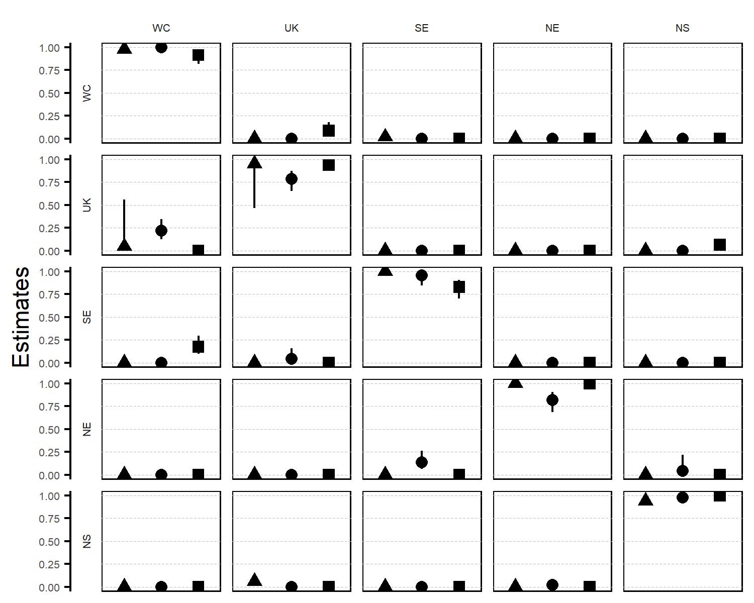

Figure 5 Migration rate estimates and their credible intervals from model 1 (full data set ${CEFAS}_{1970}$, ${IFREMER}_{1976}$, ${CEFAS}_{2002}$, ${IFREMER}_{2016}$, fishing mortality variable in space and time, seasonal variability of migrations). Rows represent areas of departure and columns areas of arrival. Triangles are MLE estimates of movement probabilities for spawning season. Circles foraging season. Squares overwintering season. Dotted lines represent the quantiles at 0, 0.25, 0.50, 0.75 and 1 for ease of reading.

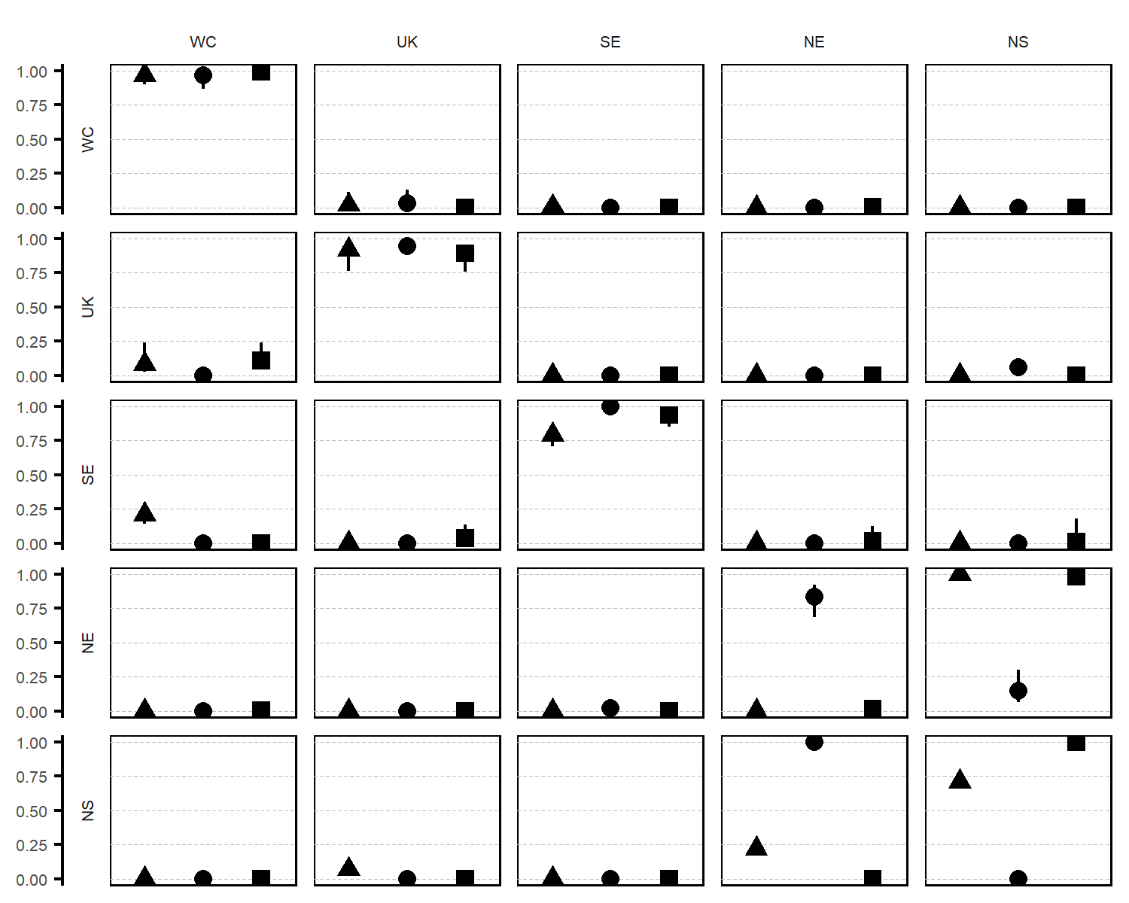

Figure 6 Migration rate estimates and their credible intervals from model 1 since 1970 to 1998. Rows represent areas of departure and columns areas of arrival. Triangles are movement probabilities for spawning season, circles for foraging season and squares for overwintering season. Dotted lines represent the quantiles at 0, 0.25, 0.50, 0.75 and 1 for ease of reading.

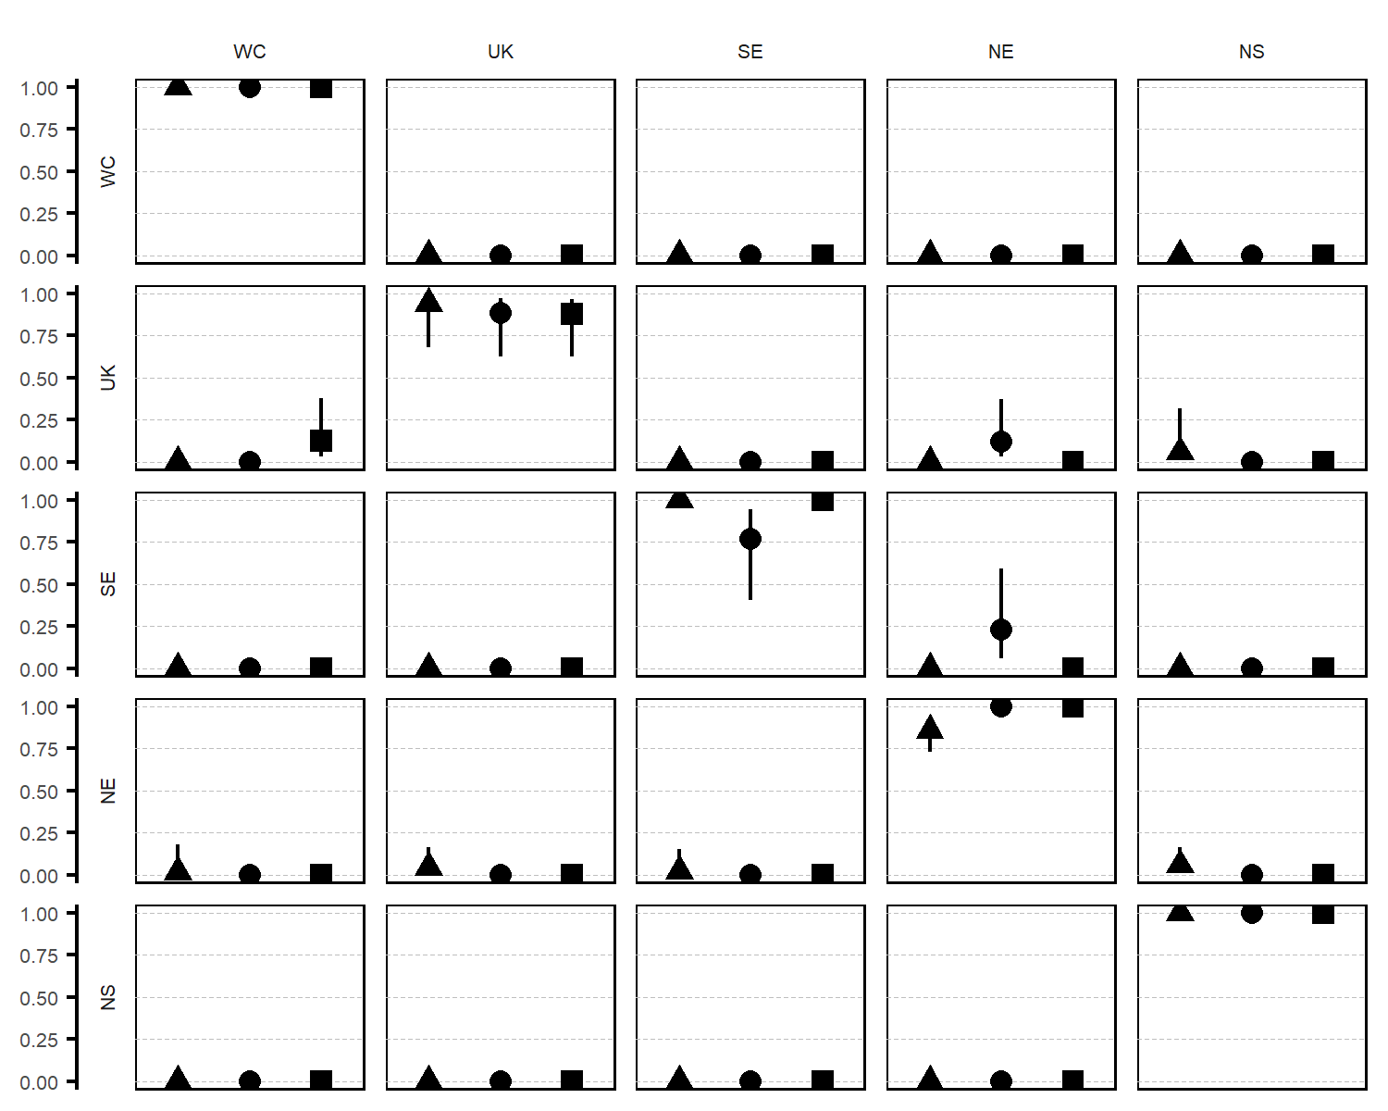

Figure 7 Migration rate estimates and their credible intervals from model 1 since 2002 to 2018. Rows represent areas of departure and columns areas of arrival. Triangles are movement probabilities for spawning season, circles for foraging season and squares for overwintering season. Dotted lines represent the quantiles at 0, 0.25, 0.50, 0.75 and 1 for ease of reading.

Table 5 Detection rate estimates associated to each tagging campaign with lower (CI-), upper (CI+) 95% confidence intervals and standard errors (SE) for model 1.

|  |  |  |  |  |
| --- | --- | --- | --- | --- |
| Campaign | Rate | CI- | CI+ | SE |
| $${CEFAS}_{1970}$$ | 0.173 | 0.165 | 0.182 | 0.004 |
| $${CEFAS}_{2002}$$ | 0.044 | 0.020 | 0.095 | 0.018 |
| $${IFREMER}_{1976}$$ | 0.070 | 0.061 | 0.081 | 0.005 |
| $${IFREMER}_{2016}$$ | 0.070 | 0.042 | 0.115 | 0.018 |

#Discussion

The selected models fitted a large mark-recapture database, running for 50 years, with 32739 released sub-adults and adults of common sole. It provided very low estimates of dispersal patterns among spatial units in the English Channel, even more low imports from adjacent areas, but low to moderate exports to the North Sea and to the western channel, mainly in winter. It brings evidence of low connectivity among sole subpopulations within the EEC, without inputs from the adjacent spatial management units. These results on local segregation are in accordance with recent studies using patterns in key life history traits (Du Pontavice *et al.* 2018; Randon *et al.* 2018) for the common sole in the EEC.

*Reliability of the esimates of dispersal*

One of the advantages of working with commercially exploited fish populations is that estimates of population vital rates are available from surveys, expert knowledge or stock assessment (McGarvey & Feenstra 2002). In our study, we used fishing and natural mortality, estimated in stock assessments (ICES 2017) as an input in our capture-mark-recapture modeling approach. Models incorporating all data available on the survival process (e.g. yearly and spatially varying fishing mortality) best explains the data. However, our model considers no spatial variability of the fishing mortality within the Eastern Channel. Du Pontavice *et al.* (2018) and Archambault *et al.* (2016) suggested that, in the NE area, the fishing pressure is higher than in the UK and SE areas. A specific fishing mortality for each subunit within the EEC would have been more accurate in terms of model fitting. However, the stock of the common sole in the EEC is considered as homogeneous. Data were not available to use specific fishing mortality in each spatial subunit of the EEC (UK, SE, NE). Also, the lack of data on the distribution of the fishing effort within a year does not allow us to use a fishing mortality that varies between seasons in a year. Potential biases could potentially result from this lack of data refinement and could hamper the reliability of the outputs, if estimated level of dispersal were high. However, the very low level of dispersal estimated among the different subunits in the EEC could not result from such potential biases; they could be considered as reliable outputs. Seasonal movement rates estimated in our study revealed low migration patterns, with small variations when considering different periods of the time series. Historical tagging campaigns ( ${CEFAS}_{1970}$ and ${IFREMER}_{1976}$) were not designed to specifically study movement patterns in the EEC. In particular, the two French coast areas (SE and NE) were less targeted than the other spatial units. Singularities in the older part of the dataset can explain the difference of dispersal patterns estimated for the 1970 to 1998 time series with regards to the full time series or to recent tagging campaign. Only recent tagging campaigns ( ${CEFAS}_{2002}$ and ${IFREMER}_{2016}$) well sampled the three spatial units of the EEC. Analyzing jointly the four tagging campaigns allowed for a more balanced dataset, and reduced singularities and potential bias incorporated by the spatial locations of fish releases between tagging campaigns.

*Interest of combined approaches to estimate connectivity*

The present approach based on mark-recapture on the long-term fit with previous analysis using patterns in key life history traits (Du Pontavice *et al.* 2018; Randon *et al.* 2018) to evidence the low level of connectivity among the sole population within the EEC. Pita *et al.* (2016) highlighted the importance of using multiple approach to study stock delineation. Integrating historical data is suitable for identifying fishery management units (Izzo *et al.* 2017). Distinct stock identification methods may provide inconsistent results, and congruence between methods improves confidence (Cadrin *et al.* 2014; Izzo *et al.* 2017). Especially for marine fish, the combined effect of a specific population dynamics (Le Pape & Bonhommeau 2015) and the lack of barriers in the ocean rend the genetic signal of segregation relatively weak (Selkoe *et al.* 2008). A very low dispersal rate linked to a restricted proportion of fish with a large dispersal behavior (Palmer *et al.* 2014) hamper genetic approach to evidence spatial structure. This leads to mismatch between ecological and genetic connectivity (Hawkins *et al.* 2016). The sole stocks in the English Channel and North Sea are divided for decades and it reflects a pattern of isolation by distance (Diopere *et al.* 2017), but there is now a substantial body of evidence that supports a genetic spatial structuration of the common sole population in the ECC. However, the combined estimates from life history traits (Du Pontavice *et al.* 2018; Randon *et al.* 2018) and tagging surveys revealed lasting segregation patterns.

*From low adult-mediated connectivity to segregation in subunits*

In the EEC, larval connectivity is low for the common sole, since spawning areas directly feed adjacent coastal nursery grounds (Rochette *et al.* 2012). After metamorphosis, juveniles grow on shallow nursery grounds (Riou *et al.* 2001; Rochette *et al.* 2010). Limited movements of juvenile flatfish (Le Pape & Cognez 2016), and the dependence of the juvenile common sole upon shallow nursery habitats (Riou *et al.* 2001) result in low juvenile connectivity (Coggan & Dando 1988). After about two years on nursery grounds, the common sole move to deeper offshore adult foraging grounds. Connectivity among subunits as a result of adult movement still remains partially unknown (Burt & Millner 2008; Archambault *et al.* 2016). Adult connectivity is a potentially important driver of marine population segregation (Frisk *et al.* 2014). Tagging surveys revealed lasting segregation patterns at adult stages among subunits in the EEC. Estimate of dispersal rate revealed very low exchanges between the three subunits delineated in the EEC, and no import from adjacent stocks. This ecological isolation allows for understanding the marked discrepancies in growth between subunits (Du Pontavice *et al.* 2018; Randon *et al.* 2018) and the lasting synchrony among density-at-age time series inside each subunit (Randon *et al.* 2018). The combination of these approaches highlights ecological segregation, in spite of the lack of genetic evidence (Diopere *et al.* 2017). However, estimated levels of dispersal demonstrate that at subadult and adult stages, EEC export a low fraction of individuals to the North Sea and a very low fraction to the Western Channel. These exports seem to occur mainly in the overwintering period, and not during the summer foraging season. EEC could thus be a low source of fish for these adjacent stocks. These movements occur mainly during the overwintering period of movements of subadults (Dorel *et al.* 1991) and adults (Horwood 1993; Burt & Millner 2008) common sole toward deeper areas.

*Interest for management*

The metapopulation dynamics of exploited fish reveal both spatial structure at small scale and exchange between stocks thus mismatches between biological population structure and stock units of marine fish (Kerr *et al.* 2017). The existence of such metapopulation structure should be considered in stock assessments (Carson *et al.* 2011; Frisk *et al.* 2014). In particular, spatial structuration within a management area should be taken into account for improving decision advice (Heino *et al.* 1997; Porch *et al.* 1998; Ulrich *et al.* 2017). Inconsistencies could impede effectiveness and appropriateness of management measures (Kerr *et al.* 2017), resulting in the overexploitation of the less productive subunits (Cadrin & Secor 2009; Ying *et al.* 2011; Goethel & Berger 2017). (Rochette *et al.* 2013) then (Archambault *et al.* 2016) have developed an integrated life cycle Bayesian model of the EEC sole stock. The modeled life cycle considers adults producing eggs then larval drift, survival and settlements in coastal nurseries, habitat–dependent growth and survival of juveniles on nurseries and a statistical catch-at-age model to estimate number-at-age and fishing mortality of subadults and adults. The model potentially accounts for three independent dynamic models for the adults’ component of the sole population in the EEC. Simulation studies considering two extreme situations, 1 adult entity / 3 fully isolated subunits, has shown that accounting for spatial segregation markedly influence stock assessment results (Archambault *et al.* 2016). Adults play a vital role in population connectivity (Frisk *et al.* 2014), especially for species with low level of connectivity at previous stages. Failure to include the role of adults in connectivity, or here in segregation, can lead to discrepancies in stock assessment and related management advice (Punt & Restrepo 1995; Porch *et al.* 1998). Further extension of life cycle models to consider fish stocks in a metapopulation structure, estimating together spatial levels of connectivity and fishing mortality will contribute for better assessment advice (Methot 2009; Goethel *et al.* 2011; Griffiths *et al.* 2018).

# Acknowledgement

We would like to thank Coline Lazard, Sophie Parrad, Nicolas Goascoz, Ronan Lebras, David Osmond and Yves Verin for their extensive involvement in the tagging program.

# Funding

This work is part of the SMAC (Sole de Manche Est Amélioration des Connaissances pour une meilleure gestion du stock) research program. This work is supported by the fisheries organization “France Filière Pêche” and the French Ministry in charge of fisheries “Direction des Pêches Maritimes et de l’Aquaculture”.

# Appendix

## Model structure and E-SURGE specification

E-SURGE (Choquet & Nogue 2010) is used to implement multi-event models which are defined by steps representing biological and observation process. Each process is associated to a row-stochastic matrix for which each row corresponds to a multinomial. All cells probability in the same row must sum to one and so one parameter is defined as the complement of the others (i.e. $1-∑others$) and is denoted by the symbol $⋆$ is the following matrices. Cells with probabilities fixed at 0 are denoted with a dash (-). Matrices rows correspond to the starting state and columns correspond to the arrival state.

*Initialization*

Table 6 $I$: initial state probabilities are assigned to alive state only, because tagging is performed on alive fish only.

|  |  |  |  |  |  |  |  |  |  |  |  |  |  |  |  |
| --- | --- | --- | --- | --- | --- | --- | --- | --- | --- | --- | --- | --- | --- | --- | --- |
| $$A_{WC}$$ | $$A_{UK}$$ | $$A_{SE}$$ | $$A_{NE}$$ | $$A_{NS}$$ | $$F_{WC}$$ | $$F_{UK}$$ | $$F_{SE}$$ | $$F_{NE}$$ | $$F_{NS}$$ | $$M_{WC}$$ | $$M_{UK}$$ | $$M_{SE}$$ | $$M_{NE}$$ | $$M_{NS}$$ | $$†$$ |
| $$⋆$$ | $$π$$ | $$π$$ | $$π$$ | $$π$$ | - | - | - | - | - | - | - | - | - | - | - |

*Dispersal*

The first five rows of matrix $D$ corresponds to fish that are alive at time $t$ and move (or not) during the transition to time $t+1$. For instance, $ϕ_{WC,UK}$ is the probability for a fish in state ‘ $A_{WC}$’ at time $t$ to move from area $WC$ to area $UK$ and be in state $A_{UK}$ at time $t+1$. The last 10 rows correspond to fish that are dead and by definition cannot move to another area and hence cannot change of state at time $t+1$.

Table 7 $D$: migration probabilities ($Φ_{i,j}$).

|  |  |  |  |  |  |  |  |  |  |  |  |  |  |  |  |  |
| --- | --- | --- | --- | --- | --- | --- | --- | --- | --- | --- | --- | --- | --- | --- | --- | --- |
|  | $$A_{WC}$$ | $$A_{UK}$$ | $$A_{SE}$$ | $$A_{NE}$$ | $$A_{NS}$$ | $$F_{WC}$$ | $$F_{UK}$$ | $$F_{SE}$$ | $$F_{NE}$$ | $$F_{NS}$$ | $$M_{WC}$$ | $$M_{UK}$$ | $$M_{SE}$$ | $$M_{NE}$$ | $$M_{NS}$$ | $$†$$ |
| $$A_{WC}$$ | $$⋆$$ | $$ϕ_{WC,UK}$$ | $$ϕ_{WC,SE}$$ | $$ϕ_{WC,NE}$$ | - | - | - | - | - | - | - | - | - | - | - | - |
| $$A_{UK}$$ | $$ϕ_{UK,WC}$$ | $$⋆$$ | $$ϕ_{UK,SE}$$ | $$ϕ_{UK,NE}$$ | $$ϕ_{UK,NS}$$ | - | - | - | - | - | - | - | - | - | - | - |
| $$A_{SE}$$ | $$ϕ_{SE,WC}$$ | $$ϕ_{SE,UK}$$ | $$⋆$$ | $$ϕ_{SE,NE}$$ | $$ϕ_{SE,NS}$$ | - | - | - | - | - | - | - | - | - | - | - |
| $$A_{NE}$$ | $$ϕ_{NE,WC}$$ | $$ϕ_{NE,UK}$$ | $$ϕ_{NE,SE}$$ | $$⋆$$ | $$ϕ_{NE,NS}$$ | - | - | - | - | - | - | - | - | - | - | - |
| $$A_{NS}$$ | - | $$ϕ_{NS,UK}$$ | $$ϕ_{NS,SE}$$ | $$ϕ_{NS,NE}$$ | $$⋆$$ | - | - | - | - | - | - | - | - | - | - | - |
| $$F_{WC}$$ | - | - | - | - | - | 1 | - | - | - | - | - | - | - | - | - | - |
| $$F_{UK}$$ | - | - | - | - | - | - | 1 | - | - | - | - | - | - | - | - | - |
| $$F_{SE}$$ | - | - | - | - | - | - | - | 1 | - | - | - | - | - | - | - | - |
| $$F_{NE}$$ | - | - | - | - | - | - | - | - | 1 | - | - | - | - | - | - | - |
| $$F_{NS}$$ | - | - | - | - | - | - | - | - | - | 1 | - | - | - | - | - | - |
| $$M_{WC}$$ | - | - | - | - | - | - | - | - | - | - | 1 | - | - | - | - | - |
| $$M_{UK}$$ | - | - | - | - | - | - | - | - | - | - | - | 1 | - | - | - | - |
| $$M_{SE}$$ | - | - | - | - | - | - | - | - | - | - | - | - | 1 | - | - | - |
| $$M_{NE}$$ | - | - | - | - | - | - | - | - | - | - | - | - | - | 1 | - | - |
| $$M_{NS}$$ | - | - | - | - | - | - | - | - | - | - | - | - | - | - | 1 | - |
| $$†$$ | - | - | - | - | - | - | - | - | - | - | - | - | - | - | - | 1 |

*Survival*

After movement, fish survive (or not) following the survival transition matrix $S$. $τ^{f}$ is the probability of fishing mortality and $τ^{m}$ the probability of natural mortality. The first five rows of matrix $S$ corresponds to fish that are alive at time $t$ and can survive or not during the transition to time $t+1$. The last 10 rows correspond to fish that are ‘long-time-dead’. $τ^{f}$ and $τ^{m}$ are input from external knowledge (Choquet & Nogue 2010) and are not estimated from the tagging data in E-SURGE.

Table 8 $S$: calculation of survival probabilities with fishing mortality probabilities ($τ^{f}$) and natural mortality probabilities ($τ^{m}$). Surival probabilities are fixed parameters and are not estimated.

|  |  |  |  |  |  |  |  |  |  |  |  |  |  |  |  |  |
| --- | --- | --- | --- | --- | --- | --- | --- | --- | --- | --- | --- | --- | --- | --- | --- | --- |
|  | $$A_{WC}$$ | $$A_{UK}$$ | $$A_{SE}$$ | $$A_{NE}$$ | $$A_{NS}$$ | $$F_{WC}$$ | $$F_{UK}$$ | $$F_{SE}$$ | $$F_{NE}$$ | $$F_{NS}$$ | $$M_{WC}$$ | $$M_{UK}$$ | $$M_{SE}$$ | $$M_{NE}$$ | $$M_{NS}$$ | $$†$$ |
| $$A_{WC}$$ | $$⋆$$ | - | - | - | - | $$τ^{f}$$ | - | - | - | - | $$τ^{m}$$ | - | - | - | - | - |
| $$A_{UK}$$ | - | $$⋆$$ | - | - | - | - | $$τ^{f}$$ | - | - | - | - | $$τ^{m}$$ | - | - | - | - |
| $$A_{SE}$$ | - | - | $$⋆$$ | - | - | - | - | $$τ^{f}$$ | - | - | - | - | $$τ^{m}$$ | - | - | - |
| $$A_{NE}$$ | - | - | - | $$⋆$$ | - | - | - | - | $$τ^{f}$$ | - | - | - | - | $$τ^{m}$$ | - | - |
| $$A_{NS}$$ | - | - | - | - | $$⋆$$ | - | - | - | - | $$τ^{f}$$ | - | - | - | - | $$τ^{m}$$ | - |
| $$F_{WC}$$ | - | - | - | - | - | - | - | - | - | - | - | - | - | - | - | 1 |
| $$F_{UK}$$ | - | - | - | - | - | - | - | - | - | - | - | - | - | - | - | 1 |
| $$F_{SE}$$ | - | - | - | - | - | - | - | - | - | - | - | - | - | - | - | 1 |
| $$F_{NE}$$ | - | - | - | - | - | - | - | - | - | - | - | - | - | - | - | 1 |
| $$F_{NS}$$ | - | - | - | - | - | - | - | - | - | - | - | - | - | - | - | 1 |
| $$M_{WC}$$ | - | - | - | - | - | - | - | - | - | - | - | - | - | - | - | 1 |
| $$M_{UK}$$ | - | - | - | - | - | - | - | - | - | - | - | - | - | - | - | 1 |
| $$M_{SE}$$ | - | - | - | - | - | - | - | - | - | - | - | - | - | - | - | 1 |
| $$M_{NE}$$ | - | - | - | - | - | - | - | - | - | - | - | - | - | - | - | 1 |
| $$M_{NS}$$ | - | - | - | - | - | - | - | - | - | - | - | - | - | - | - | 1 |
| $$†$$ | - | - | - | - | - | - | - | - | - | - | - | - | - | - | - | 1 |

*First encounter event*

This matrix is defined differently for the initialization (first encounter event $k=1$) than for the second encounter event ($k=2$).

Table 9 Events and corresponding model states for the first encounter. Fish are captured in their respective area without errors.

|  |  |  |  |  |  |  |
| --- | --- | --- | --- | --- | --- | --- |
|  | not seen | captured in WC | captured in UK | captured in SE | captured in NE | captured in NS |
| $$A_{WC}$$ | - | 1 | - | - | - | - |
| $$A_{UK}$$ | - | - | 1 | - | - | - |
| $$A_{SE}$$ | - | - | - | 1 | - | - |
| $$A_{NE}$$ | - | - | - | - | 1 | - |
| $$A_{NS}$$ | - | - | - | - | - | 1 |
| $$F_{WC}$$ | 1 | - | - | - | - | - |
| $$F_{UK}$$ | 1 | - | - | - | - | - |
| $$F_{SE}$$ | 1 | - | - | - | - | - |
| $$F_{NE}$$ | 1 | - | - | - | - | - |
| $$F_{NS}$$ | 1 | - | - | - | - | - |
| $$M_{WC}$$ | 1 | - | - | - | - | - |
| $$M_{UK}$$ | 1 | - | - | - | - | - |
| $$M_{SE}$$ | 1 | - | - | - | - | - |
| $$M_{NE}$$ | 1 | - | - | - | - | - |
| $$M_{NS}$$ | 1 | - | - | - | - | - |
| $$†$$ | 1 | - | - | - | - | - |

*Second encounter event*

The second elementary matrix presents the probability of each state given the observation for the second and solely encounter ($k=2$). In the second encounter event, only fish caught by the fishery can be seen. The matrix contains the detection rates $ψ$:

Table 10 Events and corresponding model states for the second and solely encounter. Only fish captured by the fisheries can be recaptured. Detection rate $ψ$ $ is estimated from the data.

|  |  |  |  |  |  |  |
| --- | --- | --- | --- | --- | --- | --- |
|  | not seen | captured in WC | captured in UK | captured in SE | captured in NE | captured in NS |
| $$A_{WC}$$ | 1 | - | - | - | - | - |
| $$A_{UK}$$ | 1 | - | - | - | - | - |
| $$A_{SE}$$ | 1 | - | - | - | - | - |
| $$A_{NE}$$ | 1 | - | - | - | - | - |
| $$A_{NS}$$ | 1 | - | - | - | - | - |
| $$F_{WC}$$ | $$⋆$$ | $$ψ$$ | - | - | - | - |
| $$F_{UK}$$ | $$⋆$$ | - | $$ψ$$ | - | - | - |
| $$F_{SE}$$ | $$⋆$$ | - | - | $$ψ$$ | - | - |
| $$F_{NE}$$ | $$⋆$$ | - | - | - | $$ψ$$ | - |
| $$F_{NS}$$ | $$⋆$$ | - | - | - | - | $$ψ$$ |
| $$M_{WC}$$ | 1 | - | - | - | - | - |
| $$M_{UK}$$ | 1 | - | - | - | - | - |
| $$M_{SE}$$ | 1 | - | - | - | - | - |
| $$M_{NE}$$ | 1 | - | - | - | - | - |
| $$M_{NS}$$ | 1 | - | - | - | - | - |
| $$†$$ | 1 | - | - | - | - | - |

## Goodness-of-fit test

A goodness-of-fit (GOF) test was conducted prior to model selection using the U-CARE software (version 2.2, Choquet *et al.* (2009)). A GOF test is performed to account for potential bias between the dataset on the modeling approach. It is divided in two components the 3G test, which compares the capture histories of newly-tagged and previously-tagged individuals released at the same time, and the M component testing a ‘trap-dependence’ effect by comparing future capture histories between individuals released on the current occasion versus individual released on a previous occasion, for all individuals that are seen again. In our case study, the 3G test does not exist, because our datasets only includes dead recoveries (Gauthier & Lebreton 2008). The GOF test then relies on the M component only. XXX This goodness-of-fit statistic also provides a measure of overdispersion that may arise from nonindependent movement of fish (e.g., tagged fish move in schools). This overdispersion factor can be used to adjust standard errors for model failure. XXX

GOF is performed on a reduced model that considers parameters to be state and time-dependent with only six states ‘dead’ or ‘alive’ in each area (Pradel *et al.* 2003; Duriez *et al.* 2009; Fernández-Chacón *et al.* 2016). GOF cannot handle multiple unobservable states, to address this issue observations are summarized in seven types of events (not encountered = 0, encountered alive in WC = 1, recovered dead in WC = 4, encountered alive in EEC = 2, recovered dead in ECC = 5, encountered alive in NS = 3, recovered dead in NS = 6). Subareas of the EEC are pulled together, because U-CARE cannot handle models with more than 10 different events. We then applied an overdispersion coefficient calculated as the $χ^{2}$ of the GOF test divided by the total number of degrees of freedom, to correct for potential lack of fit (Burnham & Anderson 2003; Choquet *et al.* 2009; Fernández-Chacón *et al.* 2016).

## Results of model with no seasonal movements (model 4)

Model 4 is the second-best model selected with QAIC criteria (Table 4)). Detection rate estimates are similar to the detection rates estimated with model 1 (Tables 5 and 11). Estimated movement probabilities with model 4 do not account for variability of movement between seasons (Figure 8). No dispersal patterns are estimated with all probabilities of staying in the area of origin estimated above 0.9. Small movement probabilities are estimated between the UK to the WC and the SE to the WC as it is estimated with model 1.

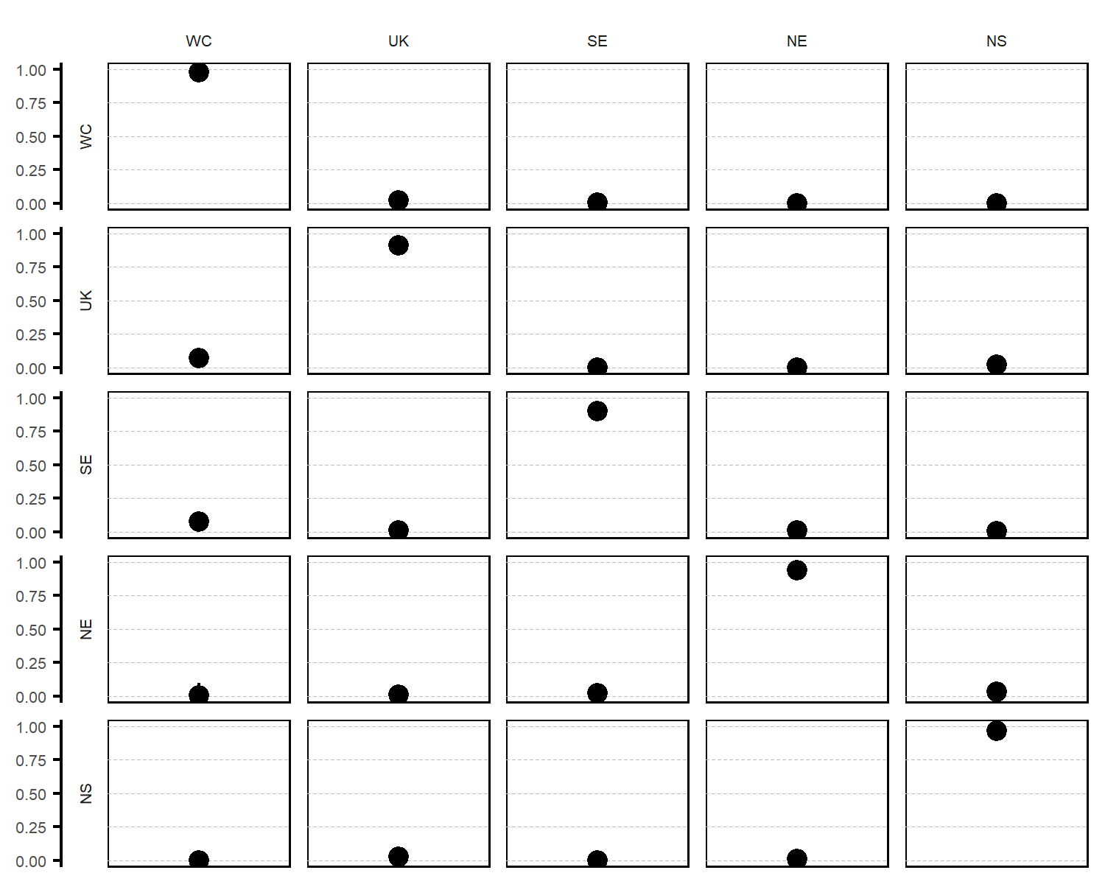

Figure 8 Migration rate estimates and their credible intervals from model 4 with no variability between seasons’ movements. Rows represent areas of departure and columns areas of arrival. Dotted lines represent the quantiles at 0, 0.25, 0.50, 0.75 and 1 for ease of reading.

Table 11 Detection rate estimates associated to each tagging campaign with lower (CI-), upper (CI+) 95% confidence intervals and standard errors (SE) for model 4.

|  |  |  |  |  |
| --- | --- | --- | --- | --- |
| Campaign | Rate | CI- | CI+ | SE |
| $${CEFAS}_{1970}$$ | 0.206 | 0.200 | 0.212 | 0.003 |
| $${CEFAS}_{2002}$$ | 0.017 | 0.012 | 0.024 | 0.003 |
| $${IFREMER}_{1976}$$ | 0.078 | 0.070 | 0.086 | 0.004 |
| $${IFREMER}_{2016}$$ | 0.078 | 0.062 | 0.099 | 0.009 |

## Results of model 1 obtained with buffered data

We tested the definition of spatial area by removing released and recovered fish which were closed to a border (see section XXX). The censored dataset was used with model 1 and no difference was observed between the full dataset and the censored dataset (Figure 9).

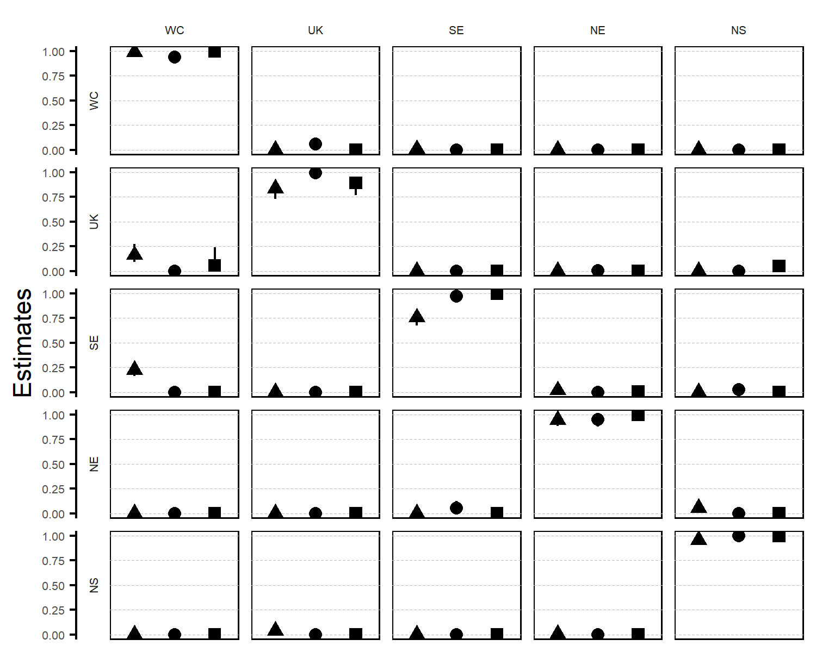

Figure 9 Migration rate estimates and their credible intervals from model 1 with buffered data. Rows represent areas of departure and columns areas of arrival. Dotted lines represent the quantiles at 0, 0.25, 0.50, 0.75 and 1 for ease of reading.

# References

Adlerstein, S.A., Rutherford, E.S., Claramunt, R.M., Clapp, D.F. & Clevenger, J.A. (2008). Seasonal movements of Chinook salmon in Lake Michigan based on tag recoveries from recreational fisheries and catch rates in gill-net assessments. *Transactions of the American Fisheries Society*, **137**, 736–750.

Allaya, H., FALEH, A.B., Rebaya, M., Zrelli, S., Hajjej, G., Hattour, A., Quignard, J.-P. & Trabelsi, M. (2016). Identification of Atlantic Chub Mackerel Scomber Colias Population through the Analysis of Body Shape in Tunisian Waters. *Cah. Biol. Mar*, **57**, 195–207.

Archambault, B., Le Pape, O., Baulier, L., Vermard, Y., Véron, M. & Rivot, E. (2016). Adult-Mediated Connectivity Affects Inferences on Population Dynamics and Stock Assessment of Nursery-Dependent Fish Populations. *Fisheries research*, **181**, 198–213.

Bacha, M., Jeyid, A.M., Jaafour, S., Yahyaoui, A., Diop, M. & Amara, R. (2016). Insights on stock structure of round sardinella Sardinella aurita off north-west Africa based on otolith shape analysis. *Journal of fish biology*, **89**, 2153–2166.

Begg, G.A., Friedland, K.D. & Pearce, J.B. (1999). Stock identification and its role in stock assessment and fisheries management: An overview. *Fisheries Research*, **43**, 1–8.

Begg, G.A. & Waldman, J.R. (1999). An holistic approach to fish stock identification. *Fisheries Research*, **43**, 35–44.

Burnham, K.P. & Anderson, D.R. (2003). *Model selection and multimodel inference: A practical information-theoretic approach*. Springer Science & Business Media.

Burt, G.J. & Millner, R.S. (2008). Movement of sole in the southern North Sea and eastern English Channel from tagging studies (19552004). *Science Series Technical Report*, **44**, 1–44.

Cadigan, N.G. & Brattey, J. (2006). Reporting and shedding rate estimates from tag-recovery experiments on Atlantic cod (Gadus morhua) in coastal Newfoundland. *Canadian Journal of Fisheries and Aquatic Sciences*, **63**, 1944–1958.

Cadigan, N.G. & Brattey, J. (2003). Semiparametric estimation of tag loss and reporting rates for tag-recovery experiments using exact time-at-liberty data. *Biometrics*, **59**, 869–876.

Cadrin, S.X., Karr, L.A. & Mariani, S. (2014). Stock Identification Methods: An Overview. *Stock Identification Methods (Second Edition)*, pp. 1–5. Elsevier.

Cadrin, S.X. & Secor, D.H. (2009). Accounting for spatial population structure in stock assessment: Past, present, and future. *The future of fisheries science in North America*, pp. 405–426. Springer.

Callicó Fortunato, R., Reguera Galán, A., García Alonso, I., Volpedo, A. & Benedito Durà, V. (2017). Environmental migratory patterns and stock identification of Mugil cephalus in the Spanish Mediterranean Sea, by means of otolith microchemistry. *Estuarine, Coastal and Shelf Science*, **188**, 174–180.

Carson, H.S., Cook, G.S., López-Duarte, P.C. & Levin, L.A. (2011). Evaluating the importance of demographic connectivity in a marine metapopulation. *Ecology*, **92**, 1972–1984.

Catalano, S.R., Whittington, I.D., Donnellan, S.C. & Gillanders, B.M. (2014). Parasites as Biological Tags to Assess Host Population Structure: Guidelines, Recent Genetic Advances and Comments on a Holistic Approach. *International Journal for Parasitology: Parasites and Wildlife*, **3**, 220–226.

Choquet, R., Lebreton, J.-D., Gimenez, O., Reboulet, A.-M. & Pradel, R. (2009). U-CARE: Utilities for performing goodness of fit tests and manipulating CAptureREcapture data. *Ecography*, **32**, 1071–1074.

Choquet, R. & Nogue, E. (2010). E-SURGE 1.7 user’s manual. *CEFE, Montpellier*.

Coggan, R.A. & Dando, P.R. (1988). Movements of juvenile Dover sole, Solea solea (L.), In the Tamar Estuary, South-western England. *Journal of Fish Biology*, **33**, 177–184.

Cuveliers, E.L., Larmuseau, M.H.D., Hellemans, B., Verherstraeten, S., Volckaert, F.A.M. & Maes, G.E. (2012). Multi-Marker Estimate of Genetic Connectivity of Sole (Solea Solea) in the North-East Atlantic Ocean. *Marine Biology*, **159**, 1239–1253.

Diopere, E., Vandamme, S.G., Hablützel, P.I., Cariani, A., Van Houdt, J., Rijnsdorp, A., Tinti, F., Consortium, F., Volckaert, F.A. & Maes, G.E. (2017). Seascape genetics of a flatfish reveals local selection under high levels of gene flow. *ICES Journal of Marine Science*, **75**, 675–689.

Dorel, D., Koutsikopoulos, C., Desaunay, Y. & Marchand, J. (1991). Seasonal distribution of young sole (Solea solea (L.)) In the nursery ground of the Bay of Vilaine (Northern Bay of Biscay). *Netherlands Journal of Sea Research*, **27**, 297–306.

Du Pontavice, H., Randon, M., Lehuta, S., Vermard, Y. & Savina-Rolland, M. (2018). Investigating spatial heterogeneity of von Bertalanffy growth parameters to inform the stock structuration of common sole, Solea solea, in the Eastern English Channel. *Fisheries Research*, **207**, 28–36.

Duriez, O., Saether, S.A., Ens, B.J., Choquet, R., Pradel, R., Lambeck, R.H.D. & Klaassen, M. (2009). Estimating survival and movements using both live and dead recoveries: A case study of oystercatchers confronted with habitat change. *Journal of Applied Ecology*, **46**, 144–153.

Erlandsson, J., Östman, Ö., Florin, A.-B. & Pekcan-Hekim, Z. (2017). Spatial structure of body size of European flounder (Platichthys flesus L.) In the Baltic Sea. *Fisheries Research*, **189**, 1–9.

Fernández-Chacón, A., Moland, E., Espeland, S.H., Kleiven, A.R. & Olsen, E.M. (2016). Causes of mortality in depleted populations of Atlantic cod estimated from multi-event modelling of markRecapture and recovery data. *Canadian journal of fisheries and aquatic sciences*, **74**, 116–126.

Fogarty, M.J. & Botsford, L.W. (2007). Population connectivity and spatial management of marine fisheries. *Oceanography*, **20**, 112–123.

Frisk, M.G., Jordaan, A. & Miller, T.J. (2014). Moving beyond the current paradigm in marine population connectivity: Are adults the missing link? *Fish and Fisheries*, **15**, 242–254.

Gauthier, G. & Lebreton, J.-D. (2008). Analysis of band-recovery data in a multistate capture-recapture framework. *Canadian Journal of Statistics*, **36**, 59–73.

Gillanders, B.M., Ferrell, D.J. & Andrew, N.L. (2001). Estimates of movement and life-history parameters of yellowtail kingfish (Seriola lalandi): How useful are data from a cooperative tagging programme? *Marine and Freshwater Research*, **52**, 179–192.

Goethel, D.R. & Berger, A.M. (2017). Accounting for Spatial Complexities in the Calculation of Biological Reference Points: Effects of Misdiagnosing Population Structure for Stock Status Indicators. *Canadian Journal of Fisheries and Aquatic Sciences*, **74**, 1878–1894.

Goethel, D.R., Quinn, T.J. & Cadrin, S.X. (2011). Incorporating Spatial Structure in Stock Assessment: Movement Modeling in Marine Fish Population Dynamics. *Reviews in Fisheries Science*, **19**, 119–136.

Griffiths, C.A., Patterson, T.A., Blanchard, J.L., Righton, D.A., Wright, S.R., Pitchford, J.W. & Blackwell, P.G. (2018). Scaling marine fish movement behavior from individuals to populations. *Ecology and evolution*, **8**, 7031–7043.

Hanselman, D.H., Heifetz, J., Echave, K.B. & Dressel, S.C. (2014). Move it or lose it: Movement and mortality of sablefish tagged in Alaska. *Canadian Journal of Fisheries and Aquatic Sciences*, **72**, 238–251.

Hawkins, S.J., Bohn, K., Sims, D.W., Ribeiro, P., Faria, J., Presa, P., Pita, A., Martins, G.M., Neto, A.I., Burrows, M.T. & Genner, M.J. (2016). Fisheries stocks from an ecological perspective: Disentangling ecological connectivity from genetic interchange. *Fisheries Research*, **179**, 333–341.

Heino, M., Kaitala, V., Ranta, E. & Lindström, J. (1997). Synchronous dynamics and rates of extinction in spatially structured populations. *Proceedings of the Royal Society of London B: Biological Sciences*, **264**, 481–486.

Henny, C.J. & Burnham, K.P. (1976). A reward band study of mallards to estimate band reporting rates. *The Journal of Wildlife Management*, 1–14.

Hilborn, R. (1990). Determination of fish movement patterns from tag recoveries using maximum likelihood estimators. *Canadian Journal of Fisheries and Aquatic Sciences*, **47**, 635–643.

Horwood, J. (1993). The Bristol Channel sole (Solea solea (L.)): A fisheries case study. *Advances in Marine Biology*, pp. 215–367. Elsevier.

Howe, A.B. & Coates, P.G. (1975). Winter flounder movements, growth, and mortality off Massachusetts. *Transactions of the American Fisheries Society*, **104**, 13–29.

Hüssy, K., Mosegaard, H., Albertsen, C.M., Nielsen, E.E., Hemmer-Hansen, J. & Eero, M. (2016). Evaluation of Otolith Shape as a Tool for Stock Discrimination in Marine Fishes Using Baltic Sea Cod as a Case Study. *Fisheries Research*, **174**, 210–218.

ICES. (2017). *Report of the Working Group on the Assessment of Demersal Stocks in the North 685 Sea and Skagerrak.* ICES HQ. ICES CM.

Izzo, C., Ward, T.M., Ivey, A.R., Suthers, I.M., Stewart, J., Sexton, S.C. & Gillanders, B.M. (2017). Integrated approach to determining stock structure: Implications for fisheries management of sardine, Sardinops sagax, in Australian waters. *Reviews in Fish Biology and Fisheries*, **27**, 267–284.

Jasonowicz, A.J., Goetz, F.W., Goetz, G.W. & Nichols, K.M. (2016). Love the One You’re with: Genomic Evidence of Panmixia in the Sablefish (Anoplopoma Fimbria). *Canadian Journal of Fisheries and Aquatic Sciences*, **74**, 377–387.

Kerr, L.A., Hintzen, N.T., Cadrin, S.X., Clausen, L.W., Dickey-Collas, M., Goethel, D.R., Hatfield, E.M.C., Kritzer, J.P. & Nash, R.D.M. (2017). Lessons learned from practical approaches to reconcile mismatches between biological population structure and stock units of marine fish. *ICES Journal of Marine Science*, **74**, 1708–1722.

Kutkuhn, J.H. (1981). Stock definition as a necessary basis for cooperative management of Great Lakes fish resources. *Canadian Journal of Fisheries and Aquatic Sciences*, **38**, 1476–1478.

Laconcha, U., Iriondo, M., Arrizabalaga, H., Manzano, C., Markaide, P., Montes, I., Zarraonaindia, I., Velado, I., Bilbao, E., Goñi, N., Santiago, J., Domingo, A., Karakulak, S., Oray, I. & Estonba, A. (2015). New Nuclear SNP Markers Unravel the Genetic Structure and Effective Population Size of Albacore Tuna (Thunnus alalunga). *PLOS ONE*, **10**, e0128247.

Le Bris, A., Fisher, J.A., Murphy, H.M., Galbraith, P.S., Castonguay, M., Loher, T., Robert, D. & Grabowski, H.e.J. (2017). Migration Patterns and Putative Spawning Habitats of Atlantic Halibut (Hippoglossus Hippoglossus) in the Gulf of St. Lawrence Revealed by Geolocation of Pop-up Satellite Archival Tags. *ICES Journal of Marine Science*, **75**, 135–147.

Le Pape, O. & Bonhommeau, S. (2015). The food limitation hypothesis for juvenile marine fish. *Fish and Fisheries*, **16**, 373–398.

Le Pape, O. & Cognez, N. (2016). The range of juvenile movements of estuarine and coastal nursery dependent flatfishes: Estimation from a meta-analytical approach. *Journal of Sea Research*, **107**, 43–55.

Lebreton, J.-D., Almeras, T. & Pradel, R. (1999). Competing events, mixtures of information and multistratum recapture models. *Bird Study*, **46**, S39–S46.

MacKenzie, K. & Abaunza, P. (2014). Parasites as Biological Tags. *Stock Identification Methods (Second Edition)*, pp. 185–203. Elsevier.

Mahe, K., Oudard, C., Mille, T., Keating, J., Gonçalves, P., Clausen, L.W., Petursdottir, G., Rasmussen, H., Meland, E. & Mullins, E. (2016). Identifying Blue Whiting (Micromesistius Poutassou) Stock Structure in the Northeast Atlantic by Otolith Shape Analysis. *Canadian journal of fisheries and aquatic sciences*, **73**, 1363–1371.

Martinez, E., Buonaccorsi, V., Hyde, J.R. & Aguilar, A. (2017). Population Genomics Reveals High Gene Flow in Grass Rockfish (Sebastes Rastrelliger). *Marine genomics*, **33**, 57–63.

McGarvey, R. & Feenstra, J.E. (2002). Estimating rates of fish movement from tag recoveries: Conditioning by recapture. *Canadian Journal of Fisheries and Aquatic Sciences*, **59**, 1054–1064.

Methot, R.D. (2009). Stock synthesis (ver. 3.02 C). *NOAA Fish. Tool*.

Milano, I., Babbucci, M., Cariani, A., Atanassova, M., Bekkevold, D., Carvalho, G.R., Espiñeira, M., Fiorentino, F., Garofalo, G. & Geffen, A.J. (2014). Outlier SNP Markers Reveal Fine-Scale Genetic Structuring across E Uropean Hake Populations (M Erluccius Merluccius). *Molecular Ecology*, **23**, 118–135.

Moreira, C., Froufe, E., Sial, A.N., Caeiro, A., Vaz-Pires, P. & Correia, A.T. (2018). Population Structure of the Blue Jack Mackerel (Trachurus Picturatus) in the NE Atlantic Inferred from Otolith Microchemistry. *Fisheries Research*, **197**, 113–122.

Östman, Ö., Olsson, J., Dannewitz, J., Palm, S. & Florin, A.-B. (2017). Inferring spatial structure from population genetics and spatial synchrony in demography of Baltic Sea fishes: Implications for management. *Fish and Fisheries*, **18**, 324–339.

Palmer, S.C.F., Coulon, A. & Travis, J.M.J. (2014). Inter-individual variability in dispersal behaviours impacts connectivity estimates. *Oikos*, **123**, 923–932.

Patterson III, W.F., Watterson, J.C., Shipp, R.L. & Cowan Jr, J.H. (2001). Movement of tagged red snapper in the northern Gulf of Mexico. *Transactions of the American Fisheries Society*, **130**, 533–545.

Pita, A., Casey, J., Hawkins, S.J., Villarreal, M.R., Gutiérrez, M.-J., Cabral, H., Carocci, F., Abaunza, P., Pascual, S. & Presa, P. (2016). Conceptual and practical advances in fish stock delineation. *Fisheries Research*, **173**, 185–193.

Porch, C., Kleiber, P., Turner, S., Sibert, J., Bailey, R. & Cort, J.L. (1998). The efficacy of VPA models in the presence of complicated movement patterns. *COLLECTIVE VOLUME OF SCIENTIFIC PAPERS-INTERNATIONAL COMMISSION FOR THE CONSERVATION OF ATLANTIC TUNAS*, **50**, 591–622.

Pradel, R. (2005). Multievent: An extension of multistate captureRecapture models to uncertain states. *Biometrics*, **61**, 442–447.

Pradel, R., Wintrebert, C.M. & Gimenez, O. (2003). A proposal for a goodness-of-fit test to the Arnason-Schwarz multisite capture-recapture model. *Biometrics*, **59**, 43–53.

Punt, A.E. & Restrepo, V.R. (1995). Some effects of ignoring mixing when managing fish populations subject to limited mixing. *ICES Long-term Management Measures Working Group WP1*.

Randon, M., Réveillac, E., Rivot, E., Pontavice, H.D. & Pape, O.L. (2018). Could we consider a single stock when spatial sub-units present lasting patterns in growth and asynchrony in cohort densities? A flatfish case study. *Journal of Sea Research*.

Régnier, T., Augley, J., Devalla, S., Robinson, C.D., Wright, P.J. & Neat, F.C. (2017). Otolith chemistry reveals seamount fidelity in a deepwater fish. *Deep Sea Research Part I: Oceanographic Research Papers*, **121**, 183–189.

Riou, P., Pape, O.L. & Rogers, S.I. (2001). Contribution respective de differentes nourriceries cotieres aux populations adultes de sole et de plie: Etude par couplage de modeles lineaires generalises avec un systeme d information geographique. *Aquatic Living Resources*, **2**, 125–135.

Rochette, S. (2011). *Effet des perturbations anthropiques sur la survie des juvéniles de poissons marins dans les nourriceries et conséquences sur les renouvellement des populations.: Application au stock de sole commune (Solea solea) en Manche Est*. PhD Thesis thesis, Rennes, Agrocampus Ouest.

Rochette, S., Huret, M., Rivot, E. & Pape, O.L. (2012). Coupling hydrodynamic and individual-based models to simulate long-term larval supply to coastal nursery areas. *Fisheries Oceanography*, **21**, 229–242.

Rochette, S., Le Pape, O., Vigneau, J. & Rivot, E. (2013). A hierarchical Bayesian model for embedding larval drift and habitat models in integrated life cycles for exploited fish. *Ecological Applications*, **23**, 1659–1676.

Rochette, S., Rivot, E., Morin, J., Mackinson, S., Riou, P. & Le Pape, O. (2010). Effect of nursery habitat degradation on flatfish population: Application to Solea solea in the Eastern Channel (Western Europe). *Journal of sea Research*, **64**, 34–44.

Rogers, L.A., Storvik, G.O., Knutsen, H., Olsen, E.M. & Stenseth, N.C. (2017). Fine-Scale Population Dynamics in a Marine Fish Species Inferred from Dynamic State-Space Models. *Journal of Animal Ecology*, **86**, 888–898.

Selkoe, K.A., Henzler, C.M. & Gaines, S.D. (2008). Seascape genetics and the spatial ecology of marine populations. *Fish and fisheries*, **9**, 363–377.

Sley, A., Jawad, L.A., Hajjej, G., Jarboui, O. & Bouain, A. (2016). Morphometric and Meristic Characters of Blue Runner Caranx Crysos and False Scad Caranx Rhonchus (Pisces: Carangidae) from the Gulf of Gabes, Tunisia, Eastern Mediterranean. *Cah. Biol. Mar*, **57**, 309–316.

Smedbol, R.K. & Stephenson, R. (2001). The importance of managing within-species diversity in cod and herring fisheries of the north-western Atlantic. *Journal of Fish Biology*, **59**, 109–128.

Smith, P.J., Jamieson, A. & Birley, A.J. (1990). Electrophoretic studies and the stock concept in marine teleosts. *ICES Journal of Marine Science*, **47**, 231–245.

Stephenson, R.L. (1999). Stock complexity in fisheries management: A perspective of emerging issues related to population sub-units. *Fisheries Research*, **43**, 247–249.

Tanner, S.E., Reis-Santos, P. & Cabral, H.N. (2016). Otolith Chemistry in Stock Delineation: A Brief Overview, Current Challenges and Future Prospects. *Fisheries research*, **173**, 206–213.

Ulrich, C., Hemmer-Hansen, J., Boje, J., Christensen, A., Hüssy, K., Sun, H. & Clausen, L.W. (2017). Variability and connectivity of plaice populations from the Eastern North Sea to the Baltic Sea, part II. Biological evidence of population mixing. *Journal of sea research*, **120**, 13–23.

Ying, Y., Chen, Y., Lin, L. & Gao, T. (2011). Risks of Ignoring Fish Population Spatial Structure in Fisheries Management. *Canadian Journal of Fisheries and Aquatic Sciences*, **68**, 2101–2120.