

**Bashar Alhafni**

**Assignment #6**

**Objective:**

Develop a matrix equation for minimizing the cost in image registration (without shear) when the correspondences between the points in two images I1 and I2 are known.

**Solution:**

After taking the partial derivatives for the cost function with respect to a, b, t1 and t2, we will end up with the following:

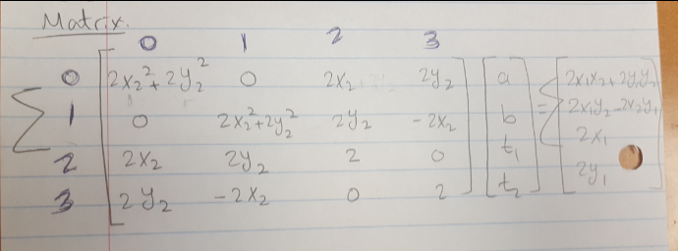

**Testing the above results:**

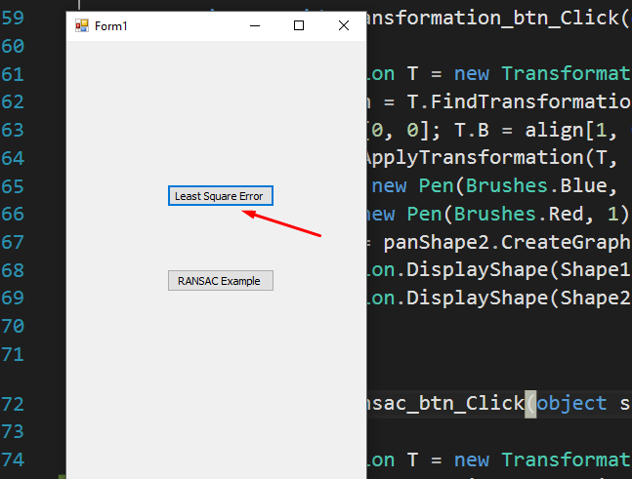

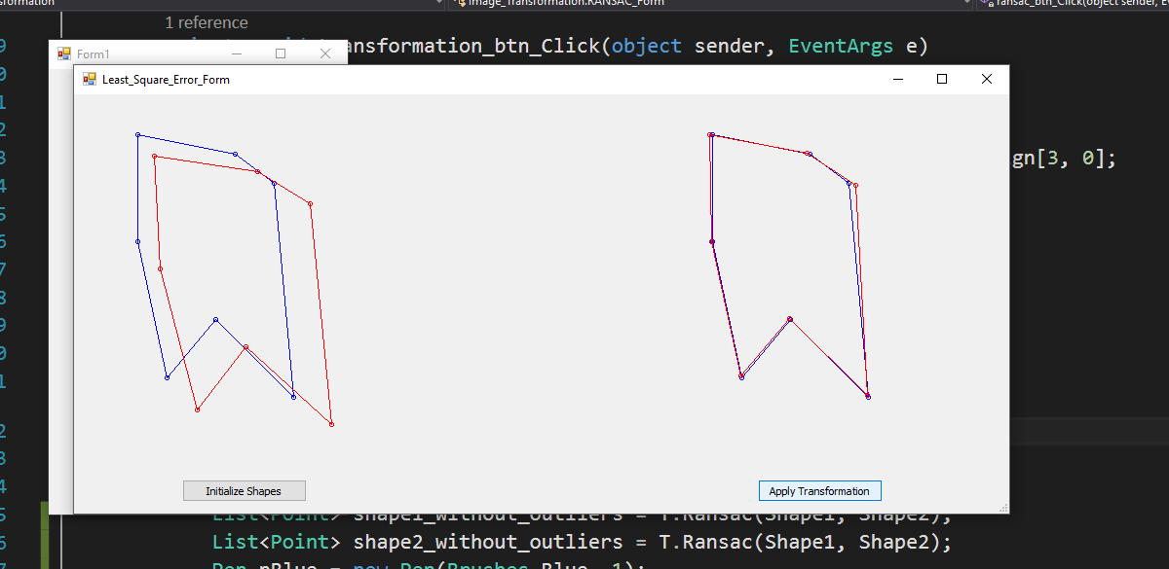

**Part B (RANSAC):**

