

**Bashar Alhafni**

**Assignment #2**

**Objective:**

**Part 1:**

Implement the Low Pass, High Pass, Sharpening, Sobel, and Laplacian Filters. The user may enter the values of the filters by a GUI.

**Screen shots:**

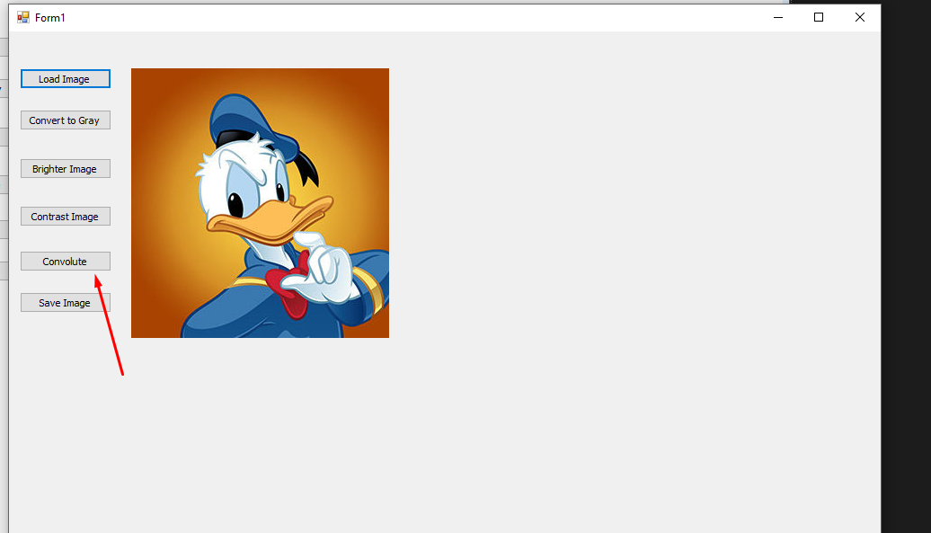

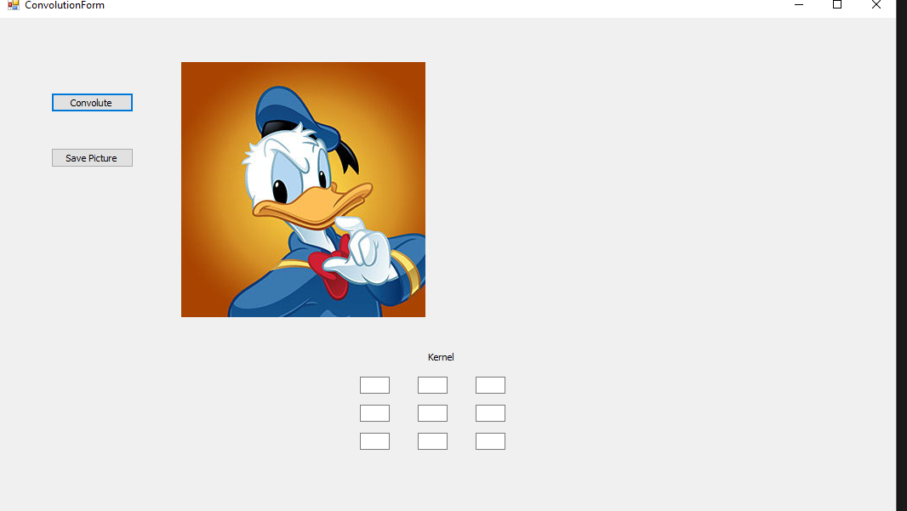

**Low Pass Filter:**

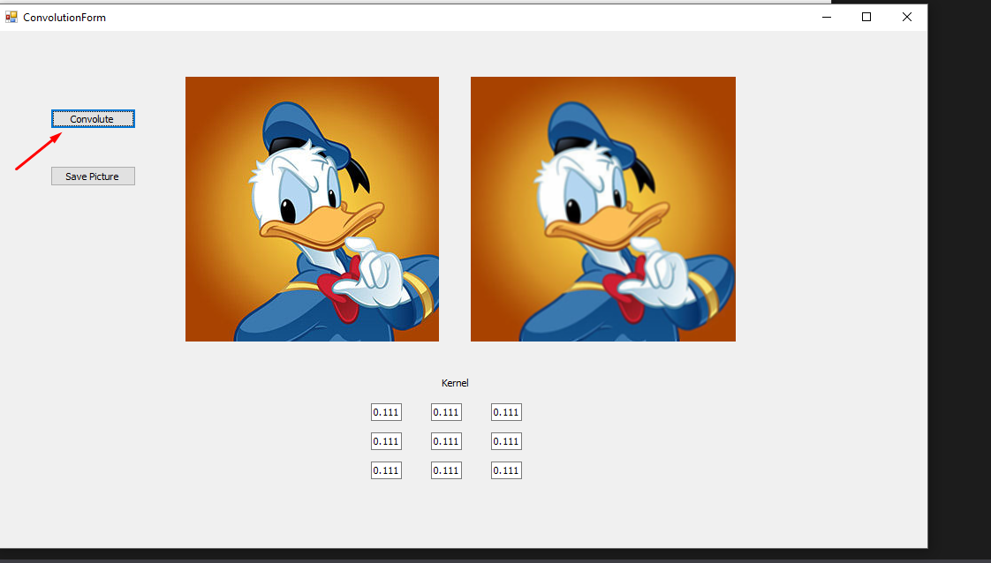

**High Pass Filter:**

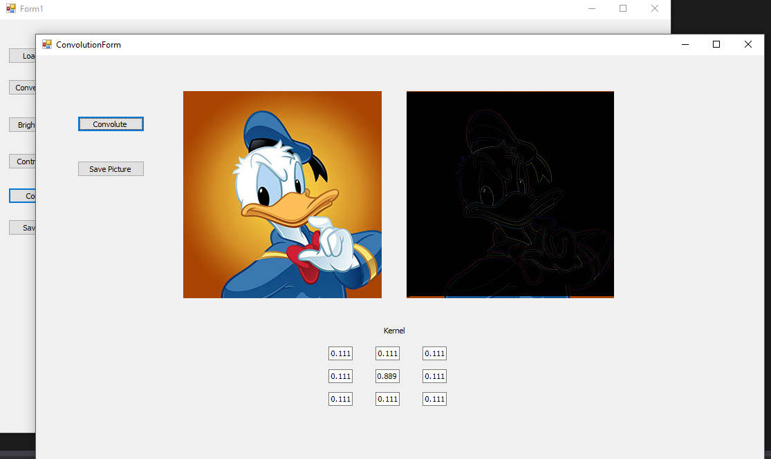

**Sharpening Filter:**

f = 0.5

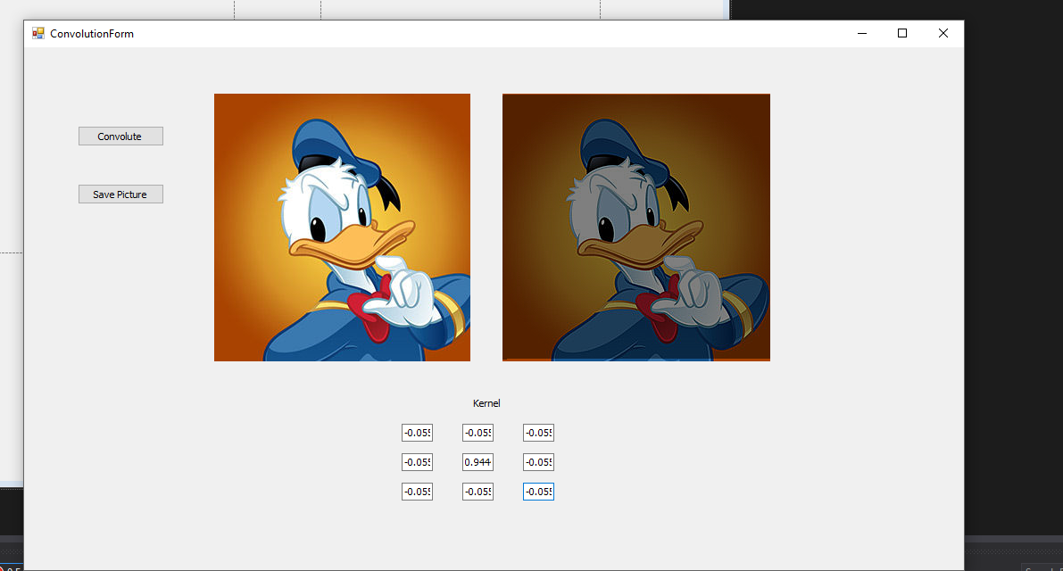

**Sobel Filter:**

**In the X direction:**

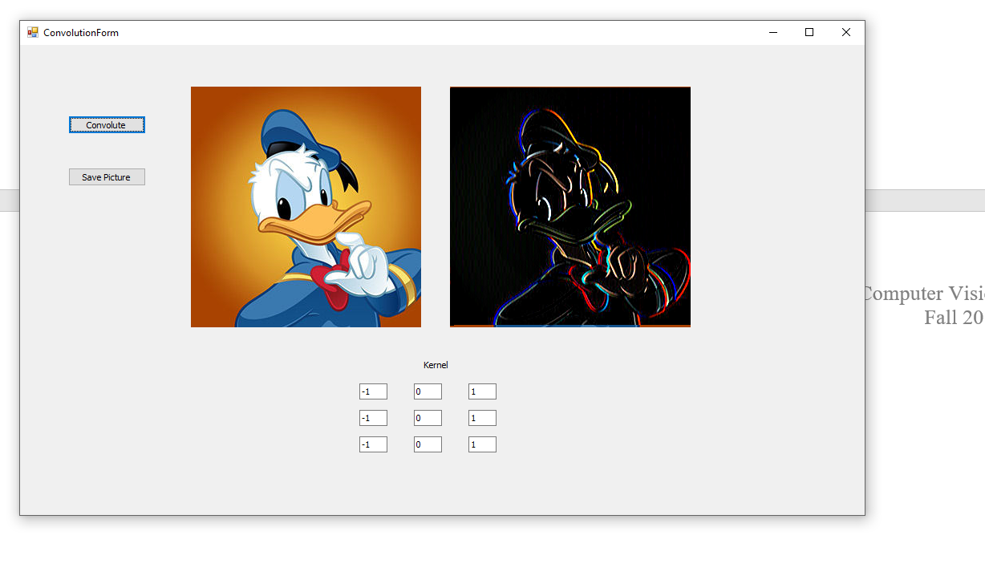

**In the Y direction:**

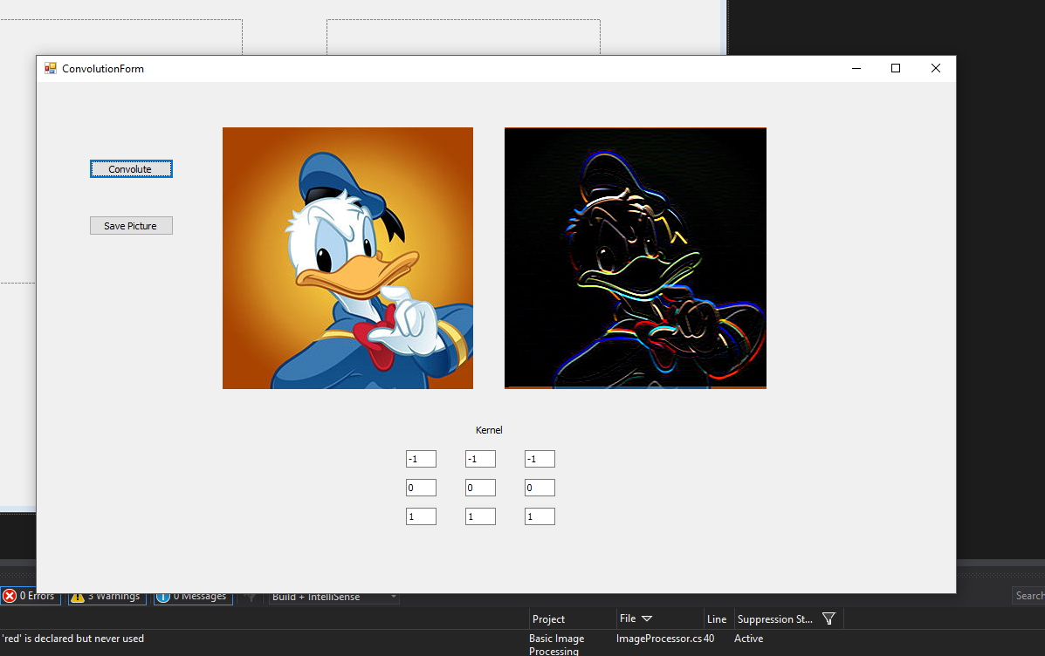

**Laplacian Filter:**

