

**Bashar Alhafni**

**Assignment #1**

**Objective:**

**Part 1:**

Creating a C# program that I will read an Image and perform the following:

1) Convert the image to gray scale

2) Increase the brightness of the image

3) Increase the contrast of the image

4) Save the image

**Part 2:**

Create a simple python class and demonstrate your knowledge with processing files

**Screen shots:**

**Gray Scale:**

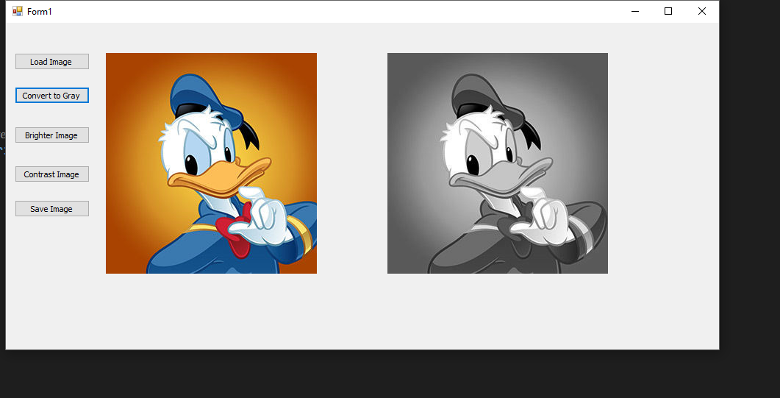

**Brighter Image:**

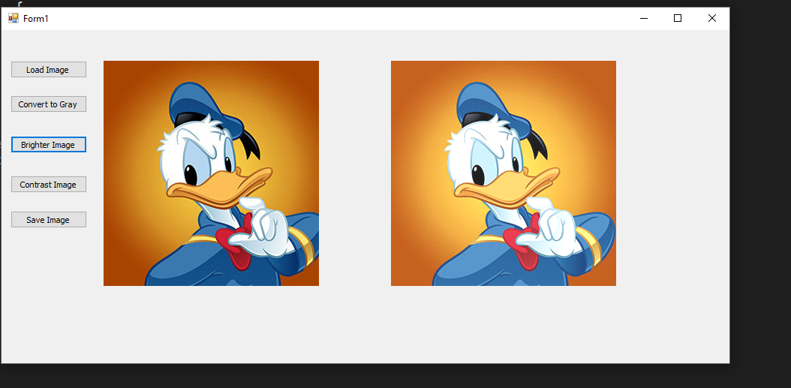

**Contrast:**

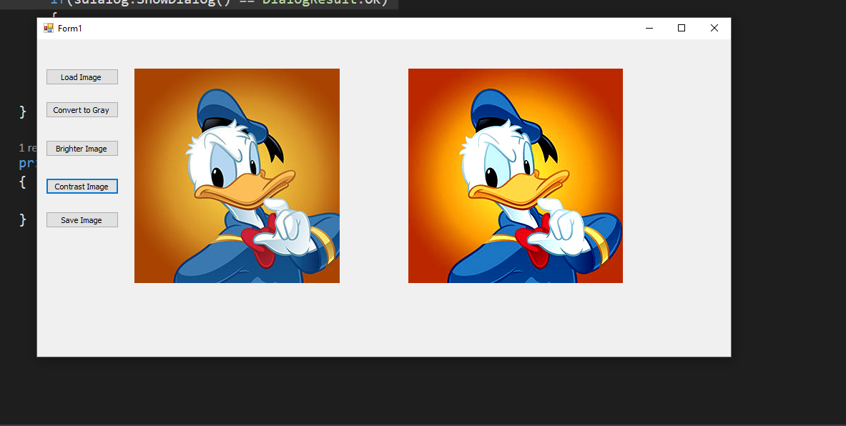

**Part 2:**

I created a python class called Student and a text file that will have information about group of students and their grades in 2 exams. I am processing this info and output the final grade of the student depending on these 2 score.

**Screen shots:**

