

**Bashar Alhafni**

**Assignment #1**

**Objective:**

1. Creating a program in C# that would take the first name, last name, id, test 1 and test 2 of a student using a GUI. The program should be able to compute the grade depending on scores that was provided.
2. Create an Employee Example that has fields of FirstName, LastName, EmpID, HoursWorked, PayRate Write the functions in the Employee class to compute pay and overtime pay. Overtime is 1.5 times the number of hours worked above 40.

**Explanation:**

**Part 1:**

I created the Student.cs class that would have all the required fields and their properties including, FirstName, LastName, ID, Test 1 and Test 2. Also, the Student class has a function computeGrade() that will return a string based on the average of the grades. I calculated the average in a way that, test 1 will be given %60 of the grade and test 2 will be given %40. I also added a bool function called correct() that will check if the input provided for test 1 and test 2 is greater than 100 or less than 0. In the Form1.cs, I added a method isEmptyTextBox() to check if the user didn’t provide any information. I also used the KeyPress event for the text box so that the user will be allowed to input only numbers and one decimal place.

If all the information was provided correctly, the grade and the student’s will be displayed on a message box when the button is clicked.

**Screenshots:**

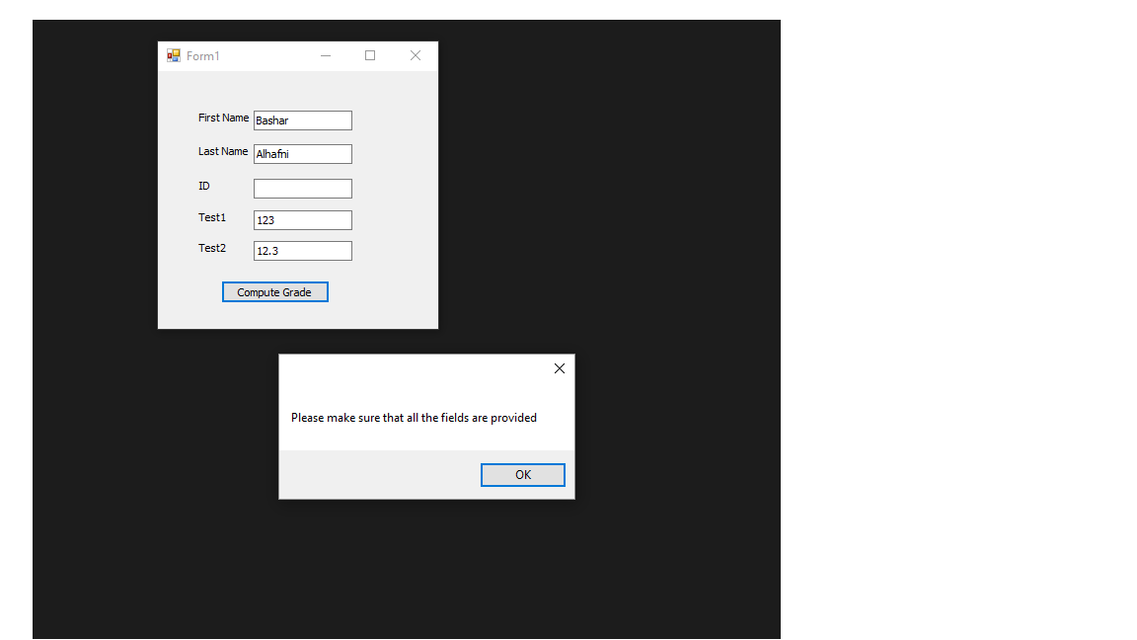

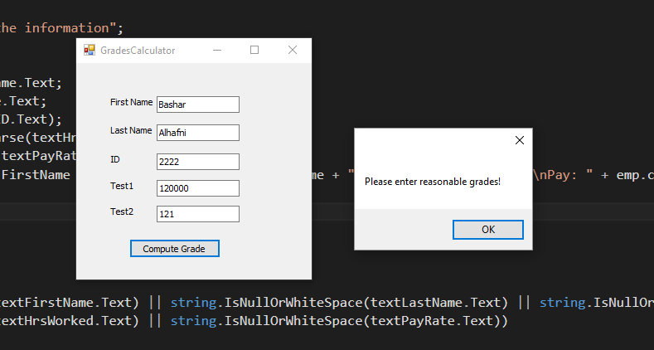

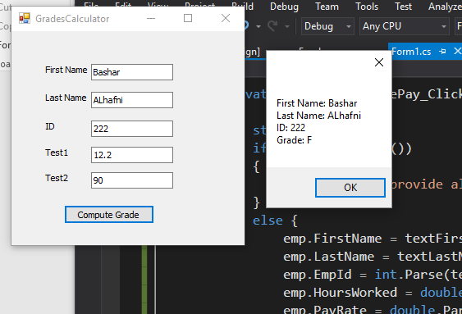

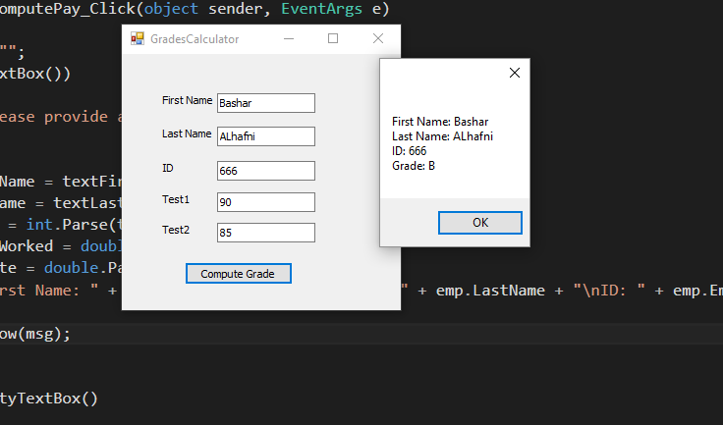

**Part 2:**

I created the Employee.cs class with all the required fields and their properties including: firstName, lastName, empId, hoursWorked and payRate. The class also has two functions, computePay() and computeOverTimePay(), to compute the gross pay and the overtime pay as well.

In the GUI, I handled the possible errors in the same way they were handled in the first part.

When the button is clicked, the normal and the overtime pay would be displayed in a message box.

**Screenshots:**

