Software Requirements Specification

**Best File Search**

Fall 2019 CPSC 362-07

Hyo Sup Cho, Hyo Seung Cho, Balwinder Singh, Haowen Yong

Professor: Dr. Lidia Morrison

Department of Computer Science

California State University, Fullerton

**Table of Contents**

1. Introduction

1.1 Purpose 2

1.2 Scope of the Problems 2

1.3 Intended Users 2

1. Description

2.1 User Objectives 3

2.2 Product Functions 3

2.3 Operating Environment 3

2.4 User Characteristics 3

2.5 Design and Implementation Constraints 4

2.6 Assumptions 4

1. Functional Requirements 4
2. Interface Requirements

4.1 GUI 6

4.2 Hardware Interfaces 7

4.3 Software Interfaces 7

1. SWOT

5.1 Strengths 7

5.2 Weaknesses 8

5.3 Opportunities 8

5.4 Threats 8

1. UML Diagrams

6.1 Use Case Diagram 9

1. User tutorial 10
2. **Introduction**

**1.1 Purpose**

This document offers a description of the software requirements of our CPSC 362 group project. The document will explain the general purpose of our Windows application, Best File Search, along with user information, targeted audience, and other useful information.

**1.2 Scope of the Problem**

As technology advanced rapidly in the past few decades, computers have become more powerful while its price has grown to be more affordable. These powerful machines we have nowadays can contain terabytes of data if we would like. While for the average users, 1 TB may seem like a lot of space. For the professionals who work in certain fields, they can actually use up to tens or even hundreds of terabytes of data. With that amount of data stored on their computers, it may be difficult to find the one file that is needed at the moment sometimes. That is where our software comes in.

With our software, the user can simply type in the keyword they are looking for and our software will return a list of documents containing that keyword, therefore making it easier for the users to finish whatever job they are trying to do.

**1.3 Intended Users**

At the current moment, the intended audience only includes Professor Lidia Morrison, the members of our group, and other students who are enrolled in our section of CPSC 362. This is due to the fact that our software has only been under development for 3 months and it still has a lot to be improved. With potential future development, our application could be deployed into the professional field and be used by workers in fields that require working with large amount of documents.

1. **Description**

**2.1 User Objectives**

Best File Search is a mobile app that focuses on providing workers in particular professions a tool to quickly find the file they are looking for simply by providing a keyword. This helps reduce the time it takes to look for specific documents when the user has to deal with a large amount of them and improves their work efficiency.

**2.2 Product Functions**

Best File Search is a Windows application that focuses on helping the user improve work efficiency by reducing the time it takes them to find needed files. With this app, users can quickly extract the files they need and complete their tasks in a timely manner. After typing in the keyword, the application will look through all the drives on the computer and return a list of files that contain the keyword either in the title or the content of the file. The user can click on the file from the list returned and open it from there. The keyword will be highlighted within the files so the user can quickly go through the files to find the part they are looking for.

**2.3 Operating Environment**

Best File Search is written in python. We wrote and tested it in Windows 10. The target operating system is only Windows at the moment. As we improve the application in the future, support for MacOS and Linux distributions will be added.

**2.4 User Characteristics**

Best File Search is simply a file search application just like its name suggested. It does not have any restrictions. Anybody with a computer can use it. The interface is really simple, so no special skills are required. As long as one knows how to read and type, they will be able to use our application with ease.

**2.5 Design and Implementation Constraints**

As mentioned in previous sections, at the current moment, our application is only compatible with Windows 10. We have not done any testing on other Operating Systems or other versions of Windows. Users are required to have Windows 10 as their operating system in order to use our application. Best File Search is not meant to be used as a mobile application, so users will not be able to run our application on iOS, Android or any other mobile operating systems. Since our application is meant for computers, keyboard and mouse are required as the users need these devices to input keywords and navigate the interface.

**2.6 Assumptions**

This SRS assumes that:

* Users have basic knowledge in using Windows 10.
* Users understand English.
* Users are able to type with a keyboard.

1. **Functional Requirements**

**3.1 The application shall have a desktop icon**

After the user has installed the application on their system, there will be a desktop icon for the user to click on when the user needs to use the application.

**3.2 The application shall have an input box**

There needs to be a section for the user to input the keyword they are looking for. The application will use this keyword as the criteria when looking through files to decide which to return and which to leave out.

**3.3 There shall be a search button**

After the user has entered the keyword they intend to look for, they can click on a button to start the search. If the button is not clicked, the search process will not start.

**3.4 The application shall display the search results**

After the application has found all the files containing the user specified keyword, it will print out the names of all of them for the user to see.

**3.5 The user can click on the search results to open files**

The user can simply double click the file he or she would like to open from all the search results returned by the application and then the file will be opened right there for the user to view.

**3.6 The application shall look for Word, Power Point, Excel, PDF and txt files\**

The application will look through files with the following extensions: .docx, .pptx, .xlsx, .pdf, and .txt.

**3.7 The user specified keyword shall be highlighted in the search results**

When the user clicks open a file from the list of search results, they will find that the keyword they wanted to find is highlighted in the file. This is to make it easier for the user to find the part of the file they need as fast as possible.

**3.8 The user shall be able to clear search results**

Aside from the search button, there will be another button for the user to click on. This button will be used to clear search results from the last search the user did. Once the button has been clicked on, the box that contains the old search results will be empty again waiting to display the results from a new search.

**3.9 Entering a new keyword and pressing the search button will start another search**

If the user would like, he or she can simply enter a new keyword in the input box and press the search button to start a new search process. This is intended for when the user are looking for multiple keywords. By entering a new keyword and pressing search, it saves the user time from having to clear search results.

1. **Interface Requirements**

**4.1 GUI**

When the user double clicks the icon on their desktop, this interface will be displayed to the user.

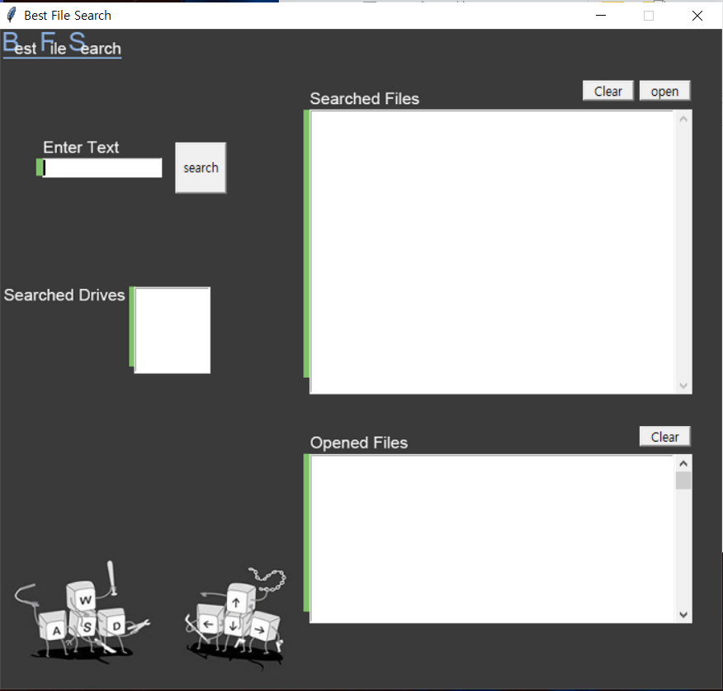

The user can type in a keyword and start searching as soon as the interface pops up on their screen. Like any other Windows applications, Best File Search will have the standard minimize, maximize and close buttons on the top right corner of the interface. Once the interface has been opened, the user will be able to see everything they need to see. All the fields, including the search box, the search result box, search button, drives the application has looked through, etc. will all be displayed on the screen.

**4.2 Hardware Interfaces**

This application is expected to function optimally with a desktop PC, including laptops. This application does not require any sound devices such as microphone or speakers. It only requires a mouse and keyboard for navigation purposes. The type of mouse and keyboard should have absolutely no effects on the user experience.

The application does not require a minimum CPU speed or RAM size. However, the application is expected to run better on PCs with more RAM and a faster CPU. There will be obvious differences in search performances depending on the specs of the PC the application is running on.

**4.3 Software Interfaces**

The software interface of this application is already stated in the “Operating Environment” section above (Section 2.3, page 3).

1. **SWOT of Best File Search**

**5.1 Strengths**

S1: Our application has a really simple interface. The user doesn’t need to be a computer expert to use our application.

S2: The software tools and techniques required for developing this application is readily available and is within our reach.

S3: This application required no financial support as it is only a project for a college course.

S4: This application is simply a file search program. The expected functionality is easily realized and all the functional requirements will be met by the deadline.

**5.2 Weaknesses:**

W1: This is a very primitive version of this application. It can certainly be improved in the future. There may be functionalities that we have missed and could be added in the future.

W2: The algorithm of our application can be improved since we believe that we can make the file search process faster.

W3: This application has a limit of the file types it searches. For certain file types, our application will not find them or highlight keywords within them.

**5.3 Opportunities:**

O1: The majority of people use a computer in today’s society. Many professions require dealing with large amount of files. Our application provides a mean for these professions to organize their files and be able to retrieve whatever is needed in the shortest amount of time.

O2: This project created an avenue for our group members to learn new technology as well as new programming methods. We were able to gain more useful experience through this project.

**5.4 Threats**

T1: This project is part of the curriculum of the CPSC 362 course, so there are other groups who are also developing a file search engine. This is an obvious threat as we don’t know how the other groups are approaching this project.

T2: File search engines already exist in the market. Windows, the operating system we intended our application for already has a built in file search engine. This is a threat because it will be difficult for our application to be recognized and accepted by consumers.

1. **UML Diagrams**

**6.1 Use Case Diagram**

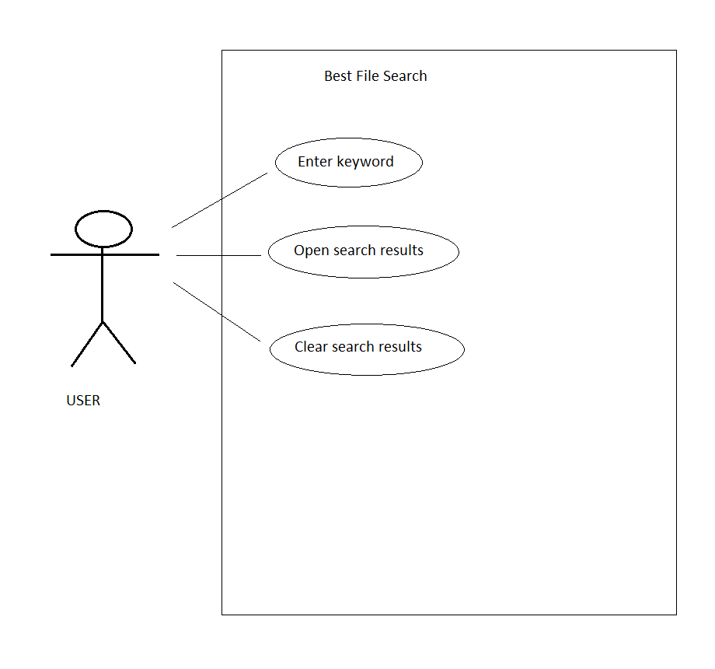

**====================================================================**

**This following section of the document provides an understanding of how to use the Best File Search application.**



**“Enter Text” and Search**

* The user can type in the keyword or the name of a document in the “Enter Text” box. Clicking the search button will begin the search process.

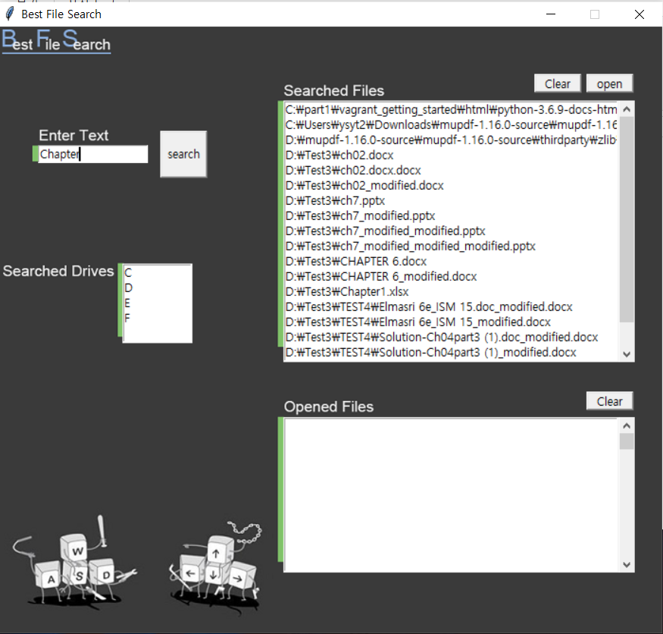

**“Searched Drives”**

* After the search is completed, “Searched Drives” displays the drives the program has searched through. For example, if a computer has a C drive and a D drive, the box will display “C D”.

**“Searched Files”**

* “Searched Files” displays the files that our application has found in the drives displayed in “Searched Drives”. These files will either contain the entered keyword in the title or in its content.
* By selecting a file and clicking the “open” button, the user can open the file right there through our application. The user can also do this by simply double clicking the file they would like to open.
* The “clear” button clears the search results in case when the user would like to begin a new search. The user doesn’t have to clear search results before beginning a new search. This is added so we can accommodate the different preferences of our users.

**“Opened Files”**

* This box displays the files that the user has opened in the search results. This is to save the user the trouble to look through all the search results again when there are too many search results returned.
* The user can clear this box by pressing the “clear” button.

**Appendix B: References and Tools Used**

**References:**

Lecture Notes and Slides by Lidia Morrison

Sample SRS provided by Lidia Morrison

Python-pptx 0.6.18 Documentation

Python-docx 0.8.10 Documentation

PyMuPDF documentation

**Tools Used:**

The following tools were used for developing this SRS and drawing all diagrams:

* Google Doc
* MS Paint
* Microsoft Word