**ID2209 – Distributed Artificial Intelligence and Intelligent Agents**

**Assignment 3 – Coordination and Utility**

***Group 7***

Gangalic Catalin

Guilherme Ramalho

**November, 2019**

For this assignment we had 2 different tasks. First task consisted in creation of a program that is going to place N-Queens on a NxN chessboard such that they can’t attack each other directly. We had to implement this using FIPA protocol. The second task consisted in a simulation of a concert where we have several scenes where people would like to go and party. These scenes are having 6 various parameters which define qualities like light, sound, type of music. The guests should be able to choose among these scenes based on their preference and own wishes for each of these qualities.

**Species**

Guest

The guest will wander through the simulation till he receives some information about a possible concert starting including all the above discussed qualities and their value. He will then choose based on his preferences the best place to go and join the concert there. Then he’ll start dancing around the scene.

Scene

Scenes will be placed somewhere on the map and offer various types of concerts. Once they decided to have a concert, they’ll spread the information using the FIPA protocol to all the guests and then start the concert, while the guests are coming to join. After a certain amount of time, they stop the concert and start a new one with different qualities and maybe even different style. This cycle continues indefinitely.

Queen

Queens from the task #1 are talking with each other and trying to find a way such that they don’t step on each other diagonally, vertically and horizontally. They try some places and talk with their predecessor and successor to see if they’re well placed and obey the rules of the game. The talking stops when all the queens are well placed on the table.

**Implementation**

We first began by setting up all the necessary variables for both tasks. For instance, the queen numbers and some other helping global variables that would help us keep track and observe when the arrangements are obeying to the rules and we can end the simulation and the communication. The next step was implementing the actual species and giving to it the necessary skills such that it can communicate and is able to understand what a good position means.

For the second assignment, we started with creating the 2 species (Guest and Scene). The Guest was able to define its preferences regarding a specific utility offered by the scenes. Then he will calculate its overall preference and assign to each scene a specific score. Based on this score, the guest chose the favorite scene and started moving to it. The guest recalculates at each simulation all the preferences again, as some scenes disappear some new qualities and values appear, so in this way he’s always up to date with the last values. The scene at the same time will just define its parameter’s values each time it decides to open a new concert. After an amount of time, the concert shuts down and a new one starts with new values.

**Result**

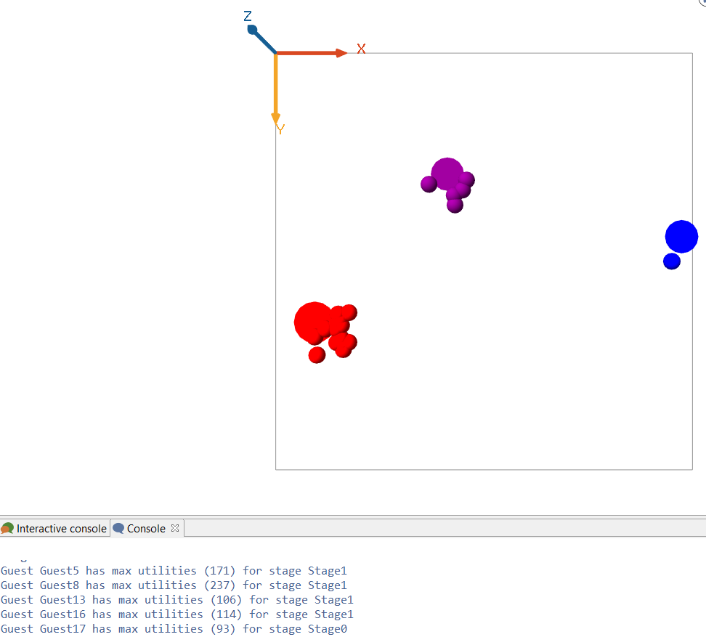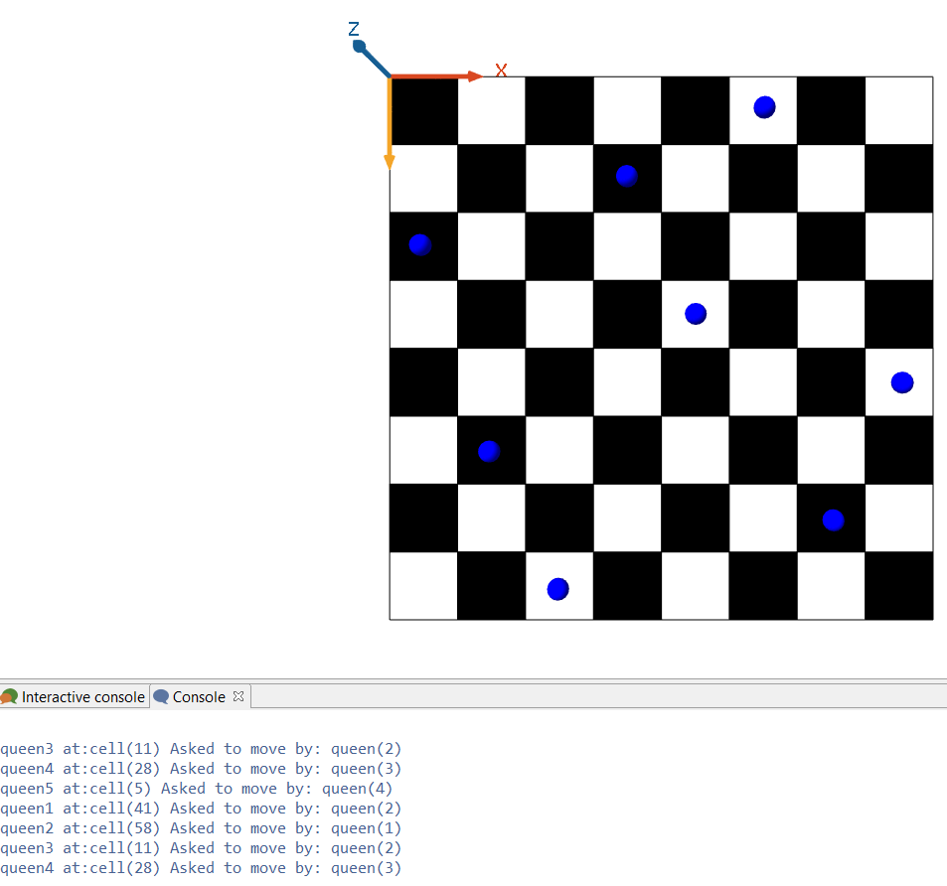

Figure - N-Queen (8) result Figure 2 – Concert result

**Conclusion**

This assignment made us spend a lot of time on the first task, related to the N-Queens, as it required a different approach then the well-known backtracking one. This implied the advance and wise usage of FIPA, therefore making us understand it even better. The second task of the assignment was way less stressing and helped us improve our skills in coding negotiating agents and just remembering how to use simple math formulas in the coding life. Per total, it was a both interesting and stressing experience.