PLC PSS REPORT

***Submitted By***

# Bali Babu Chauhan Regd.No. 19410121182

6th Semester, CSE (Section-M)

***In The Supervision Of***

# Jitesh Pradhan

Designation of concerned faculty, Department of Computer Science & Engineering,

Siksha ‘O’ Anusandhana Deemed to be University (S‘O’A), Bhubaneswar, Odisha, India



# Department of Computer Science & Engineering Institute of Technical Education and Research SIKSHA ‘O’ ANUSANDHAN

**(Deemed to be University) Bhubaneswar, Odisha, India**

# 2022

**Assignment-1**

1. Construct DFA(s) for the following languages:
   1. {w | w begins with a 1 and ends with a 0}.
   2. {w | w has length at least 3 and its third symbol from left is a 0}.
   3. {w | w doesn't contain the sub-string 110}.
   4. {w | the length of w is at most 5}.
   5. {w | the decimal equivalent number of w is divisible by 5}.
2. Consider ∑ = {a, b} and, wE∑. Design DFA(s) accepting the following languages:
   1. Starts with a and |w| = 1 (mod 4).
   2. Containing sub-string "ab" but |w| is not divisible by 2.
3. Construct DFA(s):
   1. Over the alphabet set (0, 1} such that it recognizes set of all strings in which every "00" is immediately followed by a 1. (For instance, the strings 1001, 0010, 0010011001 are in the language but 0001, 00100 are not).
   2. Over the alphabet set (a, b) and wE∑*, such that (w | w contains an even number

of a's and an odd number of b's and does not contain the sub-string "ab"). (in 5 states)

**Q1** Construct DFA(s) for the following languages:

1. 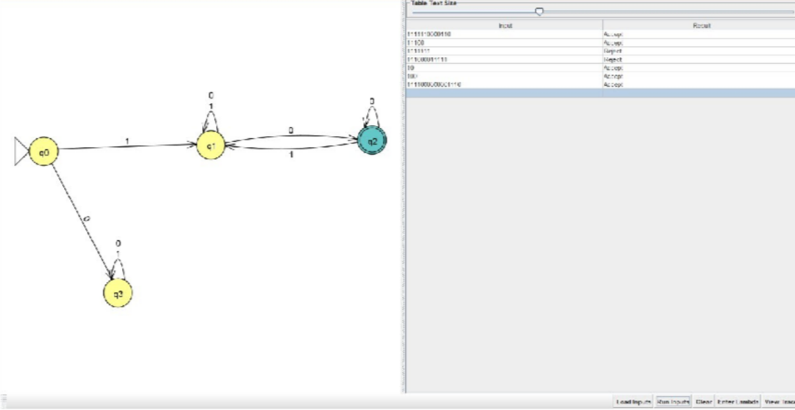{w | w begins with a 1 and ends with a 0}.
2. {w | w has length at least 3 and its third symbol from left is a 0}.

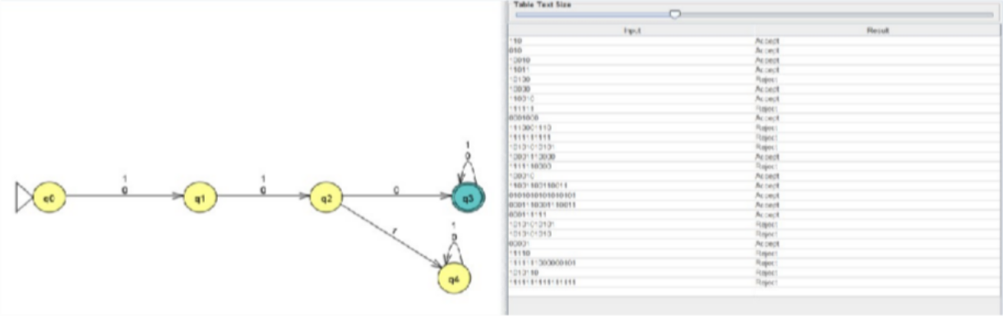

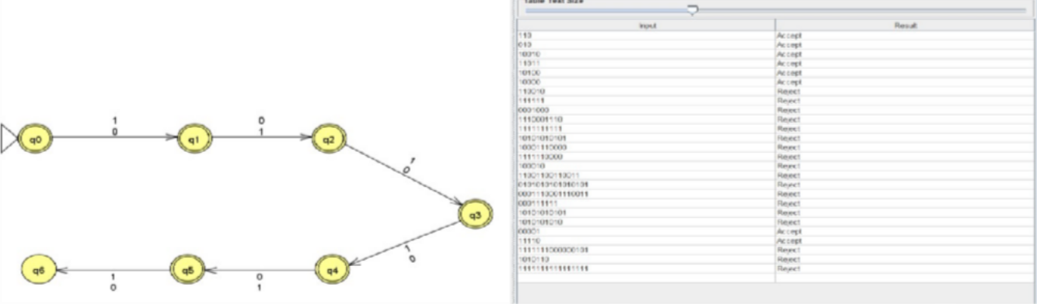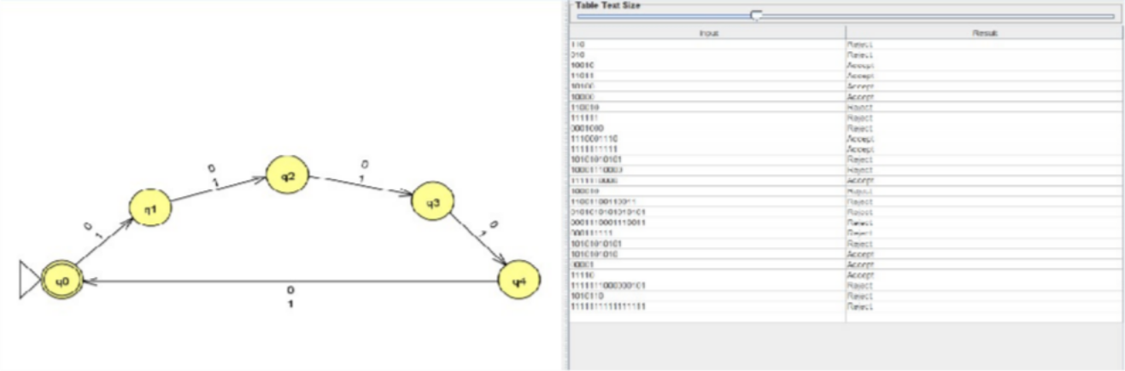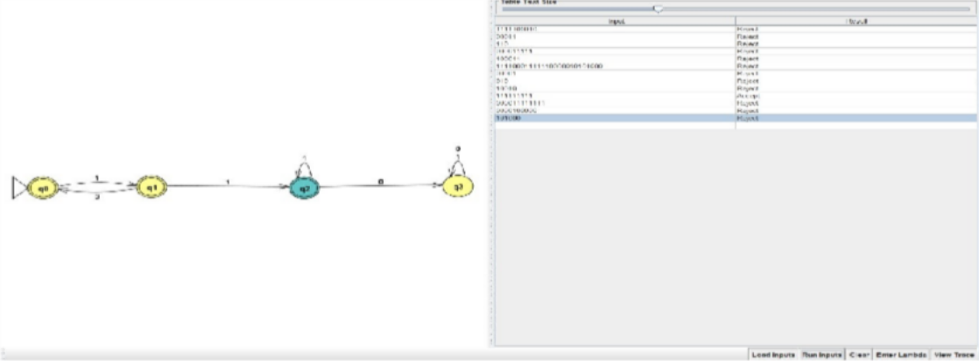

1. {w | w doesn't contain the sub-string 110}.
2. {w | the length of w is at most 5}.
3. {w | the decimal equivalent number of w is divisible by 5}.

# Q2.

Consider ∑ = {a, b} and, wE∑. Design DFA(s) accepting the following languages:

1. Starts with a and |w| = 1 (mod 4).

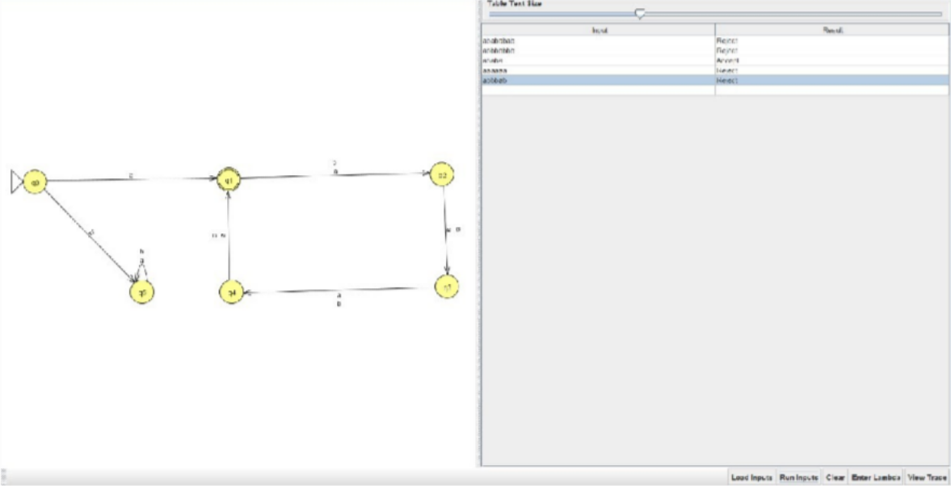

1. Containing sub-string "ab" but |w| is not divisible by 2.

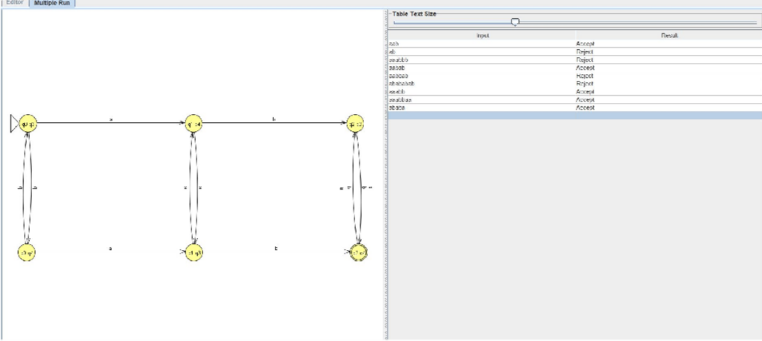

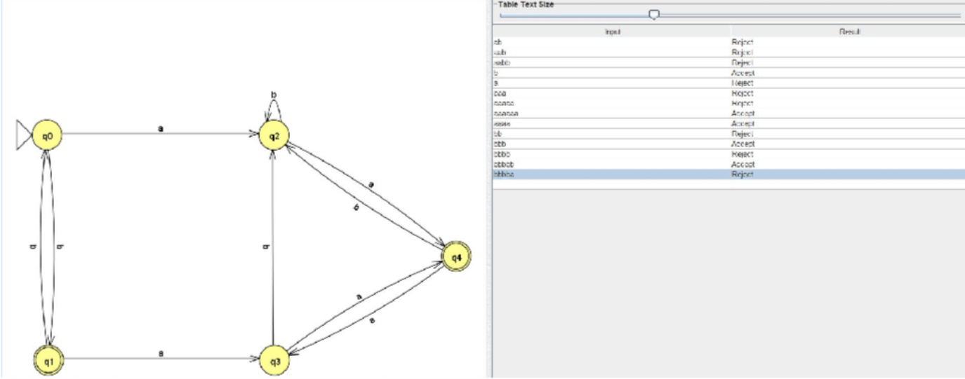

**Q3** Construct DFA(s):

1. Over the alphabet set (0, 1} such that it recognizes set of all strings in which every "00" is immediately followed by a 1. (For instance, the strings 1001, 0010, 0010011001 are in the language but 0001, 00100 are not).

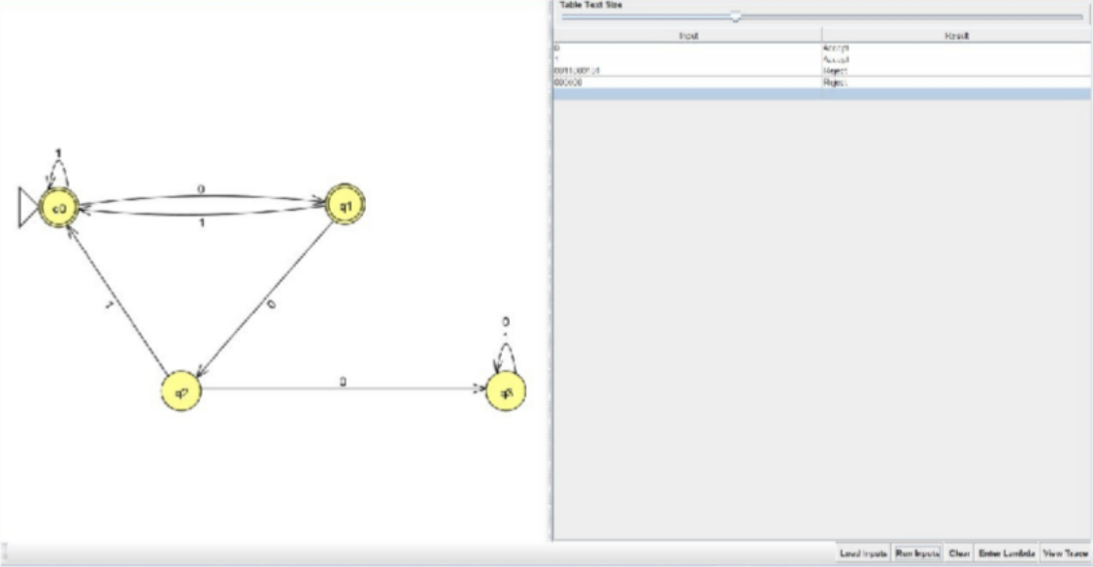

1. Over the alphabet set (a, b) and wE∑*, such that (w | w contains an even number of a's and an odd number of b's and does not contain the sub-string "ab"). (in 5 states)