**Problem Solving-1**

1. Initialize the following term-incidence matrix. Process the following query: “**Brutus AND Caesar AND NOT Calpurnia”**

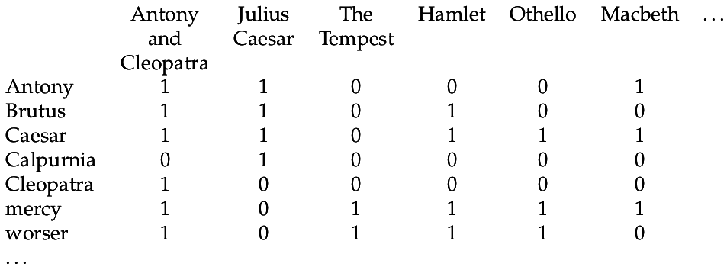

1. Given four documents:

Doc1: Breakthrough drug for Schizophernia

Doc2: New Schizophernia drug

Doc3: New approach for treatment of Schizophernia

Doc4: New hopes for Schizophernia patients

Generate the **term-document incidence matrix**.

1. Construct an Inverted Index for the above specified input document collections.
2. Construct a Sorting based Inverted Index for the above specified input document collections.
3. Process the query **'BRUTUS AND CALPURNIA**' using the **intersect algorithm**.

