

CHRISTITES FOR CLIMATE ACTION
Climate Data Visualisation and Comparative Analysis
(2020-2024)
Event: Datathon Round 1
Team Name: Data Warriors
Participant 1: KUNSH BALI (2BSc DS- 2541437)
Participant 2: NAVEEN SINGH S (2BSc DM -2541350)


Dataset
Year | City | Avg Temp (°C) | Avg Humidity (%) | Annual Rainfall (mm)
2020 | Bengaluru | 26.2 | 70 | 1180
2020 | Hyderabad | 29.4 | 60 | 1120
2020 | Delhi | 29.8 | 44 | 650
2020 | Kolkata | 29.3 | 78 | 2000
2020 | Mumbai | 29.5 | 88 | 3300
2021 | Bengaluru | 26.3 | 71 | 1200
2021 | Hyderabad | 29.6 | 61 | 1150
2021 | Delhi | 30.0 | 45 | 670
2021 | Kolkata | 29.5 | 79 | 2050
2021 | Mumbai | 29.7 | 89 | 3350
2022 | Bengaluru | 26.5 | 70 | 1220
2022 | Hyderabad | 29.8 | 60 | 1180
2022 | Delhi | 30.2 | 44 | 640
2022 | Kolkata | 29.7 | 78 | 2080
2022 | Mumbai | 29.8 | 89 | 3400
2023 | Bengaluru | 26.6 | 72 | 1250
2023 | Hyderabad | 30.0 | 62 | 1200
2023 | Delhi | 30.5 | 43 | 620
2023 | Kolkata | 29.9 | 80 | 2100
2023 | Mumbai | 30.0 | 90 | 3500
2024 | Bengaluru | 26.8 | 73 | 1280
2024 | Hyderabad | 30.2 | 63 | 1230
2024 | Delhi | 30.7 | 42 | 600
2024 | Kolkata | 30.1 | 81 | 2150
2024 | Mumbai | 30.2 | 91 | 3600

Task 1
- Temperature Trend Graph

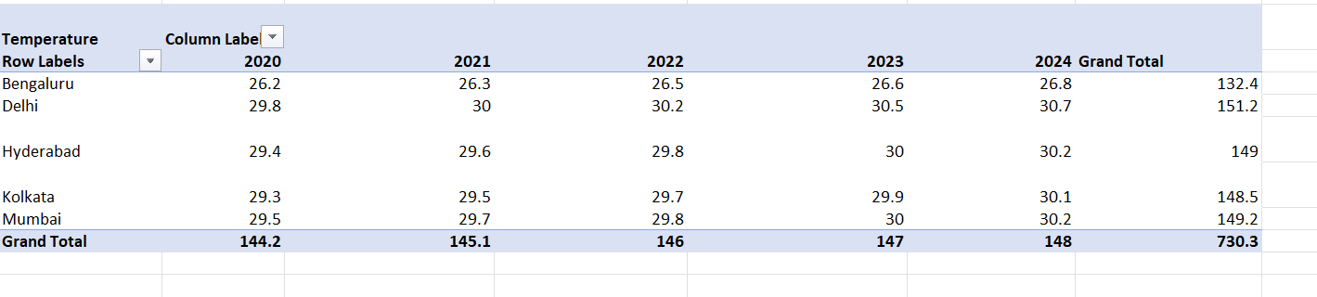

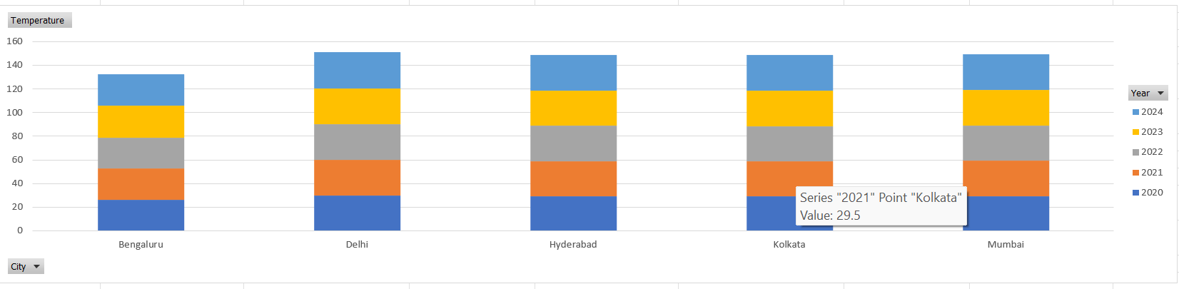
The graph shows a consistent and slightly upward trend in annual average temperatures across all cities from 2020 to 2024.
Delhi consistently records the highest average temperature (peaking at 30.7°C) while Bengaluru remains the coolest city throughout the period, where the temperature ranges between 26.2°C and 26.8°C

- Rainfall Trend Graph
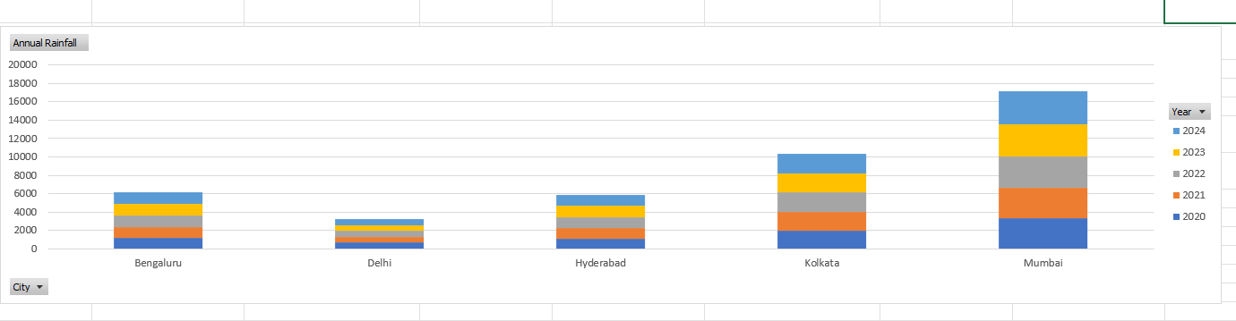
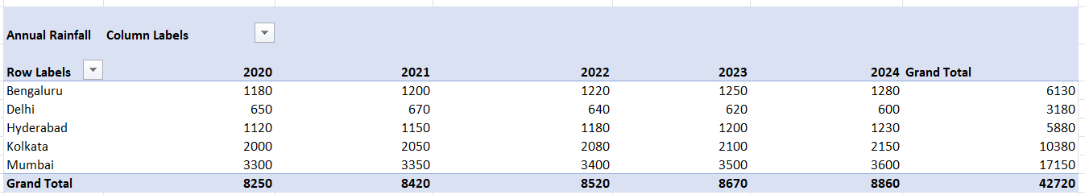

There is a massive disparity in precipitation levels among the cities.
Mumbai is the clear outlier with extreme annual rainfall reaching up to 3600 mm, whereas Delhi receives the least, hovering around 600mm-700mm.
Most cities show a slight increase in rainfall volume as they progress toward 2024.
- Humidity Trend Graph
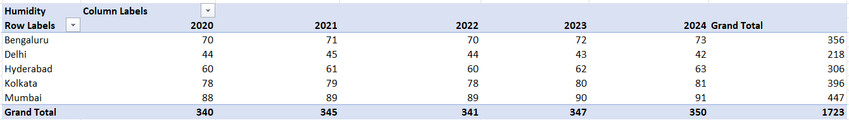
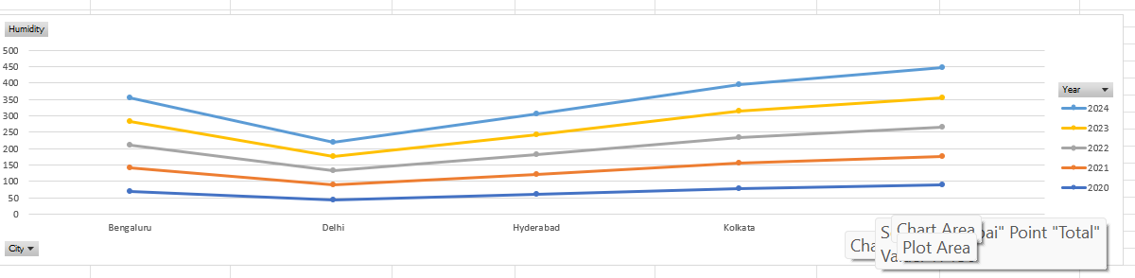
Humidity levels remain stable year -over-year for each city but vary significantly by geography. Coastal cities like Mumbai (88 -91%) and Kolkata (78 % -81%) experience very high humidity, while Delhi experiences the lowest humidity levels, dropping as low as 42 %, thus reflecting its semi-arid climate.
- Comparison Chart
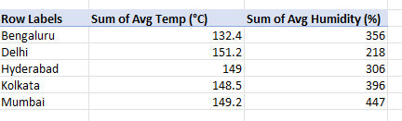
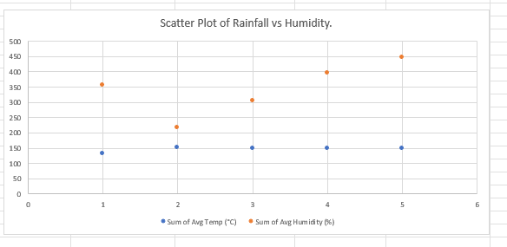
The data reveal a strong positive correlation between Annual rainfall and average humidity, implying that cities like Mumbai, with the highest rainfall, also report the highest humidity levels.
On the other hand, Delhi serves as a baseline outlier, showing that high average temperatures do not necessarily result in high humidity in inland regions.

Task 2:
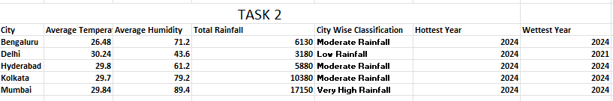

Bengaluru shows a moderate climate with stable temperature and moderate rainfall, peaking in 2024 for both temperature and rainfall.
Delhi has the highest temperature but the lowest humidity and rainfall, thus it indicates a dry climate and its hottest year is 2024, while rainfall peaked in 2021.
Hyderabad has a warm and moderately humid climate and has consistent moderate rainfall, highest in 2024.
Kolkata is highly humid with significantly high rainfall totals, reflecting its strong monsoon influence; both temperature and rainfall peaked in 2024.
Mumbai clearly stands out with extremely high humidity and rainfall, the highest among all cities, mostly because of its coastal monsoon climate; 2024 is also its hottest and wettest year.
TASK 3:

- The chart below shows that Delhi has the hottest overall temperature (30.24°C ), which peaked in 2024 and has consistently risen every year

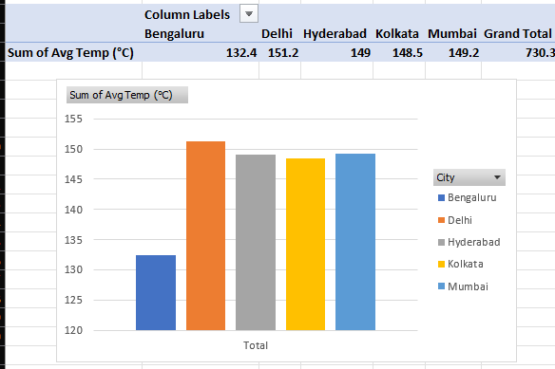

- The Chart Below shows that Mumbai has the most humid climate (89.4%-highest)
Every year Mumbai stays above 88-91 %, it's mainly due to the strong coastal influence, thereby there is high humidity across all cities.

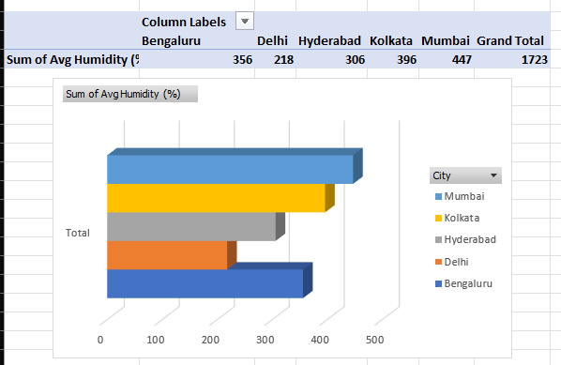

- Mumbai receives the most rainfall. The total rainfall between 2020-2024 accounted for 17150mm, which is massively higher than all others. Kolkata (10,380 mm) is far behind. Mumbai clearly leads due
to intense monsoon activity
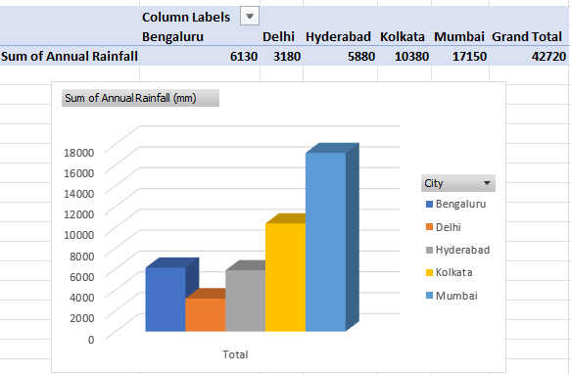

- Bengaluru has the most stable climate.
Temperature variation in Bengaluru has been very small (26.2 -> 26.8°C across 5 years)
Humidity variation has also been very narrow (70-73%)
Though there has been a steady increase in rainfall, there are no extreme jumps compared to coastal cities.
Therefore, it shows the lowest fluctuations across all three metrics.
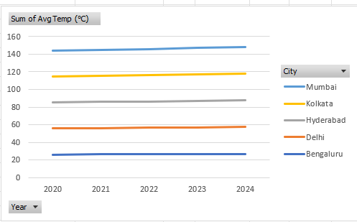
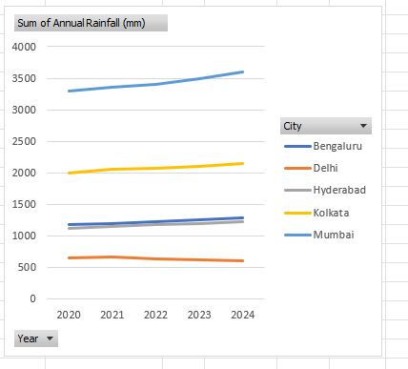
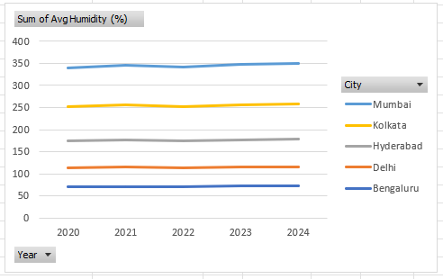

Task 4
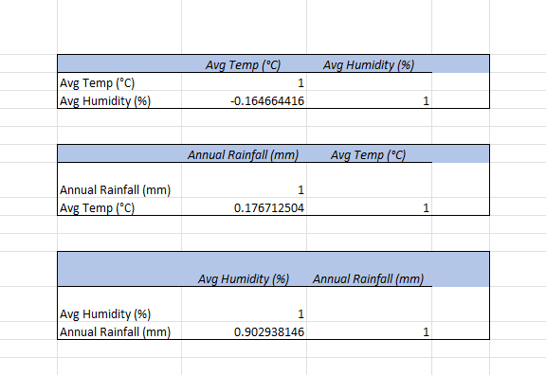
Findings:
- There is a correlation of 0.903 between Avg. Humidity and Annual Rainfall, which indicates there is a very strong positive correlation. Therefore, as average humidity increases, annual rainfall tends to increase significantly as well.
- There is a correlation of 0.177 between Annual Rainfall and Avg. Temperature. Thus, there is a weak positive relationship.
Therefore, while there is a slight tendency for rainfall to be higher in warmer temperatures within this dataset, the connection is quite loose. Temperature is not a reliable predictor of rainfall on its own here.
- There is a correlation of -0.165 between Avg. Temp and Avg. Humidity. This indicates there is a weak negative relationship.
Therefore, as temperature rises, humidity tends to dip slightly (and vice-versa), but the relationship is so weak that it’s almost negligible.

Task 5 - Insights & Interpretation
Insight 1: Mumbai’s High Humidity and Rainfall are Due to Coastal and Orographic Effects
Mumbai records the highest humidity (88-91%) and rainfall (3300-3600 mm annually).
This is because it is located along the Arabian Sea and on the windward side of the Western Ghats. During the southwest monsoon, moisture-laden winds from the sea rise when they hit the mountains, cool down, and release heavy rainfall. This process is called orographic rainfall, and it explains why Mumbai consistently experiences extreme precipitation and humidity.

Insight 2: Delhi has the highest average temperature(30.24°C) but the lowest rainfall(600-670mm) and humidity (42-45 %)
It is because Delhi is far from major water bodies, and it lacks a consistent moisture source. Even though temperatures are rising, rainfall is not increasing, which explains the weak temperature and rainfall correlation (0.177). This shows that heat alone does not determine precipitation.
Insight 3: Bengaluru has the most stable climate due to its elevation.
Bengaluru shows minimal temperature variation (26.2°C to 26.8°C over five years) and stable humidity (70-73 %).
Its higher elevation of about 900m above sea level helps maintain cooler and more consistent temperatures, reducing extreme fluctuations.

Anomalies Observed:
- Continuous Increase in Mumbai’s Rainfall:
Rainfall rises steadily from 3300 mm (2020) to 3600 mm (2024). Normally, monsoon rainfall fluctuates yearly, so this consistent rise suggests increasing atmospheric moisture.

- Delhi’s Rising Temperature but Falling Rainfall:
Delhi’s temperature increases every year, but rainfall decreases after 2021. Since humidity remains low, higher temperatures do not lead to more rainfall, indicating a shift towards drier conditions.

Climate Risk Identified
- Flood Risk in Mumbai:
As there is Extremely high rainfall, rising trends, high humidity and strong humidity -rainfall correlation (0.903), it indicates increasing flood vulnerability, especially in dense coastal city.
- Heat and Water Stress in Delhi:
High temperatures combined with declining rainfall and low humidity increase the risk of heatwaves and water scarcity.

