Marketing

Facebook ads – 1000$ - 3000$
Youtube influencers – 100$ - 1000$
Instagram influencers – 250$ - 700$
Twitter influencer marketing – 150$ - 500$

1. Research

- 3C Analysis

3C – Customer – Competitor – Company

- SWOT Analysis

SWOT – Internal:
Strengths – Weaknesses
--External:
Opportunities – Threats

Helpfull : Strengths and Opportunities
Harmful : Weaknesses and Threats

2. Planning

STP Process : Segmentation – Targeting – Positioning

Segmentation :
You should divide consumers into segments based on some type of shared characteristics.
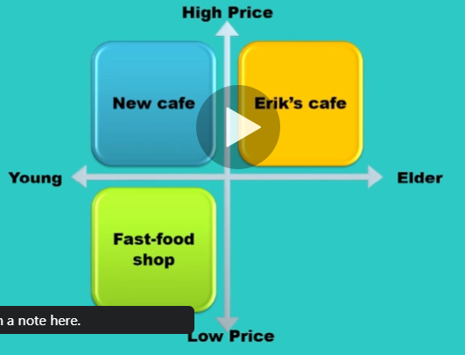

4P Marketing Mix : Product Price Place Promotion

