WEEK 4 PROJECT REPORT

Exploratory Data Analysis
and Feature Engineering
Beauty & Wellness | Customer Reviews of Skincare Products
Prepared by: Parmeet Kour
Internship / organization: yuva intern

1. Introduction
This project applies exploratory data analysis (EDA) and feature engineering to customer reviews of skincare products in the beauty and wellness domain. Customer reviews provide information about ratings, recommendations, product prices, review helpfulness, customer skin types, brands, and review dates. The purpose is to understand patterns in this information and create additional features that can support further analysis.

2. Project Objectives
- Understand the structure and important variables in the cleaned customer-review dataset.
- Use descriptive statistics and visualizations to examine ratings, prices, brands, skin types, helpfulness, and review trends.
- Explore relationships between product price, customer ratings, recommendation status, and helpfulness.
- Create additional numerical, categorical, and date-based features.
- Prepare the dataset for possible future analytical and machine-learning tasks.

3. Dataset Description
The analysis used the cleaned Sephora customer-review dataset prepared during the earlier data-cleaning stage. At the beginning of Week 4, the dataset contained 49,972 rows and 21 columns. Its fields include review ratings, recommendation status, helpfulness and feedback counts, submission date, review text and title, customer skin and appearance attributes, product identifiers, product and brand names, and product price.
- Review text: 49,912 non-missing records; 60 missing records.
- Recommendation field: 3,817 missing values.
- Helpfulness field: 13,455 missing values.
- Review title: 14,376 missing values.
- Skin type: 3,631 missing values.
- Average product price: approximately $66.87; median: $45; maximum: $1,900.
- Average rating: approximately 4.21 on a scale from 1 to 5.
Missing values were not treated as negative feedback. For example, a missing helpfulness value may mean that a review had not received feedback.

4. Tools and Technologies
- Python for programming and analysis.
- Pandas and NumPy for data handling and numerical operations.
- Matplotlib and Seaborn for visualizations.
- Visual Studio Code for writing and running the Python script.
- CSV and Excel formats for saving the final dataset.

5. EDA Approach and Workflow
- Loaded the cleaned CSV file into a Pandas DataFrame.
- Inspected the first rows, dimensions, column names, and data types.
- Generated descriptive statistics for numerical variables.
- Examined rating counts, recommendation counts, average price, and the most-reviewed brands.
- Created charts to understand individual variables and relationships between variables.
- Converted the submission date and examined review trends over time.
- Created new features and checked the updated dataset dimensions.

6. Statistical Analysis
The average rating was approximately 4.21. Rating counts were: 1 star — 3,927; 2 stars — 2,767; 3 stars — 3,761; 4 stars — 7,811; and 5 stars — 31,706. Five-star reviews were therefore the most common.
The average product price was approximately $66.87, while the median was $45. The third quartile was $74 and the maximum price was $1,900. The distribution therefore has a long upper tail. Potential price outliers identified during the earlier cleaning stage were flagged and retained rather than automatically deleted.
The most-reviewed brands included SEPHORA COLLECTION (2,434 reviews), Kate Somerville (1,770), CLINIQUE (1,567), Mario Badescu (1,299), and Paula's Choice (1,278).

7. Exploratory Data Analysis and Visualizations
The following figures were created during the analysis. Each figure is followed by its interpretation.

Figure 1. Distribution of Customer Ratings
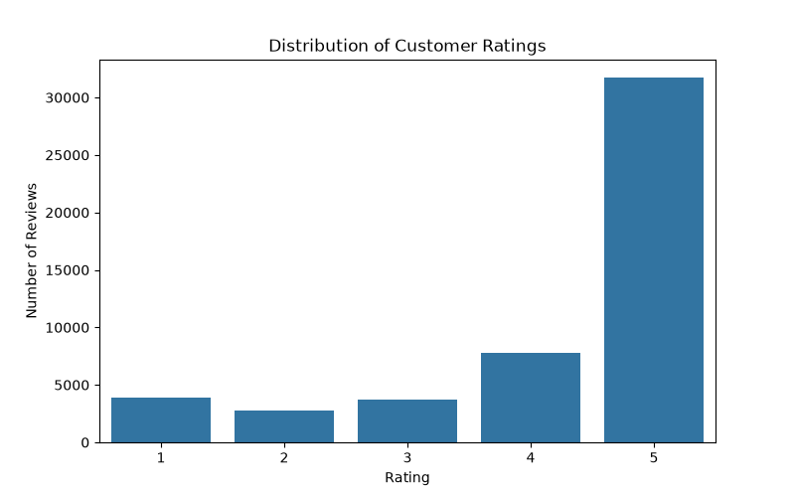
Five-star reviews are the most frequent (31,706), followed by four-star reviews (7,811). The available reviews are largely positive.

Figure 2. Top 10 Most Reviewed Brands
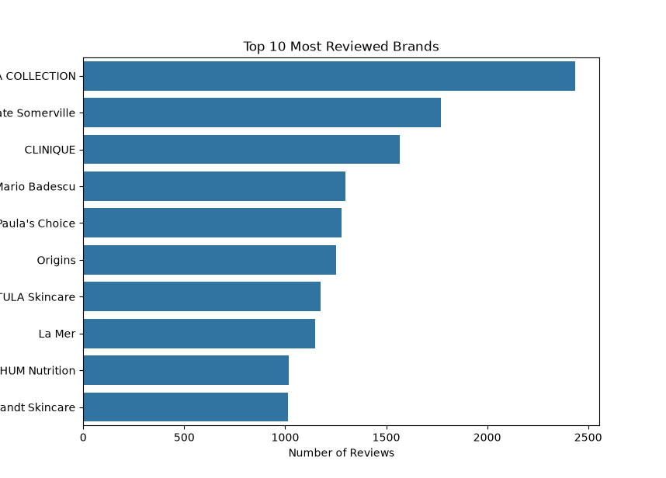
SEPHORA COLLECTION has the highest review count (2,434), followed by Kate Somerville (1,770) and CLINIQUE (1,567). Review volume does not by itself measure market share or product quality.

Figure 3. Distribution of Product Prices
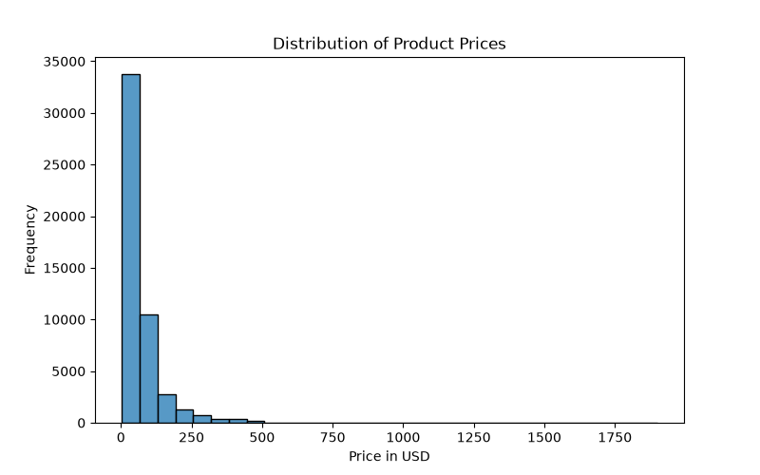
Product prices are strongly right-skewed. Most reviewed products are concentrated at lower price points, while a small number of expensive products extend the upper tail.

Figure 4. Product Price Distribution by Rating
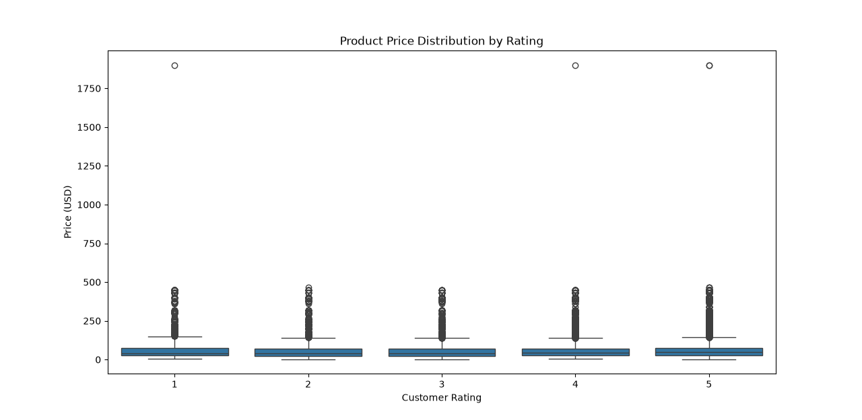
The boxplots compare product prices across rating values. High-price outliers appear in every rating group, so price alone does not clearly separate ratings.

Figure 5. Average Rating by Recommendation Status
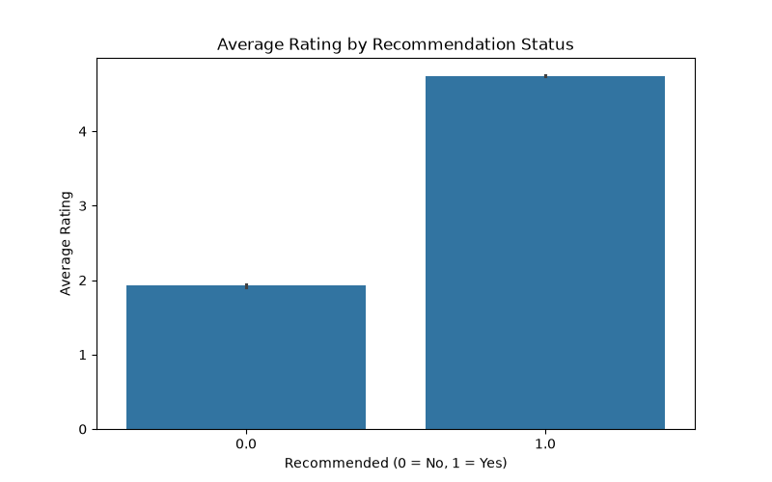
Reviews marked as recommended have a substantially higher average rating than reviews marked as not recommended, which is consistent with the meaning of the recommendation field.

Figure 6. Review Helpfulness by Rating
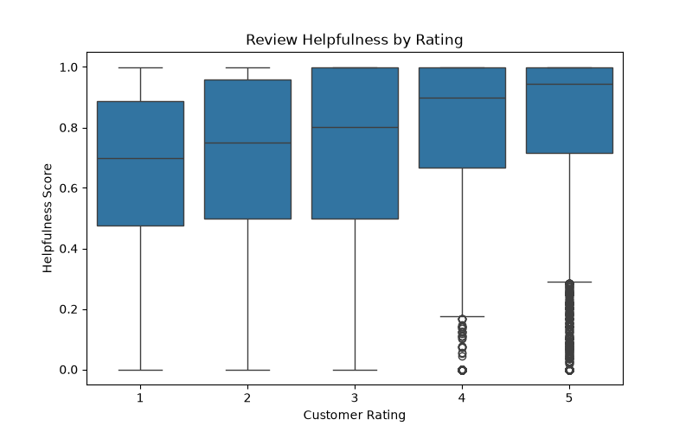
The boxplots compare helpfulness scores across ratings. The median helpfulness appears higher for four- and five-star reviews than for lower ratings.

Figure 7. Distribution of Customer Skin Types
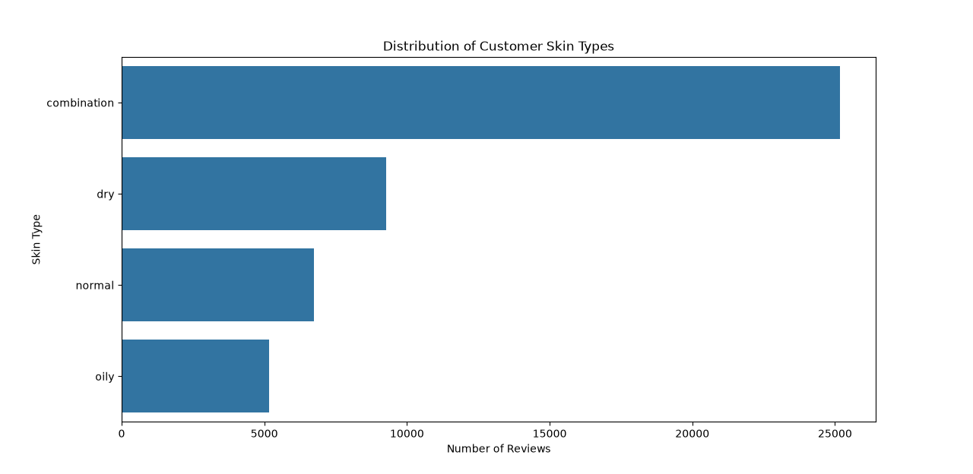
Combination skin is most common (25,168), followed by dry (9,267), normal (6,735), and oily (5,171). Missing skin-type values are not represented in this chart.

Figure 8. Customer Review Trends Over Time
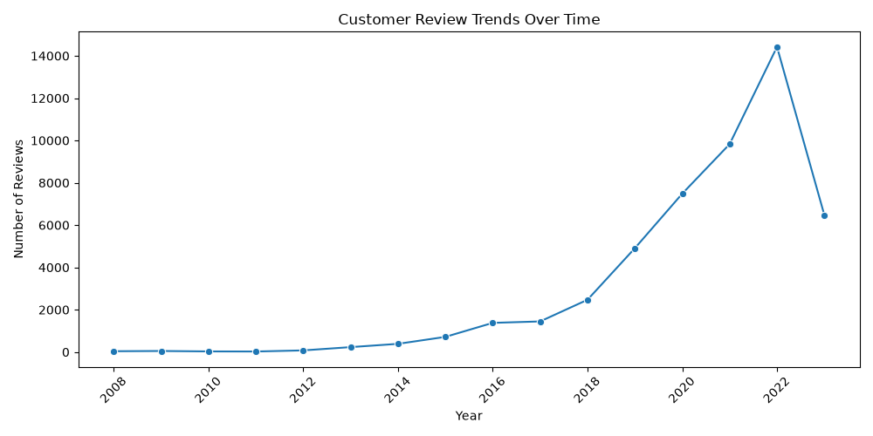
Review counts reached a maximum in 2022 (14,421). The lower count in 2023 (6,472) may reflect incomplete coverage of that year and should not automatically be interpreted as reduced customer interest.

Figure 9. Average Rating of Top 10 Most Reviewed Brands
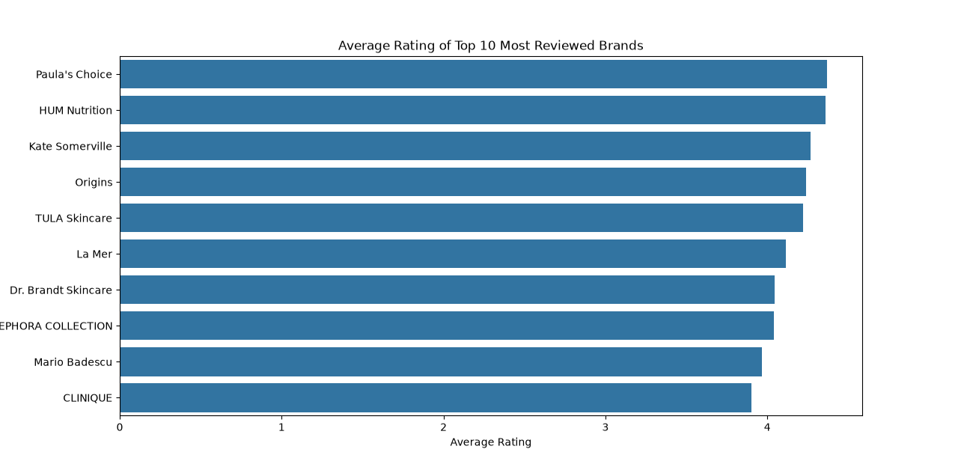
Paula's Choice had the highest average rating among the ten brands (about 4.37), followed by HUM Nutrition (about 4.36). These are descriptive comparisons within this dataset.

8. Advanced EDA

8.1 Review trends over time
The submission date was converted to a date variable and review year was extracted. Yearly review counts increased over much of the period and reached 14,421 in 2022. The 2023 count was 6,472. Dataset coverage for 2023 may be incomplete, so this difference should be interpreted cautiously.

8.2 Customer skin-type distribution
Among recorded skin types, combination skin was most common (25,168), followed by dry (9,267), normal (6,735), and oily (5,171). These counts exclude missing skin-type values.

8.3 Brand rating comparison
Among the ten most-reviewed brands, Paula's Choice had an average rating of approximately 4.37 and HUM Nutrition approximately 4.36. CLINIQUE's average was approximately 3.90. These values describe the available reviews and do not establish a universal ranking of brands.

9. Feature Engineering

9.1 Review length
The review_length feature was created by counting the words in review_text_final. Missing text was filled with an empty string for this calculation, resulting in a word count of zero for those records.

9.2 Date-based features
The review_year and review_month features were extracted from submission_time. They make it possible to group reviews by year and month and examine changes in review activity.

9.3 Price category
Prices were grouped using $28 and $74 as cut-offs, based on the first and third quartiles. Budget includes prices up to $28, Mid-Range includes prices above $28 and up to $74, and Premium includes prices above $74. The resulting review counts were 13,499 Budget, 24,109 Mid-Range, and 12,364 Premium.

9.4 Rating category
Ratings were grouped into Negative (1–2), Neutral (3), and Positive (4–5). This simplified category was used to compare review length and helpfulness across broad rating groups.

9.5 Normalization
Min-Max normalization was applied to product price and review length, creating price_normalized and review_length_normalized. These features scale the original values between 0 and 1.

9.6 One-hot encoding
One-hot encoding was applied to price_category and rating_category. Six binary columns were created: price_Budget, price_Mid-Range, price_Premium, rating_Negative, rating_Neutral, and rating_Positive.

9.7 Interaction feature
The price_rating_interaction feature was created by multiplying product price by customer rating. It provides a combined variable for exploring price and rating together. Its usefulness should be tested in later analysis rather than assumed.
After feature engineering, the dataset contained 49,972 rows and 35 columns, compared with 21 columns at the start of the Week 4 analysis.

10. Findings from Feature-Based Analysis
- Average review length was approximately 54.19 words for Negative, 64.11 for Neutral, and 61.94 for Positive reviews.
- Mid-Range products received the most reviews (24,109).
- Average ratings were approximately 4.09 for Budget, 4.27 for Mid-Range, and 4.23 for Premium products.
- March had the highest monthly review count (6,887), while November had the lowest (3,091).
- Average helpfulness was approximately 0.668 for Negative, 0.710 for Neutral, and 0.797 for Positive reviews.

11. Potential Business Insights
- Businesses could examine what drives high review engagement for frequently reviewed brands.
- Mid-range products had the highest review count and average rating among the three price groups; customer expectations and perceived value in this range may merit further study.
- The large number of five-star reviews indicates generally positive feedback in this dataset. Lower-rated reviews can also be examined to identify improvement opportunities.
- Skin-type information may help organize feedback by customer needs, while taking missing values and sample sizes into account.
- Review length and helpfulness may help businesses understand which kinds of customer feedback are useful to shoppers.
- Monthly and yearly review patterns may help businesses plan when to monitor customer feedback.
These are exploratory observations, not causal conclusions. Further data and validation are needed before making business decisions.

12. Limitations
- The dataset may not represent all skincare customers, products, or brands.
- Several columns contain missing values, including recommendation, helpfulness, review title, and customer attributes.
- The rating distribution is uneven, with five-star reviews much more common than other ratings.
- High-price observations affect the scale and shape of the price distribution.
- The 2023 review count may represent incomplete year coverage.
- No predictive model was trained in this analysis, so improvement in model accuracy has not been measured.

13. Conclusion
This project applied exploratory data analysis and feature engineering to a cleaned Sephora skincare customer-review dataset. Descriptive statistics and visualizations were used to study ratings, brand review counts, prices, skin types, helpfulness, and review trends. Additional features were created for review length, review date, price category, rating category, normalized numerical values, encoded categories, and a price-rating interaction.
The final engineered dataset contains 49,972 rows and 35 columns. The work provides a structured basis for further customer-review analysis and future machine-learning experiments after suitable validation.

14. Project Files
- week4.py — Python script used for EDA and feature engineering.
- sephora_reviews_cleaned.csv — cleaned input dataset.
- sephora_reviews_week4_final.csv — final dataset with engineered features.
- sephora_reviews_week4_final.xlsx — Excel version of the final dataset.
- graphs/ — folder containing the nine visualization images.

