Github URL: <https://github.com/baliusf/ds-linked-list>

Output: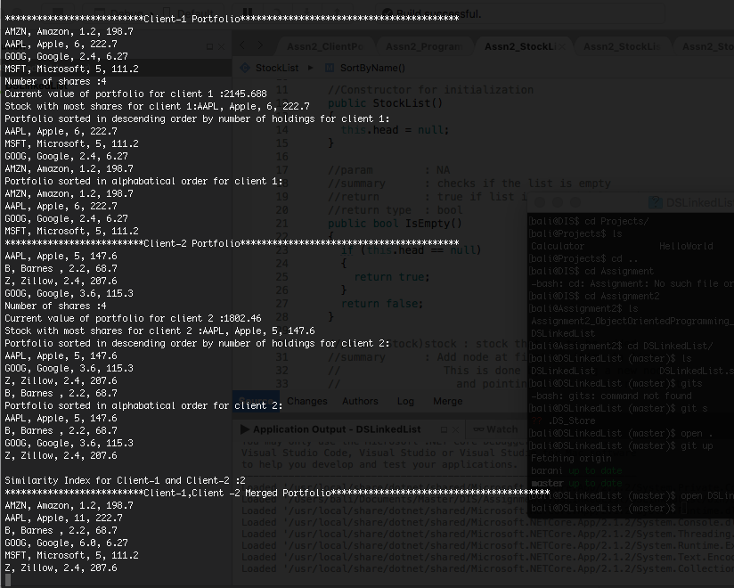

Team members with their names, git output log and their self reflection.

**Kartikay Bali**

git log --author="baliusf" --pretty=tformat: --numstat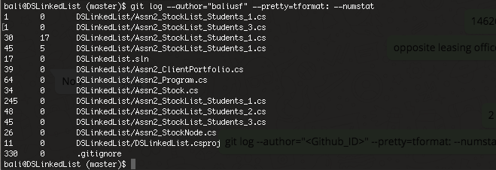

I had spent around 3-4 hours for implementing the methods in stockliststudents_1. Sorting was little tricky where there was a corner case that I encountered when I reversed my sort logic (just for testing, DESC -> ASC). The assignment could have asked us to create objects and initialize data by ourself in order to get more familiarity with OOP concepts.

**Baranidhar Eswaramoorthy Manoharan**

git log --author="barani235" --pretty=tformat: --numstat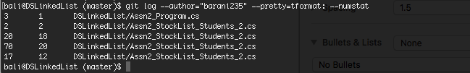

I had spent close to 6 hours for implementing the methods in partial class 2 which gave me a deeper understanding about how the “List library” would have been implemented. Also, spent close to 2 hours in getting myself accustomed to GitHub. I’d been able to draw comparisons between GitHub and SVN. The skeleton for the code was already given to us, which was really helpful but I would have liked to know more about how to form the skeleton.

**Uday Karnam**

git log --author="udaysaikarnam" --pretty=tformat: —numstat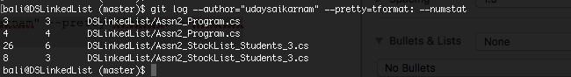

I had spent around 20 hours throgh out this week to make myself comfortable with GIT and by implementing this code I learnt the operations on single linked list and I think implementing similar or another logic tree data structure will be handy